Original Research Article

Integrated Assessment of Algal Bioaccumulation and Microbial Indicators Coupled Metal Pollution in a Human-Impacted Kuwano River system, Basti (U.P.), India

________________________________________________________________________________
ABSTRACT
Aims: This study assessed chemical and microbial contamination in the Kuwano River by (i) quantifying concentrations and spatial distribution of selected heavy metals (Cd, Pb, Zn, Cu, Cr, and trace metals), (ii) evaluating microbial pollution via total coliforms, faecal coliforms, and Escherichia coli, and (iii) determining the Bioaccumulation Factor (BAF).
Study Design and Location: An observational field–laboratory investigation was conducted across five stretches (Shivaghat, Atara, Amhat, Mahson, and Lalganj) of the Kuwano River, Basti, Uttar Pradesh, India, during 2025.
Methodology: Surface water samples were collected in pre-cleaned HDPE and sterile glass bottles. Heavy metals in water and algal biomass were quantified using Inductively Coupled Plasma–Mass Spectrometry (ICP-MS). Microbial contamination was assessed via membrane filtration to determine CFU/100 mL of total coliforms, faecal coliforms, and E. coli. BAF was calculated to evaluate metal accumulation in algae. Pearson correlation and Canonical Correspondence Analysis were applied to examine relationships between variables.
Results: Heavy metal concentrations were higher in algal biomass than in water, indicating significant bioaccumulation. Potassium dominated in water, while Cr, Mn, Fe, and Ni showed spatial variability. High BAF values for Ni, Mn, and Cr confirmed strong accumulation capacity of algae. Cd, Pb, and Cr at some sites approached or exceeded guideline limits. Microbial analysis showed elevated total coliforms (585–702 CFU/100 mL), fecal coliforms (292–308 CFU/100 mL), and E. coli (293–398 CFU/100 mL), indicating substantial faecal contamination. Multivariate analysis linked metal distribution to geochemical and anthropogenic factors, and microbial pollution primarily to sewage discharge.
Conclusion: The Kuwano River exhibits combined heavy metal and microbial contamination, posing ecological and public health risks. Algae serve as effective biomonitors, while persistent faecal indicators highlight ongoing sewage pollution, necessitating integrated monitoring and improved wastewater management.

Keywords: Heavy metals; Algal bioaccumulation; Microbial indicators; River water quality; Bioaccumulation factor; Kuwano River.

1. INTRODUCTION
Multiple anthropogenic pressures, such as urbanisation, agricultural runoff, and small-scale industrial activities, are increasingly affecting rivers in developing regions, which collectively degrade water quality. Among these stressors, heavy metal contamination and microbial pollution are of particular concern due to their persistence, toxicity, and direct implications for human health (Anh et al., 2023). Heavy metals like cadmium (Cd), lead (Pb), zinc (Zn), copper (Cu), and chromium (Cr) are common pollutants in rivers (Singh et al., 2023). They get into river systems through surface runoff, untreated wastewater discharge, and leaching from contaminated soils, where they can build up and have long-term effects on the environment (Zhao et al., 2020; Chen et al., 2025). Heavy metals are non-biodegradable and can persist in aquatic environments, where they bioaccumulate in organisms and biomagnify through food webs, ultimately posing risks to humans via drinking water and fish consumption (Sharma et al., 2025). The World Health Organization (WHO) provides global drinking water guidelines that define permissible limits for various heavy metals and microbial contaminants to protect public health. Similarly, the Bureau of Indian Standards (BIS) has established standards for drinking water quality under IS 10500, which specify acceptable and permissible limits for heavy metals and microbiological parameters in drinking water. According to these standards, excessive concentrations of heavy metals such as lead, cadmium, and chromium pose serious health risks, including neurological damage, kidney dysfunction, and carcinogenic effects (Budi et al., 2024).
Microbial contamination, particularly the presence of total coliforms and faecal coliforms, indicates faecal pollution and the potential presence of pathogenic microorganisms that can cause waterborne diseases (Gaur et al., 2026). Freshwater ecosystems, especially rivers, are essential for maintaining ecological integrity, fostering biodiversity, and delivering critical services such as potable water, agriculture, and fisheries (Arthineton et al., 2009). However, rapid urbanisation, industrial expansion, and intensified agricultural activities have significantly deteriorated river water quality worldwide, leading to the accumulation of heavy metals and the alteration of microbial communities in riverine environments (Gavrilas et al., 2025). These pollutants, often introduced through industrial effluents, domestic sewage, mining runoff, and agricultural discharge, pose serious threats to both environmental and public health due to their persistence, bioaccumulation potential, and toxicity to aquatic organisms and humans alike (Das et al., 2025; Akhtar et al., 2025). Microorganisms in river systems, including bacteria and fungi, play crucial roles in biogeochemical processes and organic matter decomposition (Lu et al., 2023). Their response to heavy metal stress can result in shifts in community composition, metabolic functions, and the emergence of metal-resistant and antibiotic-resistant strains, highlighting the interconnected nature of chemical and biological pollution (Chen et al., 2025; Faruk et al., 2025). Recent integrated studies employing physicochemical profiling and metagenomic analyses have underscored the severity of combined contamination in major river systems such as the Ganges, where levels of Cr and Cd often exceed safe thresholds, while microbial communities exhibit significant variation linked to anthropogenic stressors (Akhtar et al., 2025). These findings emphasise not only the persistence of heavy metal pollution but also its interactive effects on microbial diversity and function, which may impact water quality, ecosystem resilience, and human health risks through the potential dissemination of resistance genes (Akhtar et al., 2025; Faruk et al., 2025).
An important parameter used to evaluate the transfer and accumulation of heavy metals in aquatic organisms is the bioaccumulation factor (BAF) (Agarwal et al., 2022). It offers knowledge regarding the ability of organisms, such as algae, to absorb and concentrate metals from their environment. A higher BAF value indicates greater accumulation potential and suggests that the organism can serve as an effective biomonitoring tool for environmental contamination (Arnot et al., 2006). Its assessment also helps in understanding the movement of heavy metals through aquatic food chains and the potential ecological risks associated with long-term exposure (Chernova & Shulkin, 2019).
Despite its regional significance, comprehensive studies integrating heavy metal assessment with faecal indicator bacteria in the Kuwano River are scarce. Therefore, the present study aims to (i) quantify the concentration and spatial distribution of chosen heavy metals (Cd, Pb, Zn, Cu, and Cr), (ii) evaluate microbial contamination in the river water by quantifying key faecal indicator bacteria, namely total coliforms, faecal coliforms, and Escherichia coli, and (iii) assess the bioaccumulation potential of heavy metals in algae by calculating the Bioaccumulation Factor (BAF) in the Kuwano River water. The findings will produce foundational scientific data for the Kuwano River system, facilitating long-term monitoring, pollution management techniques, and evidence-based policy decisions to enhance river water quality in Uttar Pradesh.
2. MATERIALS AND METHODS
2.1 Study Area and Sampling
The study was conducted along 5 selected stretches (Fig. 1.) of the Kuwano River, Uttar Pradesh, India. Where site$-$1 is Shivaghat (26.931009N 82.62934E), site$-$2 is Atara (26.878605N 82.684903E), site$-$3 is Amhat (26.782366N 82.715375E), site$-$4 is Mahson (26.716965N 82.774532E), and site$-$5 is Lalganj (26.657102N 82.822267E). Surface water samples were collected in pre-cleaned polyethylene bottles for heavy metal analysis and sterile glass bottles for microbiological analysis. All samples were transported to the laboratory under refrigerated conditions.
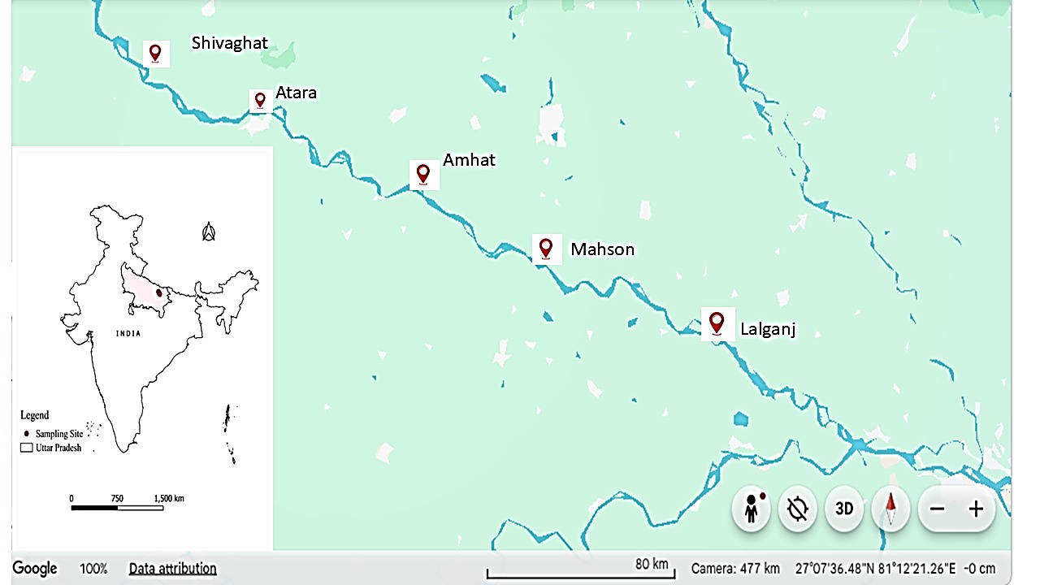
Fig. 1. Geographic map of the study area showing different sampling sites along the river where water and algal biomass samples were collected for physicochemical and biological analysis.
2.2 Heavy Metal Analysis
Water samples were filtered through 0.45 µm membrane filters to remove suspended matter. The filtered samples were acidified with ultrapure nitric acid (HNO₃) to a pH < 2 and digested following standard protocols (APHA, 2017). Concentrations of Cd, Pb, Zn, Cu, Cr, and Ni were determined using Inductively Coupled Plasma–Mass Spectrometry (ICP-MS) (Agilent 7800 ICP-MS). Analytical quality control was maintained using blanks, calibration standards, and three replicate analyses performed in tune mode. Background levels were estimated using the background count subtraction (BKG) mode, a technique commonly applied in environmental and river pollution studies to improve data accuracy (Ge et al., 2022).
Algal biomass and phytoplankton were collected (20 − 30 cm below the water surface) between 7 AM and 9 AM using a phytoplankton net with a 25 µm mesh size. The collection of phytoplankton adhered to the established protocols (APHA, 2017). A plankton net having a stainless-steel ring was used to filter a 20 L sample at each site. The phytoplankton samples were collected in polyethylene bottles. In the laboratory, the algal biomass was dried in a hot air oven at 60–70 °C until a constant weight was obtained. The pre-dried samples were ground into a fine powder using a clean mortar and pestle to ensure homogeneity. Approximately 0.5 g of the powdered algal sample was weighed accurately and transferred into a digestion vessel. Acid digestion was performed using a mixture of concentrated nitric acid (HNO₃) and a few drops of hydrogen peroxide (H₂O₂) to break down the organic matrix and release the bound heavy metals. The digestion was carried out using a hot plate system until a light-yellow-coloured solution was obtained. After digestion, the solution was allowed to cool and then filtered through Whatman filter paper to remove any particulate matter (APHA, 2017; FSSAI, 2024). The filtrate was diluted to a known volume with deionised water and stored in acid-washed polyethylene bottles.
2.3 Microbiological Analysis
The microbial quality of Kuwano River water was assessed using the membrane filtration method. Known volumes of water samples were filtered through sterile 0.45 µm membrane filters and placed on selective media:
- Faecal coliforms: m-FC agar, incubated at 44.5 ± 0.2 °C for 24 h
- Escherichia coli: Confirmed using EMB agar and standard biochemical tests
- Total coliforms: by adding E. coli and Faecal coliform
Results were expressed as colony-forming units per 100 mL (CFU/100 mL). These procedures are consistent with internationally accepted water quality monitoring methods and have been widely reported in riverine microbial studies (APHA, 2017).
2.4 Bioaccumulation Factor (BAF)
The bioaccumulation factor (BAF) is the ratio of the concentration of a substance (such as heavy metals) in an organism to its concentration in the surrounding environment (usually water). It indicates how much a pollutant accumulates in living organisms, such as algae, and is calculated (Ibrahim et al., 2021) as:
$BAF= \frac{Concentration of heavy metal in the organism}{Concentration of heavy metal in the surrounding water }$

2.5 Statistical Analysis
Descriptive statistics were used to summarise heavy metal concentrations and microbial counts. Correlation analysis was performed to evaluate relationships between heavy metals and microbial indicators, which revealed interactions between chemical and biological pollution in each site of the Kuwano River. The PAST 3.06 software was used for Canonical Correspondence Analysis (CCA) to explore interactions with heavy metals, and microbial parameters. The association between different parameters was estimated with Pearson’s correlation analysis, which is a statistical method used to measure the strength and direction of the linear relationship between two variables. Microbial variables and heavy metals, such as E. coli, faecal coliform, total coliform, As, Cr, and Mn, Fe, Co, Ni, Zn, Cd, Pb and ions like Na, K were plotted in a grouped graph using GraphPad Prism 8.0.2.
- RESULTS AND DISCUSSION
  - Heavy metals in river water and algal biomass
Heavy metal concentrations in the Kuwano River water were generally lower than those detected in algal biomass (Fig. 2.c) Table 1, indicating the strong capacity of aquatic algae to accumulate dissolved metals from the surrounding environment (Akbar et al., 2025). Among the analysed metals, potassium showed the highest concentration in river water (537.55 ± 3.31 mg/L), particularly at Site $-$ 2, while chromium (7.76 ± 0.01 mg/L) and iron (138.844 ± 0.45 mg/L) were moderately distributed at the sampling site. Trace concentrations of arsenic, cadmium, and lead were also detected, suggesting the presence of low-level contamination in the river system. The spatial variability of metal concentrations indicates possible localised anthropogenic inputs, including agricultural runoff, domestic wastewater discharge, and urban surface drainage (Singh et al., 2022; Li et al., 2023; Narayanan et al., 2025).
In contrast, algal biomass exhibited comparatively higher concentrations of several metals (Fig. 2. b). K, Cr, Mn, Fe, and Ni were the dominant elements accumulated in algae. Site$-$2 showed relatively elevated concentrations of K and Cr, whereas Mn levels were highest at Site$-$4, and Ni accumulation peaked at Site$-$5. As, Cd, and Pb were detected at comparatively lower concentrations in algal tissues. The higher metal concentrations observed in algal biomass confirm the ability of algae to absorb dissolved metals through surface adsorption and intracellular uptake mechanisms (Akbar et al., 2025). The presence of functional groups such as carboxyl, hydroxyl, and sulphate on algal cell walls facilitates metal binding and accumulation (Kumar et al., 2024; Rahman et al., 2024).

Table 1. Heavy metal concentrations (mg/ L) in the algal biomass samples.
Metals in river water | Site $-$ 1 | Site $-$2 | Site $-$ 3 | Site $-$ 4 | Site $-$ 5
Cr | 0.057 ± 0.001 | 0.087 ± 0.001 | 0.187 ± 0.001 | 0.099 ± 0.002 | 0.199 ± 0.001
Mn | 0.489 ± 0.001 | 0.689 ± 0.001 | 0.889 ± 0.002 | 0.589 ± 0.002 | 0.689 ±0.02
Fe | 0.987 ± 0.002 | 0.997 ± 0.002 | 0.999 ± 0.001 | 0.897 ± 0.002 | 0.797 ± 0.002
Ni | 0.489 ± 0.001 | 0.999 ± 0.003 | 1.321 ± 0.012 | 0.197 ± 0.00 | 0.197 ± 0.001
Zn | 1.988 ± 0.002 | 1.998 ± 0.004 | 2.998 ± 1.210 | 1.898 ± 0.002 | 1.998 ± 0.001
As | 4.324 ± 0.012 | 3.324 ± 1.23 | 2.724 ± 1.23 | 3.724 ± 1.23 | 5.724 ± 2.374
Cd | 0.007 ± 0.001 | 0.009 ± 0.001 | 0.009 ± 0.001 | 0.009 ± 0.001 | 0.009 ± 0.001
Pb | 0.189 ± 0.001 | 0.188 ± 0.001 | 0.398 ± 0.001 | 0.188 ± 0.002 | 0.288 ± 0.001
Co | 0.006 ± 0.001 | 0.006 ± 0.001 | 0.006 ± 0.001 | 0.005 ± 0.001 | 0.008 ± 0.002

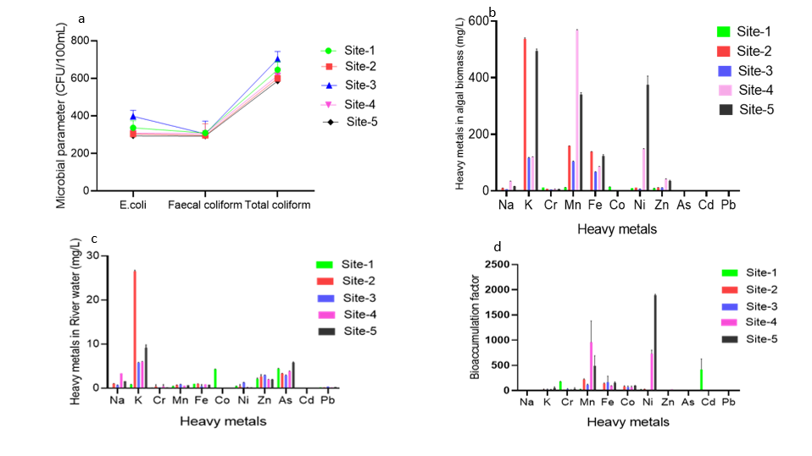
Fig. 2. Spatial variation in microbial parameters and heavy metal concentrations across different sampling sites of the river (a) Microbial parameters (b) Concentration of heavy metals in algal biomass (c) Heavy metal concentration in river water (d) Bioaccumulation factor of heavy metals in algae.
The calculated bioaccumulation factor (BAF) further highlights the role of algae as effective biomonitors of metal contamination. The highest BAF values Table 2 were recorded for Ni at Site$-$5 (approximately 1900), followed by Mn and Cr at Sites$-$4 and 5 (Fig. 2. d). Moderate accumulation was observed for Fe and Co, whereas relatively lower BAF values were recorded for Na, K, and Pb. High BAF values indicate efficient uptake and retention of certain trace metals by algal species, supporting their use as bioindicators in freshwater monitoring programmes (Singh et al., 2022; Rahman et al., 2024).
Table 2. Bioaccumulation factor (BAF) of the Kuwano River across different sampling sites.
Elements | BAF at different sampling sites in Kuwano river water
 | Site $-$1 | Site $-$ 2 | Site $-$ 3 | Site $-$ 4 | Site $-$ 5
Na | 10 ± 0.4 |  | 8.69 ± 3.23 | 10.02 ± 1.2 | 10.19 ± 2.34
  9.89 ± 0.2
K | 1.03 ± 0.0 | 20.25 ± 10.22 | 20.09 ± 10.12 | 19.89 ± 2.09 | 53.85 ± 20.11
Cr | 177.2 ± 6.28 | 19.98 ± 0.09 | 29.0 ± 11.22 | 15.86 ± 2.02 | 34.46 ± 23.22
Mn | 25.7 ± 3.28 | 222.3 ± 12.36 | 116.1 ± 12.33 | 960.4 ± 420.1 | 489.8 ± 200
Fe | 2.87 ± 0.012 | 140 ± 11.22 | 165.9 ± 121.2 | 96.1 ± 2.4 | 155.2 ± 17.87
Co | 3.25 ± 0.02 | 80.45 ± 16.22 | 67.4 ± 23.1 | 64.6 ± 23.2 | 98.5 ± 2.65
Ni | 20.1 ± 2.3 | 28.1 ± 2.68 | 5.48 ± 0.09 | 734.4 ± 68.22 | 1893 ± 18.21
Zn | 4.57 ± 0.02 | 4.5 ± 1.22 | 3.77 ± 0.009 | 21.27 ± 0.06 | 17.87 ± 0.01
As | 0.4 ± 0.009 | 0.09 ± 0.001 | 0.089 ± 0.0 | 0.048 ± 0.003 | 0.031 ± 0.002
Cd | 416.7 ± 209 | 0 ± 0 | 0 ± 0 | 0 ± 0 | 0 ± 0
Pb | 0.9 ± 0.02 | 0 ± 0 | 0 ± 0 | 0 ±0 | 0 ± 0

The detected Cd concentrations at several sampling sites approached or exceeded the permissible limits recommended by the WHO (0.003 mg L⁻¹) and the BIS (0.003 mg L⁻¹), suggesting potential ecological and health concerns. Cd is recognised for its nephrotoxic and carcinogenic effects even at relatively low concentrations (WHO, 2017; Patel et al., 2024). Similarly, Pb concentrations measured at downstream locations were close to or slightly above the guideline limits (0.01 mg L⁻¹). Elevated Pb levels in aquatic ecosystems have been associated with neurological disorders and developmental abnormalities, particularly in children (WHO, 2017; Kumar et al., 2023). However, the occurrence of Cd and Pb concentrations close to or slightly exceeding guideline limits does not always indicate purely anthropogenic contamination. In some river systems, elevated levels of Cd and Pb may also result from natural geochemical processes, including the weathering of metal-bearing rocks, sediment resuspension, and hydrological fluctuations that mobilise trace metals from riverbed sediments into the water column (Xie et al., 2022). Seasonal changes, particularly low-flow conditions during dry periods, can further concentrate dissolved metals due to reduced dilution capacity of the river (Singh et al., 2024; Li et al., 2023).
In comparison, Zn and Cu concentrations were largely within the guideline values recommended by WHO (Zn: 3 mg L⁻¹; Cu: 2 mg L⁻¹) and BIS (Zn: 5 mg L⁻¹; Cu: 0.05–1.5 mg L⁻¹). However, prolonged exposure to elevated concentrations of these metals may still induce sublethal physiological effects in aquatic organisms (Patel et al., 2024). Cr concentrations at certain sampling sites exceeded the permissible threshold (0.05 mg L⁻¹), indicating localised pollution and a potential ecological risk. The comparatively low metal concentrations observed in water samples suggested that a substantial proportion of these elements may be rapidly taken up by aquatic organisms or adsorbed onto suspended particles and sediments. In riverine systems, heavy metals commonly occur in dissolved, particulate-bound, and biologically accumulated forms, which collectively determine their mobility, bioavailability, and environmental fate (Li et al., 2023).
  - Microbial water quality
Microbiological analysis revealed considerable variation in microbial contamination across the sampling sites (Fig. 2. a). The concentration of E. coli ranged between approximately 300 and 400 CFU/100 mL, while faecal coliform counts remained relatively consistent around 300 CFU/100 mL. Total coliform concentrations were substantially higher, ranging from approximately 600 to 720 CFU/100 mL, with the highest value recorded at Site$-$3 Table 3. Elevated levels of microbial indicators, such as E. coli and total coliforms, indicate significant faecal contamination in the river water, most likely resulting from untreated domestic sewage discharges and agricultural runoff (Holcomb & Stewart, 2020). Similar patterns of microbial pollution have been widely reported in rivers influenced by urbanisation and agricultural activities, where faecal contamination poses substantial risks to aquatic ecosystems and public health (Ahmed et al., 2023; Zhang et al., 2022). The persistent detection of E. coli is particularly important, as it serves as a reliable indicator of recent faecal contamination and may signal the presence of pathogenic microorganisms (Sharma et al., 2022).
Correlation analysis indicated complex interactions between heavy metal concentrations and microbial indicators in the Kuwano River. However, the persistence of high faecal indicator bacteria even in metal-enriched sites suggests that sewage inputs exert stronger control over microbial contamination than metal toxicity alone (Marques et al., 2023). Several studies have reported that faecal pollution remains the dominant driver of microbial water quality deterioration in densely populated river basins (Kumar et al., 2023; Verma et al., 2024).
Table 3. Spatial variation in microbial indicators in river water across five sampling sites.
Parameter | Sites
Parameter | 1 | 2 | 3 | 4 | 5 | 6
E. coli | CFU 100 mL⁻¹ | 336.4 ± 37.72 | 303.5 ± 32.21 | 397.5 ± 31.22 | 307.58 ± 31.22 | 293.41 ± 30.11
Faecal coliform | CFU 100 mL⁻¹ | 308.6 ± 6.23 | 296.16 ± 6.44 | 304.58 ± 7.22 | 306.0 ± 6.22 | 292.33 ± 6.22
Total coliform | CFU 100 mL⁻¹ | 645.0 ± 43.21 | 599.6 ± 42.32 | 702.08 ± 41.22 | 613.58 ± 40.22 | 585.75 ± 40.12

  - Correlation structure of microbial indicators and hydrochemical parameters
The Pearson correlation matrix (Fig. 3.) identifies two primary clusters: microbiological markers (E. coli, faecal coliforms, and total coliforms) and heavy metal variables (Na, K, Cr, Mn, Fe, Co, Ni, Zn, As, Cd, Pb). Strong positive correlations among microbiological markers, particularly between E. coli and total coliforms (r = 1.0) and faecal coliforms and total coliforms (r = 0.6), suggest a common source of contamination, possibly linked to faecal pollution from human activities (Edberg et al., 2000; Wu et al., 2022).
Conversely, microbial indicators have moderate to significant negative associations with certain ions and metals. E. coli exhibits a negative correlation with Na (r = −0.5), K (r = −0.6), Mn (r = −0.5), Fe (r = −0.5), Ni (r = −0.6), and Zn (r = −0.6), indicating that elevated ionic strength and metal concentrations may inhibit bacterial viability or signify distinct sources of contamination (Rasmussen and Sorensen, 2021). Healthy positive relationships among various metals suggest analogous geochemical activity or related origins. Cr exhibits a substantial correlation with Co and As (r = 1.0) and with Cd and Pb (r = 0.9), but As, Cd, and Pb are fully connected (r = 1.0), suggesting a shared source, potentially from industrial emissions or mineral dissolution. Mn and Zn exhibit a perfect connection (r = 1.0), which is presumably attributable to redox-controlled mobilisation. Fe exhibits a good correlation with potassium (r = 0.9), indicating potential mineral weathering or agricultural contributions (Zhao et al., 2023).
Negative correlations, exemplified by Fe with Co, As, Cd, and Pb (r = −0.8), signify geochemical interactions such as adsorption–desorption and redox-sensitive metal partitioning in aquatic ecosystem solutions (Smedley and Kinniburgh, 2002; Kumar et al., 2021; Singh et al., 2022).
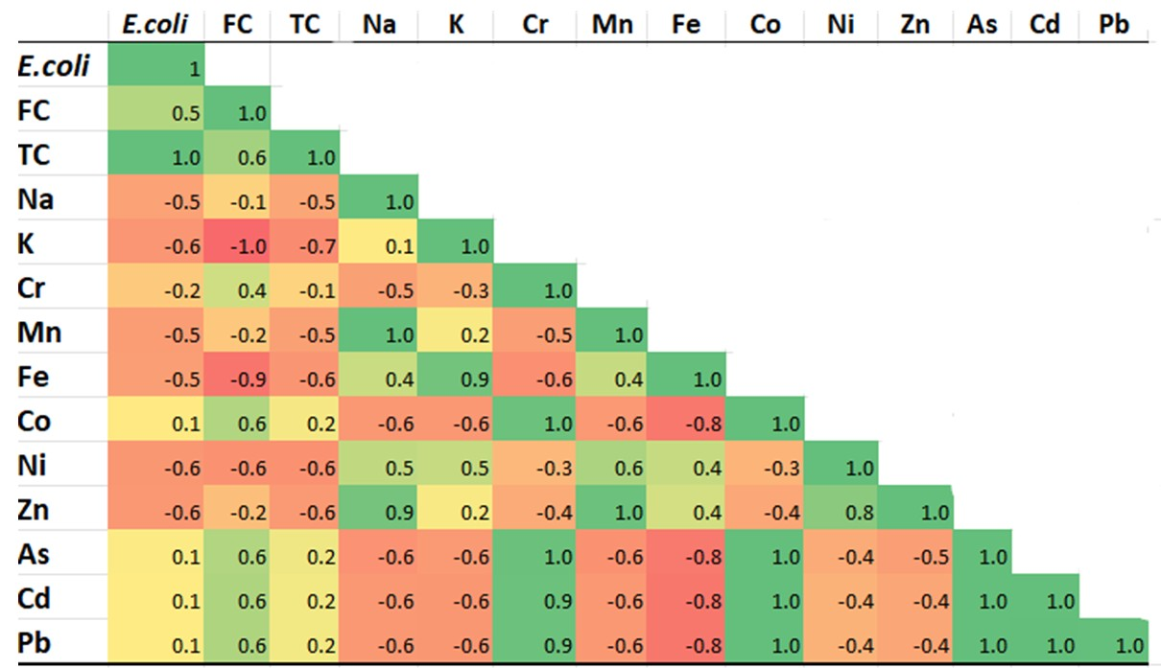

Fig. 3. Correlation analysis of microbial parameter with heavy metal in Kuwano River.

  - Canonical Correspondence Analysis (CCA)
The Canonical Correspondence Analysis (CCA) (Fig. 4.) biplot demonstrates the relationships between sampling sites, microbial indicators, and heavy metal concentrations in the Kuwano River. Axis 1 represents the primary environmental gradient explaining the largest variation in the dataset, whereas Axis 2 represents the secondary gradient. Heavy metals such as Cd, Pb, Co, and As are grouped on the negative side of Axis 1, indicating similar distribution patterns and suggesting a common anthropogenic origin, likely from agricultural chemicals, domestic sewage, and urban runoff (Zhao et al., 2020; Singh et al., 2022). In contrast, Na, Mn, Zn, Fe, and Ni are positioned toward the positive side of Axis 1, implying that their distribution is largely influenced by natural geochemical processes such as mineral weathering, sediment interactions, and ion exchange in the aquatic environment (Li et al., 2023). Microbial indicators, including E. coli, faecal coliform, and total coliform, are located near the negative region of Axis 2, reflecting their association with organic pollution and faecal contamination sources such as untreated domestic wastewater and agricultural runoff (Ahmed et al., 2023; Sharma et al., 2022).
The spatial distribution of sampling sites indicates variability in water quality across the river. Sites $-$ 3, 4, and 5 show closer association with Mn, Zn, and Na, suggesting relatively higher concentrations of these elements, possibly due to sediment interactions or agricultural inputs. In contrast, Sites $-$ 1 and 2 are associated with K and Cr, indicating different hydrochemical characteristics in upstream regions. Overall, the CCA results highlight the combined influence of anthropogenic activities and natural geochemical processes on heavy metal distribution and microbial contamination in the Kuwano River ecosystem. The analysis suggests that while natural processes control certain metal distributions, microbial pollution is primarily driven by sewage and organic waste inputs. Multivariate statistical techniques such as CCA therefore provide valuable insights into pollution sources and environmental interactions in river systems.
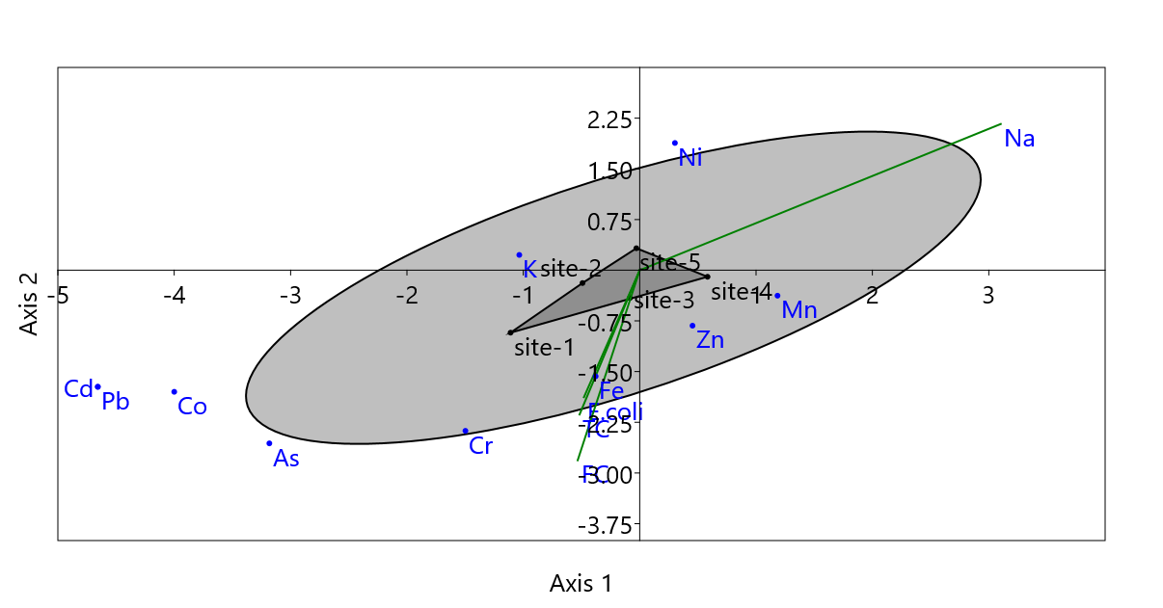
Fig. 4. Canonical correspondence analysis with heavy metal and microbial parameters in the Kuwano River.

  - Integrated assessment of chemical and microbial pollution
An integrated evaluation of the Kuwano River ecosystem reveals substantial pollution from heavy metals, algal bioaccumulation, and elevated concentrations of faecal indicator bacteria at all sampling locations. Although heavy metals serve as secondary stressors, the principal sources of microbiological contamination are untreated sewage and surface runoff. The presence of microbiological contaminants and heavy metals presents significant ecological and public health hazards, including the danger of waterborne illnesses and heavy metal bioaccumulation in aquatic organisms. This highlights the significance of employing integrated monitoring methodologies that amalgamate chemical, biological, and microbiological indices for accurate assessments of river water quality and sustainable environmental stewardship (Zhao et al., 2020; Patel et al., 2024).
Elevated microbiological levels at downstream locations signify substantial faecal pollution, chiefly originating from domestic sewage outflow and surface runoff. Untreated wastewater causes comparable pollution patterns in the rivers of the Gangetic plain (Sharma et al., 2022; Verma et al., 2024). The continual presence of E. coli, a dependable marker of recent faecal contamination, underscores possible health hazards from infections. Research indicates the presence of pathogenic and multidrug-resistant E. coli bacteria in local rivers, highlighting public health issues (Singh et al., 2024). Elevated faecal coliform contents render Kuwano River water inappropriate for direct residential use without prior treatment. The presence of heavy metals and faecal indicator bacteria presents significant environmental and health hazards, jeopardising aquatic ecosystems and enhancing the transmission of waterborne diseases; hence, it restricts the river's use for residential, agricultural, and recreational activities (Zhao et al., 2020).
Correlation research reveals a complex relationship between heavy metal concentrations and microbiological markers, wherein increased metal levels correspond with fluctuating coliform counts, indicating that heavy metals alter environmental circumstances impacting microbial abundance, which may lead to changes in ecosystem health and water quality (Zhao et al. 2020; Patel et al. 2024). Although heavy metals are recognised as secondary stressors, sewage input is the principal cause of microbial contamination, as elevated levels of faecal indicator bacteria persist in places affected by metals (Kumar et al. 2023; Verma et al. 2024). The persistent identification of E. coli, encompassing pathogenic and antibiotic-resistant variants, presents considerable public health hazards (Singh et al. 2024), with evidence suggesting that the Kuwano River may function as a conduit for waterborne infections during human interaction or irrigation.
CONCLUSION
The work presents the inaugural comprehensive evaluation of heavy metal contamination, microbial pollution, and algal bioaccumulation in the Kuwano River, uncovering complex relationships between chemical and biological stresses within the river ecosystem. The findings indicate that although dissolved heavy metal concentrations in water were predominantly mild, specific metals like Cd, Pb, Cr, Zn, and Ni surpassed recommended guideline limits at particular locations, signifying localised contamination and potential ecological hazards. The markedly elevated concentrations of metals in algal biomass and the increased bioaccumulation factors – especially for Ni, Mn, and Cr, underscore the sturdy ability of aquatic algae to accumulate trace metals and validate their effectiveness as biomonitors for assessing freshwater pollution.
Microbiological investigation consistently demonstrated elevated levels of total coliforms, faecal coliforms, and Escherichia coli at all test sites, suggesting ongoing faecal contamination presumably stemming from untreated residential sewage and agricultural runoff. Multivariate statistical analyses, such as Pearson correlation and canonical correspondence analysis, indicate that the distribution of heavy metals is affected by both anthropogenic activities and natural geochemical processes, while microbiological pollution is predominantly caused by sewage inputs. The simultaneous presence of high heavy metals and faecal indicator bacteria presents considerable ecological and public health issues, especially for communities dependent on the river for household, agricultural, and recreational activities. These findings underscore the imperative for comprehensive river monitoring systems that incorporate chemical, biological, and microbiological indicators. The implementation of efficient wastewater management, pollution control measures, and ongoing environmental monitoring is crucial to reduce contamination and guarantee the long-term ecological viability and safe use of the Kuwano River system.

COMPETING INTERESTS DISCLAIMER:
Authors have declared that they have no known competing financial interests OR non-financial interests OR personal relationships that could have appeared to influence the work reported in this paper.

REFERENCES
- Anh, N. T., Can, L. D., Nhan, N. T., Schmalz, B., & Luu, T. L. (2023). Influences of key factors on river water quality in urban and rural areas: A review. Case Studies in Chemical and Environmental Engineering, 8, 100424. https://doi.org/10.1016/j.cscee.2023.100424
- Singh, V., Singh, N., Rai, S. N., Kumar, A., Singh, A. K., Singh, M. P., Sahoo, A., Shekhar, S., Vamanu, E., & Mishra, V. (2023). Heavy metal contamination in the Aquatic ecosystem: toxicity and its remediation using Eco-Friendly approaches. Toxics, 11(2), 147. https://doi.org/10.3390/toxics11020147
- Zhao, H., Li, X., & Wang, Y. (2023). Geochemical behavior of trace metals in aquatic environments under varying redox conditions. Chemosphere, 313, 137512.
- Chen, S., & Ding, Y. (2025). Systematic bibliographic analysis of heavy metal remediation. Water Science & Technology, 91(1), 56-68.
- Sharma, M., Kant, R., Sharma, A. K., & Sharma, A. K. (2025). Exploring the impact of heavy metal toxicity in the aquatic ecosystem. In International Journal of Energy and Water Resources (Vol. 9, Number 1, pp. 267–280). Springer. https://doi.org/10.1007/s42108-024-00284-1
- Budi, H. S., Catalan Opulencia, M. J., Afra, A., Abdelbasset, W. K., Abdullaev, D., Majdi, A., ... & Mohammadi, M. J. (2024). Source, toxicity and carcinogenic health risk assessment of heavy metals. Reviews on environmental health, 39(1), 77-90.
- Gaur, N., Shankar, S., Chaudhary, R., Akhtar, N., & Vyas, A. (2026). Faecal Contamination in Drinking Water: A review of detection techniques, pathogen dynamics, and sustainable remediation approaches. Environmental Monitoring and Assessment, 198(4), 296.
- Arthington, A., Naiman, R., Mcclain, M. And Nilssons, C. (2009). Preserving the biodiversity and ecological services of rivers: new challenges and research opportunities. Freshwater Biology, 1-16. doi:10.1111 /j.1365-2427.2009.02340.x
- Gavrilas, S., Burescu, F., Chereji, B., and Munteanu, F. (2025). The impact of anthropogenic activities on the catchment’s water quality parameters. Water, 17, 1791. https://doi.org/10.3390/w17121791
- Das, B. C., Amini, M. H., & Wu, Y. (2025). Security and privacy challenges of large language models: A survey. ACM Computing Surveys, 57(6), 1-39.
- Akhtar, M., Xu, J., Kashif, U., Ali, K., Muhammad Naveed, H., & Haris, M. (2025). Bayesian neural network modelling for estimating ecological footprints and blue economy sustainability across G20 nations. Humanities and Social Sciences Communications, 12(1), 83.
- Faruk, O., Rana, M. R. K., Fatema, B., Paul, J. C., & Islam, M. R. (2025). Insight into antibiotic and heavy metal resistance gene diversity in two ecologically important rivers of Bangladesh: a metagenomics analysis. Annals of Microbiology, 75(1), 25.
- Lu, L., Zhao, D., Li, Z., & Fernández, L. D. (2023). Editorial: Microbial diversity and ecosystem functioning in fragmented rivers worldwide. Frontiers in Microbiology, 14, 1253190. https://doi.org/10.3389/fmicb.2023.1253190
- Agarwal, S., Albeshr, M. F., Mahboobb, S., Atique, U., Pramanick, P., & Mitra, A. (2022). Bioaccumulation Factor (BAF) of heavy metals in green seaweed to assess the phytoremediation potential. Journal of King Saud University-Science, 34(5), 102078.
- Arnot, J. A., Gobas, F. A. P. C., & Canadian Environmental Modelling Centre. (2006). A review of bioconcentration factor (BCF) and bioaccumulation factor (BAF) assessments for organic chemicals in aquatic organisms. Environ. Rev., 14–14, 257–297. https://doi.org/10.1139/A06-005
- Chernova, E. N., & Shulkin, V. M. (2019). Concentrations of Metals in the Environment and in Algae: The Bioaccumulation Factor. Russian Journal of Marine Biology, 45(3), 191–201. https://doi.org/10.1134/S1063074019030027
- APHA (2017). Standard Methods for the Examination of Water and Wastewater (23rd ed.). Washington DC: American Public Health Association.
- Ge, Y., Zhang, R., Jiang, Z., Shen, Z., & Yan, M. (2022). Determination of Fe, Ni, Cu, Zn, Cd and Pb in seawater by isotope dilution automatic solid-phase extraction—ICP-MS. Acta Oceanologica Sinica, 41(8), 129-136.
- FSSAI. (2024). Manual of Methods of Analysis-Trace Elements (pp. 1–60). MANUAL_FOR_ANALYSIS_OF_METALS_dt_18_04_2024.pdf
- Ibrahim, A. A., Yusuf, A. G., Ismail, G., Ibrahim, M. A., Musa, A. R., Sulaiman, M. S., University of Maiduguri, & Bayero University. (2021). Conceptual background of bioaccumulation in environmental science. World Journal of Advanced Pharmaceutical and Life Sciences, 01–01, 035–041.
- Akbar, S. A., Lestari, A. N., Fazli, R. R., & Gunawan, G. (2025). Harnessing macroalgae for heavy metal phytoremediation: A sustainable approach to aquatic pollution control. BIO Web of Conferences, 156, 02013. https://doi.org/10.1051/bioconf/202515602013
- Singh, K. P., Malik, A., & Sinha, S. (2022). Water quality assessment and apportionment of pollution sources. Water Research, 216, 118289.
- Li, X., Zhang, Y., & , G. (2023). Distribution and ecological risk of heavy metals in river ecosystems. Science of the Total Environment, 876, 162745.
- Narayanan, M. S. S., Pitchaimani, V. S., Sivakumar, M., Kumar, T. D., Abishek, S. R., & Karuppannan, S. (2025). Spatial assessment of heavy metal contamination in groundwater in the Kadaladi region, Tamil Nadu, India. Scientific Reports, 15(1), 27704. https://doi.org/10.1038/s41598-025-12120-5
- Kumar, R., Sharma, P., & Singh, S. (2024). Biosorption and bioaccumulation of heavy metals by freshwater algae: mechanisms and environmental implications. Environmental Science and Pollution Research, 31, 10245–10258.
- Rahman, M. A., Islam, M. S., & Hossain, M. B. (2024). Bioaccumulation of trace metals in freshwater algae and their application as biomonitors. Ecotoxicology and Environmental Safety, 267, 115721.
- Singh, N., Mishra, S., & Verma, A. (2022). Algae as bioindicators for monitoring heavy metal contamination in aquatic environments. Journal of Environmental Management, 316, 115276.
- World Health Organization (WHO) (2017). Guidelines for drinking-water quality, 4th edn. WHO, Geneva.
- Patel P., Shah M., & Joshi M. (2024). Interaction of heavy metals with microbial communities in freshwater ecosystems under anthropogenic stress. Environmental Monitoring and Assessment 196:88. https://doi.org/10.1007/s10661-023-12014-6
- Kumar V., Kumar P., & Singh J. (2023). Heavy metal contamination and ecological risk assessment of surface waters in the Indo-Gangetic Plain, India. Environmental Earth Sciences 82:214. https://doi.org/10.1007/s12665-023-10821-9
- Xie, S., Liu, C., He, B., Chen, M., Gao, T., Wei, X., Liu, Y., Xia, Y., & Sun, Q. (2022). Geochemical Fractionation and Source Identification of Pb and Cd in Riparian Soils and River Sediments from Three Lower Reaches Located in the Pearl River Delta. International Journal of Environmental Research and Public Health, 19(21), 13819. https://doi.org/10.3390/ijerph192113819
- Singh R., Yadav S., & Tripathi A. (2024). Prevalence of multidrug-resistant enteropathogenic Escherichia coli in a North Indian river system. Cleaner Water 2:100048. https://doi.org/10.1016/j.clwat.2024.100048
- Holcomb, D. A., & Stewart, J. R. (2020). Microbial Indicators of fecal pollution: Recent progress and challenges in assessing water quality. Current Environmental Health Reports, 7(3), 311–324. https://doi.org/10.1007/s40572-020-00278-1
- Ahmed, W., Bibby, K., & Bivins, A. (2023). Microbial indicators for water quality assessment in freshwater ecosystems. Environmental Research, 216, 114507.
- Zhang, H., Liu, Y., & Wang, Q. (2022). Assessment of microbial contamination in river water influenced by urban wastewater discharge. Water Research, 214, 118191.
- Sharma D., Kansal A., & Pelletier G. (2022). Assessment of faecal contamination and microbial water quality in Indian rivers. Environmental Monitoring and Assessment 194:509. https://doi.org/10.1007/s10661-022-10092-4
- Marques, M. V. A., Lopes, B. C., Silvério, T. H. R., Von Sperling, M., & De Alencar Neves, T. (2023). Persistence Akbar pathogens and bacterial community dynamics in tropical soil after application of raw sewage. Scientific Reports, 13(1), 13435. https://doi.org/10.1038/s41598-023-40718-0
- Kumar, M., Ramanathan, A., Tripathi, R., & Farswan, S. (2023). Hydrogeochemistry and groundwater contamination in alluvial aquifers. Environmental Research, 197, 111112.
- Verma S., Mishra A., & Singh, P. (2024). Spatio-temporal assessment of microbial water quality in rivers of northern India. Applied Water Science 14:36. https://doi.org/10.1007/s13201-023-02045-1
- Edberg, S. C., Rice, E. W., Karlin, R. J., & Allen, M. J. (2000). Escherichia coli: the best biological drinking water indicator for public health protection. Journal of Applied Microbiology, 88(S1), 106S–116S.
- Wu, J., Zhang, Y., & Zhou, H. (2022). Microbial indicators and their relationship with environmental variables in surface waters. Science of the Total Environment, 806, 150567.
- Rasmussen, L. D., & Sørensen, S. J. (2021). Effects of heavy metals on microbial communities in aquatic systems. Environmental Microbiology Reports, 13(4), 456–468.
- Smedley, P. L., & Kinniburgh, D. G. (2002). A review of the source, behaviour and distribution of arsenic in natural waters. Applied Geochemistry, 17(5), 517–568.
- Kumar V., Kumar P., & Singh J. (2021). Heavy metal contamination and ecological risk assessment of surface waters in the Indo-Gangetic Plain, India. Environmental Earth Sciences 82:214. https://doi.org/10.1007/s12665-023-10821-9.

