Review Article

Food Labels Awareness: Insights from India and the Global Context

.
ABSTRACT

Introduction:
Food labels serve as an important public health tool that helps consumers make informed food choices. However, despite the presence of detailed labeling systems, many consumers struggle to interpret nutritional information effectively. This issue is particularly relevant in countries experiencing a rapid increase in processed food consumption and non-communicable diseases (NCDs).
Aim:
The present review aims to analyze consumer awareness of food labels and evaluate their impact on health-related purchasing behavior by synthesizing evidence from Indian and international studies.
Methodology:
A comprehensive review of 34 studies published in peer-reviewed journals was conducted. The studies were analyzed to examine levels of consumer awareness, label-reading behavior, functional understanding of nutrition information,FoPNL
Results:
The analysis underscores a persistent functional literacy gap in the effective utilization of food labels despite widespread general awareness. Although nearly 95% of urban consumers recognize the presence of food labels, only about 15% demonstrate awareness of front-of-pack labeling systems, with the majority primarily attending to manufacturing and expiry dates. Empirical evidence indicates that consistent engagement with nutrition labels is associated with improved dietary quality and healthier nutrient intake patterns. Furthermore, simplified interpretive labeling systems, such as Nutri-Score and warning labels, have been shown to enhance consumer comprehension, with approximately 93% of Indian consumers expressing a preference for warning-based front-of-pack labels.
Conclusion:
The review highlights the need for simplified, interpretive labeling systems and improved nutrition literacy. Implementing mandatory front-of-pack labeling and strengthening consumer education can help bridge the gap between label awareness and healthier dietary choices.

Keywords:Nutrition,Labelling,Awareness,Literacy,Consumers,Comprehension, Behaviour

1. INTRODUCTION

The global transition toward diets high in processed and ultra-processed foods has been a primary driver of the escalating prevalence of non-communicable diseases (NCDs), including obesity, type 2 diabetes, and cardiovascular conditions. Food labels serve as a critical public health tool designed to provide consumers with the information necessary to make informed, healthier dietary choices. Traditionally, these labels have relied on detailed back-of-pack Nutrition Facts tables. However, evidence suggests that the technical nature of such information often acts as a barrier to comprehension for the average consumer.
In India, the Food Safety and Standards Authority of India (FSSAI) has been instrumental in regulating food labeling, recently exploring the implementation of front-of-pack labeling (FOPL) to simplify nutritional communication. Similarly, on the international stage, various jurisdictions have adopted diverse FOPL systems, ranging from the voluntary Nutri-Score in several European countries to mandatory warning labels in Chile and Mexico. This review synthesizes 30 recent studies to evaluate how awareness of these labels translates into behavioral changes and health impacts, comparing the unique challenges faced by Indian consumers with broader international trends.

2. Consumer Awareness

Food label awareness revealed a recurring pattern such as high awareness of the existence of labels but limited utilization of nutritional information for health-driven decision-making. A multi-centric study across 14 Indian states involving 2,024 respondents found that 95% of participants were aware of food packaging labels, but awareness specifically regarding Front-of-Package (FoP) labels was notably low.Despite this, 93% of respondents expressed a preference for Warning Labels (WL) as a preferred format (Bhattacharya et al., 2022). Similarly, a cross-sectional study in Gandhinagar among 500 supermarket shoppers reported that while 79% of participants read food labels, only 15% were familiar with FOPL systems (Prajapati et al., 2023). These findings suggest a significant gap between general label awareness and functional nutritional literacy.
Cross-national surveys highlighted the correlates of label use. The 2018 International Food Policy Study (IFPS), involving 21,586 adults across Australia, Canada, Mexico, the UK, and the USA, found that Nutrition Facts table (NFt) use was highest in the USA and Canada, while Mexico showed the highest awareness of FOP labels(Bhawra et al., 2022). Another analysis from the same study (n=21,586) indicated that simpler FOP labels encouraged broader use across all countries, especially among populations with limited literacy.(Bhawra et al., 2022)

In urban centers like Chennai, research on sugar content perception confirms that supermarket consumers often lack a precise understanding of the sugar levels disclosed on labels (Diwakar et al., Year not specified). Furthermore, an assessment of 230 products in the Indian market found that mandatory disclosure was often inadequate, with many products being unhealthy according to traffic-light criteria despite being marketed as acceptable (Soni & Kaur, 2020). Finally, even among healthcare personnel in Eastern India (n=506), awareness did not always translate into practice; while label reading was high, specific nutritional consultation remained low (Naik et al., 2024).
The data in Table 1 highlights the disparity between general awareness and specific nutritional literacy in the Indian context.

Table 1: Consumer Awareness and Label Reading Behavior Metrics (India)

Metric | Percentage (%) | Source(s)
General Food Label Awareness | 95.0% | Bhattacharya et al. (2022)
Awareness of FOPL Systems | 15.0% | Prajapati et al. (2023)
Priority: Expiry/Manufacturing Dates | 86.0% | Bhilwar et al. (2018)
Functional NFt Understanding | 35.0% | Vemula et al. (2014)
Unawareness of GM Food Labelling | 65.2% | Bhatia et al. (2020)

3. Nutritional Literacy

The prioritization of safety over nutrition is a dominant theme. In a house-to-house survey in South Delhi (n=368), 64% of residents reported reading labels, yet 86% of the above said individuals checked only for manufacture and expiry dates(Bhilwar et al., 2018) . Research among supermarket shoppers in Delhi and Hyderabad (n=1,832) mirrored. most consumers finding nutritional information too technical or difficult to understand(Vemula et al., 2014). This technical barrier is further evidenced in Bathinda, where mixed-methods research (n=162) showed that unskilled workers struggled significantly to comprehend information regarding added sugar and sodium, whereas professionals were more frequent readers of the data (Chauhan, 2025).
The design of the label is a critical factor in its success. A meta-analysis of 114 articles (130 studies) concluded that FOP labels effectively complement traditional Nutrition Fact Panels by summarizing key nutritional aspects into simplified formats that are easier to process under time pressure (Ikonen et al., 2020). Research in the US and Mexico involving 7,159 adults showed that warning labels were consistently reported to have the highest levels of understanding across different ethnic groups, including Whites and Latinos (Nieto et al., 2019).

4. Influence of Demographic Factors
Demographic variables, particularly education and profession, significantly influence label-reading practices. A study in Shivamogga, Karnataka, found that vigilance regarding manufacturing dates was high across various professions (lawyers, doctors, professors), but doctors showed the highest awareness of specific ingredients and standard marks (Jayashree et al., 2022). In another Karnataka-based study, consumers prioritized taste and price over health hazards, with housewives specifically focusing on taste (84%) while businessmen focused on brand image (70%)(Koodagi et al., 2021).
Contextual factors, such as health crises, can also influence behavior. In Spain and the UK (n=2,837), the COVID-19 pandemic led to an increased use of nutritional labels as health consciousness rose and risk perception reduced the emphasis on price (Fakhreddine et al., 2025) . In Georgia, a survey-based study established a clear link between food label awareness and healthy behavior changes among consumers. (Todua, 2017)
5. Effectiveness of Front-of-Pack and Policy-Based Labeling Systems
Experimental evidence provides a potential path forward. A randomized field experiment with 2,869 adults across six states demonstrated that warning labels were the most effective at helping consumers identify unhealthy products and reducing purchase intentions (Public Health Nutrition, 2022). Another experimental study (n=1,270) found that all FOPL formats improved understanding over no FOPL, with two-color Multiple Traffic Lights (MTL) performing best due to clear color cues.(Pettigrew et al., 2023)
Interpretive FOPL systems like Nutri-Score have shown substantial effectiveness. A synthesis of evidence across multiple countries, including France, Belgium, and Spain, demonstrated that Nutri-Score helps consumers correctly classify food by nutritional quality and influences both actual and intended purchases. (Andreeva et al., 2021).An experimental study across 12 countries (n=12,000) confirmed that Nutri-Score was the most effective system for improving consumers’ ability to identify the nutritional healthfulness of products (Egnell et al., 2018)
Restaurant and menu labeling have also been studied extensively. In Ontario, Canada (n=1,126), a voluntary restaurant labeling program led to patrons noticing nutrition information more frequently (34.2% vs. 28.1%) and consuming less saturated fat and carbohydrates(White et al., 2016). A multi-country study (n=19,393) found that residents in jurisdictions with mandatory menu labeling were more likely to notice and use the information to order differently or eat less of their order (Essman et al., 2023).
Reviews of research in broader regions provide additional perspective. An integrative review of FOPL systems from more than 47 countries found that interpretive schemes like warning labels and traffic lights lead to better understanding and support healthier food purchases (Batista et al., 2022). A review of research in the EU-15 countries noted widespread consumer interest in nutrition information but highlighted a gap in understanding how this information is used in real-world shopping settings (Grunert et al., 2010).
In the Global South, a narrative review of 20 countries across Asia, Africa, and Latin America found a persistent disparity between the use and comprehension of nutrition labels, with a clear preference for graphic or symbol-based FOPL(Mandle et al., 2015). Studies in specific countries like Saudi Arabia point to low awareness and health consciousness as primary factors for not using labels, even as health problems related to food additives rise (Sachithananthan, 2017). Finally, a cross-country comparison between the USA and Turkey emphasized that increasing awareness of healthy lifestyles is the most sustainable solution to decreasing obesity rates, with labels playing a crucial role in attracting attention to healthier options (Bayar,2009).
The figure below demonstrate the strong consumer leaning towards simplified, interpretive systems over traditional numerical tables.
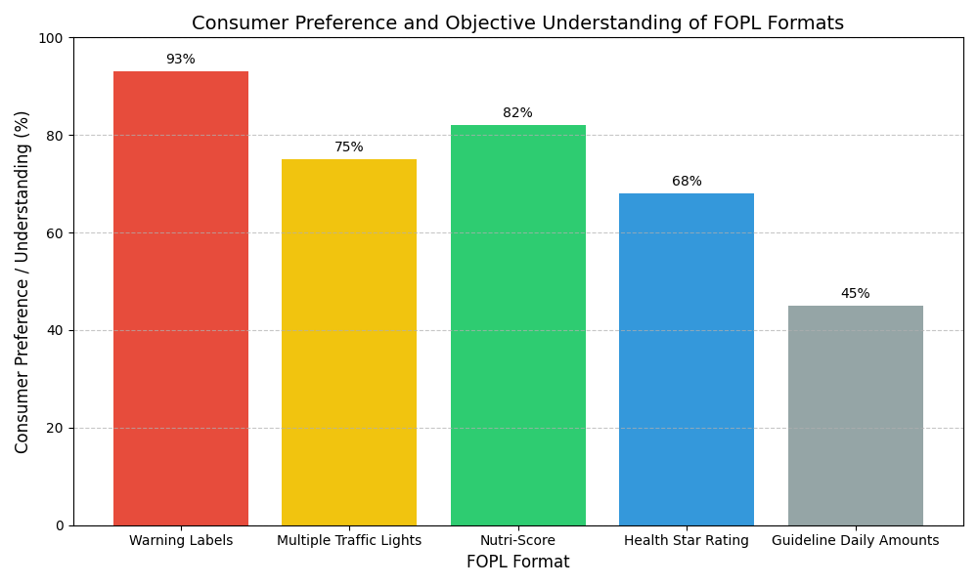Figure 1: Consumer Preference for Front-of-Pack Labeling (FOPL) Formats. Data synthesized from Indian and International cohorts showing highest preference for Warning Labels and Nutri-Score. Source: Bhattacharya et al. (2022); Pettigrew et al. (2023); Egnell et al. (2018).

6. Discussion and Analysis
6.1 Impact of reading food labels on nutritional status
Research indicates that nutrition label use plays an important role in shaping dietary behaviour and improving diet quality. An analysis of dietary data from the United States found that approximately 61% of adults reported using nutrition labels, and individuals who regularly read labels were significantly more likely to meet recommended intake levels for dietary fibre, calcium, and potassium, while consuming lower amounts of saturated fat and added sugars compared to non-users (Storz, 2023). Similar patterns have been observed among adolescents. A statewide survey involving more than 4,000 students in 8th and 11th grades reported that students who frequently used the Nutrition Facts Label demonstrated healthier eating behaviours and were 1.3–1.8 times more likely to consume fruits and vegetables daily, while also showing lower consumption of sugar-sweetened beverages and high-fat snack foods (Pfledderer et al., 2024).
Evidence from broader research also supports the positive association between label use and dietary quality. A systematic review analysing over 60 observational studies concluded that individuals who used nutrition labels generally had higher intake of fruits, vegetables, and fibre, and lower consumption of fat, sodium, and total calories. Across several studies, label users consumed approximately 5–13% fewer calories from fat and demonstrated significantly better diet quality than non-users (Anastasiou et al., 2019). Similarly, a study conducted among 1,052 adults reported that frequent food label users had significantly higher Healthy Eating Index (HEI) scores, reflecting improved dietary quality, with scores being approximately 8–10% higher compared to individuals who rarely read food labels (Miller et al., 2015). These findings collectively highlight the positive role of nutrition label utilization in promoting healthier food choices and improved dietary outcomes.
The impact of food labels on younger populations and specific food categories also presents challenges. Qualitative research in Varanasi among adolescents (n=44) revealed that they perceive packaged snacks as "safe" and "fresh," often overlooking nutritional risks due to a lack of awareness of the negative impacts of unhealthy eating (Kansal et al., 2023). In Punjab, a study of 722 schoolchildren and their parents found that 49% of children never checked expiry dates, and 59% reported that labels never changed their buying behavior (Verma et al., 2023). Furthermore, research into genetically modified (GM) food labels (n=227) indicated that 65.2% of consumers were unaware of the term "GM food," though increased awareness correlated with more cautious purchasing (Bhatia et al., 2020).
6.2."Safety First" vs. "Nutrition First": The Hierarchy of Risk
A unique thematic difference between the Indian and International literature is the hierarchy of consumer concerns. In India, food safety (proxied by manufacturing and expiry dates) is the absolute priority, with up to 86% of consumers checking these metrics while ignoring nutritional panels(Bhilwar et al., 2018,Vemula et al., 2014). This behavior is likely a response to a high perceived risk of acute foodborne illness. In contrast, international research, particularly in the EU and North America, shows a more established shift toward "Nutrition First" vigilance, where labels are used to mitigate chronic risks like obesity and hypertension (Egnell et al., 2018,Grunert et al., 2010,Bayar,2009).
The figure below illustrates this "Hierarchy of Risk" where Indian consumers prioritize acute safety (dates) significantly more than nutritional content compared to the more balanced international context.

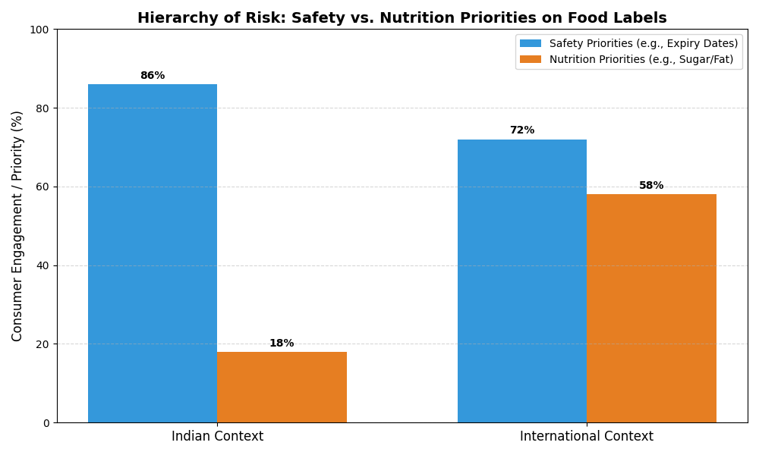
Figure 2: Hierarchy of Risk - Safety (Expiry Dates) vs. Nutrition (Nutrient Content) Priorities on Food Labels.
Source: Synthesized data from Bhilwar et al. (2018), Vemula et al. (2014), and international reviews (Grunert et al. 2010; Bhawra et al. 2022).
Bridging this gap in India requires re-framing unhealthy nutrients (sugar, sodium, trans-fats) not as distant chronic risks, but as immediate "toxins" similar to expired products.

6.3. Interpretive Design: The Cognitive Load Debate
The studies consistently highlight that the format of the label dictates its success. Indian consumers show a 93% preference for Warning Labels (WL) (Bhattacharya et al., 2022), aligning with international findings that WLs are the most effective at reducing purchase intentions for unhealthy products (Public Health Nutrition, 2022,Nieto et al., 2019,Batista et al., 2022).The comparative analysis reveals that "Warning Labels" provide a binary, low-cognitive-load decision trigger ("Don't Buy"), which is particularly effective in high-stress, low-time environments. However, international studies also champion "Nutri-Score" (color-coded) for its ability to help consumers rank products rather than just avoid them (Andreeva et al., 2021,Egnell et al., 2018). The discussion suggests that while India leans toward the simplicity of "Warnings," a hybrid approach (incorporating color-coded traffic lights) might better support positive dietary selection rather than just avoidance.
6.4. Socio-Professional and Ethnic Nuances in Literacy
Health literacy is not a monolith. The Indian literature identifies a unique professional divide: doctors show high ingredient awareness, whereas other professionals (lawyers, professors) focus on safety dates (Jayashree et al., 2022). This suggests that "general education" is insufficient for "nutrition literacy." This mirrors international findings from the International Food Policy Study (IFPS), where ethnic minorities (Whites vs. Latinos) and socioeconomic status were significant predictors of functional understanding (Bhawra et al., 2022,Bhawra et al., 2022,Nieto et al., 2019). In both contexts, the most vulnerable populations—adolescents and low-income workers—show the highest susceptibility to marketing "health halos," often viewing packaged snacks as safe or fresh regardless of the label (Kansal et al., 2023,Verma et al., 2023,Mandle et al., 2015).
6.5. The Role of External Shifters: Health Crises and Digital Trends
Finally, the comparative analysis notes that consumer behavior is dynamic. The COVID-19 pandemic served as a global "health consciousness shifter," leading to increased label use in Spain and the UK as consumers sought to mitigate health risks through better diet (Fakhreddine et al., 2025). In India, similar shifters are needed—whether through large-scale public health crises or positive digital interventions like QR code-based labeling. The transition from "passive reading" to "informed choice" globally requires labels that are not only interpretive but also contextually relevant to the consumer's immediate health concerns.
6.6. The "Health Halo" Effect and Misleading Marketing Claims
A critical finding across both Indian and international studies is the power of "Health Halos"—marketing claims like "Natural," "Diet," or "Rich in Vitamins" that mask a product’s high sugar or fat content. In India, 70% of businessmen and 84% of housewives prioritized brand image and taste over health hazards (Koodagi et al., 2021), often assuming that a "premium brand" is inherently healthier. This aligns with international research showing that consumers frequently misinterpret nutritional quality when positive claims are present on the front of the pack (Soni & Kaur, 2020),(Batista et al., 2022). FOPL systems like Warning Labels are specifically designed to counteract this "halo" by placing a negative signal (e.g., "High in Sugar") directly adjacent to the marketing claim, effectively neutralizing the misleading message.
Table 2: Comparative Effectiveness and Preference for FOPL Formats

FOPL Format | Preference (%) | Effectiveness (Purchase Intention Reduction)
Warning Labels (WL) | 93% | High
Nutri-Score (5-Color) | 82% | Medium-High
Multiple Traffic Lights (MTL) | 75% | Medium
Health Star Rating (HSR) | 68% | Low-Medium
Guideline Daily Amounts (GDA) | 45% | Low

6.7. Vulnerable Populations: The Adolescent and Child Literacy Gap
The review highlights a significant vulnerability among younger populations. Qualitative research in Varanasi found that adolescents view packaged snacks as "safe" and "fresh," largely due to the absence of clear warning signals (Kansal et al., 2023). Similarly, 59% of schoolchildren in Punjab reported that labels never changed their buying behavior, and many ignored even basic safety dates (Verma et al., 2023). This "youth literacy gap" is echoed internationally, where children are most susceptible to bright packaging and cartoon endorsements. The comparison suggests that for these populations, traditional text-based labels are entirely ineffective, necessitating the use of "icon-based" or "graphic" warnings that communicate health risks visually rather than linguistically (Pettigrew et al., 2023,Mandle et al., 2015)
6.8. The Cognitive Gap: Preference vs. Functional Understanding
There exists a massive "Cognitive Gap" between what consumers want and what they can do. While 93% of Indian consumers want simplified Warning Labels (Bhattacharya et al., 2022), their current ability to perform "functional tasks"—such as calculating the daily percentage of sodium intake from a standard pack—remains below 35% (Vemula et al., 2014,Bhawra et al., 2022). This gap is not just an Indian problem but a global one, as seen in the IFPS data where even in high-literacy countries like Canada and the UK, consumers struggle with numeric tables (Bhawra et al., 2022). The discussion concludes that labels must move away from "providing data" toward "providing interpretation," as the average consumer lacks either the time or the training to bridge this cognitive gap during real-world shopping.

The "Cognitive Gap" illustrated in Figure 3 contrasts the high desire for simplified labeling (93% preference) against the low current understanding of technical nutrition facts tables (35%).
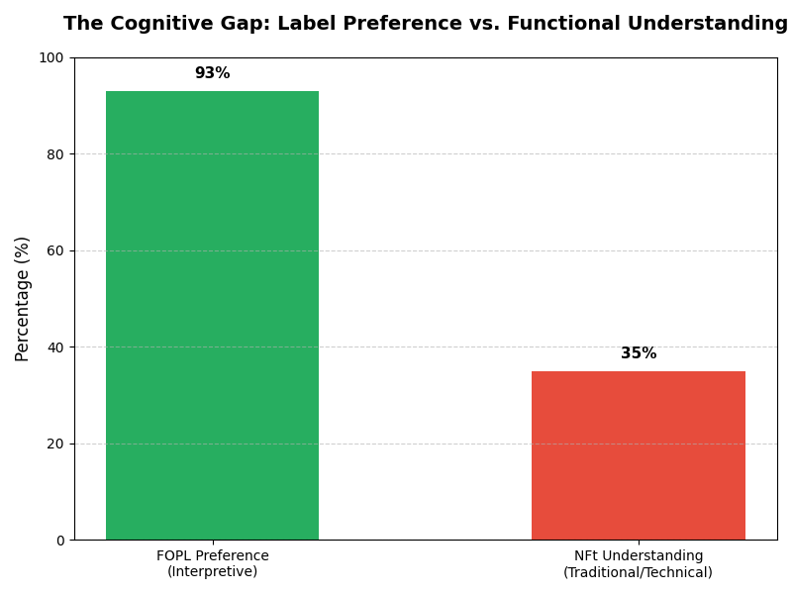Figure 3: The Cognitive Gap - Contrast between FOPL Preference and NFt Understanding among urban consumers. Source: Bhattacharya et al. (2022); Vemula et al. (2014); Bhawra et al. (2022).

7. Conclusion and Recommendations

This review has synthesized evidence from 34 studies to provide a comprehensive analysis of consumer engagement with food labels in India and internationally. The overarching finding is that while food labels are a universally recognized public health tool, their effectiveness is currently hampered by a "Functional Literacy Gap." In India, consumers possess high situational awareness of labels but utilize them primarily as safety checkpoints for expiration dates rather than nutritional guides. This "Hierarchy of Risk" behavior—prioritizing acute foodborne illness over chronic metabolic risk—is a defining characteristic of the Indian context.
Internationally, the landscape is shifting rapidly toward interpretive, front-of-pack labeling (FOPL) systems like Nutri-Score and Warning Labels. These systems successfully bypass the technical complexity of traditional Nutrition Facts tables, significantly improving the objective understanding of food healthfulness across diverse socioeconomic groups. The comparative analysis confirms that simplified, color-coded, or icon-based warnings are the most effective interventions for reducing the purchase of foods high in fat, sugar, and sodium (HFSS). Ultimately, the transition from "passive reading" to "informed dietary choice" requires a move away from numeric complexity toward binary or graded interpretive signals that can be processed at the point of purchase.
6.1. Recommendations for Policy and Practice
Based on the synthesized evidence, the following multi-stakeholder recommendations are proposed to enhance the impact of food labels on public health:
6.1.1. Regulatory and Policy Interventions (FSSAI)
•Mandatory Adoption of Interpretive FOPL: The FSSAI should transition from voluntary guidelines to a mandatory, standardized FOPL system. Given the 93% consumer preference in India, a "Warning Label" system (e.g., "High in Sugar") supplemented by a "Multiple Traffic Light" (MTL) color scheme is recommended to provide both a binary risk signal and a graded quality indicator.
•Stricter Standards for "Health Halos": Regulatory frameworks must restrict the use of misleading marketing claims (e.g., "Healthy," "Natural," "Diet") on products that qualify for high-sugar or high-fat warnings. Standardized disclosure requirements should ensure that nutritional quality is not obscured by selective highlight marketing.
6.1.2. Public Health Education and Literacy
•Targeted School-Based Programs: Since adolescents are frequent consumers of packaged foods but lack awareness of long-term health risks, nutrition literacy should be integrated into school curricula. Programs should teach students how to identify "hidden" sugars and interpret FOPL symbols.
•Vernacular Language Campaigns: To bridge the socioeconomic divide, public health campaigns should be launched in regional Indian languages. Educational messaging must specifically address the "Safety vs. Nutrition" gap, re-framing excessive sodium and sugar as immediate health threats comparable to expired food.
6.1.3. Industry and Digital Innovation
•Digital/QR Code Integration: As noted in international trends, integrating QR codes can provide tech-savvy consumers with deeper nutritional insights, allergen information, and personalized health recommendations that cannot fit on physical packaging.
•Cultural Adaptation of Portions: Manufacturers should standardize "per serving" information to reflect actual consumption patterns in India, making it easier for consumers to calculate their actual nutrient intake.
6.1.4. Directions for Future Research
•Longitudinal Health Impact Studies: Future research should move beyond cross-sectional surveys to longitudinal studies that track actual changes in BMI, blood pressure, and diabetic markers following the implementation of mandatory FOPL.
•Point-of-Purchase Behavioral Analysis: There is an urgent need for "real-world" shopping experiments in Indian supermarkets to observe how different label designs influence split-second purchasing decisions under varying levels of time pressure and cognitive load.

References

[1] S. Bhattacharya, O. P. Bera, and V. Shah, "Consumers' Perception About Front of Package Food Labels (FOPL) in India: A Survey of 14 States," Frontiers in Public Health, vol. 10, 2022. DOI: 10.3389/fpubh.2022.936802
[2] A. Prajapati et al., "Knowledge, attitude, and practice of consumers towards “Front of Package Label” (FOPL) on food packages regarding nutrition in India," Journal of Health Science, vol. 11, no. 1, 2023. DOI: 10.31101/jhes.3175
[3] M. Bhilwar, P. Tiwari, S. K. Saha, P. Sharma, and P. P. Parija, "Use of information on pre-packaged foods among residents of an urban village of South Delhi, India," The National Medical Journal of India, vol. 31, no. 3, pp. 138-141, 2018. DOI: 10.4103/0970-258X.258219
[4] S. R. Vemula et al., "Use of food label information by urban consumers in India – a study among supermarket shoppers," Public Health Nutrition, vol. 17, no. 9, pp. 2109-2117, 2014.
[5] S. Chauhan, "Food label literacy and its determinants among residents of Bathinda city: A mixed methods study," Journal of Family Medicine and Primary Care, vol. 14, 2025. DOI: 10.4103/jfmpc.jfmpc_217_25
[6] Jayashree et al., "Awareness of consumers about nutritional labelling," International Journal of Farm Sciences, vol. 12, no. 1, 2022. DOI: 10.5958/2250-0499.2022.00005.2
[7] Koodagi et al., "Food Products Buying Behaviour of Consumers: A Study in Karnataka," International Journal of Current Microbiology and Applied Sciences, vol. 10, no. 2, 2021. DOI: 10.20546/IJCMAS.2021.1002.296
[8] S. Kansal et al., "Indian adolescents' perceptions of packaged food and food labels - A qualitative inquiry," Appetite, vol. 182, 2023. DOI: 10.1016/j.appet.2022.106342
[9] M. Verma, R. Aggarwal, B. Nath, and R. Kakkar, "Exploring the influence of food labels and advertisements on eating habits of children: a cross-sectional study from Punjab, India," BMC Public Health, vol. 23, 2023. DOI: 10.1186/s12889-023-15058-3
[10] V. Bhatia, S. Malik, D. K. Mishra, and D. Paul, "The Labelling of Genetically Modified Foods in India: Consumer’s Risk Perception, Trust, and Knowledge," International Journal of Engineering Research and Technology, vol. 13, no. 11, 2020. DOI: 10.37624/IJERT/13.11.2020.3359-3366
[11] "Which Front-of-Package Labels Help Indian Consumers Identify and Reduce Unhealthy Food Purchases?," Public Health Nutrition, 2022. [Source: Summary]
[12] S. Pettigrew et al., "Developing and testing front-of-pack nutrition labels in India: An experimental study," Appetite, vol. 182, 2023.
[13] Diwakar, A. S., Poorni, S., Nishanthine, C., & Srinivasan, M. R. (2019). Perception of sugar content in food labels among supermarket consumers in Chennai city – A cross sectional study. Journal of Pierre Fauchard Academy, 33(1). https://doi.org/10.18311/jpfa/2019/22360
[14] P. Soni and K. Kaur, "Nutrition Information on Packaged Foods Marketed in India: Disclosure adequacy and consumer use," Journal of Food Science and Technology, 2020.
[15] B. N. Naik et al., "Awareness and preferences about packaged food labelling amongst healthcare personnel of a tertiary healthcare institution in Eastern India," Indian Journal of Public Health, 2024.
[16] V. A. Andreeva et al., "International evidence for the effectiveness of the front-of-package nutrition label called Nutri-Score," Central European Journal of Public Health, vol. 29, no. 1, 2021. DOI: 10.21101/CEJPH.A6239
[17] M. Egnell et al., "Objective Understanding of Front-of-Package Nutrition Labels: An International Comparative Experimental Study across 12 Countries," Nutrients, vol. 10, no. 10, 2018. DOI: 10.3390/NU10101542
[18] J. Bhawra et al., "A five-country study of front- and back-of-package nutrition label awareness and use: patterns and correlates from the 2018 International Food Policy Study," Public Health Nutrition, vol. 25, no. 1, 2022. DOI: 10.1017/S1368980022002257
[19] J. Bhawra et al., "Correlates of Self-reported and Functional Understanding of Nutrition Labels across Five Countries in the 2018 International Food Policy Study," Journal of Nutrition, vol. 152, no. 4, 2022. DOI: 10.1093/jn/nxac018
[20] C. M. White et al., "A voluntary nutrition labeling program in restaurants: Consumer awareness, use of nutrition information, and food selection," Preventive Medicine Reports, vol. 4, pp. 462-467, 2016. DOI: 10.1016/J.PMEDR.2016.08.015
[21] M. Essman et al., "A multi-country comparison of jurisdictions with and without mandatory nutrition labelling policies in restaurants," International Journal of Behavioral Nutrition and Physical Activity, vol. 20, 2023.
[22] I. Ikonen et al., "Consumer effects of front-of-package nutrition labeling: an interdisciplinary meta-analysis," Journal of the Academy of Marketing Science, vol. 48, pp. 760-781, 2020. DOI: 10.1007/S11747-019-00663-9
[23] C. Nieto et al., "Understanding and use of food labeling systems among Whites and Latinos in the United States and among Mexicans: Results from the International Food Policy Study, 2017," International Journal of Behavioral Nutrition and Physical Activity, vol. 16, no. 1, 2019. DOI: 10.1186/S12966-019-0842-1
[24] L. B. Fakhreddine et al., "From risk perception to informed choices: how consumers use food labels in health-related contexts," Journal of Risk Research, vol. 28, 2025. DOI: 10.1080/13669877.2025.2553076
[25] Todua, "Influence of food labeling awareness on healthy behavior of Georgian consumers," Ecoforum, vol. 6, no. 2, 2017.
[26] Batista et al., "Front-of-package nutrition labeling as a driver for healthier food choices: Lessons learned and future perspectives," Comprehensive Reviews in Food Science and Food Safety, vol. 21, no. 5, 2022. DOI: 10.1111/1541-4337.13085
[27] K. G. Grunert et al., "A Review of European Research on Consumer Response to Nutrition Information on Food Labels," Journal of Public Health, vol. 18, pp. 103-124, 2010.
[28] J. Mandle et al., "Nutrition labelling: a review of research on consumer and industry response in the global South," Global Health Action, vol. 8, 2015. DOI: 10.3402/GHA.V8.25912
[29] Sachithananthan, "A study on the consumer awareness of food additives in packaged food and their effects on health in Abha region, Saudi Arabia," International Journal of Advanced Research, 2017.
[30] Bayar, "The importance of nutrition label usage in the context of obesity: a cross-country study of the usa and turkey," [Source: Table] 2009
31) Storz, M. Nutrition facts labels: who is actually reading them and does it help in meeting intake recommendations for nutrients of public health concern?. BMC Public Health. 2023; 23. https://doi.org/10.1186/s12889-023-16859-2
32)Pfledderer, C., Ranjit, N., Pérez, A., Malkani, R., De Moraes, A., Hunt, E., Smith, C., & Hoelscher, D. Using the Nutrition Facts Label to Make Food Choices Is Associated with Healthier Eating among 8th and 11th-Grade Students: An Analysis of Statewide Representative Data from the 2019–2020 Texas School Physical Activity and Nutrition Survey. Nutrients. 2024; 16. https://doi.org/10.3390/nu16020311
33) Anastasiou, K., Miller, M., & Dickinson, K. The relationship between food label use and dietary intake in adults: A systematic review. Appetite. 2019; 138. https://doi.org/10.1016/j.appet.2019.03.025
34)Miller, L., Cassady, D., Applegate, E., Beckett, L., Wilson, M., Gibson, T., & Ellwood, K. Relationships among Food Label Use, Motivation, and Dietary Quality. Nutrients. 2015; 7. https://doi.org/10.3390/nu7021068

