Original Research Article
Development of an environmentally friendly composite material made from recycled plastic and sand

ABSTRACT
Aims: The sustainable management of plastic waste represents a crucial environmental challenge, particularly in developing countries where collection and recycling rates remain low. In this context, this study focuses on the development of an innovative composite material, made from recycled plastic and sand, to offer an alternative for the valorization of plastic waste in the construction materials sector.
Methodology: The composite material was manufactured by melting recycled plastic at a temperature of approximately 255°C, then progressively incorporating sand that had been previously sieved and analyzed by particle size according to the NF EN 933-1 standard. Three distinct formulations were created by varying the proportions of recycled plastic at 15%, 20%, and 25% by mass.
Results: The particle size analyses revealed that the sand used falls within the 0/5 granular class, with a uniform particle size distribution, conducive to obtaining a homogeneous material. Examination of the produced test specimens indicates a progressive improvement in compactness, surface appearance, and overall material quality with increasing percentages of recycled plastic. The composite containing 25% plastic exhibits a particularly dense structure, a smooth surface, and a significant reduction in intergranular voids, demonstrating improved cohesion between the matrix and the aggregates.
Conclusion: These results highlight the potential of recycled plastic as an alternative binder to cement for non-structural applications, while also contributing to reducing the environmental footprint of plastic waste.

Keywords: plastic waste, sand, particle size distribution, recycling, composite material.

1. INTRODUCTION
The sustainable management of plastic waste is a major environmental challenge due to its increasing accumulation in terrestrial and aquatic ecosystems. Thanks to their remarkable physicochemical properties, their adaptability to human needs, and their affordability, plastics have rapidly found their place in various sectors of activity, often supplanting metal, wood, and other traditional materials. This widespread adoption has been accompanied by an increase in global production, rising from 2 million tons in 1950 to 390 million tons in 2021 (Plastics Europe, 2022). Plastic production could reach 33 billion tons per year by 2050 (Monsaingeon, 2016). For several decades, the management of plastic waste has become a global priority in light of its growing impact. The World Health Organization warns that more than 430 million tons of plastic are produced worldwide each year. If no action is taken, production could triple by 2060, leading to significant social and environmental repercussions, with the annual cost of plastic pollution estimated at between $300 and $600 billion (OMS, 2023). Studies show that urban waste management remains a critical problem for developing countries. Also alarming is that less than 10% of the annual volume of plastic produced is recycled, leaving the majority to pollute various ecosystems (Plastics Europe, 2022). To reduce plastic waste pollution, several initiatives have been undertaken worldwide to improve the value of plastic waste.
A biocomposite material with a recycled polystyrene matrix reinforced by cotton hulls has been developed. This material should be able to replace polystyrene in various applications such as the manufacture of thermal insulation components, car interior trim, cell phone casings, computer cases, photocopier casings, and various types of packaging (Soulama, 2014). Research on the valorization of plastic waste in concrete plays a crucial role, particularly when the finished products do not require extremely stringent quality standards (Benimam, 2014). In a study on the valorization of plastic waste in construction materials, this waste can be recycled by transforming it into a binder that can be used to manufacture road surfacing materials and interior and exterior flooring (Ndepeter, 2022). Plastic waste released into the environment, and particularly into marine environments, is one of the major problems causing pollution. It constitutes a serious threat to the survival of species. Particularly harmful polymer particles have been found in the human body after fish consumption. Recycling this waste is a significant means of environmental preservation. Managing this waste through polymer blending and recycling offers an alternative to the increasingly expensive and energy-intensive synthesis of new molecules (Djeddi, 2019). Studies on the valorization of plastic waste in the production of construction materials demonstrate that it is possible to valorize plastic waste for the manufacture of local construction materials, such as paving stones. The materials thus obtained can compete technically and financially with conventional materials currently available on the market (Dairou, 2020).
The recovery of plastic waste into energy-valued products involves the chemical recycling of polyethylene waste into synthetic oils and fuel (Dahou, 2018). Plastic waste is also used as aggregate in the manufacture of mortars for the construction sector. This waste has been shredded or transformed into granules (Selma, 2025). The study on the contribution to the recovery of plastic waste indicates that the recovery of plastic waste will only develop if the conditions for environmentally sound treatment, economic viability, and a regular supply in sufficient quantity and quality are met. Urban waste management remains one of the most pressing environmental challenges for developing countries. This is particularly noticeable in several African capitals, where less than 30% of waste is actually collected (Sereme, 2008). In addition to the low rate of plastic waste collection in African cities and the share of recycled plastic in global production, the exponential growth of plastic packaging waste necessitates the development of other recycling streams. Several waste valorization options will increase the global recycling rate of plastic waste and help reduce its harmful impact on the environment. Our study, which focuses on developing a composite material from recycled plastic waste and sand, expands the range of possibilities for plastic waste valorization.

2. MATERIALS AND METHODS
2.1 Materials Used
To develop our composite material, we will use several elements, the main ones being:
- Recycled plastic: the selected plastic waste was crushed, washed, and dried (see Figure 1).
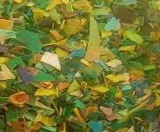
Fig. 1. Recycled plastic

- Sand: After collecting the sand, we removed impurities before using it (see Figure 2).
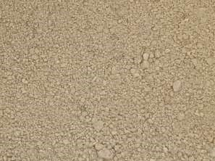
Fig. 2. Sand

- Electronic balance: This balance will allow us to measure the mass of the sand and the plastic (see Figure 3).
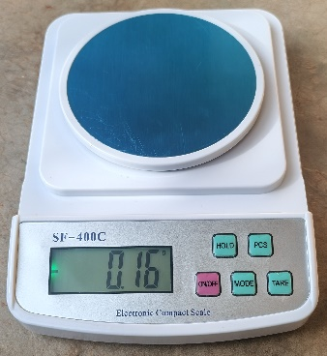
Fig. 3. Electronic balance

- Electromagnetic sieve that will be used to determine the particle size of the sand (see Figure 4).

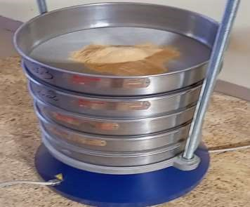
Fig. 4. Electromagnetic sieve shaker

- Cylindrical mold which will produce a test specimen with a cylindrical cross-section of 60 mm diameter and 120 mm height (Figure 5).
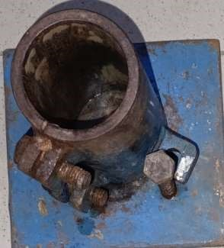
Fig. 5. Cylindrical mold

- Rectangular mold that will produce test specimens with a square cross-section of 40 mm per side and 160 mm in length (see Figure 6).
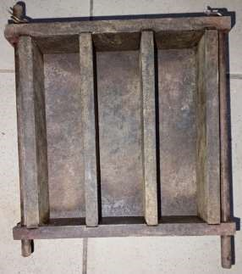
Fig. 6. Square-section molds

2.2 Methods
To produce the composite material, we followed these steps:
- Determining the sand particle size distribution;
- Preparing the recycled plastic-sand composite material.

2.2.1 Determining the Sand Particle Size Distribution
To determine the sand particle size distribution, we will use an electromagnetic sieve shaker (see Figure 3).
To analyze the sand particle size distribution, the sieving method described according to standard NF EN 933-1 is commonly used (CEN, 2012).
The detailed steps of this sieving method are:
- Sample preparation: This involves taking a representative quantity of sand and drying it to remove all moisture.
- Sieve assembly: Stack sieves conforming to the standards, arranged in descending order of their mesh diameter, and position them above an airtight container. Next, place the dry sample on the top sieve, which has the largest mesh diameter.
- Sieving: Shake or vibrate the sieves using a machine to allow the particles to pass through the mesh and be sorted by size.
- Weighing: Measure the sand retained on each sieve, called "refuse," as well as the sand that passed through the last sieve, called "sift."
- Calculation and graphical representation: Calculate the mass percentages for each grain size category. Draw the particle size distribution curve by placing the sieve openings on the horizontal axis and the cumulative percentages of the sieve fractions (or the cumulative refuse) on the vertical axis.

2.2.2 Material Production
The materials used to produce the composite material are recycled plastic and sand.
The recycled plastic used was shredded to facilitate melting.
The sand used was sieved to obtain a uniform particle size distribution.
The composite material is produced in the following stages:
- Melting of recycled plastic: The recycled plastic is melted using a multi-functional furnace. The mass of the shredded plastic is determined before being gradually introduced into a high-temperature resistant metal crucible. The melting temperature of the plastic is approximately 255°C to ensure thorough melting and a homogeneous product.
- Incorporation of sand: After verifying that the plastic has completely melted, the sand is gradually added according to the defined proportions, taking into account the mass of the plastic. The mixture is continuously stirred to ensure good dispersion of the sand grains in the molten plastic. Stirring must continue until a homogeneous mixture is obtained.
- Molding of the composite material: The homogeneous mixture obtained through stirring is poured into metal molds. The molds can be greased to facilitate demolding. The composite material in the mold is manually pressed to reduce voids and improve the material's compactness.
- Demolding: After molding, the molds containing the composite material must be left at room temperature for approximately 3 hours to cool. Once completely cooled, the contents of the molds are removed.
We will develop three types of composite materials by varying the percentage of plastic and sand by mass. This will result in composite materials containing 15%, 20%, and 25% recycled plastic.

3. RESULTS AND DISCUSSIONS
3.1 Determining the Sand Particle Size Distribution
Sieving the sand allowed us to:
- determine the mass of the retained material based on the sieve mesh size,
- calculate the cumulative mass of the retained material,
- calculate the cumulative percentage of the retained material,
- and calculate the cumulative percentage of the sieved material.
The reference method for sieving is given by the standard NF EN 933-1 (AFNOR, 2012).
Table 1 shows the cumulative percentage of the sieved material based on the mesh size of the different sieves used.
Table 1. Summary of cumulative percentages of sieved material.
Sieve diameter | % of cumulative sieving | Sieve diameter | % of cumulative sieving
0,080 | 0,664 | 0,800 | 75,691
0,100 | 1,338 | 1 | 85,969
0,125 | 2,345 | 1,25 | 91,792
0,160 | 5,478 | 1,6 | 94,928
0,200 | 8,195 | 2 | 96,840
0,250 | 13,427 | 2,5 | 97,937
0,315 | 21,193 | 3,15 | 98,762
0,400 | 29,502 | 4 | 99,299
0,500 | 48,698 | 5 | 99,755
0,630 | 58,302 | 6,3 | 100
An aggregate is characterized from a granular point of view by its d/D class, where d designates the minimum diameter of the sand grains and D designates the maximum diameter of the sand grains.
Standards from the French Standardization Association (AFNOR) provide recommendations for determining the granular class of sand (AFNOR, 2021).
When d is less than 0.5 mm, the aggregate is designated 0/D.
The granular class of our sand is 0/5.
The cumulative percentage of the sieved particles allowed us to plot the particle size distribution curve of the sand we used. The graph in Figure 7 represents the evolution of the particle size distribution curve of the sand used to produce the composite material.
Fig. 7. Particle size distribution curve of the sand

The resulting particle size distribution curve is smooth and without dips. This indicates a good mix of sizes and a well-calibrated sand, ideal for demanding applications.
The particle sizes in mm, corresponding to 10%, 30%, 50%, 60%, and 90% of the cumulative sieved percentages, are:
10% of the sieved particles have a diameter less than or equal to 0.236 mm (D10 = 0.236 mm);
30% of the sieved particles have a diameter less than or equal to 0.43 mm (D30 = 0.43 mm);
50% of the sieved particles have a diameter less than or equal to 0.51 mm (D50 = 0.51 mm);
60% of the sieves have a diameter less than or equal to 0.66 mm (D60 = 0.66 mm);
and 90% of the sieves have a diameter less than or equal to 1.22 mm (D90 = 1.22 mm).
The mesh sizes corresponding to D10 and D60 allow us to deduce the uniformity coefficient (D60/D10), which is 2.79. This uniformity coefficient allows us to conclude that the particle size distribution of the sand we used is uniform.

3.2. Composite Materials Produced
We followed the manufacturing methodology, which takes into account the melting temperature of the recycled plastic, the incorporation of sand into the molten plastic to obtain a homogeneous mixture, the introduction of the resulting mixture into a mold for molding, and finally, demolding, ensuring that the mold has cooled to room temperature. We produced composite materials with plastic content by mass of 15%, 20%, and 25%.
The composite material with 15% plastic exhibits malformations and visible voids in certain areas. These defects are due to the low plastic content and the molding method. Its density is 1903.727 kg/m³.
We produced a composite with a square cross-section measuring 40 mm x 40 mm x 160 mm and another with a cylindrical cross-section measuring 60 mm in diameter and 120 mm in height. Figures 8 and 9 show the composite material containing 15% plastic, for the square and cylindrical cross-sections, respectively.
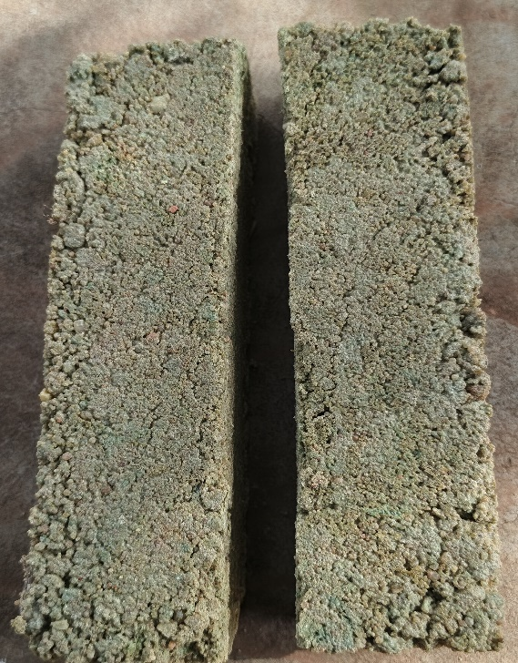
Fig. 8. Square cross-section test tube
containing 15% plastic
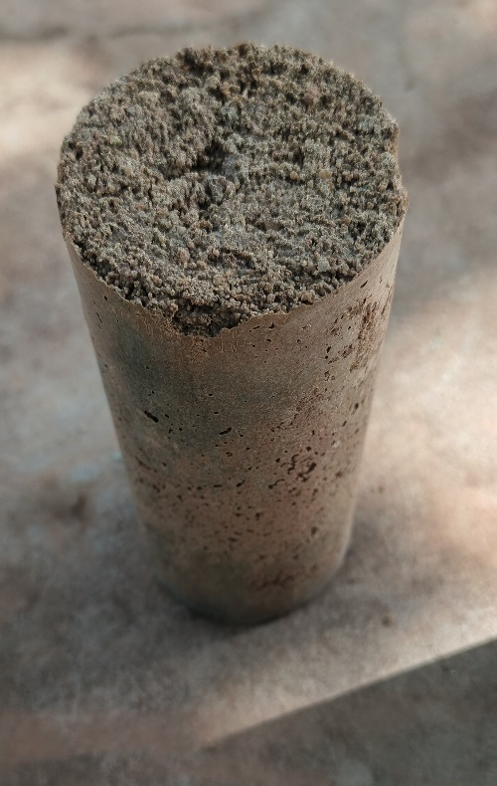
Fig. 9. Cylindrical specimen containing 15% plastic

The composite material containing 20% ​​plastic exhibits fewer dimensional defects than the composite with 15% plastic. This is due to the increased proportion of plastic, which fills the intergranular voids in the sand. Its density is 1795.537 kg/m³.
We produced a composite with a square cross-section measuring 40 mm x 40 mm x 160 mm and another with a cylindrical cross-section measuring 60 mm in diameter and 120 mm in height. Figures 10 and 11 show the composite material containing 20% ​​plastic, respectively for the square and cylindrical cross-sections.
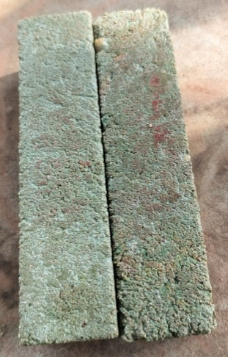
Fig. 10. Square cross-section test tube
containing 20% ​​plastic

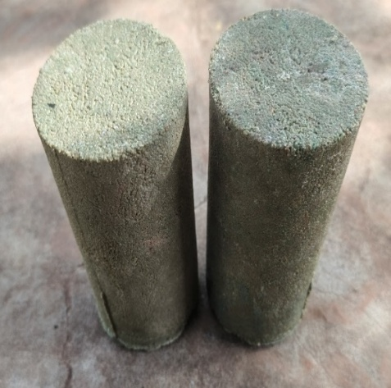
Fig. 11. Cylindrical specimen containing 20% ​​plastic

The composite material containing 25% plastic has a smooth surface with no apparent shape defects. The color of the plastic used is more pronounced than the color of the sand, resulting in a greenish hue. Its density is 1693.589 kg/m³.
We produced a composite with a square cross-section measuring 40 mm x 40 mm x 160 mm and another with a cylindrical cross-section measuring 60 mm in diameter and 120 mm in height. Figures 12 and 13 show the composite material containing 25% plastic, respectively for the square and cylindrical cross-sections.
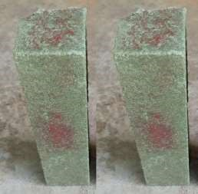
Fig. 12. Square section test tube containing 25% plastic

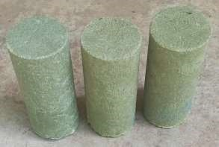
Fig. 13. Cylindrical test specimen containing 25% plastic

4. CONCLUSION
This study demonstrated the feasibility of developing a composite material based on recycled plastic and sand using a simple process involving melting, mixing, and molding. Particle size analysis of the sand confirmed its suitability for composite formulation, while macroscopic observations of the samples highlighted the crucial impact of the recycled plastic content on the final properties of the material. Increasing the recycled plastic content from 15% to 25% resulted in a significant improvement in compactness, a reduction in shape defects, and increased homogeneity of the composite. The material containing 25% recycled plastic exhibited satisfactory physical properties and a smooth surface, demonstrating promising potential for applications such as lightweight, non-load-bearing construction materials, like paving stones, cladding elements, or urban development products. Beyond the results obtained, this study is part of a broader approach to the sustainable valorization of plastic waste. It proposes an effective alternative to landfilling or incineration, while limiting the exploitation of traditional natural resources. Future research will focus primarily on in-depth mechanical testing, analysis of the material's thermal behavior and durability, and optimization of formulations through the addition of additives or fillers. A techno-economic and environmental study, incorporating a life cycle assessment, would also allow this composite material to be positioned relative to its traditional counterparts available on the market. This future work will contribute to strengthening the scientific and industrial relevance of this composite within a sustainable development framework.

COMPETING INTERESTS DISCLAIMER:
Authors have declared that they have no known competing financial interests OR non-financial interests OR personal relationships that could have appeared to influence the work reported in this paper.

REFERENCES
AFNOR, NF P18-545. (2021). Aggregates - Definition, conformity and codification.

Benimam, S., Debieb, F., Bentchikou, M., Guendouz, M. (2014). “Valorization and recycling of plastic waste in concrete”. MATEC web conf., vol. 11, p. 01033.
https://doi.org/10.1051/matecconf/20141101033
European Committee for Standardization (CEN), AFNOR. (2012). “NF EN 933-1 - Tests for determining the geometric characteristics of aggregates - Part 1: Determination of particle size distribution - Particle size analysis by sieving”, Afnor EDITIONS.

Dahou, M., Kaddour, O., Mimoun, H. (2018). “Valorization of plastic waste into energy-rich products,” in First National Conference on Environmental Protection and Renewable Energies CNPER1-2018, pp. 2–5.
Dairou, S., Loabé Pahimi, A., Gove, A., Jacques, and Housseini Djida, J. (2020). “Valorization of plastic waste in the production of construction materials: the case of paving stones in the city of Garoua.”
Djeddi, F., Mohellebi, M. (2019). “Valorization of Polyamide-based Plastic Waste through Recycling,” Int J Sci Res Eng Technol, vol. 8, pp. 1–6.
Monsaingeon, B. (2016). “Plastics: This Continent That Hides Our Waste,” Mouvements, vol. 87, no. 3, pp. 48–58.

DOI: 10.3917/mouv.087.0048.
Ndepeter, C. P., Zaguy-Guerembo, R., Deganai Gbongo, A. M., Regakouzou, L. M. P.,
Ngaissona, V. O., Kpeou-Kolengue, J. (2022). “Valorization of Plastic Waste as Construction Materials,” Eur. Sci. J. ESJ, vol. 18, no. 21, p. 317.
WHO. (2023). Climate Change, Pollution and Health.

https://apps.who.int/gb/ebwha/pdf_files/EB154/B154_24-fr.pdf
Paris. Plastics Europe. (2022). Plastics - The Facts 2022.
https://plasticseurope.org/knowledge-hub/plastics-the-facts-2022
Selma, H. (2025). "Valorization of plastic waste (bags) in the manufacture of mortars," Thesis, Mohamed Khider University of Biskra.
Sereme, A., Mey, P. (2008). Agricultural valorization of household waste in the Sudano-Sahelian zone: the case of the city of Bobo-Dioulasso, J Sci, vol. 8, pp. 28-36.
Soulama, S. (2014). “Mechanical and thermal characterization of biocomposites with a recycled polystyrene matrix reinforced by cotton husks (Gossypium Hitsutum L.) or Kenaf wood particles (Hibiscus Cannabinus L.)”, Theses, University of Technology of Belfort-Montbeliard; Institute of Exact and Applied Sciences (Bobo-Dioulasso, Burkina Faso).

