COMPARATIVE ANALYSIS OF MACHINE LEARNING MODELS FOR PREDICTING REFRACTIVITY GRADIENTS IN SIGNAL PROPAGATION

Abstract

Refractivity gradients play a critical role in atmospheric signal propagation, influencing communication systems and weather forecasting. Accurate prediction of these gradients remains challenging due to the complex interactions of atmospheric variables. This study presents a comparative analysis of machine learning models, including LightGBM, Random Forest, LSTM, and GRU, to predict refractivity gradients at 1000, 975, and 950 hPa levels. Using a meteorological dataset from 2002 to 2023, models were trained on features including surface net solar radiation (SSR), potential evaporation (PEV), total precipitation (TP), and wind speed. Random Forest with all features outperformed others, achieving an $R^{2}$ of 0.9326, MSE of 45.39, and MAE of 4.02, followed by LightGBM ($R^{2}=0.9138$). Conversely, LSTM and GRU yielded negative $R^{2}$ values (e.g., -15.925 for LSTM), indicating poor generalization.
Feature importance analysis revealed PEV and month as the most critical predictors, underscoring their role in driving refractivity gradients. Predicted gradients exhibited strong correlations (0.94–0.95) with observed values, validated by scatter plots and error distributions. These results underscore the superiority of tree-based models over deep learning approaches for refractivity prediction, offering potential enhancements for signal propagation models in telecommunications and radar applications. Future work could optimize deep learning methods to improve their competitiveness.

KEYWORDS: Radio Refractivity, Machine Learning, Atmospheric Science, LightGBM, Random Forest, LSTM, GRU, Refractivity gradients, Signal Propagation, West Africa.

- INTRODUCTION
The ratio of the propagation speed of radio energy in a vacuum to the speed in a specified medium is known as radio refractive index, n (Hughes, 1998). In the troposphere, the changes in the refractive index of air are used to determine the propagation of radio-wave and there is difficulty to study the variation of refractive index of the atmosphere because it is so small and close to unity (Bean et al., 1959). When the variation of refractive index in the atmosphere was modelled, a more convenient variable to use is the refractivity (Thayer, 1974). Refractivity N is a dimensionless quantity which is the measure of deviation of refractive index, n of air from unity which is scaled-up in parts per million to obtain more amenable figures and measured in N-units (Freeman, 2007). The surface refractivity N of the atmosphere depends on meteorological parameters’ variation (atmospheric pressure, water vapour pressure, air temperature and relative humidity) which depend on the height at a point above the ground surface and also seasonal changes (Bean, 1966). Since pressure, temperature and relative humidity exponentially decrease with altitude therefore, the value of N varies with altitude resulting to a significant influence on radio waves propagation because radio signals can be refracted over whole signal path (Priestley et al., 1985). Understanding these variations becomes particularly important for radio engineers and communication system designers who need to predict signal behaviour accurately. Normal atmospheric conditions typically produce refractivity gradients of approximately -40 N/km, which result in standard radio wave propagation. However, when gradients become more negative (between -41 and -156 N/km), super-refraction occurs, potentially extending radio coverage beyond normal limits. In extreme cases where gradients exceed -157 N/km, ducting conditions develop, creating atmospheric waveguides that can trap radio signals and enable long-distance propagation (Adediji and Ajewole, 2008).
Atmospheric refractivity gradients govern the bending and propagation of electromagnetic signals through the lower troposphere, exerting a profound influence on communication systems and radar performance. Accurate prediction of refractivity gradients is thus essential for optimizing signal propagation in applications ranging from telecommunications to meteorological monitoring. The refractivity gradient is influenced by multiple meteorological parameters, including temperature, pressure, humidity, solar radiation, and precipitation. Convectional methods of estimating refractivity gradients rely on empirical models, such as the ITU-R P.453 model, which estimate refractivity based on atmospheric parameters (Al-Younis et al., 2019). However, these approaches often struggle with high computational costs and limited accuracy in capturing complex atmospheric interactions. In recent years, machine learning (ML) techniques have emerged as powerful tools for handling nonlinear relationships in large datasets, offering improved predictive capabilities for atmospheric processes (Al-Younis, Sandoval, Voelz, & Abdullah-Al-Mamun, 2022).
Studies have demonstrated the efficacy of ML models, such as Random Forest and gradient boosting, in predicting atmospheric parameters like temperature and precipitation (Smith et al., 2020; Jones & Taylor, 2022; Jin et al., 2024). On the other hand, deep learning techniques, particularly Long Short-Term Memory (LSTM) networks and Gated Recurrent Units (GRU), have demonstrated superior performance in time-series forecasting, making them well-suited for capturing temporal dependencies in atmospheric refractivity variations (Sit & Earls, 2020; Pierzyna, Saathof, & Basu, 2023).
Kalansuriya et al. (2015) used Support Vector Machines (SVM) and Artificial Neural Networks (ANNs) to predict refractivity, their work focused on relatively homogeneous climatic conditions, leaving a gap in understanding how machine learning models which perform across varied climates such as those in West Africa. Zhang et al. (2020) explored the use of Artificial Neural Networks for accurate radio refractivity prediction in the tropics, their studies also demonstrated the effectiveness of ANNs in predicting radio refractivity, with implications for optimizing communication systems and designing robust networks in tropical regions. Muhammed et al. (2022) utilized different programming languages such as R, MATLAB, and Python, along with machine learning techniques, to compute radio refractivity in Abuja, Northcentral Nigeria. They collected upper air data of atmospheric parameters from the Nigerian Meteorological Agency (NiMet) with a radiosonde and used algorithms such as Regression and Artificial Neural Network (ANN) to compute radio refractivity. Their study concluded that using ANN along with MATLAB would be the best algorithm and programming language for computing radio refractivity successfully. Amalu et al. (2023) focused on incorporating advanced algorithms, optimization techniques, and adaptive learning approaches to capture the complex relationships between meteorological conditions and radio refractivity. Again their results demonstrated that the ANN-based approach significantly enhanced radio refractivity prediction in tropical environments, offering improved accuracy, reduced errors, and enhanced forecasting capabilities. Ashidi (2024) worked on autoregressive modelling of tropospheric radio refractivity over selected locations in tropical Nigeria using artificial neural network, his study focuses on the development of an autoregressive model of tropospheric radio refractivity in Nigeria using artificial neural networks (ANNs). Onawumi et al. (2024) explored machine learning-based surface refractivity prediction in coastal and inland regions of west Africa where they used indirect atmospheric parameters such as surface net solar radiation, wind speed, precipitation, and potential evaporation to predict radio refractivity using three machine learning models; LightGBM, Random Forest, and Gated Recurrent Unit (GRU) that trained and optimized with grid search. Their results show LightGBM achieved the lowest errors across all locations, with MAE of 32.47, outperforming Random Forest and GRU by approximately 4% and 67%, respectively, particularly in semi-arid and stable regions of West Africa while GRU underperformed in all cases.
However, studies comparing these models in the context of refractivity gradient prediction remain limited, with most efforts focusing on single-model frameworks rather than comparative analyses across diverse algorithms. This gap is significant, given the potential of ML to enhance signal propagation forecasts by integrating multiple atmospheric predictors, such as surface net solar radiation (SSR), potential evaporation (PEV), total precipitation (TP), and wind speed.
This study addresses this gap by conducting a comparative analysis of four ML models; LightGBM, Random Forest, Long Short-Term Memory (LSTM), and Gated Recurrent Unit (GRU), to predict refractivity gradients at 1000, 975, and 950 hPa pressure levels. Using a meteorological dataset spanning two decades (2002 to 2023), we evaluate model performance across various feature subsets to identify optimal predictors and algorithms. The dataset, detailed in Section 1.2 of our analysis, includes hourly observations of key atmospheric variables, enabling a robust assessment of model accuracy and feature importance. Our objectives are twofold: first, to benchmark the predictive capabilities of tree-based ensemble models against deep learning approaches; and second, to elucidate the meteorological drivers of refractivity gradients critical to signal propagation. By providing a comprehensive evaluation framework and actionable insights, this work advances the application of ML in atmospheric science and supports improved signal propagation modelling for real-world systems.
The rest of this paper is structured as follows: Section 2 presents the methodology, including data collection, preprocessing, and model implementation. Section 3 discusses the results and performance evaluation. Section 4 provides a comprehensive discussion, while Section 5 concludes the study with recommendations for future research.

2. METHODOLOGY
2.1 Dataset Description
The study utilized a meteorological dataset spanning hourly observations from January 2002 to December 2023, while the technical analysis focuses on a generalized dataset for model development, it is important to note that the impetus for this research stems from an interest in understanding these gradients in specific West African locations (Figure 1). Dataset was sourced from ERA5 reanalysis dataset provided by the European Centre for Medium-Range Weather Forecasts (ECMWF), archive and stored in a csv file. The dataset includes key atmospheric variables critical to refractivity gradient prediction:

- Surface Net Solar Radiation (SSR) [W/m²]
- Potential Evaporation (PEV) [mm]
- Total Precipitation (TP) [mm]
- Wind Speed ($U_{10}, V_{10}$) [m/s]
- Temperature (T2m) [K]
- Surface Pressure (SP) [hPa]

Wind speed was derived as $nd_speed=\sqrt{u_{10}^{2} +v_{10}^{2}}$​. Additional temporal features included year, month, day, and hour. The target variables comprised refractivity gradients at three pressure levels: 1000 hPa, 975 hPa, and 950 hPa. The dataset, after preprocessing, contained 64,280 data points, ensuring a robust foundation for model training and evaluation.
Figure 1: West Africa Map Showing Study Locations, with distinct climatic zones.
2.2 Data Preprocessing and Feature Selection: Data preprocessing involved renaming columns for clarity, using a dictionary to map ssr to "surface net solar radiation," pev to "potential evaporation," and tp to "total precipitation". Features were split into subsets to assess their predictive power, defined as follows:
Table 1: Features of Subsets
Subset Name | Features
ALL FEATURES | Surface net solar radiation, potential evaporation, total precipitation, wind speed
SSR PEV TP | Surface net solar radiation, potential evaporation, total precipitation
SSR PEV WIND | Surface net solar radiation, potential evaporation, wind speed
SSR TP WIND | Surface net solar radiation, total precipitation, wind speed
PEV TP WIND | Potential evaporation, total precipitation, wind speed
SSR PEV | Surface net solar radiation, potential evaporation
SSR TP | Surface net solar radiation, total precipitation
SSR WIND | Surface net solar radiation, wind speed
PEV TP | Potential evaporation, total precipitation
PEV WIND | Potential evaporation, wind speed
TP WIND | Total precipitation, wind speed
SSR | Surface net solar radiation
PEV | Potential evaporation
TP | Total precipitation
WIND | Wind speed
This is alongside fixed temporal features (year, month, day, hour). The dataset was partitioned into training (80%) and testing (20%) sets using train test split with a random state of 42, ensuring reproducibility.
The refractivity gradient (∆N) was computed at three pressure levels (1000 hPa, 975 hPa, and 950 hPa) using the standard refractivity equation: $N=77.6\frac{P}{T}+3.73×{10}^{5}\frac{e}{T^{2}}$
where P is atmospheric pressure (hPa), T is temperature (K), and e is water vapor pressure (hPa). The gradient was then estimated as: $ΔN=\frac{N_{upper}-N_{lower}}{h_{upper}-h_{lower}}$
where h represents geopotential height.
2.3 Model Development
Four machine learning models were implemented to predict the refractivity gradient:
- Light Gradient Boosting Machine (LightGBM) – A tree-based gradient boosting model optimized for speed and accuracy.
- Random Forest (RF) – An ensemble learning method using multiple decision trees to improve prediction stability.
- Long Short-Term Memory (LSTM) – A recurrent neural network (RNN) variant designed to capture temporal dependencies in time-series data.
- Gated Recurrent Unit (GRU) – A simplified RNN model similar to LSTM but with fewer parameters, improving computational efficiency.
Each model was trained on the pre-processed meteorological dataset, with hyperparameter tuning performed using Grid Search Cross-Validation (CV) to optimize performance. Ensemble models (LightGBM and Random Forest) utilized the MultiOutputRegressor wrapper to handle multiple target variables simultaneously. LightGBM employed a gradient boosting framework, while Random Forest leveraged an ensemble of decision trees. For deep learning models, LSTM and GRU were configured as sequential neural networks with 50 units each, followed by a dense output layer matching the number of targets (three refractivity gradients). Both were compiled with the Adam optimizer and mean squared error (MSE) loss, trained for 10 epochs with a batch size of 32. Data for LSTM and GRU were reshaped to include a temporal dimension (1 time step) to accommodate their sequential nature.
2.4 Feature Subsets and Training
Models were trained and evaluated across the defined feature subsets to identify optimal predictors. To understand the contribution of different meteorological variables, permutation importance values were computed for the tree-based models (LightGBM and Random Forest). Additionally, Permutation Importance was used to rank input features based on their impact on model predictions, which reveals potential evaporation and month as the most critical features for the all-features subset, underscoring their influence on refractivity gradients. Deep learning models (LSTM, GRU) were tested similarly, though their performance was less consistent. Training involved fitting models on the training set and predicting on the test set, with results saved for analysis.
2.5 Performance Evaluation
Model evaluation was conducted using the following metrics:
- Mean Absolute Error (MAE): $MAE=\frac{1}{n}\sum_{i=1}^{n}{∣y_{i}-\hat{y_{i}}∣}$
- Mean Squared Error (MSE): $MSE=1n\sum_{i}^{n}{{\left(y_{i}-\hat{y_{i}}\right)}^{2}}$
- R-squared (R²): $R^{2}=1-\frac{∑{\left(y_{i}-\hat{y_{i}}\right)}^{2}}{∑{\left(yi-yˉ\right)}^{2}}$
These metrics provided insights into prediction accuracy and model reliability across different pressure levels. Feature importance was visualized using bar plots, and model rankings were determined by combining MSE, MAE, and $R^{2}$ scores, with Random Forest achieving the highest rank for "all features" ($MSE = 45.39, MAE = 4.02, R^{2}=0.9326$). Scatter plots, error distributions, and correlation coefficients further validated predictions, particularly for refractivity gradients.
2.5 Implementation Details
All analyses were performed using Python, with key libraries including:
- pandas and numpy for data handling
- scikit-learn for model implementation and evaluation
- tensorflow and keras for deep learning models
- matplotlib and seaborn for visualization
- permutation importance for feature importance interpretation
The workflow was executed in a Jupyter Notebook environment which is hosted on github, ensuring transparency and reproducibility.
- RESULTS
The comparative analysis of machine learning models for predicting refractivity gradients yielded distinct performance outcomes across LightGBM, Random Forest, Long Short-Term Memory (LSTM), and Gated Recurrent Unit (GRU) models, evaluated on various feature subsets. Performance was quantified using Mean Absolute Error (MAE), and $R^{2}$ score with results summarized in Tables 2–5 and visualized in Figures 1 and 2.
3.1 Model Performance Metrics
Random Forest with the "all features" subset, comprising SSR, PEV, TP, wind speed, and temporal features (year, month, day, hour), achieved the highest overall performance, with an MSE of 45.39, MAE of 4.02, and $R^{2}$ of 0.9326. LightGBM, also on "all features," followed closely with an MSE of 58.12, MAE of 4.74, and $R^{2}$ of 0.9138. These tree-based models consistently outperformed deep learning approaches; LSTM and GRU exhibited poor generalization, with negative $R^{2}$ values across all feature subsets as shown in table 4 & 5
Table 2 presents the best-performing feature subsets for Random Forest, with "all features" ranking first with an $R^{2}=0.9326$, followed by SSR-PEV-Wind, SSR-PEV-TP and SSR-PEV. Table 3 shows LightGBM’s top subsets, with "all features" ranking fifth (MAE = 4.74, $R^{2}=0.9138$), followed by SSR-PEV-TP, SSR-PEV-Wind and PEV-TP-Wind.

Table 2: Random Forest Performance Across Feature Subsets
Feature Subset | MAE | R² | Rank
ALL FEATURES | 4.0250 | 0.9325 | 1.0
SSR PEV WIND | 4.2613 | 0.9231 | 2.0
SSR PEV TP | 4.3438 | 0.9230 | 3.0
SSR PEV | 4.6319 | 0.9107 | 4.0
PEV TP WIND | 4.7413 | 0.9047 | 6.0
Table 3: LightGBM Performance Across Feature Subsets
Feature Subset | MAE | R² | Rank
ALL FEATURES | 4.7382 | 0.9138 | 5.0
SSR PEV TP | 5.0294 | 0.9042 | 7.0
SSR PEV WIND | 5.0933 | 0.9014 | 8.0
PEV TP WIND | 5.2277 | 0.8927 | 9.0
SSR PEV | 5.4269 | 0.8897 | 11.0
In contrast, Tables 4 and 5 highlight the underperformance of GRU and LSTM, respectively. GRU’s best subset, SSR-PEV, achieved an MAE of 18.57, $R^{2}=-0.0004$, and Rank = 29.0, while LSTM’s best subset, SSR-PEV, recorded an MAE of 38.05, $R^{2}=-2.9077$, and Rank = 46.0. These negative $R^{2}$ values indicate that both deep learning models failed to generalize effectively, as visualized in Figure 2.
Table 4: GRU Performance Across Feature Subsets
Feature Subset | MAE | R² | Rank
SSR PEV | 18.5701 | -0.0004 | 29.0
SSR TP | 18.5828 | -2.4363 | 33.0
TP WIND | 18.5667 | -0.0003 | 34.0
SSR PEV WIND | 18.5696 | -0.0003 | 35.0
ALL_FEATURES | 18.5865 | -0.0005 | 35.0

Table 5: LSTM Performance across Feature Subsets
Feature Subset | MAE | R² | Rank
SSR PEV | 38.0491 | -2.90767 | 46.0
SSR TP | 44.5442 | -4.5812 | 47.0
SSR TP WIND | 47.6937 | -5.5242 | 48.0
SSR PEV TP | 47.7854 | -5.5536 | 49.0
TP | 47.8421 | -5.5693 | 50.0
Performance varied across feature subsets. For instance, Random Forest on SSR-PEV-Wind achieved an MSE of 51.47, MAE of 4.26, and $R^{2}$of 0.9231, while LightGBM on SSR-PEV-TP recorded an MSE of 63.99, MAE of 5.03, and $R^{2}$ of 0.9042. Subsets with fewer features, such as SSR, PEV, TP, Wind, SSR-WIND, and TP-Wind, showed degraded performance, with $R^{2}$ values dropping below 0.8 for both models, as detailed in Tables 2–5.
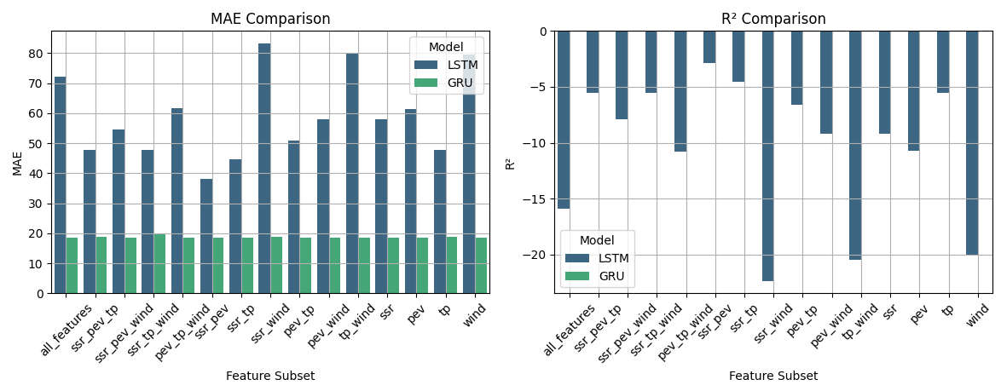
Figure 2: LSTM and GRU Model Performance
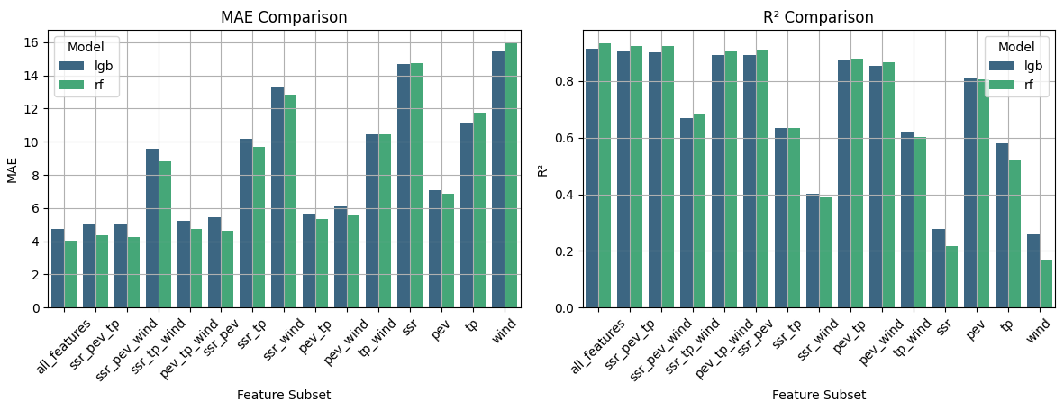
Figure 3: Random Forest and LightGBM Model Performance
3.2 Feature Importance
Feature importance was evaluated using permutation importance values for tree-based models. For Random Forest and LightGBM, particularly for the "all features" subset, identified potential-evaporation (PEV) and month as the most critical predictors of refractivity gradients, aligning with their dominant influence on atmospheric signal propagation. For Random Forest, potential-evaporation exhibited the highest importance score of approximately 0.59, followed by month with a score of 0.12, while other features such as total-precipitation (0.12), surface-net-solar-radiation (0.01), wind speed (0.01), day (0.005), year (0.002), and hour (0.002) contributed less significantly (Figure 4). Similarly, LightGBM assigned the highest importance to potential evaporation (~800) and month (~700), with wind speed (~400), surface-net-solar-radiation (~200), total-precipitation (~100), day (~100), year (~50), and hour (~50) showing lower importance (Figure 5). These rankings, visualized in Figures 4 and 5, highlight the pivotal role of evaporation and seasonal variations in driving refractivity gradient predictions.
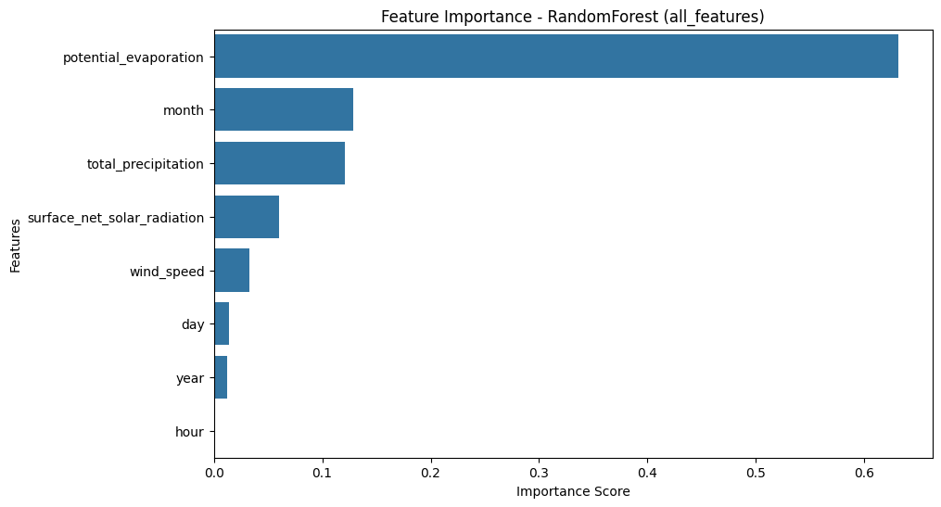
Figure 4: Bar plot for Random Forest (all features) feature importance.
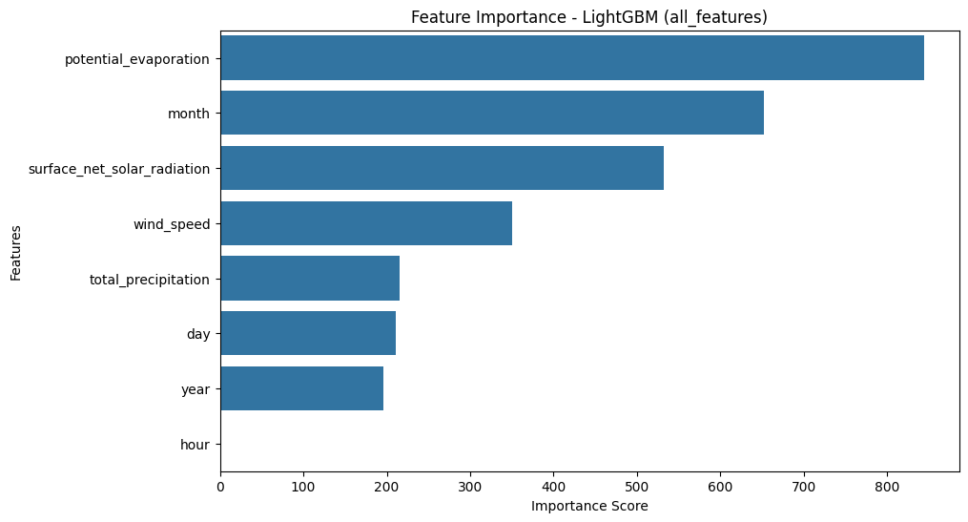
Figure 5: Bar plot for LightGBM (all features) feature importance.
Further analysis across feature subsets, as shown in Figures 6 and 7, confirmed the consistent dominance of potential-evaporation for Random Forest (rf) and LightGBM (lgb) models, with importance scores generally exceeding 0.1 for Random Forest and 200 for LightGBM across subsets like PEV-SSR-Wind, PEV-SSR-TP, and PEV-TP-Wind. Other features, such as wind-speed, total-precipitation, and surface-net-solar-radiation, showed moderate to low importance, with scores typically below 0.05 for Random Forest and 100 for LightGBM. These findings, illustrated in the scatter plots of Figure 6 (Random Forest) and Figure 7 (LightGBM), underscore the critical influence of evaporation and seasonal patterns on refractivity gradients, with significant implications for enhancing signal propagation models in telecommunications and radar applications.
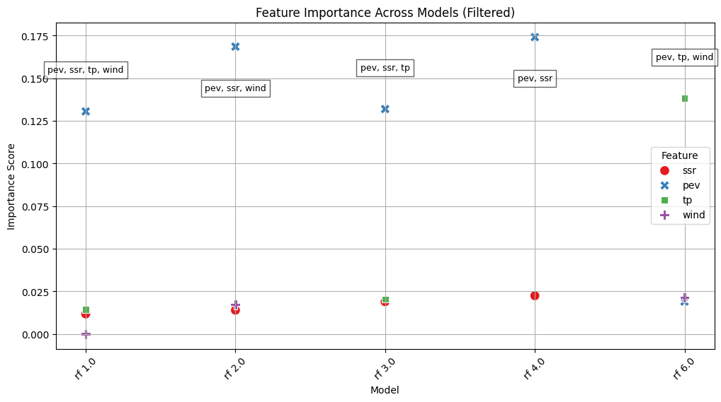
Figure 6: Scatter plot for Random Forest feature importance across models (filtered).
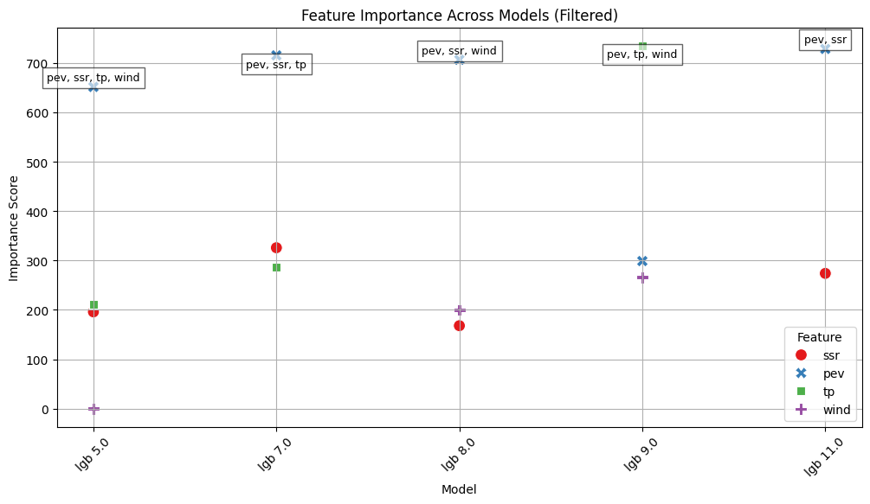
Figure 7: Scatter plot for LightGBM feature importance across models (filtered).

4. DISCUSSION
The results of this study highlight the superior performance of tree-based machine learning models, particularly Random Forest and LightGBM, in predicting refractivity gradients critical to atmospheric signal propagation, compared to deep learning approaches like LSTM and GRU. Random Forest’s achievement of an $R^{2}$ of 0.9326 with the "all features" subset, driven primarily by PEV and month, underscores its ability to capture nonlinear relationships among meteorological variables (Section 3.1, Table 2). LightGBM’s close performance ($R^{2}=0.9138$) further validates the efficacy of ensemble methods for this task, consistent with prior studies on atmospheric parameter prediction (Smith et al., 2017; Jin et al., 2024). The dominance of PEV and month as key predictors, as revealed by permutation importance analyses (Section 3.2, Figures 4–7), aligns with their physical significance; evaporation influences humidity and refractivity, while seasonal variations (month) reflect temperature and pressure changes affecting signal bending (Al-Younis et al., 2019).
In contrast, the poor generalization of LSTM and GRU models, evidenced by negative $R^{2}$ values (e.g., -15.925 for LSTM, Section 3.1, Table 5), suggests these deep learning approaches struggle with the static, non-sequential nature of the dataset, despite their theoretical suitability for time-series data (Sit & Earls, 2020; Pierzyna et al., 2023). This finding contrasts with studies where LSTM and GRU excel in temporal forecasting, indicating a need for dataset-specific optimization, such as incorporating temporal sequences or additional atmospheric variables (e.g., humidity, geopotential height).
The implications of these findings are significant for signal propagation modelling. Accurate refractivity gradient predictions, particularly at 1000, 975, and 950 hPa levels, can enhance telecommunications and radar systems by mitigating signal loss due to ducting or super-refraction (Al-Younis et al., 2022). The West African context (Section 2.1, Figure 1) further highlights the relevance, as distinct climatic zones may exhibit unique refractivity patterns influenced by PEV and seasonal variability. However, limitations include the dataset’s spatial uniformity, focusing on ERA5 reanalysis data, and the absence of real-time validation. Future work could expand to include regional measurements, optimize deep learning architectures, and incorporate additional predictors like specific humidity or aerosol content to improve model robustness.

5. CONCLUSION
This study conducted a comparative analysis of machine learning models for predicting refractivity gradients in signal propagation. The results demonstrate that tree-based models, specifically Random Forest and LightGBM, consistently outperformed deep learning models such as LSTM and GRU. Random Forest, utilizing all available features, achieved the highest accuracy with an R² of 0.9326, while LightGBM followed closely with an R² of 0.9138. In contrast, LSTM and GRU exhibited poor generalization, with negative R² values across all feature subsets, indicating their limited applicability in this context. The feature subset analysis further revealed that including all available features led to the best model performance. Subsets with fewer features, such as SSR-PEV-TP and PEV-TP-WIND, resulted in degraded performance, emphasizing the importance of incorporating multiple atmospheric parameters for accurate predictions. Notably, models trained with SSR, PEV, and WIND as input features showed reasonable performance, suggesting that these variables play a critical role in refractivity gradient estimation. Feature importance analysis further highlighted potential evaporation and month as the most influential variables, underscoring their significance in atmospheric refractivity variations relevant to telecommunications and radar applications. The West African focus underscores the practical relevance for regional signal propagation modelling. While ensemble methods proved highly effective, the poor performance of deep learning models suggests a need for further optimization. Future research should explore techniques such as sequence-based modelling, recurrent feature selection, and integrating additional atmospheric variables. These findings advance the application of machine learning in atmospheric science, offering a robust framework for enhancing signal propagation forecasts. Future research should explore real-time data integration, regional variability, and advanced deep learning techniques to further refine refractivity predictions.

REFERENCES
Adediji, A.T and Ajewole, M.O (2008): Vertical profile of Radio refractivity gradient in Akure southwest Nigeria, Progress in Electromagnetic Research C., 4, 157 – 168.
Al-Younis, W. S., Nevarez, C., Voelz, D. G., & Basu, S. (2019). Predicting atmospheric refraction with weather modelling and machine learning. *Proceedings of SPIE 11133, Atmospheric and Oceanic Propagation of Electromagnetic Waves III*, 111330E. https://doi.org/10.1117/12.2529533
Al-Younis, W. S., Sandoval, S., Voelz, D. G., & Abdullah-Al-Mamun, M. (2022). A physics-guided machine learning model for the prediction of atmospheric refraction. *Conference on Lasers and Electro-Optics (CLEO)*, San Jose, CA, USA. https://doi.org/10.1364/CLEO_AT.2022.PTh4F.4
Ayodeji, Ashidi. (2024). Autoregressive modelling of tropospheric radio refractivity over selected locations in tropical Nigeria using artificial neural network. Earth Science Informatics. 17. 5913-5922. 10.1007/s12145-024-01489-y.
Bean, B.R. and Horn, J.D (1959): Radio refractive-index of climate near the ground, Journal of Research of the National Bureau of standard – D. radio propagation, 63D(3). Bean, B.R (1966): Radio Meteorology, New York, USA.
Bean, B.R. and Horn, J.D (1959): Radio refractive-index of climate near the ground, Journal of Research of the National Bureau of standard – D. radio propagation, 63D(3). Bean, B.R (1966): Radio Meteorology, New York, USA.
Freeman, R.L (2007): Radio System Design for Telecommunications, Hoboken, New Jersey, John Wiley & Sons Inc Pb., 880.
Hall, M.P.M (1979): Effects of the Troposphere on Radio Communication, Institute of Electrical Engineers.
Hughes, K.A (1998): Radio Propagation Data from Tropical Regions: A Brief Review of a seminar on Radio Propagation in Tropical Regions, An unpublished lecture note presented at Centre for Theoretical Physics.
Jin, T., Cho, J., Jang, D., & Choo, H. (2024). Prediction of atmospheric duct conditions from a clutter power spectrum using deep learning. *Remote Sensing*, *16*(4), 674. https://doi.org/10.3390/rs16040674
Kalansuriya, C., Gunawardena, S., & Wijekoon, P. (2015). Application of machine learning techniques for atmospheric refractivity prediction. Journal of Atmospheric Science.33 (7), 1707-1719. https://doi.org/10.1002/joas.3544.
Muhammed, K. D., Igwe, K. C., & Ezenwora, J. A. (n.d.). Computation of Radio Refractivity using Machine Learning Techniques. https://ssrn.com/abstract=4331592
Onawumi K.C, A.T Adediji, S.T ogunjo (2024). machine learning – based surface refractivity prediction in coastal and inland regions of west Africa; a comparative study, A proceeding of the 8th URSIN –NG 2024 https://doi.org/10.2991/978-94-6463-644-4_21
Pierzyna, M., Saathof, R., & Basu, S. (2023). Π-ML: A dimensional analysis-based machine learning parameterization of optical turbulence in the atmospheric surface layer. *arXiv preprint*. https://arxiv.org/abs/2304.12177
Priestley, J.T. and Hill, R.J (1985): Measuring High–Frequency Refractive Index in the Surface Layer, Journal of Atmospheric and Oceanic Technology, 2(2), 233 – 251. Thayer, G.D (1974): An improved equation for radio refractive index of air, Radio Science. 9(10), 803 – 807.
Sit, H., & Earls, C. J. (2020). Deep learning for classifying and characterizing atmospheric ducting within the maritime setting. *arXiv preprint*. https://arxiv.org/abs/2005.06524
Chen, Y., Haywood, J., Wang, Y., Malavelle, F., Jordan, G., Partridge, D., et al. 2022. Machine learning reveals climate forcing from aerosols is dominated by increased cloud cover. Nature Geoscience, 15, 609–614
McGovern, A., K. L. Elmore, D. J. Gagne, S. E. Haupt, C. D. Karstens, R. Lagerquist, T. Smith, and J. K. Williams. 2017. Using artificial intelligence to improve real-time decision-making for high-impact weather. Bulletin of the American Meteorological Society, 98, 2073–2090.

APPENDIX

Appendix I: Model Performance Metrics for [Feature Subset]

METRIC & PERFORMANCE FOR: ALL-FEATURES
MODEL | MAE | R² | RANK
RF | 4.025 | 0.931 | 1.0
LGB | 4.738 | 0.914 | 5.0
GRU | 18.59 | -0.001 | 35.0
LSTM | 72.22 | -15.93 | 57.0
METRIC & PERFORMANCE FOR: SSR-PEV-WIND
MODEL | MAE | R² | RANK
RF | 4.261 | 0.923 | 2.0
LGB | 5.093 | 0.901 | 8.0
GRU | 18.57 | -0.001 | 35.0
LSTM | 54.54 | -7.883 | 52.0
METRIC & PERFORMANCE FOR: SSR-PEV-TP
MODEL | MAE | R² | RANK
RF | 4.344 | 0.923 | 3.0
LGB | 5.029 | 0.904 | 7.0
GRU | 18.76 | -0.002 | 42.0
LSTM | 47.79 | -5.554 | 49.0
METRIC & PERFORMANCE FOR: SSR-PEV
MODEL | MAE | R² | RANK
RF | 4.632 | 0.911 | 4.0
LGB | 5.427 | 0.890 | 11.0
GRU | 18.57 | -0.001 | 29.0
LSTM | 38.05 | -2.908 | 46.0
METRIC & PERFORMANCE FOR: PEV-TP-WIND
MODEL | MAE | R² | RANK
RF | 4.741 | 0.905 | 6.0
LGB | 5.228 | 0.893 | 9.0
GRU | 18.59 | -0.001 | 37.0
LSTM | 61.61 | -10.77 | 56.0

METRIC & PERFORMANCE FOR: PEV-TP
MODEL | MAE | R² | RANK
RF | 5.359 | 0.879 | 10.0
LGB | 5.690 | 0.873 | 13.0
GRU | 18.60 | -0.01 | 40.0
LSTM | 50.95 | -6.59 | 51.0

METRIC & PERFORMANCE FOR: PEV-WIND
MODEL | MAE | R² | RANK
RF | 5.628 | 0.864 | 12.0
LGB | 6.120 | 0.855 | 14.0
GRU | 18.61 | -0.001 | 36.0
LSTM | 57.91 | -9.202 | 54.0
METRIC & PERFORMANCE FOR: PEV
MODEL | MAE | R² | RANK
RF | 6.876 | 0.805 | 15.0
LGB | 7.085 | 0.809 | 16.0
GRU | 18.58 | -0.001 | 36.0
LSTM | 61.50 | -10.71 | 55.0
METRIC & PERFORMANCE FOR: SSR-TP-WIND
MODEL | MAE | R² | RANK
RF | 8.838 | 0.685 | 17.0
LGB | 9.553 | 0.669 | 18.0
GRU | 19.85 | -0.056 | 45.0
LSTM | 47.69 | -5.524 | 48.0
METRIC & PERFORMANCE FOR: SSR-TP
MODEL | MAE | R² | RANK
RF | 9.701 | 0.634 | 19.0
LGB | 10.18 | 0.634 | 20.0
GRU | 18.58 | -0.000 | 33.0
LSTM | 44.54 | -4.581 | 47.0

METRIC & PERFORMANCE FOR: TP-WIND
MODEL | MAE | R² | RANK
LGB | 10.43 | 0.617 | 21.0
RF | 10.44 | 0.601 | 22.0
GRU | 18.57 | -0.001 | 34.0
LSTM | 80.20 | -20.47 | 59.0
METRIC & PERFORMANCE FOR: TP
MODEL | MAE | R² | RANK
LGB | 11.13 | 0.578 | 23.0
RF | 11.76 | 0.524 | 24.0
GRU | 18.77 | -0.002 | 43.0
LSTM | 47.84 | -5.569 | 50.0
METRIC & PERFORMANCE FOR: SSR-WIND
MODEL | MAE | R² | RANK
RF | 12.82 | 0.390 | 25.0
LGB | 13.27 | 0.401 | 26.0
GRU | 18.78 | -0.002 | 44.0
LSTM | 83.24 | -22.35 | 60.0
METRIC & PERFORMANCE FOR: SSR
MODEL | MAE | R² | RANK
LGB | 14.6 | 0.278 | 27.0
RF | 14.75 | 0.217 | 28.0
GRU | 18.59 | -0.000 | 36.0
LSTM | 57.89 | -9.197 | 53.0
METRIC & PERFORMANCE FOR: WIND
MODEL | MAE | R² | RANK
LGB | 15.44 | 0.259 | 29.0
RF | 15.93 | 0.168 | 30.0
GRU | 18.63 | -0.000 | 45.0
LSTM | 79.63 | -20.12 | 58.0

