Case report

INCIDENCE OF DIROFILARIA IMMITIS IN A DOG WITH URETHRAL CALCULI
– A RARE CASE REPORT

ABSTRACT
A 6-year-old male Dachshund dog presented to Veterinary clinical campus with a history of good general appearance and normal appetite but had not voided faeces or urine for the past two days. Clinical examination revealed that there were no significant abnormalities observed except for signs of urinary retention. Upon routine radiographic imaging, the presence of urethral calculi in the pelvic urethra was observed, suggesting a potential obstruction. Additionally, a blood smear examination for parasite screening and complete blood count was conducted. It revealed presence of microfilariae indicating a concurrent infection with heartworm disease with elevated white blood cell count and low mean corpuscular volume. The other blood parameters were found normal except for the drop in mean corpuscular volume.
Keywords: Microfilariae, dog, heartworm, blood smear, urethral calculi

INTRODUCTION
ETIOLOGY AND LIFECYCLE
Dirofilaria immitis belongs to the family of Onchocercidae (Michalski, et. al., 2010) is commonly called as canine heart worm is a parasitic nematode that primarily infects canines, though it can also affect felines, and other mammals. They are long slender viviparous worms where the adults reside in the pulmonary arteries, right ventricle, and posterior venacava (Soulsby, 1982). Canine heartworm is transmitted by mosquitoes such as Culex, Aedes, and Anopheles species. Microfilariae, the larval stage of Dirofilaria sp. is found in blood stream which will be taken up by mosquitoes during a blood meal. Within the mosquito, the larvae develop from L1 to L2 and finally to the infective L3 stage over 10–14 days, depending on environmental temperature. The infective L3 larvae are introduced into the bloodstream of definitive host via mosquito bites. The larvae migrate through subcutaneous tissues, moult into L4 and then immature adults, and reach the pulmonary arteries within 3–4 months. Over several months, the larvae mature into adult worms by about 6–7 months (Fig. 1.), which can live for up to 5-7 years in the dog, completing the life cycle and beginning microfilarial production which result in significant cardiovascular and pulmonary damage.

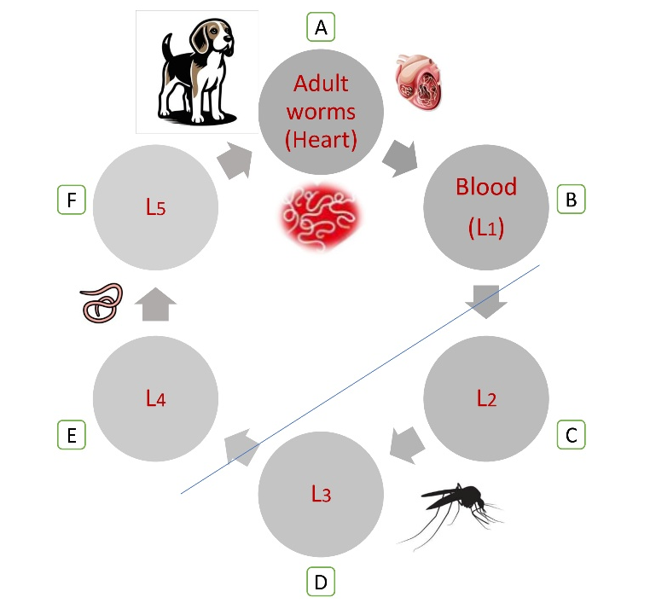
Fig.1. Lifecycle of canine heartworm
A. Adults reside in the pulmonary arteries, right ventricle, and posterior venacava. B. Microfilariae (L1), the larval stage of Dirofilaria sp. is found in blood stream B - C. L1 taken up by mosquitoes during a blood meal. C. The larvae develop from L1 to L2. D. L2 to infective L3 stage. D - E. L3 larvae are introduced into the bloodstream of definitive host via mosquito bites. E. The larvae migrates and moult into L4 F. immature adults (L5). F - A. L5 reach the pulmonary arteries

PATHOLOGY AND CLINICAL SIGNS
The pathology of canine heartworm disease is primarily associated with the presence of adult worms in the dog’s heart chamber and associated blood vessels. In severe infections, worms may migrate into the associated locations such as right atrium and vena cava. The parasites can cause mechanical obstruction due to their size and their physical presence. The worms induce inflammation of the arterial walls (endarteritis), leading to thickening and also cause reduced elasticity of pulmonary vessels. This increases pulmonary vascular resistance resulting in pulmonary hypertension. Gradually, the right ventricle undergoes hypertrophy due to increased workload and may eventually lead to right-sided heart failure. In case of heavy infection, it may cause ‘caval syndrome’ which is characterized by acute circulatory compromise. Fully matured adult worms will produce microfilariae which may cause occlusion of capillaries at times, leading to intense local inflammatory response or immune mediated damage. Mircean, et. al., (2017) reported kidney failure and chronic cystitis in a five-year-old male boxer dog infected with D.immitis and D.repens and associated pathology due to microfilariae. Additionally, death of adult worms, either spontaneously or following treatment, can cause pulmonary thromboembolism and severe inflammatory reactions which could be fatal. (Jones, et. al., 2020).
Asymptomatic to severe clinical signs can be observed in D. immitis infection, depending on the worm burden and also the duration of parasitic infection. Ilie, et al., (2009) studied the pathological manifestations of four dogs of different sex, breed and age in Romania with atypical clinical manifestations and complaints irrelevant to dirofilariosis but all cases were confirmed with heart worm infection by blood smear examination.
Mild infections with dirofilariosis may be asymptomatic or exist with an occasional soft cough. As the disease progresses, dogs may exhibit chronic cough, exercise intolerance, dyspnea, weight loss, and lethargy etc. In advanced stages, signs of right-sided heart failure such as ascites, syncope, cyanosis, and hemoglobinuria or caval syndrome (Farzana et al, 2023) may occur. Caval syndrome is a life-threatening emergency characterized by sudden weakness, pale mucous membranes, and dark-colored urine.

DIAGNOSIS
Diagnosis of canine heartworm disease is primarily made through blood smear examination, antigen tests, and also radiographic imaging to assess heart and lung involvement along with molecular detection. Standard routine blood count may reveal eosinophilia, basophilia, leukocytosis, and occasionally anemia or reduced mean corpuscular volume. Microfilariae may be detected on stained peripheral blood smear/ wet film examination or by concentration techniques such as Knott’s test (Genchi, et. al. 2005) Antigen testing is the most commonly used diagnostic method and detects antigens from adult female worms. Radiographic (X-ray) studies typically show enlargement and tortuosity of the pulmonary arteries, right ventricular enlargement, and varying degrees of cardiomegaly in chronic cases (Dillon, 1984 and Venco, et. al., 2015). Pulmonary interstitial or alveolar patterns may also be observed. Ultrasonography, particularly echocardiography, allows direct visualization of adult worms as parallel hyperechoic lines within the heart or pulmonary artery, often described as an “equal sign” appearance. It is especially useful in cases of heavy worm burden and caval syndrome. Molecular assays such as polymerase chain reaction and phylogenetic studies have been employed to detect and also to characterise Dirofilaria sp. (Casiraghi, et al., 2006). Hence, diagnosis of dirofilariosis involves a combination of hematological, serological, imaging methods and molecular techniques for confirmation of the disease at an early stage.

TREATMENT AND CONTROL
Treatment of dirofilariosis requires careful management to minimize complications. Adulticide therapy with melarsomine dihydrochloride is the drug of choice, commonly administered in a three-dose protocol. Exercising restriction is critical during and after treatment while using this drug to reduce the risk of thromboembolism. Although coagulopathy has been described in caval syndrome associated with heartworm disease and is listed as a potential side effect of melarsomine administration, disseminated intravascular coagulation following melarsomine treatment for D. immitis was reported by Philp, et. al. (2023) which highlighted a rare, but serious complication of adulticide therapy. Macrocyclic lactones such as ivermectin, milbemycin, moxidectin, or selamectin are used to eliminate microfilariae. Doxycycline is often administered to target Wolbachia endosymbionts within the worms, thereby reducing inflammation and improving treatment outcomes. In cases of caval syndrome, surgical removal of worms via jugular venotomy may be necessary prior to adulticide therapy.
Control and prevention are essential components of heartworm management. Monthly chemoprophylaxis with macrocyclic lactones is highly effective in preventing infection. Annual antigen testing is recommended even in dogs receiving preventive medication. As prevention is better than cure, vector control measures, including reducing mosquito exposure and using repellents, further decrease transmission risk. Early detection through routine screening and imaging plays a crucial role in reducing morbidity and improving prognosis in canine heartworm disease.

CASE PRESENTATION
METHOD
A 6-year-old male Dachshund dog was presented to small animal ward in veterinary clinical campus, with a history of good general appearance and normal appetite but had not voided faeces or urine for the past two days. Clinical examination revealed no significant abnormalities except for signs of urinary retention. Radiographic imaging identified the presence of urethral calculi in the pelvic urethra, suggesting a potential obstruction. Whole blood and a blood smear were collected for routine examination. The blood smear was subjected for complete blood count and also for screening of any parasites. The smear was stained with Leishman’s stain for routine differential leucocyte count and parasite examination and whole blood was subjected to routine blood count in the laboratory.

RESULTS
Microscopic examination of blood smear reveals the presence of microfilaria (Fig 2. i, ii and iii) under low power objective, high power and oil immersion respectively.
10x 40x 100x
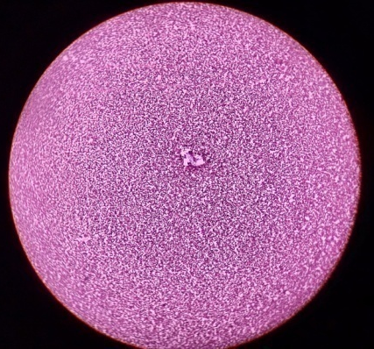 | 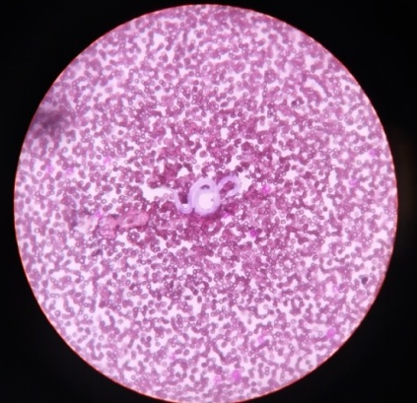 | 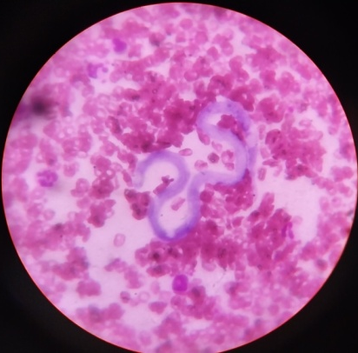
Fig.2. Blood smear stained with Leishman’s stain showing presence of microfilaria under 10x, 40x and 100 x objective lens
The blood parameters (Table 1) offer additional insight into the dog’s condition. The elevated white blood cell count suggests an inflammatory or infectious process, likely related to the heartworm infection. The dog’s red blood cell count (RBC), hemoglobin (Hb), and packed cell volume (PCV) are within normal ranges, indicating no signs of anemia or dehydration (Koenhemsi and Gönül, 2019). The low mean corpuscular volume (MCV) and mean corpuscular hemoglobin (MCH) suggest that the dog may have mild microcytic anemia, which could be associated with ongoing inflammation or a response to the parasitic infection (Ananda and D'Souza, 2006).
Table 1 Complete blood count in normal dogs and dog with dirofilariosis
Parameters | Normal value | Affected animal
WBC(10³/µl) | 6-17 | 17.7
RBC (10⁶/µl) | 5.5-8.5 | 6.08
Hb (g/dl) | 12-18 | 13.0
PCV (%) | 35-57 | 36.8
MCV (fL) | 66-77 | 60.5
MCH (pg) | 21-26 | 21.4
Neutrophils % | 58-88 | 75
Lymphocytes % | 8-21 | 18
Monocytes % | 2-10 | 06
Eosinophils % | 0-9 | 03
The differential leukocyte count, with an increase in neutrophils (75%) and a decrease in eosinophils (3%), is also suggestive of an ongoing systemic inflammatory response, which is common in parasitic infections like heartworm disease. The normal lymphocyte percentage (18%) indicates no obvious immune suppression.

DISCUSSION
The clinical presentation of this 6-year-old male Dachshund, which included urinary retention and a positive diagnosis for Dirofilaria immitis, reveals a complex case requiring multifaceted management. The radiographic finding of urethral calculi in the pelvic urethra is indicative of a urinary tract obstruction, a potentially painful and serious condition. Urethral calculi often result from mineral imbalances, leading to partial or complete blockage of the urinary tract, and require prompt intervention to prevent further complications such as bladder rupture or kidney damage. The dog’s elevated WBC count and abnormal blood parameters suggest a systemic inflammatory response likely associated with the Dirofilaria immitis infection. The concurrent urethral calculi present a separate but urgent concern that requires surgical or medical intervention to resolve the obstruction. Mircean, et.al., (2017) has reported kidney affections in a dog with dirofilariasis.The unusual findings of Sevimli, et. al., (2007) necessitates the need or requirement of parasitological examination with respect to D. immitis in the diagnosis of dogs with tumor or pneumonia.

CONCLUSION
Canine heartworm disease poses significant challenges to both pets and owners. Early detection, appropriate treatment, and preventive measures are essential. Collaboration between veterinarians and pet owners is crucial for successful management. Encourage regular veterinary visits and compliance with preventive medications. Prompt treatment of both the heartworm infection and the urinary obstruction is essential to improve the dog’s prognosis.
COMPETING INTERESTS DISCLAIMER:
Authors have declared that they have no known competing financial interests OR non-financial interests OR personal relationships that could have appeared to influence the work reported in this paper.

REFERENCE
Ananda, K. J., D'souza, P.E. (2006). Haemato-biochemical changes in dogs infected with microfilariasis caused by Dirofilaria repens. Indian Journal of Veterinary Medicine, 26(2),139-140.
Casiraghi, M., Bazzocchi, Chiara, Mortarino, M., Ottina, Eleonora, Genchi, C. (2006). A simple molecular method for discriminating common filarial nematodes of dogs (Canis familiaris). Veterinary Parasitology, 141, 368–372.
Dillon, R. Feline dirofilariasis. Vet Clin North Am Small Anim Pract 1984; 14(6): 1185-1199. http://dx.doi.org/10.1016/S0195-5616(84)50153-3. PMid:6393552
Farzana, P. M., Ambily, V. R., George, A.,Ajithkumar, S., Sreekumar, T. R. and Usha, N. P. (2023). A prospective study on the occurrence and clinical signs associated with different types of microfilariasis in dogs of Kerala. The Pharma Innovation Journal, 12(12), 2036-2040.
Genchi, C, Venco, L.,Genchi, M. (2005) Guideline for the laboratory diagnosis of canine and feline Dirofilaria infections, Mappe Parassitologiche, Ed.Rolando, Italia.
Ilie, M.S., Dărăbuş, Gh. Ciocan, R., Hotea, I., Imre, K., Morariu, S., Mederle, N., Ilie, A., Morar, D. 2009. Dirofilariosis In Dog Case Report. Lucrări Ştiinłifice Medicină Veterinară 13(1), 59 – 63
Jones, S., Graham, W., Von Simson, C., Stannard, R., Carithers, D., Payne, P., et al. 2020 Current feline guidelines for the prevention, diagnosis, and management of heartworm (Dirofilaria immitis) infection in cats [online]. Wilmington: American Heartworm Society https://d3ft8sckhnqim2.cloudfront.net/images/pdf/2020_AHS_Feline_Guidelines.pdf?1580934824
Koenhemsi, L. and Gönül, R. (2019) Determination of renal blood flow with Doppler ultrasound and the hypertension prevalence and acid-base level in dogs with chronic renal failure. J Ist Vet Sci. 3(1), 6-12.
Michalski, M.L., Bain, O., Fischer, K., Fischer, P.U., Kumar, S., Foster, J.M. (2010) Identification and phylogenetic analysis of Dirofilaria ursi (Nematoda: Filarioidea) from Wisconsin black bears (Ursus americanus) and its Wolbachia Endosymbiont. J Parasitol; 96:412–9.
Mircean, M., Ionică A.M., Mircean V., Györke A., Codea A.R., Tăbăran F.A., Taulescu M., Dumitrache M.O. (2017) Clinical and pathological effects of Dirofilaria repens and Dirofilaria immitis in a dog with a natural co-infection. Parasitology International 66(3), 331-334
Philp HS, Farrell KS and Li RHL (2023) Case report: Disseminated intravascular coagulation in a dog following treatment with melarsomine for Dirofilaria immitis. Front. Vet. Sci. 10:1118798. doi: 10.3389/fvets.2023.1118798
Sevimli, F.K., Kozan, E., Bülbül, A., Birdane, F.M., Köse, M. and Sevimli, A. (2007). Dirofilaria immitis infection in dogs: unusually located and unusual findings. Parasitol Res 101, 1487–1494. https://doi.org/10.1007/s00436-007-0665
Soulsby E.J.L. (1982) Helminths, arthropods and protozoa of domesticated animals (7thed.). Bailliere Tindall. London, p 307-312.
Venco L, Marchesotti F, Manzocchi S. (2015) Feline heartworm disease: a ‘Rubik’s-cube-like’ diagnostic and therapeutic challenge. Journal of Veterinary Cardiology. 17(1): S190-S201. http://dx.doi.org/10.1016/j.jvc.2015.08.004. PMid:26776577.

