Case Report
Successful Cutting Balloon Angioplasty In Renal Fibromuscular Dysplasia - A Case Report

Abstract
Fibromuscular dysplasia (FMD) is a rare non-atherosclerotic, non-inflammatory arterial disease that most often affects renal and carotid arteries in young women. This case report describes a 33-year-old female with symptomatic resistant hypertension refractory to multiple medications. An abdominal computed tomographic (CT) angiogram revealed mid to distal right renal artery stenosis with the classic 'string of beads' appearance, diagnostic for fibromuscular dysplasia (FMD). Following a successful percutaneous transluminal right renal angioplasty (PTRA) with cutting balloon without stent placement, the patient's blood pressure significantly improved, allowing for a reduction in medication. This case emphasizes the need for a high index of suspicion for Reno-vascular hypertension in young patients with resistant hypertension, as an early intervention with PTRA can lead to excellent clinical outcomes.
Keywords: fibromuscular dysplasia, resistant hypertension, percutaneous transluminal renal angioplasty, cutting balloon

Introduction
Resistant hypertension is defined as blood pressure that remains above goal despite the use of three or more antihypertensive medications of different classes, including a diuretic. Secondary causes should be investigated, particularly in young patients. Renal fibromuscular dysplasia (FMD), a non-atherosclerotic, non-inflammatory arterial disease, is a leading cause of Reno-vascular hypertension in patients under 50 years of age, predominantly affecting women. This report details the diagnosis and successful endovascular management of a patient with resistant hypertension caused by right renal FMD.
Timeline
Time / Event | Clinical Details
2 years prior | Diagnosis of hypertension; started on triple antihypertensive therapy
Current presentation | Persistent hypertension with headache and dizziness; BP 190/110 mmHg
Initial investigations | Normal labs; ECG showed LVH with ST depression
Echocardiography | Concentric LVH with grade I diastolic dysfunction
CT Angiography | Right renal artery ‘string of beads’ appearance confirming FMD
Intervention | Percutaneous transluminal renal angioplasty (PTRA) with cutting balloon; no stent
1-month follow-up | BP 128/75 mmHg off medications; patent renal artery on Doppler
Case Presentation
A 33-year-old Asian female with no significant past medical history presented with frequent headaches and dizziness. She had hypertension for two years, poorly controlled despite three antihypertensive medications including a diuretic. On examination, her BP was 190/110 mmHg (right arm) and 176/110 mmHg (left arm). No abdominal bruit was heard. Routine blood tests were normal. ECG revealed left ventricular hypertrophy with inferolateral ST depressions. Echocardiography showed concentric LV hypertrophy and grade I diastolic dysfunction. Renal Doppler ultrasound suggested distal right renal artery stenosis. Contrast-enhanced CT angiography confirmed alternating stenosis and dilatation of the right renal artery — the classic ‘string of beads’ appearance of medial fibroplasia. Catheter-based angiography confirmed these findings. DTPA scan showed reduced but preserved right renal function (24.8%).
Intervention
Given her uncontrolled hypertension and angiographic findings, percutaneous transluminal renal angioplasty (PTRA) was performed via the right femoral approach. Using a 6F Judkins right catheter and 0.014'' guidewire, serial balloon dilatations were attempted. The lesion was resistant to standard balloons; hence a 3.5×15 mm cutting balloon was used successfully. No stent was placed as balloon angioplasty alone is preferred for FMD. Post-procedural angiography showed restored flow without complications.
Outcome and Follow-Up
Post-procedure, the patient’s blood pressure improved markedly. She was discharged with home BP monitoring. At one month, her BP was 128/75 mmHg without medications, and follow-up Doppler ultrasound confirmed sustained patency of the renal artery.
Discussion
Fibromuscular dysplasia (FMD) is an underrecognized non-atherosclerotic, non-inflammatory arteriopathy affecting medium-sized arteries, most commonly the renal and carotid arteries (1,2). It typically affects young women and presents with resistant hypertension due to renovascular involvement. The classic “string-of-beads” angiographic pattern, caused by medial fibroplasia, is pathognomonic (1).
Percutaneous transluminal renal angioplasty (PTRA) without stenting remains the first-line revascularization strategy in hemodynamically significant renal FMD, with cure or marked improvement in blood pressure achieved in 60–70% of appropriately selected patients (3–5). Early intervention, unilateral disease, and shorter hypertension duration predict better outcomes (4,6). Cutting-balloon angioplasty is preferred in resistant or non-dilatable lesions and can yield excellent results without requiring stent placement (5,7).
Routine stenting is not advised as it carries risk of restenosis or thrombosis and offers no additional benefit over balloon angioplasty (1,3). Long-term surveillance is essential, as restenosis or new vascular involvement may develop, warranting repeat imaging and blood pressure monitoring (2,6,8).
Our patient, a young woman with unilateral mid-to-distal renal artery FMD, achieved complete normalization of blood pressure following cutting-balloon angioplasty, aligning with contemporary outcomes and management recommendations.
Learning Points
• Fibromuscular dysplasia should be suspected in young patients with resistant hypertension.
• CT angiography is the diagnostic modality of choice; catheter angiography confirms and allows treatment planning.
• PTRA without stenting is the preferred first-line treatment for renal FMD.
• Cutting balloon angioplasty can be effective in resistant lesions.
• Regular follow-up is required to detect restenosis or involvement of other vascular beds
Data Availability
All relevant data supporting the findings of this case are included within the article.
Figure Legends
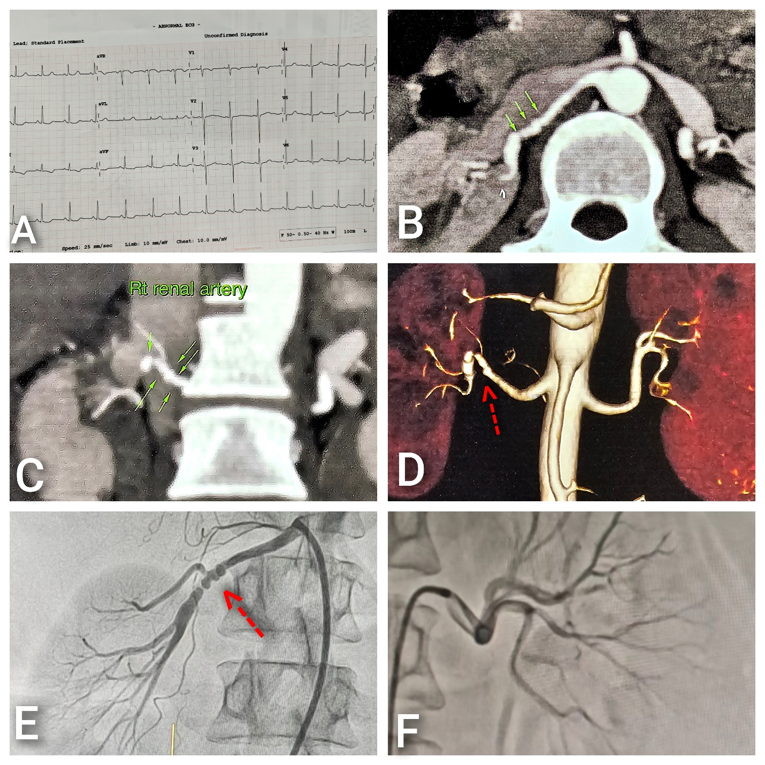

Figure 1(A) ECG showing LVH with strain;(B,C&D) CT angiography-“strings of beads” appearance of right renal artery; (E&F)Selective renal angiography-multifocal stenosis in right renal artery and normal left renal artery.

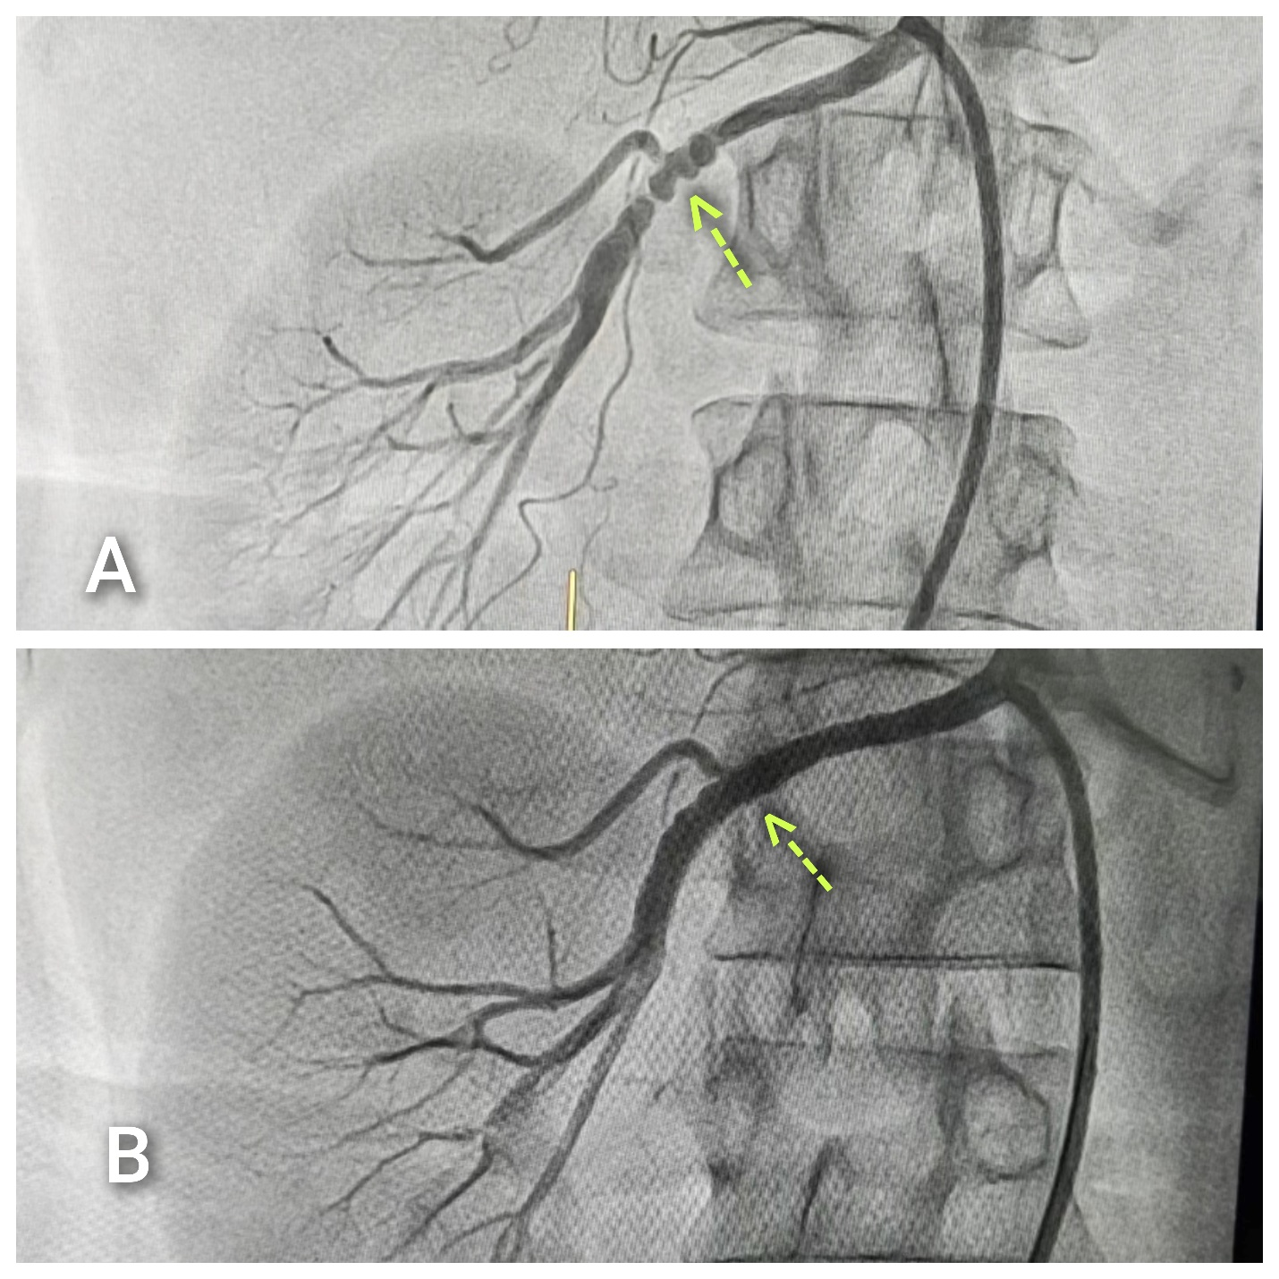
Figure 2 (A&B) Showing restored blood flow after successful balloon angioplasty

References
1. Gornik HL, Persu A, Adlam D, Aparicio LS, Azizi M, Boulanger M, Bruno RM, de Leeuw P, Fendrikova-Mahlay N, Froehlich J, Ganesh SK, Gray BH, Jamison C, Januszewicz A, Jeunemaitre X, Kadian-Dodov D, Kim ES, Kovacic JC, Mace P, Morganti A, Sharma A, Southerland AM, Touzé E, van der Niepen P, Wang J, Weinberg I, Wilson S, Olin JW, Plouin PF. First International Consensus on the diagnosis and management of fibromuscular dysplasia. Vasc Med. 2019 Apr;24(2):164-189. doi: 10.1177/1358863X18821816. Epub 2019 Jan 16. Erratum in: Vasc Med. 2019 Oct;24(5):475. doi: 10.1177/1358863X19865703. Erratum in: Vasc Med. 2021 Aug;26(4):NP1. doi: 10.1177/1358863X211035538. PMID: 30648921.
2. Olin JW, Gornik HL, Bacharach JM, Biller J, Fine LJ, Gray BH, Gray WA, Gupta R, Hamburg NM, Katzen BT, Lookstein RA, Lumsden AB, Newburger JW, Rundek T, Sperati CJ, Stanley JC; American Heart Association Council on Peripheral Vascular Disease; American Heart Association Council on Clinical Cardiology; American Heart Association Council on Cardiopulmonary, Critical Care, Perioperative and Resuscitation; American Heart Association Council on Cardiovascular Disease in the Young; American Heart Association Council on Cardiovascular Radiology and Intervention; American Heart Association Council on Epidemiology and Prevention; American Heart Association Council on Functional Genomics and Translational Biology; American Heart Association Council for High Blood Pressure Research; American Heart Association Council on the Kidney in Cardiovascular Disease; American Heart Association Stroke Council. Fibromuscular dysplasia: state of the science and critical unanswered questions: a scientific statement from the American Heart Association. Circulation. 2014 Mar 4;129(9):1048-78. doi: 10.1161/01.cir.0000442577.96802.8c. Epub 2014 Feb 18. PMID: 24548843.
3. Lu YT, Zhou ZM, Zhang D, Sun L, Liu XC, Yang YK, Jiang XJ, Zhou XL. Percutaneous Transluminal Renal Angioplasty for Fibromuscular Dysplasia and Prognostic Risk Factors: A Retrospective Chinese Cohort Study. J Clin Med. 2022 Dec 20;12(1):23. doi: 10.3390/jcm12010023. PMID: 36614824; PMCID: PMC9821653..
4. Plouin PF, Baguet JP, Thony F, Ormezzano O, Azarine A, Silhol F, Oppenheim C, Bouhanick B, Boyer L, Persu A, Hammer F, Gosse P, Mounier-Vehier C, Le Hello C, Jeunemaitre X, Azizi M, Amar L, Chatellier G, Mousseaux E, Touzé E; ARCADIA Investigators. High Prevalence of Multiple Arterial Bed Lesions in Patients With Fibromuscular Dysplasia: The ARCADIA Registry (Assessment of Renal and Cervical Artery Dysplasia). Hypertension. 2017 Sep;70(3):652-658. doi: 10.1161/HYPERTENSIONAHA.117.09539. Epub 2017 Jul 17. PMID: 28716989.
5. Slovut DP, Olin JW. Fibromuscular Dysplasia. Curr Treat Options Cardiovasc Med. 2005 Jun;7(2):159-169. doi: 10.1007/s11936-005-0017-z. PMID: 15935124..
6. Persu A, Dobrowolski P, Gornik HL, Olin JW, Adlam D, Azizi M, Boutouyrie P, Bruno RM, Boulanger M, Demoulin JB, Ganesh SK, J Guzik T, Januszewicz M, Kovacic JC, Kruk M, de Leeuw P, Loeys BL, Pappaccogli M, Perik MHAM, Touzé E, Van der Niepen P, Van Twist DJL, Warchoł-Celińska E, Prejbisz A, Januszewicz A. Current progress in clinical, molecular, and genetic aspects of adult fibromuscular dysplasia. Cardiovasc Res. 2022 Jan 7;118(1):65-83. doi: 10.1093/cvr/cvab086. PMID: 33739371; PMCID: PMC8752362.
7. Youssef S, Gill AE, Shah JH, et al. Mid-to-long term outcomes following renal artery angioplasty in children and young adults with renal artery stenosis: a retrospective review. Pediatric Nephrology (Berlin, Germany). 2025 Aug;40(8):2589-2597. DOI: 10.1007/s00467-025-06727-z. PMID: 40164847; PMCID: PMC12187876.
8. Gavalas MV, Gasparis AP, Tassiopoulos AK, Loh S, Labropoulos N. Long-term follow-up for percutaneous transluminal angioplasty in renal artery fibromuscular dysplasia. Int Angiol. 2015 Dec;34(6):529-37. Epub 2014 May 13. PMID: 24824840.

