Original Research Article
Soil nutrients distribution in Arid agriculture soils of selected taluks of Koppal district, Karnataka

ABSTRACT
This study assessed the fertility status of soils from three representative taluks of Koppal district, Karnataka, using descriptive statistics, nutrient index, and correlation analysis of key soil properties. 20 surface soil samples (0-30 cm depth) were collected from fields in Kushtagi, Kanakagiri, and Gangavathi taluks and analyzed for pH, EC, organic carbon, available N, P, K, S, exchangeable Ca & Mg, and micronutrients- Cu, Zn, Mn, and Fe. Soil pH and EC indicated neutral to alkaline and non-saline soils, with low OC levels. Nutrient index (N.I) values indicated low fertility in OC, N, P, and K; medium fertility in Ca, Mg, Zn, and Fe; and high status for S, Cu, and Mn. Correlation analysis revealed the strong positive relationships with several secondary and micronutrients and some negative correlations of Mn with pH and OC. The results highlight organic carbon, N, P, and K as primary constraints in those taluks and underline the need for management practices for the nutrient deficiencies.

Keywords: Koppal district, soil fertility, nutrient index, macronutrients, micronutrients
- INTRODUCTION
Soil is widely recognized as a vital natural resource that underpins agricultural productivity and terrestrial ecosystems. It supports key biogeochemical processes such as organic matter decomposition, nutrient cycling and carbon sequestration, which in turn sustain soil fertility, crop yields and climate regulation [4]. Through its physical chemical and biological properties, soil delivers multiple ecosystem services including food and fibre production, water filtration and storage, erosion control and greenhouse gas mitigation, making soil health central to sustainable land management and human well-being [10, 14]. Soil fertility is an essential aspect that controls agricultural viability since the accessibility of vital supplements ensures not only plant growth and crop yield but also sustainable long-term soil health. Moreover, statistical methods like descriptive statistics, nutrient index analysis, and correlation studies also assist in understanding the variation in nutrients along with both positive and negative interactions between various soil properties. Hence, the systematic assessment of soil fertility is critical for enhancing nutrient management strategies and sustaining agricultural productivity in varied agro-ecological regions.

Recent studies indicate that the nutrient dynamics and soil fertility of agricultural ecosystems are intricately governed by the physicochemical properties of the soil. Soil pH was recognized as a pivotal factor influencing nutrient solubility, microbial activity, and plant nutrient uptake [8]. Recent assessments of cultivated soils in India have revealed substantial deficiencies in major nutrients such as nitrogen and phosphorus, underscoring the importance of regular soil fertility evaluations to promote sustainable crop production. Cutting-edge methods such as nutrient index approaches and statistical analyses are increasingly being utilized to assess soil fertility levels and map the spatial distribution of soil nutrients within agricultural landscapes [1]. These investigations furnish crucial foundational information on soil nutrient availability, thereby aiding in making site-specific agronomic decisions that pertain to soil health and agricultural sustainability. The present study was undertaken to evaluate the fertility status of surface soils in three representative taluks of Koppal district to characterize the basic physico-chemical properties and available macro- and micronutrients of soils; to compute nutrient index values and examine the relationships among soil properties to identify factors influencing nutrient availability.

- MATERIAL AND METHODS
2.1 Study area
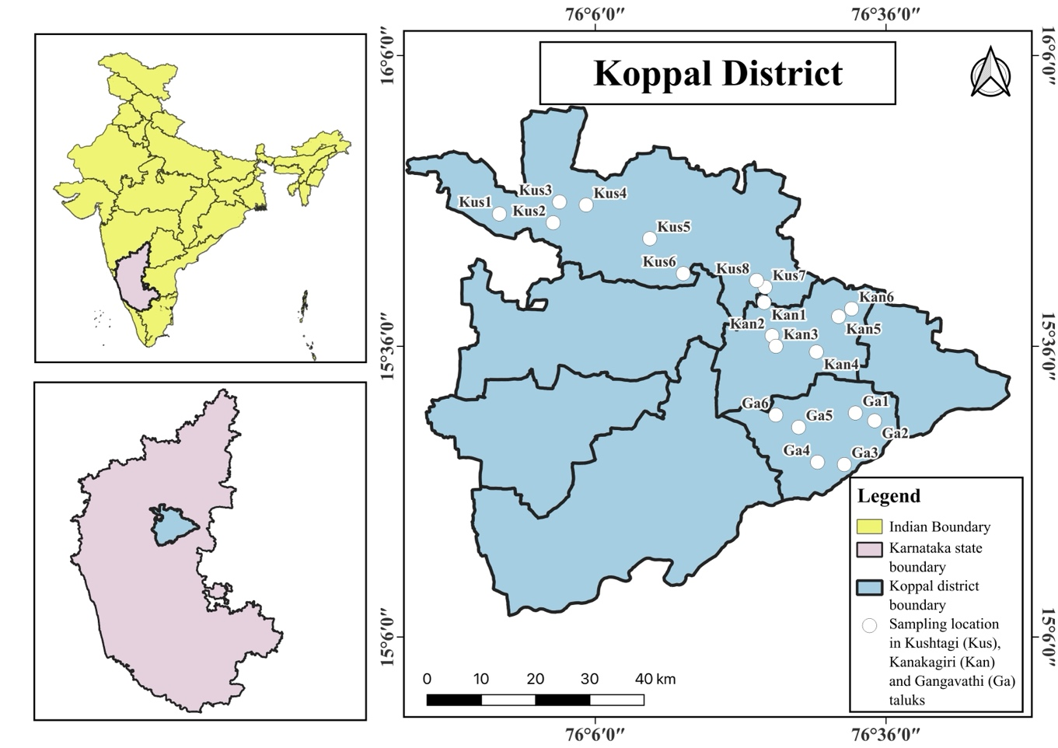
Fig. 1. Study area map of Koppal district
Koppal district lies in the northern dry zone of Karnataka and experiences an arid climate with hot summers, with an annual rainfall of 598 mm, with its frequent dry spells, with its rocky terrain on one side and acres of dry land on the other. Three taluks of Kushtagi, Kanakagiri, and Gangavathi were selected to represent important farming situations in the district. From these taluks, 8 samples were collected from Kushtagi, 6 from Kanakagiri, and 6 from Gangavathi.
2.2 Soil sampling and analysis
From the 3 regions, a total of 20 surface soil samples were gathered from farmers' fields at a depth of 0-30 cm. Subsequently, the samples were air-dried, gently crushed, and sieved through a 2 mm mesh before undergoing analysis. Soil pH and electrical conductivity (EC) were determined in water using a soil-to-solution ratio of 1:2.5 (Jackson, 1973) [5]. Soil organic carbon was measured using the volumetric method as described by Walkley and Black [16]. Available nitrogen was determined by the alkaline potassium permanganate method developed by Subbaiah and Asija [15], while available phosphorus was measured using both Bray’s [2] and Olsen’s [9] methods suitable for acidic and alkaline soils, respectively. Available potassium was quantified through the flame photometric method outlined by Jackson [5]. Exchangeable calcium and magnesium levels were determined through a neutral ammonium acetate extraction procedure [5]. Available sulphur content was measured using the turbidimetric method [3]. Lastly, soil micronutrients were extracted using DTPA and analyzed via atomic absorption spectrometry [6].

2.3 Nutrient Index
The nutrient status considers the availability of nutrients in soil. To compare the levels of soil fertility of one area with another, a single value can be obtained through the nutrient index. For each nutrient, soil test values were grouped into low, medium, and high classes using standard rating limits. The nutrient index in soil was evaluated for the soil samples analyzed using the formula [7].

Nutrient Index (N.I) = (NL × 1 + NM × 2 + NH × 3) / NT

where NL indicates the number of samples falling in the low class of nutrient status; NM indicates the number of samples falling in the medium class of nutrient status; NH indicates the number of samples falling in the high class of nutrient status; and NT indicates the total number of samples analyzed for a given area. Later the obtained results were interpreted by comparing with rating chart given in Table 1.
Table 1. Nutrient Index with range and remarks
Nutrient index | Range | Remarks
I | <1.67 | Low
II | 1.67-2.33 | Medium
III | >2.33 | High

2.4 Statistical analysis
For all soil properties, minimum, maximum, and mean were calculated. Pearson correlation coefficients were computed to examine relationships among soil parameters. A correlation heatmap was generated using R software, with cell colors indicating the magnitude and sign of r and significance levels denoted by "ns" (not significant), * for P = .05, ** for P = .01, and *** for P < 0.001.

- RESULTS AND DISCUSSION
The results of physico-chemical properties, macronutrients, and micronutrients of soil samples from three different taluks of Koppal district are given in Table 2.

Basic soil properties and macronutrient status
Soil pH in the selected taluks ranged from 6.16 to 9.58, with a mean of 7.8, indicating a predominantly neutral to moderately alkaline category in the surface soil. Higher pH is a result of the region's arid climate, reduced leaching, and a tendency for base cation accumulation [17], which fits with Koppal soil as it reflects calcareous parent material. Electrical conductivity varied between 0.04 to 0.59 dS m⁻¹, with an average of 0.22 dS m⁻¹, indicating that salinity is not a major constraint in the sampled fields. Organic carbon ranged from 0.32 to 0.75% with a mean of 0.5%, reflecting low to medium levels of organic carbon, where rainfall and incorporation of residue management increased soil organic matter accumulation [11].

Available N ranged from 115 to 346 kg/ha, with a mean of 255 kg/ha, placing many samples in the low to medium range relative to critical limits. Available phosphorus ranged from 0.33 to 6.87 kg/ha, with a mean of 1.67 kg/ha, where all the samples indicated a low range; meanwhile, its deficiency leads to low crop production [13]. Available potassium showed variability, where the ranges fell in all low, medium, and high ranges, from 32.8 to 368 kg/ha, with a mean of 93.74 kg/ha.

Secondary and micronutrient status
Exchangeable calcium and magnesium with an average of 2.8 and 0.71 cmol(p+)/kg⁻¹, and most of the samples fell in the medium range. Available sulphur ranged from 15.38 to 451 mg kg⁻¹ with a mean value of 66.7 mg kg⁻¹, which fell in the medium to high class. Micronutrient concentrations also exhibited various wide ranges: Cu (0.37-4.07, mean 1.5 mg kg⁻¹), Zn (0.2-8.04, mean 1.6 mg kg⁻¹), Mn (5.86-55.1, mean 21.8 mg kg⁻¹), and Fe (0.11-43.6, mean 9.48 mg kg⁻¹). Overall the micronutrients were sufficient with respect to critical limits.

Nutrient index and fertility class
Nutrient index values provide the fertility status across the sample locations. OC, N, P, and K show low fertility class with 1.55, 1.3, 1, and 1.2 values, respectively. This indicates the inadequate organic matter and macronutrients being the constraints in Kushtagi, Kanakagiri, and Gangavathi taluks. Calcium and magnesium, with the nutrient index values of 2 and 1.7, showed a medium fertility class. Sulphur, copper, and manganese exhibited high NI values of 2.7, 3, and 3, respectively, indicating sufficient availability of these nutrients. Zinc and iron exhibited a medium fertility class with the values of 2.25 and 1.8 of the nutrient index (Table 3). These results show that while secondary and micronutrients are sufficient, the deficiency of major macronutrients highlights the importance of balanced fertilization and organic matter management.
Table 2. Statistics of physico-chemical properties of soils from Koppal district
Parameters | Minimum | Maximum | Mean
pH | 6.16 | 9.58 | 7.8
EC (dS m⁻¹) | 0.04 | 0.59 | 0.22
Organic Carbon (%) | 0.32 | 0.75 | 0.5
Available and exchangeable macronutrients
Available. Nitrogen (kg/ha) | 115 | 346 | 255
Available Phosphorus (kg/ha) | 0.33 | 6.87 | 1.67
Available Potassium (kg/ha) | 32.8 | 368 | 93.74
Exchangeable calcium [cmol(p⁺)/kg] | 2.02 | 3.86 | 2.79
Exchangeable magnesium [cmol(p⁺)/kg] | 0.2 | 1.67 | 0.71
Available Sulphur (mg/kg) | 15.38 | 451 | 66.72
DTPA extractable micronutrients
Cu (mg/kg) | 0.37 | 4.07 | 1.5
Zn (mg/kg) | 0.2 | 8.04 | 1.6
Mn (mg/kg) | 5.86 | 55.1 | 21.75
Fe (mg/kg) | 0.11 | 43.6 | 9.48

Table 3. Soil nutrient index values of different taluks in Koppal district
Sl No | Available nutrients | Nutrient Index | Category
1 | Organic Carbon | 1.55 | Low
2 | Nitrogen | 1.3 | Low
3 | Phosphorus | 1 | Low
4 | Potassium | 1.2 | Low
5 | Calcium | 2 | Medium
6 | Magnesium | 1.7 | Medium
7 | Sulphur | 2.7 | High
8 | Copper | 3 | High
9 | Zinc | 2.25 | Medium
10 | Manganese | 3 | High
11 | Iron | 1.8 | Medium

Correlation relationships among soil properties
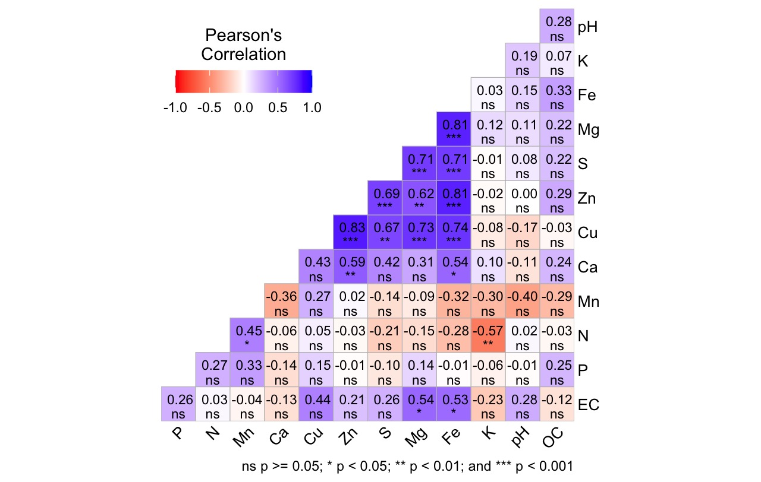
Fig. 2. Pearson Correlation heat map of soil properties in selected
taluks in Koppal district

Soil pH showed only weak relationships with most nutrients, while some positive correlation with EC and OC was found (r = 0.28), suggesting that slightly higher pH tends to have some increase in salinity and organic matter, along with a negative correlation with Mn (r = -0.4). Soil organic carbon exhibited positive correlations with Zn (r = 0.29) and Fe (r = 0.33), indicating the fields with higher OC have improved availability of these micronutrients. Available nitrogen showed a strong negative correlation with K (r = -0.57, P = .01), suggesting that higher potassium may reduce nitrogen availability, and some moderate positive relationship with Mn (r = 0.45, P = .05). Available phosphorus showed a positive relationship only with Mn (r = 0.33), while potassium showed weak relationships with all other soil properties. Calcium showed positive relationships with Fe (r = 0.54, P = .05), Mg (r = 0.31), S (r = 0.42), Zn (r = 0.59, P = .01), and Cu (r = 0.43), while magnesium showed very strong positive correlations with EC (r = 0.54, P = .05), Cu (r = 0.73, P < 0.001), Zn (r = 0.62, P = .01), S (r = 0.71, P < 0.001), and Fe (r = 0.81, P < 0.001). Sulphur had a strong positive correlation with Cu (r = 0.67, P = .01) and Zn (r = 0.69, P < 0.001), while copper had a very strong positive relation with Zn (r = 0.83, P < 0.001), and along with zinc, it has a very high correlation with Fe (r = 0.74, P < 0.001) & (r = 0.81, P < 0.001). Overall, the correlation analysis indicates complex interactions among soil nutrients, influenced by soil chemical processes, mineral composition, and nutrient cycling processes.

- CONCLUSION
Soils from Kushtagi, Kanakagiri, and Gangavathi taluks of the Koppal district are neutral to moderately alkaline and non-saline, with low to medium levels of organic carbon. Macronutrients showed their deficiency in most of the samples. Calcium and magnesium were sufficient, while other macronutrients were mostly adequate to high. Correlation analysis highlighted positive relationships with secondary macronutrients and micronutrients, while organic carbon shows its importance through which it enhances some micronutrients, whereas higher pH may limit Mn. Based on these observations, sustainable crop production can be achieved with proper management techniques like additions of organic manures and crop residues, along with balanced fertilization focusing on NPK.

REFERENCES
- Ahamad, A., Gupta, A. K., & Kumar, D. (2021). Soil fertility evaluation using nutrient index approach. Journal of Krishi Vigyan, 10(1), 276-282.
- Bray, R. H. & Kurtz, L. T. (1945). Determination of total organic and available forms of phosphorus in soils. Soil science, 59(1), 39 - 46.
- Chesnin, L. & C. H. Yien. (1951). Turbidimetric determination of available sulphur. Soil Science Society of American, Proceedings. 15, 149 - 151.
- Ghimirey, V., Chaurasia, J., & Acharya, N. (2025). Understanding soil carbon sequestration: mechanistic insights, management approaches, and future challenges. Discover Soil, 2(1), 101.
- Jackson, M. L. (1973). Soil Chemical Analysis. Prentice Hall of India Pvt. Ltd., New Delhi.
- Lindsay, W. L. & Norvell, W. A. (1978). Development of a DTPA soil test for zinc, iron, manganese and copper. Soil Science Society of America Journal, 42: 421-428.
- Muhr, G.R., Datta, N.P., Sankarasubramoney, H., Laley, V.K., & Donahue, R.L. (1965). Critical soil test values for available N, P and K in different soils. In Soil Testing in India (2 nd Edition), USAID mission to India, New Delhi. 52-56.
- Neina, D. (2019). The role of soil pH in plant nutrition and soil remediation. Applied and environmental soil science, 2019(1), 5794869.
- Olsen, S.R., Cole, C.V., Watanabe, F.S and Dean, L.A. (1954). Estimation of available phosphorus in soils by extraction with sodium bicarbonate. USDA. Circular no. 939.
- Pereira, P., Bogunovic, I., Muñoz-Rojas, M., & Brevik, E. C. (2018). Soil ecosystem services, sustainability, valuation and management. Current Opinion in Environmental Science & Health, 5, 7-13.
- Prabhavati, K., Dasog, D. S., Patil, P. L., Sahrawat, K. L., & Wani, S. P. (2015). Soil fertility mapping using GIS in three agro-climatic zones of Belgaum district, Karnataka. Journal of the Indian Society of Soil Science, 63(2), 173-180.
- Ramamurthy, B & Bajaj, J.C. (1969). Available N, P and K status of Indian soils. Fertilizer News, 14(8), 25-37.
- Singh, G., Sharma, M., Manan, J., & Singh, G. (2016). Assessment of Soil Fertility Status under Different Cropping Sequences in District Kapurthala. Journal of Krishi Vigyan, 5(1), 1- 9.
- Smith, P., Ashmore, M. R., Black, H. I., Burgess, P. J., Evans, C. D., Quine, T. A., Thomson, A, M., Hicks, K., & Orr, H. G. (2013). The role of ecosystems and their management in regulating climate, and soil, water and air quality. Journal of Applied Ecology, 50(4), 812-829.
- Subbaiah, B. U., & Asija, G. L. (1956). Rapid procedure for the estimation of the available nitrogen in soil. Current Science, 25, 259-260.
- Walkley, A & Black, C.A. (1934). Estimation of organic carbon by chromic acid titration method. Soil Science. 37, 29-38.
- Zhang, S., Zhu, Q., de Vries, W., Ros, G. H., Chen, X., Muneer, M. A.,Zhang, F., & Wu, L. (2023). Effects of soil amendments on soil acidity and crop yields in acidic soils: A world-wide meta-analysis. Journal of Environmental Management, 345, 118531.

