Assessment of Intra-Urban Logistics Constraints and Delivery Timeliness among Market-Based Suppliers in Lagos, Nigeria

.
ABSTRACT

Aims: High freight demand, congestion, and poor delivery infrastructure have continued to strain intra-urban logistics operations in Lagos, but market-based suppliers continue to experience chronic delays and unreliable delivery performance in key distribution centers. Thus, this paper evaluated the impact of intra-urban logistics bottlenecks on the timeliness of deliveries among market-based suppliers in Mile 12 Community, Kosofe LGA, Lagos State, Nigeria.
Study design: Quantitative survey design.
Place and Duration of Study: Mile 12 Community, Kosofe LGA, Lagos State, Nigeria April 2025 and November 2025.
Methodology: Data was sourced from primary source using structured questionnaires, distributed to 377 respondents. Traffic Congestion Constraint (TCC), Loading and Curbside Infrastructure Constraint (LCIC), Regulatory and Access Restriction Constraint (RARC), and Network Fragmentation and ICT Constraint (NFIC) were measured as predictors, and Delivery Timeliness (DT) was the dependent variable. Exploratory Factor Analysis (EFA), Confirmatory Factor Analysis (CFA), and Structural Equation Modelling (SEM) were used to analyse data.
Results: The SEM model was found to fit well (CMIN/DF = 1.268; GFI = 0.911; CFI = 0.981; TLI = 0.979; RMSEA = 0.030), which validated the sufficiency of the measurement and structural model. Results show that all constraints have a significant impact on timeliness of delivery: LCIC (beta = 0.307, p < 0.001) was the most significant predictor, then NFIC (beta = 0.285, p < 0.001), TCC (beta = 0.243, p < 0.001), and RARC (beta = 0.186, p < 0.001).
Conclusion: The research finds that infrastructural bottlenecks, coordination and ICT constraints, exposure to congestion, and regulatory constraints are joint determinants of delivery timeliness in Mile 12. It is recommended that loading and offloading zones should be established and applied around Mile 12 market to minimize loading delays and enhance delivery timeliness.

Keywords: intra-urban logistics; delivery timeliness; last-mile delivery; Mile 12 market; structural equation modelling

1. INTRODUCTION

The last mile logistics is viewed as the most costly, complex, and inefficient logistics process in the supply chain, but it is also the main point of interaction between the supplier and the end customer and therefore the secret to service quality and competitiveness (Bosona, 2020; Silva et al., 2023; Cárdenas et al., 2017). The rise in online and omni-channel retail, together with the growing needs of fast and accurate delivery, has put additional pressure on the intra-urban logistics system and made visible the structural limitations that affect timely and reliable distribution (Lozzi et al., 2022; Allen et al., 2017). A combination of physical, regulatory, and organizational factors affects intra-urban logistics. Freight vehicle circulation and parking are affected by high population density, traffic congestion, unavailability of curb space and loading facilities, and competing pedestrian and public transport uses of street space, which increase travel times and delivery route variability (Bosona, 2020; Allen et al., 2017; Muriel et al., 2022). In most cities, loading facilities have been reduced in size or converted to other uses, and access competition has increased, resulting in longer cruising and walking times and increased congestion and safety problems (Muriel et al., 2022). At the same time, time-window restrictions and other access controls in central or affluent neighborhoods reduce the flexibility of delivery schedules and routes, and it becomes difficult for carriers to meet the promised delivery times (Navarro et al., 2021; Allen et al., 2017). Infrastructure, security, and lack of formal addresses in low-income or peripheral areas are other but equally important factors that constitute barriers to access and reliability of delivery (Navarro et al., 2021).
These contextual factors interact with the characteristics of urban freight networks. Urban supply chains are typically fragmented, with many small and independent actors with small resources and IT systems, making it difficult to aggregate flows, optimize routes, and coordinate infrastructure use effectively (Bosona, 2020; Dreischerf & Buijs, 2022; Cárdenas et al., 2017). Suppliers in the market, such as fast-moving consumer goods (FMCG) companies, small retailers, and online shopping platforms, are increasingly reliant on time-sensitive value propositions (same-day, next-day, or time-window deliveries), capitalizing on the speed and reliability of deliveries as a key differentiator (Kervenoael et al., 2020; Allen et al., 2017; Zamal et al., 2025). However, the failure to honor these commitments in the presence of challenging intra-urban environments could lead to inefficient use of vehicles, unnecessary mileage, and rising logistics costs, and any degradation of delivery speed and reliability will directly impact the responsiveness of supply chains and business performance (Al-Shboul, 2022; Allen et al., 2017; Zamal et al., 2025).
A wide range of technological, operational, and organizational solutions to these issues has been proposed by research. Optimization, simulation, and machine learning-based data-driven decision support systems have been shown to optimize fleet size, maximize capacity utilization, and meet delivery deadlines in highly congested megacities (Gutiérrez-Franco et al., 2021; Giuffrida et al., 2022). Other network configurations such as urban consolidation centers, collection and delivery points, micro-hubs, and metro-integrated delivery networks can optimize vehicle kilometers and delivery times if properly designed and organized (Zheng et al., 2021; Lozzi et al., 2022; Dreischerf & Buijs, 2022; Heeswijk et al., 2020; Liu et al., 2022). However, empirical studies have shown that none of these solutions have been found to necessarily result in lower logistics costs or improved supplier service, and that they often fail to be economically viable and fail when the network design, IT integration, or value proposition for users are not strong (Dreischerf & Buijs, 2022; Vural and Aktepe, 2021; Heeswijk et al., 2020; Silva et al., 2023).
Despite the growing body of literature on urban freight and last-mile logistics, there is a lack of empirical research on the interaction of individual intra-urban logistics variables such as congestion, infrastructure, regulatory policies, availability of loading zones, information systems, and network fragmentation, and their impact on the perceived timeliness of delivery for market-based suppliers. The existing body of literature is more focused on individual solutions, simulation models, or policy approaches, and less on how these are systematically assessed in different urban environments and how they impact the speed of delivery to suppliers operating in competitive and market-driven environments (Gutiérrez-Franco et al., 2021; Bosona, 2020; Navarro et al., 2021; Allen et al., 2017; Silva et al., 2023; Cárdenas et al., 2017). This study bridges this gap by assessing intra-urban logistics bottlenecks and their impact on timeliness of delivery to market-based suppliers in Mile 12 Community, Kosofe LGA, Lagos State, South-West Nigeria.
2. LITERATURE REVIEW
The forces of e-commerce, traffic, regulatory constraints, and growing demands for fast and reliable delivery are building up on urban freight distribution. The literature highlights the cumulative effect of these forces on logistics constraints and delivery speed to market-oriented suppliers (retailers, FMCG suppliers, platforms, and independent contractors).
2.1 Intra-Urban Logistics Constraints
The first category of constraints is based on urban, traffic, and infrastructure characteristics. High commercial centers, narrow curb width, and traffic congestion increase travel times and route reliability, especially in developing countries’ megacities (Gutiérrez-Franco et al., 2021; Navarro et al., 2021). Low-income areas lack infrastructure and safe zones for delivery and vehicle entry, while high-income areas have strict time window and vehicle regulations that make delivery operations difficult (Navarro et al., 2021). Other constraints for informal settlements include lack of formal addresses, limited local data, difficult topography, and security issues, which could shut them out of the logistics system (Pereira et al., 2025).
The second category of constraints is based on network design and fragmentation. Small and independent players form many intra-urban supply chains that lack the capacity to organize fragmented flows, resulting in redundant delivery routes and low load factors (Heeswijk et al., 2020; Zunder, 2021). Urban Consolidation Centers (UCCs) and city hubs are encouraged to consolidate freight and reduce vehicle-kilometers, but empirical research indicates that UCCs often require subsidies, may not reduce short-term logistics costs for suppliers, and may require renegotiation of service level agreements (Heeswijk et al., 2020; Dreischerf & Buijs, 2022; Iswari et al., 2023). Multi-echelon network designs and city hubs have the potential to reduce distance and number of trips, but their benefits are highly sensitive to the number of suppliers and retailers involved and replenishment strategies (Iswari et al., 2023).
Third, time-window policies and regulation are critical. Time-window policies in central areas restrict the time of entry or unloading of vehicles, which directly affects routing flexibility and can increase costs and failed deliveries (Navarro et al., 2021). GPS modeling of delivery time-period choice shows that the distance, volume, and destination factors of shipments influence the time of delivery, suggesting that policy levers such as congestion pricing or off-hour delivery must be scaled to spatial heterogeneity in demand and travel times (Kodera et al., 2025).
Fourth, performance is limited by organizational and data factors. Lack of trusted local knowledge, fragmented IT infrastructure, and poor use of data-driven decision support tools hinder dynamic routing and capacity allocation (Gutiérrez-Franco et al., 2021; Pereira et al., 2025). Data- and model-driven decision support systems have been shown in Bogota to integrate optimization, machine learning, and simulation to minimize fleet size, maximize capacity use, and still meet delivery windows in extreme congestion, but integrated approaches are rare in emerging economies (Gutiérrez-Franco et al., 2021).
2.2 Delivery Timeliness and Service Performance
Urban e-grocery logistics with time-based marketing commitments (e.g., one-hour delivery) are subject to extreme time pressure but can also inspire independent delivery contractors to be innovative, leverage technology, and dynamically change routes in real-time, which can help to achieve timeliness and add sustainable logistics value to last-mile delivery (Kervenoael et al., 2020). Conversely, more stringent package delivery deadlines and same-day delivery requirements in two-echelon systems may raise operating costs by a substantial amount; in one study, more stringent delivery deadlines increased operating costs by about 8.5% compared to more flexible next-day delivery systems in a two-echelon routing environment (Zamal et al., 2025).
Simulation studies suggest that dynamic routing and resource allocation are critical to realizing the service times in a complex urban environment. Last-mile delivery models, such as cargo-bikes, freelancers, and micro-hubs, are agent-based microsimulation models that demonstrate the importance of consolidation strategies and having sufficient active vehicles in the network to ensure timely deliveries and minimize distance and emissions (Heeswijk et al., 2020; Fikar et al., 2018; Gómez-Marin et al., 2024). The application of discrete-event simulation to on-demand food delivery in an emerging market environment also suggests that integrated models can improve delivery times by over 50 percent and improve throughput when courier allocation and clustering are optimized (Utkurova & Djumanov, 2025).
From the perspective of network design, restructuring intra-city express networks (for example, from three to two levels) and optimizing the location of transshipment nodes can achieve the minimum total cost and average delivery time; a case study in Chengdu has achieved an 18.4% reduction in cost and a 6-hour reduction in average delivery time by optimizing the location of central transshipment nodes through multi-criteria and integer programming (Liu et al., 2022). Another new approach is metro-integrated logistics systems that use underutilized metro capacity and metro-based hubs. Studies in Shanghai, Beijing, and Nanjing have shown that metro-based hubs and metro-truck routing can reduce delivery time and cost and mitigate surface traffic congestion, provided that capacity constraints and customer time windows are properly considered (Zhao et al., 2018; Bai et al., 2025; Zheng et al., 2021).
2.3 Market-Based Suppliers and Actor Perspectives
For market-based suppliers, such as FMCG manufacturers, small retailers, and e-commerce companies, the urban logistics constraints and timeliness requirements are formulated as trade-offs between cost, service level, and risk. Studies on FMCG deliveries to small retailers in the city of São Paulo have found that there are distinct challenges for different income levels: in high-income areas, time-window management and neighborhood infrastructure hinder on-time delivery, and in low-income areas, security and infrastructure are the most significant barriers (Navarro et al., 2021). UCC suppliers may not immediately realize cost savings and will have to adjust their delivery schedules and contracts with customers to maintain or regain timeliness objectives (Dreischerf & Buijs, 2022).
Independent contractors and freelancers, who are increasingly becoming the focal point of platform-based distribution models, are both empowered and precarious. Time guarantees and digital platforms in the Singaporean e-grocery last-mile delivery agency independent drivers to test new practices and propose logistical innovations, which means that human agency and micro-level adaptation are the key to ensuring timeliness in delivery under urban constraints (Kervenoael et al., 2020). Multi-agent microsimulation-based collaborative and coordinated frameworks between carriers can also improve service levels and reduce vehicle-kilometres through customer request redistribution and capacity sharing, but they require governance structures and trust among market participants (Gómez-Marín et al., 2024).
2.4 Synthesis and Gaps
In general, the literature shows that intra-urban logistics factors, such as urban morphology, congestion, regulation, data limitations, and fragmented actor networks, have a significant impact on the timeliness of deliveries to market-based suppliers (Gutiérrez-Franco et al., 2021; Heeswijk et al., 2020; Navarro et al., 2021; Pereira et al., 2025; Dreischerf & Buijs, 2022). Timeliness and cost savings can be improved by technically advanced solutions (dynamic VRP, two-echelon routing, metro-based hubs, data-driven decision support systems), but their performance is highly context-dependent and are not usually evaluated in large-scale comparative studies (Gutiérrez-Franco et al., 2021; Liu et al., 2022; Bai et al., 2025; Fikar et al., 2018; Zheng et al., 2021; Iswari et al., Therefore, the following research gaps remain: (i) systematic, receiver- and supplier-based studies of inbound and outbound flows across market segments (Navarro et al., 2021; Zunder, 2021); (ii) longitudinal empirical evaluations of UCCs, metro-hubs, and collaborative frameworks on timeliness and equity of service (Heeswijk et al., 2020; Pereira et al., 2025); and (iii) lived experience of informal, independent, and base-of- The research gaps would be filled to improve knowledge on how to develop intra-urban logistics systems that are timely and inclusive to various market-based suppliers.
2.5 Conceptual Framework
The conceptual framework of this study is shown in Figure 1. The framework identifies Traffic Congestion Constraint (TCC), Loading and Curbside Infrastructure Constraint (LCIC), Regulatory and Access Restriction Constraint (RARC), and Network Fragmentation and ICT Constraint (NFIC) as the main explanatory constructs, and Delivery Timeliness (DT) as the outcome construct that indicates whether suppliers deliver on schedule and have consistent delivery performance. Every constraint is quantified with five observed indicators (TCC1-TCC5, LCIC1-LCIC5, RARC1-RARC5, NFIC1-NFIC5), and delivery timeliness is also quantified with five indicators (DT1-DT5), so that the study captures both operational realities and performance outcomes with reliable measurement.
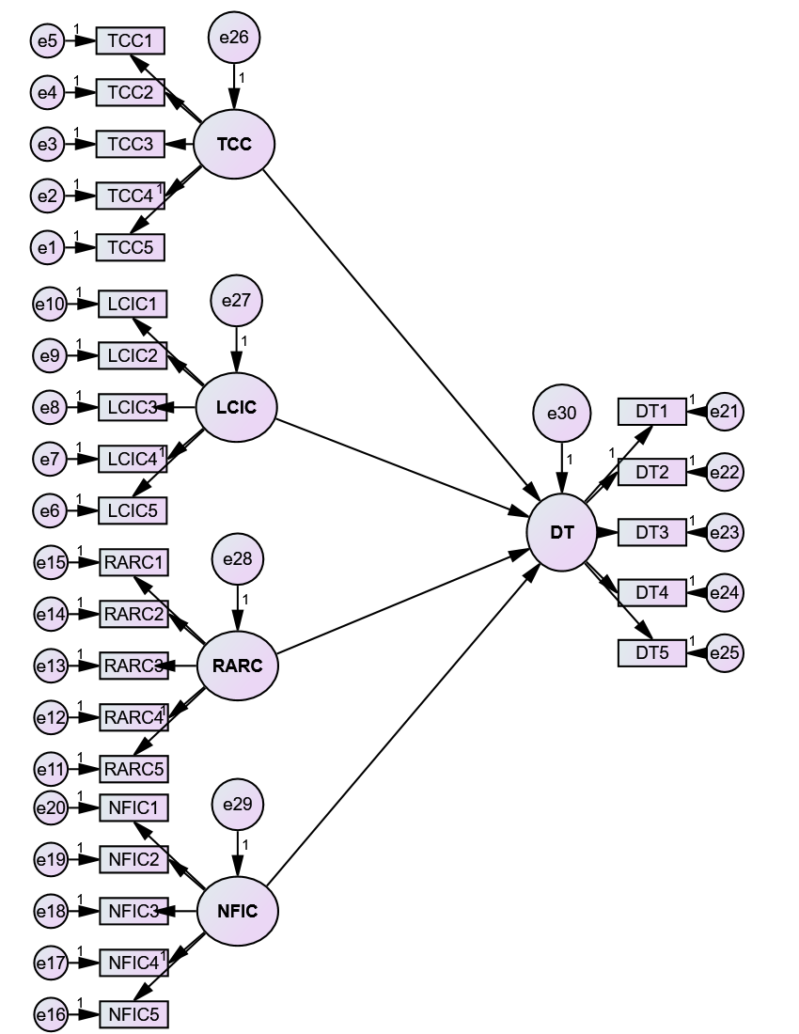
Figure 1: Conceptual Framework
Source: Field Survey (2026)

Hypotheses of the Study
H₀₁: Traffic Congestion Constraint (TCC) has no significant effect on Delivery Timeliness (DT).
H₀₂: Loading and Curbside Infrastructure Constraint (LCIC) has no significant effect on Delivery Timeliness (DT).
H₀₃: Regulatory and Access Restriction Constraint (RARC) has no significant effect on Delivery Timeliness (DT).
H₀₄: Network Fragmentation and ICT Constraint (NFIC) has no significant effect on Delivery Timeliness (DT).

2. METHODOLOGY

The research was carried out in Mile 12 Community, Kosofe LGA, Lagos State, and in Mile 12 International Market and distribution routes, where freight movement and loading are frequent operations, and delivery timing is a critical operational concern (Komolafe, 2016). The market cluster of Mile 12 has market-based suppliers with a total population of 6,674 traders, of which 2,671 are wholesalers (40.0) and 4,003 retailers (60.0) (STREAM Insight, 2014). The research uses Yamane formula and the sample size is determined as follows:
$$n=\frac{N}{(1+N^{e})}$$
$$n=\frac{6,674}{\left(1+6,674{\left(0.05\right)}^{2}\right)}$$
$$n=377.38≈377 respondents$$
The sampling was stratified, with proportional distributed, wholesalers 151 (0.40 x 377) and retailers 226 (0.60 x 377). Primary source was used to obtain data, through structured questionnaire. Each construct was measured on a 5-point Likert scale, with TCC, LCIC, RARC, NFIC (5 items each) predicting DT (5 items) to SEM suitability (Hair et al., 2019). The data were analysed with EFA and CFA, EFA refined factor structure, CFA validated measurement, and SEM was employed to test the hypothesised relationships and consider measurement error (Tabachnick and Fidell, 2019).

4. results and discussion

4.1 Socio-economic Characteristics of Respondents
The findings in Table 1 indicates the socio-economic attributes of the respondents. The outcome shows that the male respondents were more represented (60.8%) compared to the female respondents (39.2%) and that the majority of the respondents are in the active working age group of 26-45 years, which implies that the suppliers are predominantly in the productive age bracket that manages regular supply and delivery schedules. Education wise, the highest proportion was secondary education (44.3%), then tertiary education (25.4%), implying that the majority of suppliers possess basic to moderate literacy level that facilitates record keeping and delivery coordination. The supplier category also indicates that retailers (60.0%) were more than wholesalers (40.0%), which indicates the prevalence of retail distribution and frequent small deliveries in the market system. The level of experience indicates that 34.6% have been in business 5-10 years, which implies that a significant number of respondents possess adequate market knowledge and exposure to the recurring delivery issues. The mode of delivery indicates that the most common mode was hired vans or trucks (38.4) and motorcycles or tricycles (26.5), which suggests reliance on external and flexible transport solutions that can be impacted by congestion, access restrictions, and infrastructure constraints that can affect the timeliness of delivery.
Table 1: Socio-economic characteristics of respondents
Variable | Category | Frequency | Percentage (%)
Gender | Male | 225 | 60.8
 | Female | 145 | 39.2
Age group (years) | 18-25 | 54 | 14.6
 | 26-35 | 112 | 30.3
 | 36-45 | 110 | 29.7
 | 46-55 | 66 | 17.8
 | 56 and above | 28 | 7.6
Educational qualification | No formal education | 34 | 9.2
 | Primary education | 78 | 21.1
 | Secondary education | 164 | 44.3
 | Tertiary education | 94 | 25.4
Supplier category | Wholesaler | 148 | 40.0
 | Retailer | 222 | 60.0
Years in business | Less than 5 years | 82 | 22.2
 | 5-10 years | 128 | 34.6
 | 11-15 years | 88 | 23.8
 | Above 15 years | 72 | 19.5
Main delivery mode | Own vehicle | 96 | 25.9
 | Hired van or truck | 142 | 38.4
 | Motorcycle or tricycle | 98 | 26.5
 | Third party courier | 34 | 9.2
Source: Field Survey (2026)

4.2 Reliability and Validity Statistics Test
The reliability and validity findings in Table 2 affirm that the measurement model applied in this study is sufficient to analyze SEM among market-based suppliers in Mile 12. The standardized factor loadings of all constructs are typically high and within acceptable ranges, indicating that the observed indicators are strong representatives of their respective latent variables. In the case of Traffic Congestion Constraint (TCC), the item loadings are between 0.74 and 0.81, which means that questions about congestion always reflected the experiences of suppliers with delays and unpredictable travel time. The Loading and Curbside Infrastructure Constraint (LCIC) also demonstrates satisfactory loadings of 0.71 to 0.81, which means that the lack of parking space, narrow roads, and poor loading conditions are evident in the measurement items. Regulatory and Access Restriction Constraint (RARC) registered high loadings between 0.75 and 0.83, indicating that enforcement stops, movement restrictions, and compliance requirements are adequately measured as significant constraints to delivery operations. Network Fragmentation and ICT Constraint (NFIC) recorded satisfactory loadings of 0.71 to 0.80, indicating that inadequate coordination, absence of tracking systems, and poor communication among delivery actors are well represented in the construct indicators. Delivery Timeliness (DT) registered loadings between 0.76 and 0.84, indicating that the indicators of the dependent variable are effective in reflecting the degree to which deliveries are made within the anticipated time frames.
Moreover, Table 2 shows that all constructs have high internal consistency since the Cronbachs alpha values are between 0.87 and 0.91, which is above the acceptable minimum of 0.70, meaning that the items in each construct are consistent and measure the same concept. The Composite Reliability (CR) values are also between 0.87 and 0.91, which once again proves that the constructs are highly reliable according to the SEM requirements. The values of the Average Variance Extracted (AVE) are between 0.58 and 0.67, all exceeding the 0.50 mark, indicating that each construct explains more than half of the variance in its indicators, and this is a confirmation of convergent validity. In general, the results indicate that the measurement model is reliable and valid, and thus appropriate to test the hypothesised relationships between intra urban logistics constraints and delivery timeliness among Mile 12 market-based suppliers.

Table 2: Reliability and Validity Statistics for Measurement Model

Construct | Item Code | Standardized Loading | Cronbach's Alpha | Composite Reliability (CR) | AVE
Traffic Congestion Constraint (TCC) | TCC1 | 0.78 | 0.89 | 0.89 | 0.62
 | TCC2 | 0.81
 | TCC3 | 0.76
 | TCC4 | 0.79
 | TCC5 | 0.74
Loading and Curbside Infrastructure Constraint (LCIC) | LCIC1 | 0.73 | 0.88 | 0.88 | 0.59
 | LCIC2 | 0.77
 | LCIC3 | 0.81
 | LCIC4 | 0.75
 | LCIC5 | 0.71
Regulatory and Access Restriction Constraint (RARC) | RARC1 | 0.79 | 0.90 | 0.90 | 0.64
 | RARC2 | 0.83
 | RARC3 | 0.78
 | RARC4 | 0.80
 | RARC5 | 0.75
Network Fragmentation and ICT Constraint (NFIC) | NFIC1 | 0.74 | 0.87 | 0.87 | 0.58
 | NFIC2 | 0.77
 | NFIC3 | 0.80
 | NFIC4 | 0.72
 | NFIC5 | 0.71
Delivery Timeliness (DT) | DT1 | 0.76 | 0.91 | 0.91 | 0.67
 | DT2 | 0.84
 | DT3 | 0.82
 | DT4 | 0.80
 | DT5 | 0.78
Source: Field Survey (2026)

4.3 Model Fit Analysis
Table 3 results indicate that the SEM has a satisfactory overall fit, which means that the measurement and structural model is a good representation of the observed data. The chi-square value is significant (p < 0.05), but this outcome is typical in SEM research since chi-square is sensitive to sample size and small model violations, so researchers use incremental and error-based indices to judge the model (Hair et al., 2019). The relative chi-square (CMIN/DF = 1.268) indicates a good fit within the recommended limits (Kline, 2016). The goodness-of-fit indices (GPI = 0.911; AGFI = 0.893) are within acceptable levels, whereas the incremental indices (NFI = 0.915; IFI = 0.981; TLI = 0.979; CFI = 0.981) are above the minimum standard of 0.90, which proves that the proposed model is more effective in explaining the relationships than the independence model (Byrne, 2016; Hu and Bentler, 199 The value of RMSEA (0.030) also indicates good model fit since it is much lower than the maximum acceptable value of 0.08, and the PCLOSE value (1.000) shows that the model fits the population well (Browne and Cudeck, 1993).

Table 3: Model Fit Indices
Fit index | Acceptable threshold | Model value | Empirical evidence
Chi-square (CMIN) | Sensitive to sample size | 343.647 | Hair et al. (2019)
Degrees of freedom (DF) | - | 271 | Kline (2016)
CMIN/DF | < 3.00 | 1.268 | Kline (2016)
GFI | > 0.90 | 0.911 | Byrne (2016)
AGFI | > 0.80 | 0.893 | Hair et al. (2019)
NFI | > 0.90 | 0.915 | Byrne (2016)
IFI | > 0.90 | 0.981 | Hu and Bentler (1999)
TLI | > 0.90 | 0.979 | Hu and Bentler (1999)
CFI | > 0.90 | 0.981 | Hu and Bentler (1999)
RMSEA | < 0.08 | 0.030 | Browne and Cudeck (1993)
PCLOSE | > 0.05 | 1.000 | Browne and Cudeck (1993)
Source: Field Survey (2026)

Furthermore, Figure 2 validates the structural relationships within the model by demonstrating that all intra-urban logistics constraints positively and significantly influence the delivery timeliness outcomes. Traffic Congestion Constraint (TCC) has a positive predictive value on Delivery Timeliness (beta = 0.243, p < 0.001), Loading and Curbside Infrastructure Constraint (LCIC) has a stronger positive predictive value (beta = 0.307, p < 0.001), Regulatory and Access Restriction Constraint (RARC) is also significant (beta = 0.186, p < 0.001), and Network Fragmentation and ICT Con This means that the higher the congestion, poor loading conditions, access restrictions, and coordination or ICT constraints, the higher the suppliers face delivery timeliness issues in Mile 12 operations, thus validating the importance of considering multiple constraints at once in urban logistics management.
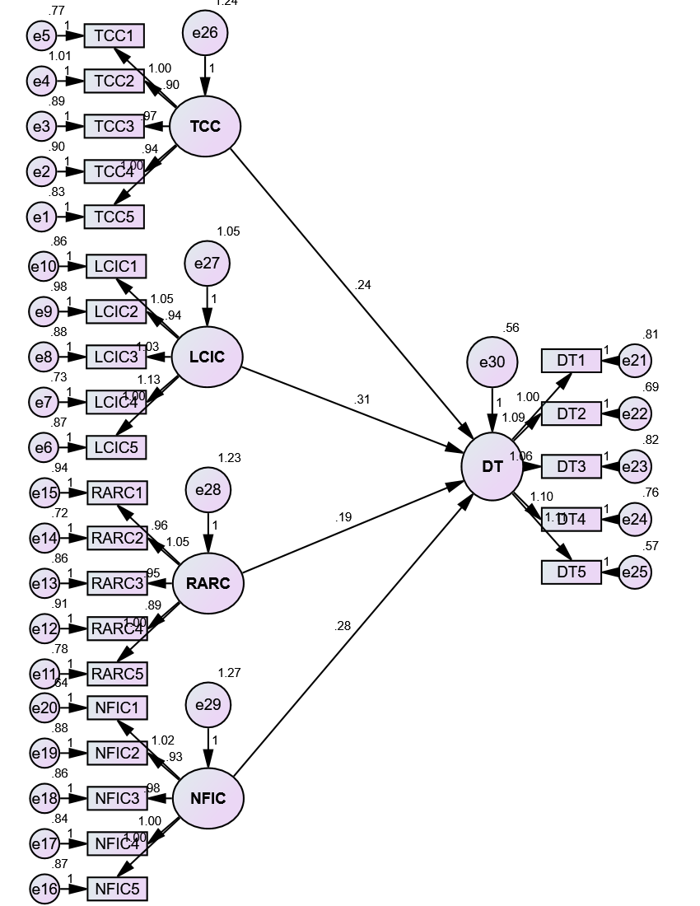
Figure 2: Model Path Diagram
Source: Author’s Compilation (2026)

4.4 Test of Hypotheses
Table 4 results indicate that the intra-urban logistics constraints have a significant positive impact on delivery timeliness (DT), i.e., the null hypotheses (H01-H04) were not accepted. In particular, Traffic Congestion Constraint (TCC) has a significant impact on DT (Beta = 0.243, C.R. = 4.790, p < 0.001), which means that congestion-related conditions are influential in the delivery timeliness outcomes among Mile 12 suppliers. The greatest impact was on Loading and Curbside Infrastructure Constraint (LCIC) (Beta = 0.307, C.R. = 5.404, p < 0.001), which means that the most significant constraint on timeliness of delivery is the challenges associated with parking, loading space, road access, and local infrastructure. Regulatory and Access Restriction Constraint (RARC) also plays a major role in DT (Beta = 0.186, C.R. = 3.763, p < 0.001), indicating that enforcement issues, movement restrictions, and compliance barriers continue to play a significant role in timeliness performance. Network Fragmentation and ICT Constraint (NFIC) are also important (Beta = 0.285, C.R. = 5.574, p < 0.001), indicating that weak coordination, limited tracking, and poor information flow contribute to the delivery timeliness challenges, and overall, the findings indicate that the delivery timeliness in Mile 12 is co-determined by operational, infrastructural, regulatory, and coordination constraints.

Table 4: Hypotheses testing results

Hypothesis | Path | Estimate (Beta) | S.E. | C.R. | P-value | Decision
H₀₁ | DT <- TCC | 0.243 | 0.051 | 4.790 | <0.001 | Reject H₀₁
H₀₂ | DT <- LCIC | 0.307 | 0.057 | 5.404 | <0.001 | Reject H₀₂
H₀₃ | DT <- RARC | 0.186 | 0.049 | 3.763 | <0.001 | Reject H₀₃
H₀₄ | DT <- NFIC | 0.285 | 0.051 | 5.574 | <0.001 | Reject H₀₄

4.5 Discussion of Findings
The research findings indicate that intra-urban logistics bottlenecks play a major role in determining the timeliness of deliveries among market-based suppliers in Mile 12, meaning that the delay in deliveries is more influenced by operational constraints in the urban setting than by supplier effort. The constraint of loading and curbside infrastructure had the greatest impact (beta = 0.307), which is consistent with Bosona (2020) who states that insufficient loading space, bad access roads, and weak last-meter infrastructure are the primary sources of inefficiency in urban freight since they raise dwell time, parking search time, and unloading delays. Network fragmentation and ICT constraint also were high and significant (beta = 0.285), and this is supported by the research of Gutiérrez-Franco et al. (2021) that highlights the importance of real-time information and data-driven decision support in controlling delays in last-mile operations. Likewise, Giuffrida et al. (2022) confirm this finding by stating that optimisation and intelligent routing tools minimise the variability of deliveries, i.e. low ICT integration in Mile 12 generates unnecessary delays due to poor coordination and visibility. Traffic congestion constraint had a significant impact on delivery timeliness (beta = 0.243), which confirms Allen et al. (2017) who demonstrated that the growth of urban delivery activity under the pressure of e-commerce increases exposure to congestion and disruption of last-mile schedules. The result also aligns with Muriel et al. (2022) that congestion and delivery policies interact to deteriorate the performance of the traffic network, and delay patterns are more intense in dense commercial areas. The weakest predictor, regulatory and access restriction constraint, was still significant (beta = 0.186), and this is consistent with Navarro et al. (2021) who emphasized that local access conditions and urban control measures influence delivery reliability and consumer service outcomes. In general, the findings support the thesis of Kervinoael et al. (2020) that time-based delivery promises impose a high level of pressure on urban delivery workers, and in case of severe constraints, timeliness is hard to maintain, undermining service reliability and competitiveness of suppliers.

4. Conclusion AND RECOMMENDATIONS

The research finds that intra-urban logistics bottlenecks play a major role in determining the timeliness of deliveries among market-based suppliers in Mile 12, Kosofe LGA, Lagos State. The research findings affirm that traffic congestion, poor loading and curbside infrastructure, regulatory and access controls, and network fragmentation with low ICT integration are all contributing factors to delays and variation in delivery schedules. More to the point, the results indicate that loading and curbside infrastructure issues are the most significant bottleneck, i.e. even when suppliers strive to plan adequately, the lack of parking space, inadequate access roads, and inefficient loading conditions may still slow down delivery rounds and decrease on-time performance. The research also establishes that coordination gaps and poor utilization of digital tools exacerbate delivery timeliness by reducing real-time visibility, slowing decision-making, and increasing delivery failures, and congestion and regulatory constraints further amplify delays and decrease scheduling flexibility. Thus, to enhance the timeliness of delivery in Mile 12, a comprehensive strategy is needed that addresses physical access constraints, operational coordination, and enabling urban freight management. Thus, the following are suggested to enhance timeliness of delivery among market-based suppliers in Mile 12:
- To minimise loading delays and enhance the efficiency of last-meter delivery, market and transport authorities should offer and implement designated loading and offloading points, enhance access roads, and curbside conflicts.
- Simple ICT tools like real-time communication, tracking, and simple route planning systems should be embraced by suppliers and delivery operators to enhance coordination, enhance visibility of deliveries, and minimize unnecessary delays.
- Traffic management measures like delivery time scheduling, off-peak deliveries, and organized entry-and-exit movement around the market should be reinforced to minimize exposure to congestion and variability in delivery time.
Regulatory agencies are advised to coordinate checkpoints, minimise unnecessary enforcement stops, and implement uniform access policies that facilitate freight movement without compromising safety and order in the Mile 12 environment.

COMPETING INTERESTS DISCLAIMER:
Authors have declared that they have no known competing financial interests OR non-financial interests OR personal relationships that could have appeared to influence the work reported in this paper.

References

Allen, J., Piecyk, M., Piotrowska, M., McLeod, F., Cherrett, T., Ghali, K., Nguyen, T., Bektaş, T., Bates, O., Friday, A., Wise, S., & Austwick, M. (2017). Understanding the impact of e-commerce on last-mile light goods vehicle activity in urban areas: The case of London. Transportation Research Part D: Transport and Environment. 61, 325-338. https://doi.org/10.1016/j.trd.2017.07.020
Al-Shboul, M. (2022). An investigation of transportation logistics strategy on manufacturing supply chain responsiveness in developing countries: the mediating role of delivery reliability and delivery speed. Heliyon, 8. https://doi.org/10.1016/j.heliyon.2022.e11283
Bai, Z., Wang, H., & Yang, K. (2025). Optimizing Metro-Based Logistics Hub Locations for Sustainable Urban Freight Distribution. Sustainability. 17(10), 4735. https://doi.org/10.3390/su17104735
Bosona, T. (2020). Urban Freight Last Mile Logistics-Challenges and Opportunities to Improve Sustainability: A Literature Review. Sustainability, 12, 8769. https://doi.org/10.3390/su12218769
Browne, M. W., & Cudeck, R. (1993). Alternative ways of assessing model fit. In K. A. Bollen & J. S. Long (Eds.), Testing structural equation models (pp. 136-162). Sage.
Byrne, B. M. (2016). Structural equation modeling with AMOS: Basic concepts, applications, and programming (3rd ed.). Routledge.
Cárdenas, I., Borbon-Galvez, Y., Verlinden, T., Van De Voorde, E., Vanelslander, T., & Dewulf, W. (2017). City logistics, urban goods distribution and last mile delivery and collection. Competition and Regulation in Network Industries, 18, 22 - 43. https://doi.org/10.1177/1783591717736505
Dreischerf, A., & Buijs, P. (2022). How Urban Consolidation Centres affect distribution networks: An empirical investigation from the perspective of suppliers. Case Studies on Transport Policy. 10(11), 518-528. https://doi.org/10.1016/j.cstp.2022.01.012
Dreischerf, A., & Buijs, P. (2022). How Urban Consolidation Centres affect distribution networks: An empirical investigation from the perspective of suppliers. Case Studies on Transport Policy. 10(1), 518-528. https://doi.org/10.1016/j.cstp.2022.01.012
Fikar, C., Hirsch, P., & Gronalt, M. (2018). A decision support system to investigate dynamic last-mile distribution facilitating cargo-bikes. International Journal of Logistics Research and Applications, 21, 300 - 317. https://doi.org/10.1080/13675567.2017.1395830
Giuffrida, N., Fajardo-Calderin, J., Masegosa, A., Werner, F., Steudter, M., & Pilla, F. (2022). Optimization and Machine Learning Applied to Last-Mile Logistics: A Review. Sustainability. 14(9), 5329. https://doi.org/10.3390/su14095329
Gómez-Marín, C., Comi, A., Serna-Urán, C., & Zapata-Cortes, J. (2024). Fostering collaboration and coordination in urban delivery: a multi-agent microsimulation model. Research in Transportation Economics. https://doi.org/10.1016/j.retrec.2023.101402
Gutiérrez-Franco, E., Mejía-Argueta, C., & Rabelo, L. (2021). Data-Driven Methodology to Support Long-Lasting Logistics and Decision Making for Urban Last-Mile Operations. Sustainability. https://doi.org/10.3390/su13116230
Gutiérrez-Franco, E., Mejía-Argueta, C., & Rabelo, L. (2021). Data-Driven Methodology to Support Long-Lasting Logistics and Decision Making for Urban Last-Mile Operations. Sustainability. 13(11), 6230; https://doi.org/10.3390/su13116230
Hair, J. F., Black, W. C., Babin, B. J., & Anderson, R. E. (2019). Multivariate data analysis (8th ed.). Cengage.
Komolafe, G. (2016). Market demolition, gentrification and survival in Lagos State. FIWON. Retreived from: https://www.wiego.org/research-library-publications/poor-also-must-live-market-demolition-gentrification-quest-survival-lagos-state/
STREAM Insight. (2014). Market enumeration of wholesalers and retailers in key hub markets. GEMS. Retrieved from: https://afchub.org/documents/16159887078-Market-Enumeration-of-Wholesalers-and-Retailers-in-Hub-Markets.pdf
Tabachnick, B. G., & Fidell, L. S. (2019). Using multivariate statistics (7th ed.). Pearson.
Yamane, T. (1967). Statistics: An introductory analysis (2nd ed.). Harper & Row.
Hair, J. F., Black, W. C., Babin, B. J., & Anderson, R. E. (2019). Multivariate data analysis (8th ed.). Cengage.
Heeswijk, W., Mes, M., Schutten, M., & Zijm, H. (2020). Evaluating Urban Logistics Schemes Using Agent-based Simulation. Transp. Sci., 54, 651-675. https://doi.org/10.1287/trsc.2019.0971
Heeswijk, W., Mes, M., Schutten, M., & Zijm, H. (2020). Evaluating Urban Logistics Schemes Using Agent-based Simulation. Transp. Sci., 54, 651-675. https://doi.org/10.1287/trsc.2019.0971
Hu, L. T., & Bentler, P. M. (1999). Cutoff criteria for fit indexes in covariance structure analysis: Conventional criteria versus new alternatives. Structural Equation Modeling: A Multidisciplinary Journal, 6(1), 1-55.
Iswari, T., Caris, A., & Braekers, K. (2023). Analyzing the benefits of a city hub: An inventory and routing perspective. Comput. Ind. Eng., 185, 109629. https://doi.org/10.1016/j.cie.2023.109629
Kervenoael, R., Schwob, A., & Chandra, C. (2020). E-retailers and the engagement of delivery workers in urban last-mile delivery for sustainable logistics value creation: Leveraging legitimate concerns under time-based marketing promise. Journal of Retailing and Consumer Services, 54, 102016. https://doi.org/10.1016/j.jretconser.2019.102016
Kervenoael, R., Schwob, A., & Chandra, C. (2020). E-retailers and the engagement of delivery workers in urban last-mile delivery for sustainable logistics value creation: Leveraging legitimate concerns under time-based marketing promise. Journal of Retailing and Consumer Services, 54, 102016. https://doi.org/10.1016/j.jretconser.2019.102016
Kline, R. B. (2016). Principles and practice of structural equation modeling (4th ed.). Guilford Press.
Kodera, R., Sakai, T., & Hyodo, T. (2025). Development of a Delivery Time-Period Selection Model for Urban Freight Using GPS Data. Smart Cities. 8(1), 31. https://doi.org/10.3390/smartcities8010031
Liu, C., Zhou, J., Gan, J., Wu, Y., Huang, Y., Shao, J., & Ouyang, L. (2022). Optimizing the ground intra-city express delivery network: An integrated multiple centrality assessment, multi-criteria decision-making, and multi-objective integer programming model. Journal of Intelligent Transportation Systems, 28, 525 - 543. https://doi.org/10.1080/15472450.2022.2157211
Liu, C., Zhou, J., Gan, J., Wu, Y., Huang, Y., Shao, J., & Ouyang, L. (2022). Optimizing the ground intra-city express delivery network: An integrated multiple centrality assessment, multi-criteria decision-making, and multi-objective integer programming model. Journal of Intelligent Transportation Systems, 28, 525 - 543. https://doi.org/10.1080/15472450.2022.2157211
Lozzi, G., Iannaccone, G., Maltese, I., Gatta, V., Marcucci, E., & Lozzi, R. (2022). On-Demand Logistics: Solutions, Barriers, and Enablers. Sustainability. 14(15), 9465. https://doi.org/10.3390/su14159465
Muriel, J., Zhang, L., Fransoo, J., & Perez-Franco, R. (2022). Assessing the impacts of last mile delivery strategies on delivery vehicles and traffic network performance. Transportation Research Part C: Emerging Technologies. 144, 103915. https://doi.org/10.1016/j.trc.2022.103915
Navarro, H., Vieira, J., & Fransoo, J. (2021). Understanding urban logistics and consumer behavior in São Paulo city. Case Studies on Transport Policy. 9(4), 1630-1640. https://doi.org/10.1016/j.cstp.2021.06.017
Navarro, H., Vieira, J., & Fransoo, J. (2021). Understanding urban logistics and consumer behavior in São Paulo city. Case Studies on Transport Policy. 9(4), 1630-1640. https://doi.org/10.1016/j.cstp.2021.06.017
Pereira, C., Zuidgeest, M., & Da Silva Lima, R. (2025). How about including urban informal settlements in city logistics? An equity comparative analysis of e-commerce last mile deliveries. The International Journal of Logistics Management. 36 (4): 1326-1345. https://doi.org/10.1108/ijlm-05-2024-0304
Silva, V., Amaral, A., & Fontes, T. (2023). Sustainable Urban Last-Mile Logistics: A Systematic Literature Review. Sustainability. 15(3), 2285. https://doi.org/10.3390/su15032285
Utkurova, N., & Djumanov, A. (2025). Improving Delivery Service Performance Using Discrete Event Simulation Modeling. Iqtisodiy taraqqiyot va tahlil. https://doi.org/10.60078/2992-877x-2025-vol3-iss8-pp136-143
Vural, C., & Aktepe, Ç. (2021). Why do some sustainable urban logistics innovations fail? The case of collection and delivery points. Research in Transportation Business & Management. 45, 100690. https://doi.org/10.1016/j.rtbm.2021.100690
Zamal, M., Schrotenboer, A., & Woensel, T. (2025). The two-echelon vehicle routing problem with pickups, deliveries, and deadlines. Comput. Oper. Res., 179, 107016. https://doi.org/10.2139/ssrn.4565559
Zamal, M., Schrotenboer, A., & Woensel, T. (2025). The two-echelon vehicle routing problem with pickups, deliveries, and deadlines. Comput. Oper. Res., 179, 107016. https://doi.org/10.2139/ssrn.4565559
Zhao, L., Li, H., Li, M., Sun, Y., Hu, Q., Mao, S., Li, J., & Xue, J. (2018). Location selection of intra-city distribution hubs in the metro-integrated logistics system. Tunnelling and Underground Space Technology. 80, 246-256. https://doi.org/10.1016/j.tust.2018.06.024
Zheng, C., Gu, Y., Shen, J., & Du, M. (2021). Urban Logistics Delivery Route Planning Based on a Single Metro Line. IEEE Access, 9, 50819-50830. https://doi.org/10.1109/access.2021.3069415
Zheng, C., Gu, Y., Shen, J., & Du, M. (2021). Urban Logistics Delivery Route Planning Based on a Single Metro Line. IEEE Access, 9, 50819-50830. https://doi.org/10.1109/access.2021.3069415
Zunder, T. (2021). A semi-systematic literature review, identifying research opportunities for more sustainable, receiver-led inbound urban logistics flows to large higher education institutions. European Transport Research Review, 13. https://doi.org/10.1186/s12544-021-00487-1

