Clinical Practice article

INSTITUTION-SPECIFIC VALIDATION OF CTV-PTV MARGINS IN HEAD AND NECK RADIOTHERAPY USING DAILY CONE BEAM COMPUTED TOMOGRAPHY ON HALCYON ELITE: A POPULATION - BASED STUDY

.
ABSTRACT
SAMPLE ABSTRACT:

Aims: To quantitatively evaluate setup errors in head and neck cancer radiotherapy using cone‑beam computed tomography (CBCT) and determine whether the institutional CTV–PTV margin adequately compensates for these uncertainties..
Study design: Retrospective observational study
Place and Duration of Study: Sample: Department of Radiation Oncology, Father Muller Medical College Hospital, Mangalore, India, conducted over a period of six months.
Methodology: Twenty patients with head and neck malignancies treated using IMRT or VMAT were retrospectively analyzed. All patients were immobilized with thermoplastic head‑and‑neck masks. Daily setup verification was performed using kV cone‑beam CT on the Halcyon Elite linear accelerator. Translational setup deviations in vertical, longitudinal and lateral directions were recorded. Population systematic (Σ) and random (σ) errors were calculated using individual patient mean and standard deviation values. The CTV–PTV margins were derived using the Van Herk margin formula.
Results: Population systematic errors (Σ) were 0.041 cm, 0.072 cm and 0.076 cm in vertical, longitudinal and lateral directions respectively. Random errors (σ) were 0.148 cm, 0.154 cm and 0.213 cm respectively. The calculated CTV–PTV margins were 0.21 cm (vertical), 0.29 cm (longitudinal) and 0.34 cm (lateral), all smaller than the institutional margin of 3 mm.
Conclusion: Daily CBCT‑based image guidance combined with thermoplastic immobilization provides high setup reproducibility in head and neck radiotherapy. The institutional 3 mm margin remains adequate as it accounts for additional clinical uncertainties beyond setup errors.

Keywords: Head and neck cancer; Setup error; Cone beam CT; Image guided radiotherapy; PTV margin.
1. INTRODUCTION
Radiotherapy is a primary treatment modality for head and neck cancers. Because of the complex anatomy and proximity of critical organs such as the spinal cord, brainstem and salivary glands, precise radiation delivery is essential to ensure tumor control while minimizing damage to surrounding healthy tissues.
Advanced radiotherapy techniques such as intensity‑modulated radiotherapy (IMRT) and volumetric modulated arc therapy (VMAT) enable highly conformal dose delivery. However, these techniques require accurate patient positioning and reproducibility throughout the treatment course. Even small deviations between planned and delivered treatment positions can result in significant dose variations.
Setup errors refer to deviations between the patient position during treatment delivery and the reference position obtained during planning CT simulation. These errors may arise due to patient movement, immobilization limitations, anatomical changes such as tumor shrinkage or weight loss, and day‑to‑day positioning variations.
Image‑guided radiotherapy (IGRT) using cone beam computed tomography (CBCT) allows verification of patient positioning prior to treatment delivery. By identifying and correcting setup deviations, CBCT significantly improves treatment accuracy.
To compensate for residual uncertainties, margins are added around the clinical target volume (CTV) to create the planning target volume (PTV). Determination of appropriate margins requires quantitative analysis of institutional setup errors. Therefore, the present study evaluates setup uncertainties in head and neck radiotherapy using CBCT and assesses whether the current institutional margin is adequate.

- material and methods / experimental details / methodology

2.1 Study Design and Setting
This study was conducted as a retrospective observational analysis in the Department of Radiation Oncology at Father Muller Medical College Hospital, Mangalore, India. The study aimed to quantitatively assess setup errors in head and neck cancer patients undergoing external beam radiotherapy using cone-beam computed tomography (CBCT) image guidance.
The study duration was six months, during which treatment records and imaging data of eligible patients were retrospectively reviewed. Ethical guidelines of the institution were followed during data collection and analysis, and no patient-identifiable information was included in the study.

2.2 Study Population
A total of 20 patients diagnosed with head and neck malignancies and treated with intensity-modulated radiotherapy (IMRT) or volumetric modulated arc therapy (VMAT) were included in the study.

Inclusion Criteria
- Patients diagnosed with head and neck cancer
- Patients treated using IMRT or VMAT techniques
- Patients who underwent daily CBCT imaging for treatment verification
- Patients immobilized using thermoplastic head and neck masks

Exclusion Criteria
- Patients treated with three-dimensional conformal radiotherapy (3DCRT)
- Patients receiving palliative radiotherapy
- Brain tumor cases or non–head and neck malignancies

2.3 Patient Immobilization
All patients underwent immobilization in the mould room prior to CT simulation. Patients were positioned in the supine position on a flat treatment couch using a dedicated head and neck base plate. An appropriate headrest was selected to ensure comfort and reproducibility of neck positioning.
A thermoplastic head and neck mask was prepared by softening the mask material in a warm water bath and molding it over the patient’s head, neck, and shoulder region. After cooling and hardening, the mask provided rigid immobilization and helped maintain consistent patient positioning during simulation and treatment.
Reference alignment marks were placed on the mask to facilitate reproducible setup during each treatment fraction.

2.4 CT Simulation
Computed tomography (CT) simulation was performed with the patient immobilized using the customized thermoplastic mask. CT images were acquired using a slice thickness of 5 mm extending from the vertex of the skull to the upper thorax to include all relevant anatomical structures required for treatment planning.
Laser alignment was used to mark the reference position and establish the treatment isocenter. The CT images were subsequently transferred to the treatment planning system (TPS) for contouring and treatment planning.

2.5 Target Delineation and Treatment Planning
Target volumes and organs at risk were delineated according to institutional protocols and international radiotherapy guidelines.
The following target volumes were defined:
- Gross Tumor Volume (GTV): Visible tumor identified on imaging studies
- Clinical Target Volume (CTV): Region containing potential microscopic disease
- Planning Target Volume (PTV): CTV with additional margins to compensate for setup uncertainties
A uniform margin of 3 mm was applied between the CTV and PTV in all directions as per institutional practice.Treatment plans were generated using IMRT or VMAT techniques on the Halcyon Elite V3.1 linear accelerator (Varian Medical Systems). All treatment plans underwent routine quality assurance (QA) procedures prior to treatment delivery.
2.6 Treatment Execution
Patient Setup
Patients were positioned using the immobilization mask and aligned with lasers.
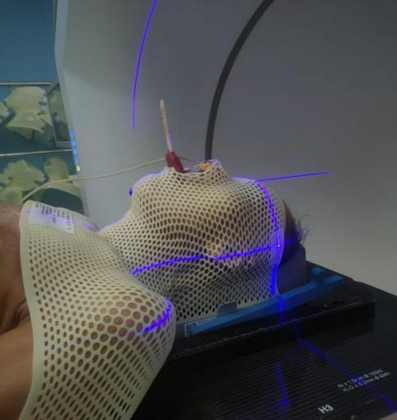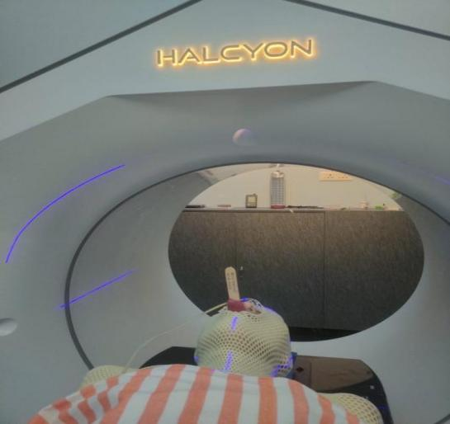
IMAGE 1: Petient setup IMAGE 2: Petient setup

2.7 Image-Guided Radiotherapy and Setup Verification
Daily image guidance was performed using kilovoltage cone-beam computed tomography (kV-CBCT) before treatment delivery. CBCT images were acquired with the patient positioned using the thermoplastic mask and aligned with room lasers. CBCT images were registered with the planning CT using bony anatomy matching.
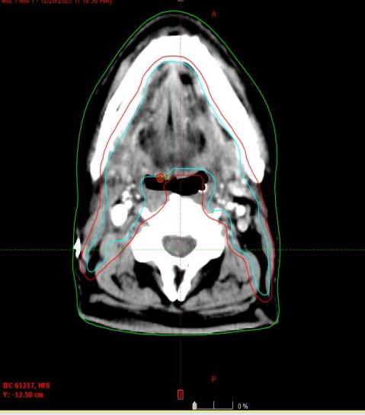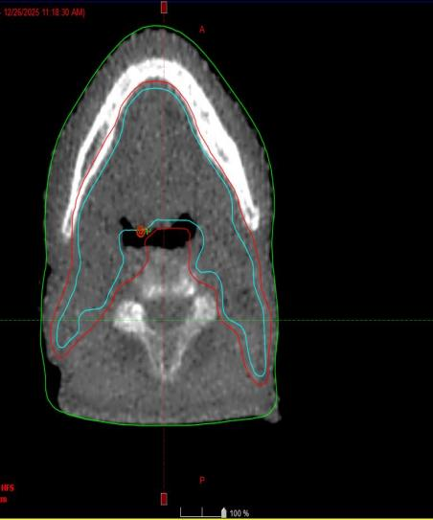
IMAGE 3:PLANNING CT IMAGE 4:KVCBCT
The CBCT images were then registered with the planning CT images using bony anatomy matching to evaluate any deviations from the planned treatment position. If deviations were detected, translational couch shifts were applied to correct patient positioning before radiation delivery.

2.7 Recording of Setup Errors
Translational setup shifts were recorded for each treatment fraction in three orthogonal directions: Vertical (X-axis), Longitudinal (Y-axis), Lateral (Z-axis). All recorded shifts were measured in centimeters (cm) and documented for subsequent analysis.
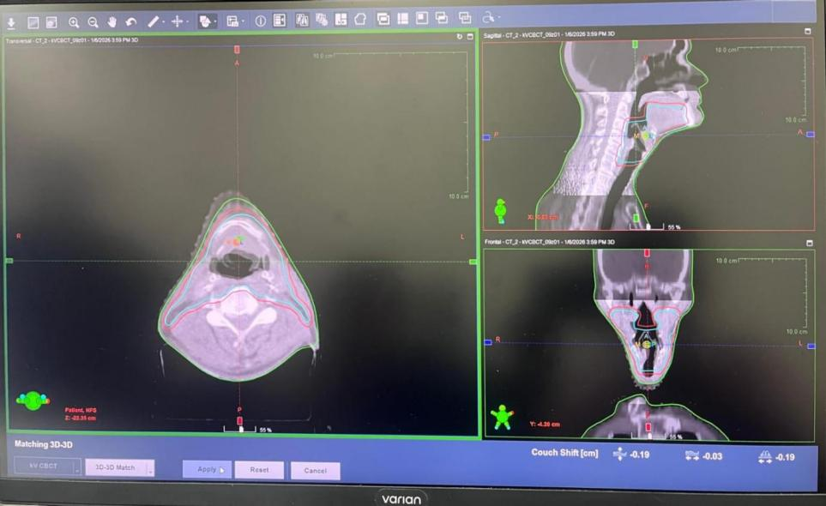
IMAGE 5 :Recording of setup shift

2.8 Statistical Analysis
Setup error analysis was performed using a population-based approach.
For each patient: The mean setup error represented the individual systematic error and the standard deviation represented the individual random error.
Population setup errors were calculated as follows:
- Population systematic error (Σ): Standard deviation of the individual patient mean errors
- Population random error (σ): Mean of individual patient random errors
The required CTV–PTV margins were calculated using the Van Herk margin formula:
Margin = 2.5Σ + 0.7σ
This formula ensures that at least 90–95% of patients receive a minimum cumulative CTV dose of 95% of the prescribed radiation dose.
Margins were calculated separately for the vertical, longitudinal, and lateral directions.

- results and discussion
A total of 20 patients diagnosed with head and neck cancer and treated with image-guided radiotherapy using IMRT or VMAT techniques were included in this retrospective analysis. All patients underwent daily setup verification using kV cone-beam computed tomography (CBCT) prior to treatment delivery. Translational setup deviations were recorded in three orthogonal directions: vertical (X-axis), longitudinal (Y-axis), and lateral (Z-axis). These recorded deviations were used to evaluate the magnitude of setup uncertainties and determine population systematic and random errors.

3.1 Analysis of Individual Patient Setup Errors
The individual patient mean setup errors were calculated for each axis using the recorded translational shifts across all treatment fractions. These values represent the average deviation in patient positioning relative to the planned treatment isocenter.
The mean individual setup errors for the vertical direction ranged from 0.012 cm to 0.483 cm, while the longitudinal direction showed deviations ranging from 0.041 cm to 0.308 cm. The lateral direction demonstrated a wider variation, with values ranging from 0.017 cm to 0.716 cm. Although the majority of setup errors were relatively small, the larger deviations observed in a few patients highlight the importance of routine image guidance and verification before treatment delivery.
The distribution of individual setup errors indicates that the immobilization system used in this study provided adequate positional stability for most patients. The thermoplastic head and neck masks ensured reproducible patient positioning across treatment fractions, minimizing variations caused by patient movement.
However, certain patients demonstrated relatively higher deviations in the lateral direction. This variation may be attributed to factors such as differences in shoulder positioning, anatomical variability, and slight movement within the immobilization mask. These findings are consistent with previous studies that report increased variability in the lateral axis due to the complexity of shoulder immobilization in head and neck radiotherapy.

3.2 Population Systematic and Random Errors
Population-based analysis was performed to determine the systematic (Σ) and random (σ) setup errors for the entire patient cohort. Systematic errors represent consistent deviations that occur throughout the treatment course, while random errors reflect day-to-day variations in patient positioning.
Population systematic and random setup errors calculated from the dataset are shown in Table 1.

Table 1.Population systematic and random setup errors.

Direction | Systematic Error Σ (cm) | Random Error σ (cm)
Vertical | 0.041 | 0.148
Longitudinal | 0.072 | 0.154
Lateral | 0.076 | 0.213
The lateral direction demonstrated the largest systematic and random errors, indicating slightly greater variability along this axis. This may be related to variations in shoulder positioning and mask fitting around the neck and shoulder region.
These values indicate that systematic errors were relatively small in all directions. The slightly higher systematic error observed in the lateral direction suggests that consistent positional deviations were more likely to occur along this axis compared to the vertical and longitudinal axes.
Random errors were larger than the corresponding systematic errors in all three directions. This finding suggests that daily setup variability contributes more significantly to treatment uncertainty than systematic positioning deviations.
The higher magnitude of random errors may be attributed to day-to-day variations in patient positioning, slight changes in posture, patient relaxation within the immobilization device, or minor anatomical changes occurring during the treatment course. Such variations are commonly observed in head and neck radiotherapy due to weight loss, tumor regression, or soft tissue deformation.

3.3 Calculation of CTV–PTV Margins
To ensure adequate dose coverage of the clinical target volume (CTV), margins must be applied to account for setup uncertainties. In this study, the required planning target volume (PTV) margins were calculated using the widely accepted Van Herk margin formula, which is expressed as:
Margin = 2.5Σ + 0.7σ
This formula ensures that at least 90–95% of patients receive a minimum cumulative PTV dose of 95% of the prescribed dose, making it a reliable method for determining appropriate PTV margins in radiotherapy.
Calculated CTV–PTV margins using Van Herk’s formula are presented in Table 2.

Table 2. Calculated setup‑based CTV–PTV margins.
Direction | Calculated Margin (cm)
Vertical | 0.21
Longitudinal | 0.29
Lateral | 0.34
Table 2. Calculated setup‑based CTV–PTV margins.

The largest margin requirement was observed in the lateral direction (0.34 cm), which corresponds to the higher systematic and random errors recorded along this axis. The smallest margin was observed in the vertical direction (0.21 cm), indicating greater positional stability in this direction.
These calculated margins were all less than the institutional margin of 3 mm (0.3 cm) used for head and neck radiotherapy at our institution. This finding demonstrates that the current clinical margin policy provides an adequate safety buffer for setup uncertainties.

3.4 Impact of Immobilization and Image Guidance
The results of this study highlight the importance of effective immobilization and daily image guidance in achieving accurate and reproducible patient positioning. The thermoplastic head and neck masks used in this study provided strong immobilization of the patient’s head and neck region, reducing positional variability during treatment.
Daily CBCT imaging allowed verification of patient positioning before each treatment fraction. By detecting translational deviations in real time, therapists were able to apply corrective shifts to ensure accurate alignment with the treatment isocenter.
The combination of thermoplastic immobilization and CBCT-based image guidance significantly reduces both systematic and random setup errors, thereby improving the precision of radiotherapy delivery.

3.5 Comparison with Previous Studies
The findings of the present study are consistent with several previously published studies investigating setup uncertainties in head and neck radiotherapy.
Delishaj et al. reported that CBCT-based image guidance can effectively reduce setup errors and recommended CTV–PTV margins of approximately 3–5 mm for head and neck cancer treatments. Similarly, Ashour et al. observed mean setup deviations of 0.14–0.16 cm in different axes and suggested margin expansions between 0.30 cm and 0.38 cm.
Another study conducted by Deb et al. reported systematic and random errors comparable to those observed in the present analysis and recommended a 5 mm margin for safe target coverage.
In comparison, the setup-based margins calculated in the current study were slightly smaller, which may reflect improved immobilization techniques and the use of daily CBCT imaging for treatment verification.

3.6 Clinical Implications
The results of this study demonstrate that setup uncertainties in head and neck radiotherapy can be effectively minimized through the use of thermoplastic immobilization and daily CBCT-based image guidance.
Although the calculated setup-based margins were smaller than the institutional margin of 3 mm, it is important to note that setup errors represent only one component of total treatment uncertainty. Other factors that contribute to target position variability include: Anatomical deformation during treatment, Patient weight loss, Tumor shrinkage, Contouring uncertainties, Intrafraction motion. These additional uncertainties justify maintaining a slightly larger clinical margin to ensure adequate target coverage.

3.7 Limitations of the Study
Despite the valuable insights obtained from this analysis, several limitations should be acknowledged.
First, the sample size of 20 patients is relatively small compared to larger institutional studies. Although the findings provide useful information regarding setup reproducibility, larger studies may provide more robust statistical conclusions.
Second, this study focused only on translational setup errors and did not evaluate rotational deviations. Rotational errors may also contribute to dose distribution uncertainties in certain cases.
Third, anatomical changes occurring during the treatment course, such as tumor shrinkage or patient weight loss, were not explicitly analyzed. Future studies may incorporate adaptive radiotherapy approaches to evaluate these changes more comprehensively.

3.8 Future Perspectives
Future research in this area may focus on evaluating intrafraction motion, rotational setup errors, and anatomical changes using advanced imaging techniques. The integration of adaptive radiotherapy workflows may further improve treatment accuracy by allowing treatment plans to be modified based on anatomical changes observed during the treatment course.
Additionally, larger multi-institutional studies may help establish standardized margin protocols for head and neck radiotherapy.

4. Conclusion

Head and neck radiotherapy delivered using thermoplastic mask immobilization and daily CBCT guidance demonstrates high setup accuracy and reproducibility. The calculated setup‑based CTV–PTV margins were smaller than the institutional margin of 3 mm. However, maintaining the current institutional margin remains appropriate because it accounts for additional clinical uncertainties including anatomical changes, contouring variability and intrafraction motion.
This study evaluated setup uncertainties in head and neck cancer radiotherapy using daily cone-beam computed tomography (CBCT) image guidance. The analysis demonstrated that patient positioning errors were relatively small in all three orthogonal directions, indicating good reproducibility of treatment setup when thermoplastic immobilization masks and daily CBCT verification are employed.
The calculated population systematic and random errors were minimal, with slightly higher deviations observed in the lateral direction. Using the Van Herk margin formula, the setup-based CTV–PTV margins were determined to be 0.21 cm in the vertical direction, 0.29 cm in the longitudinal direction, and 0.34 cm in the lateral direction. All calculated margins were smaller than the currently used institutional margin of 3 mm.
These findings indicate that the existing institutional CTV–PTV margin provides sufficient coverage for setup uncertainties in head and neck radiotherapy. The use of daily CBCT imaging allows accurate detection and correction of patient positioning errors, thereby improving treatment precision and ensuring optimal dose delivery to the target volume while minimizing radiation exposure to surrounding healthy tissues.
However, it is important to consider that setup-based margins account only for positional uncertainties and do not fully represent other clinical factors such as anatomical deformation, tumor regression, patient weight loss, contouring variability, and intrafraction motion. Therefore, maintaining a slightly larger institutional margin remains clinically justified to ensure adequate target coverage and patient safety.
Overall, the results of this study support the effectiveness of thermoplastic immobilization combined with CBCT-based image guidance in achieving accurate and reproducible patient setup in head and neck radiotherapy. Routine evaluation of setup errors should be incorporated as part of institutional quality assurance programs to continuously monitor treatment accuracy and validate margin policies in clinical practice.

Consent (where ever applicable)

All procedures involving human participants were conducted in accordance with institutional ethical standards.

Ethical approval (where ever applicable)

All procedures involving human participants were conducted in accordance with institutional ethical standards.

References

- Delishaj D, Ursino S, Pasqualetti F, Matteucci F, Cristaudo A, Soatti CP, et al. (2018). Set-up errors in head and neck cancer treated with IMRT technique assessed by cone-beam computed tomography: A feasible protocol. Radiat Oncol J. 36(1): 23–31. https://doi.org/10.3857/roj.2017.00493
- Strbac B, Spasic Jokic V. (2013). Evaluation of set-up errors in head and neck radiotherapy using electronic portal imaging. Phys Med. 29(5): 531–536. https://doi.org/10.1016/j.ejmp.2012.12.001
- Ashour MG, Shouman TH, Hassouna AH, Emad El Din RM, Mokhtar MH, Khalil MA. (2017). Measuring radiotherapy setup errors in IMRT treated head and neck cancer patients requiring bilateral neck irradiation. J Cancer Ther. 8(13): 1206–1215. https://doi.org/10.4236/jct.2017.813099
- Deb J, Chaudhuri S, Panda D, Sinha SN, Kumar S, Kumar N, et al. (2019). Retrospective analysis of random and systematic errors in radiation therapy of head and neck cancer patients and its clinical predictive implications with VMAT treatment. Int J Res Med Sci. 7(7): 2572–2577. https://doi.org/10.18203/2320-6012.ijrms20192914
- Kaur I, Rawat S, Ahlawat P, Kakria A, Gupta G, Saxena U, Mishra MB. (2016). Dosimetric impact of setup errors in head and neck cancer patients treated by image-guided radiotherapy. J Cancer Res Ther. 12(3): 1000–1004. https://doi.org/10.4103/0973-1482.181640
- Jain V, Soni TP, Singh DK, Patni N, Jakhotia N, Gupta AK, Singhal H. (2022). A prospective study to assess and quantify the setup errors with cone-beam computed tomography in head-and-neck cancer image-guided radiotherapy treatment. J Cancer Res Ther. 18(2): 381–386. https://doi.org/10.4103/jcrt.jcrt_2006_21
- Mandal A, Singh P, Bera S, Kumar A, Singh D, Verma M, Rakesh A, Sinha A. (2020). Set-up errors and determination of planning target volume margins protocol for different anatomical sites in a newly established tertiary radiotherapy centre in India. Asian J Oncol. 6(2): 81–87. https://doi.org/10.1055/s-0040-1710146

