Case Report
Taming a Persistent Cervical Aneurysmal Bone Cyst: A Salvage Radiotherapy Approach

ABSTRACT
Aims: Aneurysmal bone cyst (ABC) is a benign yet locally aggressive bone lesion that can lead to significant morbidity when it involves the spine. Cervical spine ABCs are particularly challenging due to their proximity to the spinal cord and major neurovascular structures, often limiting complete surgical excision. This report aims to highlight the role of salvage radiotherapy in managing residual cervical spine ABC following surgery.
Presentation of Case: A 17-year-old girl presented with progressive swelling in the left side of the neck associated with pain and recent onset weakness in both lower limbs. Imaging revealed a large expansile multiloculated lesion involving the C2–C3 vertebrae causing spinal cord compression. She underwent C2–C3 laminectomy with excision of the lesion and posterior fixation. Histopathology confirmed aneurysmal bone cyst. Postoperative imaging showed residual disease at the operative site. Considering the anatomical constraints and surgical morbidity, salvage external beam radiotherapy was delivered using three-dimensional conformal radiotherapy to a dose of 30 Gy in 15 fractions. The treatment was well tolerated, with gradual relief of pain and improvement in motor strength. Follow-up imaging demonstrated partial regression of the lesion.
Discussion: Although surgery remains the cornerstone of treatment for ABC, residual or recurrent disease can occur when complete excision is not feasible. In such situations, carefully planned radiotherapy can provide effective local control and symptomatic relief while minimizing risks to the spinal cord.
Conclusion: This case illustrates that moderate-dose conformal radiotherapy may serve as a valuable salvage option for persistent cervical spine ABC, particularly in anatomically complex regions where further surgery carries substantial risk.

Keywords: Aneurysmal Bone Cyst; Cervical Vertebrae; Radiotherapy; Spine Neoplasms; Salvage Therapy.

INTRODUCTION
Aneurysmal bone cyst (ABC) is a locally invasive benign bone lesion characterized by blood-filled cystic areas divided by fibroblastic septa [1]. Despite being categorized as non-malignant, ABC exhibits cortical destruction, rapid expansion, and possible neural compression, especially when it arises in the spine [2]. 10–30% of all ABCs Spinal involve the spine, with the thoracic and lumbar spine being most commonly affected. Due to its close proximity to the spinal cord, vertebral arteries, and craniovertebral junction structures, cervical spine involvement is clinically significant despite being extremely rare [3,4]. Due to cord compression, patients may exhibit neck swelling, pain, deformity, or neurological deficits.
The main treatment option is still surgical curettage or en bloc resection, but recurrence rates are between 10% and 30%, especially after incomplete excision [2,5]. Neurovascular risk may restrict radical surgery in anatomically complex areas like the upper cervical spine, and repeated interventions may compromise spinal stability. Radiation therapy has been described as an effective salvage modality in these circumstances, particularly when employing contemporary conformal techniques that reduce dose to nearby neural structures [6–8].

We describe a rare instance of an aneurysmal bone cyst affecting the C2–C3 vertebrae in a female adolescent patient that was treated with salvage external beam radiation and complicated by postoperative residual disease.

PRESENTATION OF CASE:
A 17-year-old girl presented with complaints of swelling in her left neck for the past year. The swelling started slowly and grew larger over the course of the previous six months. It was accompanied by a dull, aching pain that was made worse by neck movements. She also reported experiencing sudden onset weakness in both lower limbs two weeks before presentation. There was no prior infection history, sensory loss, cranial nerve symptoms, bowel or bladder dysfunction, or seizures. There was no family history of cancer or skeletal disorders, no significant prior medical or surgical history, and no history of alcohol, tobacco, or drug use. She had regular menstrual cycles, was premenopausal, and had no known drug allergies.
Upon examination, the left upper cervical region had a firm, slightly tender swelling that measured about 6 by 5 cm. There was no overlying erythema or warmth, and the swelling was non-pulsatile and not fixed to the skin. The neurological examination showed weakness with decreased power in the lower limbs and normal muscle power in both upper limbs.
Magnetic resonance imaging (MRI) of the cervical spine showedan expansile, multiloculated lesion that measured about 8.3 × 9.6 × 5.6 cm and involved the posterior elements and body of C2 extending to C3. The lesion showed heterogeneous enhancement after contrast and fluid-fluid levels on T2-weighted sequences, which are indicative of an aneurysmal bone cyst. Signal abnormalities suggestive of cord edema were present, along with significant spinal canal compromise, anterior displacement, and compression of the cervical cord (Figure 1). Computed tomography (CT) scan demonstrated cortical thinning, posterior element expansion, and partial destruction of the C2 vertebral body with extension into the left pedicle and lamina.

Figure 1: Cervical spine MRI
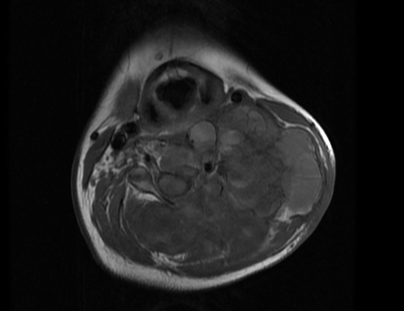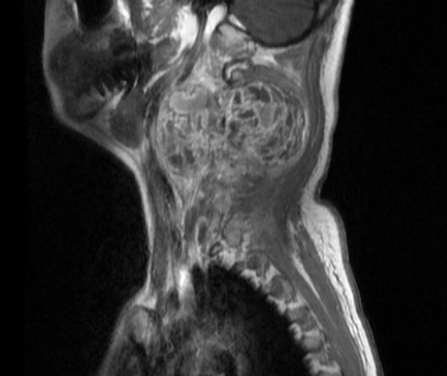
MRI images showing axial view (left) and sagittal view (right) showing features suggestive of aneurysmal bone cyst of the C2 vertebra.

The patient underwent C2–C3 laminectomy with excision of the lesion and occiput to C5 posterior fixation using rib graft along with titanium rods and screws to restore spinal stability. Histopathological examination (HPE) confirmed aneurysmal bone cyst (Figure 2).

Figure 2: Histopathology examination photomicrograph
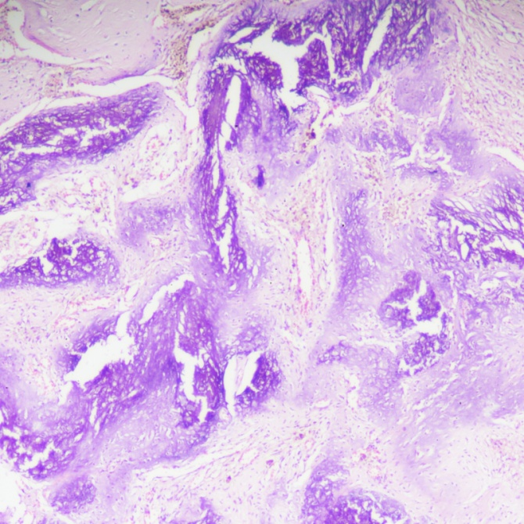
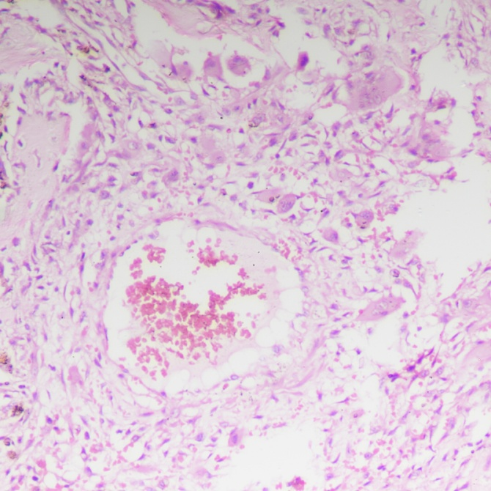
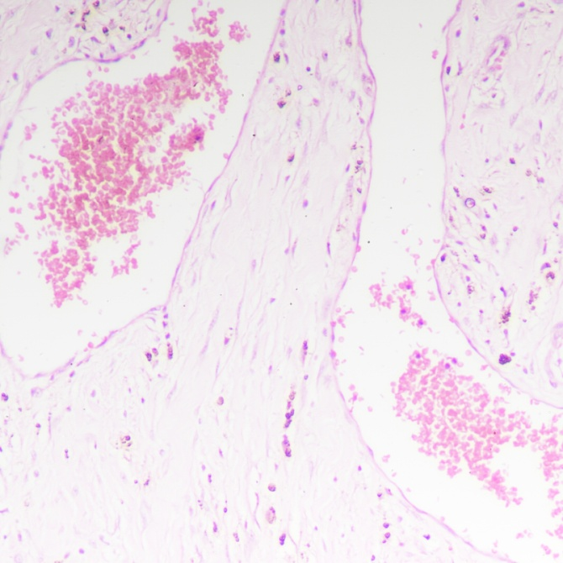

C. 40x
B. 100x
A. 100x

HPE showing cystically dilated vascular spaces (A) surrounded by cellular septa containing fibroblasts, giant cells (B) and reticulated woven bone (C).

Two months later, the patient developed progressive cervical instability and mechanical neck pain. Imaging demonstrated progressive kyphotic deformity below the initial fixation due to stress redistribution and pedicle compromise at lower cervical levels. She underwent re-exploration with right C7–D1 and left C5, C7–D1 pedicle rod and screw fixation to extend stabilization and prevent further deformity.
Postoperative MRI revealed a residual enhancing soft tissue lesion at the C2–C3 level measuring approximately 5.1 × 3.1 × 2.8 cm, abutting the thecal sac without overt cord compression, consistent with residual disease. Salvage radiotherapy was planned in view of the residual disease. Planning CT simulation demonstrated postoperative changes with metallic instrumentation and residual soft tissue mass at C2–C3. Gross tumor volume (GTV) included the residual enhancing lesion. Clinical target volume (CTV) encompassed the GTV with a 5 mm margin accounting for microscopic extension within the body and posterior elements of vertebrae, and the entire pre-operative tumor volume. Planning target volume (PTV) was made by adding an isotropic 5 mm margin.
Treatment was planned using the MONACO treatment planning system (TPS) (Elekta AB, Stockholm, Sweden). A total dose of 30 Gray (Gy) in 15 fractions (2 Gy per fraction) was delivered using 6 MV photon beams via linear accelerator employing three-dimensional conformal radiotherapy (3DCRT) (Figure 3). Spinal cord dose was maintained within tolerance, with a maximum dose below 45 Gy.
Figure 3: Radiotherapy treatment planning images
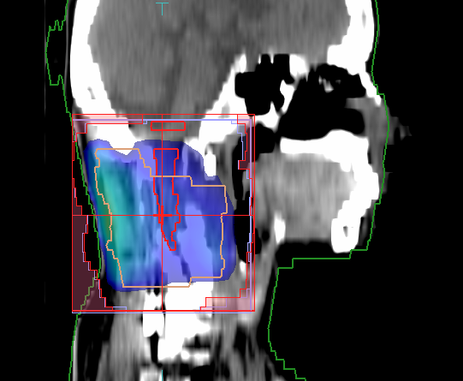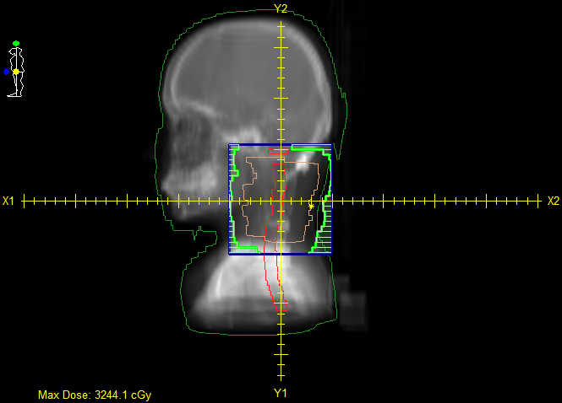
Planning images generated using the Monaco TPS showing the 3DCRT plan demonstrating target volume coverage with dose distribution (left) and beam arrangement shown (right).

Treatment was well tolerated. No acute toxicities were observed. The patient reported significant relief in neck pain and gradual improvement in lower limb strength over the course of treatment.
Three months after completion of radiotherapy, clinical assessment demonstrated improvement in motor power in both lower limbs, accompanied by complete resolution of pain. Follow-up MRI revealed a small residual lesion with no evidence of disease progression (Figure 4). The patient was lost to follow-up after that.

Figure 4: MRI comparison
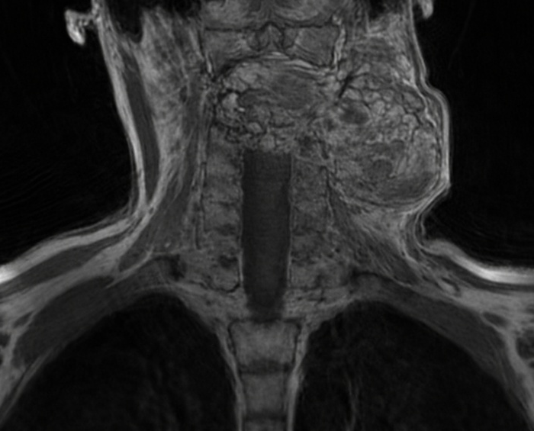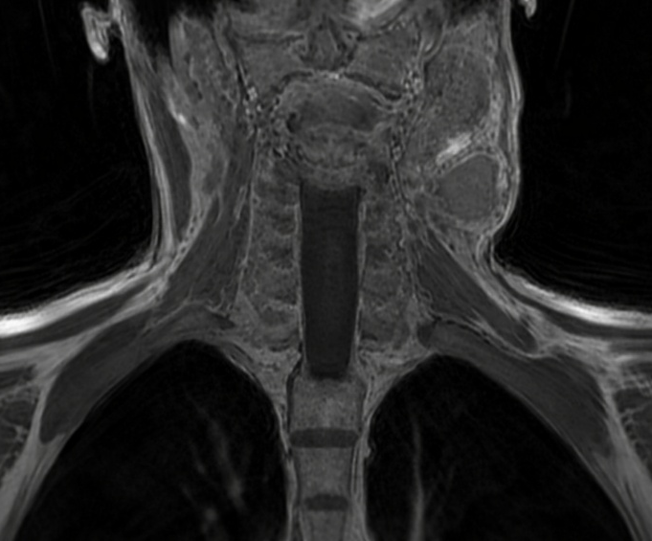
Images showing the coronal view of pre (left) and post (right) radiotherapy MRI, suggestive of partial resolution of the lesion.

DISCUSSION
The management of cervical spine ABC is challenging. Although histologically benign, its expansile and vascular nature can result in rapid growth and neurologic compromise [1,3]. Upper cervical involvement is particularly concerning because of the proximity to the cervico-medullary junction and vertebral arteries.
Surgery remains the first-line treatment, however, recurrence rates after curettage can reach 20–30%, especially in spinal lesions where complete excision is technically challenging [2,5]. In our case, complete resection was limited by anatomical constraints, leading to residual disease despite extensive decompression and stabilization.
The requirement for repeat surgery in this case highlights the mechanical implications of multilevel resection in the cervical spine. Following decompression, spine instability may require more extensive fixation, especially in developing adolescents.
Radiotherapy in ABC has historically been controversial due to concerns of radiation-induced sarcoma and growth disturbances in young patients. However, modern megavoltage radiotherapy using conformal techniques has demonstrated high local control rates of 85–90%, with a low incidence of secondary malignancy when moderate doses of 26–36 Gy are used [6–8]. Feigenberg et al. reported durable control with doses of 26–30 Gy and minimal toxicity [6].
The German Cooperative Group on Radiotherapy for Benign Diseases reported outcomes of EBRT in ABC patients treated over three decades, with a median dose of 28 Gy (range 5–40 Gy) delivered in conventional fractions. In this national registry, all patients achieved durable pain relief and radiological response, with no observed late toxicities or secondary malignancies during long-term follow-up (median 65 months). The authors concluded that fractionated doses below 30 Gy appear effective and safe for persistent or recurrent ABC, particularly in anatomically challenging locations. Similarly, recent reviews emphasize the role of radiotherapy in unresectable or recurrent ABC, particularly in axial skeleton involvement [7,8].
Given our patient’s young age, minimizing high-dose exposure was essential, so a dose of 30 Gy in 15 fractions was selected to balance tumor control with spinal cord tolerance. The role of radiotherapy in symptom control and disease stabilization is supported by clinical improvement after treatment.
Despite its effectiveness, radiotherapy should only be used sparingly because of potential long-term risks. Highly conformal dose distribution is made possible by contemporary methods like intensity-modulated radiation therapy (IMRT), 3DCRT, and image guidance, which reduce exposure to the spinal cord and surrounding organs. The risk of radiation myelopathy at doses of 26–30 Gy in conventional fractionation is extremely low when modern spinal cord tolerance constraints are respected [7].
The absence of long-term follow-up is one of the report's limitations. Nonetheless, the efficacy of salvage radiotherapy in this situation is supported by early response and neurological recovery.

CONCLUSION
Aneurysmal bone cyst of the upper cervical spine is rare and potentially neurologically devastating. Conformal radiotherapy can effectively manage residual or recurrent disease in anatomically complex regions, although surgery is still the primary treatment. When modern radiotherapy planning techniques are used, salvage radiotherapy at moderate doses offers acceptable toxicity, sufficient local control, and symptom relief.

COMPETING INTERESTS DISCLAIMER:
Authors have declared that they have no known competing financial interests OR non-financial interests OR personal relationships that could have appeared to influence the work reported in this paper.

REFERENCES
- Oliveira AM, Perez-Atayde AR, Dal Cin P, et al. Aneurysmal bone cyst: a neoplasm driven by upregulation of USP6. J Clin Oncol. 2004;22:341–347.
- Leithner A, Windhager R, Lang S, et al. Aneurysmal bone cyst: a population-based epidemiologic study. Clin Orthop Relat Res. 1999;363:176–179.
- Boriani S, De Iure F, Campanacci L, et al. Aneurysmal bone cyst of the mobile spine. Spine. 2001;26:27–35.
- Papagelopoulos PJ, Choudhury SN, Frassica FJ, et al. Treatment of aneurysmal bone cyst of the spine. J Bone Joint Surg Am. 1998;80:1674–1680.
- Mendenhall WM, Zlotecki RA, Gibbs CP, et al. Aneurysmal bone cyst. Am J Clin Oncol. 2006;29:311–315.
- Feigenberg SJ, Marcus RB Jr, Zlotecki RA, et al. Megavoltage radiotherapy for aneurysmal bone cysts. Int J Radiat Oncol Biol Phys. 2001;49:1243–1247.
- Cottalorda J, Kohler R, et al. Current strategies for the treatment of aneurysmal bone cyst. Orthop Traumatol Surg Res. 2015;101:S89–S95.
- Radiotherapy for aneurysmal bone cysts: A rare indication in modern practice. J Cancer Pract Res. 2020.

