Survival and Prognostic Factors in Ewing’s Sarcoma: Evaluating the role of radiotherapy in multimodality management

.
ABSTRACT
Background: Ewing’s sarcoma is an aggressive small round blue cell malignancy that predominantly affects children and young adults. Radiotherapy plays a central role in local control, particularly in anatomically complex or unresectable disease. This study evaluates the effectiveness and safety of radiotherapy and analyzes prognostic factors influencing overall survival and disease-free survival.
Methods: A retrospective cohort study of 51 patients with histologically confirmed Ewing’s sarcoma treated between January 2022 and December 2024 was conducted at our centre. All patients received multi-agent chemotherapy; radiotherapy was delivered with curative (adjuvant or definitive) or palliative intent. Survival outcomes were estimated using the Kaplan–Meier method, and prognostic factors were evaluated using univariate Cox proportional hazards regression. Statistical significance was set at p < 0.05.
Results: Median age was 21 years (interquartile range 14.5–28.0); 43.1% cases were in the paediatric age group. Metastatic disease at diagnosis was present in 27.5% of the cases. Radiotherapy was delivered using conformal techniques in 68.6% of patients. Median radiotherapy dose was 45 Gy. Median overall survival was 25 months, and median disease-free survival was 25 months. The 2-year overall survival was 75%. Metastatic disease at diagnosis was independently associated with inferior disease-free survival. Higher radiotherapy dose and use of conformal techniques were associated with improved survival in univariate analyses. There were no grade 3 or higher acute toxicities in the cohort.
Conclusion: Radiotherapy contributes significantly to local control and survival in Ewing’s sarcoma. Metastatic disease at presentation remains the dominant adverse prognostic factor. Optimisation of dose and advanced radiation delivery techniques may improve outcomes, though larger prospective studies are required.

Keywords: : Sarcoma, Ewing; Radiotherapy; Limb Salvage; Extracorporeal Irradiation

1. INTRODUCTION

Ewing’s sarcoma is a highly aggressive malignant tumor, characterized by primitive small round blue cells and recurrent chromosomal translocations involving the EWSR1 gene, most commonly EWSR1–FLI1 [1]. It accounts for approximately 1% of all childhood cancers, with an annual incidence of approximately 2–3 cases per million population [2]. The disease most frequently affects children, adolescents, and young adults, with peak incidence in the second decade of life [1].
Clinically, Ewing’s sarcoma most commonly arises in the bones—particularly the pelvis, femur, tibia, and ribs—but can also present in extraskeletal soft tissue sites [1,3]. Patients typically present with pain, swelling, or a pathological fracture. Approximately 20–30% of patients have metastatic disease at diagnosis, most commonly involving lungs, bone, and bone marrow [4]. The presence of metastasis at presentation remains the strongest adverse prognostic factor [4,5].
The management of Ewing’s sarcoma has evolved significantly over the past five decades. Prior to the introduction of systemic chemotherapy, survival rates were dismal, with most patients succumbing to metastatic progression [6]. The incorporation of multi-agent chemotherapy regimens such as vincristine, doxorubicin, cyclophosphamide alternating with ifosfamide and etoposide has improved long-term survival in localised disease to approximately 70–75% [7,8]. However, outcomes in metastatic and recurrent disease remain poor, with five-year survival rates below 30% [4].
Local control is achieved through surgery, radiotherapy, or a combination of both. Radiotherapy plays a critical role in several clinical scenarios: unresectable tumours, anatomically complex sites, positive surgical margins, and as definitive therapy when surgery would result in significant functional compromise [9]. With advances in radiotherapy planning and delivery, including three-dimensional conformal radiotherapy (3DCRT), intensity-modulated radiotherapy (IMRT), volumetric modulated arc therapy (VMAT), and image-guided techniques (IGRT), dose conformality has improved, reducing toxicity while maintaining tumour control [10,11].
Despite its established role, several questions remain regarding optimal dose, technique, timing, and integration with systemic therapy. Additionally, the prognostic factors influencing survival outcomes in contemporary radiotherapy-treated cohorts are not clear.
This study aims to evaluate the effectiveness and safety of radiotherapy in a retrospective cohort of patients with Ewing’s sarcoma treated at a tertiary care centre. Secondary objectives include assessment of recurrence patterns, toxicity profile, and identification of prognostic factors affecting outcomes.

2. material and methods

This retrospective cohort study was conducted between January 2022 and December 2024. Patients with a histologically confirmed diagnosis of Ewing’s sarcoma were included if they had received radiotherapy as part of their multimodal treatment and if complete clinical, treatment, and follow-up records were available. Patients were excluded from the study if they had incomplete medical records or if they had not undergone treatment with radiotherapy. A total of 51 patients fulfilled eligibility criteria.
Data were extracted from the electronic medical records of the patients. Variables collected included demographic and patient details, disease characteristics (tumour location, skeletal versus extraskeletal, metastatic status, stage), treatment details (chemotherapy regimen, number of cycles, surgery, radiotherapy dose, intent, and technique), outcomes (local control, recurrence pattern, survival) and toxicity graded according to Common Terminology Criteria for Adverse Events (CTCAE) version 5.0.
All patients received multi-agent chemotherapy. The most common regimen was vincristine, doxorubicin, and cyclophosphamide (VAC), either alone or alternating with ifosfamide and etoposide (IE) as per the Intergroup Ewing Sarcoma Study protocol [12,13]. Chemotherapy cycles ranged from 4 to 9, depending on risk stratification and response. Neoadjuvant chemotherapy was administered in 96% of patients. Adjuvant chemotherapy was delivered post-local therapy as per institutional protocol.
Surgical resection was performed in 28 patients (54.9%). Limb-sparing procedures were preferred whenever feasible. Surgical margins were assessed and radiotherapy was considered in cases of positive margins, poor histological response, or unresectable disease.
Radiotherapy was delivered with curative (adjuvant or definitive) or palliative intent. The prescribed dose was 45 Gray (Gy) in an adjuvant setting, delivered in conventional fractionation (1.8–2 Gy per fraction) using advanced techniques such as 3DCRT or VMAT. In selected definitive cases, doses approached 55–55.8 Gy. Target volumes were defined using pre- and post-chemotherapy imaging. Organs at risk were contoured according to international guidelines [11].
Overall survival was defined as the time from diagnosis to death from any cause or last follow-up. Disease-free survival was the time from completion of primary treatment to recurrence or last follow-up, and local control was defined as the absence of tumour progression at the primary site. Descriptive statistics summarised baseline characteristics. Survival analyses were performed for OS and DFS. Time-to-event endpoints were estimated using the Kaplan–Meier method, and survival differences between groups were compared using the log-rank test. Prognostic factors were evaluated using Cox proportional hazards regression. Univariate Cox models were constructed to estimate hazard ratios (HRs) with 95% confidence intervals (CIs) for demographic, disease-related, and treatment-related variables. A two-sided p-value < 0.05 was considered statistically significant. All statistical analyses were performed using Python.

3. results and discussion

A total of 51 patients with Ewing's Sarcoma were included in the study. The median age was 21 years (IQR 14.5–28.0). Twenty-two patients (43.1%) were paediatric (<18 years). Males constituted 60.8% of the cohort.
Skeletal tumours accounted for 86.3%, while 13.7% were extraskeletal. The most common location was the dorso-lumbar vertebrae (Figure 1). Fourteen patients (27.5%) presented with metastatic disease (Stage IV), with the brain being the most common site of metastasis (Figure 2). Localised disease (Stage I–II) was observed in 72.5%. The demographic and clinical characteristics of the cohort are summarized in Table 1.
Figure 1: Distribution of tumor location in the cohort.
Figure 2: Common sites of distant metastasis in the cohort

Table 1: Demographic and Clinical Characteristics of Patients with Ewing's Sarcoma
Characteristic | N
Demographics
Age (years), median (IQR) | 21.0 (14.5-28.0)
Age group
Paediatric | 22 (43.1%)
Young adult/adult | 29 (56.9%)
Sex
M | 31 (60.8%)
F | 20 (39.2%)
Disease characteristics
Tumor location (skeletal vs extraskeletal)
Skeletal | 44 (86.3%)
Extraskeletal | 7 (13.7%)
Presentation
Localized at diagnosis | 37 (72.5%)
Metastatic at diagnosis | 14 (27.5%)
Stage at diagnosis (AJCC)
Stage I | 26 (51.0%)
Stage II | 11 (21.6%)
Stage III | 0 (0.0%)
Stage IV | 14 (27.5%)
^{M= male, F= female}
All patients received chemotherapy, with a majority receiving the VAC regimen (80.4%). The number of cycles varied between 4 and 9, with the majority of the patients receiving 6 cycles of chemotherapy. Surgery was performed in 28 patients. Twenty-five patients underwent tumour resection, and 3 underwent limb amputation. Radiotherapy was delivered using conformal techniques in 68.6% of patients. The treatment protocols are summarised in Figure 5. The VMAT technique was the most commonly used for radiotherapy (Figure 3A and B). A total of 55.8 Gy was delivered in 31 fractions for definitive treatment, while 45 Gy was administered in 25 fractions for adjuvant therapy. One case of left distal femur Ewing’s sarcoma was treated with extracorporeal radiotherapy (ECRT). After wide resection of the tumor-bearing femoral segment, the specimen was wrapped in sterile saline-soaked gauze, transported to the radiation suite, and irradiated ex vivo to 50 Gy in a single fraction using megavoltage (MV) photons to sterilize residual microscopic disease while preserving the structural integrity of the bone. The devitalized segment was then reimplanted, thereby achieving oncologic clearance while maintaining limb length and function as part of a limb-salvage strategy (Figure 4). Most cases of palliative radiotherapy were planned using 3DCRT. The doses varied, typically ranging from 20 Gy in 5 fractions to 30 Gy in 10 fractions. Treatment characteristics of the cohort are summarized in Table 2.

Figure 3: VMAT Planning for Ewing’s sarcoma
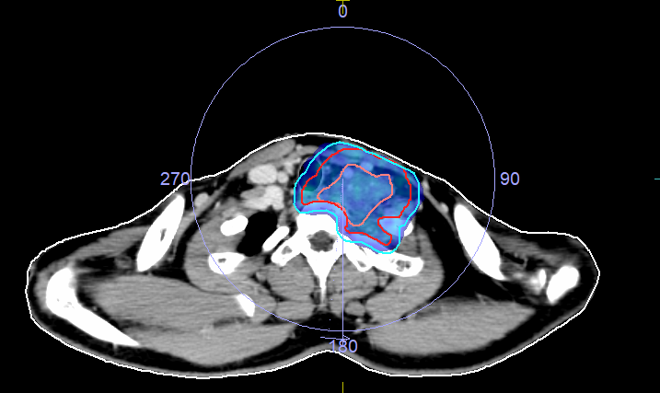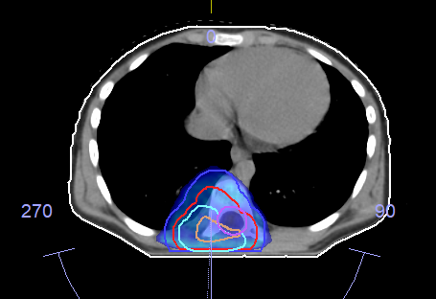
(A) Axial CT image of a VMAT plan for Ewing’s sarcoma in the left supraclavicular region, showing the gross tumor volume (GTV) in light red, clinical target volume (CTV) in red, and planning target volume (PTV) outlined in blue. The plan features a 360° arc arrangement and optimal target coverage while sparing adjacent critical structures. B) Axial CT image of a VMAT plan for Ewing’s sarcoma in the dorsal vertebra, with the GTV in light red, CTV in red, and PTV in dark blue. The isodose colorwash indicates sufficient target coverage while adhering to dose constraints for nearby critical structures, including the spinal cord.

Figure 4: 3DCRT plan for extracorporeal radiotherapy (EC-RT) of the left distal femur.
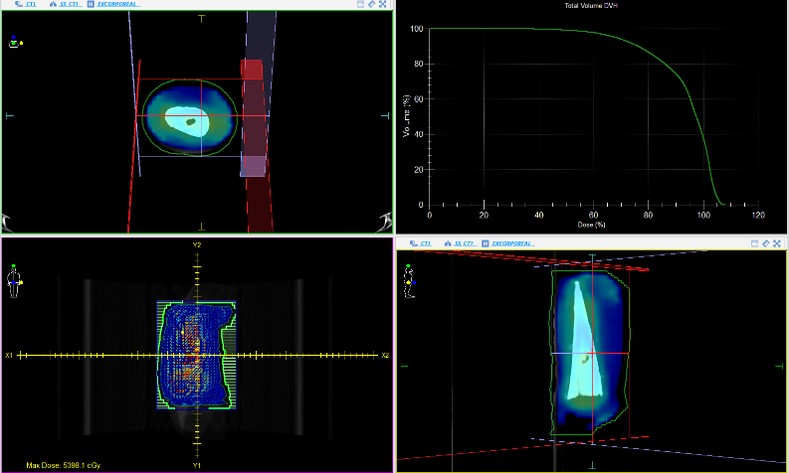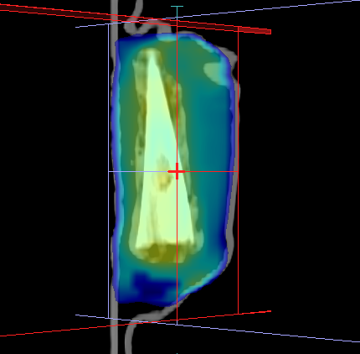
Top left: (A) Axial CT slice demonstrating the isodose distribution (85% to 120%). Top right: Dose–volume histogram (DVH) depicting target coverage and dose homogeneity within the PTV. Bottom left: Coronal beam’s-eye-view illustrating field shaping with multileaf collimator margins around the distal femur. Crosshairs indicate isocentre placement. (B) Sagittal reconstruction showing longitudinal dose distribution along the resected femoral segment.

Figure 5: Treatment Protocols

Figure 6: 3DCRT Planning for Ewing’s sarcoma
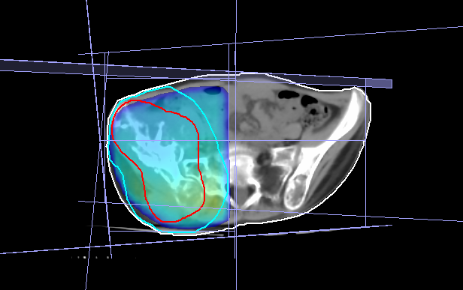
Axial planning CT image showing a 3DCRT plan for palliative treatment of iliac bone metastasis from Ewing’s sarcoma, using one anterior and two oblique photon beams. The GTV is outlined in red, with the PTV in blue.

Table 2: Treatment Characteristics
Treatment | N (%)
Chemotherapy regimen
VAC | 31 (60.8%)
VAC-IE | 20 (39.2%)
Surgery performed
Yes | 28 (54.9%)
No | 23 (45.1%)
Radiotherapy intent
Adjuvant Curative | 27 (52.9%)
Palliative | 14 (27.5%)
Definitive Curative | 10 (19.6 %)
Radiotherapy technique group
VMAT | 35 (68.6%)
3DCRT | 16 (31.4%)
VAC= vincristine, doxorubicin, and cyclophosphamide, IE= ifosfamide and etoposide, VMAT= volumetric modulated arc therapy, 3DCRT= three-dimensional conformal radiotherapy
The median follow-up duration was 28 months. The median OS was 25 months (IQR 20.5–29.0) with a median DFS of 25 months (IQR 11.0–29.0). Local control was achieved in 37 patients (72.5%), and the 2-year OS was 75%. 8 out of the 14 patients who presented with metastasis and received palliative radiotherapy died within 24 months of treatment. 1 out of 37 patients treated with curative intent died within 24 months of treatment due to a disease-related cause. The treatment outcomes are summarised in Table 3.

Table 3: Survival outcomes and toxicities.
Outcomes | n
Local control achieved
Yes | 37 (72.5%)
No | 14 (27.5%)
Recurrence pattern
No recurrence | 34 (66.7%)
Metastatic | 14 (27.5%)
Local | 3 (5.9%)
OS (months), median (IQR) | 25.0 (20.5-29.0)
DFS (months), median (IQR) | 25.0 (11.0-29.0)
Acute toxicity
Yes | 35 (68.6%)
No | 16 (31.4%)
Most common acute toxicity types
Dermatitis | 15 (29.4%)
Fatigue | 7 (13.7%)
Loss of appetite | 7 (13.7%)
Dermatitis | 6 (11. 8%)
OS= overall survival, DFS= disease-free survival
Univariate Cox proportional hazards analysis identified several factors significantly associated with OS. Higher radiotherapy dose was associated with improved OS (HR 0.84 per Gy increase; 95% CI 0.77-0.93; P = .001). The use of advanced radiotherapy techniques demonstrated a significant survival benefit compared with conventional techniques (HR 0.03; 95% CI 0.0-0.28; P = .002). Complete surgical resection of the primary tumour was also associated with improved OS (HR 0.08; 95% CI 0.01-0.64; P= .018).
On univariate Cox proportional hazards analysis, increasing radiotherapy dose, analysed as a continuous variable per Gy, was significantly associated with improved DFS (HR 0.87 per Gy increase; 95% CI 0.82–0.92; P =.001). Similarly, surgical resection (HR 0.11; 95% CI 0.03–0.40; P= .001), utilisation of advanced radiotherapy techniques (HR 0.05; 95% CI 0.01–0.17; P=.001), and combined-modality treatment (radiotherapy plus other modalities versus radiotherapy alone) (HR 0.06; 95% CI 0.02–0.21; P= .001) were each significantly associated with superior disease-free survival. In contrast, age (HR 1.01; 95% CI 0.96–1.06; P= 0.74), and sex (HR 0.56; 95% CI 0.21–1.44; P= 0.23) were not significantly associated with disease-free survival on univariate analysis. There was no recurrence in 66.7% of the patients. 27.5% patients had metastatic recurrence, and 5.9% had local recurrence in the follow- up period.
Acute grade 1–2 toxicities occurred in 68.6% of the cohort. The most common was dermatitis (29.4%), followed by fatigue (13.7%). No grade 3 or higher toxicity was documented.
In our single-centre cohort of 51 patients with Ewing’s sarcoma, radiotherapy emerged as a central determinant of disease control within a multimodality framework. With a 2-year OS of 75% and local control achieved in 72.5% of patients, our outcomes align with previously reported institutional and cooperative group experiences in predominantly localised disease settings [7,9,14]. Although direct comparison is limited by heterogeneity in stage distribution and follow-up duration, these findings reaffirm that modern radiotherapy remains foundational in achieving durable remission.
Metastatic disease at presentation remained the dominant adverse prognostic factor in our cohort, consistent with data from the Euro-EWING 99 and Children’s Oncology Group trials [4,7]. In our study, more than half of patients with metastatic disease who received palliative radiotherapy died within 24 months, underscoring the biological aggressiveness of disseminated Ewing’s sarcoma.
The pattern of metastatic spread observed in our research—mainly affecting the central nervous system and bones—shows some variation from traditional accounts that highlight lung and bone marrow involvement as being more common. [4]. This may reflect referral patterns or imaging practices in our region. Nonetheless, the significance of metastatic disease in prognosis is clear. It emphasizes the necessity for risk-adapted intensification strategies and novel systemic approaches in this subgroup.
One of the most striking findings of this analysis is the statistically significant association between higher radiotherapy dose and improved overall and disease-free survival. Each incremental Gy was associated with a measurable reduction in hazard for both endpoints. While retrospective in nature, this dose–response signal aligns with prior reports suggesting superior local control with doses ≥45–50 Gy in definitive settings [9,15].
From a radiobiological perspective, Ewing’s sarcoma is generally considered radiosensitive; however, local failure remains a concern in bulky or poorly responding tumours, and total dose escalation may compensate for residual burden after chemotherapy. Importantly, in our cohort, definitive cases received up to 55.8 Gy, which may have contributed to durable control in anatomically challenging sites such as the spine.
However, the observed association between dose and survival may partly reflect treatment selection bias: patients eligible for higher curative doses were likely to have localised disease and better performance status. Prospective validation is required before advocating routine dose escalation beyond established standards.
Modern conformal techniques enable improved planning target volume coverage, reduction of high-dose spillage into adjacent organs at risk, and better sparing of growth plates, spinal cord, bowel, and gonadal structures. The use of the advanced VMAT technique demonstrated a profound association with improved survival outcomes in univariate analysis. Despite the clinical rationale of this observation, it must be interpreted within the context of sample size and potential confounding.
Prior studies have demonstrated improved dosimetric conformity and acceptable toxicity profiles with IMRT in Ewing’s sarcoma, particularly for pelvic and axial primaries [10,16]. In anatomically complex regions, such as the spine and supraclavicular fossa in our cohort, VMAT facilitates homogeneous dose distribution while respecting the spinal cord. Additionally, advanced techniques could allow for the safe dose increment, thus strengthening the noted dose–response relationship.
Surgical resection was significantly associated with improved overall and disease-free survival in our analysis. This observation strengthens the accepted understanding that optimal outcomes in Ewing's sarcoma are achieved with multimodality management. [7,9].
Surgery offers several advantages, including immediate cytoreduction, histopathological response assessment, and margin status evaluation. The combination of surgery and adjuvant radiotherapy demonstrated favourable DFS compared with radiotherapy alone, reflecting the importance of consolidative local therapy in high-risk features such as positive margins or suboptimal histologic response.
In select cases, extracorporeal radiotherapy can be employed to sterilise the entire resected bone segment before reimplantation. Though limited to a single patient in this cohort, this approach exemplifies innovation in limb-preserving strategies.
Acute toxicities were predominantly grade 1–2, with dermatitis and fatigue being the most common. No grade ≥3 acute events or significant late toxicities were documented during follow-up. These findings are consistent with modern series utilising conformal planning [10,16]. However, the median follow-up of 28 months limits assessment of late effects, particularly relevant in paediatric cases, and vigilant toxicity monitoring remains essential.
Our 2-year overall survival of 75% aligns closely with the results seen in interval-compressed chemotherapy regimens for localized disease [7]. The poor survival in metastatic patients mirrors international data demonstrating <30% 5-year survival in disseminated disease [4,8].
The local control rate of 72.5% slightly lower compared to results observed in radiotherapy-based series [9,14]. Differences may reflect anatomical distribution as our cohort included a notable proportion of axial and vertebral tumours, traditionally associated with higher local failure risk.
Molecularly targeted therapies and immunotherapeutic strategies aimed at disrupting EWSR1–FLI1-driven oncogenesis are under investigation [1,17]. Future integration of targeted systemic agents could potentially alter survival rates more significantly than improvements in local treatment alone.
There are several limitations in our study. The retrospective design introduces inherent selection bias and potential confounding. The sample size limits multivariate analysis, and the short follow-up precludes assessment of late toxicity and long-term survival. Additionally, heterogeneity in treatment intent among cases may influence survival interpretation.
The pronounced hazard ratios observed for some variables are not precise effect estimates as they reflect small event numbers. Rather, they signal the direction of association.
Prospective multicentre registries incorporating molecular risk stratification and standardised radiotherapy protocols are needed. Randomised evaluation of dose intensification strategies or integration of novel systemic agents could refine treatment algorithms.
As survival improves, the burden of late toxicity and quality-of-life outcomes becomes increasingly relevant, particularly in young patients, so survivorship research must remain a priority.

4. Conclusion

Our findings support the significant role of radiotherapy in Ewing’s sarcoma. While metastatic disease at diagnosis remains the dominant adverse prognostic factor, meticulous optimisation of local therapy through appropriate dose, advanced delivery techniques, and coordinated surgical integration shows promising associations with improved outcomes. However, confirmation in larger prospective studies is necessary.

COMPETING INTERESTS DISCLAIMER:
Authors have declared that they have no known competing financial interests OR non-financial interests OR personal relationships that could have appeared to influence the work reported in this paper.

References

- Grünewald TGP, Cidre-Aranaz F, Surdez D, et al. Ewing sarcoma. Nat Rev Dis Primers. 2018;4:5.
- Gaspar N, Hawkins DS, Dirksen U, et al. Ewing sarcoma: Current management. J Clin Oncol. 2015;33:3036–3046.
- Balamuth NJ, Womer RB. Ewing’s sarcoma. Lancet Oncol. 2010;11:184–192.
- Ladenstein R, Pötschger U, Le Deley MC, et al. Euro-EWING 99 trial. J Clin Oncol. 2010;28:3284–3291.
- Leavey PJ, Mascarenhas L, Marina N, et al. Prognostic factors at recurrence. Pediatr Blood Cancer. 2008;51:334–338.
- Nesbit ME, Gehan EA, Burgert EO, et al. Multimodal therapy trials. Cancer. 1990;65:157–164.
- Womer RB, West DC, Krailo MD, et al. Interval-compressed chemotherapy. J Clin Oncol. 2012;30:4148–4154.
- Bernstein ML, Devidas M, Lawrence W, et al. Metastatic Ewing tumor study. J Clin Oncol. 2006;24:152–159.
- Paulussen M, Ahrens S, Dunst J, et al. Role of radiotherapy. Int J Radiat Oncol Biol Phys. 2001;51:948–958.
- Casey DL, Wexler LH, Moskowitz CS, et al. Radiotherapy outcomes. Int J Radiat Oncol Biol Phys. 2009;74:1141–1146.
- Timmermann B, et al. Modern radiotherapy planning. Radiother Oncol. 2010;95:1–7.
- Burgert EO Jr, Nesbit ME, Garnsey LA, Gehan EA, Herrmann J, Vietti TJ, et al. Multimodal therapy for the management of nonpelvic, localized Ewing’s sarcoma of bone: Intergroup Study IESS-II. J Clin Oncol. 1990;8(9):1514–24.

