Original Research Article
Chemical analysis of soil samples to evaluate the soil fertility status of semi-arid region of three taluks of Tumakuru district, Karnataka

ABSTRACT
A study was conducted to assess the fertility status of surface soils from three representative taluks (Gubbi, Madhugiri and Sira) based on their agro-climatic zones, using descriptive statistics, a nutrient index, and correlation analysis of important soil properties. Thirty-four surface soil samples (0-30 cm depth) were collected from fields of farmers, studied for pH, electrical conductivity (EC), organic carbon (OC), available N, P, K, Ca, Mg, S, Cu, Zn, Mn, and Fe. Soil pH varied between 4.7 and 8.9 (mean = 7.3), EC ranged from 0.01 to 0.72 dS m⁻¹ (mean = 0.21 dS m⁻¹), and OC was between 0.35 and 1.18% (mean = 0.59%); thus, most soils were classified as non-saline, neutral to slightly alkaline, with low to medium organic matter content. Nutrient Index (NI) values showed medium fertility (NI 1.8), while N, P, K, Ca, and Mg had low fertility; S, Cu, Zn, Mn, and Fe reflected high NI values, indicating generally adequate secondary and micronutrient status. Results of correlation analysis indicated positive relationships between several cations and micronutrients as well as strong associations between Ca and S, while OC and Mg tended to be negatively correlated with Fe. The results indicate that N, P, K, and base cations are the principal limitations in selected taluks of Tumakuru and recognize the importance of adequate management of organic matter and balanced fertilization for sustainable yields.

Keywords: Tumakuru district, soil fertility, nutrient index, macronutrients, micronutrients
- INTRODUCTION
Soil, alongside air and water, plays a crucial role in ecosystems and is essential for supporting life on Earth. Being a non-renewable resource, soil acts as a reservoir of vital nutrients and a habitat for microorganisms that sustain life [15]. It supports key biogeochemical processes such as organic matter decomposition, nutrient cycling, and carbon sequestration, which in turn sustain soil fertility, crop yields, and climate regulation [6]. Various factors like temperature, parent material, agricultural practices, rainfall, human activities, fertilizer usage, cropping methods, microorganisms, and geographical conditions can influence the properties of soil. The excessive exploitation of natural resources for agriculture, including land and water, is leading to significant damage to soil ecosystems. Agricultural activities, in an effort to increase yields, have depleted soils of nutrients and caused the emergence of nutrient deficiencies. The health of the soil is a crucial factor in determining desired yield levels. Changes in the physical and chemical properties of soil due to heavy metal accumulation can reduce crop yields, especially in rapidly urbanizing areas, thus worsening food insecurity. Soil organic matter is pivotal for long-term conservation and restoration efforts, as it enhances soil fertility by improving soil properties.
Soil fertility is a critical factor that governs agricultural sustainability as the availability of essential nutrients not only supports plant growth and crop yield but also maintains long-term soil health. Proper application of organic manure, fertilizers, and strategic crop rotation can help to maintain soil fertility. Land use practices and management affect nutrient availability in soil for plant uptake [4, 18]. Soil testing categorizes measured nutrient levels as low, medium, or high, which aids in estimating crop response to fertilizers. Crop diversification, particularly with legumes, can enhance soil fertility by promoting biological nitrogen fixation and reducing reliance on synthetic nitrogen fertilizers [16]. Several studies in the Indian semi-arid tropics have shown a decline in soil organic carbon levels and widespread deficiencies in primary nutrients like nitrogen and phosphorus due to continuous cultivation with low organic inputs [3, 12, 19]. This study assesses the fertility status of Gubbi, Madhugiri, and Sira taluks of Tumakuru district and key soil properties to pinpoint major nutrient limitations for sustainable crop production.
- MATERIAL AND METHODS
  - Study area
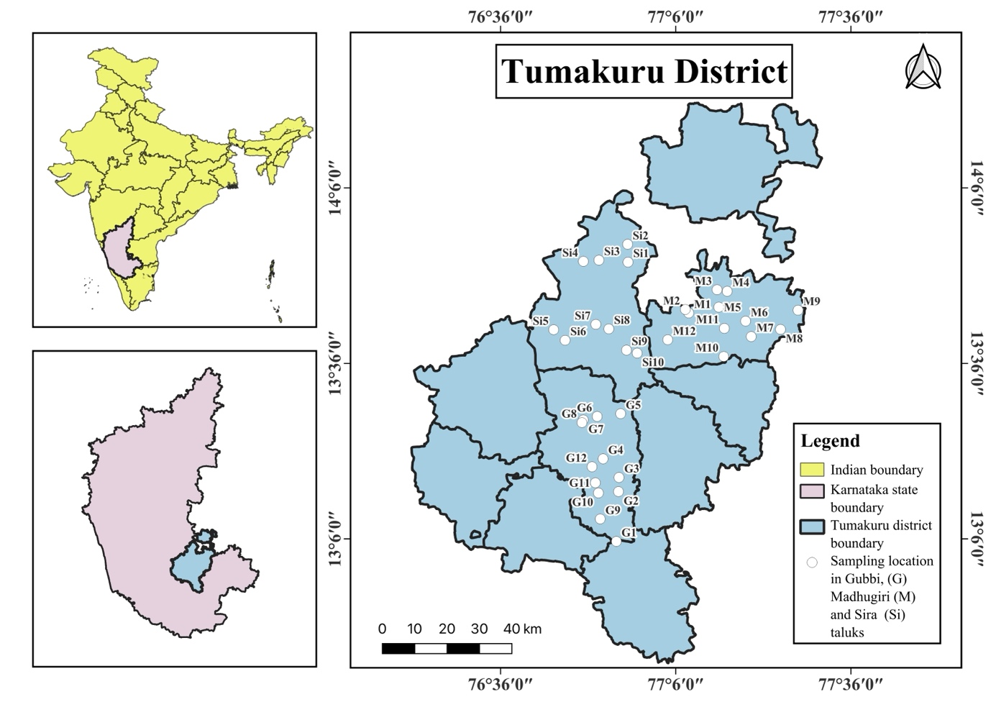
Fig. 1. Map showing the details of sampling locations in the study area
Tumakuru district lies in the southeastern part of Karnataka and experiences a semi-arid climate with hot summers, with an annual rainfall of 1016 mm and a predominance in rainfed agriculture. Three taluks- Gubbi (Southern dry zone- Zone 6), Madhugiri, and Sira (Central dry zone- Zone 4) were selected as fall under different agroclimatic zones. From these taluks, 12 surface soil samples were collected from Gubbi, 10 from Sira, and 12 from Madhugiri.
  - Soil sampling and analysis
From the 3 regions, a total of 34 surface soil samples were collected from farmers' fields at a depth of 0-30 cm. Subsequently, these samples were air-dried, gently crushed, and sieved through a 2 mm mesh before undergoing analysis. Soil pH and electrical conductivity (EC) were determined in water using a soil-to-solution ratio of 1:2.5 [5]. Soil organic carbon was assessed using the volumetric method as described by Walkley and Black [17]. Available nitrogen was determined by the alkaline potassium permanganate method developed by Subbaiah and Asija [14], while available phosphorus was measured using both Bray’s [1] and Olsen’s [10] methods suitable for acidic and alkaline soils, respectively. Available potassium was quantified through the flame photometric method outlined by Jackson [5]. Exchangeable calcium and magnesium levels were determined through a neutral ammonium acetate extraction procedure [5]. Available sulphur content was measured using the turbidimetric method specified by Chesin and Yien [2]. Lastly, soil micronutrients were extracted using DTPA and analyzed using atomic absorption spectrometry in accordance with the method described by Lindsay and Norvell [7].
2.3 Nutrient Index
The nutrient status considers the availability of nutrients in soil. To compare the levels of soil fertility of one area with another, a single value can be obtained through the nutrient index. For each nutrient, soil test values were grouped into low, medium, and high classes using standard rating limits. The nutrient index in soil was evaluated for the soil samples analyzed using the formula [8].
Nutrient Index (N.I) = (NL × 1 + NM × 2 + NH × 3) / NT
where NL indicates the number of samples falling in the low class of nutrient status; NM indicates the number of samples falling in the medium class of nutrient status; NH indicates the number of samples falling in the high class of nutrient status; and NT indicates the total number of samples analyzed for a given area. Later the obtained results were interpreted by comparing with the rating chart given in Table 1.
Table 1. Nutrient Index with range and remarks [11]
Nutrient index | Range | Remarks
I | <1.67 | Low
II | 1.67-2.33 | Medium
III | >2.33 | High

  - Statistical analysis
For all soil properties, minimum, maximum, and mean were calculated. Pearson correlation coefficients were computed to examine relationships among soil parameters. A correlation heatmap was generated using R software, with cell colors indicating the magnitude and sign of r and significance levels denoted by "ns" (not significant), * for P = 0.05, ** for P = 0.01, and *** for P < 0.001.
3. RESULTS AND DISCUSSION
The results of physico-chemical properties, macronutrients and micronutrients of soil samples, from three different taluks of Tumakuru district are given in Table 2.
3.1 Basic soil properties and macronutrient status
Soil pH in the selected taluks ranged from 4.7 to 8.9, with a mean of 7.3, indicating a neutral to moderately alkaline category in the surface soil. EC values varied from 0.01 to 0.72 dS m⁻¹, with a mean of 0.21 dS m⁻¹, which confirms that salinity is not a problem, making these areas ideal for crop growth because there is little salt deposition due to precipitation and low evaporation demand [9]. Organic carbon content ranged from 0.35 to 1.18%, with a mean of 0.59%, reflecting low to medium organic matter levels.
Available nitrogen ranged from 101 to 458 kg/ha, with a mean of 245 kg/ha, while available P spanned a wide range from 0.23 to 55.77 kg/ha (mean 4.72 kg/ha) [8]. Available potassium varied between 6.85 to 147.19 kg/ha with a mean of 55.32 kg/ha, indicating that many soils fall in low to medium categories of these macronutrients. Studies emphasize that nutrient mining under rainfed conditions, low and imbalanced fertilizer use, and strong P fixation are the main reasons why semi-arid soils commonly show low to medium NPK status [15].
3.2 Secondary and micronutrient status
Exchangeable calcium and magnesium had an average of 3.19 and 0.72 cmol(p+)/kg⁻¹, and most of the samples fell in the low to medium range [20]. Long-term textured experiments in Indian rainfed systems show that intensive cropping with only NPK fertilizers and little or no organic inputs can result in negative Mg balances and declining exchangeable Mg, especially in lighter or low-clay soils [13]. Available sulphur ranged from 15.72 to 97.98 mg kg⁻¹ with a mean value of 41.39 mg kg⁻¹, where the majority fell into the high class [21]. Micronutrient concentrations also exhibited various wide ranges: Cu (0.36-4.2, mean 1.5 mg kg⁻¹), Zn (0.2-8.0, mean 1.6 mg kg⁻¹), Mn (1.46-111.39, mean 16.4 mg kg⁻¹), and Fe (1.68-12.24, mean 12.24 mg kg⁻¹). Overall the micronutrients were sufficient with respect to critical limits [7].
3.3 Nutrient index and fertility class
The nutrient index provides the fertility status across the sample locations, as mentioned in Table 3, N, P, K, Ca, and Mg showed low fertility with 1.3, 1.0, 1.0, 1.1, and 1.6, respectively. This indicates the inadequate macronutrients and exchangeable cations being the constraints in Gubbi, Sira, and Madhugiri taluks. Sulphur, copper, zinc, manganese, and iron exhibited high NI of 3.0, 3.0, 2.5, 2.9, and 2.7, respectively, indicating sufficient availability of these nutrients. Only organic carbon exhibited a medium fertility class with 1.8 of the nutrient index. These results show that while micronutrients are sufficient, the deficiency of macronutrients highlights the importance of balanced fertilization and organic matter management.
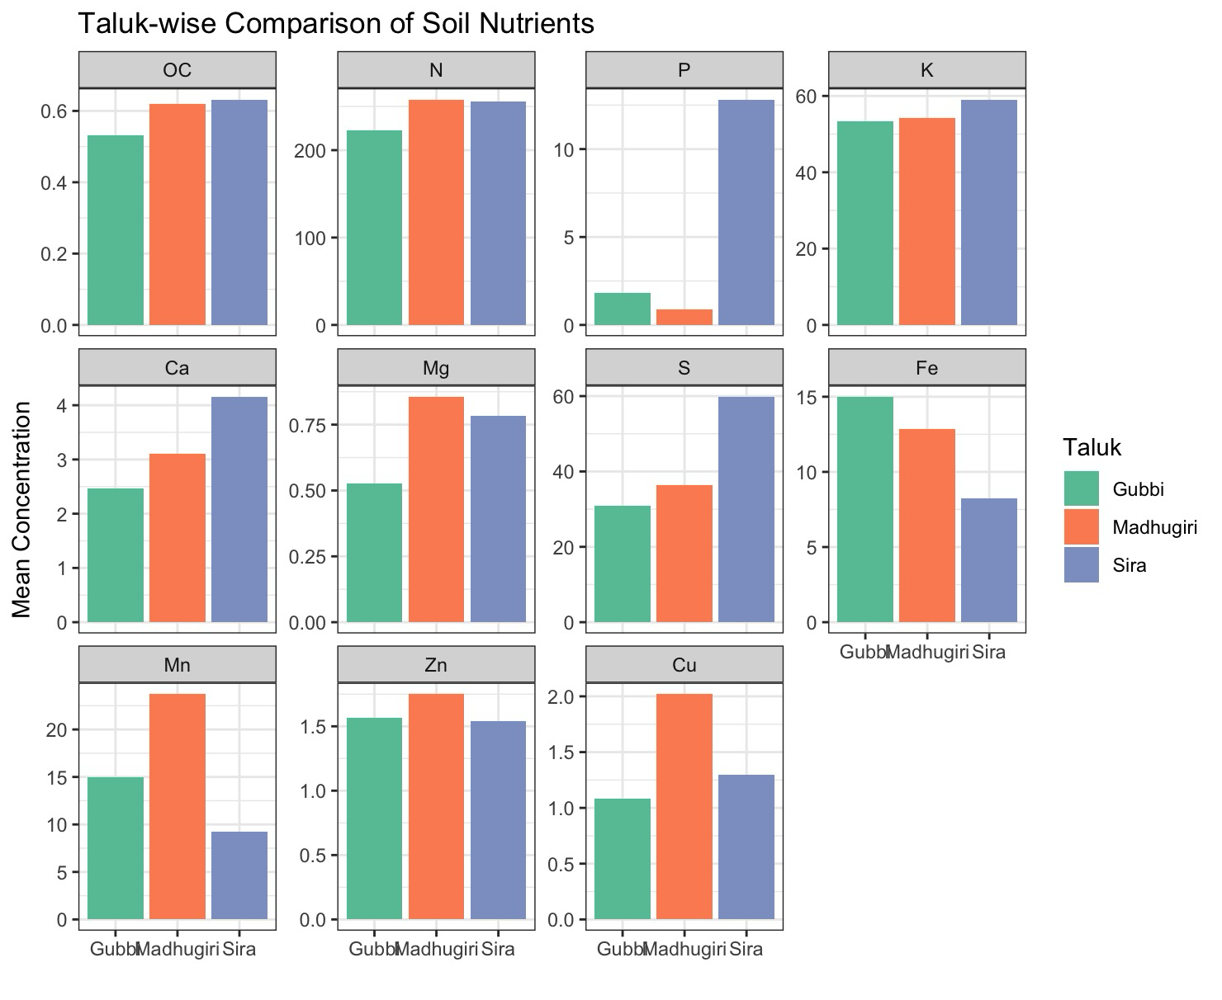
Fig. 2. Taluk-wise comparison of mean soil nutrient concentrations across Gubbi, Madhugiri, and Sira taluks of Tumakuru district

Table 2. Statistics of physico-chemical properties of soils from Tumakuru district
Parameters | Minimum | Maximum | Mean
pH | 4.7 | 8.9 | 7.3
EC | 0.01 | 0.72 | 0.21
Organic Carbon (%) | 0.35 | 1.18 | 0.59
Available and exchangeable macronutrients
Available. Nitrogen (kg/ha) | 101 | 458 | 245
Available Phosphorus (kg/ha) | 0.23 | 55.8 | 4.72
Available Potassium (kg/ha) | 6.85 | 147 | 55.3
Exchangeable calcium [cmol(p⁺)/kg] | 1.92 | 6.95 | 3.19
Exchangeable magnesium [cmol(p⁺)/kg] | 0.13 | 1.44 | 0.72
Available Sulphur (mg/kg) | 15.7 | 98 | 41.4
DTPA extractable micronutrients
Cu (mg/kg) | 0.36 | 4.2 | 1.48
Zn (mg/kg) | 0.21 | 7.9 | 1.62
Mn (mg/kg) | 1.46 | 111.39 | 16.38
Fe (mg/kg) | 1.68 | 12.24 | 12.24
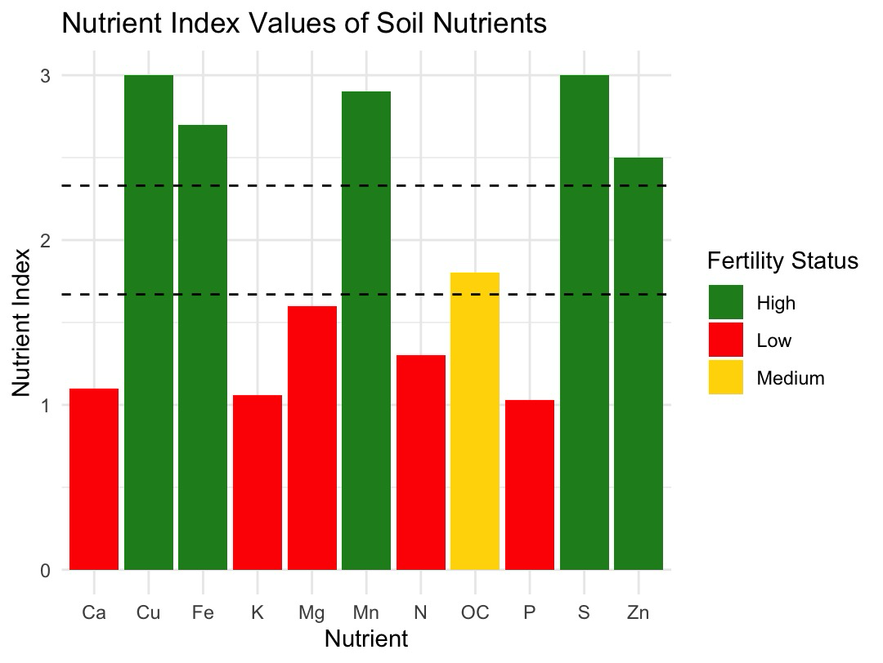
Fig. 3. Nutrient index values of major soil nutrients indicating fertility status across the study area
Table 3. Soil nutrient index values of different taluks in Tumakuru district
Sl No | Available nutrients | Nutrient Index | Category
1 | Organic Carbon | 1.8 | Medium
2 | Nitrogen | 1.3 | Low
3 | Phosphorus | 1.0 | Low
4 | Potassium | 1.1 | Low
5 | Calcium | 1.1 | Low
6 | Magnesium | 1.6 | Low
7 | Sulphur | 3.0 | High
8 | Copper | 3.0 | High
9 | Zinc | 2.5 | High
10 | Manganese | 2.9 | High
11 | Iron | 2.7 | High

3.4 Correlation relationships among soil properties
Correlation analysis helped to elucidate linkages among soil properties. Soil pH showed moderate positive relationships with EC (r = 0.33), Mg (r = 38, P = .05), and Cu (r = 0.35, P = .05) nutrients, indicating that the higher the pH, the EC, Mg, and Cu properties will also increase. EC exhibited a strong positive correlation with P (r = 0.57, P < 0.001), Ca (r = 0.43, P = .05), and S (r = 0.41, P = .05), showing that higher soluble salt content is associated with increased levels of these nutrients, possibly due to fertilizer inputs or accumulation. OC showed a moderate positive correlation with K (r = 0.35, P = .05) and a strong one with Mg (r = 0.58, P < 0.001), suggesting that soils with higher organic matter tend to retain more Mg and support K availability. Available nitrogen showed a negligible weak correlation with all other properties, except Zn (r = 0.31), a weak positive correlation. Available phosphorus also showed weak relations, except for K (r = 0.38, P = .05), which is a moderate positive correlation, and a moderate negative correlation with Fe (r = -0.32).
Exchangeable calcium showed a moderate relation with Mg (r = 0.41, P = .05) and a very strong correlation with S (r = 0.8, P < 0.001), indicating the increasing concentration of Mg and S with higher Ca, which reflects common parent material or similar management practices. While exchangeable magnesium exhibited a positive relationship with Cu (r = 0.41, P = .05) and a strong negative relationship with Fe (r = -0.60, P < 0.001), indicating the decrease in concentration of Fe with an increase in Mg. Sulphur showed a positive relation with Zn (r = 0.31), while copper showed a positive relation with Mn (r = 0.33). P and Fe displayed negative correlations with most soil properties. Micronutrients showed several moderate positive relationships, Cu with Mg and Ca, and Zn with N and S, indicating that improvements in soil organic matter and base cation status are likely to enhance micronutrient availability. Overall, the correlation patterns support the nutrient index and highlight the importance of managing organic carbon and macronutrients, particularly N, P, K, and Ca-Mg, to improve overall soil fertility in the selected Tumakuru taluks.
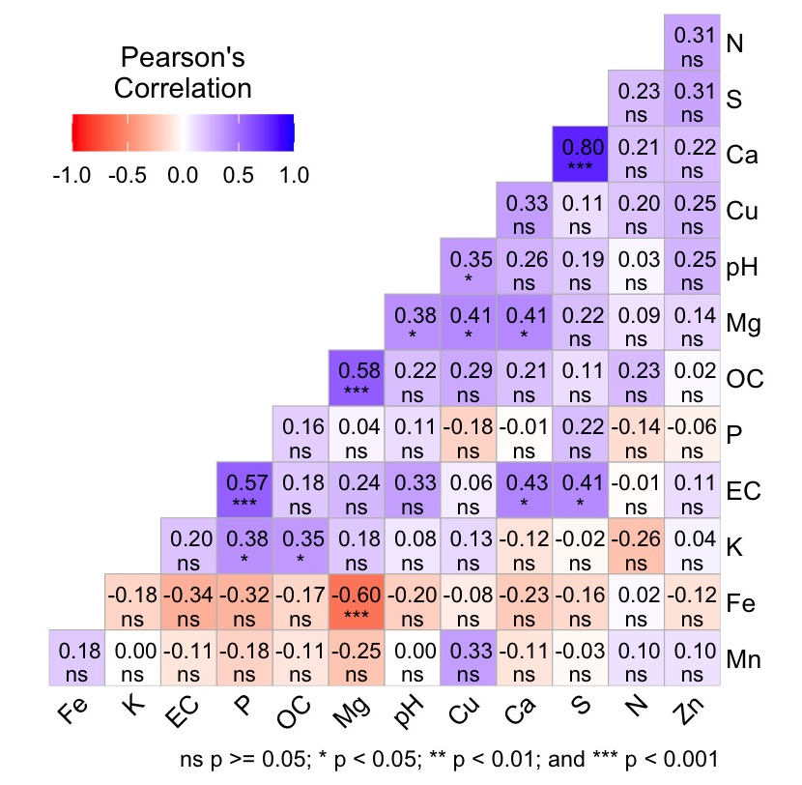
Fig. 4. Pearson Correlation heatmap of soil properties in selected taluks of Tumakuru district
- CONCLUSION
Soils from Gubbi, Madhugiri, and Sira taluks of the Tumakuru district are predominantly non-saline and near neutral to slightly alkaline, with low to medium organic carbon levels. Nutrient index values identify N, P, K, Ca, and Mg as the major fertility constraints, while S and the micronutrients Cu, Zn, Mn, and Fe were generally in the high fertility class. Correlation analysis revealed strong positive associations among Ca, Mg, and S and between several micronutrients and indicated that higher organic carbon tends to enhance Mg and some micronutrient availability, whereas Fe is negatively related to several other properties. For sustainable crop production in these taluks, emphasis should be placed on practices that build soil organic matter and provide balanced applications of N, P, and K along with appropriate management of Ca and Mg, while micronutrient fertilization can be targeted only where deficiencies are confirmed.

Disclaimer
The authors have used generative AI tools for language refinement and structuring of the manuscript. All scientific content, data analysis, interpretation, and conclusions were developed and verified by the authors. The authors take full responsibility for the accuracy and integrity of the manuscript.

REFERENCES
- Bray, R., H. & Kurtz, L., T. (1945). Determination of total organic and available forms of phosphorus in soils. Soil science, 59(1), 39-46.
- Chesnin, L. & C. H. Yien. (1951). Turbidimetric determination of available sulphur. Soil Science Society of American, Proceedings. 15, 149- 151.
- Da Silva Santana, M., de Andrade, E. M., Sampaio, E. V. D. S. B., Ferreira, T. O., Salviano, A. M., da Silva, D. J., Cunha, T, J, F., & Giongo, V. (2022). Do agrosystems change soil carbon and nutrient stocks in a semiarid environment?. Journal of Arid Environments, 201, 104747.
- Islam, K. R., & Weil, R. R. (2000). Land use effects on soil quality in a tropical forest ecosystem of Bangladesh. Agriculture, Ecosystems & Environment, 79(1), 9-16.
- Jackson, M. L. (1973). Soil Chemical Analysis. Prentice Hall of India Pvt. Ltd., New Delhi.
- Lal, R. (2016). Soil health and carbon management. Food and energy security, 5(4), 212-222.
- Lindsay, W. L., & Norvell, W. A. (1978). Development of a DTPA soil test for zinc, iron, manganese and copper. Soil Science Society of America Journal, 42: 421-428.
- Muhr, G.R., Datta, N.P., Sankarasubramoney, H., Laley, V. K., & Donahue, R.L. (1965). Critical soil test values for available N, P and K in different soils. In Soil Testing in India (2 nd Edition), USAID mission to India, New Delhi. 52-56.
- Naik, A. K., Madhu, B. M., Chandravamshi, P., & Hanumanthappa, M. (2020). Study on Physico-chemical Properties and Fertility Status of Tumkur District (Zone-4) of Karnataka. International Research Journal of Pure and Applied Chemistry, 21(24), 42-47.
- Olsen, S.R., Cole, C.V., Watanabe, F.S and Dean, L.A. (1954). Estimation of available phosphorus in soils by extraction with sodium bicarbonate. USDA. Circular no. 939.
- Ramamurthy, B & Bajaj, J.C. (1969). Available N, P and K status of Indian soils. Fertilizer News, 14(8), 25-37.
- Sahrawat, K. L., & Wani, S. P. (2013). Nutrient Deficiencies and their Management in Soils of the Semi-Arid Tropical Regions. 73-89.
- Srinivasarao, C., Kundu, S., Sharma, K. L., Reddy, S., Pharande, A. L., Vijayasankarbabu, M., Satish, A., Singh, R. P., Singh, S. R., Chary, G. R., Osman, M., Gopinath, K. A., & Yasmin, C. (2015). Magnesium balance in four permanent manurial experiments under rainfed agro-ecosystems of India. Crop & Pasture Science, 66, 1230–1240.
- Subbaiah, B. U., & Asija, G. L. (1956). Rapid procedure for the estimation of the available nitrogen in soil. Current Science, 25, 259-260.
- Surjeet, A. K., Kant, S., Yadav, R. K., Nishad, S., Pal, A., Kumar, V., Agnihotri, A., & Bargah, P. (2025). Status of chemical properties of soil in semi-arid region of Bundelkhand, Uttar Pradesh. International Journal of Advanced Biochemistry Research, 9(3), 687-695.
- Walia, S. S., Rani, N., Ravisankar, N., Bhagat, R., Kaur, T., and Kaur, K. (2025). Legume-based crop rotation sustain the soil biodiversity, fertility levels, productivity, and profitability: evidence from a long-term study under Indian subtropical conditions. Frontiers in Agronomy. 7:1681733.
- Walkley, A. & Black, C.A. (1934). Estimation of organic carbon by chromic acid titration method. Soil Science. 37, 29-38.
- Wang Jun, W. J., & Sha LiQing, S. L. (2007). Effects of land use on soil nutrients in Tibetan region, Northwest Yunnan, China.
- Wani, S. P., Chander, G., Sahrawat, K. L., Pal, D. K., Pathak, P., Pardhasaradhi, G., & Kamadi, P. J. (2016). Sustainable use of natural resources for crop intensification and better livelihoods in the rainfed semi-arid tropics of Central India. NJAS-Wageningen Journal of Life Sciences, 78, 13-19.
- Sathish, A., Ramachandrappa, B. K., Devaraja, K., Savitha, M. S., Gowda, M. T., & Prashanth, K. M. (2018). Assessment of spatial variability in fertility status and nutrient recommendation in Alanatha Cluster Villages, Ramanagara District, Karnataka using GIS. Journal of the Indian Society of Soil Science, 66(2), 149-157.
- Singh, G., Sharma, M., Manan, J., & Singh, G. (2016). Assessment of Soil Fertility Status under Different Cropping Sequences in District Kapurthala. Journal of Krishi Vigyan, 5(1), 1-9.

