The effect of Biochar on the Growth and uptake of Pb by Spinach (Spinacia oleracea L.) grown in Contaminated Soil

Abstract
Agricultural soil contamination with lead (Pb) is a most serious problem because it adversely effects-on crop growth, soil quality and poses severe hazards to human health by way of its entry into the food web. A pot experiment was carried out to evaluate the interaction of Pb × biochar to assess the phytoremediation efficiency of spinach (Spinacia oleracea L.) plants in Pb-contaminated soils. The study’s findings that the application of biochar to soil at a rates of 75 and 150 g pot⁻¹ significantly increased shoot and root length of spinach in Pb contaminated soil (21.87, 4.85%) and (35.86, 12.13%) in (T₇, T₈) and shoot and root dry weight (6.59, 68.95%) and (4.54, 32.57%), respectively, of Spinacia oleracea L. Pb content at 80 mg kg⁻¹ contamination levels with respect to the non-amendment (T₁). It was observed that biochar significantly affected the form of Pb concentration in Spinacia oleracea L. (P<0.05). The minimum and maximum Pb concentrations present in the shoot and root (0.07±0.01, 6.99±1.70 mg kg⁻¹) and (0.17±0.01, 8.21±1.42 mg kg⁻¹), respectively, are Spinacia oleracea L. grown in contaminated Pb 80 mg kg⁻¹ soils. While the Pb absorption in shoot and root declined up to (25.72% and 21.04%) and (20.75% and 18.59%) in treatments T7 and T8 as compared to non-amendment T₀, respectively, by the addition of biochar at 80 mg kg⁻¹ Pb stress. TF was <1 at all contamination levels, indicating limited Pb translocation. The results showed that the interaction between Pb × biochar reduced Pb uptake by the plant, with uptake decreasing as the biochar application rate increased. Therefore, it highlights the importance of biochar and its applications in promoting environmental sustainability and ensuring global food security.
Key Words: Biochar, Contamination, Lead, Phytotoxicity, Soils and Spinacia oleracea L.

Introduction
In recent years, Biochar amendments are becoming more popular for remediation of contaminated soils. It’s defining characteristics like high surface area, excellent water-retention capacity, strong cation exchange capacity strong cation exchange capacity, and alkaline pH (Dhimans et al. 2020). Biochar contains all primary components viz. Carbon, Oxygen, Hydrogen, Sulphur, and Nitrogen and other elements. These unique properties make it an effective conditioner for enhancing the physico-chemical features of soil. Due to presence of large surface area and functional groups it can absorb metallic elements and decrease the dissolvability and mobility of metallic elements (Nandillon et al. 2019, Wang et al. 2020). According to related research on biochar, its surface functional groups have the ability to absorb ions and anions of heavy metals, control their movement patterns and lessen the release chance of hazardous elements (Zhang et al. 2024 and Kim et al. 2025). Researchers have shown that using biochar, it can improve the ability of cementitious materials and restraint capacity of heavy metals (Chi et al. 2024 and Wang et al. 2022). Furthermore, pertinent research has shown that using biochar can improve cementitious materials in compressive strength, this is because optimizes the pore structure and drastically decrease the number of pollutant release channels (Mishra et al. 2023, Chen et al. 2022 and Shahmansouri et al. 2025).
According to (Agegnehu et al. 2017 & Ding et al. 2016), biochar has a substantial impact on quality of soil, nutrient retention, crop output, as well as the growth of the soil carbon reservoir and the decrease of carbon dioxide emissions (Li et al. 2018). Furthermore, it has numerous uses for cleaning up soil contamination, including cleaning up organic and heavy metal contaminants (Dai et al. 2019 & O'Connor et al. 2018). Biochar, an accessible product, provides an effective method for cleaning up organic waste from industries and cultivating processes. In comparison to traditional soil remediation techniques, biochar proves essential for immobilising and remediating organic soil contaminants (heavy metal contaminants; Cd, Pb, and Zn, among others) and polycyclic aromatic hydrocarbons, polychlorinated biphenyls and antibiotics (Ahmad et al. 2014). Recent research suggests that employing soil enhancements like biochar to immobilise contaminants like PTEs in agricultural soil can help clean up polluted soil (Rizwan et al. 2016, Karami et al. 2011, Mohamed et al. 2015 & Lu et al. 2017).
Further to enhancing plant development and production, biochar is essential for protecting plants from abiotic challenges such as salinity and severe drought (Shaaban et al. 2018, Rizwan et al. 2016). As shown by current studies, the use of biochar has increased significantly to mitigate the harmful effects of metallic trace element contamination (Younis et al. 2016). Recent research found that adding biochar to polluted soil significantly boosted the soil's antioxidant properties and promoted better plant growth and development. Applying biochar helps reduce the quantity of heavy metals that plants take up from the soil (Virk et al. 2020, El-Naggar et al. 2020).
A plant-based technique called phytoremediation is used to restore harmed land and water supplies. It can use natural or genetically modified plant species (Muthu and Saravanan et al. 2018). The facility encourages the disintegration, immobilisation, and removal of contaminants from the environment (Shrestha et al. 2019). This is due to the fact that plants have a more immediate influence on contamination levels and because phytoextraction concentrates pollutants (heavy metals) from the environment into plant tissues. Even though this technology will slightly modify the landscape, it is less expensive than using a landfill or an off-site storage facility to dispose of hazardous waste. Therefore, the goal of this study was to estimate plant and Pb contamination indices in soil that had been intentionally polluted with Pb (i) to find out about the physico-chemical properties of SDI Farm pot soil (ii) to assess the impact of biochar on growth performance (d. w. and length), interaction between Pb and the absorption of lead concentration in roots and shoots of spinach (iii) to find out the ability of the biochar for reducing the uptake of lead by a Spinacia oleracea L. growing in a soil added with Pb.
Materials and Methods
Collection, Extraction and Detection of Soils
Samples of soil were collected from the outermost layer (0-20 cm) at an experimental (pot made of 5 kg black plastic) field in Sheila Dhar Institute Farm, Department of Chemistry, UoA, Prayagraj, (U.P.), India. Each soil samples were hands-crushed and allowed to air-dry in the laboratory before being passed through a sieve with a diameter of 2 mm.

Table 1 : The treatments applied in the pot trial experiment in detail
Sr. No. | Treatment ID | Rate of Application
1. | T₀ (Control) | Biochar 0.0 g pot⁻¹ + Pb 0.0 mg kg⁻¹
2. | T₁ | Biochar 75 g pot⁻¹ + Pb 0.0 mg kg⁻¹
3. | T₂ | Biochar 150 g pot⁻¹ + Pb 0.0 mg kg⁻¹
4. | T₃ | Biochar 0.0 g pot⁻¹ + Pb 40 mg kg⁻¹
5. | T₄ | Biochar 75 g pot⁻¹ + Pb 40 mg kg⁻¹
6. | T₅ | Biochar 150 g pot⁻¹ + Pb 40 mg kg⁻¹
7. | T₆ | Biochar 0.0 g pot⁻¹ + Pb 80 mg kg⁻¹
8. | T₇ | Biochar 75 g pot⁻¹ + Pb 80 mg kg⁻¹
9. | T₈ | Biochar 150 g pot⁻¹ + Pb 80 mg kg⁻¹
Control treatment ID: soil without amendment and Treatment ID: identification number
The experimental soil's physicochemical properties are shown in Table 3. 4 kg of uniform, air-dried soil mixed with various treatments was used to prepare the pots. There were nine applications of biochar soil additions, either alone or in combination, along with a control (soil without amendment) Table 1. There were triplicates of each experiment. In order to modify the soil, biochar was employed. Following that, tags with the treatment identification number and amount of amendment applied were placed on each of the experimental pots. In this investigation, biochar was obtained from a local market shop in Alopibagh, Prayagraj (U.P.), and India.
Extraction of Lead (Pb) Content in Soil
The di-acid mixture method (HNO₃ and HClO₄ in a 9:4 ratio) was used to digest the collected soil samples. One g soil material was digested in 5 ml of HNO₃ and HClO₄ (perchloric acid, 60%) and the mixture was heated until dry. Hot distilled water was then added after that. After being filtered, the contents were measured, with the standard method of (Li et al. 1995) and 50 ml was made for the heavy metals assessment.
Cultivation of Spinacia oleracea L.
For the pot experiment, the test crop, Spinacia oleracea L. was grown under various conditions in Prayagraj, Uttar Pradesh, and India. A local seed shop in Alopibagh provided fresh and high-quality spinach seeds. Most of the seeds germinated within 6 days of seeding, and the seeds were harvested between January 12, 2022, and March 17, 2022. In order to establish favourable conditions for the growth of seedlings, various intercultural activities were often carried out, including light irrigation, weeding, and thinning.
Plant Sample Collection
65 days after seeding, the roots and shoots of S. oleracea L. were harvested when they were fully grown. Plant samples that had been harvested were placed in sterile polythene bags with labels and delivered to the lab for additional processing and examination. The samples were cut into small pieces after being thoroughly cleaned using distilled water to get rid of dust and other contaminants, then finally oven-dried for 48 hours at 70 °C to calculate the dry weight biomass.
Extraction of lead (Pb) content in plants
To find the presence of Pb in plants, 1 g fine powder plant matter was digested using a 15-ml tri-acid mixture that had 5:1:2 ratio of HNO₃, H₂SO₄, and HClO₄. The prepared mixture was then heated for 30 minutes on a hot plate at 60°C (Kumar and Mani 2010). A tri-acid combination extract's total Pb concentration was determined using an AAS at NBRI Lucknow.
Biochar preparation
Poplar is a distinctively energetic woody plant. A variety of conversion techniques exist, with pyrolysis standing out as one of the more promising ones that might quickly convert biomass into combustible gases, solid biochar, and liquid bio-oil (Gholizadeh et al. 2019, Kan et al. 2016). Poplar wood was used to produce biochar, which was then heated to 550ºC for 48 hours. Poplar wood was cut into 2.5-cm-long pieces after being air-dried in the sun. According to the study's methodology, slow pyrolysis was performed in a stainless-steel tube furnace at 550 °C with residence times of approximately 8 hours to produce biochar from the poplar wood pieces, we also found similar findings by (Kloss et al. 2012). A 2 mm sieve was used to filter the ground biochar before it was added to the soil. The poplar biochar's basic characteristics are displayed in Table 2.

Table 2 : Parameters of the biochar used for this investigation on a dry weight basis (Bio Dea et al. 2021).
Characteristics | Unit | Value (>550 ºC)
pH | - | 8.85±1.81
EC | at 25ºC (dS/m) | 4.4±0.80
Total Carbon | (%) | 65±4.80
CEC | (cmol (p⁺) kg⁻¹) | 96.5±6.20
Water holding capacity (maximum) | (%) | 210±9
Ash content | (%) | 5.5±0.70
Total Nitrogen | (%) | <0.19±0.02
Phosphorous | (mg/kg) | 0.07±0.01
Potassium | (mg/kg) | 3019±211
Total Calcium | (mg/kg) | 9920±420
Available Pb | (mg/kg) | 0.06±0.01
Available Cr | (mg/kg) | 0.07±0.01
C:N ratio | - | 130±6.20:1±0.1
Three repetitions of each value (n = 3, mean±SD). At a significance level of p<0.05, all show data represented at variations between observed applications of various treatments.
Translocation factor (TF)
The value of TF was compulsive from the ratio of heavy metals in plants` aerial parts to those in plant roots, as shown (Levizou et al. 2016).
TF = $\frac{Croot}{Cshoot}$
Where C_{shoot} is the concentration of metals measured in mg kg⁻¹ for every plant shoot's dry weight. For determining whether a plant is a metal hyperaccumulator, C_{root} = mg kg⁻¹ metals concentration in plant roots and TF must be considered. At all levels of contamination, TF was <1 (Baker and Brooks, 1989 & Kabata-Pendias, 2011).

Statistical Analysis
The results were analysed using the ICARGOA WASP-1.0, Goa, India, and MS Excel 2011. The influence of biochar on plant growth and Pb uptake. All data were presented as the roots and shoots average lead (Pb) concentrations were measured. Using one-way three repetitions of the analysis of variance (ANOVA) and a degree of significance differences set at (P<0.05). Utilising GraphPad Prism 9.3.1.471 (MSI, Version 2.0, USA), the graphic work was done.

Results and Discussion
Physicochemical characteristics of soils and additions like biochar amendments
Organic carbon (OC) of soil samples and biochar were 0.45±0.06 and >65±4.8%, respectively, and the available nutrients N, P, and K contents in soil were 175±7.59, 23±3.06, and 5.26±1.15 kg ha⁻¹ at Sheila Dhar Institute Farm, as shown in (Table 1). The sandy loam textures, which are sand, silt, and clay, made up the percentage of soil samples at 68.5±4.5, 19.30±2.1, and 12.10±1.9%, respectively. pH samples of soil and biochar were 7.72±2.45 and 8.85±1.81, respectively. The electrical conductivity and cation exchange capacity of soil samples with biochar’s were found to be 0.18±0.01, 4.4±0.8 at 25ºC dSm⁻¹, and 21.9±1.57, 96.5±6.2 (cmol (p⁺) kg⁻¹, respectively. Popular wood biochar application at different rates (0, 75, and 150 g p ot⁻¹) in pots increases rates, generally decreasing the available heavy metal concentration as compared to the control soil (Table 1) present in the artificially contaminated soils, also similar results have been found by (Liu et al. 2016).
Table 3: Physicochemical characteristics of soil before the installation of the experiment at Sheila Dhar Institute Farm, Prayagraj region (U.P.), India
Soil characteristics | Unit | Experimental (pot) soil
Texture | – | Sandy loam
Sand | (%) | 68.5±4.50
Silt | (%) | 19.30±2.10
Clay | (%) | 12.20±1.95
pH | – | 7.72±2.45
EC | at 25ºC (dS/m) | 0.18±0.01
OC | (%) | 0.45±0.06
CEC | (cmol) (p⁺)/kg) | 21.9±1.57
Available N | (kg/ha) | 175.76±7.59
Available P | (kg/ha) | 23.28±3.06
Available K | (kg/ha) | 5.26±1.15
Total N | (%) | 0.14±0.01
Lead | (mg/kg) | 0.38±0.04
A total of three replications of all values were conducted. P>0.05 is the limit for significance, all the represented data show variations between observed applications of various treatments.

Growth Responses
Shoot length
The results showed that, as compared to no modifications (T₅), Pb treatments (of 0, 40, and 80 mg kg⁻¹) reduced shoot length (cm) of the Spinacia oleracea L. crop. After biochar was applied, the shoot length increased by 21.87 and 4.85% in tests (T₇) and (T₈) with Pb contamination levels of 80 mg kg⁻¹ and 75 and 150 g pot⁻¹, respectively. The longest shoot length was obtained when (0, 75, and 150 g pot⁻¹⁾ of biochar were applied in the (T₀) treatment number, which was free of Pb contamination. Amendments were found to be helpful at lengthening shoots in Pb-contaminated soil. Mixed application of household waste, biochar organic amendment improved the higher yields of Spinach over the single use of either organic or inorganic sources of nutrients (Rahman, 2010, Rahman, 2013), have also observed similar findings (Fig. 1a).

Root length
Results showed that roots of plants Pb exposure at doses of (0, 40, and 80 mg kg⁻¹) Spinacia oleracea L. crop growth in Pb-contaminated soil compared to non-amendments (T₀). The use of biochar increased the roots in comparison to (T₅). The application enhanced the root length by 35.86 and 12.13% in (T₇) and (T₈) at 75 and 150 g pot⁻¹ biochar and 80 mg kg⁻¹ Pb contaminated, in that order, over respective with non-amendments (T₀). In Pb-contaminated soil, biochar was found to be effective at increasing root length (Fig. 1b) also similar findings have been reported by (Naeem et al. 2020).
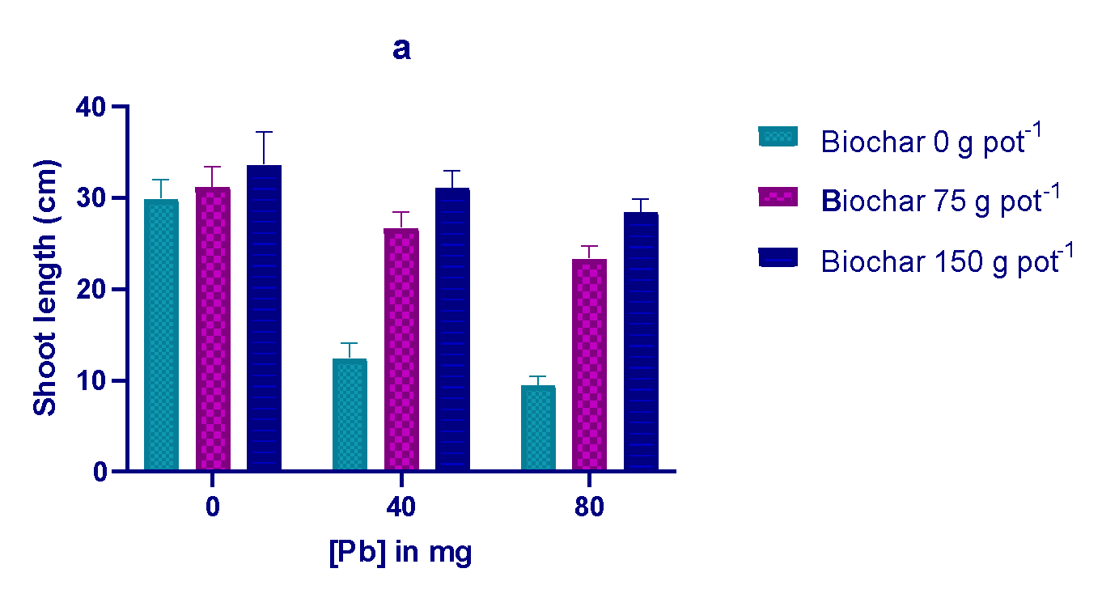

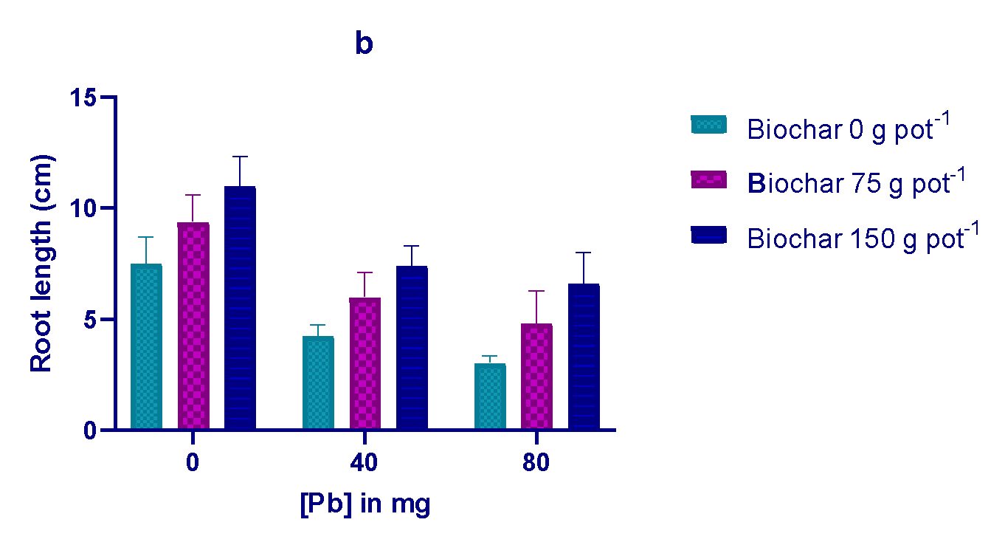Fig. 1: Showing how the application of biochar affected the shoot and root lengths (a and b) of spinach plants cultivated in soil contaminated with lead.

Dry weight of shoot
The plants' shoot dry weights were considerably (P<0.05) decreased after Pb treatment of the Spinacia oleracea L. crop by 6.59 and 32.57% in (T₇) and (T₈) at both application 75 and 150 g pot⁻¹ biochar and treatments 80 mg kg⁻¹, respectively, as compared to non-amendment under soil (T₀) (Fig. 2a), also similar findings have been reported by (Khan et al. 2017).
Root dry weight
Results in (Fig. 2b) showed that biochar application considerably increased root dry weight in comparison to non-amendment (T₅) while Pb reduced root dry weight. As the Pb contamination level increased, the root's dry weight decreased. There was a 6.59 and 68.95% reduction shown in (T₇) and (T₈) root dry weights of Spinacia oleracea L. grown at 75 and 150 g pot ⁻¹, respectively, as compared to non-amendment (T₀) (Gul and Whalen 2016).
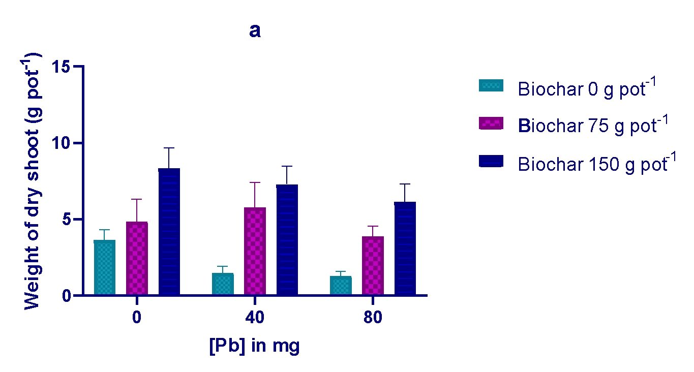
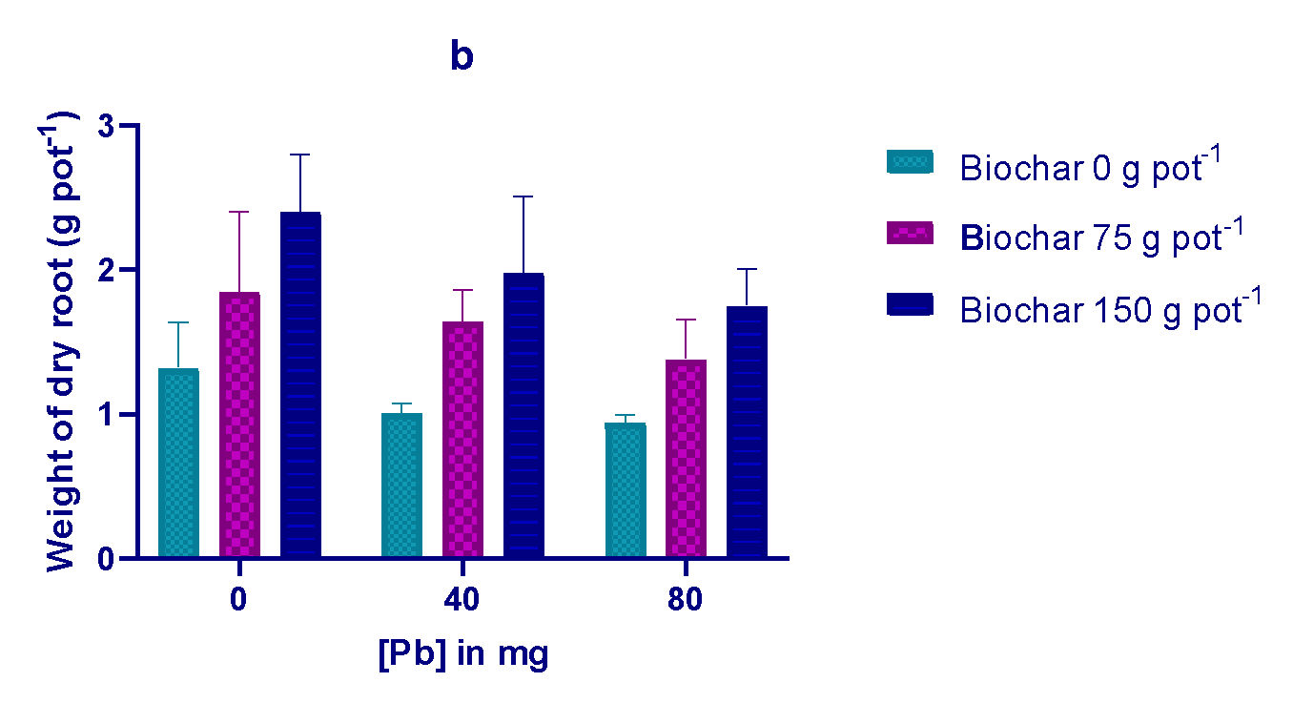
Fig. 2: Showing how the application of biochar affects the weight of the dry shoots and dry roots (a and b) in Spinach plants that are grown in soil contaminated with lead.

Effect of biochar on Pb concentration in root and shoot
According to this study, applying biochar to the soil at the Sheila Dhar Institute Farm resulted in Spinach plants having higher Pb concentrations in their root and shoot associated to the control at each absorption level (Fig. 3b, Table 3. Application of 80 mg kg⁻¹ Pb in (T₇ and T₈) drastically promoted the concentration of Pb by 25.72 and 21.04% in shoot and 20.75 and 18.59% in root for the treatments (T₇ and T₈) over the treatment non-amendment (T₀), respectively. Applying 80 mg kg⁻¹ of Pb registered the highest concentration of Pb (8.21±1.42 and 6.99±1.70 mg kg⁻¹ in the respective root and shoot of spinach in Fig. 3a, b. The study further indicated that the Pb-toxicity when used in combination with biochar 150 g pot⁻¹ along with varying rates of Pb (0, 40, and 80 mg kg⁻¹) decreased significantly. Applying Pb in treatment (T₉) increases plant’s roots and shoots to accumulate more Pb than the control, also similar findings have been found by (Mani et al. 2012).

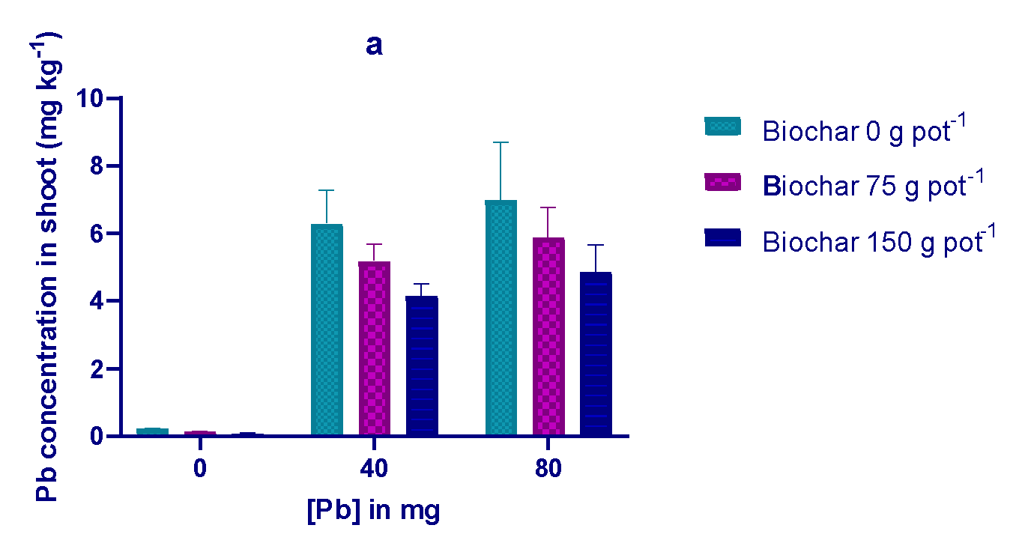
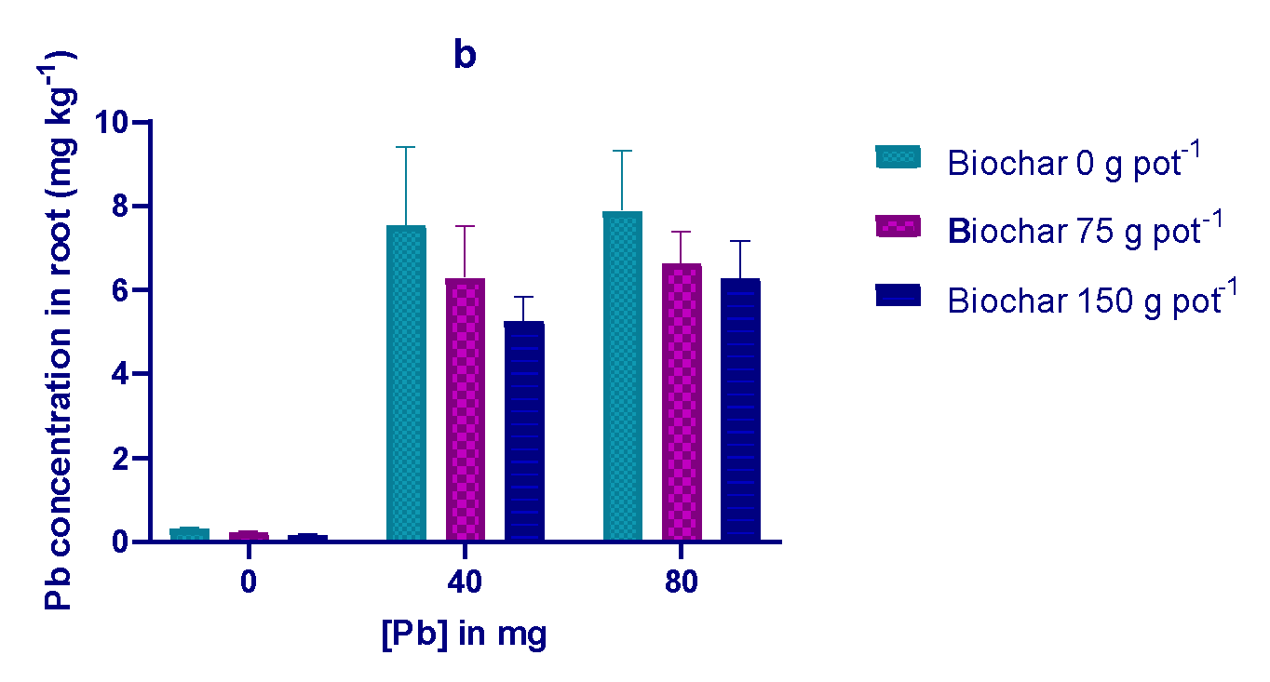Fig. 3: Showing the effect of biochar application on the Pb concentration in the shoot and the Pb concentration in the root (a and b) of a spinach plant growing in Pb-contaminated soils.

Table 4: Effect of the interaction between Pb and biochar on length of plants, dry weight, and transfer factor, as well as Pb concentration in shoot and root tissue
Treatments  ID | Length (cm) |  | Weight of dry matter (g pot⁻¹) |  | Pb-Concentration  (mg kg⁻¹) |  | TF  (mg kg⁻¹)
Treatments  ID | Root | Shoot | Root | Shoot | Root | Shoot | -
T₀ | 7.5±1.2 | 29.87±2.0 | 1.32±0. | 3.64±0.6 | 0.32±0.1 | 0.22±0.1 | 0.68±0.3
T₁ | 9.38±1.1 | 31.19±21 | 1.85±0.5 | 4.83±0.14 | 0.23±0.1 | 0.13±0.1 | 0.56±0.2
T₂ | 10.98±3 | 33.58±0.55 | 2.4±0.4 | 8.34±13 | 0.17±0.1 | 0.07±0.1 | 0.41±0.1
T₃ | 4.25±0.5 | 12.43±1.5 | 1.01±0.1 | 1.48±0.4 | 7.54±1.85 | 6.32±1.03 | 0.83±0.04
T₄ | 5.99±1.1 | 29.69±1.7 | 1.64±0.2 | 5.78±1.6 | 6.29±1.22 | 5.18±0.50 | 0.82±0.03
T₅ | 7.73±0.9 | 31.07±1.8 | 1.98±0.5 | 7.28±1.1 | 5.23±0.50 | 4.15±0.35 | 0.79±0.02
T₆ | 3.03±0.3 | 9.48±0.9 | 0.94±0.1 | 1.28±0.2 | 8.21±1.42 | 6.99±1.70 | 0.85±0.04
T₇ | 4.81±1.4 | 23.33±1.3 | 1.38±0.2 | 3.88±0.6 | 6.96±0.75 | 5.88±0.89 | 0.84±0.03
T8 | 6.59±1.4 | 28.42±1.4 | 1.75±0.2 | 6.15±1.1 | 6.27±0.88 | 4.85±0.80 | 0.77±0.02
ID= identification number, T₀= Control and TF= translocation factor. Each value is three replicates (n = 3, mean±SD). At p<0.05.

Translocation factor (TF)
The metals concentration ratio is known as the transfer factor of metals since root to shoot and from shoot to soil to determine whether shoots have the ability to transmit metals from contaminated soil to shoot tissues (Kormoker et al. 2020). The determined TF values for the various treatments are shown in Fig. 4a, where a greater TF value indicates a higher potential for transporting Pb ions from the soil to the shoot. The lowest and highest TF values were observed for spinach at 0.41±0.01 mg kg⁻¹ and 0.85±0.04 mg kg⁻¹ (T₂, T₆, and Table 4, respectively, showing the efficacy of applying biochar (at a mixing rate of 150 g, Pb 0 mg kg⁻¹, and biochar 0 g, Pb 80 mg kg⁻¹, respectively) to reduce the transfer of Pb from the soil to the shoot.
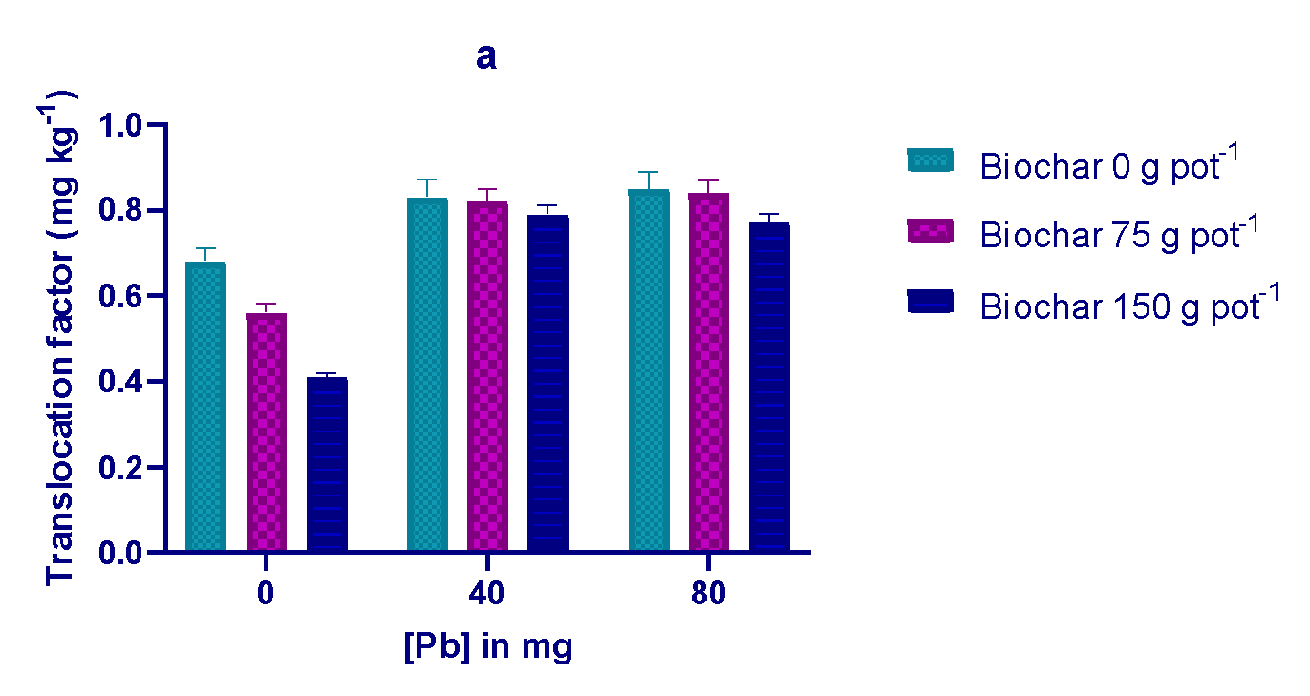Fig. 4: Showing that applying biochar affects the amount of Pb that moves from the roots to the shoots of (a) spinach plants that have grown in response to various treatments.

Conclusion
In the present study, organic amendment (biochar) was used to enhance soil fertility, spinach growth, and reduce the phytotoxicity of varying amounts of Pb. The findings showed that Pb contamination of the soil had an adverse effect on spinach growth and development. Significant soil properties that biochar can affect include increased organic matter, nutrient content, pH, and water-holding capacity; it can also draw in and improve physico-chemical properties of soil, enhance cation exchange capacity (CEC), and enhanced the capacity to retain nutrients and sequester carbon. Biochar increased plant height, dry biomass (root and shoot) and the accumulation of soil in rhizodeposits under contaminated soils, and the positive influence was observed to be more profound when biochar was used. Thus, it can be concluded that the application of biochar is a viable option for reducing heavy metals toxicity in plants and to improve the plant growth cultivated in polluted soils. In the present scenario, conservation of natural resources is most important. Thus, to combat the increasing effect of pollution, there is a need to expand this type of research further.

COMPETING INTERESTS DISCLAIMER:
Authors have declared that they have no known competing financial interests OR non-financial interests OR personal relationships that could have appeared to influence the work reported in this paper.

References
Agegnehu, G., Srivastava, A. K., Bird, M. I. (2017). The role of biochar and biochar compost in improving soil quality and crop performance: a review. Appl. Soil Ecol. 119, 156-170.
Ahmad, M., Rajapaksha, A. U., Lim, J. E., Zhang, M., Bolan, N., Mohan, D., Vithanage, M., Lee, S.S., Ok, Y.S. (2014). Biochar as a sorbent for contaminants management in soil and water: a review. Chemosphere 99, 19-33.
Baker, A. J., Brooks, R. (1989). Terrestrial higher plants which hyper accumulate metallic elements. A review of their distribution, ecology and phytochemistry. Bio recovery 1(2), 81-126.
Biederman, L. A., Harpole, W. S. (2013). Biochar and its effects on plant productivity and nutrient cycling: a meta-analysis. GCB Bioenergy. 5, 202–214.
BioDea. (2021). Available online: https://www.biodea.bio/il-biochar-biodea-ammendante-nel-terreo/ (accessed on 4- January 2021).
Chen, T., Zhao, L., Gao, X., Li, L., Qin, L., 2022. Modification of carbonation-cured cement mortar using biochar and its environmental evaluation. Cem. Concr. Compos. 134, 104764.
Chi, L., Huang, C., Li, Z., Ruan, S., Peng, B., Li, M., et al., 2024. Heavy metals immobilization of LDH@biochar-containing cementitious materials: effectiveness and mechanisms. Cem. Concr Compos 152, 105667.
Dai, Y., Zhang, N., Xing, C., Cui, Q., Sun, Q. (2019). The adsorption, regeneration and engineering applications of biochar for removal organic pollutants: a review. Chemosphere 223, 12–27.
Dhiman S, Handa N, Sharma N, Kaur R, Ohri P, Bhardwaj R. (2020). Role of Biochar in Heavy Metal Toxicity in Plants. Cellular and Molecular Phytotoxicity of Heavy Metals: Springer; p. 349–71.
Ding, Y., Liu, Y., Liu, S., Li, Z., Tan, X., Huang, X., Zeng, G., Zhou, L., Zheng, B. (2016). Biochar to improve soil fertility. A review. Agron. Sustain. Dev. 36 (2), 36.
El-Naggar, A., Lee, M. H., Hur, J., Lee, Y. H., Igalavithana, A. D., Shaheen, S. M., Ryu, C., Rinklebe, J., Tsang, D. C. W., O. k, Y. S. (2020). Biochar-induced metal immobilization and soil biogeochemical process: an integrated mechanistic approach. Sci. Total Environ. 698, 134112.
Gholizadeh, M., Hu, X., Liu, Q. (2019). A mini review of the specialties of the bio-oils produced from pyrolysis of 20 different biomasses. Renew. Sustain. Energy Rev. 114, 109313.
Gul, S., and Whalen, J. K. (2016). Biochemical cycling of nitrogen and phosphorus cycling in biochar amended soils. Soil Biology and Biochemistry, 103, 1-15. https://doi.org/10.1016/j.soilbio.2016.08.001.
Kabata-Pendias, A., Pendias, H. (2011). Trace elements in soils and plants. V. Kan, T., Strezov, V., Evans, T.J., 2016. Lignocellulosic biomass pyrolysis: a review of product properties and effects of pyrolysis parameters. Renew. Sustain. Energy Rev. 57, 1126-1140.
Karami N, Clemente R, Moreno-Jiménez E, Lepp NW, Beesley, L. (2011). Efficiency of green waste compost and biochar soil amendments for reducing lead and copper mobility and uptake to ryegrass. J. Hazard Mater 191(1-3):41–48. https://doi.org/10.1016/j.jhazmat.2011.04. 025.
Kim, H.-B., Kim, J.-G., Alessi, D.S., Baek, K. (2025). Mechanistic understanding of copper (Cu) mobility in aged biochar: influence of dissolved organic matters release and oxygen-containing groups. J Hazard Mater 495, 139123.
Kloss, S., Zehetner, F., Dellantonio, A., Hamid, R., Ottner, F., Liedtke, V., Soja, G. (2012). Characterization of slow pyrolysis biochar: effects of feedstocks and pyrolysis temperature on biochar properties. J. Environ. Qual. 41 (4), 990e1000. https://doi.org/10.2134/jeq2011.0070.
Kormoker, T., R. Proshad, M. S. Islam, T. R. Tusher, M. Uddin, S. Khadka, K. Chandra and A. Sayeed. (2020). Presence of toxic metals in rice with human health hazards in Tangail district of Bangladesh. International Journal of Environmental Health Research 1–21. doi:10.1080/09603123.2020.1724271.
Kumar, C. and Mani, D. (2010). Enrichment and management of heavy metals in sewage-irrigated soil. Lap LAMBERT Academic Publishing. Dudweiler, Germany.
Levizou E, Antoniadis V, Papatheodorou S. (2016). Without exceeding the limits: industrial soil rich in Zn and Cd have no effect on purslane and lettuce but promotes geranium growth. Environ Earth Sci.75(18):1–10. doi:10.1007/s12665-016-6070-y.
Li, C., Bair, D. A., Parikh, S. J. (2018). Estimating potential dust emissions from biochar amended soils under simulated tillage. Sci. Total Environ. 625, 1093–1101.
Liu, X., Zheng, J., Zhang, D., Cheng, K., Zhou, H., Zhang, A., Crowley, D. (2016). Biochar has no effect on soil respiration across Chinese agricultural soils. Sci. Total Environ. 554, 259e265. https://doi.org/10.1016/j.scitotenv.2016.02.179.
Lu K, Yang X, Gielen G, Bolan N, Ok YS, Niazi NK, Xu S, Yuan G, Chen X, Zhang X, Liu D, Song Z, Liu X, Wang H. (2017) Effect of bamboo and rice straw biochar’s on the mobility and redistribution of heavy metals (Cd, Cu, Pb and Zn) in contaminated soil. J. Environ Manage 186(Pt 2): 285–292. https://doi.org/10.1016/j.jenvman.2016.05.068.
Mishra, G., Danoglidis, P.A., Shah, S.P., Konsta-Gdoutos, M.S. (2023). Carbon capture and storage potential of biochar-enriched cementitious systems. Cem Concr Compos 140, 105078.
Mohamed, I, Zhang, G. S., Li, Z. G., Liu, Y., Chen, F., Dai, K. (2015) Ecological restoration of an acidic Cd contaminated soil using bamboo biochar application. Ecol. Eng. 84:67–76. https://doi.org/10.1016/j.ecoleng. 2015.07.009.
Muthu, Saravanan, S., Siva, Rajasekar, N., Vivek, J., S, Paramasivan, Mu Naushad, T., Prakash Maran, J. V. Gayathri, V., and Al‐Dauji, O. K. (2018). Phytoremediation of heavy metals: mechanisms, methods and enhancements. Environ Chem Lett. 16. 1339.
Nandillon R, Lebrun M, Miard F, Gaillard M, Sabatier S, Villar M, et al. (2019). Capability of amendments (bio char, compost and garden soil) added to a mining technosol contaminated by Pb and As to allow poplar seed (Populus nigra L.) germination. Environmental monitoring and assessment. 191(7):1–12. https://doi.org/10.1007/s10661-019-7561-6 PMID: 31243568.
O’Connor, D., Peng, T., Zhang, J., Tsang, D. C., Alessi, D. S., Shen, Z., Bolan, N. S., Hou, D. (2018). Biochar application for the remediation of heavy metal polluted land: a review of in situ field trials. Sci. Total Environ. 619, 815–826.
Proshad, R., T. Kormoker, M. S., Islam, and K. Chandra. (2020). Potential health risk of heavy metals via consumption of rice and vegetables grown in the industrial areas of Bangladesh. Human and Ecological Risk Assessment: An International Journal 26 (4):921–43. doi:10.1080/10807039.2018.1546114.
Rizwan, M., Ali, S., Abbas, T., Zia-ur-Rehman, M., Hannan, F., Keller, C., Al-Wabel, M. I., O. k., Y. S. (2016). Cadmium minimization in wheat: a critical review. Ecotoxicol. Environ. Saf. 130, 43–53.
Rizwan, M., Ali, S., Qayyum, M. F., Ibrahim, M., Zia-ur-Rehman, M., Abbas, T., O. k., Y. S. (2016). Mechanisms of biochar-mediated alleviation of toxicity of trace elements in plants: a critical review. Environ Sci. Pollut. R. 23(3):2230–2248. https://doi.org/10.1007/s11356-015-5697-7.
Shahmansouri, A.A., Zhang, Z., AzariJafari, H., Shi, X. (2025). Biochar-amended high-strength engineered cementitious composites. Cem Concr Compos, 106219.
Shahzad, B., Tanveer, M., Che, Z., Rehman, A., Cheema, S. A., Sharma, A., Song, H., U, R., Rehman, S., Zhaorong, D. (2018). Role of 24-epibrassinolide (EBL) in mediating heavy metal and pesticide induced oxidative stress in plants: a review. Ecotoxicol. Environ. Saf. 147, 935–944.
Shrestha, P., Bellitürk, K., and Gorres, J. H. (2019). Int. J. Environ. Res. Public Health 16 1261. Virk, A.L., Kan, Z.-R., Liu, B.-Y., Q, i., J. Y., He, C., Liu, Q. Y., Zhao, X., Zhang, H. L. (2020). Impact of biochar water extract addition on soil organic carbon mineralization and C fractions in different tillage systems. Environ. Technol. Innov., 101193 https://doi.org/10.1016/j.eti.2020.101193.
W. H., Hendershot, H., Lalande, M., Duquette, Soil reaction and exchangeable acidity, in: M. R. Carter (Ed.), Soil Sampling and Methods of Analysis, Lewis Publishers, London, 1993, p. p. 141–145. Canadian Society of Soil Science.
Wang Y, Zhang K, Lu L, Xiao X, Chen B. (2020). Novel insights into effect so silicon-rich biochar (Sichar) amendment on cadmium uptake, translocation and accumulation in rice plants. Environmental Pollution.; 265:114772. https://doi.org/10.1016/j.envpol.2020.114772 PMID: 32454359.
Wang, Q., Li, J.-s, Xue, Q., Poon, C.S. (2022). Immobilization and recycling of contaminated marine sediments in cement-based materials incorporating iron- biochar composites. J Hazard Mater 435, 128971.
Younis, U., Malik, S. A., Rizwan, M., Qayyum, M. F., Ok, Y. S., Shah, M. H. R., Rehman, R. A., Ahmad, N., (2016). Biochar enhances the cadmium tolerance in spinach (Spinacia oleracea) through modification of Cd uptake and physiological and biochemical attributes. Environ. Sci. Pollut. Res. 23, 21385–21394. https://doi.org/10.1007/s11356-016-7344-3.
Yuan, P., Wang, J., Pan, Y., Shen, B., Wu, C. (2019). Review of biochar for the management of contaminated soil: preparation, application and prospect. Sci. Total Environ. 659, 473–490. https://doi.org/10.1016/j.scitotenv.2018.12.400.
Zhang, J., Zhang, H., Li, F., Wang, H. (2024). Synthesis of porous functional biochar through template method and plasma modification for Pb²⁺ removal: performance and mechanism. Energy 312, 133549.

