Original Research Article

EFFECT OF SALINITY TOLERANT RHIZOBIAL STRAINS ON GROWTH, NODULATION AND YIELD OF GROUNDNUT IN POT CONDITION

Abstract
Soil salinity is a major abiotic stress that severely limits global crop production, particularly in arid and semi-arid regions. Groundnut (Arachis hypogaea L.), a vital oilseed and legume crop, is moderately sensitive to salt stress, which negatively impacts its growth, nodulation efficiency, and final yield. This pot experiment was conducted to evaluate the efficacy of salinity-tolerant rhizobial strains as a sustainable strategy to mitigate the detrimental effects of salt stress on groundnut. One groundnut cultivar Binachinabadam-8 were grown in a pot-culture setup under varying levels of induced salinity (2-7 dS saline water), with treatments including T₁(uninoculated control), and inoculation with selected superior salt-tolerant rhizobial isolates (T₂: STGN-1, T₃: STGN-3, T₄: STGN-4, T₅: STGN-5, T₆: STGN-6, T₇: STGN-7, T₈: STGN-9, T₉: STGN-10), which demonstrated high tolerance to saline water in preliminary in vitro screening. The results indicated that increasing salinity levels significantly reduced all measured parameters in the uninoculated and inoculated treatments, including shoot dry weight, root dry weight, nodule number effective nodule, nodule dry weight, and pod yield. However, inoculation with the salinity-tolerant strains STGN-4 was found as the best performer and STGN-9 and STGN-10 better and good STGN-1, STGN-3, STGN-6 performer respectively. Plants inoculated with STGN-4 showed increase in effective nodule (25.00), total nodule (53.00), root length (11.00) cm, number of brunches (5.33) and STGN-10 Pod plant⁻¹ (18.67) and grain yield plant⁻¹ (29.4 gm) over control. These superior results are attributed to the enhanced biological nitrogen fixation (BNF) capacity and potential plant growth-promoting (PGP) activities of the salt-tolerant strains, which likely supported better root colonization and function under osmotic stress. The findings demonstrated that inoculating groundnut with carefully selected, salinity-tolerant rhizobial strains is a highly effective, eco-friendly, and economical approach to enhancing growth, improving nodulation, and securing economically viable yields of groundnut in saline-affected soils.

Keywords: Salinity stress, Salt Tolerant Rhizobial Strain, Groundnut, Nodulation, Yield.

Introduction
Groundnut, also known as peanut, is a vital food legume and oilseed crop with global and national significance. Its nutrient-rich seeds provide a valuable source of edible oil and high-quality plant-based protein. As one of the world’s largest producers and consumers of groundnuts, groundnut is a very crucial crop for food and agricultural sectors in Bangladesh. Salinity is an ever-increasing problem throughout the world and imposes major constraints to food production (Hasegawa et al., 2000; Tester and Davenport, 2003). Globally, nearly 100 million ha of land is affected by salinity which accounts for 6-7% of the total arable land (Munns and James, 2003). In the coastal belt of Bangladesh, 1.02 million ha of cultivated land is affected by different degrees of soil salinity, 2.0 to > 16 dS/m (Karim and Iqbal, 2001; SRDI, 2003). Groundnut (Arachis hypogaea L.) is moderately sensitive to salinity stress (Shalhevet et al., 1969) can tolerate 3.4 dS/m. Yield of groundnut increases below this threshold level while reduces above this level. The widespread cultivation of groundnut underscores its importance as a valuable food and oil source, as well as its role in promoting sustainable farming practices through its symbiotic relationship with nitrogen-fixing bacteria. Notably, groundnut’s ability to thrive with minimal reliance on synthetic nitrogen fertilizers, thanks to its symbiotic association with nitrogen-fixing Rhizobium bacteria, contributes to more environmentally-friendly agricultural practices (Asante et al., 2020; Mohammed et al., 2018). Inoculation of legumes with biofertilizer (Rhizobium bacteria) increased the nodule and nitrogen-fixing activity of the plants (Argaw 2017). When inoculated with the proper strain of bacteria, legumes can supply up to 90% of their nitrogen. Comparably, the researcher reported
that inoculation with Rhizobium bacteria brings about significant increases in all the growth and yield parameters than when not inoculated; biochar addition to soil increases soil nutrient concentrations and microbial activity, leading to the development of plant growth (Sajid et al., 2011; Asante et al., 2020). The symbiotic performance of legumes with rhizobia can be significantly enhanced by biochar-based rhizobial inoculants, reducing N fertilizer demand and thus promoting the sustainability of crop production in any agroecosystems (Egamberdieva et al., 2018), including Charland agro -ecosystems. Legumes have symbiotic relationships with rhizobia and are known as the most efficient system for biological nitrogen fixation (Reckling et al., 2016). In light of these concerns, there is an increasing focus on the development of more sustainable agricultural practices that can enhance crop yields without compromising the health of the environment and the well-being of the population (Sandhu, 2021). One promising approach is the utilization of beneficial microbes, known as rhizobacteria, to promote plant growth and reduce the reliance on synthetic fertilizers (Mabrouk et al., 2018, Zambrano-Mendoza et al., 2021). Rhizobacteria are a group of bacteria that reside in the plant’s rhizosphere, the region surrounding the root system. These bacteria can form symbiotic relationships with plants, providing them with essential nutrients, such as nitrogen, through processes like nitrogen fixation. Rhizobacteria can also indirectly contribute to plant growth by producing plant growth-promoting substances, solubilizing nutrients, and suppressing plant pathogens (Verma et al., 2022, Aloo et al., 2019). The use of rhizobacteria as biofertilizers has been found to be an effective and sustainable alternative to synthetic fertilizers. The addition of rhizobacteria can improve plant nutrition and yield, while also enhancing soil fertility and reducing the environmental impact of agricultural practices (Raimi et al., 2017, Aloo et al., 2019). The growing demand for sustainable agriculture presents a promising solution in the use of salinity tolerant rhizobacteria-based biofertilizers to mitigate the adverse effects of synthetic fertilizers. The use of rhizobacteria as a biofertilizer for groundnut cultivation has been the subject of extensive research. Studies have demonstrated the beneficial effects of rhizobacteria inoculation on groundnut growth, yield, and nutrient profile (Ka et al., 2018, Mondal et al., 2018). While the advantages of Rhizobium bacteria in promoting sustainable agriculture are well-established, there is a lack of scientific understanding regarding newly isolated Rhizobium strains and their potential application as biofertilizers for groundnut cultivation (Sharma et al., 2018, Purwaningsih et al., 2021). Investigating the growth-enhancing and yield-boosting capabilities of novel Rhizobium strains could provide valuable insights for developing effective biofertilizer solutions (Ka et al., 2018, Naseer et al., 2019) to address the challenges posed by synthetic fertilizers. Isolating and screening fresh rhizobacterial samples is crucial, as the efficacy of different strains can vary depending on local soil and climatic conditions (Oo et al., 2020, Agustiyani et al., 2022). Comprehensive research is needed to characterize the diversity, functional attributes, and field performance of newly isolated Rhizobium isolates, in order to harness their full potential for enhancing crop productivity and reducing reliance on synthetic fertilizers (Sijilmassi et al., 2020, Mabrouk et al., 2018). Exploring the metabolic capabilities, nitrogen fixation efficiency, plant growth promoting properties, and environmental adaptability of these Rhizobium strains can provide valuable insights for developing effective biofertilizer formulations (Ka et al., 2018) tailored to specific crop and soil conditions. For saline area of Bangladesh, salinity tolerant Rhizobium-based biofertilizers is a must. Bridging this research gap is crucial for expanding the practical utilization of salinity tolerant Rhizobium-based biofertilizers as a sustainable alternative to chemical inputs in modern agriculture. Keeping these factors in mind, the present study aimed to investigate the isolation and screening of native Rhizobium strains collected from groundnut plant nodules grown in saline agro-climatic regions of southern Bangladesh. After characterizing and identifying these native strains and salinity test were done in laboratory in saline medium, then they were compared through a pot culture experiment with the widely utilized available slow growing Rhizobium spp., GN2-(1) and GN2-(4) of BINA for groundnut cultivation.
The study evaluated the performance of these salinity tolerant rhizobia strains on the growth attributes of groundnut plants, including root and shoot dry weight, nodulation, nodule dry weight, and plant nitrogen uptake in pot within glass house condition.

Materials and Method
A pot experiment was conducted in glass house of Soil Science Division of BINA in the year of 2025 at Rabi-Kharif-1 season with CRD and three replications. Experimental pot filled up with 5 kg sterilized sand and we used Binachinabadam-8 as a crop variety. All isolates were identified as Bradyrhizobium sp. based on their growth and colony morphology. The isolates were round shaped colonies with short rod type bacterial cell and all were gram negative in gram reaction. The isolated strains were found alkali producer and showed no growth on GPA. From 17 isolates, ten (10) bradyrhizobial strains which were isolated from root nodules of Groundnut grown in saline soils of Satkhira and Noakhali. Isolated strains were passed through a series of salinity test where we used saline water which was collected from Satkhira. Then eight (8) isolates were placed for pod experiment. In that experiment there were nine (9) treatments, among them eight (8) were inoculated (i.e., T₂: STGN-1, T₃: STGN-3, T₄: STGN-4, T₅: STGN-5, T₆: STGN-6, T₇: STGN-7, T₈: STGN-9, T₉: STGN-10) and uninoculated (T₁: control). Data were collected at 60 DAS, 90 DAS and 120 DAS on effective nodule plant⁻¹, non-effective plant⁻¹, total nodule number plant⁻¹, root length plant⁻¹ (cm), shoot length (cm) plant⁻¹ number of brunch plant⁻¹, pod plant⁻¹, yield plant⁻¹ (gm). Data were analyzed with RStudio Software version-4.5.1.

Results and Discussion
A number of 10 Bradyrhizobial strains were isolated from root nodules of groundnut grown in saline soils of Satkhira and Noakhali. The isolates were round shaped colonies with short rod type bacterial cell and all were gram negative in gram reaction. The isolated strains were found alkali producer and showed no growth on GPA. The strains were found salinity tolerance (Table 1) from 2.5 to 7.0 dS. Most of the strains were salinity tolerant at 7 dS except STGN-2, STGN-7, STGN-8 (2.0, 3.5, 3.0). The strains could grow in the temperature of 15⁰C to 42⁰C. Some strains (STGN-1, STGN-3, STGN-4, STGN-6, STGN-9, STGN-10) showed a trace amount of Indole acetic acid (IAA) production and all were identified as Bradyrhizobium sp. based on their growth and colony morphology. Among them, 8 isolates were placed for pod experiment.

Table 1. Biochemical characterization of salinity tolerant rhizobia strains/isolated of groundnut from saline areas

Sl. No. | Rhizobia isolates | Salinity tolerance  dS | Growth in different Temp. conditions (⁰C) | IAA production | Species of Rhizobium
1 | STGN-1 | 7 | 36 | trace | Bradyrhizobium
2 | STGN-2 | 2.0 | 15 | - | Bradyrhizobium
3 | STGN-3 | 7 | 32 | trace | Bradyrhizobium
4 | STGN-4 | 7 | 42 | trace | Bradyrhizobium
5 | STGN-5 | 7 | 35 | - | Bradyrhizobium
6 | STGN-6 | 7 | 35 | trace | Bradyrhizobium
7 | STGN-7 | 3.5 | 35 | - | Bradyrhizobium
8 | STGN-8 | 3.0 | 28 | - | Bradyrhizobium
9 | STGN-9 | 7 | 35 | trace | Bradyrhizobium
10 | STGN-10 | 7 | 35 | trace | Bradyrhizobium

Growth parameters of salinity tolerant rhizobial strains on groundnut in pot condition Result (Table 2) showed that inoculation of STGN-4 had good effect on effective nodule and total nodule number, number of branches and highest root length as it has IAA production ability at 60 days after sowing (DAS). Strain STGN-3 showed the highest root length at the sampling time at 90 DAS and STGN-1 in case of shoot length DAS. All the uninoculated (T₁= control) and nitrogen treated treatments showed lower plant height than inoculated treatments. STGN-9 recorded higher nodule number over control and root length showed higher inoculated with STGN-3 at 90 DAS. Inoculant STGN-9 and STGN-10 recorded statistically similar effective nodule number and total nodule at 120 DAS

Table 2. Growth parameters of salinity tolerant rhizobial strains on groundnut in pot condition at 60 DAS and 90 DAS

60 DAS |  |  |  |  |  |  | 90 DAS
Treatment | Effective nodule | Non effective | Total nodule | Root length (cm) | Shoot length (cm) | No of Brunch | Effective nodule | Non effective | Total nodule | Root length (cm) | Shoot length (cm) | No of Brunch
T₁: Control | 0.00c | 0.00c | 0.00c | 8.50c | 20.67a | 2.33b | 0.00b | 0.0 | 0.00b | 11.67a | 19.67ab | 4.33e
T₂: STGN-1 | 17.33ab | 27.00ab | 44.33ab | 9.83b | 20.67a | 4.67a | 34.00a | 20.67a | 54.67a | 12.67a | 27.67a | 7.33c
T₃: STGN-3 | 18.67ab | 25.67ab | 44.33ab | 10.17b | 18.83a | 5.00a | 23.67ab | 14.00ab | 37.67ab | 13.00a | 23.67ab | 8.00bc
T₄; STGN-4 | 25.00a | 28.00ab | 53.00a | 11.00a | 18.83a | 5.33a | 12.00ab | 7.67ab | 19.67ab | 12.67a | 22.67ab | 8.67ab
T₅: STGN-5 | 13.67b | 21.00b | 34.67b | 8.33c | 10.67c | 2.67b | 21.67ab | 10.00ab | 31.67ab | 11.33a | 17.67b | 6.00d
T₆: STGN-6 | 12.00b | 22.00b | 34.00b | 9.67b | 20.50a | 3.00b | 30.00ab | 14.00ab | 44.00a | 12.67a | 22.00ab | 5.33de
T₇: STGN-7 | 20.00ab | 21.33b | 35.67b | 8.50c | 15.5b | 3.00b | 29.67ab | 11.33ab | 41.00ab | 11.33a | 21.33ab | 6.00d
T₈: STGN-9 | 14.33b | 27.00ab | 47.00ab | 10.33ab | 16.1b | 4.67a | 42.67a | 16.33a | 59.00a | 13.00a | 21.67ab | 9.00ab
T₉: STGN-10 | 17.00ab | 30.67a | 47.67ab | 10.33ab | 19.00a | 5.00a | 38.00a | 20.33a | 58.33a | 10.67a | 19.67ab | 9.33a
Significant level | ** | ** | *** | *** | *** | *** | NS | NS | NS | NS | NS | ***
CV | 33.59 | 22.20 | 23.41 | 4.31 | 6.01 | 10.58 | 70.36 | 63.80 | 64.65 | 16.40 | 21.35 | 10.35

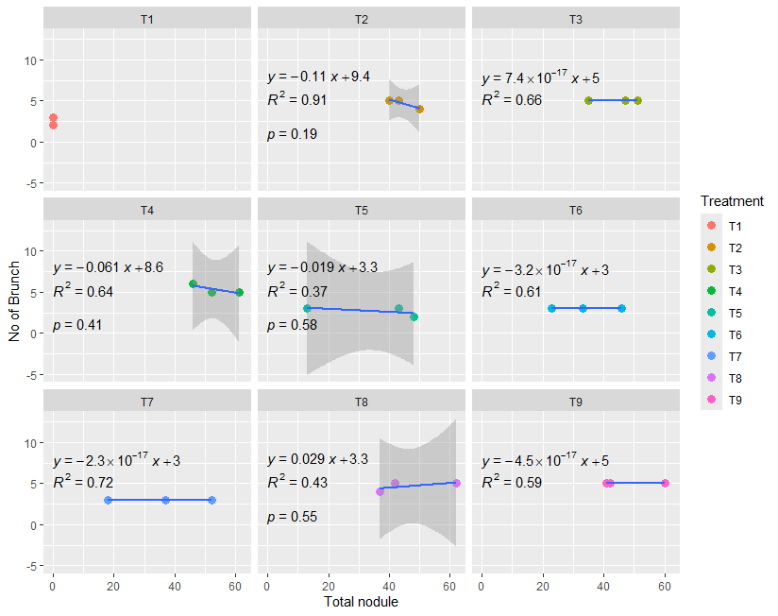
Figure-1: Regression between Total nodule with Number of Branches at 60 DAS
Figure 1 showed that thre was strong relation R²=0.91 in T₂ treatment ( inoculated with STGN-1 strain) in respect of total nodule number and number of branches. In figure 2, there were strongest positive correlation between root length and number of branches, effective nodule with non effective nodule also stronger positive correlation between effective nodule and number of branch and total nodule and effective nodule. In some cases, there was negative correlation aslo existed. Where, * indicates level of significance inrespect with p value.
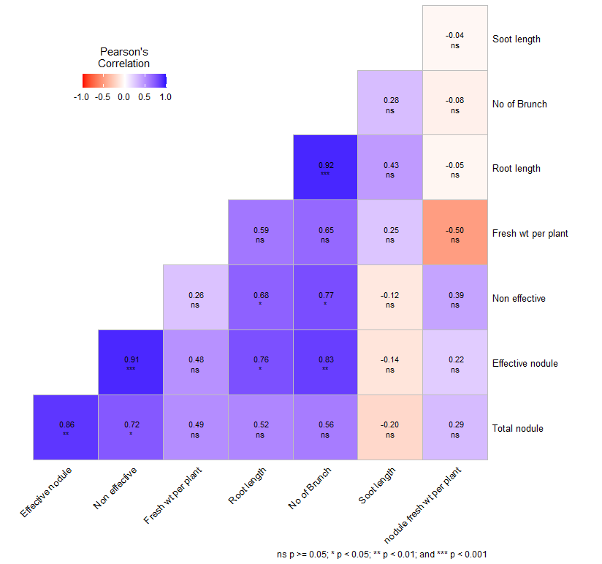

Figure-2: Correlation with different parameters at 60 DAS

From this above correlation matrix, which is a table showed the correlation coefficients between several variables. In that case, the variables appear to be related to plant growth or biological characteristics based on nodule. The matrix showed the correlation between the following variables effective nodule, non-effective nodules, fresh weight plant-1, root length, plant-1, number of brunches plant-1, shoot length plant-1, total nodule plant-1, nodule fresh weight plant-1. The matrix is a triangular heatmap, where the color intensity and numerical value in each cell represent the Pearson's correlation coefficient (r) between the two intersecting variables. The legend indicates the strength and direction of the correlation. The asterisks (∗) denote the statistical significance (p-value) of the correlation. Where (ns) denoted not significant (p≥0.05); ∗ denoted significant (p<0.05); ∗∗ denoted highly significant (p<0.01) and ∗∗∗ denoted very highly significant (p<0.001). The analysis revealed several very strong positive relationships, many of which are highly significant between effective nodule and non-effective very strong positive correlation (r=0.91, p<0.001). This is an interesting finding, suggesting that conditions favoring the formation of effective nodules also strongly favor the formation of non-effective nodules. Effective nodule and total nodule have a very strong positive correlation (r=0.86, p<0.01). This is expected, as effective nodules are a component of the total nodule count. Non-effective and root length have strong positive correlation (r=0.76, p<0.05). Number of brunches with effective nodule/Non effective/root length shows strong, highly significant positive correlations with all three like, Root length (r=0.92, p<0.01), non-effective (r=0.83, p<0.01), effective nodule (r=0.72, p<0.05). Suggested that root length and number of brunches are very closely linked and that factors increasing nodulation and root growth also strongly increase branching. Here also moderate positive correlation among fresh weight plant-1 and effective nodule/Non-effective: These show moderate positive correlations (r=0.49 and r=0.48, respectively). However, neither correlation is statistically significant (ns). Root length and fresh weight plant-1 also a moderate positive and significant correlation (r=0.68, p<0.05), indicating longer roots are associated with heavier plants. There was in nodule fresh weight plant-1 and fresh weight plant-1 has a strong, significant negative correlation (r=−0.50, p<0.05). This was a surprising finding. It suggests that a higher proportion or amount of fresh weight dedicated to nodules is associated with a lower overall plant fresh weight. This could imply a trade-off or a limiting resource. Shoot length has mostly weak and non-significant correlations with the other traits. The strongest correlation it has is a weak negative one with effective nodule (r=−0.20, ns), and a weak positive one with number of brunches (r=0.28, ns). This suggests that shoot growth (length) is relatively independent of the nodulation and root growth factors we measured.

Table 3. Growth parameters of salinity tolerant rhizobial strains on groundnut in pot condition at 90 DAS and 120 DAS
90 DAS |  |  |  |  |  |  | 120 DAS
Treatment | Effective nodule | Non effective | Total nodule | Root length (cm) | Shoot length (cm) | No of Brunch | Effective nodule | Non effective | Total nodule | Pod plant⁻¹ | Yield plant⁻¹ (gm)
T₁; Control | 0.00b | 0.0 | 0.00b | 11.67a | 19.67ab | 4.33e | 0.00c | 0.00c | 0.00b | 10.67b | 16.85b
T₂: STGN-1 | 34.00a | 20.67a | 54.67a | 12.67a | 27.67a | 7.33c | 14.33ab | 9.67a | 24.00a | 12.33ab | 19.51ab
T₃: STGN-3 | 23.67ab | 14.00ab | 37.67ab | 13.00a | 23.67ab | 8.00bc | 10.00abc | 4.33abc | 14.33ab | 15.33ab | 24.34ab
T₄: STGN-4 | 12.00ab | 7.67ab | 19.67ab | 12.67a | 22.67ab | 8.67ab | 5.00bc | 4.00abc | 9.00ab | 15.00ab | 23.62ab
T₅: STGN-5 | 21.67ab | 10.00ab | 31.67ab | 11.33a | 17.67b | 6.00d | 9.00abc | 4.67abc | 13.67ab | 12.00ab | 19.01ab
T₆: STGN-6 | 30.00ab | 14.00ab | 44.00a | 12.67a | 22.00ab | 5.33de | 12.67abc | 6.33ab | 19.00a | 16.67ab | 26.24ab
T₇: STGN-7 | 29.67ab | 11.33ab | 41.00ab | 11.33a | 21.33ab | 6.00d | 13.33ab | 6.33ab | 19.67a | 14.00ab | 22.14ab
T₈: STGN-9 | 42.67a | 16.33a | 59.00a | 13.00a | 21.67ab | 9.00ab | 19.67a | 6.33ab | 26.00a | 13.33ab | 21.11ab
T₉: STGN-10 | 38.00a | 20.33a | 58.33a | 10.67a | 19.67ab | 9.33a | 16.67ab | 7.67ab | 24.33a | 18.67a | 29.43a
Significant level | NS | NS | NS | NS | NS | *** | NS | NS | NS | NS | NS
CV | 70.36 | 63.80 | 64.65 | 16.40 | 21.35 | 10.35 | 59.72 | 66.12 | 60.83 | 31.12 | 31.17

There was pod per plant and yield of pod per plant statistically similar among all the inoculated treatment compare to uninoculated control treatment. This experiment was conducted in pod condition with 5 kg sterilized soil and watering was done with saline water which was collected from Satkhira.

Conclusion
From overall growth, nodulation and effective nodule strain STGN-4 was found as the best performer and STGN-9 and STGN-10 better and good performer respectively. Inoculant STGN-1, STGN-3, STGN-6, also perform well and the correlation matrix clearly showed a strong interconnectedness among nodulation variables (Effective, Non-effective, Total nodule) and key plant architectural traits (Root length, No of Brunches). The most striking relationships are the highly significant, very strong positive links between root length and number of brunches (r=0.92) and between effective nodule and non-effective (r=0.91). This suggests these traits are highly co-regulated. So, these 6 strains may be further evaluated in field condition in saline areas.

Competing interests

Authors have declared that no competing interests exist.

References
Aloo, B. N., Makumba, B. A., & Mbega, E. R. (2019). The potential of Bacilli rhizobacteria for sustainable crop production and environmental sustainability. Microbiological Research, 219, 26–39. https://doi.org/10.1016/j.micres.2018.10.011
Argaw, A. (2017). Development of environmental friendly bioinoculate for peanut (Arachis hypogea L.) production in Eastern Ethiopia. *Environmental Systems Research*, *6*(1), 1–12. https://doi.org/10.1186/s40068-017-0100-y
Asante, M., Ahiabor, B. D. K., & Atakora, W. K. (2020). Growth, nodulation, and yield responses of groundnut (Arachis hypogaea L.) as influenced by combined application of rhizobium inoculant and phosphorus in the Guinea Savanna zone of Ghana. International Journal of Agronomy, 2020, 8691757. https://doi.org/10.1155/2020/8691757
Egamberdieva, D., Hua, M., Reckling, M., Wirth, S., & Bellingrath-Kimura, S. D. (2018). Potential effects of biochar-based microbial inoculants in agriculture. Environmental Sustainability, 1(1), 19–24. https://doi.org/10.1007/s42398-018-0010-6
Hasegawa, P. M., Bressan, R. A., Zhu, J. K., & Bohnert, H. J. (2000). Plant cellular and molecular responses to high salinity. Annual Review of Plant Physiology and Plant Molecular Biology, 51, 463-499. https://doi.org/10.1146/annurev.arplant.51.1.463
Monika, Shashikala, & Wati, L. (2018). Biofertilizers: Potential Candidate for Sustainable Agriculture. *International Journal of Current Microbiology and Applied Sciences*, *7*(3), 2839–2851. https://doi.org/10.20546/ijcmas.2018.703.327
Karim, Z. and Iqbal A. 2001. Impact of land degradation in Bangladesh: Changing Scenario in Agricultural Land Use, Bangladesh Agricultural Research Council, pp. 46-47.
Mabrouk, Y., Hemissi, I., Salem, I. B., Mejri, S., Saidi, M., & Belhadj, O. (2018). Potential of Rhizobia in Improving Nitrogen Fixation and Yields of Legumes. In Symbiosis. https://doi.org/10.5772/intechopen.73495
Mohammed, M., Jaiswal, S. K., Sowley, E. N. K., Ahiabor, B. D. K., & Dakora, F. D. (2018). Symbiotic N2 Fixation and Grain Yield of Endangered Kersting's Groundnut Landraces in Response to Soil and Plant Associated Bradyrhizobium Inoculation to Promote Ecological Resource-Use Efficiency. Frontiers in Microbiology, 9, 2105. https://doi.org/10.3389/fmicb.2018.02105
Mondal, M., Gunri, S. K., Sengupta, A., & Kundu, R. (2018). Productivity Enhancement of Rabi Groundnut (Arachis hypogaea L.) under Polythene Mulching and Rhizobium Inoculation under New Alluvial Zone of West Bengal. International Journal of Current Microbiology and Applied Sciences, 7(9), 2308–2313. https://doi.org/10.20546/ijcmas.2018.709.286
Munns, R. and James R.A. (2003). Screening methods for salinity tolerance: a case study with tetraploid wheat. Plant and Soil 253:201-218.
Naseer, I., Ahmad, M., Nadeem, S. M., Ahmad, I., Najm-Ul-Seher, & Zahir, Z. A. (2019). Rhizobial inoculants for sustainable agriculture: Prospects and applications. In Biofertilizers for Sustainable Agriculture and Environment (pp. 245–283). Springer Nature. https://doi.org/10.1007/978-3-030-18933-4_11
Oo, K., Win, T., Khai, A., & Fu, P. (2020). Isolation, screening and molecular characterization of multifunctional plant growth promoting Rhizobacteria for a sustainable agriculture. American Journal of Plant Sciences. https://doi.org/10.4236/ajps.2020.116055
Purwaningsih, S., Agustiyani, D., & Antonius, S. (2021). Diversity, activity, and effectiveness of Rhizobium bacteria as plant growth promoting rhizobacteria (PGPR) isolated from Dieng, central Java. Iranian Journal of Microbiology, 13(1), 130-136. https://doi.org/10.18502/ijm.v13i1.5504
Raimi, A., Adeleke, R., Roopnarain, A., & Moral, M. T. (2017). Soil fertility challenges and Biofertiliser as a viable alternative for increasing smallholder farmer crop productivity in sub-Saharan Africa. Cogent Food & Agriculture, 3(1), 1400933. https://doi.org/10.1080/23311932.2017.1400933
Reckling, M., Bergkvist, G., Watson, C. A., Stoddard, F. L., Zander, P. M., Walker, R. L., Pristeri, A., Toncea, I., & Bachinger, J. (2016). Trade-Offs between Economic and Environmental Impacts of Introducing Legumes into Cropping Systems. Frontiers in Plant Science, 7, 669. https://doi.org/10.3389/fpls.2016.00669
Sajid, M., Rab, A., Wahid, F., Shah, S. N. M., Jan, I., Khan, M. A., Hussain, S. A., Khan, M. A., & Iqbal, Z. (2011). Influence of Rhizobium Inoculation on Growth and Yield of Groundnut Cultivars. *Sarhad Journal of Agriculture*, *27*(4), 573–576.
Sandhu, H. (2021). Bottom-Up Transformation of Agriculture and Food Systems. Sustainability. https://doi.org/10.3390/su13042171
Shalhevet, J., Reiniger P., and Shimsi D. (1969). Peanut response to uniform and non-uniform soil salinity. Agronomy Journal, 61:384-387.
Sharma, R., Dahiya, A., & Sindhu, S. S. (2018). Harnessing proficient Rhizobacteria to minimize the use of agrochemicals. International Journal of Current Microbiology and Applied Sciences, 7(10), 3186–3197. https://doi.org/10.20546/ijcmas.2018.710.369
Sijilmassi, B., Filali-Maltouf, A., Fahde, S., Ennahli, Y., Boughribil, S., Kumar, S., & Amri, A. (2020). In-Vitro Plant Growth Promotion of Rhizobium Strains Isolated from Lentil Root Nodules under Abiotic Stresses. Agronomy, 10(7), 1006. https://doi.org/10.3390/agronomy10071006
SRDI. (2003). Soil salinity in Bangladesh 2000. Soil Resource Development Institute, Ministry of Agriculture, Dhaka-1215. pp. 90-91.
Tester, M., & Davenport, R. (2003). Na+ tolerance and Na+ transport in higher plants. Annals of Botany, 91(5), 503-527. https://doi.org/10.1093/aob/mcg058
Verma, K. K., Song, X., Li, D., Singh, M., Wu, J., Singh, R. K., Sharma, A., Zhang, B., & Li, Y. (2022). Silicon and soil microorganisms improve rhizospheric soil health with bacterial community, plant growth, performance and yield. Plant Signaling & Behavior, 17(1), 2104004. https://doi.org/10.1080/15592324.2022.2104004
Zambrano-Mendoza, J. L., Caiza, C. A. S., Campaña-Cruz, D. F., & Yánez-Guzmán, C. F. (2021). Use of biofertilizers in agricultural production. IntechOpen. https://doi.org/10.5772/intechopen.98264

