Case Report

Giant Type IV Paraesophageal Hernia With Multivisceral Intrathoracic Migration and Severe Loss of Domain: A Case Report

Abstract
Background:
Type IV paraesophageal hernia represents the most advanced and least common form of hiatal hernia, characterized by herniation of the stomach along with additional abdominal viscera into the thoracic cavity. Chronic intrathoracic displacement may result in significant loss of abdominal domain, increasing operative complexity and the risk of postoperative intra-abdominal hypertension. Preoperative radiological quantification plays a crucial role in surgical planning.
Case Presentation:
A 51-year-old hypertensive postmenopausal female presented with progressive dyspnea on exertion and intermittent retrosternal discomfort. Examination revealed reduced air entry over the left lower lung zone. Contrast-enhanced computed tomography demonstrated herniation of the stomach, transverse colon, small bowel loops, distal pancreas, and splenic vessels up to the D5 vertebral level with mediastinal shift. Volumetric analysis revealed a Tanaka index of 0.75, consistent with severe loss of domain. Elective open transabdominal repair with complete sac excision, posterior cruroplasty, and 360° fundoplication was performed successfully.
Conclusion:
Giant Type IV paraesophageal hernias with severe loss of domain require meticulous preoperative assessment and individualized operative planning. Open repair provides controlled reduction and durable reconstruction in high-complexity cases.
Keywords:
Type IV paraesophageal hernia; Hiatal hernia; Loss of domain; Tanaka index; Open transabdominal repair; Nissen fundoplication

Introduction
Hiatal hernia is defined as the herniation of abdominal contents through the esophageal hiatus of the diaphragm into the mediastinum. Based on anatomical classification, hiatal hernias are categorized into four types: Type I (sliding), Type II (true paraesophageal), Type III (mixed), and Type IV. Type IV paraesophageal hernia represents the most advanced and least common subtype, characterized by herniation of organs beyond the stomach—such as colon, small intestine, spleen, or pancreas—into the thoracic cavity. Progressive enlargement of the hiatus and attenuation of the phrenoesophageal membrane, often compounded by chronically increased intra-abdominal pressure and age-related connective tissue degeneration, contribute to its development.
Unlike sliding hernias, paraesophageal variants may present predominantly with obstructive or respiratory symptoms due to mediastinal compression rather than classic gastroesophageal reflux manifestations. Giant Type IV hernias may be further complicated by “loss of domain,” defined as adaptive reduction of intra-abdominal cavity capacity following prolonged intrathoracic displacement of viscera. Sudden reduction during surgical repair can precipitate acute elevation in intra-abdominal pressure, impaired ventilation, reduced venous return, and abdominal compartment syndrome.
Contrast-enhanced computed tomography with volumetric assessment has emerged as an important tool for objective risk stratification and operative planning in such complex cases. Surgical repair remains the definitive treatment, with approach selection individualized according to anatomical complexity and physiological risk.

Case Presentation
A 51-year-old postmenopausal female, known case of systemic hypertension on regular medication, presented with a one-month history of progressively worsening dyspnea on exertion (NYHA class II–III) and intermittent retrosternal discomfort. There was no history of dysphagia, regurgitation, hematemesis, melena, significant weight loss, or previous abdominal or thoracic surgery.

Clinical Examination
On admission, the patient was hemodynamically stable with controlled blood pressure. Oxygen saturation was maintained on room air. Respiratory examination revealed decreased air entry over the left lower lung zone without added sounds. Cardiovascular examination was normal. Per abdominal examination revealed a soft, non-tender abdomen with no palpable organomegaly or masses. Bowel sounds were present and normal.

Laboratory Findings
Baseline laboratory investigations including complete blood count, renal function tests, liver function tests, serum electrolytes, and coagulation profile were within normal limits. There was no evidence of anemia, leukocytosis, metabolic derangement, or organ dysfunction.

Radiological Evaluation
Chest radiograph demonstrated a retrocardiac air–fluid level suggestive of intrathoracic herniation of abdominal viscera.
Contrast-enhanced computed tomography (CECT) of the thorax and abdomen confirmed a giant Type IV paraesophageal hernia with herniation of the stomach, transverse colon, multiple small bowel loops, distal pancreas, and splenic vessels into the thoracic cavity, extending up to the D5 vertebral level. Significant mediastinal shift was noted without radiological evidence of ischemia or obstruction. Volumetric analysis demonstrated a Tanaka index of 0.75, consistent with severe loss of domain and increased perioperative risk.

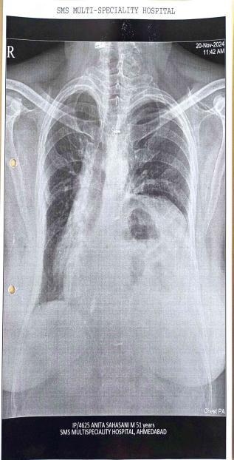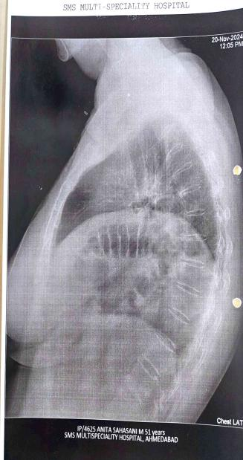
Fig 1: "Chest radiographs (PA and lateral views) demonstrating intrathoracic air–fluid level with elevated hemidiaphragm suggestive of diaphragmatic hernia."
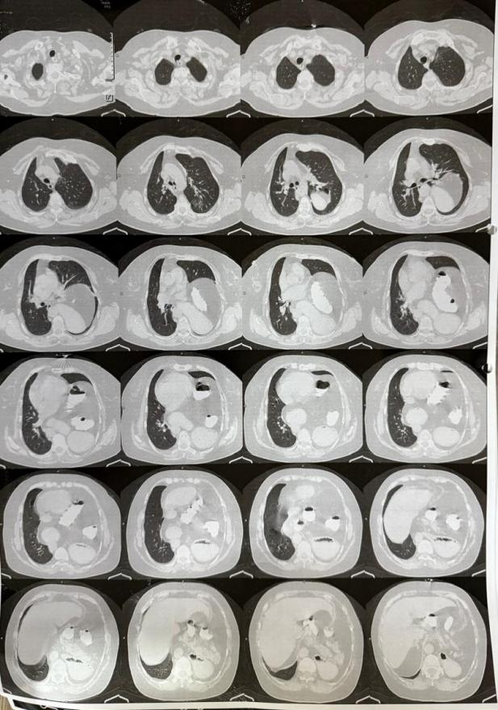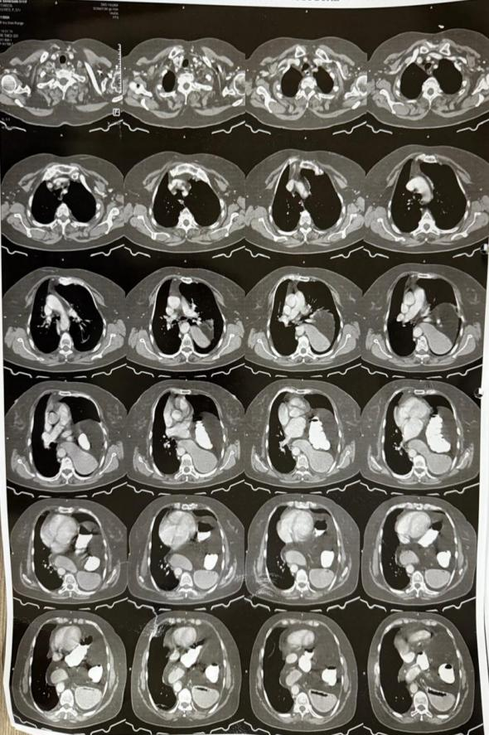
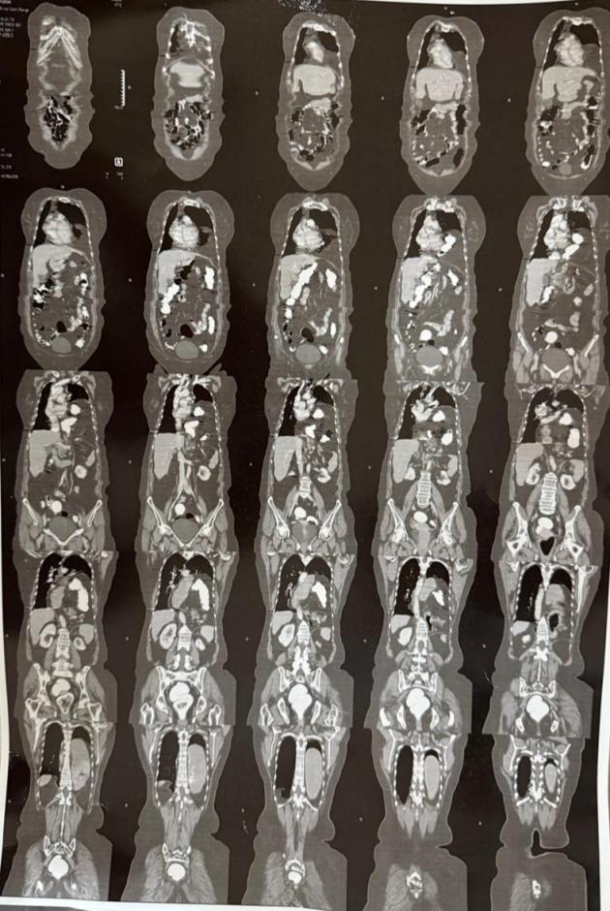
Fig 2: “CECT thoraco-abdominal axial sections demonstrating large diaphragmatic defect with intrathoracic herniation of abdominal viscera.”

Preoperative Preparation:
In view of symptomatic respiratory compromise and complex mediastinal involvement, elective open surgical repair was planned.

Surgical Procedure:
The patient underwent elective open repair under general anesthesia via an upper midline laparotomy. Intraoperatively, a giant Type IV hiatus hernia was confirmed, with herniation of the stomach and transverse colon into the mediastinum. The herniated viscera were gently reduced into the abdominal cavity. The hernia sac was carefully dissected free from mediastinal adhesions and excised completely.
The distal esophagus was mobilized to achieve adequate intra-abdominal length. Posterior cruroplasty was performed using interrupted non-absorbable sutures to approximate the diaphragmatic crura. Due to the large hiatal defect, mesh reinforcement was placed to reduce recurrence risk. A tension-free 360° Nissen fundoplication was then fashioned.
Hemostasis was secured, a drain was placed near the hiatus, and the abdomen was closed in layers. The patient tolerated the procedure well and remained hemodynamically stable postoperatively.

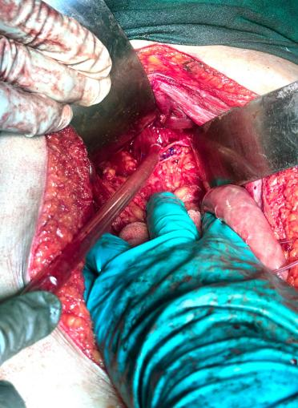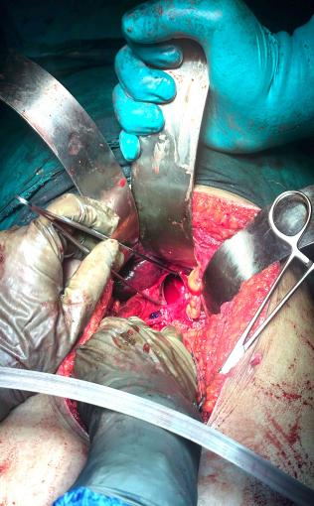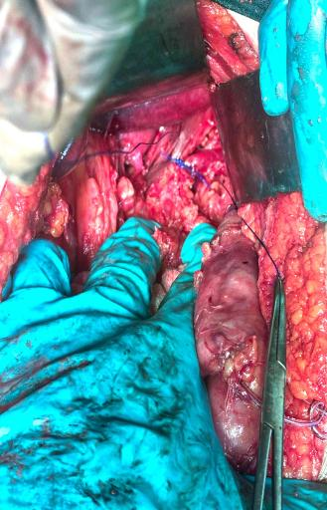
Fig 3: "Intraoperative images demonstrating adhesiolysis, reduction of herniated stomach and viable large bowel from the thoracic cavity, and primary repair of a large diaphragmatic defect with interrupted non-absorbable sutures."
Postoperative Course:
The postoperative course was uneventful. The patient was extubated on table and monitored closely. Nasogastric decompression was maintained for 24 hours. Oral liquids were started on postoperative day 2 and advanced as tolerated. Drain output was minimal and removed on day 4. She was discharged stable on day 6, asymptomatic on follow-up.

Discussion
Paraesophageal hiatus hernia (PEH) represents a distinct clinical entity within the spectrum of hiatal hernias and corresponds to Types II–IV in the anatomical classification system. Unlike the common sliding hiatal hernia (Type I), where the gastroesophageal junction migrates above the diaphragm, paraesophageal hernias are characterized by herniation of the gastric fundus or other abdominal viscera alongside a relatively fixed gastroesophageal junction. Type IV paraesophageal hernia represents the most advanced and least common subtype, in which additional organs such as the transverse colon, small intestine, spleen, or pancreas may herniate into the thoracic cavity. These hernias typically develop due to progressive enlargement of the esophageal hiatus, attenuation of the phrenoesophageal membrane, and chronic elevation of intra-abdominal pressure, often compounded by age-related connective tissue degeneration.

The clinical presentation of paraesophageal hernias is variable and may range from asymptomatic incidental findings to severe respiratory or gastrointestinal manifestations. Unlike sliding hiatal hernias, which commonly present with gastroesophageal reflux symptoms, PEH often manifests with obstructive or compressive symptoms due to mediastinal displacement of abdominal viscera. Patients may present with postprandial fullness, dysphagia, chest discomfort, dyspnea, or anemia due to chronic mucosal irritation. Large or “giant” paraesophageal hernias may also cause respiratory compromise due to lung compression and mediastinal shift. In advanced cases, complications such as gastric volvulus, strangulation, obstruction, ischemia, and gastrointestinal bleeding may occur, potentially leading to life-threatening emergencies if not treated promptly.

Radiological evaluation plays a crucial role in diagnosis and operative planning. Chest radiography may demonstrate retrocardiac air–fluid levels or intrathoracic gastric shadows, while contrast-enhanced computed tomography provides precise delineation of the diaphragmatic defect and the extent of visceral herniation. CT imaging is particularly valuable in giant Type IV hernias because it allows assessment of mediastinal involvement, identification of associated organ displacement, and detection of complications such as obstruction or ischemia. Additionally, volumetric measurements have been increasingly utilized to evaluate “loss of domain,” a condition in which prolonged intrathoracic displacement of abdominal viscera leads to adaptive reduction of the abdominal cavity capacity. Sudden reduction of large hernias during surgical repair may precipitate elevated intra-abdominal pressure, impaired ventilation, decreased venous return, and abdominal compartment syndrome, emphasizing the importance of careful preoperative planning.

Surgical repair remains the definitive treatment for symptomatic paraesophageal hernias. Historically, asymptomatic PEH was often managed conservatively; however, contemporary surgical literature increasingly supports elective repair in medically fit patients due to the unpredictable risk of acute complications. Emergency surgery for strangulated or obstructed PEH is associated with significantly higher morbidity and mortality compared with elective repair. Therefore, early operative intervention is generally recommended once the diagnosis is established in symptomatic individuals.

The fundamental principles of operative management include reduction of the herniated viscera into the abdominal cavity, complete excision of the hernia sac, mobilization of the distal esophagus to achieve adequate intra-abdominal length, tension-free closure of the diaphragmatic hiatus, and restoration of the antireflux mechanism. Excision of the hernia sac is considered an important step because it facilitates adequate esophageal mobilization and reduces mediastinal dead space, thereby lowering recurrence risk. Adequate mediastinal dissection is required to achieve at least 2–3 cm of tension-free intra-abdominal esophagus. In cases where sufficient esophageal length cannot be obtained despite extensive mobilization, esophageal lengthening procedures such as Collis gastroplasty may be considered.

Hiatal reconstruction is typically performed using posterior cruroplasty, which involves approximation of the right and left diaphragmatic crura with interrupted non-absorbable sutures. In large hiatal defects or cases with weakened crural musculature, mesh reinforcement may be employed to reduce the risk of recurrence. Both synthetic and biologic meshes have been described in the literature; however, the routine use of mesh remains controversial due to potential complications including erosion, migration, and postoperative dysphagia.

Fundoplication is commonly incorporated into PEH repair to restore the antireflux barrier and stabilize the gastroesophageal junction. Nissen fundoplication (360° wrap) remains the most widely performed procedure due to its excellent long-term reflux control. Partial fundoplication procedures such as Toupet (270° posterior wrap) or Dor (anterior wrap) may be preferred in patients with impaired esophageal motility in order to reduce the risk of postoperative dysphagia. In selected high-risk patients, gastropexy may also be performed to anchor the stomach and prevent recurrent herniation or gastric volvulus.

Minimally invasive laparoscopic repair has become the preferred approach in most centers due to reduced postoperative pain, shorter hospital stay, and faster recovery. However, open transabdominal repair remains an appropriate and sometimes necessary option in giant paraesophageal hernias with multivisceral herniation, dense mediastinal adhesions, or severe loss of abdominal domain. In such complex cases, open surgery allows safer reduction of herniated viscera and controlled reconstruction of the diaphragmatic hiatus, thereby ensuring a durable repair.

Conclusion:
Giant Type IV paraesophageal hernia with multivisceral intrathoracic migration is a rare and complex surgical condition that can lead to significant respiratory and gastrointestinal compromise. Accurate preoperative evaluation with contrast-enhanced computed tomography and volumetric assessment is essential for defining anatomical complexity and identifying loss of abdominal domain. Early surgical intervention remains the definitive treatment to prevent life-threatening complications such as obstruction, strangulation, and gastric volvulus. In large and complex hernias, open transabdominal repair allows safe reduction of herniated viscera, complete sac excision, and durable reconstruction with cruroplasty and fundoplication. Careful operative planning and adherence to established surgical principles are key to achieving favorable outcomes.

Conflicts of Interest: None declared
Consent: Written informed consent obtained from the patient

References:
- Townsend CM, Beauchamp RD, Evers BM, Mattox KL. Sabiston Textbook of Surgery: The Biological Basis of Modern Surgical Practice. 21st ed. Elsevier; 2022.
- Brunicardi FC, Andersen DK, Billiar TR, et al. Schwartz’s Principles of Surgery. 11th ed. McGraw-Hill; 2019.
- Williams NS, O’Connell PR, McCaskie AW. Bailey & Love’s Short Practice of Surgery. 27th ed. CRC Press; 2018.
- Fischer JE, Bland KI, Callery MP. Mastery of Surgery. 7th ed. Lippincott Williams & Wilkins; 2020.
- Doherty GM, editor. Current Surgical Therapy. 13th ed. Elsevier; 2021.
- Zinner MJ, Ashley SW, editors. Maingot’s Abdominal Operations. 13th ed. McGraw-Hill; 2019.
- Cameron JL, Cameron AM. Current Surgical Therapy. 12th ed. Elsevier; 2017.
- Townsend CM et al. Surgery: Scientific Principles & Practice. 2nd ed. Lippincott Williams & Wilkins; 2019.
- Fischer JE. Mastery of Operative Surgery. 4th ed. Lippincott Williams & Wilkins; 2015.
- Clowes GH, et al. Vascular Surgery: Principles and Practice. 3rd ed. Lippincott Williams & Wilkins; 2014.
- Patankar R, et al. Laparoscopic management of giant paraesophageal hernia: technical strategies and outcomes. Amer Surg. 2025.
- Habeeb TAAM, Hussain A, Aiolfi A, et al. Frailty predicts recurrence after laparoscopic Nissen fundoplication with mesh cruroplasty in giant sliding hiatal hernia. Hernia. 2025;29:235.
- Khan MU, et al. Laparoscopic hiatal hernia repair: reliable long-term symptom control and recurrence patterns. PMC Surg Endosc. 2025.
- Ning Alsayegh F, et al. Minimally invasive hiatal hernia repair: trends from 2018–2024. Ann Thorac & Cardiovasc Surg. 2025.
- Rieder E. Management of paraesophageal hernia: recent data on mesh, gastropexy, and fundoplication trends. J Gastrointest Surg. 2025;(in press).
- Schneider MA, et al. Surgical strategies to prevent recurrence after hiatus hernia repair. Eur Surg Rev. 2025.
- De Bernardi S, et al. Mesh-reinforced cruroplasty for type III–IV hiatus hernia: medium-term outcomes. OAEPublish. 2025;
- Gerdes S, et al. Delphi consensus on management of paraesophageal hiatus hernia: perioperative and surgical recommendations. Surg Endosc. 2023.
- Saleh Z, et al. Recurrence after paraesophageal hernia repair and critical view technique. J Hernia Surg. 2024.
- Lukman K, et al. Laparoscopic surgery of a rare giant paraesophageal hernia: a case report and review. IJ Sorb Open. 2024.

