Case report
Neurogenic Heterotopic Ossification of the Hip in an Adolescent Following Postoperative Coma: A Case Report

.
ABSTRACT:

Background:
Neurogenic heterotopic ossification (NHO) is an uncommon but potentially disabling complication of severe neurological injury, particularly in pediatric patients.
Case Presentation:
We report the case of a 13-year-old adolescent who developed NHO of the hip following surgical treatment of an astrocytoma complicated by prolonged postoperative coma and immobilisation. The patient progressively presented with hip pain and severe limitation of joint mobility, leading to significant functional impairment.
Initial conservative management including analgesic therapy and structured physiotherapy failed to improve symptoms. Radiographs and computed tomography with three-dimensional reconstructions confirmed mature heterotopic ossification. Surgical excision was performed, resulting in complete pain relief and full restoration of hip range of motion.
DISCUSSION
Neurogenic heterotopic ossification is a rare complication of neurological injury, particularly in the pediatric population. Imaging studies, especially computed tomography, are essential to confirm the maturity of heterotopic bone and guide the timing of surgical excision in patients presenting with severe functional limitation.
Conclusion:
At 1-year follow-up, the patient remained asymptomatic with no radiological evidence of recurrence. This case highlights the importance of early recognition of NHO in pediatric patients with prolonged immobilisation and neurological injury, and supports surgical excision as an effective treatment once ossification maturity is confirmed.

Keywords: heterotopic ossification; neurogenic heterotopic ossification; pediatric; hip joint; surgical excision; postoperative coma

1. INTRODUCTION

Neurogenic heterotopic ossification (NHO) is defined as the abnormal formation of lamellar bone within periarticular soft tissues occurring as a consequence of severe neurological injury. It is most commonly described in adults following traumatic brain injury or spinal cord injury, but pediatric cases remain rare and are probably underdiagnosed [1,2]. The true incidence of NHO in children remains poorly documented and is likely underestimated in the current literature. The hip joint is a preferential site of involvement and carries significant functional implications, including pain, progressive joint stiffness and impaired ambulation [3].
The pathophysiology of NHO is multifactorial and involves neuroinflammatory mechanisms, prolonged immobilisation and abnormal osteogenic differentiation of mesenchymal precursor cells [4]. Diagnosis may be delayed in children because early symptoms are often nonspecific and may mimic other conditions. Conservative management is generally considered the first-line therapy; however, surgical excision may be required in refractory cases associated with severe functional impairment [5].
We report a rare case of hip NHO in a 13-year-old adolescent developing after prolonged postoperative coma following intracranial astrocytoma surgery, successfully managed by surgical excision after failure of conservative treatment. To our knowledge, such an association between postoperative coma, prolonged immobilisation and pediatric NHO remains rarely described in the literature.

2. CASE PRESENTATION:
A 13-year-old female adolescent was referred to our orthopaedic department for evaluation of progressive pain and complete loss of mobility of the left hip. Her past medical history was significant for surgical resection of an intracranial astrocytoma, which was complicated by a prolonged postoperative course requiring more than six months of strict bed rest in the intensive care unit.
During this period, the patient developed a left hemiparesis, rendering her entirely dependent for all transfers and daily activities. Due to the severity of neurological impairment, any mobilisation of the right lower limb was precluded by intense and refractory pain, resulting in complete and sustained immobilisation of the right hip throughout the postoperative period.
Upon neurological stabilisation and transfer to the rehabilitation unit, clinical assessment revealed a markedly painful and completely ankylosed left hip, with no residual active or passive range of motion in any plane. The patient was unable to bear weight or ambulate independently. There was no local inflammatory sign, no fever, and no history of prior local trauma or infection.
Prolonged immobilisation and hemiparesis were considered the main risk factors for the development of heterotopic ossification in this patient.
Initial management consisted of multimodal analgesic therapy including non-steroidal anti-inflammatory drugs, combined with a structured physiotherapy programme aimed at progressive mobilisation of the right hip. Despite several weeks of appropriate conservative treatment, the patient showed no clinical improvement, with persistent pain and complete absence of joint range of motion, resulting in severe functional impairment and preventing independent ambulation.
Standard anteroposterior pelvic radiographs ( figure 1)demonstrated dense periarticular ossifications surrounding the right hip joint, with no evidence of underlying bone destruction or articular joint space narrowing.

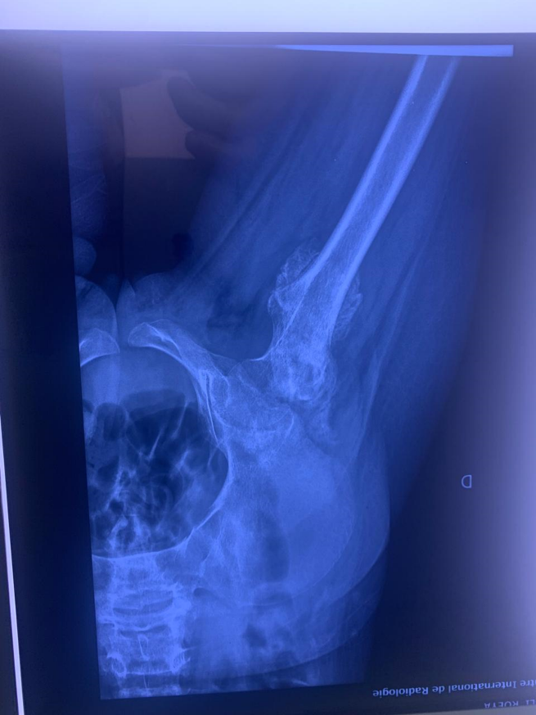
Figure 1: Preoperative anteroposterior radiograph of the pelvis demonstrating extensive periarticular ossification surrounding the right hip joint consistent with heterotopic ossification.
Computed tomography (CT) (figure 2)of the pelvis confirmed the presence of mature heterotopic ossification, Radiological maturity was suggested by the presence of well-defined cortical margins and clear separation from the adjacent femoral cortex.
Three-dimensional CT reconstructions were used to precisely delineate the extent of the ossified mass, assess its anatomical relationships with adjacent neurovascular structures, and guide surgical planning. Biological inflammatory markers were not significantly elevated. No signs of infection were identified, and imaging review excluded tumour recurrence.
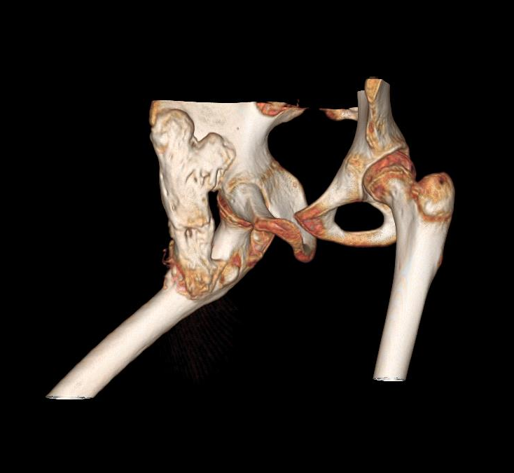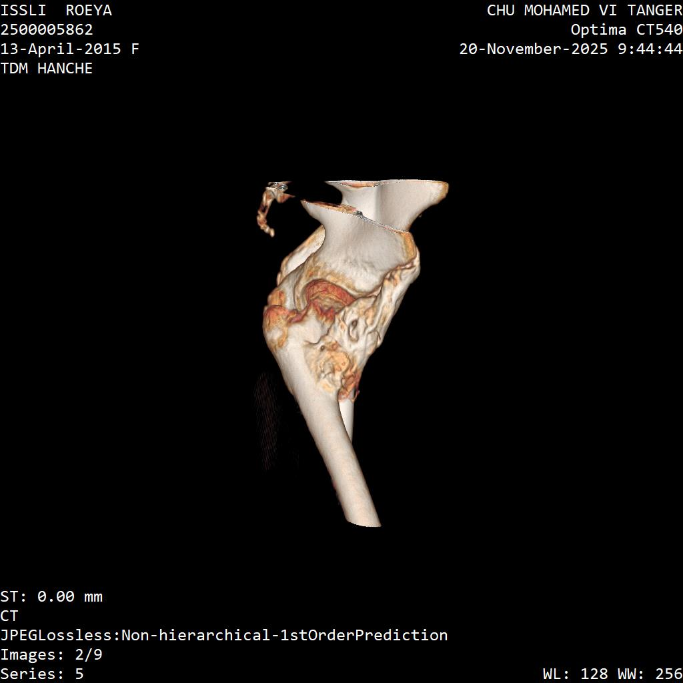

Figure 2.Three-dimensional CT reconstruction illustrating the extent of periarticular ossification and its anatomical relationship with the proximal femur and acetabulum.
Given the failure of conservative management and the severity of functional impairment, surgical excision of the heterotopic ossification was indicated. The decision to proceed with surgery was taken after multidisciplinary discussion, taking into account the radiological maturity of the ossification on CT imaging and the absence of active neurological deterioration.
The procedure was performed through an appropriate surgical approach to the right hip, with meticulous dissection to protect adjacent neurovascular structures. Complete macroscopic (Figure 3) resection of the ossified mass was achieved. Intraoperatively, the heterotopic bone was found to be clearly demarcated from the underlying femoral cortex, consistent with preoperative imaging findings.
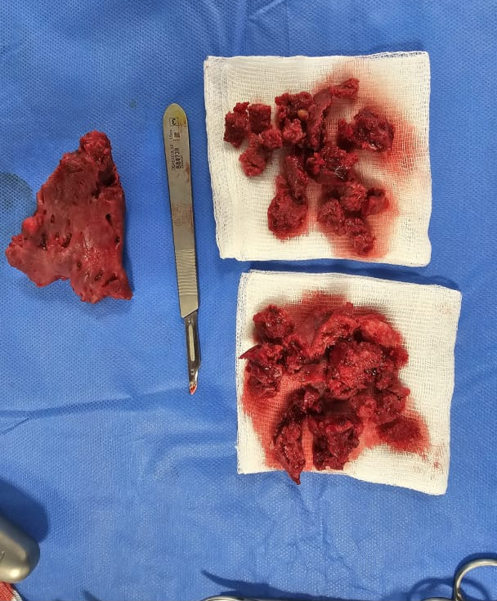
Figure 3: Intraoperative view of the excised heterotopic ossification. Multiple fragments of mature ectopic bone removed from the periarticular region of the left hip are shown on sterile gauze, with a scalpel used as a scale reference.

Early postoperative mobilisation and intensive physiotherapy were initiated within 48 hours of surgery. Prophylactic treatment to prevent recurrence was administered in the form of non-steroidal anti-inflammatory drugs, in accordance with current recommendations for the management of neurogenic heterotopic ossification [7].
The postoperative course was uneventful. The patient experienced complete resolution of hip pain and a marked improvement in joint range of motion. Hip flexion improved from complete ankylosis preoperatively to approximately 110°, while abduction reached about 40° within weeks of surgery.
Gait progressively returned to normal and the patient regained full functional autonomy, including the ability to resume school activities.
Clinical and radiological follow-up (Figure 4) was conducted at 3, 6 and 12 months postoperatively. At the 1-year follow-up visit, clinical examination confirmed sustained and complete functional recovery with a pain-free hip and full range of motion. Follow-up radiographs showed no evidence of recurrence of heterotopic ossification at the surgical site.
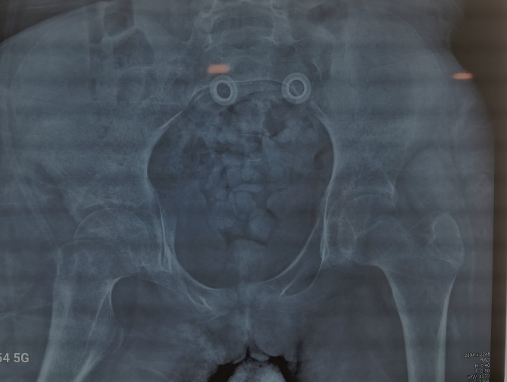
Figure 4: Postoperative anteroposterior radiograph of the pelvis demonstrating satisfactory hip joint alignment after surgical excision of heterotopic ossification, with no residual periarticular ossified mass.

3. Discussion
Neurogenic heterotopic ossification (NHO) is a well-recognised complication of severe neurological injury, occurring in up to 20% of adults following traumatic brain injury or spinal cord injury [1,2]. In children, however, the condition remains rare, and existing knowledge is largely extrapolated from adult series. The true incidence of NHO in the pediatric population remains poorly defined and is likely underestimated in current clinical practice. The present case is unusual in that NHO developed following a postoperative non-traumatic coma related to intracranial astrocytoma surgery, a mechanism that has been seldom reported in paediatric patients.
The pathophysiology of NHO remains incompletely understood. The current leading hypothesis involves a dysregulation of osteoblastic differentiation of mesenchymal stem cells, driven by a combination of neurogenic signals, local inflammatory mediators and immobilisation-induced mechanical factors [4,8]. Prolonged immobilisation, as seen in the context of intensive care management, is widely recognised as a major contributing factor, acting synergistically with neuroinflammatory mechanisms [3]. In pediatric patients, prolonged immobilisation associated with neurological impairment appears to play a particularly important role in the development of heterotopic ossification.
Diagnosis of NHO in children may be challenging. Early symptoms — local swelling, warmth and pain — are nonspecific and may mimic septic arthritis, deep vein thrombosis or tumour. Plain radiographs are often normal in the early stages, and the ossification typically becomes radiologically apparent only after 3 to 6 weeks. CT with three-dimensional reconstruction remains the gold standard for confirming ossification maturity and planning surgical intervention [6]. Bone scintigraphy may be useful in detecting early-stage disease, though it was not required in the present case.
Conservative treatment, including analgesic therapy, gentle physiotherapy and pharmacological prophylaxis with NSAIDs, is recommended as the initial approach. Surgical excision is generally reserved for cases with severe functional impairment, joint ankylosis or failure of conservative management [5,7]. The timing of surgery has historically been debated, with earlier recommendations advocating waiting for radiological and scintigraphic evidence of ossification maturity to minimise recurrence risk. More recent evidence, however, suggests that surgery can be safely performed once CT maturity criteria are fulfilled, without waiting for complete scintigraphic quiescence [9].
In the present case, surgical excision performed after confirmation of ossification maturity on CT resulted in excellent functional outcomes with no recurrence at 1-year follow-up. These findings are consistent with published series reporting low recurrence rates after complete resection in the context of adequate maturity criteria [5,9]. Long-term follow-up remains essential, however, as recurrence has been reported in some cases beyond 12 months, particularly in patients with ongoing neurological injury.
This case therefore illustrates that early recognition and timely surgical management may lead to excellent functional recovery in selected pediatric patients with mature NHO.
This case also underscores the importance of early clinical suspicion for NHO in paediatric patients with prolonged immobilisation or coma following any severe neurological insult, regardless of the underlying aetiology. A structured surveillance protocol — including serial clinical assessment and timely radiological evaluation — could contribute to earlier diagnosis and more effective management in this vulnerable population.
Clinicians should therefore maintain a high index of suspicion for neurogenic heterotopic ossification in pediatric patients with prolonged immobilisation following neurological injury, as early diagnosis and appropriate management can prevent severe and potentially irreversible functional limitations.

4. Conclusion

We report a rare case of neurogenic heterotopic ossification of the hip in a 13-year-old adolescent following prolonged postoperative coma after intracranial astrocytoma surgery. After failure of conservative management, surgical excision resulted in complete pain relief and substantial restoration of hip mobility, with no radiological recurrence at 1-year follow-up.
This case highlights the importance of maintaining a high index of suspicion for NHO in paediatric patients with neurological injury and prolonged immobilisation, as early diagnosis may prevent severe functional impairment. Our findings also support surgical excision as a safe and effective treatment option in selected patients with mature heterotopic ossification refractory to conservative management

References

[1] Citak M, Suero EM, Backhaus M, et al. Risk factors for heterotopic ossification in patients with spinal cord injury: a case-control study of 264 patients. Spine (Phila Pa 1976). 2012;37(23):1953–1957.
[2] Aubut JA, Mehta S, Cullen N, Teasell RW; ERABI Group; Scire Research Team. A comparison of heterotopic ossification treatment within the traumatic brain and spinal cord injured population: an evidence based systematic review. NeuroRehabilitation. 2011;28(2):151–160.
[3] Meyers C, Lisiecki J, Miller S, et al. Heterotopic ossification: a comprehensive review. JBMR Plus. 2019;3(4):e10172.
[4] Taly AB, Nair KP, Murali T. Neurogenic heterotopic ossification: a clinical review. Ann Indian Acad Neurol. 2009;12(1):8–12.
[5] Genêt F, Jourdan C, Schnitzler A, et al. Troublesome heterotopic ossification after central nervous system damage: a survey of 570 surgeries. PLoS One. 2011;6(1):e16632.
[6] Ledermann HP, Schweitzer ME, Morrison WB. Pelvic heterotopic ossification: MR imaging characteristics. Radiology. 2002;222(1):189–195.
[7] Vanden Bossche L, Vanderstraeten G. Heterotopic ossification: a review. J Rehabil Med. 2005;37(3):129–136.
[8] Convente MR, Wang H, Pignolo RJ, Kaplan FS, Shore EM. The immunological contribution to heterotopic ossification disorders. Curr Osteoporos Rep. 2015;13(2):116–124.
[9] Garland DE. A clinical perspective on common forms of acquired heterotopic ossification. Clin Orthop Relat Res. 1991;(263):13–29.

