Case report

Quadruple Amputations in professional electrical burns: multidisciplinary approach and impact of early prosthetics and patient motivation

.
ABSTRACT

High voltage electrical burns constitute a rare but severe mechanism of injury especially in workplace accidents, responsible for deep tissue damage resulting in amputations and mortality. We report the case of a 32-year-old male who sustained a work-related high-voltage electrical injury with entry points at both upper limbs and exit points in both lower limbs resulting in extensive necrosis of all four extremities. Surgical management dictated proximal amputations of the upper limbs and bilateral mid-leg amputations. The patient was admitted in an intensive care unit for four days and then underwent a structured rehabilitation program including progressive prosthetic fitting. The overall outcome has been judged satisfactory to the patient with a significant functional recovery, a notable improved autonomy and social reintegration. We aim to highlight the utmost importance of psychological support and the active involvement of the patient in the therapeutic project.

Keywords: Electrical burns, high voltage, quadruple amputations, prosthesis, psychological support.

1. INTRODUCTION

Electrical burns are a relatively infrequent cause of burns accounting for less than 10% of admissions to specialized burn centers (Koumbourlis, 2002; Al-Benna, 2023), yet they are responsible for disproportionately higher mortality and a significantly higher degree of morbidity compared to thermal burns. High-voltage electrical burns (>1000V) occur predominantly in work related instances (39%) , particularly in construction, industry and energy sectors, affecting primarily young working-age men (Arnoldo et al., 2004).
These injuries are the cause mostly associated with extensive and deep damage including muscular, vascular and neural necrosis. These injuries are often clinically underestimated at the initial stage and frequently require multiple debridements, decompressive fasciotomies and may lead to limb amputations (Handschin et al., 2007).
Patients who underwent limb amputations face an uphill battle to regain a satisfactory level of autonomy and social reintegration. This implicates an advancement in the management of prosthetics and rehabilitation process to avoid prosthetics rejection (Resnik et al., 2012).

2. Presentation of Case

A 32-year-old male, electrician, with no significant medical history, was admitted on an emergency basis following a work-related high-voltage electrical injury caused by direct exposure to an industrial electrical line. The current pathway showed entry points in both hands and exit points at both feet.
Initial assessment revealed an extensive necrosis of all four limbs including necrosis reaching muscular, neural and vascular tissues. Given the irreversible nature of the lesions and the major metabolic risk present in a conservative treatment, immediate quadruple amputations were indicated as a saving gesture.

- Surgical management and initial care:
The patient was subject to bilateral scapulohumeral disarticulation with adapted myoplasty of both upper limbs and a bilateral lower limb amputation at the upper-middle thirds of both legs.
Immediate post operative was conducted in the Intensive care unit for 4 days, focusing on hemodynamic stabilization, prevention of systemic complications and pain control. A particular focus was allocated to psychological support with immediate supportive psychotherapy aiming to improve the patient’s acceptance of the amputation and his integration in the planned therapeutic plan.

Figure 1. Postoperative view of the patient
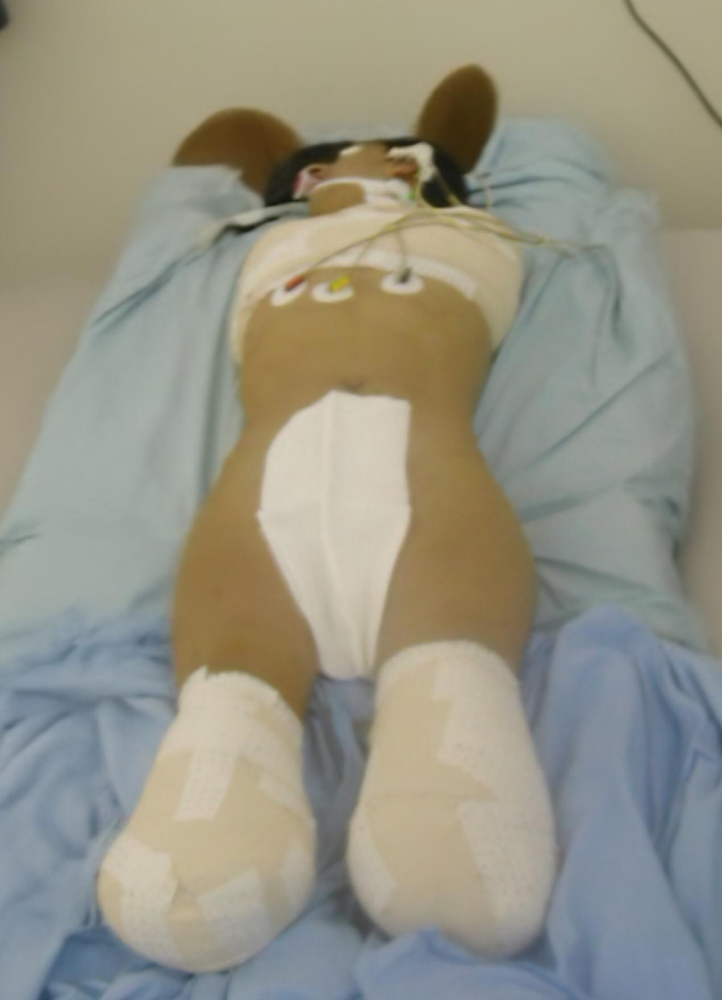
- Rehabilitation and prosthetic fitting:
After satisfactory stump healing, the patient was transferred to a physical medicine and rehabilitation department. Management followed a progressive and hierarchical strategy, in accordance with recommendations for quadruple prosthetics for multiple limb amputees (Tanaka et al., 2024).
Prosthetic fitting began with leg prostheses in order to restore standing, balance and gait training; The patient was integrated in a rehabilitation process allowing him to achieve the ability to walk without a cane.
Once the initial goals were achieved, bilateral myoelectric upper-limb prostheses were fitted allowing a recovery of grasping functions enabling a satisfactory level of independence such as eating, dressing and toileting.
The rehabilitation process was conducted following a sustained psychological support ensuring an adherence and an acceptance of the prosthesis.
Functional outcome was favorable, with significant gains in autonomy, improved quality of life, and satisfactory social reintegration.
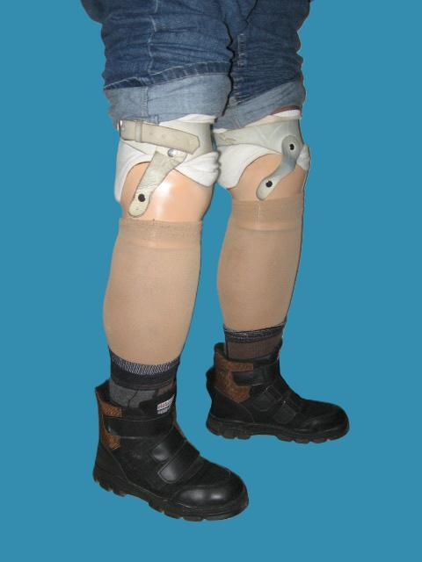

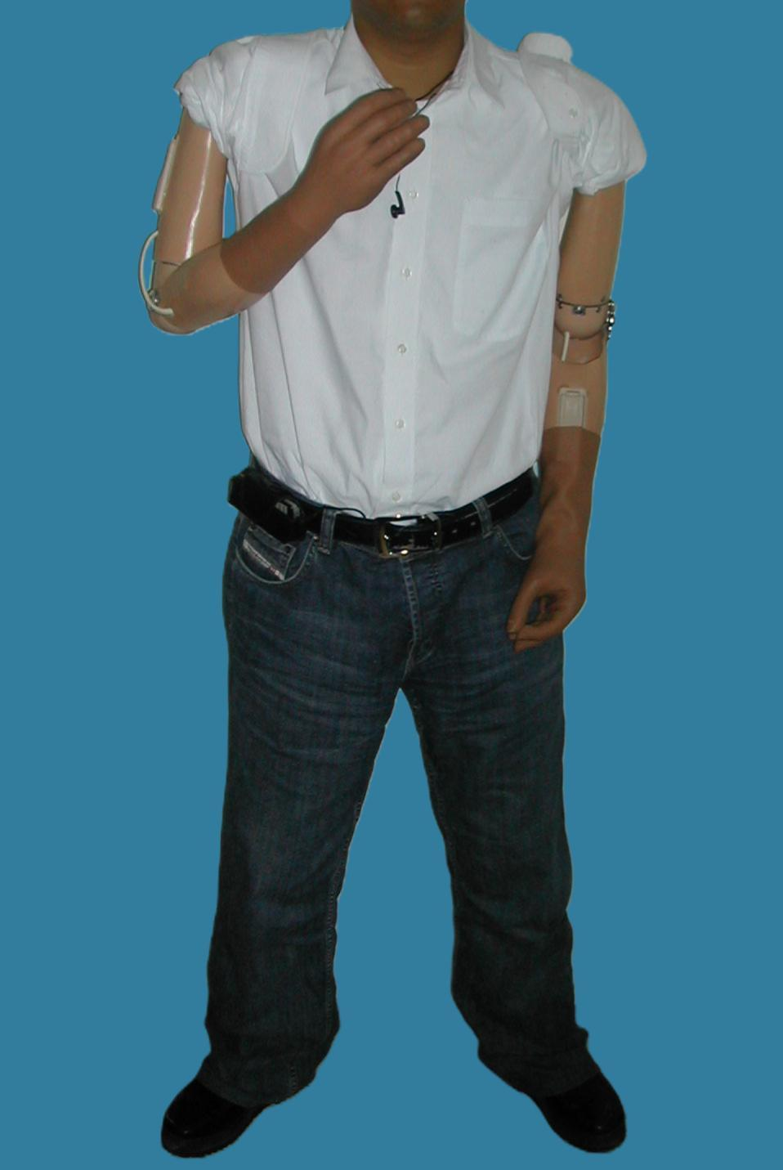
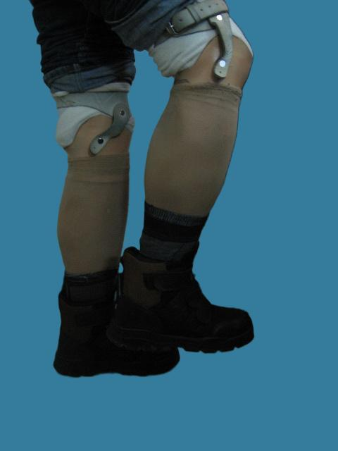
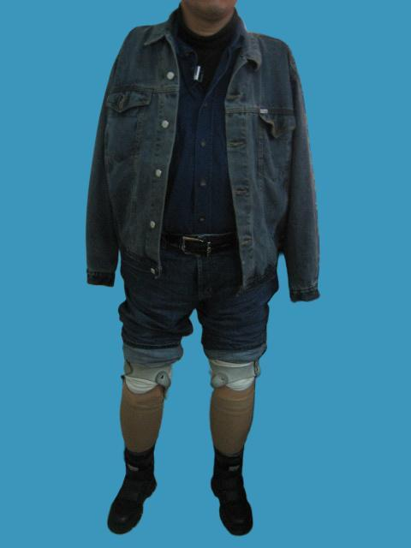
Figure 2. - Rehabilitation and Prosthetic Fitting in the Patient

3. discussion
Epidemiology of high-voltage electrical injuries
Electrical injuries represent an uncommon occupational accident but are associated with high mortality and very serious complications and disabilities (Salehi et al., 2022). High-voltage currents account for the second highest rate of mortality related to electrical injury (5%) and are the most common cause of complications (Arnoldo et al., 2004).
Incidence of amputations after electrical burns
High-voltage electrical burns carry a high risk of deep-tissue necrosis affecting the limbs resulting in frequent extremity compartment syndrome and leading to secondary amputation as a salvatory solution. According to published series, 10–30% of patients with extensive electrical burns require at least one amputation (Handschin et al., 2007,Cancio et al., 2005). Upper limbs, usually corresponding to entry points, are most frequently affected. Multiple, particularly quadruple, amputations remain exceptional but dramatic cases.
Prosthetic fitting and reliability
Technological advances have and continue to significantly improve functional outcomes in amputees. Modern lower-limb prostheses provide reliable gait restoration with a decreased reliance on walking aid, they also add a significant comfort and decreased pain allowing for a long-term use rate exceeding 80% in appropriately selected patients (Highsmith et al., 2016).
For upper limbs, myoelectric prostheses significantly improve grasping and functional autonomy, allowing for a satisfactory level of independence and lowering the rejection rate to less than 20% (Biddiss & Chau, 2007).
Role of supportive psychotherapy
Multiple limb amputation represents a major psychological trauma, especially in young and active individuals resulting in a high level of anxiety (29.9%) and depression (13.4%) (Atherton & Robertson, 2006). Persistent psychological distress may lead to non-compliance with rehabilitation and prosthesis rejection. Supportive psychotherapy is a cornerstone of psychological care and should be initiated as soon as possible to establish a strong therapeutic alliance underpinning the rehabilitation project.
Role of patient motivation and family support
The literature emphasizes that patient motivation and active involvement are independent prognostic factors for successful prosthetic rehabilitation, constituting a decisive factor in prostheses acceptance regardless of prosthetic sophistication. Patient motivation and involvement has been found to be directly influenced by outside factors namely family support which may constitute a positive impact on the patient’s psychological status (Resnik et al., 2012, Monné Cuevas et al., 2021) .In this case, the patient’s determination and adherence to the therapeutic program enabled effective prosthetic use and successful social reintegration.
Post-prosthetic course
The patient had gradually accepted and adapted to the prostheses and has regained an adequate level of autonomy. Follow up is outlined by continued psychological evaluation and prosthesis replacement in case of significant wear and tear.

4. Conclusion
Occupational high-voltage electrical injuries can lead to catastrophic and extensive tissue damage requiring major amputations. Early multidisciplinary management including surgery and psychological support combined with modern prosthetic fitting and intensive rehabilitation can nonetheless achieve encouraging functional and social outcomes. Patient motivation and active engagement in the therapeutic program remain central determinants of functional prognosis.
Competing interests
Authors have declared that no competing interests exist.

Consent (where ever applicable)
All authors declare that they received written informed consent was obtained from the patient

COMPETING INTERESTS DISCLAIMER:
Authors have declared that they have no known competing financial interests OR non-financial interests OR personal relationships that could have appeared to influence the work reported in this paper.

References
[1] Koumbourlis AC. Electrical injuries. Crit Care Med 2002;30:S424-430. https://doi.org/10.1097/00003246-200211001-00007.
[2] Al-Benna S. Electrical burns in adults. Acta Chir Plast 2023;65:66–9. https://doi.org/10.48095/ccachp202366.
[3] Arnoldo BD, Purdue GF, Kowalske K, Helm PA, Burris A, Hunt JL. Electrical injuries: a 20-year review. J Burn Care Rehabil 2004;25:479–84. https://doi.org/10.1097/01.bcr.0000144536.22284.5c.
[4] Handschin AE, Jung FJ, Guggenheim M, Moser V, Wedler V, Contaldo C, et al. [Surgical treatment of high-voltage electrical injuries]. Handchir Mikrochir Plast Chir 2007;39:345–9. https://doi.org/10.1055/s-2007-965721.
[5] Resnik L, Meucci MR, Lieberman-Klinger S, Fantini C, Kelty DL, Disla R, et al. Advanced upper limb prosthetic devices: implications for upper limb prosthetic rehabilitation. Arch Phys Med Rehabil 2012;93:710–7. https://doi.org/10.1016/j.apmr.2011.11.010.
[6] Tanaka Y, Nakayama S, Ueno T, Miura T. Prosthetic Rehabilitation for a Patient With Purpura Fulminans Undergoing Quadruple Amputation: A Case Report. Cureus 2024;16:e67384. https://doi.org/10.7759/cureus.67384.
[7] Salehi SH, Sadat Azad Y, Bagheri T, Ghadimi T, Rahbar A, Ehyaei P, et al. Epidemiology of Occupational Electrical Injuries. Journal of Burn Care & Research 2022;43:399–402. https://doi.org/10.1093/jbcr/irab171.
[8] Cancio LC, Jimenez-Reyna JF, Barillo DJ, Walker SC, McManus AT, Vaughan GM. One Hundred Ninety-Five Cases of High-Voltage Electric Injury: Journal of Burn Care & Rehabilitation 2005;26:331–40. https://doi.org/10.1097/01.BCR.0000169893.25351.A9.
[9] Highsmith MJ, Kahle JT, Miro RM, Orendurff MS, Lewandowski AL, Orriola JJ, et al. Prosthetic interventions for people with transtibial amputation: Systematic review and meta-analysis of high-quality prospective literature and systematic reviews. J Rehabil Res Dev 2016;53:157–84. https://doi.org/10.1682/JRRD.2015.03.0046.
[10] Biddiss E, Chau T. Upper-Limb Prosthetics: Critical Factors in Device Abandonment. American Journal of Physical Medicine & Rehabilitation 2007;86:977–87. https://doi.org/10.1097/PHM.0b013e3181587f6c.
[11] Atherton R, Robertson N. Psychological adjustment to lower limb amputation amongst prosthesis users. Disability and Rehabilitation 2006;28:1201–9. https://doi.org/10.1080/09638280600551674.
[12] Monné Cuevas P, Borrás Correa A, Vidal Fortuny E, Ángeles Diaz Vela M, Calvo Sanz J. Traumatic quadruple amputee rehabilitation: from amputation to prosthetic functionality: a case report. Disabil Rehabil Assist Technol 2021;16:112–8. https://doi.org/10.1080/17483107.2019.1644675.

