CASE REPORT
DUPLICATION OF INTERNAL JUGULAR VEIN: ANATOMIC VARIATION IN NECK DISSECTION

ABSTRACT
Aims: Our aim of this case report is to explain the anatomical variation and the presentation of such duplication, to emphasize that aneurysmal dilatation is a part of anomalies and lastly to discuss about literature and embryological hypotheses related to internal jugular vein duplication.
Presentation of case: In this case report, while doing bilateral neck dissection we found the incidental finding of unilateral duplication of Right internal jugular vein in a case of oral squamous cell carcinoma of lower labial vestibule with lymph node metastasis.
Discussion: It is essential for the clinicians performing catheterization and surgeons operating in the neck to understand normal and abnormal venous anatomy structure within the neck. Duplication of the internal jugular vein is an uncommon anatomical variation which may be incidentally found at surgery on the neck. This abnormality is manifested as two separate internal jugular veins rather than a single one.
Conclusion: Such anatomical variations are considered to be more easily noted intraoperatively or unexpectedly, and as there might be a potential for SAN and vascular injuries, patients should be evaluated thoroughly before surgery so that the risk of iatrogenic injury could at least theoretically reduced.

Keywords: Neck dissection, Internal Jugular Vein, Duplication, Unilateral

- INTRODUCTION

Anomaly of vessels from their normal course is so common, that it occurs more frequently in veins than arteries. The internal jugular vein (IJV) courses from the skull base to the base of the neck along the carotid axis. (1) The internal carotid and common carotid arteries are situated in the neck and above two non-descriptive structures pass hypoglossal nerve and spinal accessory neve, which descend downwards to join the subclavian vein. The internal jugular vein serves as an important surgical landmark for identifying the carotid arteries and cervical lymph nodes. The left jugular vein is usually smaller than the right side vein. (2)
The thoracic duct on the left, and the right lymphatic duct on the right, each open in the angle of junction between the internal jugular and subclavian veins. These vessels typically originate from the anterior surface in the neck and almost never have posterior branches, thus facilitating dissection of the posterior triangle of the neck. The vein may present with posterior branches and duplications.
Duplication of the internal jugular vein (IJV) is very rare with incidence of only 4 in 1000 unilateral neck dissection cases. (3) On reviewing the literature, we found that there are only 21 reported cases of IJV duplication in 18 patients to date, out of which, 15 were unilateral and 3 were bilateral [7]. During neck dissection procedures, the duplication of the internal jugular vein (IJV) can present unique challenges and considerations.
In this case report, while doing bilateral neck dissection we found the incidental finding of unilateral duplication of Right internal jugular vein in a case of oral squamous cell carcinoma of lower labial vestibule with lymph node metastasis.

- PRESENTATION OF THE CASE

A 60-year-old female patient reported to the department of oral and maxillofacial surgery with ulceroproliferative lesion involving lower labial vestibule for the past 2 months. On clinical examination an ulceroproliferative lesion of size approximately 6 × 6 cms, roughly oval in shape, reddish white in color and fixed to underlying soft tissue and bone. Biopsy was confirmed to be well differentiated oral squamous cell carcinoma of lower labial vestibule. The patient was clinically stage as T4aN2cM0. She underwent wide Local excision of the primary lesion, bilateral modified radical neck dissection type III (Level I-IV) preserving spinal accessory nerve, internal jugular vein, and sternocleidomastoid muscle. Marginal mandibulectomy was done and reconstruction with Pectoralis major myocutaneous (PMMC) flap.
During neck dissection on right side, accidentally we encountered the duplication of Internal jugular vein(IJV) at a level of the superior belly of the omohyoid muscle with medial and lateral tributaries. The medial tributary was approximately 6 cms long and it was lying medial to the carotid bulb. The lateral tributary was approximately 7cms and located at the normal anatomical location of IJV lateral to the common carotid artery. On dissecting superiorly to trace the spinal accessory neve we found that both the tributaries were communicating with each other through a small communicating vein in the shape of letter ‘H’ (fig 1). The spinal accessory nerve was found further lateral to the lateral tributary and anterior to the external carotid artery. Both the tributaries were preserved and levels of lymph nodes were removed while dissecting along the plane of both the medial and lateral tributary of IJV.
Post-operative CECT was not taken to identify and confirm the origin of duplication due to financial constraints.

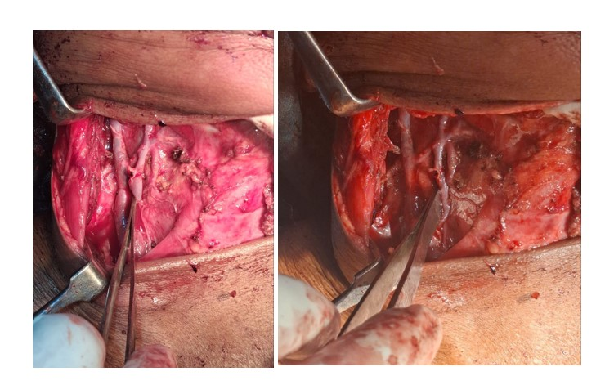
Fig. 1 – Duplication of Internal jugular vein. Medial and lateral tributaries are separated and recommunicated by an interconnecting vein at upper part.

- DISCUSSION
The principal blood vessels of the head and neck consist of the carotid arteries for the arterial supply and the jugular veins for venous drainage. These vascular structures are commonly encountered by head and neck surgeons during selective neck dissection and by anesthesiologists or intensivists during central venous catheter placement for central venous pressure monitoring, drug administration, or volume resuscitation.
There are three proposed classifications of IJV duplication. Mumtaz S et al. classified anatomical variations of the internal jugular vein as follows [5] Duplication; Bifurcation; Fenestration; Posterior tributary; Trifurcation.
Another classification Downie et al classified it into a duplicated and fenestrated vascular pattern. In a duplicated pattern, IJV bifurcates into two veins which separately join the subclavian vein, thereby, forming an Inverted-Y pattern. On the other hand, in a fenestrated pattern, IJV commences from the base of the skull as a single vein and then branches into two for some distance before uniting again proximal to the subclavian vein. (10)
Another classification based on the level and extent of IJV duplication proposed three main patterns. Type A duplication, the most common type, involves the union of duplicate veins cranial to or at the level of omohyoid tendon. In type B duplication the union occurs caudal to the omohyoid tendon. Whereas type C duplication starts around the hyoid bone level and the lateral vein runs outside the carotid sheath in the posterior triangle before entering the carotid sheath at the root of the neck. (7)
So in our case report, in the duplication of the right internal jugular vein the medial tributaries and lateral tributaries runs parallel to carotid axis and spinal accessory nerve is present lateral to lateral tributaries of the internal jugular vein. Lateral and medial tributaries combine at both upper and lower parts of the internal jugular vein, at upper parts through a small communicating vein and at lower parts as a main branch of IJV which supplies further to subclavian vein.
So, according to Nayak SP et al. classification and variation we discovered while doing neck dissection, we would like to suggest a modification in Nayak SP classification:
1) Type 4: involves the union of duplicate veins at the level of omohyoid tendon which again united superiorly just below the level of hyoid bone giving the anterior tributaries. (fig 2)

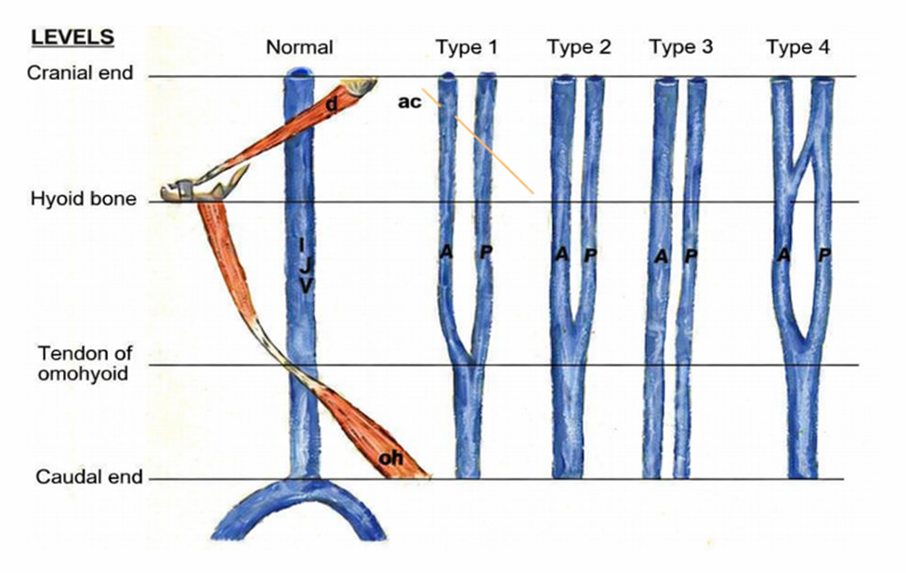
FIG 2: Modification of Nayak SP et al. classification

- CONCLUSION
Duplication of the internal jugular vein is a rare anatomical variation that may be encountered incidentally during neck surgeries. Awareness of such vascular anomalies is important for head and neck surgeons, as unrecognized variations may increase the risk of vascular injury or damage to adjacent structures such as the spinal accessory nerve during neck dissection. Careful intraoperative identification and preservation of these structures are essential to prevent complications. Therefore, a thorough understanding of possible venous variations and meticulous surgical dissection are crucial for safe and effective surgical management in the cervical region.

COMPETING INTERESTS DISCLAIMER:
Authors have declared that they have no known competing financial interests OR non-financial interests OR personal relationships that could have appeared to influence the work reported in this paper.

REFERENCES

1) Rusu MC, Vrapciu AD, Popescu ȘA. High bilateral fenestration of the internal jugular vein. Surg Radiol Anat. 2022 May;44(5):703-708. doi: 10.1007/s00276-022-02931-w. Epub 2022 Apr 9. PMID: 35396939.
2) Deepak CA, Sarvadnya JJ, Sabitha KS. Variant anatomy of internal jugular vein branching. Ann Maxillofac Surg. 2015 Jul-Dec;5(2):284-6. doi: 10.4103/2231-0746.175751. PMID: 26981491; PMCID: PMC4772581.
3) Vijayakumar Jain, K.V. Sureka, G. Satheesh, V. Venugopalan, D. Durairaj, Duplication of internal jugular vein - An incidental finding, Oral Oncology Reports, Volume 13, 2025, 100699, ISSN 2772-9060, https://doi.org/10.1016/j.oor.2024.100699
4) Wang X, Peng L, Guo H, Hernesniemi J, Xiong X, Andrade-Barazarte H, Qian R. Internal Jugular Vein Fenestration and Duplication: Anatomical Findings, Prevalence, and Literature Review. Front Surg. 2020 Nov 13; 7:593367. doi: 10.3389/fsurg.2020.593367. PMID: 33282909; PMCID: PMC7691239.
5) Mumtaz S, Singh M. Surgical review of the anatomical variations of the internal jugular vein: an update for head and neck surgeons. Ann R Coll Surg Engl. 2019 Jan;101(1):2-6. doi: 10.1308/rcsann.2018.0185. Epub 2018 Oct 16. PMID: 30322289; PMCID: PMC6303832.
6) Young M, Zavitsky A, Niceley J, Battiston G, Sakthi-Velavan S. A unique variation of the jugular veins and its clinical significance. Folia Morphol (Warsz). 2024;83(4):920-924. doi: 10.5603/fm.98618. Epub 2024 Feb 23. PMID: 38390747.
7) Nayak SP, Ashraf M, Dam A, Biswas J. Internal Jugular Vein Duplication: Review and Classification. Indian J Surg Oncol. 2017 Jun;8(2):222-226. doi: 10.1007/s13193-015-0452-6. Epub 2015 Sep 24. PMID: 28546726; PMCID: PMC5427012.
8) Nova-Baeza P, Valenzuela-Fuenzalida JJ, Valdivia-Arroyo R, Becerra-Rodríguez ES, Escalona-Manzo C, Castaño-Gallego YT, Luque-Bernal RM, Oyanedel-Amaro G, Suazo-Santibáñez A, Orellana-Donoso M, Bruna-Mejias A, Sanchis-Gimeno J, Gutiérrez-Espinoza H. Systematic Review and Meta-Analysis of Internal Jugular Vein Variants and Their Relationship to Clinical Implications in the Head and Neck. Diagnostics (Basel). 2024 Dec 9;14(23):2765. doi: 10.3390/diagnostics14232765. PMID: 39682673; PMCID: PMC11640428.
9) Contrera KJ, Aygun N, Ward BK, Gooi Z, Richmon JD. Internal jugular vein duplication and fenestration: Case series and literature review. Laryngoscope. 2016 Jul;126(7):1585-8. doi: 10.1002/lary.25743. Epub 2015 Oct 26. PMID: 26498831; PMCID: PMC5405004.
10) Downie SA, Schalop L, Mazurek JN, Savitch G, Lelonek GJ, Olson TR. Bilateral duplicated internal jugular veins: case study and literature review. Clin Anat. 2007 Apr;20(3):260-6. doi: 10.1002/ca.20366. PMID: 16838288.

