Case report
The Silent Swell in the Anterior Maxilla: Unmasking a Peripheral Ameloblastoma

Abstract
Peripheral ameloblastoma is an uncommon variant of odontogenic tumours, typically arising in the gingival or alveolar mucosa without bony involvement. Its clinical presentation often mimics reactive or benign soft tissue lesions, posing diagnostic challenges. We report a rare case of peripheral ameloblastoma in a 44-year-old male, presenting as a firm, sessile swelling in the anterior palatal region extending from tooth 21 to 13. The lesion was surgically excised under local anaesthesia, and histopathological evaluation confirmed the diagnosis. This case underscores the importance of considering peripheral ameloblastoma in the differential diagnosis of palatal swellings and highlights the role of histopathology in definitive diagnosis and management.
Keywords: Peripheral ameloblastoma, anterior palate, odontogenic tumour, gingival swelling, histopathology, surgical excision
Introduction
Ameloblastomas are benign but locally aggressive odontogenic tumours, most commonly arising intraosseously within the mandible. However, a rare subset known as peripheral or extraosseous ameloblastomas arises in the soft tissues overlying tooth-bearing areas, particularly the gingiva or alveolar mucosa. These tumours account for less than 10% of all ameloblastomas and are typically slow-growing, painless, and non-ulcerated swellings that may clinically resemble fibromas, pyogenic granulomas, or other reactive lesions [1,2]. The anterior maxillary region is an exceedingly rare site for peripheral ameloblastoma, with very few cases documented in the literature [3,4,14]. Given their innocuous appearance and low recurrence potential, these lesions may be underdiagnosed or mismanaged. This report presents a rare case of peripheral ameloblastoma involving the anterior palatal mucosa, emphasizing the need for histopathological confirmation and appropriate surgical management.
Case Report
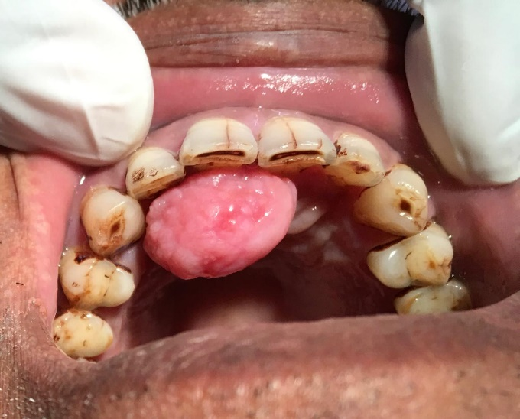
A 44-year-old male patient reported to the outpatient department with a chief complaint of a painless swelling on the anterior palate that had gradually increased in size over the past six months. The patient denied any history of trauma, bleeding, or ulceration in the region. Intraoral examination revealed a firm, sessile, dome-shaped mass measuring approximately 2.5 × 1.5 cm, located on the palatal mucosa extending from the region of tooth 21 to 13 (FIG. 1).
FIG: 1

FIG: 2

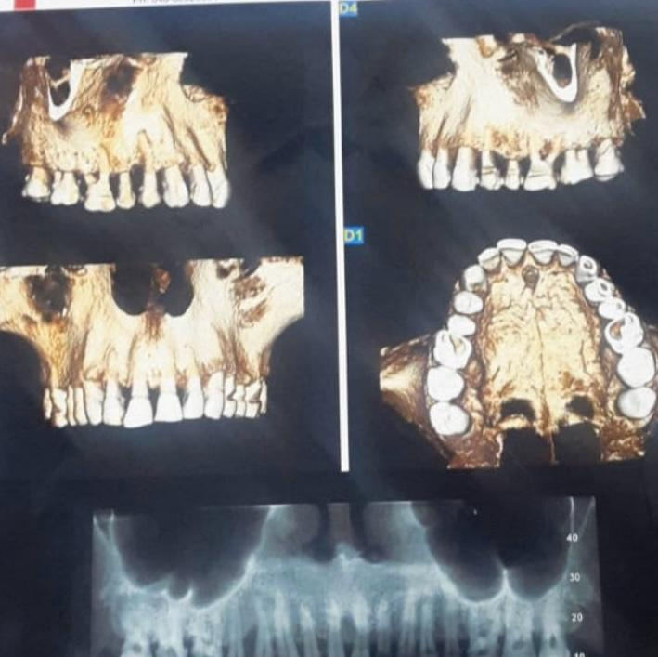
The overlying mucosa appeared intact and non-ulcerated, with no signs of inflammation. The lesion was non-tender, non-fluctuant, and did not blanch on pressure. There was no associated tooth mobility or radiographic evidence of bony involvement on periapical, occlusal radiographs, and CBCT (FIG 2). Based on the clinical presentation, a provisional diagnosis of a benign reactive lesion, such as a fibroma or pyogenic granuloma, was considered.
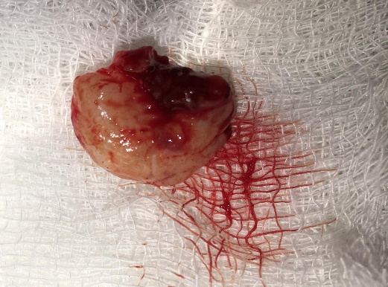
An excisional biopsy was performed under local anaesthesia, and the specimen was submitted for histopathological evaluation (FIG 3). Microscopic examination revealed islands and strands of odontogenic epithelium resembling the follicular pattern of ameloblastoma, with peripheral palisading columnar cells exhibiting reverse polarization and central stellate reticulum-like cells.
No evidence of bone invasion was noted. The final diagnosis was peripheral ameloblastoma. Postoperative healing was uneventful, and the patient was followed up for 12 months with no signs of recurrence.
Discussion
FIG: 3
Peripheral ameloblastoma is a rare entity, first described by Stanley and Krogh in 1959, and is believed to originate from remnants of the dental lamina or basal cells of the oral epithelium [5]. It typically affects middle-aged adults, with a slight male predilection, and is most commonly found in the mandibular premolar region [6,7]. Maxillary involvement, particularly in the anterior palatal region, is exceedingly rare and may lead to diagnostic confusion with other soft tissue lesions [3,4,14].
Clinically, peripheral ameloblastomas present as slow-growing, painless, and well-circumscribed masses. Their resemblance to reactive lesions such as fibromas, peripheral ossifying fibromas, or pyogenic granulomas often leads to misdiagnosis [2,9,10]. In the present case, the lesion was initially suspected to be a fibroma based on its location and clinical appearance. However, histopathological examination revealed classic features of ameloblastoma, including peripheral palisading and reverse polarization of basal cells, confirming the diagnosis [1,6].
Radiographically, peripheral ameloblastomas typically do not show bony involvement, although superficial erosion or saucerization of the underlying bone may occasionally be observed [8,10]. In our case, imaging did not reveal any osseous changes, consistent with the extraosseous nature of the lesion.
The treatment of choice is conservative surgical excision with adequate margins. Recurrence is rare but has been reported, particularly in cases with incomplete excision or long-standing lesions [5,11]. Therefore, long-term follow-up is recommended. In our case, complete excision was achieved, and the patient remained recurrence-free at 12 months.
Recent literature has documented similar cases, including lesions mimicking pyogenic granuloma [2], cases with granular cell differentiation [6], rare presentations in paediatric [7] and edentulous patients [12], and hybrid lesions with calcifying epithelial odontogenic tumour-like areas [13]. Clear cell changes [11] and rapid growth patterns [15] have also been reported, further expanding the histopathological spectrum of this tumour. The present case adds to the growing body of evidence emphasizing the diverse clinical spectrum of peripheral ameloblastoma and the critical role of histopathology in diagnosis.
Conclusion
Peripheral ameloblastoma, though rare, should be considered in the differential diagnosis of persistent, firm gingival or palatal swellings, especially in middle-aged adults. Its clinical mimicry of reactive lesions necessitates histopathological confirmation for accurate diagnosis. Conservative surgical excision remains the mainstay of treatment, with a favourable prognosis and low recurrence risk. This case highlights the importance of vigilance in evaluating soft-tissue lesions of the oral cavity and underscores the need for long-term follow-up.
References:
- Anpalagan A, Tzortzis A, Twigg J, Wotherspoon R, Chen-got P, Kanatas A. Current practice in the management of peripheral ameloblastoma: A structured review. Br J Oral Maxillofac Surg. 2021;59(1):e1-e8. doi:10.1016/j.bjoms.2020.08.084. Available from: https://doi.org/10.1016/j.bjoms.2020.08.084 (doi.org in Bing)
- Baden E, Doyle JL, Petriella V. Malignant transformation of peripheral ameloblastoma. Oral Surg Oral Med Oral Pathol. 1993;75(2):214-9. PMID:8426721. doi:10.1016/0030-4220(93)90096-M. Available from: https://pubmed.ncbi.nlm.nih.gov/8426721 (pubmed.ncbi.nlm.nih.gov in Bing)
- Borrello R, Bettio E, Bacci C, Valente M, Sivolella S, Mazzoleni S, Berengo M. A conservative approach to a peripheral ameloblastoma. Case Rep Dent. 2016;2016:8254571. PMID:27840747. doi:10.1155/2016/8254571. Available from: https://pubmed.ncbi.nlm.nih.gov/27840747 (pubmed.ncbi.nlm.nih.gov in Bing)
- Chhina S, Rathore AS. Peripheral ameloblastoma of gingiva with cytokeratin 19 analysis. BMJ Case Rep. 2015;2015:bcr2015210227. PMID:26045522. doi:10.1136/bcr-2015-210227. Available from: https://pubmed.ncbi.nlm.nih.gov/26045522 (pubmed.ncbi.nlm.nih.gov in Bing)
- Ghai S. Ameloblastoma: An updated narrative review of an enigmatic tumor. Cureus. 2022;14(8):e27734. PMID:36127985. doi:10.7759/cureus.27734. Available from: https://pubmed.ncbi.nlm.nih.gov/36127985 (pubmed.ncbi.nlm.nih.gov in Bing)
- Ide F, Mishima K, Miyazaki Y, Saito I, Kusama K. Peripheral ameloblastoma in-situ: An evidential fact of surface epithelium origin. Oral Surg Oral Med Oral Pathol Oral Radiol Endod. 2009;108(5):763-7. PMID:19748296. doi:10.1016/j.tripleo.2009.06.018. Available from: https://pubmed.ncbi.nlm.nih.gov/19748296 (pubmed.ncbi.nlm.nih.gov in Bing)
- Ide F, Ito Y, Miyazaki Y, Nishimura M, Kusama K, Kikuchi K. A new look at the history of peripheral ameloblastoma. Head Neck Pathol. 2020;14(4):1052-7. PMID:32451874. doi:10.1007/s12105-020-01168-6. Available from: https://pubmed.ncbi.nlm.nih.gov/32451874 (pubmed.ncbi.nlm.nih.gov in Bing)
- Luciani F, Papa E, Leggeri A, Condò R, Giovannetti F, Calabrese L. Peripheral ameloblastoma: Case report and our experience over 20 years. Acta Biomed. 2023;94(S1):e2023127. doi:10.23750/abm.v94iS1.13527. Available from: https://doi.org/10.23750/abm.v94iS1.13527 (doi.org in Bing)
- Manor Y, Mardinger O, Katz J, Taicher S, Hirshberg A. Peripheral odontogenic tumours—Differential diagnosis in gingival lesions. Int J Oral Maxillofac Surg. 2004;33(3):268-73. PMID:15287310. doi:10.1016/j.ijom.2003.05.008. Available from: https://pubmed.ncbi.nlm.nih.gov/15287310 (pubmed.ncbi.nlm.nih.gov in Bing)
- Philipsen HP, Reichart PA, Nikai H, Takata T, Kudo Y. Peripheral ameloblastoma: Biological profile based on 160 cases from the literature. Oral Oncol. 2001;37(1):17-27. PMID:11120479. doi:10.1016/S1368-8375(00)00064-6. Available from: https://pubmed.ncbi.nlm.nih.gov/11120479 (pubmed.ncbi.nlm.nih.gov in Bing)
- Shi HA, Ng CWB, Kwa CT, Sim QXC. Ameloblastoma: A succinct review of the classification, genetic understanding, and novel molecular targeted therapies. Surgeon. 2021;19(4):238-43. PMID:32712102. doi:10.1016/j.surge.2020.06.009. Available from: https://pubmed.ncbi.nlm.nih.gov/32712102 (pubmed.ncbi.nlm.nih.gov in Bing)
- Singh R, Shrestha S, Acharya P, Shrestha A. Peripheral ameloblastoma of acanthomatous variant: A case report. JNMA J Nepal Med Assoc. 2022;60(256):1045-8. doi:10.31729/jnma.7739. Available from: https://doi.org/10.31729/jnma.7739
- Tajima Y, Kuroda-Kawasaki M, Ohno J, Yi J, Kusama K, Tanaka H, Fukunaga S, Shimada J, Yamamoto Y. Peripheral ameloblastoma with potentially malignant features: Report of a case with special regard to its keratin profile. J Oral Pathol Med. 2001;30(8):494-8. PMID:11545241. doi:10.1034/j.1600-0714.2001.030008494.x. Available from: https://pubmed.ncbi.nlm.nih.gov/11545241 (pubmed.ncbi.nlm.nih.gov in Bing)
- Vanoven BJ, Parker NP, Petruzzelli GJ. Peripheral ameloblastoma of the maxilla: A case report and literature review. Am J Otolaryngol. 2008;29(5):357-60. PMID:18722894. doi:10.1016/j.amjoto.2007.10.002. Available from: https://pubmed.ncbi.nlm.nih.gov/18722894 (pubmed.ncbi.nlm.nih.gov in Bing)
- Vered M, Wright JM. Update from the 5th Edition of the World Health Organization Classification of Head and Neck Tumors: Odontogenic and maxillofacial bone tumours. Head Neck Pathol. 2022;16(1):63-75. PMID:35312978. doi:10.1007/s12105-021-01404-7. Available from: https://pubmed.ncbi.nlm.nih.gov/35312978 (pubmed.ncbi.nlm.nih.gov in Bing)

