Case Report
Intraoperative Management of Undisclosed Calcified Dermal Fillers and Altered Anatomy During Rhytidectomy

Abstract
Aims: To report the surgical challenges and adaptive techniques required when encountering unexpected, calcified dermal fillers during rhytidectomy, highlighting the critical disconnect between patient-reported history and surgical reality in the modern aesthetic practice.
Presentation of Case: A 41-year-old female presented for primary rhytidectomy, denying any prior facial procedures. Intraoperative dissection revealed a hostile, fibrous plane containing multiple calcified nodules, causing significant surgical difficulty. Subsequent patient disclosure confirmed remote calcium hydroxylapatite injections and submental liposuction. A technique of meticulous debulking using curved scissors was employed to restore a viable surgical plane. The procedure was completed successfully with an optimal aesthetic outcome.
Discussion: This case illustrates a growing surgical dilemma where undisclosed prior treatments alter facial anatomy. The calcific remnants of biostimulatory fillers, combined with post-liposuction fibrosis, create a uniquely challenging dissection environment that demands intraoperative reassessment and technical adaptation. The scenario underscores the limitations of patient history and the primacy of surgical preparedness for managing altered tissue planes.
Conclusion: Surgeons must maintain high suspicion for retained fillers in all patients, regardless of age or reported history. When confronted with an unexpectedly resistant dissection plane, calcified filler material should be considered. A controlled, fine-dissection debulking strategy is essential for navigating this increasingly common surgical challenge safely and effectively.

Keywords: Rhytidectomy, dermal fillers, calcium hydroxylapatite, surgical complications, difficult dissection, revision surgery, case report

1. Introduction
The landscape of facial rejuvenation has been fundamentally transformed by the proliferation of minimally invasive procedures. Biostimulatory dermal fillers such as calcium hydroxylapatite (CaHA) and semi-permanent hyaluronic acid (HA) formulations have become mainstays of aesthetic practice [1]. While often described as biodegradable, these agents can induce persistent foreign-body reactions leading to granuloma formation, fibrosis, and in the case of CaHA, dystrophic calcification that may become permanent [2,3]. Consequently, surgeons are increasingly operating on patients with hidden, surgically relevant anatomical alterations.
A significant clinical challenge arises when patients fail to disclose their complete treatment history during preoperative consultation for surgical procedures like rhytidectomy. This omission—whether due to forgetfulness, perception of injectables as "non-surgical," or treatment by different providers—creates an intraoperative dilemma: the unexpected encounter with pathologic tissue that obstructs dissection and compromises surgical planes [4].
This case report presents a particularly illustrative example of this modern surgical challenge. The novelty lies in the detailed description of the intraoperative technical adaptation required when standard dissection fails due to undisclosed calcified fillers in a relatively young patient. The report emphasizes the critical importance of surgical flexibility, provides a specific technical approach for managing a hostile operative plane, and highlights the evolving nature of facial anatomy in the era of ubiquitous aesthetic interventions.

2. Case Presentation
2.1 Patient Demographics and History
A 41-year-old female with no significant medical history presented to our clinic seeking surgical correction of lower facial and cervical laxity. She reported dissatisfaction with her jawline contour and submental fullness. During comprehensive preoperative consultation, she was specifically questioned regarding any history of facial surgeries, injectable treatments, or energy-based procedures. She unequivocally denied all such interventions.
2.2 Clinical Findings and Preoperative Assessment
Physical examination revealed moderate jowling and submental adiposity with skin laxity that appeared disproportionate to her chronological age. Palpation of the midface and mandibular border suggested diffuse, mild firmness without discrete nodularity. No scars or other signs of previous procedures were evident. Based on clinical findings and patient goals, a treatment plan was established for primary extended SMAS rhytidectomy with possible submental liposuction and platysmaplasty.
2.3 Surgical Procedure and Intraoperative Findings
Surgery was performed under general anesthesia. Following standard pre-auricular and post-auricular incisions, subcutaneous flap elevation was initiated in the mid-cheek region. Immediately, the dissection proved unexpectedly difficult. The tissue plane was abnormally firm, fibrous, and resistant to both blunt and sharp dissection with conventional facelift instruments, lacking the normal gliding plane typically encountered in primary rhytidectomy.
This created significant intraoperative confusion regarding the anatomical cause of the resistance. Careful, millimeter-by-millimeter sharp dissection with curved Metzenbaum scissors was employed to navigate this hostile plane. This meticulous approach revealed the underlying pathology: numerous small, white, gritty calcified nodules embedded within the subcutaneous tissue and densely adherent to the dermal undersurface (Fig. 1). The nodules ranged from 2-5 mm in diameter and formed an interconnected network that had created the rigid, unyielding dissection plane.
2.4 Technical Adaptation and Surgical Management
Confronted with this altered anatomy, the surgical strategy was recalibrated from standard flap elevation to diagnostic debulking and functional planoplasty.
1. Fine Dissection and Exposure: Using fine, curved scissors, the fibrotic tissue surrounding individual nodules was carefully spread and released, exposing their full extent while preserving the overlying dermal vascular plexus.
2. Selective Debulking: Nodules that directly obstructed flap advancement or threatened postoperative contour irregularity were targeted. Discrete nodules were excised completely, while broader plaques of calcified material were tangentially shaved to the level of the surrounding soft tissue using a 15 scalpel blade.
3. Progressive Planoplasty: This process of precise dissection and selective removal was systematically performed across the entire surgical field. The objective was not complete eradication, which would risk dermal compromise and neurovascular injury, but rather debulking of major obstructive elements and fracturing of the calcified scaffold to re-establish a functional plane.
Following this meticulous technique, the tissue plane became pliable and smooth (Fig. 2). The SMAS was then plicated, and conservative skin excision and closure were performed without further complication. Total operative time was extended by approximately 45 minutes due to the required careful dissection.
2.5 Outcome and Follow-up
The patient's postoperative course was unremarkable with standard healing. At the one-week follow-up appointment, when presented with photographic documentation of the intraoperative findings, she disclosed her complete history. She admitted to undergoing submental liposuction five years prior and receiving injections of both hyaluronic acid and calcium hydroxylapatite (CaHA) in her midface and jawline approximately seven years earlier. She stated she had not considered these treatments relevant to her current surgery.
At six-month follow-up, the patient expressed high satisfaction with her aesthetic outcome. Examination revealed well-healed incisions, natural facial contours, and no evidence of skin irregularity, nerve dysfunction, or palpable residual nodules. The cervicomental angle was significantly improved, and the midface appeared volumetrically balanced without irregularities.
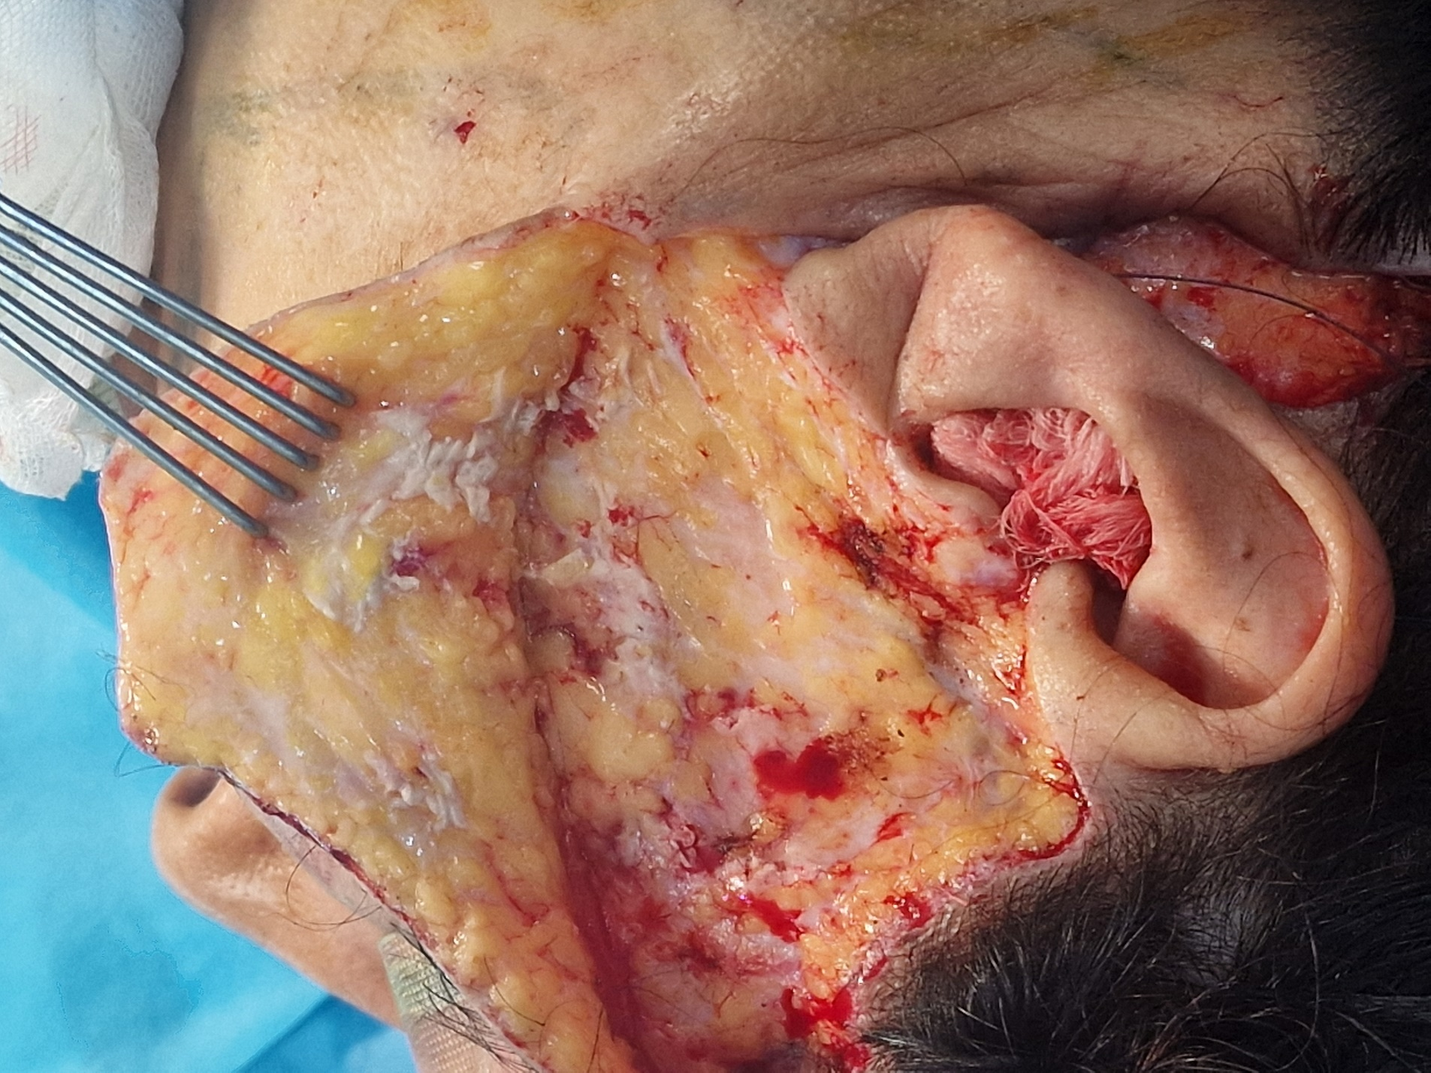
Figure 1. Intraoperative view demonstrating difficult dissection through a hostile, fibrous plane. Curved Metzenbaum scissors are used to carefully isolate a white, calcified nodule embedded within the subcutaneous tissue.

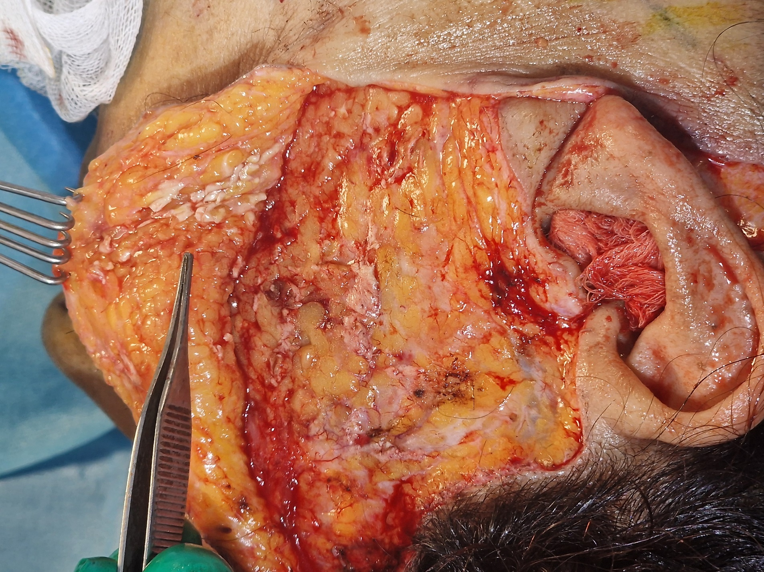
Figure 2. The surgical field after debulking and planoplasty. The previously resistant plane has been converted to a smooth, viable subcutaneous layer, allowing for proper flap advancement.

3. Discussion
This case encapsulates a growing challenge in contemporary facial plastic surgery: operating on anatomy altered by undisclosed prior interventions. The patient's relatively young age (41) for rhytidectomy likely contributed to a lower index of suspicion for significant prior treatment—a cognitive bias this case explicitly counters. The intraoperative discovery of a hostile dissection plane secondary to calcified filler material represents a critical teaching moment with several important implications.
3.1 The Unreliable History and the Hostile Plane
The most striking aspect of this case is the complete disconnect between the patient's denied history and the surgical reality encountered. This phenomenon is increasingly recognized in aesthetic surgery, where patients may not perceive injectable treatments as "real procedures" worthy of disclosure, may have forgotten distant treatments, or may have been treated by practitioners who did not adequately educate them about the permanent nature of certain filler sequelae [5]. Our experience reinforces that physical examination and intraoperative findings must often supersede historical account. The initial surgical challenge was not the nodules themselves but the confusion and increased risk created by an unanticipated, resistant tissue environment that defied standard dissection techniques.
3.2 Pathophysiological Considerations
The encountered pathology represents the confluence of two processes. First, the calcium hydroxylapatite, a biostimulatory agent intended to promote neocollagenesis, is known to undergo phagocytosis by macrophages with subsequent transformation into histiocytes and foreign-body giant cells. Over time, this can lead to granuloma formation and, particularly with CaHA, dystrophic calcification and even ossification [6,7]. Second, the previously undisclosed submental liposuction likely contributed to subdermal fibrosis, creating a scarred plane that compounded the difficulty of dissection [8]. The synergy between post-liposuction fibrosis and filler-induced calcification created a uniquely challenging surgical environment distinct from both virgin anatomy and typical post-surgical scar tissue.
3.3 Technical Implications and Adaptive Strategy
The primary intraoperative challenge was decision-making under uncertainty. The unexpectedly difficult plane required rapid differential diagnosis: aggressive idiopathic fibrosis, aberrant anatomy, or foreign material. The discovery of calcified nodules provided the answer and dictated a specific technical response. Standard facelift dissection techniques—which rely on identification of relatively avascular planes, proved ineffective against this calcified scaffold.
The successful strategy employed several key principles:
1. Instrumentation: The use of curved Metzenbaum scissors was instrumental. Their fine tips and curved blades allowed for precise, controlled spreading and cutting in a confined, altered plane where standard facelift scissors were too blunt.
2. Intraoperative reflexe: The goal changed from complete flap elevation to functional planoplasty . Rather than attempting to remove all calcified material (an impractical and risky endeavor), the objective became debulking obstructive elements to create a workable plane.
3. Topographic Approach: Dissection proceeded in a meticulous, topographic fashion, treating each nodular area individually rather than attempting en bloc elevation.
This approach aligns with emerging strategies for managing filler complications surgically, where complete excision is often neither necessary nor advisable [9].
3.4 Clinical Recommendations and Practice Implications
This case suggests several important practice modifications:
1. Enhanced Preoperative Assessment: Surgeons should specifically inquire about injectable treatments using brand names (e.g., "Have you ever had Radiesse, Sculptra, or permanent fillers?") and consider routine palpation of known injection sites in all patients.
2. Preoperative Imaging Consideration: In cases with palpable irregularities or suspicious history, preoperative ultrasound could identify filler deposits and their depth, aiding surgical planning [10].
3. Intraoperative Preparedness: When dissection is abnormally difficult, surgeons should immediately consider retained filler as a potential cause. A mental and instrumental toolkit for this scenario—centered on fine, sharp dissection and a planoplasty mindset—should be part of contemporary surgical training.
4. Informed Consent Enhancement: The possibility of encountering altered anatomy from undisclosed prior treatments should be included in surgical consent discussions, particularly for revision or secondary procedures.

4. Conclusion
This case illustrates that the modern facelift surgeon must be prepared to function as both anatomist and archeologist, uncovering and navigating hidden anatomical alterations from the aesthetic past. Undisclosed calcium hydroxylapatite fillers, particularly when combined with prior surgical interventions like liposuction, can create a hostile surgical plane that poses significant intraoperative challenges. The key lessons are: (1) patient history regarding aesthetic treatments is frequently incomplete and should be viewed with appropriate skepticism regardless of patient age; (2) unexpectedly difficult dissection should prompt consideration of retained filler material as a potential cause; and (3) a shift to a meticulous, topographic debulking technique using fine curved instruments is essential for safely managing this altered anatomy. As the population of treated patients ages and seeks surgical rejuvenation, preparedness for this scenario has become an essential component of contemporary facial plastic surgery practice.

3.5 Limitations
This report shares limitations inherent to single-case observations. The techniques described may require modification for fillers in different anatomical locations (e.g., perioral or periorbital regions). Furthermore, while the patient's postoperative confession and the macroscopic appearance are diagnostically consistent with CaHA calcification, histopathological confirmation would have strengthened the pathological description. Nonetheless, the clinical and technical lessons remain robust and widely applicable.
Declarations: Patient consent obtained for publication of de-identified intraoperative images.

COMPETING INTERESTS DISCLAIMER:
Authors have declared that they have no known competing financial interests OR non-financial interests OR personal relationships that could have appeared to influence the work reported in this paper.
References
1. Funt D, Pavicic T. Dermal fillers in aesthetics: an overview of adverse events and treatment approaches. Clin Cosmet Investig Dermatol. 2013 Dec 12;6:295-316. doi: 10.2147/CCID.S50546. PMID: 24363560; PMCID: PMC3865975.
https://pubmed.ncbi.nlm.nih.gov/24363560/
2. Lemperle G, Morhenn V, Charrier U. Human histology and persistence of various injectable filler substances for soft tissue augmentation. Aesthetic Plast Surg. 2003 Sep-Oct;27(5):354-66; discussion 367. doi: 10.1007/s00266-003-3022-1. Epub 2003 Dec 4. PMID: 14648064.
https://pubmed.ncbi.nlm.nih.gov/14648064/
3. Graivier MH, Bass LS, Busso M, Jasin ME, Narins RS, Tzikas TL. Calcium hydroxylapatite (Radiesse) for correction of the mid- and lower face: consensus recommendations. Plast Reconstr Surg. 2007 Nov;120(6 Suppl):55S-66S. doi: 10.1097/01.prs.0000285109.34527.b9. PMID: 18090343.
https://pubmed.ncbi.nlm.nih.gov/18090343/
4. DeLorenzi C. Complications of injectable fillers, part I. Aesthet Surg J. 2013 May;33(4):561-75. doi: 10.1177/1090820X13484492. PMID: 23636629.
https://pubmed.ncbi.nlm.nih.gov/23636629/
5. De Boulle K, Heydenrych I. Patient factors influencing dermal filler complications: prevention, assessment, and treatment. Clin Cosmet Investig Dermatol. 2015 Apr 15;8:205-14. doi: 10.2147/CCID.S80446. PMID: 25926750; PMCID: PMC4404720.
https://pubmed.ncbi.nlm.nih.gov/25926750/
6. Lee JM, Kim YJ. Foreign body granulomas after the use of dermal fillers: pathophysiology, clinical appearance, histologic features, and treatment. Arch Plast Surg. 2015 Mar;42(2):232-9. doi: 10.5999/aps.2015.42.2.232. Epub 2015 Mar 16. PMID: 25798398; PMCID: PMC4366708.
https://pubmed.ncbi.nlm.nih.gov/25798398/
7. Beleznay K, Carruthers JD, Carruthers A, Mummert ME, Humphrey S. Delayed-onset nodules secondary to a smooth cohesive 20 mg/mL hyaluronic acid filler: cause and management. Dermatol Surg. 2015 Aug;41(8):929-39. doi: 10.1097/DSS.0000000000000418. PMID: 26166260.
https://pubmed.ncbi.nlm.nih.gov/26166260/
8. Rohrich RJ, Rios JL, Smith PD, Gutowski KA. Neck rejuvenation revisited. Plast Reconstr Surg. 2006 Oct;118(5):1251-1263. doi: 10.1097/01.prs.0000209406.80690.9f. PMID: 17016198.
https://pubmed.ncbi.nlm.nih.gov/17016198/
9. Urdiales-Gálvez F, Delgado NE, Figueiredo V, Lajo-Plaza JV, Mira M, Moreno A, Ortíz-Martí F, Del Rio-Reyes R, Romero-Álvarez N, Del Cueto SR, Segurado MA, Rebenaque CV. Treatment of Soft Tissue Filler Complications: Expert Consensus Recommendations. Aesthetic Plast Surg. 2018 Apr;42(2):498-510. doi: 10.1007/s00266-017-1063-0. Epub 2018 Jan 5. PMID: 29305643; PMCID: PMC5840246.
https://pubmed.ncbi.nlm.nih.gov/29305643/
10. Wortsman X, Wortsman J. Clinical usefulness of variable-frequency ultrasound in localized lesions of the skin. J Am Acad Dermatol. 2010 Feb;62(2):247-56. doi: 10.1016/j.jaad.2009.06.016. Epub 2009 Dec 3. PMID: 19962214.
https://pubmed.ncbi.nlm.nih.gov/19962214/
11. Bailey SH, Cohen JL, Kenkel JM. Etiology, prevention, and treatment of dermal filler complications. Aesthet Surg J. 2011 Jan;31(1):110-21. doi: 10.1177/1090820X10391083. PMID: 21239678.
https://pubmed.ncbi.nlm.nih.gov/21239678/
12. Requena L, Requena C, Christensen L, Zimmermann US, Kutzner H, Cerroni L. Adverse reactions to injectable soft tissue fillers. J Am Acad Dermatol. 2011 Jan;64(1):1-34; quiz 35-6. doi: 10.1016/j.jaad.2010.02.064. Erratum in: J Am Acad Dermatol. 2011 Jun;64(6):1178. PMID: 21167403.
https://pubmed.ncbi.nlm.nih.gov/21167403/
13. Humphrey CD, Arkins JP, Dayan SH. Soft tissue fillers in the nose. Aesthet Surg J. 2009 Nov-Dec;29(6):477-84. doi: 10.1016/j.asj.2009.09.002. Erratum in: Aesthet Surg J. 2010 Jan;30(1):119. PMID: 19944992.
https://pubmed.ncbi.nlm.nih.gov/19944992/
14. Alijotas-Reig J, Fernández-Figueras MT, Puig L. Late-onset inflammatory adverse reactions related to soft tissue filler injections. Clin Rev Allergy Immunol. 2013 Aug;45(1):97-108. doi: 10.1007/s12016-012-8348-5. PMID: 23361999.
https://pubmed.ncbi.nlm.nih.gov/23361999/
15. Grippaudo FR, Di Girolamo M, Mattei M, Pucci E, Grippaudo C. Diagnosis and management of dermal filler complications in the perioral region. J Cosmet Laser Ther. 2014 Oct;16(5):246-52. doi: 10.3109/14764172.2014.946048. Epub 2014 Aug 13. PMID: 25046237.
https://pubmed.ncbi.nlm.nih.gov/25046237/
16. Kassir R, Kolluru A, Kassir M. Extensive necrosis after injection of hyaluronic acid filler: case report and review of the literature. J Cosmet Dermatol. 2011 Sep;10(3):224-31. doi: 10.1111/j.1473-2165.2011.00562.x. PMID: 21896135.
https://pubmed.ncbi.nlm.nih.gov/21896135/
17. Park TH, Seo SW, Kim JK, Chang CH. Clinical experience with polymethylmethacrylate microsphere filler complications. Aesthetic Plast Surg. 2012 Apr;36(2):421-6. doi: 10.1007/s00266-011-9803-z. Epub 2011 Sep 10. PMID: 21909864.
https://pubmed.ncbi.nlm.nih.gov/21909864/
18. Dua A, Bhardwaj B. Delayed Onset Nodules After Hyaluronic Acid Fillers: A Case Series. J Cutan Aesthet Surg. 2022 Jan-Mar;15(1):91-94. doi: 10.4103/JCAS.JCAS_200_20. PMID: 35655648; PMCID: PMC9153319.
https://pmc.ncbi.nlm.nih.gov/articles/PMC9153319/
19. Stocks D, Sundaram H, Michaels J, Durrani MJ, Wortzman MS, Nelson DB. Rheological evaluation of the physical properties of hyaluronic acid dermal fillers. J Drugs Dermatol. 2011 Sep;10(9):974-80. PMID: 22052265.
https://pubmed.ncbi.nlm.nih.gov/22052265/
20. Christen MO, Vercesi F. Polycaprolactone: How a Well-Known and Futuristic Polymer Has Become an Innovative Collagen-Stimulator in Esthetics. Clin Cosmet Investig Dermatol. 2020 Jan 20;13:31-48. doi: 10.2147/CCID.S229054. PMID: 32161484; PMCID: PMC7065466.
https://pubmed.ncbi.nlm.nih.gov/32161484/

