Case report

Unveiling Hidden Threats in Sports-Related Ocular Trauma: A Case Report

ABSTRACT

Sports-related orbitopalpebral trauma is a common cause of ocular injury and may lead to complex anterior and posterior segment involvement with severe visual consequences. Despite prominent external findings, significant intraocular lesions may remain occult at initial presentation. We report the case of a 22-year-old patient who sustained severe orbitopalpebral trauma during a sports accident, presenting with extensive eyelid laceration, periorbital hematoma, hyphema, corneal abrasion and lens subluxation. Clinical evolution and imaging raised suspicion of an occult posterior scleral injury, prompting urgent surgical exploration, which confirmed a highly posterior and surgically inaccessible scleral lesion. This case underscores the necessity of a thorough and systematic ophthalmic evaluation in orbitopalpebral trauma to prevent missed diagnoses with potentially detrimental visual outcomes. Early recognition, appropriate imaging, and timely intervention are essential, while preventive strategies such as protective eyewear and education remain crucial in reducing sports-related ocular injuries.

Keywords: Sports-related - Orbitopalpebral trauma- Posterior scleral injury- Visual prognosis

- INTRODUCTION

Ocular trauma is a critical ophthalmic emergency with potential for permanent vision loss. Sports-related injuries constitute 7.5–27.3% of cases nearly 90% of which are preventable [1]. Sports injuries refer to physical harm sustained during athletic activities and represent a critical concern for athletes [19]. It range from minor to severe, often resulting in physical challenges, and disruptions to their social and overall quality of life [20]. Sports-related injuries are a common complaint in the emergency department, and account for a significant percentage of all penetrating eye-injuries [21]. Different sports carry variable ocular risks which are dependent on many factors: the level of contact involved, the type of equipment involved (which can cause blunt or penetrating trauma), and the size, velocity and weight/density of the game-object. Each of these factors plays an important role in determining the severity of ocular injury [21].

- CASE PRESENTATION

We report the case of a 22-year-old patient with no medical history who presented to the emergency department with redness, ocular pain, and decreased visual acuity in the right eye following orbitopalpebral trauma sustained during a sports accident involving an elastic band and wooden equipment. Ophthalmologic examination of the right eye revealed near counting-fingers visual acuity, a large horizontal eyelid laceration, and periorbital ecchymosis with hematoma restricting eyelid mobility (Fig.1.).
Slit-lamp examination revealed mild corneal edema, epithelial debridement with fluorescein uptake,grade 1 hyphema,inferior iris tear with mydriasis and lens subluxation(Fig.2.). Intraocular pressure could not be assessed due to the extent of the eyelid hematoma, severe pain, and the presence of corneal edema, and fundus visualization was obscured.The examination of the fellow eye showed no abnormalities.Orbital CT demonstrated a right frontal bone fracture and signs of vitreous hemorrhage without evidence of intraocular foreign body, the contours of the globes were preserved(Fig.3).
The patient was admitted, started on antibiotics and corticosteroids, and underwent eyelid laceration repair with 10 sutures (6-0 silk); maxillofacial consultation was obtained for the fracture.
Ten hours later, visual acuity suddenly dropped from near counting fingers to light perception, with pronounced chemosis and worsening corneal edema (Fig. 4). Reassessment of the orbital CT raised suspicion of a scleral rupture prompting urgent surgical exploration (Fig.5).
Intraoperative exploration after 360° peritomy and 4-0 silk muscle traction revealed sub-Tenon hyperpigmentation,likely choroidal,in the superotemporal quadrant without vitreous prolapse (Fig. 6). A posterior scleral wound was suspected but could not be visualized and was presumed self-sealed. Sub-Tenon and conjunctival closure was performed with 8-0 Vicryl . The patient was evaluated at one week and one month postoperatively. Examination revealed negative light perception, resolution of corneal edema, a nonreactive dilated pupil with sphincter rupture, a subluxated crystalline lens, and a flat retina (Fig. 7).

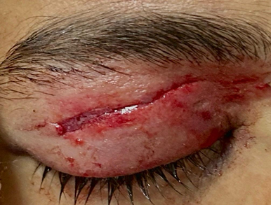
Fig.1. Aspect of the eyelid on admission showing a large horizontal eyelid laceration, and periorbital ecchymosis.

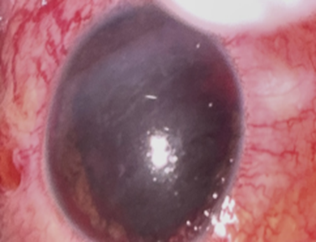
Fig.2.Aspect of the eye on admission showing corneal edema,hyphema , inferior iris tear with mydriasis and lens subluxation



Fig.3.Orbital CT of the patient in admission showing a right frontal bone fracture and signs of vitreous hemorrhage , without evidence of intraocular foreign body, the contours of the globes were preserved
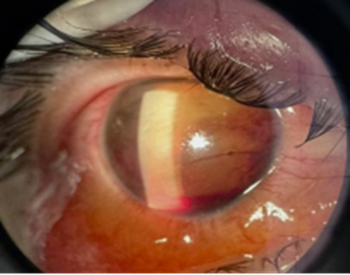

Fig.4.Picture of the eye ten hours post admission showing pronounced chemosis and worsening corneal edema

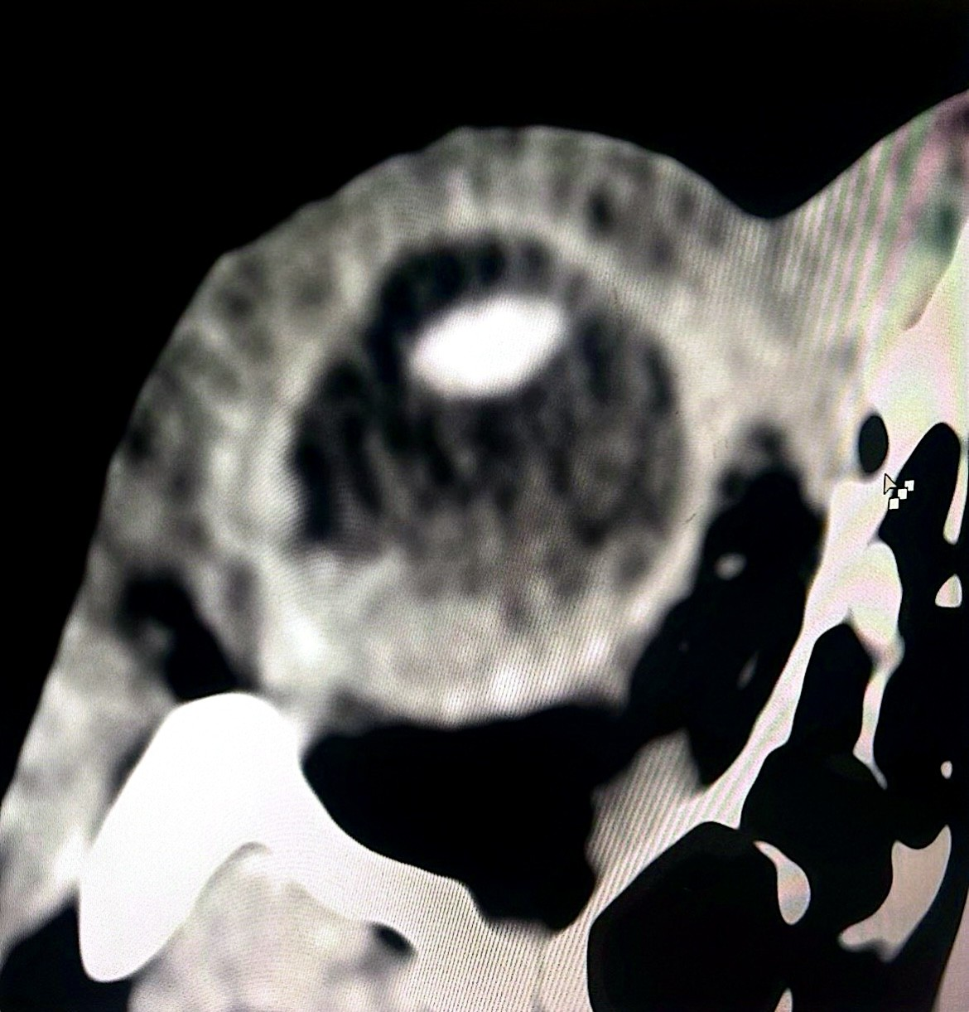

Fig.5. Re-review of the orbital CT scan revealed a questionable scleral discontinuity on the temporal aspect of the right globe (blue arrow)

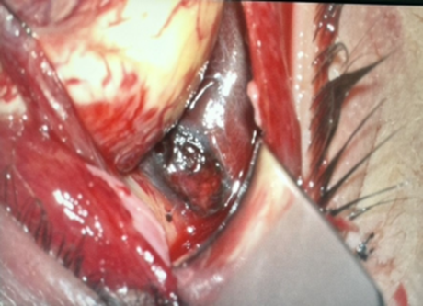
Fig.6.Intraoperative exploration revealing sub-Tenon hyperpigmentation in the superotemporal quadrant .

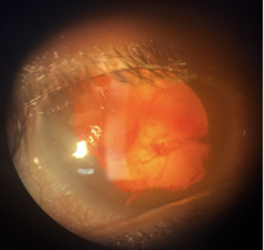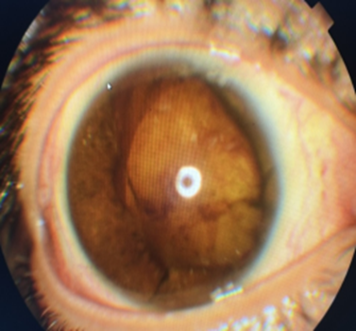
Fig.7.Postoperative aspect of the eye

3. DISCUSSION
Sports-related contusive ocular trauma represents a form of blunt, non-penetrating injury affecting the eye or periocular tissues, typically caused by impact sustained during sports activities.
In the United States, an estimated 40,000–600,000 cases occur annually, with approximately 13,500 resulting in permanent vision loss [1,2,3]. Globally, sports injuries account for 7.5–12.5% of ocular trauma hospitalizations [4.5] with bilateral involvement reported in 17.7% of cases [6]. Young adults aged 20–29 are predominantly affected, with a marked male predominance (male-to-female ratio 15.4:1) [2,7,8]. The most frequent mechanisms include direct ball impacts (74.7%), player collisions (13.8%), and strikes from sports equipment (9%) [7].
Closed-globe injuries (CGI) are characterized by partial-thickness damage to the ocular wall without full-thickness rupture and may involve periocular structures [2]. In sports-related trauma, these injuries are predominant, although open periocular wounds have also been reported [9]. Blunt force can induce a sudden rise in intraocular pressure, leading to rupture at anatomically vulnerable sites such as the limbus, equator, or areas previously compromised by surgery or trauma. the extent of damage dependes on the energy and depth of impact [7]. This mechanism was illustrated in our case, where a severe orbitopalpebral contusion resulted in a posterior scleral laceration. In contrast, open-globe injuries (OGI) involve complete transmural rupture of the ocular wall and are classified as rupture, penetrating, or perforating injuries. Penetrating and perforating wounds typically result from sharp objects or projectiles and primarily affect the anterior segment of the globe[10].
Closed globe injuries can affect both the anterior and posterior segments of the eye. Eyelid lacerations, from superficial cuts to complex canalicular injuries, require careful assessment and precise repair to prevent ptosis, epiphora, or lid malposition. Subconjunctival hemorrhage is common. Corneal abrasions present with pain, foreign body sensation, and tearing; fluorescein staining and prompt evaluation are essential to exclude deeper injuries. Hyphema can elevate intraocular pressure and threaten the optic nerve. When hyphema occurs with subconjunctival hemorrhage, particularly in the setting of ocular hypotony, a scleral laceration should be suspected. In our case, the presence of non-hemorrhagic chemosis alongside hyphema drew attention to the possibility of a scleral wound, prompting surgical exploration. Posterior segment injuries include retinal contusions, tears, detachment,Berlin oedema and choroidal ruptures. Moreover Retrobulbar hematoma can lead to orbital compartment syndrome while traumatic optic neuropathy often results in poor visual outcomes despite treatment [10].
In case of suspected globe rupture or scleral laceration, all contact or pressure-inducing ocular examinations are contraindicated , imaging is required to identify intraocular foreign bodies, with CT for metallic and MRI for non-metallic materials. [10].
Visual outcomes after ocular trauma depend on age, initial acuity, ocular structures involved, trauma type,and surgical intervention[2], and may be further compromised by severe complications such as traumatic cataract, retinal detachment, endophthalmitis, or sympathetic ophthalmia [11].The Ocular Trauma Score (OTS), with ~80% accuracy, reliably predicts visual outcomes, guiding management and patient counseling [12].According to a U.S study ,most sports-related ocular injuries are minor anterior segment trauma, while severe injuries are rarer and linked to high-velocity projectile sports [13].
Ocular trauma management depends on injury severity, ranging from medical treatment with antibiotics, NSAIDs, and ocular hypotensives for minor lesions, to urgent surgery for severe or open-globe injuries. A Chinese retrospective study (2015–2019) reported surgery in 21.5% of sports-related ocular injuries, including intraocular surgery, vitrectomy, lens procedures, and scleral buckling. Rare interventions included keratoplasty, optic nerve sheath decompression, and orbital fracture repair. Eye loss occurred in 0.8% of cases [1] [14].
Accessible posterior scleral ruptures may be closed using a progressive ‘close-as-you-go’ technique, while extensive or inaccessible defects are often managed conservatively due to the risk of iatrogenic vitreous prolapse. Small defects may heal spontaneously by granulation, whereas larger tissue losses may require scleral or pericardial patch grafting[15,16,17].Select posterior pole defects have been successfully managed using ab interno suturing or autologous scleral patch grafting during pars plana vitrectomy [18]
A multidisciplinary preventive strategy—including education, regular ophthalmologic screening, and protective eyewear—can prevent up to 90% of sports-related ocular injuries, as endorsed by major ophthalmologic and pediatric organizations [10].

4. Conclusion

Sports-related eye injuries are a major cause of visual morbidity; severe cases require specialized care, while prevention is key to reducing their incidence and severity. This case underscores the importance of considering posterior scleral rupture, which may be occult on clinical examination, and the necessity of maintaining vigilance for radiologic signs indicative of such injuries.

CONSENT

The authors certify that they have obtained all appropriate patient consent forms.

ETHICAL APPROVAL

As per international standards or university standards written ethical approval has been collected and preserved by the author(s).

COMPETING INTERESTS

Authors have declared that no competing interests exist.

REFERENCES

[1] Y. Zhang et al., « Discrepancy of eye injuries in mechanism, clinical features, and vision prognosis by different causative sports », Front. Public Health, vol. 11, p. 1182647, oct. 2023, doi: 10.3389/fpubh.2023.1182647.
[2] « (PDF) Epidemiology and outcome of Sports-related Ophthalmic Trauma from lower middle-income countries using The International Globe and Adnexal Trauma Epidemiology Study (IGATES) registry », ResearchGate. Consulté le: 8 septembre 2025. [En ligne]. Disponible sur: https://www.researchgate.net/publication/380568919_Epidemiology_and_outcome_of_Sports-related_Ophthalmic_Trauma_from_lower_middle-income_countries_using_The_International_Globe_and_Adnexal_Trauma_Epidemiology_Study_IGATES_registry
[3] D. E. Lee, H. W. Ryoo, S. Moon, J. Y. Ahn, J. H. Kim, et J.-Y. Kim, « Epidemiology and risk factors for sports- and recreation-related eye injury: a multicenter prospective observational study », Int. J. Ophthalmol., vol. 14, no 1, p. 133-140, janv. 2021, doi: 10.18240/ijo.2021.01.19.
[4] G. Ashraf, J. Arslan, C. Crock, et R. Chakrabarti, « Sports-related ocular injuries at a tertiary eye hospital in Australia: A 5-year retrospective descriptive study », Emerg. Med. Australas. EMA, vol. 34, no 5, p. 794-800, oct. 2022, doi: 10.1111/1742-6723.13982.
[5] S. Zafar et al., « Epidemiology of Hyphema-Related Emergency Department Visits in The United States Between 2006 and 2015 », Ophthalmic Epidemiol., vol. 26, no 3, p. 208-215, juin 2019, doi: 10.1080/09286586.2019.1579917.
[6] R. P. Maurya et al., « The study of simultaneous bilateral ocular trauma in Northern India: clinical presentation, epidemiology and patterns of injury », Int. Ophthalmol., vol. 42, no 4, p. 1193-1203, avr. 2022, doi: 10.1007/s10792-021-02104-5.
[7] Y. Zhang et al., « Discrepancy of eye injuries in mechanism, clinical features, and vision prognosis by different causative sports », Front. Public Health, vol. 11, oct. 2023, doi: 10.3389/fpubh.2023.1182647.
[8] « Protective Eyewear for Young Athletes - 2013 », American Academy of Ophthalmology. Consulté le: 9 septembre 2025. [En ligne]. Disponible sur: https://www.aao.org/education/clinical-statement/protective-eyewear-young-athletes
[9] R. S. Haring, I. D. Sheffield, J. K. Canner, et E. B. Schneider, « Epidemiology of Sports-Related Eye Injuries in the United States », JAMA Ophthalmol., vol. 134, no 12, p. 1382-1390, déc. 2016, doi: 10.1001/jamaophthalmol.2016.4253.
[10] O. Ohana et C. Alabiad, « Ocular related sports injuries », J. Craniofac. Surg., vol. 32, no 4, p. 1606-1611, juin 2021, doi: 10.1097/SCS.0000000000007618.
[11] S. Morikawa et al., « Clinical characteristics and visual outcomes of sport-related open globe injuries », Acta Ophthalmol. (Copenh.), vol. 96, no 7, p. e898-e899, nov. 2018, doi: 10.1111/aos.13704.
[12] R. Scott, « The Ocular Trauma Score », Community Eye Health, vol. 28, no 91, p. 44-45, 2015.
[13] V. Patel, P. Pakravan, D. Mehra, A. Watane, N. A. Yannuzzi, et J. Sridhar, « Trends in Sports-Related Ocular Trauma in United States Emergency Departments from 2010 to 2019: Multi-Center Cross-Sectional Study », Semin. Ophthalmol., vol. 38, no 4, p. 333-337, mai 2023, doi: 10.1080/08820538.2022.2107400.
[14] A. C. Gauthier et al., « Clinical Characteristics and Outcomes in Patients Undergoing Primary or Secondary Enucleation or Evisceration After Ocular Trauma », Clin. Ophthalmol. Auckl. NZ, vol. 14, p. 3499-3506, oct. 2020, doi: 10.2147/OPTH.S273760.
[15] Chronopoulos A, Ong JM, Thumann G, Schutz JS. Occult globe rupture: diagnostic and treatment challenge. Surv Ophthalmol. 2018 Sep–Oct;63(5):694-699. doi:10.1016/j.survophthal.2018.04.001. PMID: 29649485.
[16] Zhou Y, DiSclafani M, Jeang L, Shah AA. Open globe injuries: review of evaluation, management, and surgical pearls. Clin Ophthalmol. 2022;16:2545–2559. doi:10.2147/OPTH.S372011. PMID: 35983163; PMCID: PMC9379121.
[17] Chang EK; Curriculum Editors. Video-based surgical curriculum for open-globe injury repair, V: scleral wounds. Digit J Ophthalmol. 2023;29(2):14–19. PMID: 37727461; PMCID: PMC10506619.
[18] Doganay S, Kiristioglu MO, Ucan Gunduz G. A novel surgical technique: “Ab interno” autologous lamellar scleral patch for a large traumatic scleral defect at the posterior pole. Oman J Ophthalmol. 2025;18(1):77–80. doi:10.4103/ojo.ojo_104_24. PMID: 40124454; PMCID: PMC11925371.
[19] Jiao, Z., & Hou, T. (2025). Analyzing the causes of sports injuries in college sports activities and research on the recovery strategy using an intelligent approach. Scientific Reports, 15(1), 13357.
[20] Sheehan, N., Summersby, R., Bleakley, C., Caulfield, B., Matthews, M., Klempel, N., & Holden, S. (2024). Adolescents’ experience with sports-related pain and injury: A systematic review of qualitative research. Physical Therapy in Sport, 68, 7-21.
[21] Mishra, A., & Verma, A. K. (2012). Sports related ocular injuries. Medical journal, Armed Forces India, 68(3), 260–266. https://doi.org/10.1016/j.mjafi.2011.12.004

