Pattern of Serum vitamin A, Zinc, and Magnesium in Patients with Abnormal Thyroid Hormones

Abstract
Introduction: Thyroid hormones perform various metabolic functions, including regulating lipids, carbohydrates, protein, electrolytes, and mineral metabolism. Some micronutrients, including zinc and magnesium, have been implicated in the accurate functioning of some enzymes involved in thyroid metabolic function. The primary aim of this study was to evaluate the levels of retinol (vitamin A), zinc, and magnesium in adult males and females with abnormal thyroid function. The secondary aim was to determine the correlation between thyroid hormones and vitamin A, zinc, and magnesium in study participants.

Methods: This case-control study involved male and female subjects with abnormal levels of thyroid-stimulating hormone (TSH), triiodothyronine (T3), and thyroxine (T4). TSH, T3, T4, Vitamin A, zinc, and magnesium were analyzed from the serum of test and control participants. The data was analyzed using the IBM Statistical Package for Social Sciences (SPSS) Statistics (version 22.0).

Results: This study included 300 male and female subjects. 100 were males with abnormal serum thyroid hormones, while 100 were females with abnormal serum thyroid hormones. The results obtained showed that serum zinc levels in Test subjects with hyperthyroidism (1.19 ± 0.6) were significantly lower than in control (2.27 ± 0.7; p=0.00), but significantly higher than in subjects with hypothyroidism (0.92 ± 0.4; p=0.00). Magnesium levels in Test subjects with hyperthyroidism (1.19±0.38) were significantly lower than in control (2.09±0.36; p=0.00), but significantly higher than in Test subjects with hypothyroidism (1.31±0.22; p=0.00). Vitamin A levels in Test subjects with hyperthyroidism (255.8±70.3) were significantly lower than in control (342.9±57.9; p=in 0.00), but significantly higher than subjects with hypothyroidism (154.2±44.5; p=0.00). Subjects with hypothyroidism had significantly lower vitamin A than in control (p=0.00).

Conclusion: From our findings, it could be seen that deficiency of Zn Mg and Vitamin A had minimal involvement in hypothyroid and hyperthyroid disorders. Further studies should be carried out with a large sample size to depict the exact roles of these trace elements and vitamins in the disease-causing mechanism of thyroid abnormalities.

Keywords: thyroid, vitamin A, zinc, magnesium
Introduction
Variation in the TSH and thyroid hormone levels may indicate that normal thyroid function has been altered [1]. Mineral metabolisms like calcium, magnesium, and phosphorous are frequently disturbed in thyroid dysfunctions. Zinc is a trace element, which is required for the activity of more than 300 enzymes [1]. Zinc, which plays an important role in the endocrine system due to its above-mentioned effects, is also necessary for optimal activity of many hormones, including thyroid hormones [2]. Low zinc concentrations have been reported in hypothyroidism and high zinc concentrations in hyperthyroidism, which are diseases of the Thyroid gland [3]. Zinc acts on the hypothalamus and hypophysis, and is necessary for thyrotropin-releasing hormone (TRH) production [2]. It is also required for the activity of the enzyme 1, 5’-deiodinase, which converts biologically less active T4 (thyroxine) to its active form T3 (triiodothyronine) [4]. Magnesium is an essential mineral involved in the functioning of more than 300 enzymes which are important for thyroid hormone production [5]. Magnesium is absorbed mainly from magnesium-rich food such as leafy greens, nuts, whole grains, and seeds [6]. Following the action of thyrotropin on the Thyroid gland which is mediated by the formation of cyclic AMP, the availability of magnesium could affect the response of the gland to the pituitary hormone [5]. Vitamin A is a group of fat-soluble compounds essential to human nutrition, which vary in their sources and bioavailability [7]. Vitamin A seems to play an especially significant role due to its ability to modulate thyroid homeostasis alone or its interactions with other micronutrients, particularly with iodine [8]. These compounds share a retinoid chemical structure and can be supplied in the diet via both animal (all-trans-retinol or retinyl esters) and vegetable (carotenoids) sources [7]. The complex process of absorption, distribution, and metabolism of vitamin A, and its natural or synthetic derivatives shares characteristics with the corresponding processes for thyroid hormones [8]. Moreover, the absorption of retinoids follows the pathway of lipids: due to their hydrophobicity, these compounds require a binding protein so that they can be transported within the bloodstream [7]. Previous studies demonstrate that changes occur in serum levels of various elements in case of impaired thyroid functioning [9-10]. Evaluating some of these micronutrients in this study area will contribute significantly to the management of thyroid abnormalities.

Materials and Methods
This study was a case-control study carried out between December 2023 and July 2024 at the Chemical Pathology Laboratory of the College of Medical Sciences of Ambrose Alli University, Ekpoma, Nigeria. Ethical approval was obtained from the Health Research Ethics Committee of Ambrose Alli University, Ekpoma, Nigeria before the study commenced, and informed consent was also sought and obtained from all study participants.
The study population consisted of 300 participants between the ages of 30 to 80 years. 100 were male subjects with abnormal serum thyroid hormones, 100 were females with abnormal serum thyroid hormones (test groups), 50 were healthy male subjects with normal thyroid function and 50 were healthy female subjects with normal thyroid function (control).
The test groups were subjects with abnormal serum thyroid hormone levels attending Irrua Specialist Teaching Hospital (ISTH). Male and female subjects with other clinical illnesses, pregnant and lactating women, were excluded from this study.
Thyroid function tests include Thyroid stimulating hormone, Triiodothyronine, and Thyroxine; Micronutrients such as Vitamin A, Zinc, and Magnesium, were assessed. Thyroid stimulating hormone, Triiodothyronine, and Thyroxine were analyzed using the Tecan Infinite F50 ELISA microplate reader (Tecan Trading AG, Switzerland).
The data obtained was analyzed with the commercially available IBM Statistical Package for Social Sciences (SPSS) Statistics (Released 2021. IBM SPSS Statistics for Windows, Version 28.0. Armonk, NY: IBM Corp) using a sample t-test. Percentage was used to describe categorical demographic data. Mean and standard deviation were applied to describe continuous data. Analysis of variance was used to analyze the differences in Serum Zinc, Magnesium, and Vitamin A levels between Normal thyroid function (TFT), Hyperthyroidism, and Hypothyroidism. Mean values were regarded as significant at P-value <0.05.

Results
300 participants from 2022 to 2024 were administered questionnaires. 100 male Subjects with abnormal serum thyroid hormones and 100 female Subjects with abnormal serum thyroid hormones were sampled as test subjects (participants), 50 healthy male Subjects with normal thyroid function, and 50 healthy female Subjects with normal thyroid function were used as normal control. From the demography, males with hypothyroidism were 16.66% of the study population, females with hypothyroidism were 16.66%, males with hyperthyroidism were 16.67%, females with hyperthyroidism were 16.67%, males with normal thyroid function (male control subjects) was 16.67%, while females with normal thyroid function (female control subjects) were 16.67% of the study population (Figure 1).

Figure 1: Demographic characteristics of the study population
Normal Thyroid function test (TFT): TSH of 0.4-4.0, Total T3 of 0.9 – 2.8 nmol/L, Total T4 of 57-149 nmol/L.
Hypothyroidism: TSH >10 mIU/L with normal T3 and T4.
Hyperthyroidism: TSH <1.8 mIU/L with elevated T3 > 2.8 nmol/L and/or T4 > 150 nmol/L.

Thyroid function test parameters of Test subjects were compared with control. There was a significant increase in serum TSH levels in test subjects (5.34 ± 1.1) compared with normal subjects (1.32 ± 0.2) (p=0.019). Serum T₃ was significantly higher in test subjects (2.07 ± 0.2) in comparison with control (1.49 ± 0.1; p=0.039) (Figure 2).

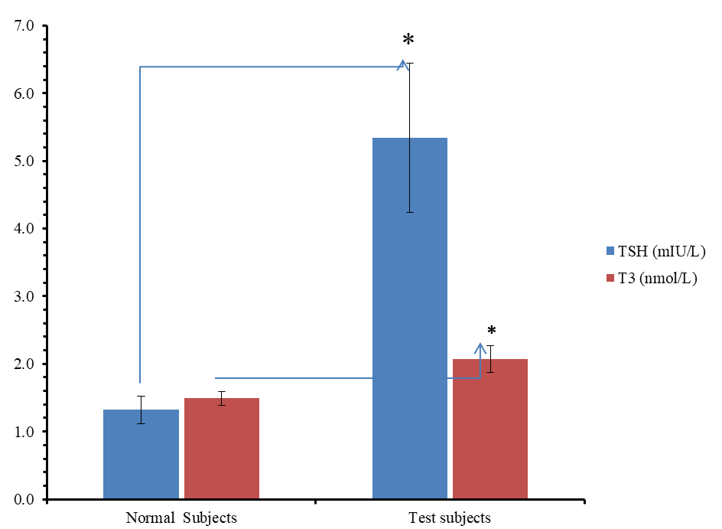

Figure 2: Thyroid Stimulating Hormone (TSH) and Triiodothyronine (T₃) levels in Test subjects and normal subjects
*: Values are statistically significant at p< 0.05. Values are Mean ± Standard deviation

Thyroxine (T₄) levels of Test subjects were compared with the control. The serum T₄ was significantly higher in test subjects (166.8 ± 79.2) compared with the control (102.6 ± 25.6; p=0.003) (Figure 3).

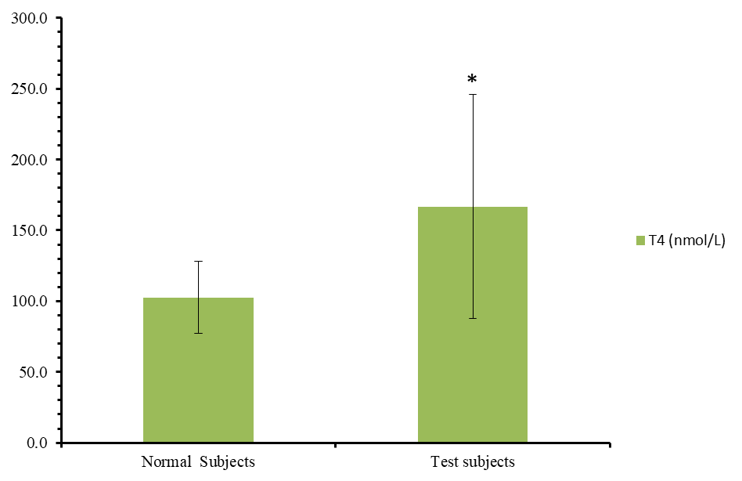

Figure 3: Thyroxine (T4) levels in Test subjects and normal subjects.
*: Values are statistically significant at p< 0.05. Values are Mean ± Standard deviation.

Serum Zinc (Zn) levels in Test subjects with hyperthyroidism (1.19 ± 0.6) were significantly decreased when compared with the control (2.27 ± 0.7; p=0.00). Serum Zn levels in Test subjects with hyperthyroidism (1.19 ± 0.6) were significantly increased when compared with hypothyroidism (0.92 ± 0.4; p=0.00). Serum Magnesium levels in Test subjects with hyperthyroidism (1.19±0.38) were significantly lower when compared with the control (2.09±0.36) (p=0.00), while Magnesium levels in Test subjects with hyperthyroidism were significantly higher than in Test subjects with hypothyroidism (1.31±0.22; p=0.00). Serum Vitamin A levels in Test subjects with hyperthyroidism (255.8±70.3) were significantly decreased when compared with control (342.9±57.9; p=0.00), while Vitamin A levels in Test subjects with hyperthyroidism were significantly higher than in Test subjects with hypothyroidism (154.2±44.5; p=0.00). Test Subjects with hypothyroidism had significantly lower vitamin A than control (p=0.00) (Table 1).

Parameters | Normal TFT  (n=100) | Hyperthyroidism  (n=100) | Hypothyroidism  (n=100) | f-value | p-value
Zn (mg/l) | 2.27 ± 0.7ª | 1.19 ± 0.6^{b} | 0.92 ± 0.4^{b} | 22.3 | 0.000*
Mg (mg/dl) | 2.09 ± 0.36a | 1.19 ± 0.38^{b} | 1.31 ± 0.22^{b} | 34.4 | 0.000*
Vitamin A (ng/ml) | 342.9 ± 57.9ª | 255.8 ± 70.3^{b} | 154.2 ± 44.5^{c} | 34.5 | 0.000*
Table 1: Zinc, Magnesium, and Vitamin A levels in study subjects with Hyperthyroidism and Hypothyroidism in comparison with subjects with normal Thyroid function, using ANOVA Statistics
*: Values are statistically significant at p< 0.05. Values are Mean ± Standard deviation.
Values with different superscripts ^{a, b, and c} are statistically significant at p<0.05.
Normal Thyroid function test (TFT): TSH of 0.4-4.0, Total T3 of 0.9 – 2.8 nmol/L, Total T4 of 57-149 nmol/L.
Hypothyroidism: TSH >10 mIU/L with normal T3 and T4.
Hyperthyroidism: TSH <1.8 mIU/L with elevated T3 > 2.8 nmol/L and/or T4 > 150 nmol/L.

Serum Zinc levels in male Test subjects with hyperthyroidism (1.2±0.7) were significantly lower when compared with the male control (2.4±0.6; p=0.00). Serum Zinc levels in female Test subjects with hyperthyroidism (1.2±0.6) were significantly decreased when compared with female control (2.1±0.9; p=0.033). There was no significant difference between serum Zinc levels in male Test subjects with hypothyroidism and female Test subjects with hyperthyroidism (p=0.935). Also, there was no significant difference between serum Zinc levels in male control and female control (p=0.311). Serum Magnesium levels in male Test subjects with hyperthyroidism (0.9±0.3) were significantly decreased when compared with male control (2.0±0.3; p=0.00). Serum Magnesium levels in female Test subjects with hyperthyroidism (1.3±0.3) were significantly decreased when compared with female control (2.1±0.4; p=0.00). Serum Vitamin A levels in male Test subjects with hyperthyroidism (343.8±64.7) were not significant when compared with male control (342.0±62.5; p=0.945). Serum Vitamin A levels in female Test subjects with hyperthyroidism (222.8±35.7) were significantly reduced when compared to female control (344.5±54.7; p=0.00) (Table 2).

Parameters | Normal  Males  (n=50) | Normal  Females  (n=50) | Male Hyperthyroidism  (n=50) | Female Hyperthyroidism  (n=50) | f-value | p-value
Zn (mg/l) | 2.4 ± 0.6ª | 2.1 ± 0.9ª | 1.2 ± 0.7^{b} | 1.2 ± 0.6^{b} | 8.72 | 0.000
Mg (mg/dl) | 2.0 ± 0.3ª | 2.1 ± 0.4ª | 0.9 ± 0.3^{b} | 1.3 ± 0.3^{c} | 22.6 | 0.000
Vitamin A (ng/ml) | 342.0 ±62.5ª | 344.5 ± 54.7ª | 343.8 ± 64.7ª | 222.8 ± 35.7^{b} | 16.9 | 0.000
Table 2: Mean serum Zinc, Magnesium, and Vitamin A levels in Male and Female subjects with Hyperthyroidism
*: Values are statistically significant at p< 0.05. Values are Mean ± Standard deviation.
Values with different superscripts ^{a, b, and c} are statistically significant at p<0.05.
Normal Thyroid function test (TFT): TSH of 0.4-4.0, Total T3 of 0.9 – 2.8 nmol/L, Total T4 of 57-149 nmol/L.
Hyperthyroidism: TSH <1.8 mIU/L with elevated T3 > 2.8 nmol/L and/or T4 > 150 nmol/L.

Serum Zinc levels in male Test subjects with hypothyroidism (1.0±0.4) were significantly reduced in comparison with male control (2.4±0.6; p < 0.00). Similarly, serum Zinc levels in female Test subjects with hypothyroidism (0.8±0.3) were significantly decreased when compared with female control (2.1±0.9; p < 0.001). Serum Magnesium levels in male Test subjects with hypothyroidism (1.5±0.2) were significantly reduced when compared with male control (2.0±0.3; p < 0.001). Similarly, serum Magnesium levels in female Test subjects with hypothyroidism (1.2±0.2) were significantly reduced when compared with female control (2.1±0.4; p < 0.001). Serum Vitamin A levels in male Test subjects with hypothyroidism (147.2±44.9) were significantly reduced than in male control (342.0±62.5; p<0.001), while the Vitamin A levels in female Test subjects with hypothyroidism (160.1±47.5) was significantly decreased than in female control (344.5±54.7; p <0.001) (Table 3).

Table 3: Zinc, Magnesium, and Vitamin A levels in Male and Female subjects with Hypothyroidism in comparison with Male and Female subjects with normal Thyroid function
Parameters | Normal  Males  (n=50) | Normal  Females  (n=50) | Male Hypothyroidism  (n=50) | Female hypothyroidism  (n=50) | f-value | p-value
Zn (mg/l) | 2.4 ± 0.6ª | 2.1 ± 0.9ª | 1.0 ± 0.4^{b} | 0.8 ± 0.3^{b} | 12.27 | 0.000
Mg (mg/dl) | 2.0 ± 0.3ª | 2.1 ± 0.4ª | 1.5 ± 0.2^{b} | 1.2 ± 0.2^{b} | 17.17 | 0.000
Vitamin A (ng/ml) | 342.0 ± 62.5ª | 344.5 ± 54.7ª | 147.2 ± 44. 9^{b} | 160.1 ± 47.5^{b} | 29.10 | 0.000
*: Values are statistically significant at p< 0.05. Values are Mean ± Standard deviation.
Values with different superscripts ^{a, b, c}are statistically significant at p<0.05.
Normal Thyroid function test (TFT): TSH of 0.4-4.0, Total T3 of 0.9 – 2.8 nmol/L, Total T4 of 57-149 nmol/L.
Hypothyroidism: TSH >10 mIU/L with normal T3 and T4.

Scattered plot showing a significant negative Pearson’s Correlation between Thyroid stimulating Hormone (TSH) and Serum Vitamin A in the Test subjects (Figure 4).

Figure 4: Correlation between thyroid stimulating hormone (TSH) and serum vitamin A in the Test subjects.

**. Correlation is significant at the 0.01 level (2-tailed).
*. Correlation is significant at the 0.05 level (2-tailed).
Scattered plot showing a significant negative Pearson’s Correlation between thyroid stimulating hormone (TSH) and serum zinc levels in Test subjects (Figure 5).

Figure 5: Pearson’s Correlation between thyroid stimulating hormone (TSH) and serum zinc levels in Test subjects.
**. Correlation is significant at the 0.01 level (2-tailed).
*. Correlation is significant at the 0.05 level (2-tailed).

Scattered plot showing significant positive Pearson’s Correlation between serum zinc levels and serum vitamin A in Test subjects (Figure 6).

Figure 6: A scattered plot showing a significant positive Pearson’s Correlation between serum zinc levels and serum vitamin A in study subjects.
**. Correlation is significant at the 0.01 level (2-tailed).
*. Correlation is significant at the 0.05 level (2-tailed).

Discussion
Thyroid hormones perform a wide array of metabolic functions, including regulating lipids, carbohydrates, protein, electrolytes, and mineral metabolism [11]. Mineral metabolisms and vitamins are frequently disturbed in thyroid dysfunctions. Both trace elements and thyroid hormones play important roles in the human body [6].
In this study, zinc levels for Test subjects with hyperthyroidism were significantly lower than for control (p <0.001), but significantly higher than for Test subjects with hypothyroidism (p <0.001). This finding is in agreement with the previous study of Vargas-Uricoechea, et al. found decreased serum Zn levels in patients with hypothyroidism as compared to control subjects; they noted that gastrointestinal absorption of zinc is severely impaired in hypothyroidism subjects [12]. An alternative explanation would be a change in zinc distribution; the low zinc level may reflect the sequestration of zinc by the liver or other tissues. The reason for this decrease in serum Zn level is the decreased gastrointestinal absorption of zinc in subjects with hyper- and hypothyroidism. Previously various studies have also depicted the decreased Zn levels in hypothyroidism. Many of these reports also highlighted the correlation of Zn deficiency with low levels of thyroid hormones [10, 13-14]. Contrary to the finding of our study, Aktuna, et al. stated that serum zinc levels in hyperthyroid subjects were not significantly different from hypothyroid patients [15], while Nishi, et al. observed no significant difference in serum Zn concentrations between patients with hypothyroidism and control [16]. Although low Zn status was associated with decreased thyroid hormone levels, the biochemical basis of such changes has yet to be established [10].
In this study, there was a significant negative Pearson’s Correlation between Thyroid Stimulating Hormone (TSH) and serum Zinc levels in Test subjects. Similar findings have been reported by Dhawan, et al. [17]. One of the endocrine functions associated with zinc is changes in thyroid hormone metabolism and energy consumption in humans on a low-zinc diet [3]. In contrast to our study, some studies highlighted differences in the correlation between Zn and thyroid hormones. Rashid, et al. found a positive correlation between plasma T3 and Zn levels [18]. Ertek, et al. reported that Zn deficiency had a synergistic effect on goiter formation [19], Gustin, et al. reported that zinc deficiency could directly influence thyroid hormone synthesis [20]. Likewise, El Hendy, et al. argued that zinc could directly affect thyroid function which could play a role in thyroid hormone metabolism by increasing the production of thyroxin-binding proteins [21]. Olivieri, et al. showed that Zn deficiency has led to decreased iodothyronine levels and they also found a strong positive association between Zn and free T3 levels [22].
Zinc levels for male Test subjects with hypothyroidism were significantly lower than male control (p<0.001). Furthermore, zinc levels in female Test subjects with hypothyroidism were significantly lower compared to female control (p < 0.001). Similar results were obtained in patients with hyperthyroidism. A decrease in thyroid hormones leads to the suppression of zinc levels [14]. In a study including 34 hypothyroid patients, serum zinc content was shown to be remarkably decreased in both male and female subjects compared with control [14].
In this study, magnesium levels of Test subjects with hyperthyroidism were significantly lower than control, but significantly higher than subjects with hypothyroidism (p<0.001). Test Subjects with hypothyroidism had non-significantly lower magnesium levels than control (p>0.05). These findings might be due to the major influence of thyroid glands on Mg levels. Heightened thyroid activity increases Mg requirements due to increased oxidative phosphorylation. Therefore hypomagnesemia is found in hypothyroid and hyperthyroid states [2]. In hypothyroidism, there is hypomagnesemia because of urinary output and fractional excretion of magnesium through urine. Magnesium level is reduced due to influence on GFR and decreased clearance. In hypothyroidism, renal blood flow is increased causing high clearance of magnesium from the kidneys. Lower serum magnesium levels in hypothyroid patients are due to impaired magnesium homeostasis [23]. Erdal, et al. showed that serum Mg level was significantly lower in patients with hypothyroidism than in control [24]. Results of studies on how magnesium values are affected in hypothyroidism seem contradictory and are focused on changes in tissues.
The results of this study showed that the mean magnesium level of male Test subjects with hypothyroidism was significantly lower than control (p<0.001). Similarly, mean serum magnesium level in female Test subjects with hypothyroidism was significantly lower when compared with female control (p<0.001) respectively. This finding is in agreement with previous studies which reported significantly lower magnesium levels in male and female subjects with hypothyroidism compared with male and female control [2]. Magnesium is an incredibly vital mineral found in the human body. Magnesium plays an important role in a wide range of body functions. Not only does magnesium stimulate the thyroid gland to produce more T4, but it simultaneously changes T4 into T3. This is a huge reason why magnesium is so vital. Magnesium helps the body to make more T4 in the thyroid gland. Thyroid hormone is a central regulator of body hemodynamics, thermoregulation, and metabolism. Therefore, it influences renal hemodynamics, glomerular filtration, and electrolyte handling [25].
In this study, vitamin A levels in Test subjects with hyperthyroidism were significantly lower than in control (p<0.001), but significantly higher than in Test subjects with hypothyroidism (p<0.001). Test subjects with hypothyroidism had significantly lower vitamin A than control (p<0.001). Vitamin A deficiency affects thyroid hormones resulting in iodine deficiency disorders. Vitamin A deficiency appears to be closely related to thyroid gland impairment, from its frequent association with iodine deficiency. Deficiency of vitamin A has been observed in thyroid diseases [26-27]. Similarly, the influence of a deficiency of this vitamin on TSH and thyroid hormone levels in individuals with abnormal thyroid hormones has also been reported [27]. Vitamin A levels in male Test subjects with hypothyroidism were significantly lower than in control (p<0.001). Similarly, the mean vitamin A level in female Test subjects with hypothyroidism was significantly lower than the female control (p<0.001). In this study, there was a negative correlation between Thyroid stimulating Hormone (TSH) and serum vitamin A levels in Test subjects and a positive correlation between serum zinc levels and serum vitamin A in Test subjects. The impact of thyroid dysfunction on vitamin A as well as magnesium and zinc levels is significant enough to suggest clinical trials of their supplementation in improving treatment outcomes and improving patients’ immune function. This is in addition to the already existing iodination of salt and some foods to prevent goitre.

Conclusion
It is concluded from the results that there is involvement of Zn, Mg, and Vitamin A deficiencies in hypothyroidism and hyperthyroidism. Zinc, Magnesium, and Vitamin A were significantly decreased in hyperthyroid and hypothyroid subjects compared to normal subjects. Concerning gender, Zinc, Magnesium, and Vitamins were decreased significantly in male and female hyperthyroid and hypothyroid subjects compared to male and female control respectively.

References
- Dhungana A, Shreevastva NK, Pant S, Pokharel BR. A study of serum calcium, phosphorous and magnesium level in hypothyroid cases. J Pathol Nep 2022;12(1):1933-7. 10.3126/jpn.v12i1.40422.
- Maxwell C, Volpe SL. Effect of zinc supplementation on thyroid hormone function. A case study of two college females. Ann Nutr Metab. 2007, 51 (7): 188-194. 10.1159/000103324.
- Ganapathy S, Volpe SL. Zinc, exercise, and thyroid hormone function. Crit Rev Food Sci Nutr. 1999, 39 (9): 369-390. 10.1080/10408699991279213.
- Aphamis G, Bogdanis GC, Sakkas GK, Roupa Z, Giannaki CD. The Effects of Zinc and Selenium Co-Supplementation on Resting Metabolic Rate, Thyroid Function, Physical Fitness, and Functional Capacity in Overweight and Obese People under a Hypocaloric Diet: A Randomized, Double-Blind, and Placebo-Controlled Trial. Nutrients. 2023,15; 3133. 10.3390/nu15143133.
- Dündar İ, Akıncı A. The frequency of subclinical hypothyroidism in obese children and adolescents and its relationship with metabolic parameters and atherogenic index. Turk Arch Pediatr. 2022, 57(3);316-322. 10.5152/TurkArchPediatr.2022.21264.
- Panahi Y, Mojtahedzadeh M, Najafi A, Ghaini MR, Abdollahi M, Sharifzadeh M, Ahmadi A, Rajaee SM, Sahebkar A. The role of magnesium sulfate in the intensive care unit. EXCLI J. 2017 16:464-482.10.17179/excli2017-182.
- Carazo A, Macaakovaa K, Matoussova K, Krccmovaa LK, Protti M, Mladeenka P. Vitamin A update: Forms, sources, kinetics, detection, function, deficiency, therapeutic use and toxicity. Nutrients, 2021, 13(5): 1703. doi: 10.3390/nu13051703.
- Brossaud J, Pallet V, Corcuff JB. Vitamin a, endocrine tissues and hormones: interplay and interactions. Endocr. Connect, 2017, 6(7): 121–130. 10.1530/EC-17-0101.
- Ucal Y, Serdar M, Akın-Levi C, Yıldırım-Keles ZZ, Turam C, Kumru P, M, Ozpinar A. "Association of maternal serum trace elements with newborn screening-thyroid stimulating hormone" turk j biochem, 2020, 45(5); 507-514. 10.1515/tjb-2019-0372.
- Zhou Q, Xue S, Zhang L, Chen G. Trace elements and the thyroid. Front Endocrinol (Lausanne). 2022, 24;13:904889. 10.3389/fendo.2022.90488.
- Pearce EN. Update in lipid alterations in subclinical hypothyroidism. J Clin Endocrinol Metab. 2012, 97(2):326-33.10.1210/jc.2011-2532.
- Vargas-Uricoechea H, Urrego-Noguera K, Vargas-Sierra H, Pinzón-Fernández M. Zinc and Ferritin Levels and Their Associations with Functional Disorders and/or Thyroid Autoimmunity: A Population-Based Case-Control Study. Int J Mol Sci. 2024, 23;25(18):10217. doi: 10.3390/ijms251810217.
- Padoan F, Piccoli E, Pietrobelli A, Moreno LA, Piacentini G, Pecoraro L. The Role of Zinc in Developed Countries in Pediatric Patients: A 360-Degree View. Biomolecules. 2024, 17;14(6):718. doi: 10.3390/biom14060718..
- Ye Y, Li Y, Ma Q, Li Y, Zeng H, Luo Y, Liang Y, Liu L, Liu L, Lin X, Yu G, Song C, Wan H, Shen J. Association of multiple blood metals with thyroid function in general adults: A cross-sectional study. Front Endocrinol (Lausanne). 2023, 27;14:1134208. 10.3389/fendo.2023.1134208.
- Aktuna D, Buchinger W, Langsteger W, Meister E, Sternad H, Lorenz O, Eber, O. Beta-carotene, vitamin A and carrier proteins in thyroid diseases. Acta of Medicine, 2019, 20 (2): 17-20.
- Nishi Y, Kawate R, Usui T. Zinc metabolism in thyroid disease. Postgrad. Med. J, 2018, 56 (9): 833-837. PMID: 8475673.
- Dhawan D, Singh BM, Dani V. Zinc sulphate following the administration of iodine-131 on the regulation of thyroid function in rats. Hell J Nucl Med, 2017, 10 (3); 167-171. PMID: 18084658.
- Rashid NF, Abed BA, Abas TA. Relationship between Some Trace Elements, Lipid profile and Hypothyroidism. Al Mustansiriyah J Pharma Sci. 2010, n.pag. 10.32947/ajps.v8i2.346.
- Ertek S, Cicero AF, Caglar O, Erdogan G. Relationship between serum zinc levels, thyroid hormones and thyroid volume following successful iodine supplementation. Hormones (ATH). 2010, 9(3):263-8. 10.14310/horm.2002.1276.
- Gustin K, Vahter M, Barman M, Jacobsson B, Skroder H, Filipsson H, Sandin A, Sandberg AS, Wold AE, Kippler M. Assessment of Joint Impact of Iodine, Selenium, Zinc Status on Women’s Third-Trimester Plasma Thyroid Hormone Concentrations. J Nutr. 2022, 152(7); 1737-1746. 10.1093/jn/nxac081.
- El Hendy HA, Yousef MI, Abo El-Naga NI. Effect of dietary zinc deficiency on hematological and biochemical parameters and concentrations of zinc, copper, and iron in growing rats. J Toxicol, 2001. 167(2); 163-70. 10.1016/s0300-483x(01)00373-0.
- Olivieri O, Girelli D, Stanzial AM, Rossi L, Bassi A, Corrocher R. Selenium, zinc, and thyroid hormones in healthy subjects: low T3/T4 ratio in the elderly is related to impaired selenium status. Biol Trace Elem Res, 1996, 51 (9); 31-41. 10.1007/BF02790145.
- Mane AY, Bhagwat VR. Assessment of some biochemical markers of bone turnover in thyroid dysfunction state. Int J Pharma Bio Sci, 2020, 3 (3); 126–133. Corpus ID: 159496277
- Chatterjee S, Chakrabarti P., Lokanathan V. Calcium and Magnesium levels in Subclinical and Overt Hypothyroidism: A Cross-sectional Study. j clin diagn res. 2023, 17(9); BC15-BC17. 10.7860/JCDR/2023/63791.18465
- Laura HM, Jeffrey SB. The Renal Manifestations of Thyroid Disease. J Am Soc Nephrol, 2012, 23 (5); 22–26. 10.1681/ASN.2010070766.
- Hess SY. The impact of common micronutrient deficiencies on iodine and thyroid metabolism: The evidence from human studies. Best Pract Res Clin Endocrinol Metab, 2010, 24 (1); 117–132. 10.1016/j.beem.2009.08.012.
- Zimmermann MB, Wegmüller R, Zeder C, Chaouki N, Torresani T. The effects of vitamin A deficiency and vitamin A supplementation on thyroid function in goitrous children. J Clin Endocrinol &Metabolism, 2004, 89 (4); 5441–5447. 10.1210/jc.2004-0862.

