Original Research Article

Presence and Habitat Use of the Indian Chevrotain (Moschiola indica) in the Buffer Zone of Bhadra Wildlife Sanctuary: A Case Study from Kuvempu University Campus, Shivamogga, Karnataka

ABSTRACT
The Indian chevrotain (Moschiola indica) is a cryptic, understudied ungulate vital to forest dynamics facing increasing habitat fragmentation. This study aims to verify the presence, habitat utilization, and co-occurring threats of this species within a human-modified landscape. The research was carried out at the Kuvempu University campus, situated in the buffer zone of the Bhadra Wildlife Sanctuary in the Western Ghats from Jan to June 2025. A non-invasive, multi-faceted methodology was employed, utilizing motion-activated infrared camera traps deployed across three forested sites for a continuous period of 6 months, complemented by indirect sign surveys for pellets and tracks along with the opportunistic sightings. The investigation confirmed the persistence of M. indica in the area. Detections were highest in microhabitats featuring dense bamboo thickets and minimal human disturbance with 75% of frequency rate, march had the highest encounter rate compared to other months of study while June being the least. Heat map was plotted based on the collected coordinates to know the variations in the density of the mouse deer at the study area. The survey also documented a diverse sympatric herbivore community, and the predators, including other species inhabiting the study arear. However, the study identified significant threats, particularly the presence of feral dogs near wildlife zones. These findings establish the ecological significance of the university campus as a functional refuge for the Indian chevrotain outside traditional protected areas. The study underscores the necessity of mitigating feral dog activity, to ensure the continued survival of cryptic fauna in fragmented, semi-natural landscapes.

Keywords: Indian Chevrotain, Western Ghats, Camera trap, Non-invasive monitoring.

INTRODUCTION
Among the hoofed animals of Asia, the Indian chevrotain or mouse deer (Moschiola indica), is Asia's tiniest hoofed mammal from family Tragulidae (Groves and Meijaard 2005) credited as the smallest Artiodactyl (Menon 2003) they are distributed in the countries like India and Srilanka and some parts of Nepal (Corbett and Hill 1992; Nandini 2005). No much study has been carried out on the mouse deer as they are mostly nocturnal and crepuscular in nature and is characterized by small, compact body with short and slender legs, inhabiting the evergreen and deciduous forests of India, with dense shrub and undergrowth, in the areas with less human disturbances (Barrette 1987; Matsubayashi et al. 2003). They act as major seed dispersals, in turn balancing the ecosystem where it inhabits (Devy 2006; Soumya and Sukumar 2010) Mouse deer are omnivorous in nature, their predominant diet includes fruits and plant extracts, bus also found to feed on fungi animal matter and tubers (Soumya et al. 2010) found mainly foraging in the forest floors (Hofmann 1985).
Mouse deer is listed as Schedule 1 under Wildlife protection act 1972 (Amol et al. 2013) and currently classified Least concerned by IUCN Red list (IUCN), also there is a lot of gaps in the literature as no formal study on this species or documentation of its habitat usage are made (McShea et al. 2009; Sridhara 2010). The mouse deer are the key stone species of moist deciduous and semi-evergreen forests as their presence influence the forest widely because of their contribution as seed dispersals also for their role in nutrient cycling (Ramesh et al., 2013; Sridhara et al., 2013). With the diminishing forest and increase human activity mouse deer are subjected to intense anthropogenic pressures, also are been extensively hunted for food, which has resulted in the drastic decrease of their population (Madhusudan and Karanth 2000, 2002; Raman 2004). At present the knowledge on the ecology of these species is oblivious, we really need to dig deeper into research if we want to understand how tropical forests work and how primitive ruminants evolved (MacKenzie et al. 2002; Ramesh et al. 2012). Systematic studies on the ecology of Mouse deer and implementation of standard, methodology with systematic monitoring systems are restricted only to the areas like Mudumalai and Periyar Tiger Reserves (Kalle, et al. 2013). Studies in the human dominated fragmented landscapes are comparatively low though they support wide varieties of faunal species including the least studies ones (Srivathsa et al. 2014). In recent times the camera trapping method is emerging as the most used methodology in wildlife research for evaluating the abundance, occupancy, and habitat selection of animals (Tobler et al. 2009). They have also gained importance because of documentation of the shy, nocturnal and cryptic animals such as the mouse deer (Rovero and Zimmermann 2016). To know the overall ecology of any species, long term monitoring of them is the only way (Raman 2004). Kuvempu University campus sits on the eastern slopes of the Western Ghats, right at the edge of Karnataka’s Bhadra Wildlife Sanctuary. Forest type at the study area is of moist deciduous mixed in with built-up areas. With this background study aimed to know the habitat preference, distribution pattern and frequency of mouse deer, through camera trap method. The study blends camera traps and indirect sign surveys, data on anthropogenic threats and threats by the predators were also collected to provide a baseline information on the importance of mouse deer, its current status and the threats that are faced by them at the study area to suggest the mitigation measures.

MATERIALS AND METHODS

Study Area
The present study was conducted within the forest area of university campus, located at Shankaraghatta in Shivamogga District, Karnataka. Geographically, the campus lies on the eastern slopes of the Western Ghats, a recognized global biodiversity hotspot. The campus is situated within the buffer zone of the Bhadra Wildlife Sanctuary and covers an area of approximately 230 acres. The region features a tropical monsoon climate with average annual rainfall ranging between 1200 and 1600 mm, and temperatures fluctuating between 15°C and 35°C across different seasons. The terrain is moderately undulating, comprising moist deciduous forest types interspersed with bamboo thickets. Despite the presence of academic infrastructure and moderate human activity, several semi-natural forest patches remain intact, providing suitable microhabitats for cryptic fauna.
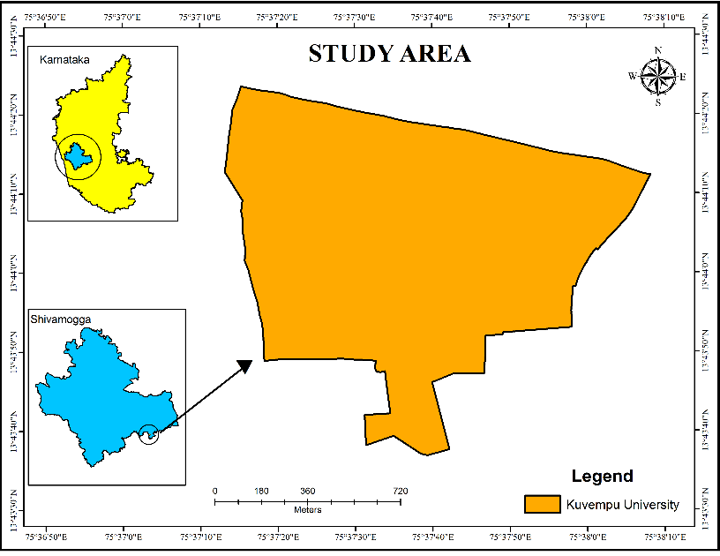
Figure 1. Location of the Study Area University campus, located at Shankaraghatta, Shivamogga District

Methodology
Study was carried out from January 2025 to June 2025 for the span of 6 months with methodologies such as camera trapping (Avinash et al. 2018), indirect sign surveys (Gopalaswamy et al.2012), opportunistic sighting, and threat assessments. Camera traps were deployed at 20 locations covering the entire forest patch, by dividing the area into grids and choosing the locations based on the indirect signs and the trail paths. Infrared camera traps. were deployed at a height of 30-40 cm along animal trails, operating 24 hours a day and recording GPS coordinates for each location with the help of GPS device Garmin 64S. Indirect surveys like pellet, and hoof marks were also photographed and GPS locations were noted to know the distribution (Kumbhar et al. 2013; Basak et al. 2017). Furthermore, we also recorded ecological and anthropogenic threats like activity of feral dog and other carnivore species in the forest.
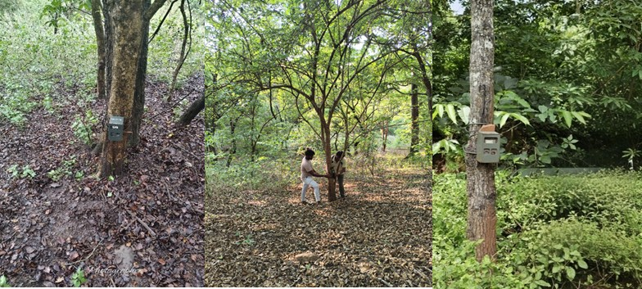
Figure 2. Camera Traps deployment

RESULTS AND DISCUSSION

3.1 Species Occurrence
The study confirmed the presence of Indian mouse deer (M. indica) in the forested regions of Kuvempu University campus using camera trap evidence and indirect field signs. A total of 20 sites were selected using grid method, camera traps were deployed along the trail paths. From the total captures of cameratrap 18% comprised of mouse deer, the dominated ones were the other ungulates such as Spotted deer, Sambar deer, Wildboar and Barking deer with 38%, others with false triggers and others animals like porcupine, monkeys, mangoose etc (20%), stray dog comprised of 15% captures, next were the human movement with 11% of photo records and least was found to be the predator animals like Tiger, Leopard, Dhole and Jackal and with only 5%(Figure. 3). Mouse deer were detected at 15 sites out of 20, confirming their continued presence, indirect signs of mouse deer were recorded, these included pellet and hoof prints, the coordinates of the location were noted using the GPS device, a total of 6 sites with the indirect signs were recorded, of which 4 were the locations with no recordings of mouse deer were observed in the camera trap survey. The highest pellet concentrations were found in particularly areas with dense bamboo thickets and minimal human movement. Footprints were occasionally observed in soft soil along animal trails. The temporal pattern of the animal capture and the sightings from Jan to June revealed that, the highest sightings and camera trap captures were observed in the month of march (n= 57) followed by April(n=39) with second highest, then falls February and January(n=28) and followed by May with n=25 and least in the month of June(n=19) (Figure. 4). The variation in the result is because of the ecology of the mousedeer, as they are ground dwellers and summers are the dry month with greater visibility and scares food and water sources it results in the highest sightings at the month of march, which is a peak summer month (Eisenberg and Lockhart 1972; Duckworth et al. 2015)
3.2 Density of Mouse deer
Heat map or the Density map was plotted to check for the density of probability of occupancy, of mouse deer with the help of the recorded locations of species occurrence and indirect signs (Figure 5). Density map showed the uneven distribution of the mouse deer in the study area, highlighting the priority zones. Based on the data the occurrence probability was made into 4 zones (Very high, High, Moderate and Low/ Unexplored). Higher density zones were the areas with dense undergrowth and thick bamboo patches and minimal human disturbances. Moderate zone was observed by little less herb and shrub cover, while the low-density area was the fragment forest area and the human habitations, also it contained some patch of forest which was unexplored during the study. Result revealed that the chevrotains prefer well grown thick forest patch as they act as the hiding ground and safeguard them from the predators, it also highlights the quality and health of habitat that plays a major role in supporting the presence of the mouse deer, intern highlights the need for the conservation of the habitat preferred by the mouse deer which may serve as the hideout, breeding and foraging grounds and so on(Eisenberg and lockhart 1972).
3.2: Non-target species and threats
The camera traps recorded other species of ungulates that occur in the study area, such as the Spotted Deer (Axis axis), Sambar (Rusa unicolor), Barking Deer (Muntiacus muntjak), and Wild Boar (Sus scrofa). The Spotted Deer were most commonly recorded and were found in groups or pairs, Barking Deer and sambar were less frequently recorded. Wild boars were also photographed in several locations, in addition, the study also recorded several signs of threats during the survey. Predator species such as Leopard, Tiger, Dholes, Jackals and Feral dogs were found at the sited that are marked with the presence of the mouse deer. Their presence close to the wildlife areas is a threat due to predation and displacement. Mouse deer were less frequently recorded in the more disturbed areas and were more abundant in areas with dense vegetation. No anthropogenic threats to mouse deer were observed during the study though there were human movement recorded, it was only limited to the fragmented habitats. The one that can be called a severe threat to the deer was the frequent movement of feral dogs in the forest patched. Only anthropogenic effect was the movement of humans into some areas of the forest, but it’s was not that significant to be considered threat to the mouse deer as the frequency was also quite low. Feral dogs were frequently sighted along animal trails and forest edges which pose the risk to small, ground-dwelling mammals such as M. indica. Many studies have revealed that feral dogs can suppress small mammal activity and contribute to localized population declines, particularly in fragmented or semi-disturbed areas (Vanak and Gompper 2009).

Figure 3. Species wise % of photos Figure 4. Encounter rate of Mouse deer

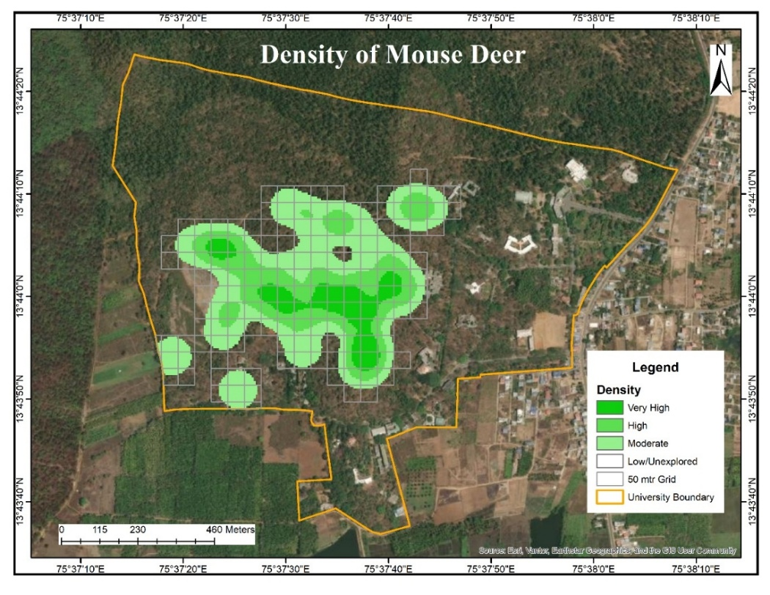
Figure 5. Density map showing the probability of occupancy of mouse deer

Conclusion
The present study successfully confirmed the presence of the Indian mouse deer (M. indica) within the forested patches of Kuvempu University campus. The data collected through camera traps and field observation for indirect signs like pellets and hoof marks provide clear evidence of M. indica presence and habitat use within the Kuvempu University campus. The study also indicates spatial distribution of mouse deer and suggests that mouse deer are more active in relatively undisturbed patches with rich understorey vegetation and low human disturbance. The results of the study provided a strong baseline data on the occurrence, distribution and dependence of the mousedeer in the study area. Study also showed the role and importance of the forest patches under Kuvempu university for inhabiting such rare and cryptic species. Also, the camera trap survey exhibited the presence of many non-target species highlighting the ecological value the forest of Kuvempu University hold. However, the study also identified several threats, most notably from the feral dogs, which pose challenges for conservation and management of many species including the mouse deer. Identification of individuals is also necessary to know the abundance of the mouse deer and also it reveals the overall ecology of the species and dependence on the forest patch, in this view present study lack the individual count which limits the study as individual count is necessary to know the ecology, reproductive trends, survival and population dynamics of the species (Karanth and Nichols 1998). In future studies incorporation of capture and recapture method can strengthen the work (O’Connell et al. 2011), it is most reliable method used oversees for the individual identification of the species with the photographic evidences based on the natural body markings (Amol et al. 2013), with accurate emphasis on the abundance of the mouse deer for its study, ecological role, conservation and managemental plans. Current findings emphasize the need for immediate management actions to cutdown the pressure on the mouse deer and other resident and migrant fauna of the study area. Study act as the baseline for future long term ecological studies on the mouse deer. With appropriate habitat protection the landscape of the Kuvempu University can continue to serve as vital area for the wildlife.

References

Amol Kumbhar, Charles Leo Prabhu, Jaya Kumar Yogesh, Pichaiyan Francies, Gaurang Patwardhan, Qamar Qureshi and Yadavendradev Jhala (2013). Application of Photographic Capture-Recapture Sampling for Estimating Abundance of Indian Mouse Deer Moschiola indica. World Journal of Zoology. 8 (4): 388-391

Avinash Krishnan, Aaranya Gayathri, Sagarika Phalke, Dilip Kumar AV (2018). Terrestrial mammals of Bannerghatta National Park, Karnataka, India: A camera-trap inventory and seasonal assessments. Journal of Biodiversity and Environmental Sciences (JBES). 12(3): 273-282.

Barrette C (1987) The comparative behaviour and ecology of chevrotains, musk deer, and morphologically conservative deer. In: Wemmer CW (ed) Biology and management of the Cervidae. Smithsonian Institution Press, Washington DC, 200-213.

Basak, K, Mondal, M & Ahmed, M. F. (2017). Confirming presence of Indian mouse deer from Chhattisgarh, Central India with photographic evidence after 112 years. International Journal of Fauna and Biological Studies. 4(4):192-195

Devy, MS (2006) Effects of fragmentation on a keystone tree species in the rainforest of Kalakad-Mundanthurai Tiger Reserve, India. Project Report, Ashoka Trust for Research in Ecology and the Environment, Bangalore.

Duckworth, J. W., Timmins, R. J., & Choudhury, A. (2015). Moschiola indica. The IUCN Red List of Threatened Species 2015.Raffles Bull Zool 12:413–421

Eisenberg JF, Lockhart M (1972) An ecological reconnaissance of Wilpattu National Park, Ceylon. Smithson Contr Zool 101:1-118.

Hofmann RR (1985) Digestive physiology of the deer—their morpho-physiological specialization and adaptation. Roy Soc New Zealand Bull 22:393–407

IUCN Red List of Threatened Species. Version <www.iucnredlist.org>.

Karanth, K. U., & Nichols, J. D. (1998). Estimation of tiger densities in India using photographic captures and recaptures. Ecology, 79(8): 2852–2862.

Kalle, R., Ramesh, T., Qureshi, Q., & Sankar, K. (2013). Density of striped hyena and coexistence with large carnivores in Mudumalai Tiger Reserve, India. Acta Theriologica, 58:405–413.

Kumbhar, A. K., Pillai, N. G., & Muraleedharan, T. R. (2013). Application of photographic capture-recapture sampling for estimating abundance of Indian mouse deer. Moschiola indica. World Journal of Zoology. 8(4): 388-391

M. Gopalaswamy, K. U. Karanth, N. S. Kumar, D. W. Macdonald (2012) Estimating tropical forest ungulate densities from sign surveys using abundance models of occupancy. Animal Conservation. 15(6): 669-679

McShea, WJ, Stewart C, Peterson L, Erb P, Stuebing R, Giman B (2009) The importance of secondary forest blocks for terrestrial mammals within an Acacia/secondary forest matrix in Sarawak, Malaysia. Biol Conserv 142:3108-3119.

MacKenzie, D.I., Nichols, J.D., Lachman, G.B., Droege, S., Royle, J.A. & Langtimm, C.A. (2002) Estimating site occupancy rates when detection probabilities are less than one. Ecology, 83:2248-2255.

Madhusudan MD, Karanth KU (2000) Hunting for an answer: is local hunting compatible with large mammal conservation in India. In: Robinson JG, Bennett EL (eds) Hunting for sustainability in the tropics. Columbia University Press, New York, pp 339-355

Madhusudan MD, Karanth KU (2002) Local hunting and the conservation of large mammals in India. Ambio 31:49-54

Matsubayashi H, Bosi E, Kohshima S (2003) Activity and habitat use of lesser mouse-deer (Tragulus javanicus). Journal of Mammalogy. 41():234-242.

Menon, V. 2003. A field guide to Indian mammals. India: Dorling Kindersley (India) Pvt. limited. Nowak, R. M.(1999) Walker’s mammals of the world. .Sixth edition. Balitmore: Johns Hopkins University Press.

Nandini R. (2005) Predation by Forest Eagle-Owl Bubo nipalensis on Mouse Deer Moschiola meminna Indian Birds. 1(5):119-120

O’Connell, A. F., Nichols, J. D., & Karanth, K. U. (2011). Camera Traps in Animal Ecology: Methods and Analyses. Springer.

Soumya Prasad and R. Sukumar (2010) Context-dependency of a complex fruit-frugivore mutualism: temporal variation in crop size and neighborhood effects. Oikos 119:514-523.

Soumya Prasad, Andre´ Pittet and R. Sukumar (2010) Who really ate the fruit? A novel approach to camera trapping for quantifying frugivory by ruminants. Ecol Res 25:225-231.

Raman TRS (2004) Mouse deer (Moschiola meminna Erxleben, 1777). ENVIS Bulletin: Wildlife Institute of India, Dehra Dun 7:131-140

Ramesh T, Kalle R, Sankar K, Qureshi Q (2012) Factors affecting habitat patch use by sloth bears in Mudumalai Tiger Reserve, Western Ghats, India. Ursus 23:78-85.

Ramesh, T., Kalle, R., Sankar, K., & Qureshi, Q. (2013). Dry season factors determining habitat use and distribution of mouse deer in the Western Ghats. Europian Journal of Wildlife Research.

Rovero, F., & Zimmermann, F. (2016). Camera Trapping for Wildlife Research. Pelagic Publishing.

Srivathsa, A., Karanth, K. U., Kumar, N. S., & Oli, M. K. (2014). Human-modified landscapes and mammal persistence in the Western Ghats of India. PLoS ONE, 9(5).

Sridhara, S., Edgaonkar, A., & Kumar, A. (2013). Understorey structure and refuges from predators influence habitat use by a small ungulate, the Indian chevrotain in Western Ghats, India. Journal of Mammalogy. 94(5): 1153-1161.
- The Wildlife protection act. 1972.

Tobler MW, Carrillo-Percastegui SE, Powell G (2009) Habitat use, activity patterns and use of mineral licks by five species of ungulate in south-eastern Peru. J Trop Ecol 25:261-270.
- Vanak, A. T., & Gompper, M. E. (2009). Dogs Canis familiaris as carnivores: Their role and function in intraguild competition. Mammal Review. 39(4):265-283.

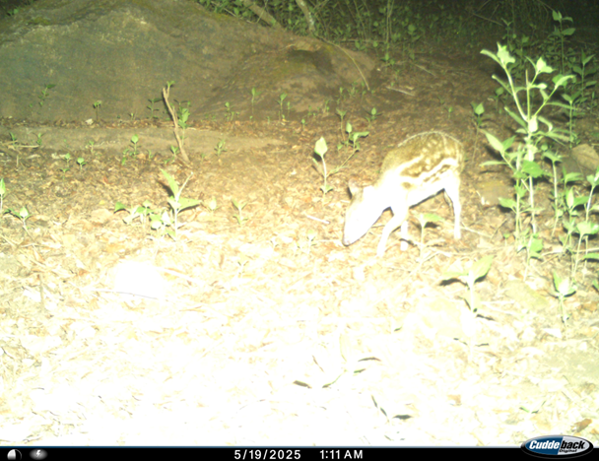
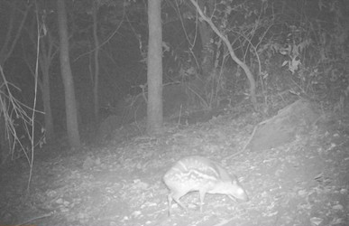
Figure 6. Camera Trap images
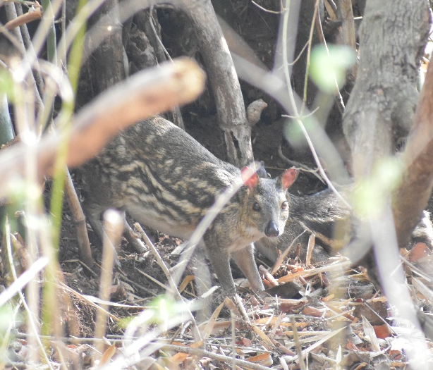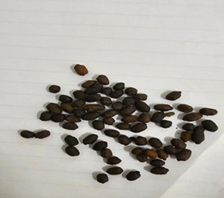
Figure 7. Visual sighting Figure 8. Pellets of Mouse Deer

Instruments Used
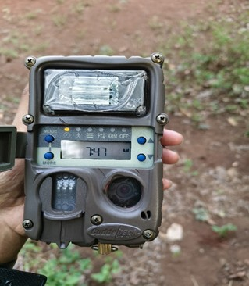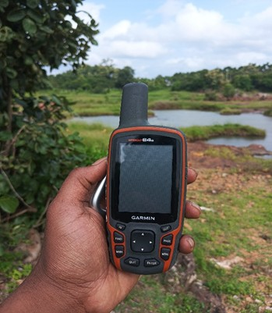
Figure 9. Camer trap Figure 10. GPS Device
Non- Target Species
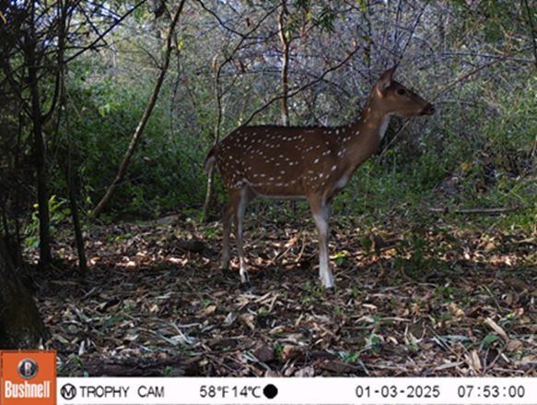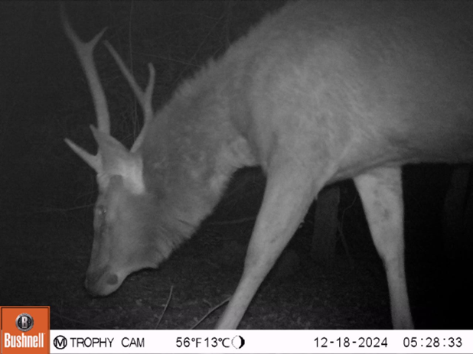
Figure 11. Spotted Deer Figure 12. Sambar

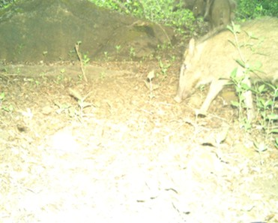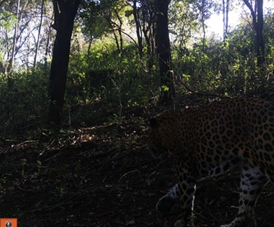

Figure 13. Wild Boar Figure 14. Leopard

Threat

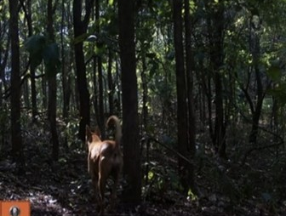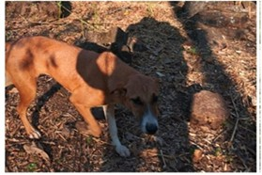
Figure 15 . Feral Dogs

