Toxicological Impact of Silver Oxide (Ag₂O) Nanomaterials on Brain Histological Alterations in Lissachatina fulica

Abstract-
This study investigated the neurotoxic effects of silver oxide nanoparticles (Ag₂O NPs) on the cerebral ganglia of snails using histological analysis. Control animals showed normal architecture with well-defined giant nerve cell, white matter, Gray matter lacuna, dorsal medium tissue, ventral medium tissue, cerebrum ganglion. Globuli cells had distinct nuclei, giant neurons were prominent, and the neuropil was compact and organized.
Exposure to Silver oxide (Ag₂O) nanoparticles caused different concentration (5ppm, 10ppm, 15ppm) duration-dependent (24h. 48h. 72h) damage. Early changes included perineurial disruption, vacuolization, swelling of the neuropil, and reduced clarity between cerebral regions. At higher exposure levels, necrosis, neuronal degeneration, hyperplasia, and abnormal fusion of brain regions were observed. Severe exposure led to fragmentation of neuropil, pyknotic nuclei in giant neurons, loss of small and medium neurons, and collapse of overall ganglionic structure.
The results confirm that Ag₂O nanoparticles induce progressive neurodegeneration in snail cerebral tissue.

Graphical Abstract –
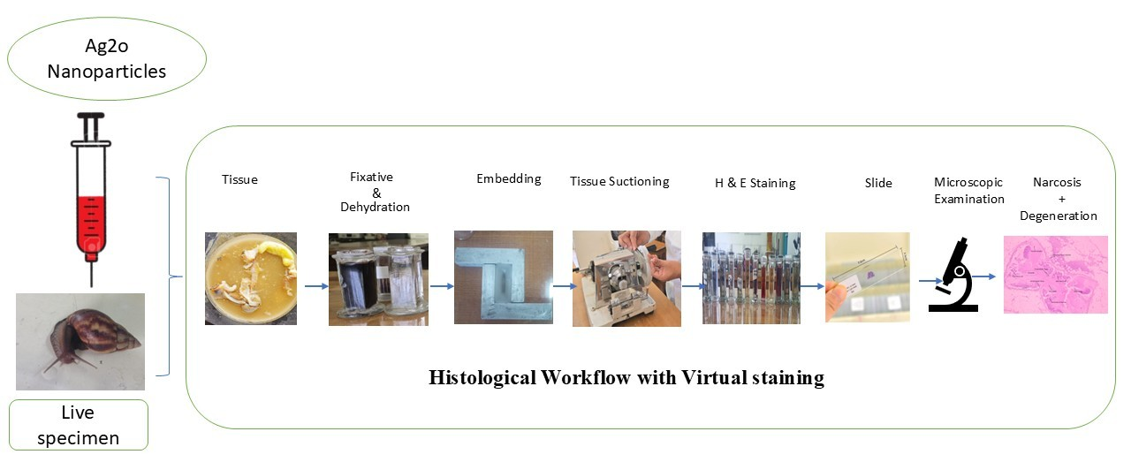
Fig-1. Representation of regular paraffin embedding method
Keyword- Lissachatina fulica, Silver Oxide (Ag2O), Brain histology, Cellular changes

- Introduction-
The giant African snail, Achatina fulica, is listed among the world’s 100 worst invasive alien species by the International Union for Conservation of Nature (International Union for Conservation of Nature) (Lowe et al., 2000). Native to East Africa, the species has been widely introduced across many parts of the globe (Lowe et al., 2000). Its invasion success is largely attributed to its high reproductive potential, voracious feeding behaviour on nearly 500 plant species, poor quarantine measures, and human-mediated dispersal (Fontanilla et al., 2007).
The snail is of considerable public-health importance because it serves as an intermediate host of Angiostrongylus cantonensis, the causative agent of angiostrongylosis and eosinophilic meningoencephalitis in humans. Furthermore, the faecal matter of the snail aids in spreading black pod disease caused by Phytophthora palmivora (Raut & Barker, 2002).
A. fulica is regarded as one of the most destructive pests in tropical and subtropical regions, producing extensive damage to agricultural fields, commercial plantations, and home gardens (Vasconcellos & Pile, 2001). The species is commonly associated with trees, decomposing organic substrates, and garbage accumulation sites. Climate-based predictive models have been developed to understand and forecast its invasion pattern in India, which may support management planning (Sarma et al., 2015).
Historically, control of A. fulica has relied on non-specific molluscicides (Panigrahi & Raut, 1994). In recent years, there has been a shift toward safer and more selective plant-based products to minimize environmental hazards (Panigrahi & Raut, 1994). A variety of botanical compounds have proven effective against snails such as Lymnaea acuminata (Chauhan et al., 2011), Subulina octona (Silva et al., 2012), Indoplanorbis exustus (Pandey & Singh, 2009), Eobania vermiculata, and Monacha cartusiana (Aal & Hamed, 2010). However, only limited natural compounds have been evaluated specifically against A. fulica (Panigrahi & Raut, 1994; Justin et al., 2008; Rao & Singh, 2002).
Several investigations have demonstrated that metal-based nanoparticles can be transferred along terrestrial food chains, highlighting the importance of dietary exposure in nanoparticle accumulation (Hawthorne et al., 2014; Unrine et al., 2012). Nevertheless, the quantitative contribution of dietary intake to silver nanoparticle (AgNP) bioaccumulation remains unclear.
In aquatic organisms, dietary exposure is widely regarded as the dominant pathway for metal uptake according to biodynamic modelling based on metal-uptake kinetics (Luoma & Rainbow, 2005; Dang et al., 2009). Partitioning total accumulation into individual processes, such as dietary versus waterborne routes, may therefore enhance the mechanistic understanding of nanoparticle bioavailability. Recent research has confirmed that biodynamic models are powerful tools for evaluating AgNP uptake through both food and water in estuarine and freshwater snails, as well as for elucidating the mechanisms governing this process (Khan et al., 2012, 2015; Croteau et al., 2011, 2014; Oliver et al., 2014). Despite these advances, distinguishing the specific contribution of dietary exposure to overall AgNP accumulation remains unresolved.
Accordingly, the present study aimed to change histological behavior of AgNPs in the land snail lissachatina fulica under both waterborne and dietary exposure scenarios and to determine the relative importance of each pathway in bioaccumulation. In addition, silver nitrate (AgNO₃) was included for direct comparison with nanoparticulate silver, providing further insight into AgNP bioaccumulation patterns in lissachatina fulica.

- Material and Method-
  - Materials-
All chemicals and reagents used in this study were of analytical grade and used without further purification. Silver Oxide NPs (Ag2O, 99%), was purchased from Sigma-Aldrich.
2.2 Collection and maintenance of snails
Adult snails of Lissachatina fulica were collected from local grapes garden Nashik Maharashtra, India. Healthy snails in the weight range of 62 gms ± 22 gms were used for the current studies. They were maintained at a temperature of 25˚C ± 2˚C in transparent plastic boxes ( 14’’ x 10.5’’x 10’’). These boxes were laden with garden soil at the bottom forming a 4 cm layer. The open ends of the boxes were small holes to facilitate free flow of air. The snails were fed on grapes leaves on a daily basis and appropriate humidity was maintained by sprinkling water on the soil layer intermittently.
2.3 Experimental Design
For histological, adult specimens of Lissachatina fulica were randomly allocated into 4 groups: All treatments were applied topically using a stainless stell needle, following the method described by Hussein et al. (1994). After 24h. 48h. and 72 h. of exposure, the snails were dissected. Relevant tissues brain were carefully excised, rinsed with phosphate-buffered saline (PBS), and weighed to further investigation.

2.4 Toxicity test
A series of concentrations were prepared (5ppm, 10ppm, 15ppm). Three replicates with ten snails for each were exposed. After 24 hrs of exposure, dead snails were counted, removed, Toxicity assessment was carried out according to the method described by Hussein et al. (1994). Adult Lissachatina fulica snails were randomly assigned into experimental groups (n = 10 per group), including a control and treatment groups receiving silver oxide (Ag2O NP’s) nanoparticles at concentrations of 5 ppm, 10 ppm and 15 PPM respectively. The nanoparticle suspensions were administered by injection. Mortality was monitored at 24h. 48h. and 72h. hours after exposure. Snails were considered dead when they failed to exhibit any response to gentle tactile stimulation with a fine stainless-steel needle, in accordance with WHO guidelines (1965).
For histological examination, brain tissues were carefully dissected and immediately fixed in 10% neutral buffered formalin to preserve cellular architecture. The fixative was prepared by mixing 10 ml of formalin (40% formaldehyde) with 90 ml of distilled water, and tissues were kept in the solution for 24–48 hours. After fixation, the specimens were rinsed under running tap water to remove excess fixative. The tissues were then subjected to dehydration through ascending grades of ethanol (30%, 50%, 70%, 90%, and two changes of absolute alcohol), with each step lasting approximately one hour to ensure complete removal of water. Clearing was performed by transferring the tissues into a 1:1 mixture of absolute alcohol and xylene for 30 minutes, followed by immersion in pure xylene for two hours, rendering the tissues transparent and preparing them for wax impregnation. Infiltration was carried out using a 1:1 mixture of xylene and paraffin wax at 58 °C for 30 minutes, after which the tissues were kept overnight in molten paraffin wax. For embedding, L-shaped metal moulds were used; a base layer of melted wax was allowed to solidify slightly, the tissue was positioned at the centre with heated forceps, and additional molten wax was poured to form a block. The paraffin blocks were trimmed and mounted on a Leica semi-automatic microtome, and sections of approximately 4–7 µm thickness were cut. Glass slides were coated with egg albumin to improve adhesion, and the sections were placed on the slides, gently warmed, and dried overnight. Finally, the prepared sections were stained with hematoxylin and eosin (H&E) and examined under a light microscope for detailed histological analysis.

2.5 Histological Staining Procedure (Haematoxylin and Eosin Stain)
Paraffin-embedded tissue sections mounted on glass slides were processed for Haematoxylin and Eosin (H&E) staining following a standard histological procedure. Slides were first gently warmed and immersed in xylene for 2–3 minutes, then placed in fresh xylene until the tissues became fully transparent. The sections were subsequently rehydrated through a descending ethanol series, beginning with two changes of absolute alcohol (1 minute each), followed by brief dips in 95%, 70%, 50%, and 30% ethanol. After thorough washing in distilled water, the slides were stained in haematoxylin for 2–20 minutes depending on the type used (Harris’ haematoxylin: 3–5 minutes; Ehrlich’s haematoxylin: 15–20 minutes). The slides were rinsed in distilled water and examined under low magnification to assess staining intensity, with additional staining or washing performed as needed. Differentiation was carried out using acidified alcohol, and the slides were then “blued” in either alkaline tap water or 1% lithium carbonate solution. Following another rinse in distilled water, the sections were dehydrated through an ascending ethanol series (30%, 50%, 70%, and 95%), and counterstained with 0.5–1.0% eosin in 90% ethanol for 30 seconds to 1 minute. Final dehydration was completed with 95% ethanol, followed by two changes of absolute alcohol (3 minutes each). The sections were cleared in two successive xylene baths until fully transparent and finally mounted using DPX. Prepared slides examined under a light microscope. Histological lesions and severity assessed and documented.

- Result and Discussion-
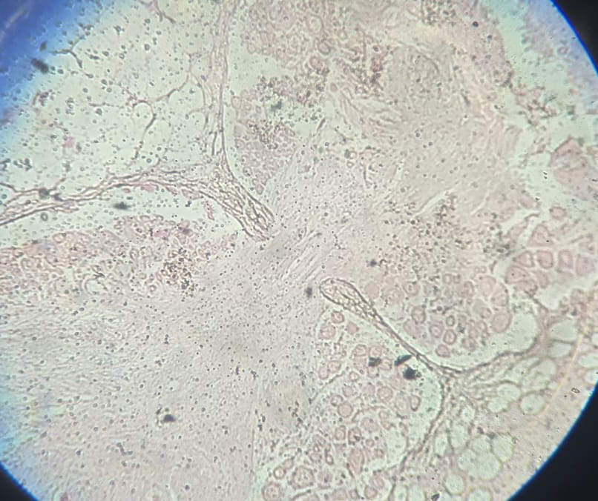
CTC
GNC
B
A
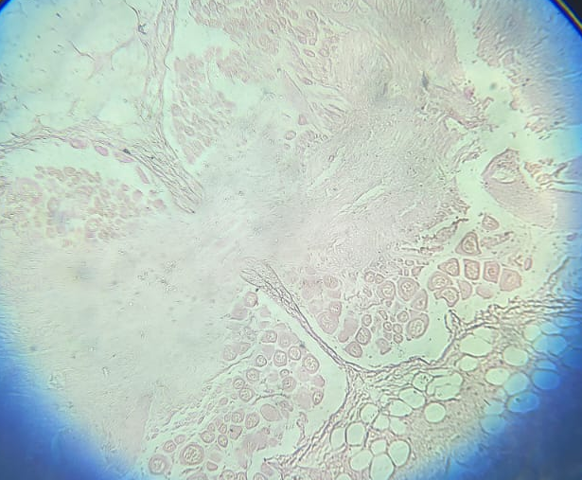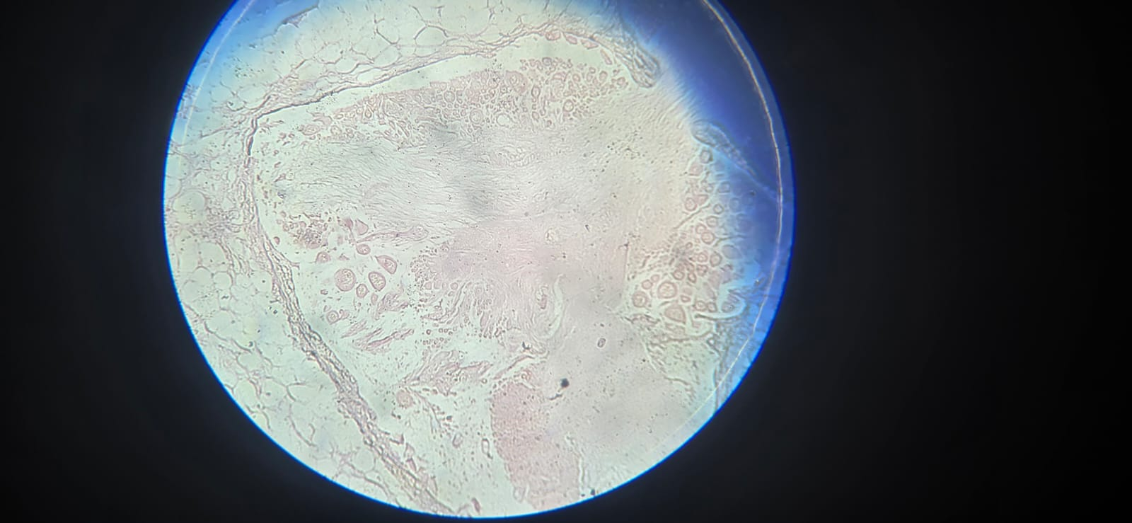
CG
CG
CTC
GNC
CTC
GNC
D
C
Fig- 2T. S. of Brain of Lissachatina fulica A-(Normal) tissue histology B-(5PPM /24h.) GNC-Giant Nerve cell Disturb CTC-connective tissue capsules changes MT-median tissue Degeneration C - GNC-Giant Nerve cell Disturb CTC--(10PPM /48h.) connective tissue capsules changes MT-median tissue Degeneration D- -(15PPM /72h.) GNC-Giant Nerve cell Disturb CTC-connective tissue capsules changes MT-median tissue Degeneration

3.1 Staining Results:
In H&E-stained sections, the nuclei appear pink colour, while the nucleoli are distinctly dark pink. The cytoplasm typically shows a pink coloration. Other tissue components also exhibit characteristic staining patterns: cartilage displays shades of pink to blue, and collagen fibres along with osteoid tissue appear light pink.
In Lissachatina fulica, the cerebral ganglia are paired structures located dorsally to the oesophagus, behind the buccal ganglia, and enclosed by two connective tissue layers — the outer loose perineurium and the inner dense endoneurium. Both ganglia are interconnected by a cerebral commissure and are subdivided into three regions: the procerebrum, mesocerebrum, and metacerebrum. The central neuropil, composed of nerve fibers, glial filaments, giant nerve cell, white matter, Gray matter lacuna, dorsal medium tissue, ventral medium tissue, cerebrum ganglion and synapses, extends toward the posterior end. These ganglia regulate sensory and motor functions related to feeding and coordination.
3.2 Control (Normal Histology)
In the control snails, the cerebral ganglia exhibited normal histoarchitecture. The procerebrum contained small globuli cells with distinct nuclei and minimal cytoplasm. The mesocerebrum had numerous large and giant nerve cells with prominent nuclei, while the metacerebrum showed clusters of large, medium, and small neurons. The neuropil appeared compact and well-organized, maintaining clear boundaries between the three cerebral regions.
3.3 Exposure to Silver Oxide Nanoparticles (Ag₂O NPs) 24h.
Exposure to Ag₂O nanoparticles caused progressive neurodegenerative changes in the cerebral ganglia, depending on concentration and exposure duration.
At lower exposure levels (5PPM 24h.), partial destruction of the perineurium, vacuolization, and swelling of the neuropil were observed. The demarcation between giant nerve cell, white matter, Gray matter lacuna, dorsal medium tissue, ventral medium tissue, cerebrum ganglion became unclear, and the connective tissue exhibited early signs of damage. Giant nerve cells appeared enlarged, but their numbers decreased. Vacuolated cytoplasm in globuli cells of the procerebrum and altered morphology of neurons were common.
With increasing nanoparticle concentration or prolonged exposure (10PPM for 48h.), necrosis, hyperplasia of neuropil cells, and loss of neuronal organization became more pronounced. while the neuropil extended abnormally towards the lateral and posterior sides. Many nerve cells displayed cytoplasmic degeneration, lysis, and reduced staining intensity.
At higher concentrations, (15 PPM for 48h.), extensive tissue damage occurred — including disintegration of perineurium and endoneurium, necrosis of neural tissue, and collapse of the normal ganglionic architecture. The neuropil appeared fragmented and vacuolated, with loss of axonal integrity and disoriented glial cells. Giant nerve cells exhibited pyknotic nuclei and cytoplasmic vacuolation, while small and medium neurons were reduced in number.
In severe exposure, the cerebral ganglia lost their distinct regions. The neuropil and nerve cells were heavily degenerated, showing complete disorganization, necrosis, and structural collapse. The number of globuli cells drastically declined, and the extracellular matrix was extensively damaged
Table-1 Histological Changes in Cerebral Ganglia: Control vs Ag₂O NP Exposure
Feature | Control (Normal Histology) | Low Exposure to Ag₂O NPs | Moderate / Increased Exposure | High Concentration | Severe Exposure
Overall architecture | Well organized; clear separation of procerebrum, mesocerebrum, metacerebrum | Early disturbance; boundaries start becoming unclear | Organization markedly disturbed | Ganglionic architecture collapsing | Complete loss of regional identity
Perineurium / Endoneurium | Intact | Partial destruction begins | Further degeneration | Disintegration evident | Completely damaged
Procerebrum (globuli cells) | Small cells, distinct nuclei, minimal cytoplasm | Cytoplasmic vacuolization common | Fusion tendency with mesocerebrum | Strong reduction in number | Drastic decline
Mesocerebrum (giant cells) | Numerous large & giant neurons, prominent nuclei | Cells enlarged but fewer | Morphology altered | Pyknotic nuclei, vacuolated cytoplasm | Mostly degenerated
Metacerebrum | Clusters of large, medium & small neurons | Neuronal arrangement disturbed | Loss of organization increases | Small & medium neurons reduced | Regions indistinguishable
Neuropil | Compact, dense, well arranged | Swelling and vacuolization | Hyperplasia; abnormal extension | Fragmented, vacuolated | Heavily degenerated
Connective tissue | Normal | Early damage signs | Progressive damage | Severe disruption | Collapsed
Cytology of neurons | Normal staining, intact cytoplasm | Altered morphology | Degeneration, lysis, reduced staining | Extensive degeneration | Necrotic
Axonal / glial condition | Normal | Beginning alteration | Increasing disarray | Loss of axonal integrity; glial disorientation | Structural failure
General outcome | Healthy neural tissue | Initial neurodegeneration | Advanced pathology | Extensive tissue damage | Complete disorganization

4.0 Conclusion-
The histological progression summarized in the table demonstrates a clear, concentration-dependent neurotoxic impact of silver oxide nanoparticles (Ag₂O NPs) on the cerebral ganglia of Lissachatina fulica. Neural tissues in the control group display well-defined regional organization, intact protective layers, compact neuropil, and healthy neuronal cytology.
With low exposure, the earliest responses include mild architectural disturbance, cytoplasmic vacuolization, and the beginning of perineurial and axonal alterations, indicating the onset of neurodegeneration. As exposure increases, structural integrity declines markedly. neuronal arrangement becomes irregular, and both globuli and giant cells show reductions in number together with nuclear abnormalities.
At high and severe concentrations, damage becomes extensive and often irreversible. The ganglionic framework collapses, neuropil fragments, connective tissues disintegrate, and neurons exhibit pyknosis, lysis, and necrosis. Ultimately, regional identity is lost and the nervous system reaches a stage of complete disorganization.
Overall, the findings indicate that Silver oxide (Ag₂O NP) toxicity escalates from subtle cellular stress to catastrophic neural destruction as dose intensifies, confirming a strong dose–response relationship and highlighting the vulnerability of molluscan neural tissue to nanoparticle exposure.

  - .
Research Highlight-
- Recent investigations indicate that silver oxide (Ag₂O) nanoparticles exert strong cytotoxic effects in the land snail Lissachatina fulica.
- Lissachatina fulica is a major non-insect agricultural pest responsible for considerable economic losses in crop production.
- The present study aims to evaluate the neurotoxic potential of Ag₂O nanoparticles by examining histological alterations in the brain tissue.
- Exposure to the nanoparticles resulted in pronounced structural and cellular damage within the cerebral architecture.

- 5.0 . References:
- 1. Pandey, J. K., & Singh, D. K. (2009). Molluscicidal activity of plant-derived products against Indoplanorbis exustus. Indian Journal of Experimental Biology, 47(8), 643–648.
- 2. Panigrahi, A., & Raut, S. K. (1994). Plant products as molluscicides against the giant African snail Achatina fulica. Memórias do Instituto Oswaldo Cruz, 89(4), 495–499. https://doi.org/10.1590/S0074-02761994000400004
- 3. Rani, P. U., Rajasekharreddy, P., & Ramakrishna, A. (2012). Eugenol—A potential antifungal and antiseptic compound. International Journal of Pharmaceutical Sciences and Research, 3(9), 3231–3237.
- 4. Rao, I. G., & Singh, D. K. (2002). Toxic effects of plant extracts on Achatina fulica. Journal of Applied Toxicology, 22(3), 211–215. https://doi.org/10.1002/jat.850
- 5. Raut, S. K., & Barker, G. M. (2002). Achatina fulica Bowdich and other achatinidae as pests in tropical agriculture. In G. M. Barker (Ed.), Molluscs as crop pests (pp. 55–114).
- 6. Santos Carvalho, O. S., Scholte, R. G. C., Mendonça, C. L. F., Passos, L. K. J., & Caldeira, R. L. (2003). Role of Achatina fulica in the transmission of Angiostrongylus cantonensis. Revista de Biología Tropical, 51(2), 219–227.
- 7. Silva, E. J., et al. (2012). Molluscicidal activity of plant extracts against Subulina octona.
- 8. Vasconcellos, M. C., & Pile, E. (2001). Occurrence of Angiostrongylus cantonensis in the giant African snail Achatina fulica. Memórias do Instituto Oswaldo Cruz, 96(8), 1199–1204.
- 9. Croteau, M.-N., & Luoma, S. N. (2008). A biodynamic understanding of diet-borne metal uptake by a freshwater invertebrate. Environmental Science & Technology, 42(5), 1801–1806. https://doi.org/10.1021/es7022913
- 10.Dang, F., Huang, Y., Wang, Y., Zhou, D., & Xing, B. (2021). Transfer and toxicity of silver nanoparticles in the food chain. Environmental Science: Nano, 8(6), 1519–1535. https://doi.org/10.1039/D0EN01190H
- 11. Hawthorne, J., De la Torre Roche, R., Xing, B., Newman, L. A., Ma, X., Majumdar, S., Gardea-Torresdey, J., & White, J. C. (2014). Particle-size dependent accumulation and trophic transfer of cerium oxide through a terrestrial food chain. Environmental Science & Technology, 48(22), 13102–13109. https://doi.org/10.1021/es503792f
- 12. Khan, F. R., Misra, S. K., García-Alonso, J., Smith, B. D., Strekopytov, S., Rainbow, P. S., Luoma, S. N., & Valsami-Jones, E. (2012). Bioaccumulation dynamics and modeling in an estuarine invertebrate following aqueous exposure to nanosized and dissolved silver. Environmental Science & Technology, 46(14), 7621–7628. https://doi.org/10.1021/es301253s
- 13.Lopez-Serrano Oliver, A., Croteau, M., Stoiber, T. L., Tejamaya, M., Römer, I., Lead, J. R., & Luoma, S. N. (2014). Does water chemistry affect the dietary uptake and toxicity of silver nanoparticles by the freshwater snail Lymnaea stagnalis? Environmental Pollution, 189, 87–91. https://doi.org/10.1016/j.envpol.2014.02.010
- 14. Luoma, S. N., & Rainbow, P. S. (2005). Why is metal accumulation so variable in aquatic organisms? A biodynamic explanation. Environmental Toxicology and Chemistry, 24(10), 2496–2506.
- 15. Unrine, J. M., Shoults-Wilson, W. A., Zhurbich, O., Bertsch, P. M., & Tsyusko, O. V. (2012). Trophic transfer of Au nanoparticles from soil along a simulated terrestrial food chain. Environmental Science & Technology, 46(17), 9753–9760. https://doi.org/10.1021/es3025325

