Case report

Successful treatment of ulcerative facial scar with multimodal regenerative therapy: a case report

.
ABSTRACT

Aims
To report successful management of a chronic ulcerative facial scar following ablative laser therapy using multimodal regenerative treatment combining photobiomodulation and fractional laser.
Presentation of Case
A 29-year-old female presented with a 3 cm ulcerative scar on the left cheek secondary to undocumented ablative laser treatment. The lesion showed persistent granulation tissue, fibrinous exudate, and poor healing. A multimodal approach was implemented, consisting of four sessions of red and near-infrared light-emitting diode photobiomodulation therapy combined with five sessions of fractional ablative Erbium:YAG laser. This regimen resulted in approximately 80% clinical improvement, with the Vancouver Scar Scale decreasing from 11 to 2.
Discussion
Chronic ulcerative scars after ablative laser therapy remain uncommon but challenging, often resulting from prolonged inflammation, impaired re-epithelialization, and collagen disorganization. The combination of photobiomodulation and fractional Erbium:YAG laser likely promoted tissue regeneration through mitochondrial stimulation, reduced inflammation, enhanced angiogenesis, and controlled neocollagenesis. Photobiomodulation accelerates wound closure and modulates inflammatory pathways, while fractional laser induces microthermal zones that trigger collagen remodeling and scar maturation. This synergistic effect appears particularly effective for chronic ulcerative scars, offering a safe, non-invasive alternative to prolonged conservative care or more aggressive interventions.
Conclusion
Early multimodal therapy combining photobiomodulation and fractional ablative Erbium:YAG laser is highly effective for managing chronic ulcerative facial scars post-ablative laser, achieving rapid healing and excellent aesthetic outcomes.

Keywords: hyaluronic acid, laser therapy, light-emitting diode therapy, scars, wound healing.

1. INTRODUCTION

Scar formation is an outcome of the wound healing process in tissues damaged by physical injury, surgical incisions, or inflammatory disorders of the skin (Osman et al., 2024). Although they may seem like cosmetic concerns, they do have a significant impact on physical health, such as limiting mobility, pain, itching, and also on mental health, causing low self-esteem and social isolation (Chowdhury et al., 2021). Various modalities have been employed for scar treatment with varying success(Hsieh et al. 2021). Ablative lasers, such as erbium: yttrium-aluminum-garnet (Er: YAG) and LED (light-emitting diode) therapy, improve scar appearance by modulating skin fibrosis and reducing pro-inflammatory signals (El-Orabi et al. 2022) showing a promising efficacy in scar management. We report a case of successful management of a chronic ulcerative facial scar following ablative laser therapy using a multimodal regenerative protocol combining photobiomodulation and fractional ablative laser. This approach highlights the therapeutic interest of early non-invasive regenerative treatment to accelerate healing, significantly improve scar quality, and achieve excellent aesthetic outcomes in post-laser ulcerative complications.

2. Presentation of Case

A 29-year-old female patient presented to our center with a chronic ulcerative scar on the left cheek, secondary to prior laser treatment of an undocumented lesion that developed 18 months earlier and subsequently progressed to ulceration. Clinical examination revealed an oval-shaped ulceration lesion, measuring approximately 3 cm in major axis, well-demarcated, with a clean surface, a fibrous base, and areas of granulation tissue (Figure 1). We started with mechanical debridement to clear the fibrin, followed by surgical suture to bring the edges together and accelerate healing, resulting in a linear scar (Figure 2), succeeded by several sessions of LED therapy using red and infrared light, 625 to 940 nm, every 15 days for a total of 4 sessions. Five sessions of fractional ablative Erbium: YAG laser (Fotona F-Runner, 2940 nm) were performed at 4-week intervals, with the fluence progressively reduced from 100 J to 45 J, a frequency ranging from 10 to 20 Hz, and a 10% coverage. Intradermal mesotherapy with hyaluronic acid was performed concomitantly during each laser session to enhance hydration and tissue regeneration (Figure 3). Treatment outcome was objectively assessed using the Vancouver Scar Scale (VSS) by both an independent clinician and the patient herself. After the five sessions, the scar improved by approximately 80% improvement, with the VSS score decreasing from 11 to 2 (Figure 4).

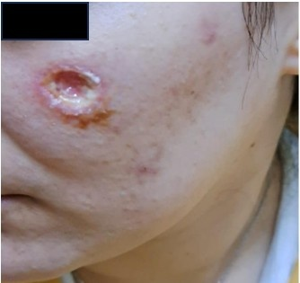
Figure 1: Baseline appearance of the facial scar before treatment.

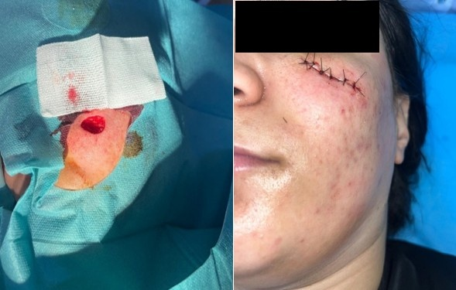
Figure 2: Surgical debridement and excision of the facial scar with immediate postoperative suturing.

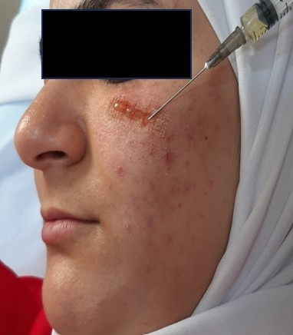
Figure 3: Erbium laser resurfacing combined with hyaluronic acid mesotherapy for facial scar.
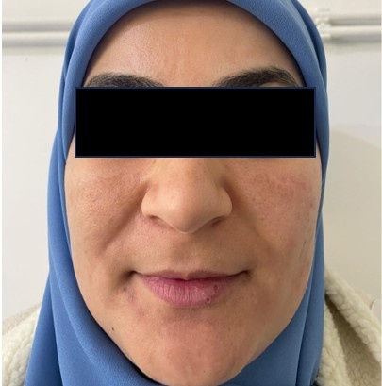
Figure 4: A noticeable improvement in scar appearance and texture at the end of the combined regenerative treatment with VSS decreased from 11 to 2.

3. Discussion

The skin is the most vulnerable organ, constantly exposed to potential injury. Chronic ulcerative scars are a rare but serious and devastating complication that can occur after ablative or fractional laser resurfacing of the skin (Schmidt et al. 2025),, particularly on the face, where the skin is thin and more susceptible to damage. This complication can arise from excessive thermal injury, delayed re-epithelialization, secondary infections, or abnormal wound healing, leading to prolonged ulceration, crusting, and eventual atrophic or hypertrophic scarring(Prohaska et al.2025). Most frequently in areas presenting with pruritus, prolonged erythema, and delayed healing that become hardened or red, moreover, various body regions tend to be more susceptible to scarring after resurfacing procedures, such as the cervicofacial area, and those with bony prominences, like the malar area(Costa,et al.2011). As can be noted, this is particularly relevant in our patient, where a chronic ulcerative scar is noticeable on the left cheek, a region with thin overlying skin and bony prominence, indicating its role in delaying healing and ulceration. Wound healing involves hemostasis, inflammation, proliferation, and remodeling (Magni et al. 2022). Treatment targets inflammation reduction, collagen remodeling, and physical scar modification, often requiring multimodal approaches(Elsaie et al. 2010). Debridement of necrotic tissue and fibrinous exudate is a key initial step in managing chronic ulcerative wounds, as it reduces bacterial load and prepares a viable bed for subsequent therapies (Manna et al. 2025). In selected cases, surgical scar revision with precise excision and layered suturing can achieve tension-free closure and improve aesthetic outcomes (Căiţă et al. 2024). Lasers are employed for remodeling scars with better results when initiated early[12] (Akl et al. 2025). The fractional ablative Erbium: YAG laser (2940 nm) promotes neocollagenesis and collagen remodeling through the creation of microthermal zones, followed by transepidermal elimination of debris (Yumeen et al. 2025). Red and near-infrared LED therapies (630–830 nm) enhance wound healing by photobiomodulation, stimulating the proliferation of fibroblasts, increasing type 1 collagen and MMP-9, decreasing MMP-1, stimulating angiogenesis, cytokine release (TNF-alpha, IL-1, IL-6), reducing reactive oxygen species ROS and interleukins (Ngoc et al. 2023). The association of the fractional Er: YAG laser with LED therapy was found to be more efficient and superior to the fractional Er: YAG laser alone (Osman et al., 2024). On the other hand, intradermal mesotherapy with hyaluronic acid provides hydration, anti-inflammatory effects, skin rejuvenation, and regeneration(Scarano et al. 2025). It is therefore an important tool for improving the pliability of scars.

4. Conclusion

Facial scarring is known to be a cause of considerable psychosocial distress and can negatively impact quality of life. The combination of intralesional hyaluronic acid injection, laser treatments, and LED in the early stage of wound healing has made a profound impact on improving scar aesthetic results. Larger cohort studies will be necessary to better validate its effectiveness and long-term safety.

References

- Osman MA, Samy NA, Jasim AS. (2024). Efficacy of fractional 2940-nm erbium:yag laser combined with platelet-rich plasma versus its combination with low-level laser therapy for scar revision. Journal of Clinical and Aesthetic Dermatology, 17(11), 39-44. PMID: 39758221
- Chowdhury B, Kassir M, Salas-Alanis J, Nistico S, Galadari H, Fritz K, et al. (2021). Laser in surgical scar clearance: an update review. Journal of Cosmetic Dermatology, 20(12), 3808–3811. https://doi.org/10.1111/jocd.14325

- Hsieh JC, Maisel-Campbell AL, Joshi CJ, Zielinski E, Galiano RD. (2021). Daily quality-of-life impact of scars: an interview-based foundational study of patient-reported themes. Plastic and Reconstructive Surgery Global Open, 9(4), e3522. doi: 10.1097/GOX.0000000000003522. PMID: 33868874
- El-Orabi RA, El-Hadidy MR, El-Sabbagh AH. (2022). Assessment and management of immature facial scars by non-surgical methods. Chinese Journal of Plastic and Reconstructive Surgery, 4(2), 67-73. https://doi.org/10.1016/j.cjprs.2022.06.004
- Schmidt TR, Mármora BC, Brochado FT, Gonçalves L, Campos PS, Lamers ML, et al. (2025). Red light-emitting diode on skin healing: an in vitro and in vivo experimental study. Anais Brasileiros de Dermatologia, 100(1), 54–62. https://doi.org/10.1016/j.abd.2024.02.008
- Prohaska J, Hohman MH. (2025). Laser complications. In: StatPearls [Internet]. Treasure Island (FL): StatPearls Publishing. PMID: 30335281
- Costa FB, El Ammar ABPC, Campos VB, et al. (2011). Complications in laser dermatologic surgery. Part II: fractional and non-fractional ablative laser and fractional non-ablative laser. Surgical and Cosmetic Dermatology, 3(2), 135-146.
- Magni G, Tatini F, Siena GD, Pavone FS, Alfieri D, Cicchi R, et al. (2022). Blue-led-light photobiomodulation of inflammatory responses and new tissue formation in mouse-skin wounds. Life (Basel), 12(10), 1564. https://doi.org/10.3390/life12101564
- Elsaie M, Choudhary S. (2010). Lasers for scars: a review and evidence-based appraisal. Journal of Drugs in Dermatology, 9(11), 1355–1362. PMID: 21061757
- Manna B, Nahirniak P, Morrison CA. (2025). Wound debridement. In: StatPearls [Internet]. Treasure Island (FL): StatPearls Publishing. PMID: 29939659
- Căiţă GA, Lascu CF, Bodog FD, Buhaş CL, Voiţă-Mekeres F, Voiţă GF. (2024). Surgical scar management - an evaluation of surgical techniques. Medicine and Pharmacy Reports, 97(2), 149–153. https://doi.org/10.15386/mpr-2701
- Akl J, El Hajj H, Jeha D, Habre M. (2025). A multimodal approach to the early treatment of a facial scar: a case report. Clinical Case Reports, 13(8), e70719. https://doi.org/10.1002/ccr3.70719Digital Object Identifier (DOI)
- Yumeen S, Hohman MH, Khan T. (2025). Laser erbium-yag resurfacing. In: StatPearls [Internet]. Treasure Island (FL): StatPearls Publishing. PMID: 32809766
- Ngoc LTN, Moon J, Lee Y. (2023). Utilization of light‐emitting diodes for skin therapy: systematic review and meta‐analysis. Photodermatology, Photoimmunology and Photomedicine, 39(4), 303–317.https://doi.org/10.1111/phpp.12841
- Scarano A, Qorri E, Sbarbati A, Gehrke SA, Marchetti M, Desiderio V, et al. (2025). Mesotherapy with hyaluronic acid solutions enriched by amino acids in the neck area: open-label uncontrolled, monocentric study. Journal of Cosmetic and Laser Therapy, 27(4–5), 121–126. https://doi.org/10.1080/14764172.2025.2502380

