Reticular alopecia areata associated with subclinical hyperthyroidism

Abstract
Background: Alopecia areata is an autoimmune disorder that affects a significant number of people worldwide, causing sudden and unpredictable hair loss in specific areas of the scalp or body. Among its clinical variants is reticular alopecia areata, a reticulated or network-like pattern that can progress to more severe forms. It also shares genetic and immunological etiology with autoimmune thyroid diseases. Clinical case: We describe the case of a 31-year-old male patient, Fitzpatrick skin phototype III/VI, with asymmetric dermatosis located on the bilateral scalp, characterized by multiple alopecia plaques with well-defined irregular borders of variable shapes and sizes, some of which converge and adopt a reticular distribution with smooth, shiny skin. The patient presented with decreased TSH and positive anti-TSH receptor antibody, with Graves-Basedow disease. Conclusions: It has been shown that the risk of autoimmune thyroid diseases is significantly higher in patients with severe and refractory cases of alopecia areata, so it is important to remember to evaluate thyroid function and perform antithyroid antibodies in patients with moderate to severe clinical variants such as reticular alopecia areata.
Keywords: Alopecia areata, hyperthyroidism, Graves' disease.

Background
Alopecia areata (AA) is an autoimmune disorder that affects a significant number of people worldwide, causing sudden and unpredictable hair loss in specific areas of the scalp or body.1 The condition is chronic, often leading to stress and anxiety in sufferers.2 Considered the second most common form of non-scarring alopecia, this condition not only has an emotional and psychological impact on individuals who suffer from it, but also poses significant challenges in terms of diagnosis and effective treatment.1,2
The disease has a prevalence of 1 in 1,000 and a lifetime incidence of 2% worldwide. Most patients are younger than 30 years, and only 20% are 40 years or older.2,3
The clinical manifestations of alopecia areata range from small, well-defined patches of hair loss to diffuse involvement of the scalp or hairy areas throughout the body. In 75% of cases, the alopecia lesions are located in monofocal or multifocal patches on the scalp. More specific but less common patterns are ophiasis (fronto-temporo-occipital band-like hair loss), sisaifo (opposite ophiasis, central hair loss resembling androgenetic alopecia), and reticular alopecia (active, stable, and resolving patches present simultaneously).3
Likewise, hair loss can be more extensive and affect eyelashes, eyebrows, and beards (alopecia totalis) or affect hair growth throughout the body (alopecia universalis). Quite rare conditions are perinevoid alopecia, patchy hair loss around a nevus, and acute diffuse total alopecia of the female scalp.4
Regarding its etiopathogenesis, genetic factors are included that determine a predisposition of the individual (as seen by the existence of certain HLA such as DQ3, DQ7, DR4 and DR11), a cellular type autoimmune response (CD4+ helper T lymphocytes) with loss of the immune privilege of the hair follicle, association with autoimmune diseases (such as thyroid diseases) and external triggering factors (psychological, stress, etc.).3
Alopecia areata is usually diagnosed based on clinical manifestations, but dermoscopy and histopathology may be helpful.4

Clinical case
This is a 31-year-old male patient, originally from Valencia, Venezuela, with no known medical history. The patient's current condition began five years ago when he began experiencing hair loss. He visited his doctor twice, with partial improvement. Treatment was subsequently discontinued, with a relapse three years later. Due to the persistence of the symptoms, he sought a dermatology consultation.
The physical examination presented skin phototype III/VI according to Fitzpatrick with a dermatosis located on the bilateral and asymmetric scalp characterized by multiple alopecia patches with well-defined irregular edges of variable shapes and sizes, some of which converge and adopt a reticular distribution with smooth and shiny skin (Figure 1). The rest of the physical examination was unalterable. Trichoscopy was performed, revealing exclamation point hairs, short hairs, blackheads, empty follicles, perifollicular erythema and vellus hairs (Figure 2).
A work plan was drawn up with the opening of a clinical history, a search for relevant background, photographic records (authorized by the patient) and paraclinical tests that reported a decrease in TSH (0.1 uIU/mL) and in view of subclinical hyperthyroidism, an anti-TSH receptor antibody was performed, which was positive (TRAb: 1.8 U/L), so the diagnosis of Graves-Basedow disease was raised.
A scalp biopsy was subsequently performed, revealing a histological slide stained with HE, which showed at 10x and 40x an epidermis with mild hyperkeratosis, irregular acanthosis, fibrosis in the papillary dermis and focally in the periphery of a hair follicle, as well as a scarce intrafollicular lymphocytic inflammatory infiltrate (Figure 3).
In view of clinical, dermatoscopic and histopathological findings, a diagnosis of moderate reticular alopecia areata was made with SALT:S2 scale (score: 33%).
The treatment plan was initiated with oral dexamethasone minipulses (0.1 mg/kg/day) for 2 consecutive days a week in combination with topical treatment of Clobetasol 0.05%, Tretinoin 0.025% and Minoxidil 5% daily. A follow-up at the fourth month showed hair regrowth with a decrease in the SALT scale from S2 (33%) to S1 (15.3%) (Figure 4).

Discussion
Alopecia areata is defined as a type of non-scarring telogene alopecia of autoimmune etiology characterized by the appearance of alopecia patches of various shapes (circumscribed, diffuse, or band-like) of variable size and number, with smooth, shiny, soft skin that preserves the follicular orifice without scarring; and on the periphery of the patch, normal or slightly shorter hair can be seen, often shaped like an exclamation mark (the distal end is wider than the proximal end). These patches are located on the scalp or other hairy areas of the body (beard, eyebrows, eyelashes, body hair, axillary hair, and pubic hair).1,5
The course of AA is unpredictable, though usually benign. With each episode of the disease, alopecia may remain active, spread, or resolve months or even years later. Although a minority of people with the disease experience a single episode, most have a chronic or chronic relapsing course.1
Regarding its epidemiology, it is one of the most common causes of hair loss due to inflammation, with a worldwide prevalence of 0.1%–0.2%. AA is estimated to account for 0.7%–3.8% of all clinical dermatological consultations, with no gender predilection; however, some reports indicate that it is more common in men with a estimated lifetime risk of developing AA of 1.7%.3,4
The exact pathogenesis has not been fully established; however, current evidence suggests that it is an autoimmune disease mediated by CD8 T cells due to the breakdown of immune privilege in hair follicles. The autoimmune etiology has also been supported by epidemiological studies evaluating the association between AA and several autoimmune diseases, including thyroid diseases, showing an association with thyroid dysfunction and the presence of antithyroid autoantibodies; for this reason, screening for thyroid dysfunction is sometimes recommended for patients with AA.6

Although the exact mechanism linking AA to thyroid diseases has not been fully elucidated, potential mechanisms, including shared genetic background and mutual inflammatory processes, may explain their association. First, several shared risk loci with other autoimmune diseases have been identified, particularly cytotoxic T lymphocyte-associated protein 1, interleukin (IL)-2/IL-21, IL-2RA, and genes critical for the maintenance of regulatory T cells. Furthermore, a genetic association of human leukocyte antigen genes with AA and thyroid autoimmunity has been demonstrated, with evidence showing that the frequency of the DRB1*15:01-DQB1*06:02 haplotype is significantly higher in AA patients with positive TSH receptor antibodies than in control subjects. 6,7
Second, previous studies have found that regulatory T cells (Tregs) in patients with autoimmune thyroid diseases are unable to down-modulate the autoimmune response and tissue damage, which could explain their autoimmunity, therefore an imbalance of Treg cells could be involved in the pathogenesis of AA.Besides,The early onset of AA marked by extensive hair loss and refractory disease is also considered a poor prognostic factor that may contribute to autoimmunity against the thyroid gland.6,7
Current diagnostic practice is clinical and based on a detailed clinical history and physical examination. Furthermore, the clinical manifestation of AA is characterized by diverse patterns of hair loss with varying extent. Therefore, a classification system was proposed grouping the most common presentations into focal, multifocal, ophiasic, sisaifo, reticular, diffuse, total, and universal alopecia areata, which can progress between these two categories.3
Reticular alopecia areata, on the other hand, is characterized by hair loss in a reticular or network-like pattern. Instead of presenting completely alopecic patches, as in other forms of alopecia areata, in reticular alopecia areata there are areas of normal hair interspersed with areas of hair loss, creating a network-like appearance. This pattern can make diagnosis more difficult, which is why the use of trichoscopy and histopathology is the necessary complement to allow greater diagnostic accuracy. Likewise, it is important to consider the differential diagnoses, as they bear clinical similarities to moth-eaten alopecia and trichotillomania.3,8
A wide variety of treatments have been used in the management of AA. Topical or intralesional therapies, including corticosteroids, anthralin, diphenylcyprone, and minoxidil, are primarily used in mild and less extensive cases. Extensive cases are more commonly treated with systemic medications, including oral corticosteroids or immunosuppressive agents such as methotrexate or azathioprine. More recently, Janus kinase inhibitors (JAKi) have emerged as alternatives for the treatment of severe cases, acting through intracellular disruption of the JAK-STAT pathway.
Given their accessibility and low cost, oral corticosteroids remain the preferred option for moderate to severe cases of alopecia areata. Although systemic corticosteroids have proven effective, their drawback lies in the presence of adverse effects with high doses. Therefore, minipulse therapy with oral dexamethasone (0.1 mg/kg/day) for two consecutive days a week could reduce the rate of adverse effects while maintaining treatment efficacy and allowing for an effective and safe therapeutic approach for patients with refractory AA compared to topical therapies.9,10

Conclusion
It has been shown that the risk of autoimmune thyroid diseases is significantly higher in patients with severe and refractory cases of alopecia areata, so it is important to remember to evaluate thyroid function and perform antithyroid antibodies in patients with moderate to severe clinical variants such as reticular alopecia areata.

References
- Lepe K, Syed HA, Zito PM. Alopecia Areata. In: StatPearls [Internet] [Internet]. StatPearls Publishing; 2024. Available in:https://www.ncbi.nlm.nih.gov/books/NBK537000/
- Alhanshali L, Buontempo MG, Lo Sicco KI, Shapiro J. Alopecia Areata: Burden of Disease, Approach to Treatment, and Current Unmet Needs. Clin Cosmet Investig Dermatol [Internet]. 2023 Mar 31;16:803-20. Available in:https://www.ncbi.nlm.nih.gov/pmc/articles/PMC10072216/
- Sterkens A, Lambert J, Bervoets A. Alopecia areata: a review on diagnosis, immunological etiopathogenesis and treatment options. Clin Exp Med. 2021;21(2):215-230. doi:10.1007/s10238-020-00673-w.
- Zhou C, Li X, Wang C, Zhang J. Alopecia Areata: an Update on Etiopathogenesis, Diagnosis, and Management. Clin Rev Allergy Immunol. 2021;61(3):403-423. doi:10.1007/s12016-021-08883-0.
- Galán-Gutiérrez M, Rodríguez-Bujaldón A, Moreno-Giménez JC. Therapeutic update on alopecia areata. Actas Dermosifiliogr [Internet]. 2009;100(4):266–76. Available from: https://linkinghub.elsevier.com/retrieve/pii/S0001731009708208.
- Dai YX, Tai YH, Chang YT, Chen TJ, Chen MH. Bidirectional association between alopecia areata and thyroid diseases: a nationwide population-based cohort study. Arch Dermatol Res. 2021 Jul;313(5):339-346. doi:10.1007/s00403-020-02109-7.
- Han TY, Lee JH, Noh TK, Choi MW, Yun JS, Lee KH, Bae JM. Alopecia areata and overt thyroid diseases: A nationwide population-based study. J Dermatol. 2018 Dec;45(12):1411-1417. doi:10.1111/1346-8138.14648.
- Lacueva Modrego L, Ferrando Barberá J. Alopecia: diagnostic, clinical, and therapeutic guidance. Med Integri [Internet]. 2000 [cited January 8, 2025];35(2):54–71. Available from:https://www.elsevier.es/es-revista-medicina-integral-63-articulo-alopecias-orientacion-diagnostica-clinica-terapeutica-15356.
- Sánchez-Díaz M, Montero-Vilchez T, Bueno-Rodriguez A, Molina-Leyva A, Arias-Santiago S. Alopecia Areata and Dexamethasone Mini-Pulse Therapy, A Prospective Cohort: Real World Evidence and Factors Related to Successful Response. J Clin Med. 2022 Mar 18;11(6):1694. doi:10.3390/jcm11061694.
- Ramírez V, Arrazola K. Alopecia areata universalis treated with oral dexamethasone pulses. Case report. DermatologiaCMQ. 2022;20(2):143-147.

Figure

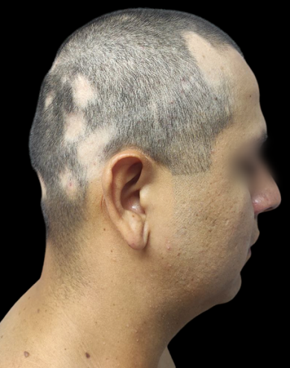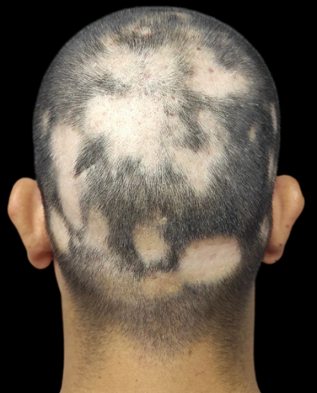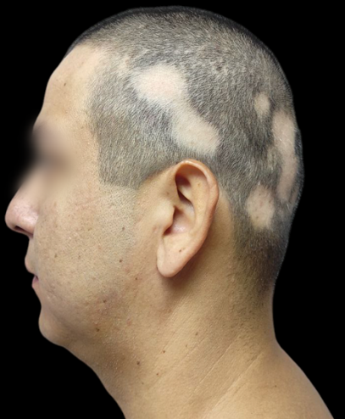
Figure 1: A bilateral, asymmetric dermatosis on the scalp characterized by multiple alopecia patches with well-defined, irregular borders of varying shapes and sizes, some of which converge and adopt a reticular distribution with smooth, shiny skin.

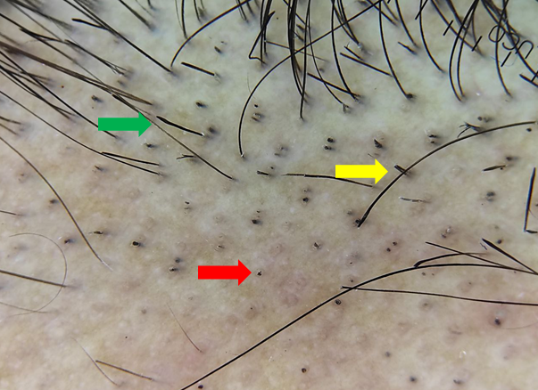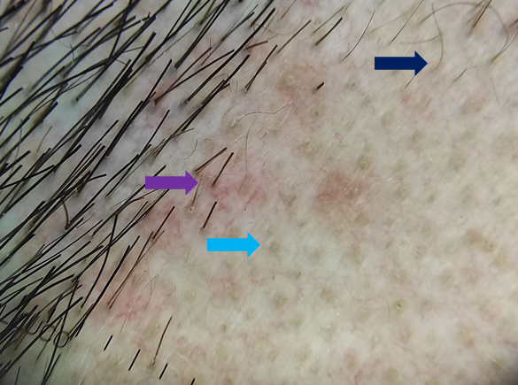
Figure 2: Trichoscopy reveals exclamation point hairs (green arrow), short hairs (yellow arrow), black dots (red arrow), empty follicles (light blue arrow), perifollicular erythema (purple arrow) and vellus hairs (dark blue arrow).
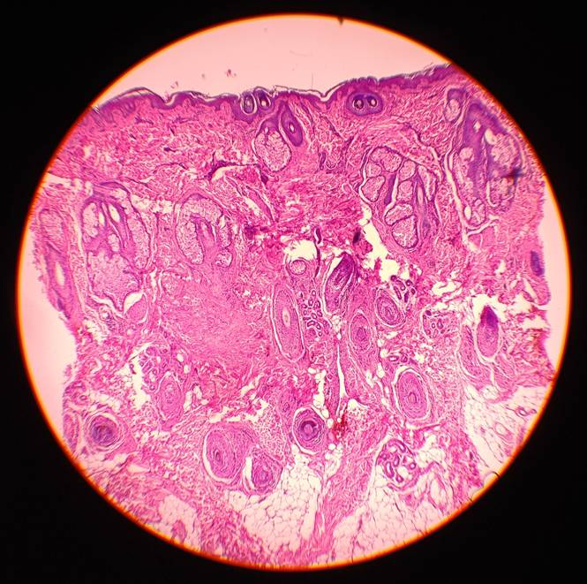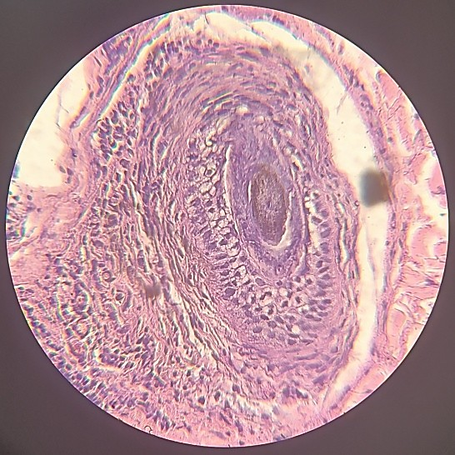
Figure 3: HE-stained slide showing at 10x and 40x epidermis with mild hyperkeratosis, irregular acanthosis, fibrosis in the papillary dermis and focally in the periphery of a hair follicle, as well as a scarce intrafollicular lymphocytic inflammatory infiltrate.
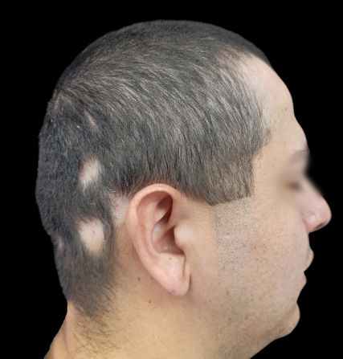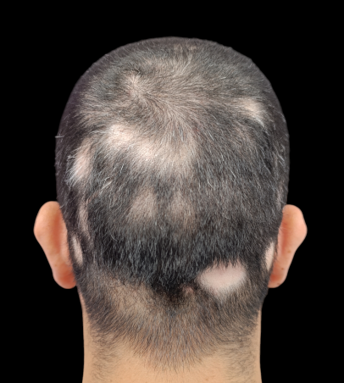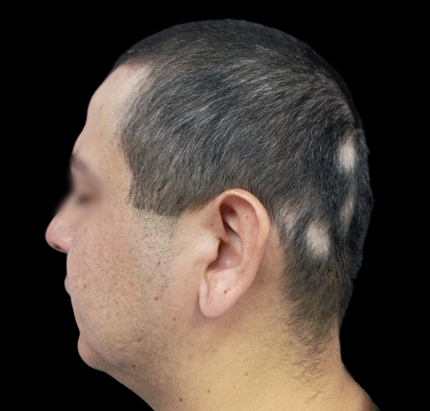
Figure 4: Evolution at 4 months of treatment showing hair regrowth with a decrease in the SALT scale from S2 (33%) to S1 (15.3%).

