Original Research Article
COMBINED EFFECTS OF EICHHORNIA CRASSIPES AQUEOUS EXTRACT AND ORGANIC MANURE ON ROOT GALL SEVERITY IN BEETROOT (BETA VULGARIS) IN TOGO

ABSTRACT
Plant-parasitic nematodes of the genus Meloidogyne represent a major constraint to beetroot production in Togo. This study, conducted at the Agronomic Experimental Station of the University of Lomé, aimed to evaluate the combined effectiveness of organic manure and aqueous extracts of water hyacinth (Eichhornia crassipes) in nematode management and yield improvement. The experiment was arranged in a split-plot design with nine treatments and three replications, combining three manure rates (0, 10, and 15 t/ha) and three formulations: Furadan, aqueous extract from the aerial parts, and aqueous extract from the submerged parts of water hyacinth.Results showed that organic manure and aqueous extracts enhanced nematode control and promoted plant growth. The combination of 15 t/ha organic manure with Furadan reduced soil nematode density by 60.69%. In roots, the greatest reduction (65.03%) was obtained with 15 t/ha manure combined with the submerged-part extract, lowering the mean nematode population to 5.01 individuals. This treatment also produced the highest root yield (54.25 t/ha). The lowest gall index (1.93) was recorded under the same treatment, corresponding to a 69.56% reduction in infestation compared with Furadan alone.
These findings indicate a synergistic effect between organic manure and water hyacinth extracts, particularly from submerged parts, highlighting their potential as a sustainable agroecological alternative to chemical nematicides for improving beetroot production.
Keywords: Beetroot, Plant-parasitic nematodes, Eichhornia crassipes, Organic manure, Sustainable management.

Introduction
Vegetable crops constitute a key component of food security and household income in West Africa. In Togo, they are widely cultivated in both rural and urban areas, with approximately 43 species distributed across 30 genera and 17 families (Kanda et al., 2014). Among these crops is beetroot (Beta vulgaris subsp. vulgaris), a root vegetable rich in carbohydrates and micronutrients, valued for its culinary versatility and nutritional properties. However, its production is severely constrained by plant-parasitic nematodes, particularly species of the genus Meloidogyne, which induce root galls that disrupt water and nutrient uptake, leading to general plant decline (Gohar et al., 2023; Hassan et al., 2024). Species of Meloidogyne are among the most widespread and destructive nematode pests of beetroot worldwide, significantly reducing yield and root quality (Gohar et al., 2023; Rady, 2021). Their broad host range, high reproductive capacity, and persistence in tropical soils make them formidable and enduring pests.To date, chemical control remains the primary management strategy adopted by farmers, relying on synthetic nematicides such as carbamates and methyl bromide. However, these compounds are costly, hazardous to human health and the environment, and increasingly restricted under international regulations (Gamliel et al., 1997; Regnault-Roger, 2002). In response to these limitations, research efforts are increasingly directed toward sustainable, affordable, and environmentally safe alternatives. The use of plant extracts with nematicidal properties represents a promising ecological strategy for managing plant-parasitic nematodes. Recent studies report that more than 200 plant species, particularly from the Fabaceae, Asteraceae, and Euphorbiaceae families, exhibit inhibitory effects on nematodes through the production of bioactive compounds such as alkaloids, flavonoids, fatty acids, and terpenoids (Ntalli & Caboni, 2012). These secondary metabolites interfere with the development, mobility, and reproduction of Meloidogyne species.Eichhornia crassipes, commonly known as water hyacinth, is an invasive aquatic plant widely recognized for its applications in composting, water purification, and biomass production (Lata & Dubey, 2010; Mailu, 2001). It contains phytochemicals with antimicrobial and antifungal activities and has demonstrated notable in vitro nematicidal effects (Umar & Mohammed, 2013; Atungwu et al., 2009). Furthermore, the application of organic amendments not only improves plant nutrition but also enhances the proliferation of antagonistic microorganisms such as Trichoderma harzianum, whose effectiveness against Meloidogyne incognita has been documented (Sharon et al., 2001; Feyisa et al., 2016).
In this context, the present study aimed to evaluate the combined effects of aqueous extracts of Eichhornia crassipes and organic manure on the reduction of root galling in beetroot in Togo, within an integrated, cost-effective, and sustainable nematode management framework.

Objectives

General Objective
To evaluate the combined effect of Eichhornia crassipes extract and organic manure on plant-parasitic nematodes and beetroot productivity.

Specific Objectives
- To quantify nematode populations in soil and roots before and after treatment application.
- To determine the effect of treatments on nematode-induced root gall formation.
- To assess beetroot productivity following the different treatments.

Materials and Methods

Experimental Site
The experiment was conducted at the Agronomic Experimental Station of the Higher School of Agronomy, University of Lomé (SEAL/ESA), located at 06°17′N and 001°21′E. The area is characterized by a tropical Guinean climate with annual rainfall ranging from 800 to 1200 mm. The soil is ferralitic, locally referred to as “terre de barre,” and exhibits the following chemical properties: 1.87% organic matter, 0.15% total nitrogen, 0.05% phosphorus (P₂O₅), 0.46% potassium (K₂O), and 0.01% magnesium (MgO). Exchangeable bases (mg/kg) include 51.1 Mg²⁺, 210.1 Ca²⁺, 148.8 K⁺, and 15.3 Na⁺. Soil pH was 6.8. The site is naturally infested with mixed nematode populations (Assih et al., 2018).

Plant Material and Inputs
Beetroot (Beta vulgaris subsp. vulgaris) seeds, cultivar CRIMSON GLOBE, certified at 99% purity and 80% germination rate, were obtained from Togo Semence. Water hyacinth (Eichhornia crassipes) plants were collected from the Bè lagoon (Lomé) for the preparation of aqueous extracts. The organic manure used (N > 1.5%, P₂O₅ 2.5%, K₂O 0.8%, organic matter 40%) was supplied by ENPRO. The chemical nematicide J-FURAN (carbofuran 3% G) was used as the chemical control.

Laboratory Equipment
A stereomicroscope and a manual hand counter were used for nematode observation and enumeration.

Experimental Design and Trial Management
The experiment was conducted during the major dry season of 2022–2023 using a split-plot design with nine treatments and three replications. Two factors were evaluated: organic manure (F0: 0 t/ha; F1: 10 t/ha; F2: 15 t/ha) and formulation type (aqueous extract from aerial parts, root extract, and J-FURAN). Main plots received the manure treatments, while subplots received the formulations. Each experimental unit measured 3 m × 1.2 m (3.6 m²). The aqueous extracts were applied at a rate of 30 ml per plant, starting on the 15th day after transplanting and repeated every 15 days for a total of four applications.

Preparation of Aqueous Extracts from Aerial and Submerged Parts of Water Hyacinth and Dilution
According to the modified method of Afouda et al. (2012), water hyacinth plants were collected, cleaned, and air-dried in the shade for 48 hours before being cut into approximately 1 cm pieces to facilitate grinding. For each plant part, 500 g of material was weighed and blended with 1000 ml of water using a kitchen blender to obtain a crude extract. The resulting extract was filtered through a fine cloth. To prepare the diluted solution, 500 ml of the crude extract was mixed with 1000 ml of distilled water, resulting in a 33.33% dilution.

Estimation of Nematode Population Densities
On each plot, three beetroot plants from the central row were randomly sampled. Washed, pooled, cut, and ground roots were used to extract nematodes from 5 g of sample using the crushing technique (Coyne et al., 2010). Soil samples were collected at a depth of 20 cm (Hooper et al., 2005), homogenized, and nematodes were extracted from 100 g of soil using the modified Baermann method (Coyne et al., 2010). Nematode densities were observed under a binocular microscope and expressed as the mean of three counts per sample (Kouakou et al., 2017; Tchabi et al., 2019) (Figure 1).

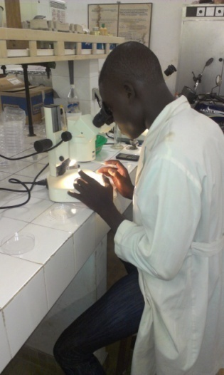
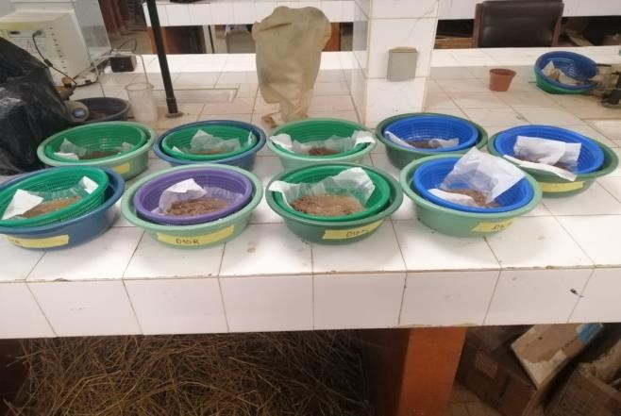

Figure 1: Setup of samples and nematode observation in the laboratory (August 2023)

Measured Parameters
The parameters evaluated included nematode densities in soil and roots, determined by manual counting in Petri dishes. The gall index was assessed using the Bridge and Page (1980) scale, ranging from 0 (no galls) to 10 (roots completely galled). Agro-morphological traits measured included the number of living leaves, as well as, at harvest, the total plant biomass (including leaves) and the tuber yield.
Yield was calculated using the following formula:
$$Yield (t/ha)=\frac{N × M/5}{{10}^{6}}$$ | M: The yield was determined based on the fresh weight of five plants per replication.  1/10⁶: To convert grams to metric tonnes:  N: The number of plants per hectare was 250,000, based on the planting scheme used in this study.

Statistical Analysis of Collected Data
All collected data were entered into Microsoft Excel and analyzed using SPSS (Statistical Package for the Social Sciences), version 21.1. Analysis of variance (ANOVA) was performed to compare the effects of factors and treatments. The Student-Newman-Keuls (SNK) test was applied at a 5% significance level to separate means within factors and treatments.

Results

Effects of Organic Manure Rates on the Mean Number of Nematodes Infesting Beetroot
The results (Figure 2) show a significant reduction in the mean nematode densities in both soil and beetroot roots with increasing rates of organic manure (P < 0.001). At 10 weeks after transplanting, the 15 t/ha rate resulted in a remarkable decrease in nematode populations: 69.73% in soil (10.22 nematodes) and 82.75% in roots (4.33 nematodes) compared with the unfertilized control. This rate also reduced the gall index to 1.32, representing an 81.46% reduction relative to the control (7.12).
Number of leaves

Fertilizer dose
Gall index
ROOTS
SOIL

Figure 2: Changes in the mean number of nematodes in soil and beetroot roots according to organic manure rate

Effects of Furadan- and Water Hyacinth–Based Formulations on the Mean Number of Nematodes Associated with Beetroot
Table 1 shows that Furadan- and water hyacinth–based formulations exerted differential effects on the mean number of nematodes in soil and roots at 10 weeks after transplanting. Furadan exhibited the highest efficacy in reducing soil nematode populations (11.22 nematodes), performing significantly better than extracts from the aerial (38.33 nematodes) and submerged parts (19.88 nematodes) of water hyacinth (P < 0.05).In roots, Furadan (11.22 nematodes) and the submerged-part extract (12.66 nematodes) showed comparable control efficiency, both being significantly more effective than the aerial-part extract (33.02 nematodes). Furadan also recorded the lowest gall index (2.19), indicating superior suppression of root galling.
Table 1: Effects of Furadan- and water hyacinth–based formulations on the mean number of nematodes associated with beetroot cultivation
Formulation Types | Average number of nematodes 10 weeks after transplanting |  | Gall index
Formulation Types | SOIL | ROOTS | Gall index
FURADAN | 11,22±1,38c | 11,22±1,21b | 2,19 ±1,45c
JACINTH (P/A) | 38,33±7,21a | 33,02±4,10a | 7,68 ±0,43a
JACINTH (P/Im) | 19,88±3,48b | 12,66±3,19b | 4,67 ±0,21b
F | 20,173 | 14,077 | 3,42
P | 0 | 0 | 0,004
Means within the same column followed by the same letters are not significantly different according to the Student–Newman–Keuls (SNK) test at the 5% level.

P/A = Aerial part; P/Im = Submerged part
F = F-value; P = p-value

Effects of Organic Manure Rate Combined with Furadan- and Water Hyacinth–Based Formulations on the Mean Number of Nematodes Associated with Beetroot
The results (Table 2) indicate that the combination of organic manure with Furadan- or Eichhornia crassipes–based formulations significantly affected the mean number of nematodes in both soil and beetroot roots (P < 0.001). The application of 15 t/ha of organic manure combined with Furadan resulted in the lowest mean soil nematode density (6.14 nematodes), corresponding to a 60.69% reduction compared with the unfertilized control.In roots, although a marked reduction was also observed with the treatment combining 15 t/ha manure and Furadan (5.16 nematodes), its effect was comparable to that obtained with 15 t/ha manure combined with the submerged-part extract of water hyacinth (5.01 nematodes). Notably, this latter combination represented a 65.03% reduction relative to the Furadan-only treatment.

Table 2: Effects of organic manure rate combined with Furadan- and water hyacinth–based formulations on the mean number of nematodes associated with beetroot cultivation
TREATMENTS | Densité moyenne des nématodes à 10 semaines*  SOIL ROOTS
D0FU (0t/ha+ FURADAN) | 15,62±2,33bc | 14,33±2,84bc
D0Ja.P/A (0t/ha+ JACINTH.P/A) | 65,66±4,33a | 57,66±6,00a
D0 Ja.P/Im (0t/ha+ JACINTH.P/Im) | 29,00±2,22b | 21,33±3,21b
D10FU (10t/ha+ FURADAN) | 12,00±1,00c | 10,00±1,52c
D10Ja.P/A (10t/ha+ JACINTH /A) | 14,53±3,78bc | 17,00±2,88bc
D10 Ja.P/Im (10t/ha+ JACINTH.P/Im) | 12,33±2,18c | 10,00±2,08c
D15FU (15t/ha+ FURADAN) | 6,14±1,12d | 5,16±0,66d
D15Ja.P/A (15t/ha+ JACINTH.P/A) | 13,21±1,76bc | 11,00±1,73c
D15 Ja.P/Im (15t/ha+ JACINTH.P/Im) | 11,33±2,60c | 5,01±0,88d
F | 15,014 | 33,619
P | <0,001 | <0,001
Means within the same column followed by the same letters are not significantly different according to the Student–Newman–Keuls (SNK) test at the 5% level.
P/A = Aerial part; P/Im = Submerged part
F = F-value; P = p-value

Effects of Organic Manure Rate Combined with Furadan- or Water Hyacinth–Based Formulations on the Gall Index of Beetroot Nematodes

The results presented in Figures 3 and 4 show that the combination of aqueous water hyacinth extracts or Furadan with higher rates of organic manure enhanced protection against nematode infestation in beetroot.The lowest gall index (1.93) was recorded with the application of 15 t/ha of organic manure combined with the aqueous extract from the submerged part of water hyacinth. This treatment reduced nematode infestation, as reflected by gall formation, by 69.56% compared with the control treatment receiving Furadan alone.

Figure 3: Changes in the gall index of beetroot nematodes according to the different manure rates and formulations applied
C
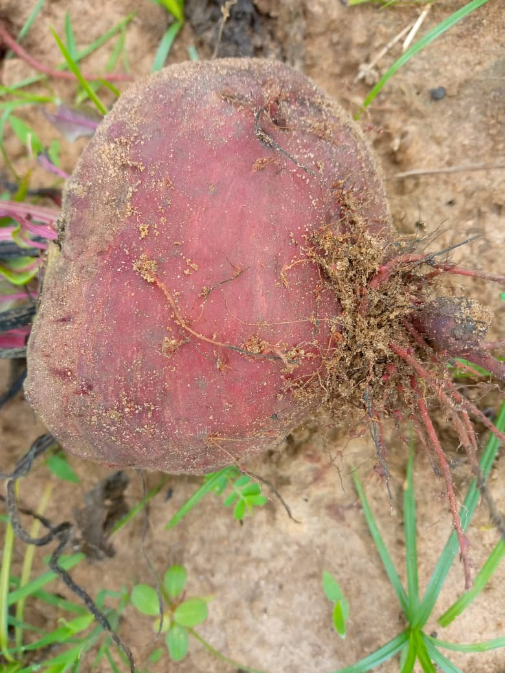

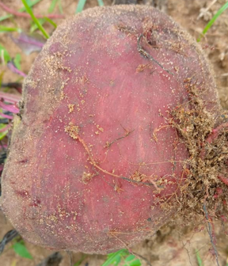
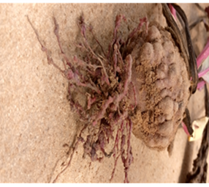

B

B
A

Figure 4: Effects of organic manure rate combined with Furadan- or water hyacinth–based formulations on the gall index of beetroot nematodes (October 2023)
A: D15 Ja.P/Im (15 t/ha + water hyacinth submerged-part extract)
B: D0FU (0 t/ha + Furadan)C: D15 Ja.P/Fu (15 t/ha + Furadan)

Effects of Organic Manure Combined with Furadan- or Water Hyacinth–Based Formulations on the Mean Number of Beetroot Leaves
The results (Figure 5) show the effect of the interaction between organic manure and Furadan- or water hyacinth–based formulations on the mean number of leaves per beetroot plant. Statistical analysis revealed a significant interaction between these factors on leaf development (P = 0.001). In general, increasing organic manure rates combined with the different formulations enhanced the mean leaf number. The combination of organic manure with the submerged-part aqueous extract of water hyacinth was particularly effective. At 15 t/ha, the D15 Ja.P/Im treatment produced the highest mean (14.13 leaves per plant), followed by D15 Ja.P/A (12.78 leaves) and D15 FU (12 leaves). At 10 t/ha, D10 Ja.P/Im (12.46 leaves) also outperformed Furadan alone (11.94 leaves). Unfertilized controls (D0) showed the lowest values: 10 leaves for Ja.P/Im, 9.33 for Furadan, and 9 for Ja.P/A.

Figure 5: Effects of organic manure combined with Furadan- or water hyacinth–based formulations on the number of beetroot leaves.
P/A = Aerial part; P/Im = Submerged part

Effects of Organic Manure Rates on Beetroot Root Yield
The results presented in Figure 6 show a significant increase in beetroot root yield with increasing rates of organic manure (P < 0.001). The lowest yield was recorded in the control (D0), without manure, at 17.21 t/ha. Application of 10 t/ha of manure resulted in an average yield of 35.15 t/ha, representing a 104.34% increase compared with the control. The highest yield was obtained with 15 t/ha, reaching 40.45 t/ha, corresponding to a 135.11% increase relative to the unfertilized treatment.

Figure 6: Effects of organic manure rates on beetroot root yield

Effects of Furadan- and Water Hyacinth–Based Formulations on Beetroot Root Yield
The results presented in Figure 7 show a notable variation in beetroot root yield depending on the formulation applied. Furadan alone (FU) produced an average yield of 28.83 t/ha, serving as the reference value in this study. Application of the aqueous extract from the aerial part of water hyacinth (P/A) resulted in a yield of 25.43 t/ha, slightly lower than Furadan, indicating no significant effect on root yield. In contrast, the submerged-part extract (P/Im) produced the highest yield, 38.54 t/ha, corresponding to a 33.75% increase compared with the Furadan-only treatment.
Root yield (t/ha)
Figure 7: Effects of Furadan- and water hyacinth–based formulations on beetroot root yield

Effects of Organic Manure Combined with Furadan- or Water Hyacinth–Based Formulations on Beetroot Root Yield

The results presented in Table 3 show that combining organic manure with Furadan- or water hyacinth–based formulations had a highly significant effect on beetroot root yield (P = 0.003). The lowest yields were observed in treatments without organic manure (0 t/ha), particularly with the aerial-part extract of water hyacinth (D0 Ja.P/A, 9.43 t/ha), which was markedly lower than Furadan alone (D0 FU, 17.86 t/ha) and the submerged-part extract (D0 Ja.P/Im, 24.35 t/ha).Applying 10 t/ha of manure significantly increased yields across all treatments (33.68–37.03 t/ha). The highest yield was achieved with 15 t/ha combined with the submerged-part extract (D15 Ja.P/Im), reaching 54.25 t/ha a 203.8% increase compared with the control (D0 FU). This yield was significantly higher than other 15 t/ha combinations, including D15 FU (33.91 t/ha) and D15 Ja.P/A (33.2 t/ha).

Table 3: Effects of organic manure combined with Furadan- or water hyacinth-based formulations on beetroot root yield
Treatments | Root Yield (t/ha)
D0FU (0t/ha+ FURADAN) | 17,86±5,54c
D0Ja.P/A (0t/ha+ JACINTH.P/A) | 9,43±8,14c
D0 Ja.P/Im (0t/ha+ JACINTH.P/Im) | 24,35±4,53bc
D10FU (10t/ha+ FURADAN) | 34,73±3,84b
D10Ja.P/A (10t/ha+ JACINTH /A) | 33,68±7,19b
D10 Ja.P/Im (10t/ha+ JACINTH.P/Im) | 37,03±4,91ab
D15FU (15t/ha+ FURADAN) | 33,91±7,96b
D15Ja.P/A (15t/ha+ JACINTH.P/A) | 33,2±7,77b
D15 Ja.P/Im (15t/ha+ JACINTH.P/Im) | 54,25±2,34a
F | 5,152
P | 0,003
Means within the same column followed by the same letters are not significantly different according to the Student–Newman–Keuls (SNK) test at the 5% level.
P/A = Aerial part; P/Im = Submerged part
F = F-value; P = p-value

Discussion
The results of this study indicate that organic fertilization and formulations based on Eichhornia crassipes extracts or Furadan significantly influence nematode density, galling index, leaf development, and beetroot root yield. These findings support the growing interest in alternative and environmentally sustainable approaches for managing plant-parasitic nematodes, aligning with the principles of agroecology and integrated pest management (Oka, 2010; Gebrehiwot et al., 2022).

Effects of Organic Manure on Nematodes and Galling Index
Application of organic manure significantly reduced nematode populations in both soil and roots, with efficacy increasing with higher doses. At 15 t/ha, nematode density decreased by 69.73% in soil and 82.75% in roots, accompanied by a notable reduction in the galling index (1.32), representing an 81.46% decrease compared with the control. These findings are consistent with Devi and Das (1998) and Assih et al. (2018), who reported that organic amendments reduce Meloidogyne spp. infestation through gradual release of bioactive compounds (volatile fatty acids, phenols) and stimulation of antagonistic microflora (Arancon et al., 2006). Organic amendments also improve soil structure, enhance water retention, and promote biological interactions unfavorable to nematodes (Oka, 2010; Stevenson, 1999).

Effects of Furadan- and Water Hyacinth–Based Formulations
The aqueous extract from the submerged part of water hyacinth (P/Im) proved more effective than that from the aerial part (P/A), significantly reducing nematode density in roots with efficacy comparable to Furadan. This superior performance may be attributed to higher concentrations of secondary metabolites in the submerged tissues, including flavonoids, saponins, tannins, and phenols, known for their nematicidal and antifungal properties (Adeleke & Babalola, 2020). In vitro studies have shown that crude water hyacinth extracts can cause up to 100% mortality of Meloidogyne incognita juveniles (Umar & Mohammed, 2013; Atungwu et al., 2009).
Carbofuran (marketed as Furadan) is recognized for its high effectiveness against soil pests but is also highly toxic to the environment due to persistence and potential contamination of soil and water (Ariffin & Abdul Rahman, 2018; Zafar et al., 2022). In contrast, the use of plant extracts or organic amendments as plant protection solutions offers ecological and sustainable advantages, reducing risks associated with chemical residues in soil and the environment while contributing to crop protection.

Synergistic Effects of Organic Fertilizer and Formulations
The combination of organic fertilizer with water hyacinth-based formulations, particularly the submerged part (P/Im), produced significant synergistic effects. This approach not only controlled nematode populations but also enhanced foliar development and root yield. For instance, the 15 t/ha dose combined with the submerged extract (D15 Ja.P/Im) achieved a record root yield of 54.25 t/ha a 203.8% increase compared to the Furadan-only control without fertilizer and reduced root nematode density by 65.03%.
These findings indicate that vegetative growth stimulation by organic amendments and plant extracts improves plant resistance to biotic stress. The increased mean number of leaves observed with D15 Ja.P/Im (14.13 leaves/plant) reflects enhanced aboveground biomass, consistent with Stevenson (1999) and Tchaniley et al. (2020), who reported that nitrogenous organic inputs stimulate vegetative growth and photosynthesis. Furthermore, Tigoun (2021) demonstrated that water hyacinth extracts can function as biofertilizers, improving nutrient availability and activating plant natural defenses.

Conclusion
This study aimed to evaluate the effectiveness of combining organic fertilizer with aqueous extracts of water hyacinth (Eichhornia crassipes) in reducing phytoparasitic nematode populations and improving sugar beet productivity in Togo. The results demonstrated that the use of organic fertilizer, combined with either Furadan or water hyacinth extracts particularly from the submerged part provides an effective and sustainable strategy for nematode management and crop improvement.Increasing doses of organic fertilizer significantly reduced mean nematode numbers in soil and roots, as well as the galling index, while promoting foliar growth and root yield, with the maximum effect observed at 15 t/ha. The combination of 15 t/ha fertilizer with Furadan produced the greatest reduction in soil nematodes (6.14 nematodes), representing a 60.69% decrease compared to the unfertilized control. In roots, the combination of 15 t/ha fertilizer with the submerged water hyacinth extract was most effective, reducing mean nematode numbers to 5.01a 65.03% reduction relative to the Furadan-only control.Regarding yield, 15 t/ha fertilizer combined with the submerged extract achieved the highest root yield of 54.25 t/ha, surpassing all other treatments, whereas fertilizer alone or aerial-part extracts produced lower yields. The observed synergistic effect on leaf number and root biomass confirms that this strategy optimizes both nematode protection and overall plant development.These findings highlight the potential of water hyacinth aqueous extracts, particularly from the submerged part, as a promising agroecological alternative to chemical nematicides. Future research should focus on optimizing doses, identifying active compounds, and integrating them into various cropping systems for sustainable, large-scale adoption

Competing Interests
The authors declare that they have no competing financial or personal interests that could have influenced the work reported in this study.

References
Adeleke, B. S., et Babalola, O. O. (2020). Oilseed crop sunflower (Helianthus annuus) as a source of food: Nutritional and health benefits. Food Science et Nutrition, 8(9), 4666-4684.
Afouda, L., Baimey, H., Bachabi, F. X., Sero-Kpera, D. H., et Balogoun, R. (2012Effect of Hyptis (Hyptis suaveolens), Neem (Azadirachta indica), Vernonia (Vernonia amygdalina), and Amaranth (Amaranthus sp.) on root-knot nematodes (Meloidogyne spp.) in vegetable crops. Agronomie Africaine, 24(3).
Arancon, N. Q., Edwards, C. A., Lee, S., et Byrne, R. (2006). Effects of humic acids from vermicomposts on plant growth. European journal of soil biology, 42, S65-S69. https://doi.org/10.1016/j.ejsobi.2006.06.004
Ariffin, F., et Rahman, S. A. (2020). Biodegradation of carbofuran: a review. Journal of Environmental Microbiology and Toxicology, 8(1), 50–57.
Assih Alèdi., Amen, Nenonene. Y., Atti, T., Rodrigue, F. K., et Pikassalé, A. K.(2018). Effets de la fertilisation sur les nématodes parasites et le rendement en rhizomes frais du gingembre, Zingiber officinale Rosc. URL:http://dx.doi.org/10.19044/esj.2018.v14n24p216
Atungwu, JJ, Ademola, AA et Aiyelaagbe, IOO (2009). Evaluation of organic materials for inhibiting nematode reproduction in soybean. African Journal of Crop Science, 17(4). https://doi.org/10.4314/acsj.v17i4.54292
Bridge, J., et Page, S. L. J. (1980). Estimation of root-knot nematode infestation levels on roots using a rating chart. International journal of pest management, 26(3), 296-298. https://doi.org/10.1080/09670878009414416
Coyne, D. L., Nicol, J. M., et Claudius-Cole, B. (2010). Plant Nematodes: A Practical Guide to Field and Laboratory Techniques.
Devi, G., et Das, P. (1998). Effect of different organic amendments for the management of root-knot nematode, Meloidogyne Incognita on carrot. Indian Journal of Nematology, 28(2), 203-207.
Feyisa, B., Lencho, A., Selvaraj, T., et Getaneh, G. (2016). Evaluation of some botanicals and Trichoderma harzianum against root-knot nematode (Meloidogyne incognita (Kofoid & White) Chitwood) in tomato. Journal of Entomology and Nematology, 8(2), 11–18. https://doi.org/10.4172/2329-8863.1000201
Gamliel, A., Grinstein, A., et Katan, J. (1997). Improved technologies for reducing methyl bromide emissions from fumigated soils. Phytoparasitica, 25, S21–S30. https://doi.org/10.1007/BF02980328
Gebrehiwot, H., Dekebo, A., et Annisa, M. E. (2022). Chemical composition, pharmacological activities and biofuel production of Eichhornia crassipes (water hyacinth): a review. Journal of the Turkish Chemical Society Section A: Chemistry, 9(3), 849-866. DOI: https://doi.org/10.18596/jotcsa.
Gohar, I. M., Alyamani, A., Shafi, M. E., Mohamed, E. A., Ghareeb, R. Y., Desoky, E. M., ... et Elnahal, A. S. (2023). A quantitative and qualitative assessment of sugar beet genotype resistance to root-knot nematode, Meloidogyne incognita. Frontiers in plant science, 13, 966377.
Hassan, M. H., Khattab, S. A., Gohar, I., et El-Sharnoby, H. M. (2024). Ecofriendly management approaches for sugar beet root-knot nematodes Meloidogyne spp. by seed treatment with bio-origin compounds and Oxamyl. Egyptian Sugar Journal, 22(22), 19-33.
Hooper, D. J., Hallmann, J., et Subbotin, S. A. (2005). Methods for extraction, processing and detection of plant and soil nematodes. In Plant parasitic nematodes in subtropical and tropical agriculture (pp. 53-86). Wallingford UK: CABI Publishing. https://doi.org/10.1079/9780851997278.0053
Kanda, M., Akpavi, S., Wala, K., Djaneye-Boundjou, G., et Akpagana, K. (2014). Diversité des espèces cultivées et contraintes à la production en agriculture maraîchère au Togo. International Journal of Biological and Chemical Sciences, 8(1), 115-127. https://doi.org/10.4314/ijbcs.v8i1.11
Kouakou, YYFR, Kra, KD, Assiri, KP, et Diallo, HA (2017). Efficacité nématicide de produits issus de feuilles séchées de ricin (Ricinus communis L.) sur Meloidogyne et Pratylenchus, nématodes pathogènes de l'igname en Côte d'Ivoire. Revue internationale d'agronomie et de recherche agricole , 11 (5), 57-68.
Lata, N., et Dubey, V. (2010). Criblage phytochimique préliminaire d'Eichhornia crassipes : la pire mauvaise herbe aquatique au monde. Journal of pharmacy Research , 3 (6), 1240-1242.
Mailu, A. M. (2001). Preliminary assessment of the social, economic and environmental impacts of Water Hyacinth in Lake Victoria basin and status of control.
Ntalli, N. G., et Caboni, P. (2012). Botanical nematicides: a review. Journal of agricultural and food chemistry, 60(40), 9929-9940.
Oka, Y. (2010). Mécanismes de suppression des nématodes par les amendements organiques du sol – une revue. Applied Soil Ecology , 44 (2), 101-115. https://doi.org/10.1016/j.apsoil.2009.11.003
Rady, G. H. (2021). Evaluation of some root-knot nematode management strategies in sugarbeet fields at West Nubaryia district. Annals of Agricultural Science, Moshtohor, 59(5), 617-630.
Regnault-Roger, C. (2002). Philogène, B.J.R., Regnault-Roger, C., & Vincent, C. (2012). New plant-derived phyto-insecticides for the third millennium. In Plant-derived biopesticides (pp. 19–39). Paris: Lavoisier – Tec & Doc. https://doi.org/10.4236/ojots.2012.24009
Sharon, E., Bar-Eyal, M., Chet, I., Herrera-Estrella, A., Kleifeld, O., et Spiegel, Y. (2001). Biological control of the root-knot nematode Meloidogyne javanica by Trichoderma harzianum. Phytopathology, 91(7), 687-693. https://doi.org/10.1094/PHYTO.2001.91.7.687
Stevenson, F. J., et Cole, M. A. (1999). Cycles of soils: carbon, nitrogen, phosphorus, sulfur, micronutrients. John Wiley et Sons.
Tchabi, A., Sokame, BM, Agboka, K., Tounou, AK, et Penoukou, E. (2019). Sélection de champignons mycorhiziens arbusculaires indigènes pour favoriser le rendement de Solanum macrocarpon L. et la suppression de Meloidogyne Spp. en conditions de terrain. J. Pharm. Chem. Biol. Sci , 6 (4), 282-291.
Tchaniley, L., Ayisah, K. D., et Kassa, K. A. D. (2020). Effet de la combinaison des fertilisants organiques et minéraux (NPK 15-15-15 et urée) sur le rendement de la laitue (Lactuca sativa L.) dans le sud du Togo: Effect of the combination of organic and mineral fertilizers (NPK 15-15-15 and urea) on the yield of lettuce (Lactuca sativa L.) in southern Togo. Journal of Applied Biosciences, 151(1), 15540-15549. https://doi.org/10.35759/JABs.151.3
Tigoun, A. E. (2021). Détermination de la dose optimale des composts à base de jacinthe d'eau pour la production de légumes feuilles sur sol ferralitique au Sud-Bénin.
Umar, I., et Mohammed, B. A. (2013). Effect of Water Hyacinth (Eichhornia Crassipes (Mart) Solms Leaf Extract on the Juvenile Mortality of Meloidogyne Incognita. IOSR Journal of Agriculture and Veterinary Science, 4, 46-48. https://doi.org/10.9790/2380-0424648 office.scicell.org+8
Zafar, M. I., Khalid, A., Kali, S., Khan, F., Tahir, M., Ali, M., et Siddiqa, A. (2022). Organic amendments as an ecofriendly substitute of carbofuran for the suppression of nematodes associated with Malus pumila. South African Journal of Botany, 144, 187-193.

