6G-Enabled IoT: Emerging Communication Technologies, AI Integration, and Future Research Directions

Abstract
The development speed of IoT applications has brought with it ultra-low delay, high reliability, large scale access and energy saving needs. 5G makes massive IoT possible, but new use cases like autonomous systems, XR, Industry 4.0 and smart cities are beyond what our networks can support today. 6G will solve these problems by leveraging advanced technologies, such as THz communication (TC), RIS, massive MIMO (mMIMO), ultra-dense networks (UDNs) and integrated space–air–ground link. In this paper, we provide a comprehensive cross-layer perspective on 6G-based IoT solutions by combining AI intelligence, network slicing, URLLC support and secure architecture with sustainable communication solutions. Open issues and future research directions towards IMT-2030 are presented.

Keywords
Internet of Things (IoT), Sixth-Generation Networks (6G), Artificial Intelligence (AI), Massive MIMO, Ultra-Dense Networks (UDN), Quality of Service (QoS)
- Introduction
The Internet of Things (IoT) is rapidly gaining significance as the fundamental technology behind innovative new applications that span many industries. For such applications, our work requires a heterogeneous mix of technologies to address common requirements, which are: extremely low latency and high reliability in communication; massive connectivity; dynamic traffic patterns; maximum energy efficiency; as well as suitability for mobile and simple devices [1]. For example, 6th generation (6G) wireless networks will transform the performance of current IoT applications and emerging IoT paradigms. While the technology for 6G is still in its infancy, various communication technologies are being developed to cope with these high requirements [2]. In addition, due to the generation of terahertz technology it is feasible that there could be high speed communication at short distances, which is also very appealing for IoT networks. The environment can be incorporated into the communication system by reconfigurable/metasurfaces and smart interfaces, which leads to better resource allocation and broader communication coverage. By applying heavy MIMO and UD networks we could achieve better performance in terms of reliability and throughput. Hybrid wireless designs can also offer redundant communication channels and prolong the battery lifetime by supporting visible light communication (VLC) in parallel with low frequency (LF) communication. These are combined with artificial intelligence (AI) and edge computing to enable more efficient computing power management within the IoT space[3]. The overall enabling technologies and future roadmap of 6G-IoT are illustrated in Figure 1 Security, privacy and trust are fundamental challenges in many of IoT applications. As one example, in federated learning on IoT devices, data is an authenticatable device without moving the data among the devices (the data are trained by a global AI model). Privacy-protecting data economy models enable the anonymisation of data without losing information required for value creation. Trust and policies such as risk management are the essence of preventing nefarious attackers from gaining entry. While both 5G URLLC and ultra-low-latency switching mechanisms aim to ensure the reliability, latency, and QoS of mobile and vehicular IoT communications. New energy harvesting solution, ultra-low power, batteryless and backscattered IoT communications and biomimetic green prototyping are some of the examples for physically inspired energy efficient solutions. [4] The vision of 6G envisages that by 2030, the world will have around 30 billion devices and approximately 2 billion of them would be operating in smart cities[5]. Population and data volume will grow further as individual consumption increases[6]. Bandwidth shortages in the radio frequency domain will induce technology migration toward higher bands and hybrid communication systems such as optical, radio frequency (RF), terahertz (THz)-band communications. 6G will revolutionize the way IoT services are provided[7].
The remainder of this paper is organized as follows. Section II reviews the related work and identifies existing research gaps. Section III presents the research methodology. Section IV discusses emerging communication technologies for IoT in 6G networks. Section V explores the role of artificial intelligence and edge intelligence in 6G-enabled IoT systems. Section VI addresses security, privacy, and trust challenges in 6G IoT environments. Section VII examines reliability, ultra-low latency, and mobility management mechanisms in 6G-enabled IoT systems. Section VIII presents energy harvesting techniques and green protocol design. Section IX highlights key applications of IoT over 6G networks. Finally, Section X discusses open challenges and future research directions.
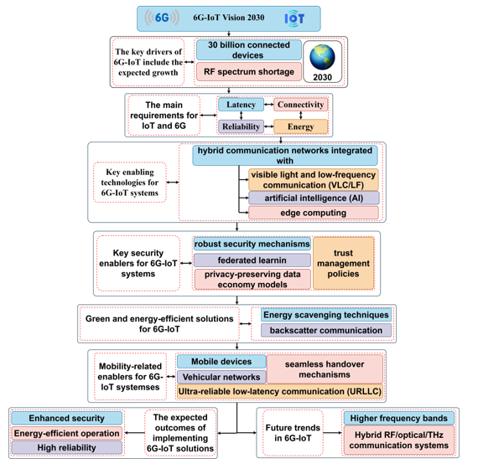
Figure 1. 6G-IoT: Enabling Technologies & Future Roadmap
1.2 Evolution from 5G to 6G
The overpass spanning 5G to 6G signifies transformation from higher connection speed-oriented architecture to intelligent, autonomous and completely integrated communication environment Figure 2. In contrast to 5G where achievements and technologies were focused on enhanced mobile broadband (eMBB), ultra-reliable low-latency communication (URLLC) and massive machine-like communication (mMTC), future applications such as holographic telepresence, digital twins, tactile internet and huge AI based IoT systems require superior functionalities beyond the architectural design points of 5G. 1 ms) latency, ultra-high reliability above 99.99999% of availability and global coverage through the convergence of terrestrial networks, airborne vehicles, low-earth orbit satellites (LEO), geostationary satellites (GEO), they support maritime traffic as well [8].
A significant paradigm change here is from AI-aided optimization in 5G to AI-native ubiquitous network design in 6G, where intelligence is integrated at all protocol layers which results into self-optimizing, self-healing and context-aware communication systems[9]. Moreover, 6G will also exploit spectrum in the terahertz (THz) bands which provides an enormous bandwidth but is also introducing new propagation and hardware challenges with a corresponding need for effective beamforming schemes, intelligent reflecting surfaces and novel materials[10]. From an architectural point of view, the 6G is expected to be completely distributed, edge-native and cell-free with sensing, computation and semantic communications deeply integrated into it. Energy efficiency is an optimization objective in 5G, while sustainability becomes a design principle of its own right in 6G with the emergence of green communication technologies, energy harvesting schemes and carbon-aware network management[11]. Thus, 6G is not just the next natural step after 5G in terms of speed and capacity improvement, but significantly reshapes the paradigm of wireless systems to intelligent, ubiquitous, and sustainable digital infrastructures that can support the rise of cyber– physical–human interactions.
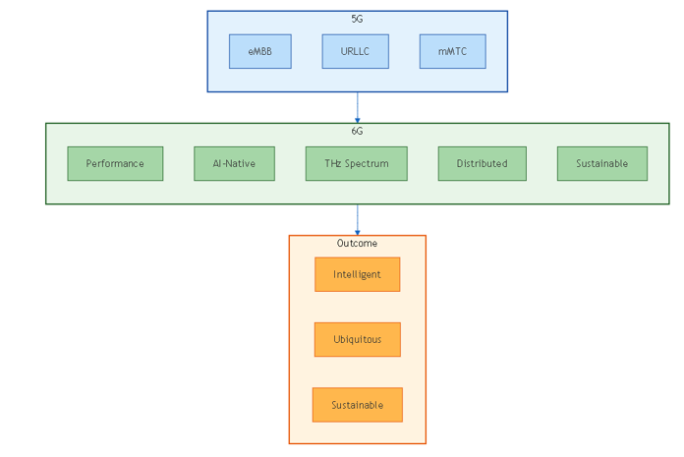
Figure 2. The 5G–6G Evolution: From Connectivity to Intelligence

- Related work
The sixth generation (6G) wireless communications system is expected to be the next revolutionary leap that will comprehensively facilitate a variety of emerging applications related to increasingly extending Internet of Things (IoT)[12]. Fast development and increasing requirement for higher degree of automation drive the need for ubiquitous, high-c capacity networks supporting ultra-reliable low-latency communication (URLLC) also efficient-supporting machine-type communications (MTC). Novelties such as the development of intelligent transport systems (ITSs), advanced vehicular networks, the modern smart cities built for urban mobility, and complete industry Internet serving Industry 4.0 applications are just some examples. The general target of 6G is to offer varied services that contain not only high capacity-content delivery, but also intelligent network orchestration and a sophisticated network slicing which is dedicated for promising applications with high revenue. An in-depth analysis of the basic technological enablers has been carried out to recognize which key technologies are expected to be crucial for the development of next-generation communication systems and service supporting at 6G age, with great emphasis on huge demand due to its extensive requirements by IoT that transforms diversely sectors and fosters innovative mobile communication.
Despite next-generation communication systems being deployed with Internet of Things (IoT) connectivity as the primary focus for interoperability in traditional cyber–physical scenarios with interaction between humans and physical objects at the level of machine-learning, 6G networks will pave the way to a cyber–cyber–physical approach that positions intelligence together with information and knowledge as an indispensable constituent for IoT communications: where layers in cloud–cyber agents are combined within these ends, socializing based on shared natural learning capabilities inherent within both data, information, and knowledge resources that interconnect via Internet[13]. IoT of the traditional definition in which only machine machines can be interconnected to network will not for so long belong only to IoT category; thus, a more generalized approach related with IoT is being envisaged, widening still more 6G/IoT. The 6G network will transform into fully flexible and self-evolving, decidable learning and self-configuring networks. Time information provisioning and control are the other key elements in 6G IoT architecture, as time domain was largely missing for 5G and former communication systems and not well served for general IoT applications despite fact that for many machines highly precise time is demanded to ensure high precision operation[14]. A large number of machines that are already networked via different access technologies want and gain highly precise time reference and time control for timing, synchronization and pay-load transfer On Trigger Enter(A).
Production architecture of IoT connectivity is also not yet available, and the appropriate handling about transportation of time superimposed to the regular space-time-effort-and intelligence based information for future IoT systems has not been fully explained. Motivated by this, the concept of when-IoT is introduced that explains the scenario where time and its control provisioning are essential; we propose a joint-charge model which includes space-time domain as well as fifth dimension termed cyber/machine interaction (CMI) smart-A-B-C hole for intelligence-information-knowledge envisaged charges[15]. It is important to set the quality of service (QoS) from an end user’s point of view, and also to clearly state and classify the sustainable, resilient, flexible, universal service provision time. In addition, the QoS broadens communication service domain beyond demand-side IoT to supply-side IoT by providing essential services of IoT, such as energy supply and ultimate water drought feeding and dry food provisioning by the IoT connected resource-centric regulators through them transmission mechanisms that are capable of transporting IEEE 802. 15. 4 IoT divided supply-side communication ( [16][17]).
The continuous development of 6G networks are to meet the requirements of Internet-of-Things (IoT) applications with key performance indicators beyond what may be achieved using current 5G technologies, such as ultra-reliable low-latency communications (URLLC), high-energy efficiency even for battery-free devices in long-term deployments and massive connectivity for tightly placed devices in factories and homes. 6G is predicted to bring about further growth areas, which will include improved mixed-reality experiences that incorporate volumetric video, spatial audio, haptics and autonomous systems (involving drone-to-drone communication, ground- robot communication and vehicleto-vehicle communication[18]). These new and (or) complementary KPIs are suggested including the Average Data Rate, Nominal Throughput, Area Traffic Capacity and even specific indicators like Quality of Experience, degree of freedom or amount of information Table 1. The high data-rate demands, also characterized as the performance requirement initially designed for eMBB, are still challenging 6G IoT for applications like AR/VR/XR and these works can be integrated with communication and monitoring/control capabilities in 6G IoT. Maturity of the volumetric video communication is a new turning point in Ubiquitous Ultra HD, and transmission interactive volumetric video over partial streaming also affects IoT with immersive MR experience. Further, multi-user collaborative AR/VR/XR based on UHD multiplayer volumetric video and multi-finger haptics raise the requirement of 6G in communication [19].

Table 1 Comparative Analysis of Existing Surveys on 6G-Enabled IoT
Ref. | Focus  Area | Communication Technologies | AI Integration | Security & Privacy | QoS / URLLC | Energy Sustainability | Limitations
[20]  [21] | THz Communications | ✔ THz | ✖ | ✖ | Limited | ✖ | Focuses mainly on PHY-layer aspects
[22] [23] | RIS & Smart Radio | ✔ RIS | Partial | ✖ | Limited | ✖ | Lacks IoT scalability analysis
[24] [25] | Massive MIMO & UDN | ✔ Massive MIMO | ✖ | ✖ | Partial | ✖ | Focused on broadband users
[26] [2] | AI for 6G | Partial | ✔ Federated & Edge AI | Limited | Partial | ✖ | Does not integrate energy or trust
[27] [28] | Network Slicing | Partial | ✔ AI-based slicing | ✖ | ✔ | ✖ | Mainly 5G-oriented frameworks
[29]  [30] | Security & Trust | ✖ | Partial | ✔ | ✖ | ✖ | High-level frameworks, lacks integration
[31]  [32] | Energy Harvesting | Partial | ✖ | ✖ | ✖ | ✔ | Studied independently from QoS/security
This Work | Integrated 6G IoT Ecosystem | ✔ | ✔ | ✔ | ✔ | ✔ | Unified cross-layer perspective

- Research Methodology
This paper follows a systematic and analytical review approach to analyses technologies that make IoT systems possible over the 6G networks. The research methodology is organized in a three-step cycle of extensive literature survey, comparative positioning and cross-layer abstract modeling. We pursued An SLR to identify state-of-the-art and high-impact works on 6G communication technology, AI-driven networking systems, edge intelligence approaches in communications networks, security mechanisms for communication network/subsystems and sustainable IoT solutions. Peer-reviewed literature was searched in the major scientific databases including IEEE Xplore, Science Direct, MDPI, Springer and Wiley. The basis for selection was the existence of publications at the timeframe between 2020 and 2025, with emphasis on technological enablers such as Terahertz (THz) communications, Reconfigurable Intelligent Surfaces (RIS), massive MIMO, ultra-dense networks (UDNs), federated learning, network slicing, and energy harvesting. Second, the identified works were classified according to major dimensions which includes innovations on communication layer, level of integration of intelligence with AI, support for QoS/URLLC, security and privacy schemes and strategies for energy sustainability. A framework of comparative analysis was subsequently established (Table 1; Table 2) to systematically assess limitations, strengths and research gaps of the included studies.
Third, we explore a cross-nay integrated architecture for physical-layer innovations, AI-native orchestration, secure communication methods and green IoT principles. Its approach focuses in particular on interoperability, scalability and alignment with IMT-2030 (which is why the technological enablers are not considered separately but as part of a complete ecosystem). Last, open research challenges in the area have been identified through a gap analysis that covered topics that are still unresolved such as limitations regarding THz propagation, scalability of AI models, trade-off considerations for privacy-preserving learning, mobility management for ultra-dense deployments, and energy-autonomous IoT devices. Such a structured approach guarantees high analytical quality, technological coverage and forward-thinking perspective on the 6G-enabled IoT ecosystems evolution.
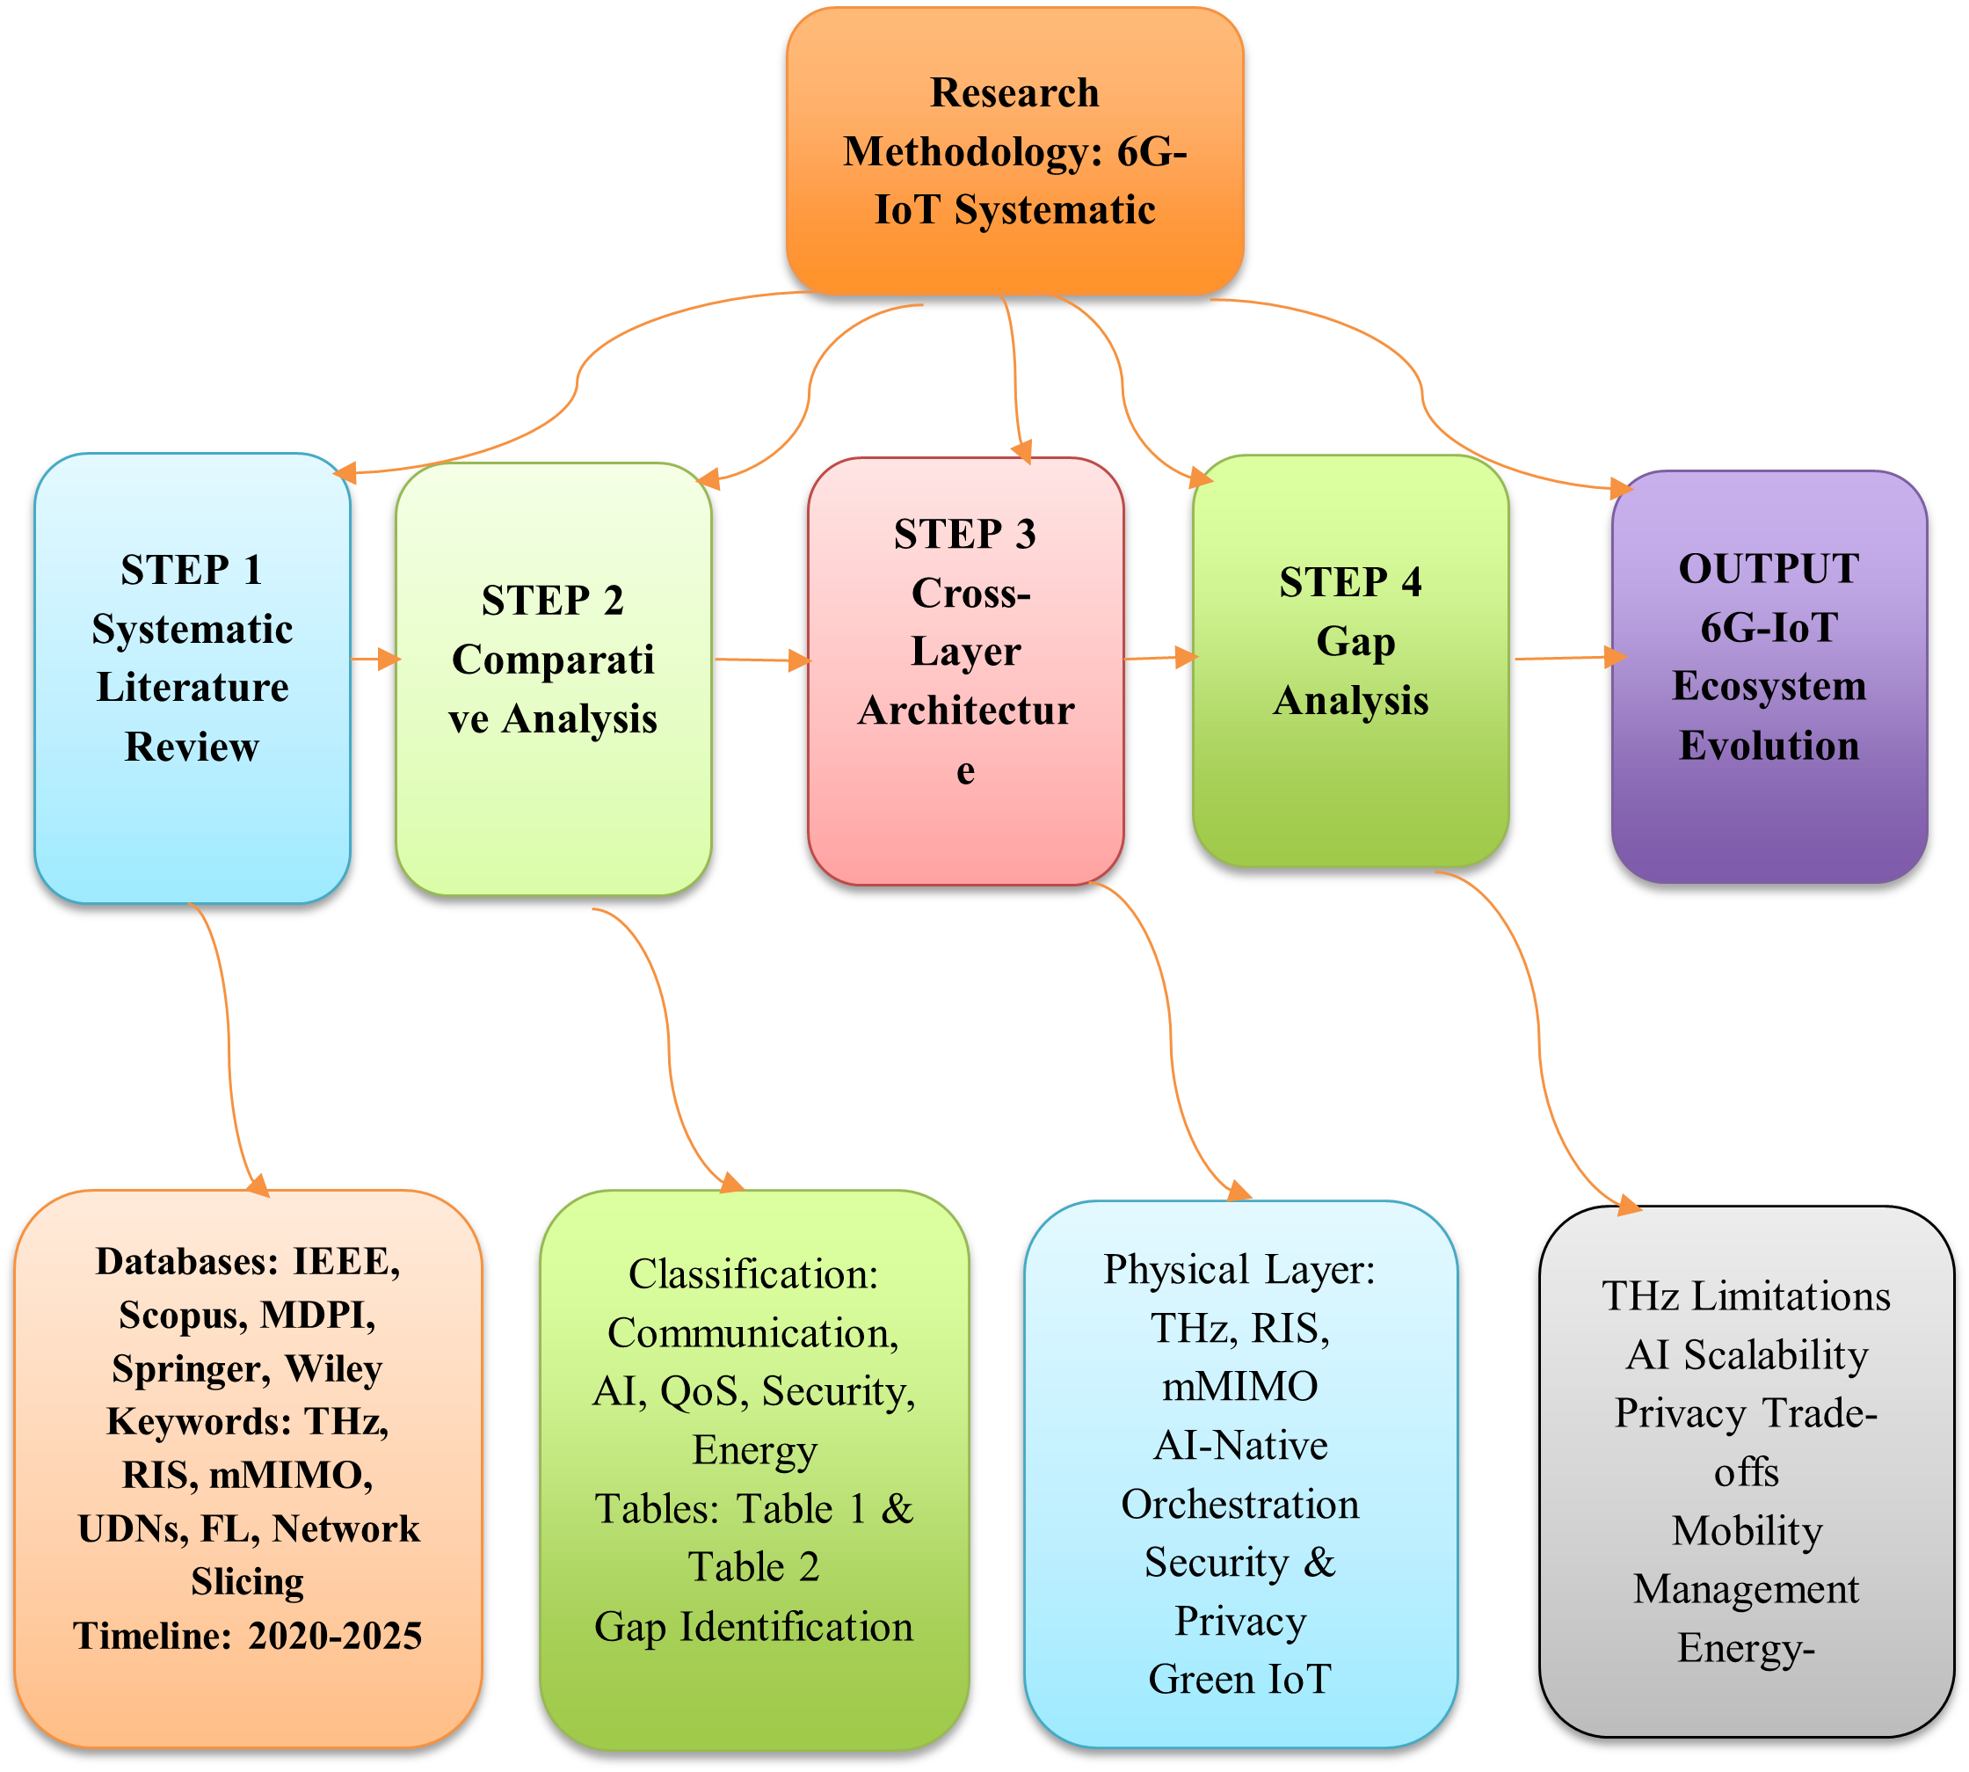
Figure 3. Systematic Research Methodology for 6G-IoT Review
- Emerging Communication Technologies for IoT in 6G
Revolutionizing connectivity, the sixth generation (6G) wireless system is expected to increase the interaction of everything from the digital world in an unprecedented level through emerging Internet of Things (IoT) paradigm. Where the previous generation of mobile technology, 5G, greatly increases the number of wireless devices that can be connected — as many as a million per square kilometer in some estimates — technology experts believe 6G will take that up by an order of magnitude. It is predicted that it could improve the capacity 100-fold, allowing well over a hundred million devices to work together in a similar space. These great advance needs novel communication techniques that are now high in demand for research and society. Among the proposed advancements there are terahertz communications, which can process data at unrivaled speeds, as well as intelligent surfaces that enhance signal quality. More interestingly, reconfigurable met surfaces have been proposed by researchers (Table 2, Figure 4): These structures can greatly control electromagnetic waves, which could not only be flexible but also effective in wireless communication. Furthermore, complex system designs, including massive MIMO systems and ultra-dense networks, show potential to provide additional connectivity. Furthermore, progress in visible light communication and hybrid radio architecture is also an important part of the 6G vision. This next generation wireless will not be working in the vacuum; it is expected to be synergized with advanced AI techniques extensively. The joint initiative will be focusing on the needs for 6G in a variety of IoT services and how to meet them to support requirements through increasingly diverse use cases in future interconnections, etc.[33] [34].

-Terahertz and beyond Terahertz Communications: Terahertz (THz) and sub-terahertz frequency ranges are expected to be a key enabler for 6G, being able to provide reliable and efficient connectivity for emerging multi-gigabit/terabit applications in multiple vertical domains. These frequency bands are emerging as the next, and possibly last, frontier in the growing spectrum for new wireless communications technology that will satisfy the needs of tomorrow's technology. The THz band has an incredibly wide frequency range (from 0.1 to 10 THz) but is still largely unregulated, so it follows that 6G will be the first communications system designed from the very start with both its sights set on and its boots ready to exploit such extremely high frequencies! The special and surprising properties of the THz band lead to a potential extremely wide spectrum space that perfectly matches Shannon’s law, thus promising rates we never thought possible. Given the growing strong connection between this frequency regime and the dynamic of microelectronics, there is no doubt that THz regime stands as a frontier space for ground- breaking advanced-technology-enabled wireless system integration. Some of the major benefits that one can expect when using THz systems for communications are their inherently short-range nature, non-ionizing properties of THz radiation as well as reduced susceptibility to different types of EM noise originating from external sources. Tackling the above challenges on next generation’s THz-focused 6G architecture aims to establish a strong and dynamic THz oriented 6G system, integrating a full-stack comprehensive THz framework with comprehensive set of enablers across different layers of OSI model, contributing for ultra-channel multiplicity and optimized NHS.[20] [22].
-Intelligent Surfaces and Reconfigurable Metasurfaces :The rapid spread of wireless communication systems has brought the requirements for broad band transmission and connectivity out of reach of future most advanced networks extending high-speed spectrum support to the beyond 5 th generation (B5G) frameworks. Some of the established notions to fulfill these requirements are terahertz (THz) communications, integrated sensing, visible-light communications and ultra-reliable low-latency communications (URLLC). RIS and meta-surfaces (which we use interchangeably to refer to a surface consist of multiple unit cells) represent a new frontier in enabling high data rates or avoiding interference and deep fading by manipulating radio-wave propagation. RIS is a manmade surface that can be intelligently programmed for manipulating EM wave scattering to make the wireless systems work better. Such programmable surfaces can be used in combination with wireless communication systems for critical system use cases, like supply chain tracking/monitoring; social distancing/crowd control measures and autonomous-driving/vehicular networks[35].
There are numerous new technologies that support the realization of 6G wireless networks. Many of these technologies, when combined with complementary artificial intelligence algorithms are reported as being able to satisfy traffic requirements in next-generation wireless networks, lower energy consumption and enhance coverage for the Internet of Things (IoT) [36],[37] [23].
-Massive MIMO and Ultra-Dense Network Architectures:In the race for the beyond-5G and even Digi tal-6G systems, in which massive connectivity, extremely high data rates, and ultra-low latency will be essential requirements that must be fulfilled at all costs, to appropriately meet these demands ultra-dense network (UDN) topologies are expected to see a significant surge of prominence. Such high standards are driven by the skyrocketing demands for overall connectivity solutions, machine type communications and difficult multi-sensory data transmissions that originate from 6G enabled applications in a wide variety of domains and industries including smart environments, augmented reality (AR)/ virtual reality (VR), digital twins, as well as automated factory processes. One of the key technologies that serves as a strong enabler for UDNs is the technology of massive multiple input multiple output (MIMO) which has been identified as one of the most disruptive technology introduced in wireless-age. This advanced methodology introduces base stations (BSs) equipped with significantly larger number of antennas than the users fulfilling equipment complementarity to explore long communication distance, greatly improve average capacity of the overall system, as well as guarantee extremely high data rate for mobile user all over the network. This technology had a significant development throughout the years, since its first appearance with massive multi-antenna single BS and leads up to massive MIMO in cooperative systems. This evolution also goes on to cover cell-free massive MIMO system design in a novel way. In such state-of-the-art cell-free massive MIMO networks, strategically deployed access points (APs) over a large geographical area act as a joint interface cancellation device to serve a large number of users with low-cost single antennas simultaneously that makes the network an ideal framework for achieving high data rates and connectivity [24],[38],[39]
-Visible Light Communication and Hybrid Radio Architectures: Optical wireless communication (OWC) with the light-emitting diode (LED) as a transmitter, visible light communication (VLC), can provide high data rates in dL ranging from only few kb/s to several Gbit/s. The technology has been harshly explored for interconnecting IoT enabled devices, due to its native features like safety, reliability and security [26]. VLC can be integrated with the traditional RF communication to form hybrid VLC/RF networks where both technologies are complementary to each other and support the 6G KPIs (key performance indicators). The hybridization has been extensively studied for access point, channel, and sensor fusion. Hybrid VLC/RF networks offer the synergistic benefits in terms of throughput, coverage, reliability and latency performance as well as being able to enable satellite, aerial and underwater communication.Terahertz (THz) communications are a significant enabler for the next generation Internet of Things (IoT) systems, as they provide high capacity and ultra-wide bandwidth VPN access in frequency bands from 0.1 to 10 THz. This THz is defined as a significant threshold that lies between electronics and optics, and it contains the weakest linkage among electromagnetic spectrum, its origins, generation concepts, enabling technologies, physical limits and health problems. In terms of applications, the THz field has seen extensive research in wireless communication applications, such as free-space high-speed wireless communication (THz-wireless/wired), multi-interference wireless communications on chip optical wireless communication and satellite communication. Furthermore, THz can be employed for energy harvesting relevant to visible light communication (VLC), indoor localization, vehicular communication, spectral imaging and environmental sensing as important candidates of the future smart city[40].
Table 2 .Comparative Overview of Emerging 6G Communication Technologies for IoT Applications
Technology | Frequency/Scope | Key Advantages | Applications | Performance Metrics (KPI)
Terahertz (THz) | 0.1 – 10 THz | High data rates, wide bandwidth | IoT, smart cities, satellite communication | Throughput, Latency
RIS / Metasurfaces | Reconfigurable surfaces | Improved signal propagation, interference mitigation | Autonomous vehicles, monitoring | Reliability, Coverage
Massive MIMO | Multi-antenna BS | Increased capacity, extended range | Smart factories, AR/VR | Capacity, Connectivity
VLC / Hybrid RF | LEDs + RF | Reliable, secure, high-speed | IoT, underwater, satellite | Throughput, Latency

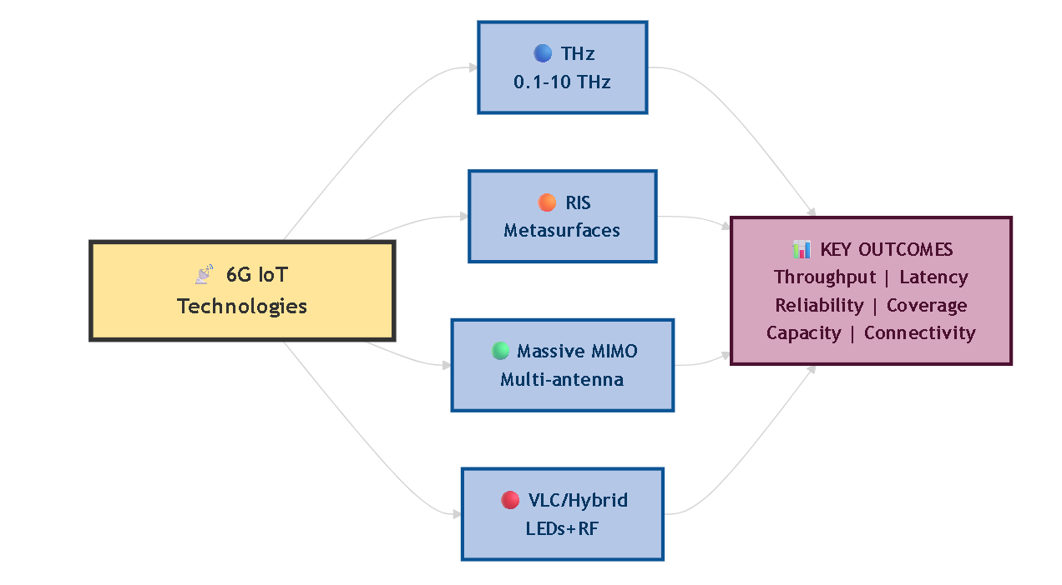
Figure 4 Emerging 6G Communication Technologies for IoT

- AI and Edge Intelligence in IoT over 6G
Novel communication techniques for the Internet of Things (IoT) on beyond-6G networks are in active development with a number of state-of-the-art schemes. These communications include terahertz (THz) and beyond THz, where intelligent surfaces are incorporated to better transmit the signals. Moreover, the development of big MIMO and ultra-dense network architecture will further improve connectivity. Hybrid radio–visible-light communication architectures are starting to play an importance role, inspiring new ways of co-managing light and RF. The energy saving oriented design inspiration, further motivates more research into AI and Edge computing systems tailored for 6G. AI methods are the key towards improving network capacity and have significantly benefited interference management, fine-granularity transmission resources scheduling. Furthermore, the aim of edge-computing architectures is to relieve the pressure of data-processing tasks on the Cloud by enabling such computations to be offloaded to closer Edge nodes. This transition results in achieving a remarkable reduction in delay and energy consumption by utilizing the spectrum and harvested-energy sources more efficiently. In this unique and novel context, a decentralized federated learning approach is developed to specifically address the particularities of 6G IoT applications. This approach would allow edge training to occur directly on Edge devices and model weight updates to be transmitted back to centralized Cloud servers for further aggregation. This bottom-up, progressive application enables you to manage and review the outside edges of smart systems. This method, together with an AI driven resource orchestration paradigm, enables a broad range of services under heavy operational constraints. In this regard, network slicing is considered a cornerstone of such approaches; backed by intelligent AI algorithms and optimizations, it adjusts resource allocation according to different service types. Each service has dedicated RAN components designed to fulfill different QoS needs. User satisfaction in a variety of services can thus be guaranteed by the efficient management of these customized resources, enhancing efficiency and reliability of emerging communication technologies in the 6G environment[41],[42].
-Federated and Semi‑Federated Learning for IoT:AI-based applications, services, and devices, deployed or developing rapidly over 6G networks, require continuous contextual information to operate efficiently. Edge intelligence (EI)—an extension of artificial intelligence at the edge of networks and the Internet of Things (IoT)—has emerged as a possible solution. EI reduces the amount of data transferred to the cloud, generates real-time local context at the device level, and enables machine-learning (ML) algorithms to process and learn locally on devices before transferring knowledge to the cloud. For IoT deployed in areas with limited or no connectivity, EI minimizes data transfer to the cloud, allowing devices to operate autonomously for extended time periods while continuously learning, processing, enhancing, and reactivating the crucial data provided by events in their surroundings. Federated ML (FedML) enables collaborative training of a global model among diverse edge devices whereas user-specific or domain-specific training remains a concern since heterogeneous data are locally kept by IoT devices after chronological learning events and training cannot be further fine-tuned locally to accommodate quick mood variation. Semi federated learning and its subset, Semi FL, train AI models with diverse universal knowledge in hybrid scenarios indicated under FedML and user-specific knowledge in scenarios under tuned sequential learning with additional continual knowledge [43],[3] .
-Edge Computing and Resource Orchestration :The enormous volume of data generated in the Internet of Things (IoT) raises demands on both storage and computation beyond those of today’s Cloud Computing and Cloud Intelligence scenarios. Mobile Edge Computing (MEC) brings computation closer to the user, but with a base-band, ready-to-be-matrix-multiplied signal typically input to the edge processor. Many IoT applications, from smart robotics to autonomous driving, require further increased processing power to handle this complexity. As the reconfigurable Internet of Intelligent Things emerges, federated learning (FL) and semi-federated learning (SFL) on the edge avoid centralizing the raw data in the network [44]. In conjunction with these key AI technologies, additional advances in computation-offloading resource orchestration help extend resource capacity on the edge and achieve still further power gain. Some processing can also be migrated from devices to the edge (and from edge to cloud)—for example, speech recognition or video analysis. Process migrations depend on a multitude of factors, including power/energy, latency and delay, radio-frequency (RF) conditions, user mobility, and characteristics of the application or service (e.g. connectivity, ubiquitous, low-latency, and ultra-high-definition). Automatically detecting and predicting these resource-management constraints generates information for further enhancement[45],[16].
-AI-Driven Network Slicing and QoS Assurance Ensuring the QoS is of high level for low-bitrate long-lifetime devices and providing reliable service with ultra-low latency for high-bitrate energy-harvesting devices are two major challenges of IoT in 6G. For example, in a scenario of smart home, video devices powered by energy harvesters can capture quality video data and deliver it to edge servers in real time while smoke sensors with limited power could report events through wide-area network at low frequency; though the latter may consume less resources than the former do there are still requirements on transmitting delay. AI empowered network slicing provides dynamic QoS-aware resource allocation and configuration, therefore ensuring the QoS. With the growth of information transmission, the demand for resources on data channels and reconciliation parameters increases significantly. Scenarios like electric-mobility and attention-based perceptual video coding motivate size reduction in the data dimension as well as the system-configuration dimensions, which can be addressed by means of methods such as federated and semi-federated learning. Multi-stage federated learning assigns 1T, 1M and 1K data in one slice. Each stage keeps residual learning on outer-aggregation models to cut downlink data more than 95% [36]. Parameters and hyper-parameters of the DNNs are outsourced for timely scheduling, routing and slicing policy adjustments. Furthermore, reinforcement learning based joint resources allocation frameworks and methods such as deep Q-network provide dynamic resource allocation among bandwidth, power and edge-computing for variety-slice of the edge nodes against time-varying traffic requirements. Such typical workloads of deep learning training, including image classification (e.g., on CIFAR-10) and video analytic (e.g., for smart-city scenarios), are used as the benchmark of the training tasks, which still keep high performance [28].
6. Security, Privacy, and Trust in 6G IoT
Although the International Telecommunication Union (ITU) has made remarkable work to set global efforts for 6G, covering a visionary part and an implementation plan of industrial requirements, it is important to emphasize that a achievable approach toward the complete interoperable global architecture looks more like concepts. In tandem with that, it's eminently possible -- even profoundly worthwhile -- to actively investigate the varied IoT citizens' needs and its relevant concepts, which will be key in driving 6G tech forward and beyond. The different desired properties for 6G IoT can be aptly summarized as: [38]
6G is anticipated to leap performance across the board including economic, latency, data rate, devices per connection density, energy efficiency, coverage and mobility. In addition, they are based on major technology breakthroughs in THz/beyond-THz, AI and the building of space-air-ground-sea integrated network. Nonetheless, those improvements bring a lot of challenges to the security, privacy, and trust in 6G that are beyond anything previously encountered regarding these three dimensions. To overcome such challenges, we envision a security and trust framework for 6G called SIX-Trust. The architecture is composed of three layers Sustainable trust, looking at the sustainability of the 6G system as a whole. - Infrastructure trust, making sure that infrastructures build and operate correctly. - Xenogeneic trust, takes into account trust on other things than just the usual septenary dimensions of 6G.
-Lightweight Cryptography and Secure Authentication: The Internet of Things (IoT) vision offers an enormous number of connected devices for a wide range of real-time applications such as smart cities, e-health, e-governance, Intelligent Transport systems (ITS), Industrial-IoT(IIoT), wearable sensor networks disaster management, smart homes and many more. These new use cases require advanced technology, which will need to work over the current 4G, 5G networks and future 6G. [30]. Society, and the very definition of a network, have been transformed by 4G and 5G connections as well as the spread of Internet of Thing (IoT) tools. In the beginning, emphasis was more on connectivity as opposed to security. With more and more clients deploying the IoT, security concerns come to light. What is more, 6G networks can provide the service capabilities and satisfy security requirements of confidentiality, integrity, data freshness and authenticity. [46]. Lightweight cryptology and secure authentication are essential to realize strong security measures in 6G networks. Existing there are already numerous lightweight cryptographic protocols for specific use cases, some of which also address IoT requirements [47]. New lightweight cryptographic protocols like ones that we presented here should be seriously taken into account while addressing security aspects of 6G networks in order to answer threats from IIoT environments.
-Privacy-Preserving Data Economics:The rapid development of 6G networks will bring unprecedented connectivity for IoT systems, but such deployments will also require a careful assessment of the privacy and security requirements for these systems [47]. IoT devices are often deployed in contexts where significant personal data is collected and shared, such as smart homes, smart cities, and remote health monitoring. As the number of devices and the amount of data collected grow, it becomes increasingly difficult for even knowledgeable individuals to track how data is collected, processed, and shared, which constitutes a violation of privacy [47]. The sophistication of the devices, the channels over which data can be transmitted, and the types of data being shared differ vastly among systems; thus, it is important to be able to take privacy considerations into account while also configuring the rest of the network parameters. The general requirements for ensuring privacy over IoT devices in 6G networks include the ability to control whose consent is required for a dataset to be considered “open,” the ability to prevent sensitive attributes from potentially being inferred by transmitted data, and the assurance that the individuals involved either actively consent or are not identifiable from the data [47]. The final requirement is often referred to as differential privacy, and ensuring that the privacy is controlled according to the types of consent also constitutes a major challenge.
- Trust, Resilience, and Risk Management :The Internet of Things (IoT) link a wide range of physical things to the internet for monitoring and controlling which enables transformation from Manual World to Autonomous World. The emerging technologies of 6G is crucial to the increasingly large number of IoT connectivity and high-capacity communication systems that provide greater spectral efficiency and energy efficiency. 6G will provide enormous data volume and massively distributed data generation, which could be realized by smart sensing and transmission, MMTC (machine-type communications) and unlimited connectivity[47]. resource orchestration, federation and integration) in order to support the diversity of services that different IoT devices may offer [48]. The local and servant domain federated, semi-federated learning based schemes contributes to the intelligent deployment of Machine Learning (ML) algorithms preserving confidentiality so that privacy is improved. If different type of connectivity was widely studied in 5G, the need to meet the various quality requirements handled by a heterogeneous set of applications is still open. Different applications with different Quality of Service (QoS) specifications, such as Ultra-Reliable Low-Latency Communication (URLLC), and massive Machine-Type Communication (mMTC), entail increasing demands.

7. Reliability, Ultra-Low Latency, and Mobility Management in 6G-Enabled IoT Systems
Ultra-Reliable Low-Latency Communications (URLLC) has emerged as a fundamental performance pillar for 5G networks and is expected to become even more critical in future 6G systems, particularly for industrial automation, intelligent transportation, and other mission-critical Internet of Things (IoT) applications. While low latency is a general requirement for most IoT services, advanced use cases such as factory automation and autonomous driving impose extremely stringent latency constraints of 1 ms or less, with future visions targeting 0.1 ms under enhanced URLLC frameworks [18],[49]. Applications including vehicular communications, drone-assisted disaster management, and telemedicine further reinforce the necessity for ultra-low latency and ultra-high reliability, thereby requiring a fundamental reconsideration of 6G design principles to accommodate extreme latency scenarios [33],[50]. The coexistence of ultra-high reliability and ultra-low latency introduces significant challenges in wireless access network design, as transmission schemes must minimize resource occupation while maintaining high efficiency and packet error rates as low as 10⁻⁹ to 10⁻¹², benchmarks historically associated with advanced 4G/LTE systems but still below theoretical spectral efficiency limits [50]. Emerging 6G scenarios expand these requirements by supporting a broader diversity of use cases, encouraging the development of highly constrained yet robust transmission mechanisms that carefully balance latency, reliability, access probability, and throughput during the access phase [45],[51],[52].
In parallel, mobility and handover management constitute critical components for sustaining Quality of Service (QoS) in dynamic IoT environments, particularly within the Internet of Vehicles (IoV). The IoV integrates vehicle ad hoc networks (VANET) and vehicle-to-everything (V2X) communications, enabling vehicle-to-vehicle, vehicle-to-infrastructure, and vehicle-to-pedestrian interactions to enhance safety and efficiency. In such highly dynamic scenarios, data rates may range from 100 kbps to 1 Gbps, especially under URLLC conditions [53][54]. However, conventional 5G mobility solutions face limitations in high-speed vehicular contexts, as handovers are not always optimally performed with the nearest base station, necessitating advanced horizontal and vertical handover strategies. Additionally, millimeter-wave communications and expanded satellite broadband coverage contribute to broader and more reliable connectivity, even across remote regions. Despite the anticipated integration of 6G technologies into IoV systems, comprehensive understanding of mobility and handover optimization in 6G IoV remains limited. Current Long-Term Evolution (LTE) systems incorporating 5G New Radio and IP-based vehicular communication still exhibit inefficiencies at high mobility speeds, prompting proposals such as single-point mobility management for V2X–IoT scenarios to enhance seamless connectivity and maintain stringent QoS requirements[55].
- Energy Harvesting and Green Protocol Design :Energy self-sustainability is a primary target for the future sixth generation (6G) of wireless communication systems and for the Internet of Everything (IoE)[31]. The full-spectrum of electromagnetic waves, ranging from sub-6 GHz through terahertz (THz) up to visible light, is expected to be exploited in 6G networks to reach unprecedented key performance indicators (KPIs). Energy self-sustainability is sought to address the high energy consumption of network infrastructure and the limited battery life of IoE devices, [56]. Network-wide energy efficiency can be achieved by implementing cell-free and airborne access networks and by deploying intelligent holographic environments. Wireless power transfer and passive backscatter communication, utilizing either radio-frequency (RF) or visible light signals, can enable zero-energy devices, according to. Moreover, IoE devices can actively adapt their transceivers to cope with dynamic environments. A hybrid energy harvesting design for on-body IoT networks, proposed by Saraereh et al. (2020), illustrates the principle of energy localization. By mistuning the mass of one of the moving magnets, energy localization is achieved, which mitigates the complexity of energy harvesting for on-body devices and extends battery life, Saraereh et al. described. Thermoelectric energy harvesting takes advantage of the temperature gradient between the human body and the surrounding environment to produce electricity. The generated thermal energy is converted into direct current by thermoelectric generators, stored in super capacitors, boosted to the required voltage level, and used by sensor nodes to enable battery-free IoT operation. Such an approach increases network reliability and reduces costs, according to Saraereh et al. An efficient energy management policy is essential for balancing energy refilling and maintaining network reliability, due to the random nature of available energy, Saraereh et al. argued. The proposed hybrid energy harvesting system, which employs both RF and thermal sources, significantly extends network lifetime, as demonstrated by simulation results, Saraereh et al. reported[57].
-Battery-Free and Backscatter IoT in 6G :Sustainable connectivity is also an important issue for IoT devices which use high-frequency bands to connect and so communicate in throughout the 6G spectra [58]. One of the proposed solutions to achieve alternate energy for different devices is harvesting from surrounding sources [32]. Energy harvesting devices still rely on batteries, so loss of energy from such a device that fails is in turn still an issue. For example, the average end-us-es of this system would be concerned about devices that do not require a source of power and theta backscatter systems. Communication without using any energy and modulation signals back in VLR or RF-band is achievable. Newer devices of this kind are selecting different operating parameters depending on the surrounding. Communication network equipment deployed in an aerial environment, working closely with intelligent holographic wireless environments has been recently introduced for designing and operating zero-power devices.
8. Deployment Scenarios and Standardization Frameworks for 6G-Enabled IoT Ecosystems
Prospective deployment use-cases of IoT in the highly heterogeneous 6G network architecture cover a wide range of environments including smart cities, advanced healthcare systems, Industry 4.0 facility, and intensive agricultural systems. As these domains are still growing, specialized deployment architectures are rising to meet stringent needs such as ultra-low latency, ultra-high reliability, advanced data security and huge scalability. These capacities are more and more supported by new hardware platforms, flexible software frameworks, as well as smart orchestration approaches. Smart cities in particular are revolutionizing urban infrastructures into densely connected spaces with ubiquitous connectivity, massive sensor deployment and intelligent service endpoints that employ disruptive technologies to minimize energy consumption, communication bandwidth and urban mobility[48]. Leveraging on the 5G advanced specifications (Release 18 and further) and International Telecommunication Union (ITU) IMT-2030 requirements, future generation solutions will need to guarantee aero-trust security for the Industrial Internet of Things (IIoT), wide area vehicular communications, as well as smart transportation systems[59]. At the same time, Industry 4.0 predicts a future where production/management/supply chain operate fully independently with continuous monitoring in real-time and full transparency over industrial processes [60], [61].
Such heterogeneity should be addressed through the interoperability not only of devices, but also services and applications. As a result, standardization work has been accelerated with the emergence of low-power and low-throughput wireless networks, resource-constrained devices, machine-to-machine (M2M) communications, smart grid networks as well as building management systems. The vision of the expected widespread deployment of IPv6 multicasting is to obviate private addressing and at the same time permitting millions of hosts to access the global Internet [62]. In this regard, the Internet Engineering Task Force (IETF) is working on standardized IoT protocol stacks for deployment over diverse technological spaces [63]. These mechanisms aim at modifying existing Internet protocols in an incremental manner or the definition of new lightweight protocols to be used in highly constrained nodes such as sensors and actuators with low processing, memory capacity, radio transmission range and bandwidth. Therefore, addressing the issues of operating Internet protocol stacks over low-power and lossy networks, is a key for providing scalable, secure and sustainable 6G-enabled IoT ecosystem[64], [17].
- Applications of IoT over 6G: The convergence of Internet of Things (IoT) with sixth generation (6G) wireless networks is envisioned to open a new era of smart, autonomous and ultra-connected things. Contrary to the past generations, 6G is expected to deliver ultra-low latency (sub-millisecond), extremely high throughput (terabit per second scale), massive connection of devices, integrated sensing and communication, and in-network AI natively. These features greatly broaden the scope of IoT use cases beyond traditional smart monitoring. Enabling real-time digital twins, autonomous traffic coordination, and massive environmental sensing in smart cities powered by 6G-IoT. In health, it provides worldwide robotic ‘surgery at a distance’, continuous holographic telepresence and AI-supported health monitoring with ultra-reliable communications. Distributed-latency control, including Industry 5.0 industrial IoT (IIoT), and co-machines with a deterministic latency enabling fully autonomous factories and human-machine co-workers configuration. Besides, other applications such as XR, connected autonomous driving (CAD), precision agriculture, space–air–ground integrated networks and mission-critical public safety become realizable thanks to 6G’s communication–sensing convergence and high reliability. More generally, IoT in 6G reflects a move away from massive connectivity towards intelligent context-aware and self-optimizing cyber-physical ecosystems.
9. Open Challenges and Future Directions
According to world economic forum estimates, IoT will create $78.9 trillion of global economic value for predictive maintenance, robotic process automation, and smart infrastructure. The combination of AI and IoT is expected to influence 50% of the overall technology investments by 2030. Enabling the full potential of the events for a decade at least is necessary. Future research and standardization global collaboration are required and already developed 5G offers a proper industrial environment to initiate such developments. Large open challenges remain to determine the acceptable way to exploit massive connectivity while enabling on the same time the most important attributes for the full deployment of the IoT 5G solution. Directly accelerate open IOT towards 6G research, especially the market prospect promises a dominating influence for an economically. Future industries IoT interacting with production process, device resources, and distributed trust relies on IOT 5G technology and the urgency future directing maintaining massive evolution and the capacity to increase the forecast production resource dedicated by IoT 5G. Directly toward the natural evolution coordinated expand research on collaborative 5G and collaborative IoT the necessary direction to allow IOT deployment within exception few countries simple transition co-evolve 5G and IoT toward 6G [48].

10. Conclusion
Internet of Things (IoT) The development of the Internet has spurred the growth of the Internet of Things (IoT), which consists in a web network between connected objects and sensors exchanging data on shared communication networks. Although future 5G as envisioned by the ITU IMT-2020 path has provided more low-power connectivity support of large-scale IoT, bottleneck related to massive edge produced data and cloud-induced latency remain prominent. Looking beyond, the seamless integration of physical, digital and human worlds will be realized in 6G by achieving ultralow-latency connections (below 1 ms), massive connectivity including support for very low-Earth orbit satellites and immersive applications such as mixed reality or tactile Internet. Research is generally in advanced connectivity, intelligent routing, AI (or deep learning) driven network management and service orchestration, new cost-effective security mechanisms. In addition to enhancing performance, 6G highlights energy efficiency, sustainability, trustworthiness, privacy and lightweight security solutions against prospective cyber threats while maintaining trustable and reliable IoT ecosystems.

References
[1] P. Popovski et al., “Internet of Things (IoT) connectivity in 6G: An interplay of time, space, intelligence, and value,” arXiv Prepr. arXiv2111.05811, 2021.
[2] R. Chataut, M. Nankya, and R. Akl, “6G Networks and the AI Revolution-Exploring Technologies, Applications, and Emerging Challenges.,” Sensors (Basel)., vol. 24, no. 6, Mar. 2024, doi: 10.3390/s24061888.
[3] A. Bourechak, O. Zedadra, M. N. Kouahla, A. Guerrieri, H. Seridi, and G. Fortino, “At the confluence of artificial intelligence and edge computing in iot-based applications: A review and new perspectives,” Sensors, vol. 23, no. 3, p. 1639, 2023.
[4] M. M. Rashid, S. U. Khan, F. Eusufzai, M. A. Redwan, S. R. Sabuj, and M. Elsharief, “A Federated Learning-Based Approach for Improving Intrusion Detection in Industrial Internet of Things Networks,” Network, vol. 3, no. 1. pp. 158–179, 2023. doi: 10.3390/network3010008.
[5] S. Sharma et al., “The role of 6G technologies in advancing smart city applications: Opportunities and challenges,” Sustainability, vol. 16, no. 16, p. 7039, 2024.
[6] E. Ganivet, “Growth in human population and consumption both need to be addressed to reach an ecologically sustainable future: E. Ganivet,” Environ. Dev. Sustain., vol. 22, no. 6, pp. 4979–4998, 2020.
[7] M. A. AbdlNabi, B. J. Hamza, and A. T. Abdulsadda, “6G optical-RF wireless integration: a review on heterogeneous cellular network channel modeling, measurements, and challenges,” Telecommun. Syst., vol. 87, no. 4, pp. 1201–1244, 2024.
[8] M. Höyhtyä et al., “Multi-layered satellite communications systems for ultra-high availability and resilience,” Electronics, vol. 13, no. 7, p. 1269, 2024.
[9] Y. Usman, H. Oladipupo, A. D. During, A. Robert, and R. Chataut, “AI, ML, and LLM integration in 5G/6G networks: A comprehensive survey of architectures, challenges, and future directions,” IEEE Access, 2025.
[10] Z. Chen, X. Ma, C. Han, and Q. Wen, “Towards intelligent reflecting surface empowered 6G terahertz communications: A survey,” China Commun., vol. 18, no. 5, pp. 93–119, 2021.
[11] E. Alzubi, “AI-Powered Smart Grids in the 6G Era: A Comprehensive Survey on Security and Intelligent Energy Systems”.
[12] D. C. Nguyen et al., “6G Internet of Things: A comprehensive survey,” IEEE Internet Things J., vol. 9, no. 1, pp. 359–383, 2021.
[13] X. Wang, Y. Zhao, C. Qiu, Q. Hu, and V. C. M. Leung, “Socialized learning: A survey of the paradigm shift for edge intelligence in networked systems,” IEEE Commun. Surv. Tutorials, vol. 27, no. 3, pp. 2085–2128, 2024.
[14] N. Gupta, S. Sharma, P. K. Juneja, and U. Garg, “Sdnfv 5g-iot: A framework for the next generation 5g enabled iot,” in 2020 international conference on advances in computing, communication & materials (ICACCM), 2020, pp. 289–294.
[15] P. Popovski et al., “A perspective on time toward wireless 6G,” Proc. IEEE, vol. 110, no. 8, pp. 1116–1146, 2022.
[16] O. Said, “Design and performance evaluation of QoE/QoS-oriented scheme for reliable data transmission in Internet of Things environments,” Comput. Commun., vol. 189, pp. 158–174, 2022, doi: https://doi.org/10.1016/j.comcom.2022.03.020.
[17] T. Mazhar et al., “Quality of Service (QoS) Performance Analysis in a Traffic Engineering Model for Next-Generation Wireless Sensor Networks,” Symmetry, vol. 15, no. 2. p. 513, 2023. doi: 10.3390/sym15020513.
[18] N. H. Mahmood, G. Berardinelli, E. J. Khatib, R. Hashemi, C. De Lima, and M. Latva-aho, “A functional architecture for 6G special-purpose industrial IoT networks,” IEEE Trans. Ind. informatics, vol. 19, no. 3, pp. 2530–2540, 2022.
[19] A. Hazarika and M. Rahmati, “Towards an Evolved Immersive Experience: Exploring 5G- and Beyond-Enabled Ultra-Low-Latency Communications for Augmented and Virtual Reality,” Sensors, vol. 23, no. 7. p. 3682, 2023. doi: 10.3390/s23073682.
[20] M. Polese, J. M. Jornet, T. Melodia, and M. Zorzi, “Toward end-to-end, full-stack 6G terahertz networks,” IEEE Commun. Mag., vol. 58, no. 11, pp. 48–54, 2020.
[21] W. Jiang et al., “Terahertz communications and sensing for 6G and beyond: A comprehensive review,” IEEE Commun. Surv. Tutorials, vol. 26, no. 4, pp. 2326–2381, 2024.
[22] Y. Feng, Q. Hu, K. Qu, W. Yang, Y. Zheng, and K. Chen, “Reconfigurable intelligent surfaces: Design, implementation, and practical demonstration,” Electromagn. Sci., vol. 1, no. 2, pp. 1–21, 2023.
[23] G. Gradoni et al., “Smart radio environments,” arXiv Prepr. arXiv2111.08676, 2021.
[24] Z. Gao et al., “Compressive-sensing-based grant-free massive access for 6G massive communication,” IEEE Internet Things J., vol. 11, no. 5, pp. 7411–7435, 2023.
[25] V. Stoynov, V. Poulkov, Z. Valkova-Jarvis, G. Iliev, and P. Koleva, “Ultra-Dense Networks: Taxonomy and Key Performance Indicators,” Symmetry, vol. 15, no. 1. p. 2, 2023. doi: 10.3390/sym15010002.
[26] E. Peltonen et al., “6G white paper on edge intelligence,” arXiv Prepr. arXiv2004.14850, 2020.
[27] S. Khan, S. Khan, Y. Ali, M. Khalid, Z. Ullah, and S. Mumtaz, “Highly accurate and reliable wireless network slicing in 5th generation networks: a hybrid deep learning approach,” J. Netw. Syst. Manag., vol. 30, no. 2, p. 29, 2022.
[28] S. Mhatre, F. Adelantado, K. Ramantas, and C. Verikoukis, “Intelligent QoS-aware slice resource allocation with user association parameterization for beyond 5G O-RAN-based architecture using DRL,” IEEE Trans. Veh. Technol., vol. 74, no. 2, pp. 3096–3109, 2024.
[29] Y. Wang, X. Kang, T. Li, H. Wang, C.-K. Chu, and Z. Lei, “SIX-trust for 6G: Towards a secure and trustworthy 6G network,” arXiv Prepr. arXiv2210.17291, 2022.
[30] T. Alam, “A reliable communication framework and its use in internet of things (IoT),” Authorea Prepr., 2023.
[31] J. Hu, Q. Wang, and K. Yang, “Energy self-sustainability in full-spectrum 6G,” IEEE Wirel. Commun., vol. 28, no. 1, pp. 104–111, 2020.
[32] O. L. A. López, H. Alves, R. D. Souza, S. Montejo-Sánchez, E. M. G. Fernández, and M. Latva-Aho, “Massive wireless energy transfer: Enabling sustainable IoT toward 6G era,” IEEE Internet Things J., vol. 8, no. 11, pp. 8816–8835, 2021.
[33] S. K. Pattnaik et al., “Future Wireless Communication Technology towards 6G IoT: An Application-Based Analysis of IoT in Real-Time Location Monitoring of Employees Inside Underground Mines by Using BLE.,” Sensors (Basel)., vol. 22, no. 9, Apr. 2022, doi: 10.3390/s22093438.
[34] F. Salahdine, T. Han, and N. Zhang, “5G, 6G, and Beyond: Recent advances and future challenges,” Ann. Telecommun., vol. 78, no. 9, pp. 525–549, 2023, doi: 10.1007/s12243-022-00938-3.
[35] M. Di Renzo et al., “Smart radio environments empowered by reconfigurable intelligent surfaces: How it works, state of research, and the road ahead,” IEEE J. Sel. areas Commun., vol. 38, no. 11, pp. 2450–2525, 2020.
[36] W. Tang et al., “Wireless communications with reconfigurable intelligent surface: Path loss modeling and experimental measurement,” IEEE Trans. Wirel. Commun., vol. 20, no. 1, pp. 421–439, 2020.
[37] W. U. Khan, M. A. Javed, S. Zeadally, E. Lagunas, and S. Chatzinotas, “Intelligent and secure radio environments for 6G vehicular aided HetNets: Key opportunities and challenges,” IEEE Commun. Stand. Mag., vol. 7, no. 3, pp. 32–39, 2023.
[38] H. Q. Ngo, G. Interdonato, E. G. Larsson, G. Caire, and J. G. Andrews, “Ultradense cell-free massive MIMO for 6G: Technical overview and open questions,” Proc. IEEE, vol. 112, no. 7, pp. 805–831, 2024.
[39] V. Stoynov, V. Poulkov, Z. Valkova-Jarvis, G. Iliev, and P. Koleva, “Ultra-dense networks: Taxonomy and key performance indicators,” Symmetry (Basel)., vol. 15, no. 1, p. 2, 2022.
[40] M. T. Mamaghani, G. S. Member, Y. Hong, and S. Member, “Aerial Intelligent Reflecting Surface Enabled Terahertz Covert Communications in Beyond-5G Internet of Things,” pp. 1–24, 2027.
[41] A. Bstract, “6G W HITE P APER ON E DGE I NTELLIGENCE,” no. June, pp. 1–27, 2020.
[42] M. Z. Asghar, S. A. Memon, and J. Hämäläinen, “Evolution of Wireless Communication to 6G: Potential Applications and Research Directions,” Sustainability, vol. 14, no. 10. p. 6356, 2022. doi: 10.3390/su14106356.
[43] K. Yang, Y. Shi, Y. Zhou, Z. Yang, L. Fu, and W. Chen, “Federated Machine Learning for Intelligent IoT via Reconfigurable Intelligent Surface,” pp. 1–7.
[44] H. H. Qasim, A. E. Hamza, L. Audah, H. H. Ibrahim, H. A. Saeed, and M. I. Hamzah, “Design and implementation home security system and monitoring by using wireless sensor networks WSN/internet of things IoT,” Int. J. Electr. Comput. Eng., vol. 10, no. 3, pp. 2617–2624, Aug. 2020, doi: 10.11591/ijece.v10i3.pp2617-2624.
[45] H. Kopetz and W. Steiner, “Internet of Things BT - Real-Time Systems: Design Principles for Distributed Embedded Applications,” H. Kopetz and W. Steiner, Eds. Cham: Springer International Publishing, 2022, pp. 325–341. doi: 10.1007/978-3-031-11992-7_13.
[46] P. Bhide, D. Shetty, and S. Mikkili, “Review on 6G communication and its architecture, technologies included, challenges, security challenges and requirements, applications, with respect to AI domain,” IET Quantum Commun., vol. 6, no. 1, p. e12114, 2025.
[47] H. Al-Aqrabi, P. Lane, and R. Hill, “Performance evaluation of multiparty authentication in 5G IIoT environments,” in International Conference on Cyberspace Data and Intelligence, 2019, pp. 169–184.
[48] S. Li, M. Iqbal, and N. Saxena, “Future industry internet of things with zero-trust security,” Inf. Syst. Front., vol. 26, no. 5, pp. 1653–1666, 2024.
[49] G. J. Sutton et al., “Enabling technologies for ultra-reliable and low latency communications: From PHY and MAC layer perspectives,” IEEE Commun. Surv. Tutorials, vol. 21, no. 3, pp. 2488–2524, 2019.
[50] V. Chunduri, A. Kumar, A. Joshi, S. R. Jena, A. Jumaev, and S. More, “Optimizing energy and latency trade-offs in mobile ultra-dense IoT networks within futuristic smart vertical networks,” Int. J. Data Sci. Anal., vol. 19, no. 4, pp. 631–643, 2025.
[51] P. Popovski et al., “Wireless access in ultra-reliable low-latency communication (URLLC),” IEEE Trans. Commun., vol. 67, no. 8, pp. 5783–5801, 2019.
[52] M. S. Akbar, Z. Hussain, M. Ikram, Q. Z. Sheng, and S. Mukhopadhyay, “6G survey on challenges, requirements, applications, key enabling technologies, use cases, AI integration issues and security aspects,” arXiv Prepr. arXiv2206.00868, 2022.
[53] R. Karmakar, G. Kaddoum, and S. Chattopadhyay, “Mobility Management in 5G and Beyond: A Novel Smart Handover With Adaptive Time-to-Trigger and Hysteresis Margin,” IEEE Trans. Mob. Comput., vol. 22, no. 10, pp. 5995–6010, 2023, doi: 10.1109/TMC.2022.3188212.
[54] M. U. A. Siddiqui, F. Qamar, M. Tayyab, M. H. D. N. Hindia, Q. N. Nguyen, and R. Hassan, “Mobility Management Issues and Solutions in 5G-and-Beyond Networks: A Comprehensive Review,” Electron., vol. 11, no. 9, 2022, doi: 10.3390/electronics11091366.
[55] H. H. Qasim, H. Z. Abidin, and S. A. C. Abdullah, “Handover management in vehicle communication: applications, techniques, issues, and challenges: a review,” Bull. Electr. Eng. Informatics, vol. 13, no. 5, pp. 3167–3186, 2024.
[56] O. A. Saraereh, A. Alsaraira, I. Khan, and B. J. Choi, “A hybrid energy harvesting design for on-body internet-of-things (IoT) networks,” Sensors, vol. 20, no. 2, p. 407, 2020.
[57] Q. Zhang et al., “Human body IoT systems based on the triboelectrification effect: energy harvesting, sensing, interfacing and communicaation,” Energy Environ. Sci., vol. 15, no. 9, pp. 3688–3721, 2022.
[58] A. L. Imoize, O. Adedeji, N. Tandiya, and S. Shetty, “6G enabled smart infrastructure for sustainable society: Opportunities, challenges, and research roadmap,” Sensors, vol. 21, no. 5, p. 1709, 2021.
[59] L. Mohjazi, B. Selim, M. Tatipamula, and M. A. Imran, “The journey toward 6G: A digital and societal revolution in the making,” IEEE Internet Things Mag., vol. 7, no. 2, pp. 119–128, 2024.
[60] A. Jahid, M. H. Alsharif, and T. J. Hall, “The convergence of blockchain, IoT and 6G: Potential, opportunities, challenges and research roadmap,” J. Netw. Comput. Appl., vol. 217, p. 103677, 2023.
[61] L. Jebaraj, A. Khang, V. Chandrasekar, A. R. Pravin, and K. Sriram, Smart city: Concepts, models, technologies and applications. CRC Press, 2023.
[62] A. Nikoukar, S. Raza, A. Poole, M. Güneş, and B. Dezfouli, “Low-power wireless for the internet of things: Standards and applications,” IEEE Access, vol. 6, pp. 67893–67926, 2018.
[63] R. Morabito and J. Jiménez, “IETF protocol suite for the Internet of Things: Overview and Recent Advancements,” IEEE Commun. Stand. Mag., vol. 4, no. 2, pp. 41–49, 2020.
[64] M. Höyhtyä, S. Boumard, A. Yastrebova, P. Järvensivu, M. Kiviranta, and A. Anttonen, “Sustainable satellite communications in the 6G era: A European view for multilayer systems and space safety,” IEEe Access, vol. 10, pp. 99973–100005, 2022.

