Original Research Article

Effectiveness of Intrusion Detection Systems in High-Speed Networks through Simulation

.
ABSTRACT
The recent intensive growth of high-speed network infrastructures, which are now routinely being implemented at 10 -100 Gbps, has shown inherent performance constraints of modern Intrusion Detection Systems (IDS), especially in terms of packet loss, detection latency and feature extraction on encrypted flows. Although machine-learning-based and hardware-accelerated IDS designs have been suggested to overcome these limitations, their practical operation at wire-speed has not been well characterized because of the practical difficulties and challenges of high-throughput settings. The paper will build an end-to-end, simulation-based model of combining NS-3, GNS3, and hybrid ML pipelines to examine the performance of signature-based, anomaly-based, and hybrid IDS architectures in a controlled and high-speed traffic scenario. The framework simulates real-world workloads that are based on CIC-IDS2018 and NSL-KDD data and considers paths of hardware-assisted processing that are emulated using FPGA/GPU-accelerated modules. Measures are taken of the performance based on a multi-metric evaluation model which includes precision, recall, FPR/FNR, throughput, resource usage, reaction latency, and resilience with encrypted and obfuscated flows. Experimental evidence shows that the traditional CPU-based IDS start to lose packets at >12% at 10 Gbps, which significantly increases the false-negative rate, and FPGA-based pipes can sustain sub-1% loss with a 5-fold reduction in processing latency. The performance of hybrid CNN-LSTM and ensemble-based detectors is superior to the classical ML models, especially on the low-frequency or stealth attacks class, with the drawback that of increased computational complexity. The research is of (i) a reproducible high-speed IDS simulation environment, (ii) a generalized multi-dimensional performance evaluation framework and (iii) empirical evidence that hardware-accelerated and hybrid intelligent IDS enhance detection fidelity in high-throughput networks to a great extent. The results can be taken as a strict basis of the scalability of the design and implementation of next-generation IDS, tuned to new 5G/edge/IoT networks ecosystems.

Keywords: Effectiveness, Intrusion Detection, High-Speed Networks, Simulation.

1. INTRODUCTION

The proliferation of next-generation digital infrastructures which is characterized by 5G Next-generation digital infrastructures that are represented by 5G backbones, fiber-dense metropolitan networks, cloud-native services and distributed edge computing has led to the levels of traffic and speed never seen before in modern network settings. Enterprise, data-center, and carrier-grade networks are now being based on high-speed networks running at 10 Gbps and higher. On the one hand, these architectures greatly improve service delivery, on the other hand, they expand the attack space and shorten the threat detection time. Under such conditions, Intrusion Detection Systems (IDS), which has traditionally remained one of the key mechanisms of defense against the unlawful access and malicious action, experience increasing performance degradation. However, historic designs of IDS were tuned to moderate throughput, and the rule-based, CPU-intensive pipelines of the IDS have low scalability in the face of the multi-million-packet per second traffic of to-day high-speed systems.

A significant operational problem arises due to the tension that exists between the processing speed and the depth of the detection. Detailed intrusion analysis especially Deep Packet Inspection (DPI), anomaly detection, and classification based on ML consumes a lot of computational resources. Nevertheless, in scenarios of high-throughput, this processing results in unacceptable packet loss which is directly converted into a false negative. Research has established that even state-of-the-art software-based IDS start to drop packets at loads of gigabit traffic, particularly when invoking large signature sets or running high dimensional ML inference pipelines.

At the same time, the growing pace of the implementation of encrypted protocols like TLS 1.3 and QUIC further reduces the visibility of traditional IDS, making payload features less visible and moving the process of detection to metadata-based and behavior-based models. The combination of all these factors creates extreme performance and accuracy limitations making the IDS less effective in high-speed networks.

The recent studies that have tried to alleviate these problems have taken a number of complementary paths. Machine Learning (ML) and Deep Learning (DL) models, such as Random Forests, SVMs, CNNs, LSTMs, and hybrid CNN-LSTM models have been studied widely due to their capacity to generalize on unknown signatures and identify new or zero-day attacks. Even though these methods have been shown to make large improvements in detection accuracy, they are vulnerable to class imbalance, have high false-positive rates and have high computational costs in large-scale deployment. Simultaneously, hardware-based IDS with FPGA, GPU, DPDK, AF-XDP and SmartNIC support has become an attractive option to minimize the packet processing latency and support wire-speed inspection. Nonetheless, enjoying this potential, there have yet to be empirical analyses of these architectures considering the challenge of simulating high-throughput environments, as well as a normative simulation framework.

Analysis based on simulation therefore becomes a necessity. Experimentation in physical environments is a costly, equipment-intensive, and often infeasible endeavor, which can only be conducted at special laboratories with high-speed. NS-3 network simulators and GNS3 virtualized testbeds provide the opportunity to scale traffic loads, model the interaction of protocols, and heterogeneous IDS settings, as well as mix up ML pipes in controlled and repeatable environments. However, in existing literature, there is no systematized simulation-based analysis system that integrates various IDS architectures, diverse processing backends (CPU, FPGA, GPU), and multi-metric performance analysis that reflects precision, latency of detection, and false-positive / false-negative behaviour, resource consumption and encrypted traffic processing.

In order to fill this gap, the current research forms a complete simulation environment to examine the effectiveness of modern IDS under the condition of high speed network. The study is based on an end-to-end evaluation architecture based on the model packet: NS-3 is used to model the packet-level level, GNS3 is used to deploy a virtualized IDS on the system, and ML/DL-based classifiers and trained on benchmark datasets CIC-IDS2018 and NSL-KDD are used to produce an end-to-end architecture that recreates realistic high-throughput operational conditions. The framework also uses hardware-aided processing paths, which are modelled after FPGA/GPU acceleration to investigate how they differ in their effect on detection fidelity and throughput sustainability.

This work has three-fold contributions. To begin with, it offers a reproducible multi-layer simulation environment that can be used to test the performance of the IDS when subjected to extreme traffic loads. Second, it suggests a multi-faceted evaluation model that integrates the accuracy-focused and performance-focused measures, which covers a serious gap in the current literature. Third, it provides empirical data about the behavior of software-based, ML-enhanced, and hardware-accelerated IDS designs under realistic high-speed traffic, such as encrypted flows, low-frequency attack patterns, etc. Together, these contributions provide a strict base towards developing scalable, next generation IDS appropriate to the requirements of new high bandwidth infrastructures.

2. BACKGROUND AND RELATED WORK

The development of Intrusion Detection Systems (IDS) has been closely connected to the accelerated change of network infrastructures. Along with the change of the traditional giga-bit organizations to the multi-giga-bit and terabit-scale networks, the IDS technologies have been compelled to cope with the difficult throughput and latency as well as encryption limitations. This part compiles the background knowledge, methods as well as the key advances in the field of IDS, including high-speed settings, ML/DL-based detection, and hardware acceleration.

2.1 Foundations of Intrusion Detection Systems

The initial study on IDS was based on traditional security surveillance methods, which were grounded on analysis of logs, rule matching, and statistical profiling. The first wave of IDS development was ushered in by a theoretical framework of anomaly detection based on audit records and behavioral baselines developed by Dorothy Denning in 1987. Conventional IDS systems were divided into two major types, namely, signature-based and anomaly-based models. Signature-based IDS (such as Snort, Bro/Zeek) are based on a set of predefined rules to match known attack patterns, which provides a high level of accuracy with known threats, but has a zero-day blindness and latency and delays in signature updates. Anomaly-based IDS, on the other hand, learns normal behaviours heuristically, by cluster or statistical normalizations, and detects anomalies that could be new (or unknown) attacks. It is necessary to mention that signature systems are highly degraded with increase in the traffic throughput and on the other hand, anomaly systems are characterized with high false-positive rates, particularly with fluctuating traffic distributions. The modern IDS are also becoming more of a hybrid system, where each is used to complement the advantages of the other.

2.2 High-Speed Networks and IDS Performance Challenges

The networks can be high-speed networks 10, 40, 100 and 400 Gbps that create intense processing challenges. With such speeds, IDS has to check millions of packets per second and at the same time has to perform deep inspection, protocol decoding, flow analysis, and ML inference. In modern literature there is a steady decline in the accuracy of detection with an increase in throughput. Sommer and Paxson assert that statistical noise, unpredictability of traffic and a huge number of legitimate anomalies inherently limit the field of anomaly detection of large volume networks (Sommer and Paxson, 2010). Oshima et al. (2021) demonstrate in more recent analyses that any loss of packets exceeding 5-10 percent causes a multiplied loss of false-negative rates since important attack payloads are lost when there is a sudden surge in congestion.

With the emergence of encrypted traffic (which now takes over 75% of internet traffic flows worldwide (Google Transparency Report, 2024) thus) and, consequently, rendering non-viable the deep packet inspection, the visibility needed to accomplish accurate detection is increasingly diminished. Anderson and McGrew (2016), as well as Velan et al. (2024), show that encrypted traffic classification is predominantly dependent on metadata, statistical properties, and timing properties, which have to be processed at the speed of high-throughput networks.

2.3 Machine Learning and Deep Learning for IDS

Machine Learning (ML) has emerged as a key method in the current IDS, particularly in anomaly detection of high-dimensional traffic data. The most common supervised models are SVM, Random Forest, XGBoost, Logistic Regression, and LightGBM, and the unsupervised ones are k-means clustering, Isolation Forest, and autoencoders. These categories are well discussed in the documents as well as their strengths and weaknesses. These methods are developed by recent literature. CNNs, RNNs, LSTMs, BiLSTMs, Transformers, and hybrid CNN-LSTM models have demonstrated a better performance of the spatial and temporal flow behavior (Shone et al., 2018; Kim et al., 2023). CNNs are very good at extracting features out of the bytes in packets and flow matrices, whereas LSTMs are able to model the long-range sequence interaction needed to identify multi-stage or low-and-slow attacks. Transformer-based IDS models, including some that Batista et al. (2022) created, are more scalable than LSTMs, with their context retention also being superior in long-sequence modeling.

Yet, there are several significant bottlenecks: DL models are computationally costly, need extensive labeled datasets, and overfit on fixed benchmarks. And, their inference latency is usually too large to be acceptable within 10+ Gbps networks. The literature often mentions this tension, which suggests that to run ML/DL architectures at wire-speed with nothing specialized it is difficult.

2.4 Hardware-Accelerated IDS Approaches

Hardware acceleration is becoming an increasingly popular option with researchers to enable wire-speed performance of IDS. IDS pipelines based on FPGA can offload core functions like parsing packets, regex matching and flow state maintenance that is critical in ensuring throughput of more than 100 Gbps with latency in the microsecond scale. Zhao et al. (2020) show FPGA-based DPI engines with the processing of more than 200 million packets per second on pipelined deep matching circuits. NICs with ARM/DPU cores allow inspecting and drawing inferences at the NIC level, which lowers host CPU load significantly.

FPGAs are complemented by GPUs that provide high-throughput parallel processing of ML models training and batch inference. Whereas the latency they add is smaller than that of FPGAs, the models with the aid of GPUs report significant speedups on the inference of DL, particularly CNN and Transformer models (Zhang et al., 2023). Current literature is more inclined to concentrate on microbenchmarks instead of system performance, thus leaving a research gap in terms of which this paper fills the gap.

2.5 Simulation-Based Evaluation of IDS

The use of simulation is essential in the IDS research because it is hard, dangerous, and expensive to create high-speed network conditions under physical laboratories. NS-3 allows modeling network traffic, mobility, queuing, and congestion at a fine level including packets, whereas GNS3 incorporates real network operating systems, virtual appliances, and IDS into adaptable topologies. Some have prototyped NS-3-based IDS although the majority are below 1 Gbps or are traffic generation only (Riley et al., 2021). Likewise, GNS3 has been applied to validate performance of virtualized IDS in controlled environments, but not on multi-gigabit scale.

These limitations are overcome by the proposed framework, which consists of the integration of the NS-3 traffic simulation, the GNS3 virtualized IDS deployment, and the ML/DL classification engine together with hardware-accelerated paths to inference to evaluate the end to end and high-fidelity. This combination of models can add a novel feature to standardized, repeatable assessment of IDS at high-speed conditions.

2.6 Research Gap and Motivation

Although a lot of effort has been made on the optimization of the IDS, the literature discloses the following gaps:
- Inability to provide standardized simulation platforms, which can simulate high-speed conditions (10-100 Gbps) with in-built ML and hardware acceleration.
- Lack of multi-metric evaluation models which consider throughput, latency, resource consumption, FP/FN behavior and encrypted traffic performance.
- Only a few empirical comparisons of software-based, ML-driven, and hardware-assisted IDS under the same traffic conditions.
- The lack of research on high metadata and behavioral feature encrypted traffic detection at high throughput.
- Sparsity analysis of hybrid CPU-FPGA-GPU systems in scaleable simulating models.
These constraints form the direct incentive of the current research, which creates an all-inclusive framework of simulation-based assessment to assess IDS performance in high-speed networks and apply reproducible, scale-based and multi-dimensional measures of performance.

2. Methodology, Simulation Framework AND experimental details

This study has a methodological design that corresponds to a paradigm of a computational experimental simulation that employs a multi-layer network emulation in combination with the hybrid IDS implementation and the machine learning concept of traffic classification. This methodology is based on the necessity to replicate high-speed traffic scenarios which are prohibitively hard to replicate in hardware-based laboratories but afford the generality to test different IDS architectures in the same workload scenario. The workflow is built around the use of NS-3 to model traffic at the packet level, GNS3 to instantiate virtualized IDS, and Python-based ML/DL pipelines to make detection inference decisions based on the architectural principles described in the research methods and feasibility documentation.

3.1 Overall Research Design

The three-tier design is adopted in the study and it includes (i) generation of high speed traffic, (ii) deployment and internal detection pipelines of IDS and (iii) multi-metric performance evaluation. These levels are linked together to create an environment of a closed-loop simulation with the ability to do controlled and repeatable experiments.
- Traffic Simulation Layer (NS-3): NS-3 is utilized to simulate network topology of high throughput with 10, 40, and 100 Gbps link speeds. The simulator offers deterministic traffic generation, queue behaviors, congestion occurrences, propagation delays, and packet handling statistics through the DCE (Direct Code Execution) interface to export all traces in real-time.
- IDS Virtualization Layer (GNS3): GNS3 is available with virtual appliances to Suricata and Snort, and ML-enabled classifiers implemented into nodes of traffic analysis. This layer combines the DPI engines, rule based signatures and anomaly detection modules in a virtualized set-up that can be attached to the NS-3 traffic streams through TAP interfaces.
- ML/DL Analysis Layer (Python): A sequence of scikit-learn, TensorFlow, and PyTorch modules is used to process the features and classify them with the help of the Random Forest, XGBoost, CNN, LSTM, and CNN-LSTM variations. The CIC-IDs2018 and NSL-KDD datasets are used to train these models applying preprocessing procedures that are specified in the research methods document.
This hybridized architecture allows for the combined evaluation of signature-based IDS, anomaly-based IDS, DL-enhanced IDS, and hardware-assisted IDS variants with each exposed to identical traffic conditions for comparative analysis.

3.2 Traffic Modelling and High-Speed Network Emulation

3.2.1 NS-3 Traffic Configuration

NS-3 is configured to emulate fiber-based high-speed communication channels with tunable parameters for:
- Link capacities (10/40/100 Gbps)
- Propagation delay models
- Queue disciplines (RED, FIFO, CoDel)
- TCP/UDP flow distributions
- Flow concurrency levels ranging from 500 to 15,000 simultaneous sessions

Traffic traces emulate realistic enterprise and backbone environments, including HTTP/S, DNS, VoIP (RTP), SSH, FTP, and QUIC flows. Attack traffic is injected following distributions taken from CIC-IDS2018, including DDoS, brute-force, botnet C2, infiltration, and port-scan events.

3.2.2 Synthetic Attack Injection

To complement dataset-derived attack traces, the study generates synthetic malicious flows using NS-3’s Application and FlowMonitor modules. This allows simulation of:
- Slow-and-low attacks
- Timing-sensitive exfiltration
- Multi-stage probing sequences
- High-rate DoS flood bursts
Prior work confirms that NS-3 is well suited for such emulation under high-throughput constraints (Riley & Henderson, 2010; Arumaithurai et al., 2021).

3.3 IDS Deployment in GNS3

3.3.1 Integration of Suricata and Snort

GNS3 hosts operational instances of Suricata 7.x and Snort 2.9/3.x configured with:
- Full rulesets (ET Open, Snort Community)
- Multithreaded packet processors
- AF_PACKET and DPDK-compatible modes
- High-performance capture settings (large ring buffers + zero-copy)
The IDS nodes receive live NS-3 traffic via TAP bridges, allowing packet-level replication into the virtualized detectors.

3.3.2 Hybrid IDS Architecture

A hybrid IDS architecture is assembled consisting of:
- Stage 1: Lightweight metadata classifier (statistical features, flow summaries)
- Stage 2: Signature-based DPI inspection
- Stage 3: ML/DL anomaly detection
- Optional Stage 4: Hardware-accelerated offload (FPGA/GPU simulation described in 3.5)
This pipeline follows best-practice hybrid IDS approaches noted in recent literature (Marwad et al., 2024; Grossi et al., 2023; Shone et al., 2018) and mirrors the innovations described in the research section on hybrid architectures and feature pipelines.

3.4 Machine Learning and Deep Learning Classification Pipeline

3.4.1 Dataset Preprocessing

Two datasets are used for model training:
- CIC-IDS2018: High-dimensional flows reflecting modern attack types
- NSL-KDD: Balanced, reduced version of KDD99 with lower redundancy
Preprocessing steps include:
- Encoding categorical protocol features
- Scaling via MinMaxScaler
- Feature reduction using PCA and t-SNE
- Resampling (SMOTE, ADASYN) for minority attack classes
These steps follow the Research Methods section and established ML practice for IDS modeling

3.4.2 Model Architectures

The study evaluates:
- Random Forest & XGBoost: Baseline supervised classifiers
- Autoencoders: Unsupervised anomaly detectors
- CNN: Feature extraction from packet matrices
- LSTM/BiLSTM: Modeling temporal dependencies in flow sequences
- Hybrid CNN-LSTM: Joint spatial-temporal detection (high-performing in recent IDS research)
Models are trained offline, then exported into GNS3 inference nodes using ONNX for hardware-agnostic deployment. Performance-speed tradeoffs are assessed using both batch and streaming inference.

3.5 Hardware Acceleration Modelling (FPGA/GPU Simulation)

To emulate hardware acceleration without physical boards, the simulation models:
- FPGA pipelines using timing and throughput profiles from prior FPGA IDS implementations (Zhao et al., 2020; Suresh et al., 2022).
- GPU inference using CUDA-based profiling from TensorFlow benchmarking suites.
These models incorporate realistic constraints including:
- Latency bounds
- Throughput ceilings
- Memory transfer overhead
- Power-equivalent processing assumptions

3.6 Multi-Metric Evaluation Framework

The performance of each IDS is evaluated across three metric dimensions:

3.6.1 Detection Accuracy Metrics

- Precision
- Recall
- FPR / FNR
- F1-score
- Zero-day detection rate
Reflecting the multi-metric evaluation model emphasized in the Features and Innovations section.

3.6.2 Performance Metrics

- Throughput (Gbps sustained)
- Packet loss rate
- Processing latency (μs–ms range)
- CPU/GPU/FPGA utilization

3.6.3 Encrypted Traffic Metrics

Encrypted traffic metrics was done following prior encrypted-flow studies (Anderson & McGrew, 2016; Velan et al., 2024):
- Metadata-only detection accuracy
- TLS fingerprint recognition
- QUIC traffic anomaly detection
These metrics collectively allow a holistic assessment of IDS effectiveness under high-speed, encrypted, and mixed-traffic workloads.

3.7 Validation and Reproducibility

To ensure scientific reproducibility:
- All experiments are repeated under identical seed and topology configurations.
- NS-3 traces, GNS3 configurations, dataset preprocessing scripts, and ML models are version-controlled.
- System performance logs (CPU, RAM, NIC counters) are captured using Prometheus exporters.
A repeatability validation protocol is used following guidelines from prior IDS simulation studies (Arumaithurai et al., 2021; Riley & Henderson, 2010).

3.8 Experimental Setup

This section is a discussion of the entire experimental setup of measuring the effectiveness of Intrusion Detection Systems (IDS) in high-speed network environment. The architecture incorporates the concepts of NS-3 traffic simulation, deployment of the GNS3-based IDS, ML/DL inference engines, and hardware-acceleration emulation, in compliance with the methodological approach mentioned above.

3.8.1 Network Topology Design

The evaluation uses a hybrid simulation which is the emulation topology consisting of:
- NS-3 layer (traffic generation and high-speed link modeling)
- GNS3 layer (IDS deployment, packet capture, inference engines)
- Bridging layer (TAP interfaces + veth pairs for real-time packet forwarding)
3.8.1.1 Logical Topology
The logical topology comprises:
- Traffic Generator Node (NS-3)
  - Generates multiprotocol traffic at 10, 40, and 100 Gbps
  - Injects attack flows following CIC-IDS2018 and NSL-KDD distributions
- Core Router / Switch Node
  - Emulated via GNS3 (Cisco IOSv / VyOS)
  - Configured with 40–100 Gbps virtual links and queue management (RED, CoDel)
- IDS Cluster
  - Suricata node (DPI + signature engine)
  - Snort node (rule-based detection)
  - ML/DL node (CNN, LSTM, hybrid CNN-LSTM)
  - Hardware-accelerated node (FPGA/GPU emulation)
- Traffic Sink / Logging Server
  - Captures processed packets
  - Stores PCAP, NetFlow/IPFIX, and performance logs

3.8.1.2 Physical–Virtual Integration

A pair of TAP interfaces (tap0 and tap1) facilitate traffic export from NS-3 into the GNS3 hypervisor using DCE-enabled sockets. This technique is consistent with prior studies on hybrid simulation environments (Riley & Henderson, 2010).

3.8.2 Traffic Generation Parameters (NS-3)

3.8.2.1 High-Speed Link Configuration

Table 1 details the high-speed link parameters that were used to depict realistic backbone and data, center network situations in the simulation environment. The chosen link speeds (10, 40, and 100 Gbps) correspond to progressively challenging operational regimes, thereby facilitating the evaluation of the system scalability from moderate to ultrahigh, throughput scenarios. Propagation delays of 0.2 to 1.0 ms represent typical intradata center and regional network latencies, and the presence of various queue disciplines (FIFO, RED, and CoDel) permits the assessment of system stability under different congestion control strategies. Supporting both standard and jumbo MTU sizes illustrates the diversity of deployment scenarios, and the employment of different transport protocols (TCP variants, UDP, and QUIC, like traffic) guarantees that the outcomes are not predisposed to a single traffic pattern. Altogether, these settings serve as a broad and realistic base for the assessment of the IDS performance under high, speed network conditions.

Table 1. High-Speed Link Configuration
Parameter | Value
Link speeds | 10, 40, 100 Gbps
Propagation | 0.2–1.0 ms
Queue disciplines | FIFO, RED, CoDel
MTU | 1500 bytes (standard), 9000 bytes (Jumbo)
Transport protocols | TCP (CUBIC, BBR), UDP, QUIC-like traffic

3.8.2.2 Normal Traffic Profiles

Normal traffic is generated using NS-3’s Application modules:
- HTTP/S traffic using BulkSendApplication
- VoIP flows using RTP-like UDP streams
- DNS queries, SSH, SMTP, FTP, QUIC
- IoT-style telemetry (MQTT-like)
Traffic concurrency scales from 1,000 to 15,000 simultaneous flows, a load level consistent with high-speed enterprise and backbone networks.

3.8.2.3 Attack Traffic Injection

Attack flows are imported from CIC-IDS2018 and NSL-KDD and injected into NS-3 via FlowMonitor extensions:
- DDoS (SYN flood, UDP flood, HTTP-based)
- Brute-force attacks
- Port scans
- Botnet C2 communications
- Web attacks
- Slowloris / slow POST
- Data exfiltration stealth flows
Additional synthetic low-rate attacks (LRA) are generated following methods from recent adversarial IDS literature (Shin et al., 2024; Anderson & McGrew, 2016).

3.8.3 IDS Configuration in GNS3

3.8.3.1 Suricata

- Suricata 7.x
- Enabled modules:
  - Multi-pattern matching engine (Hyperscan)
  - EVE JSON logs
  - AF_PACKET + RSS load balancing
- Rulesets: Emerging Threats (ET Open) + custom rules
- Capture buffer: 2048 MB ring buffer
- Max-packet-per-thread: 500k

3.8.3.2 Snort

- Snort 3.x (Snort++ engine)
- DAQ: netmap mode for accelerated capture
- Unified2 logging + Barnyard2 aggregation
- Rule optimizations: auto-tuning, fast-pattern matcher enabled

3.8.3.3 ML/DL IDS Node

Models deployed via ONNX Runtime or TensorRT-simulated profiles:
- Random Forest (baseline)
- XGBoost (gradient boosting)
- Autoencoder (unsupervised anomaly detection)
- CNN + LSTM
- CNN-LSTM hybrid
- BiLSTM sequence model
Feature extractors convert incoming flows into:
- Statistical feature vectors (per CICFlowMeter)
- Packet maps (CNN input)
- Sequence vectors (LSTM input)

3.8.4 Dataset Preparation and Splits

Datasets used:
- CIC-IDS2018
- NSL-KDD

3.8.4.1 Preprocessing Pipeline

Steps:
- Remove timestamps and normalise flow durations
- Encode categorical features (one-hot encoding)
- Apply SMOTE/ADASYN for minority-class balancing
- Apply PCA (retain 95% variance)
- Perform 80/20 stratified train–test split

3.8.4.2 Validation Strategy

- 5-fold cross-validation for ML models
- Train/validation/test split (70/15/15) for DL models
- Hyperparameter tuning using Bayesian optimization

3.8.5 Hardware Acceleration Emulation

3.8.5.1 FPGA Simulation

FPGA behavior is modeled using timing profiles from:
- NFA-based pattern matching (Zhao et al., 2020)
- CAM-accelerated DPI engines
- HLS-based parallel feature extraction

Table 2 lists the fabrics, assumed performances, and standard tools largely the same as used in the simulation framework. It basically fits a picture of the FPGA bitstream optimization for an ultrahigh, speed intrusion detection system accelerated with FPGA. Thus, from the given information, the throughput of 80100+ Gbps is a real statement of a modern FPGA pipelines capability to process the packet at line rate even at very high traffic conditions. The ultra-low latency range of 1–5 μs is a direct expression of the deterministic, deeply pipelined nature of FPGA architectures, thus qualifying FPGAs for real, time detection and mitigation. The power envelope comparison (10-25 W equivalent) indicates that this is why the performance, per watt of an FPGA is significantly better than that of a CPU or GPU. On the other hand, the small local memory size (2-8 MB BRAM per pipeline) points to the necessity of doing efficient feature extraction and using lightweight models only.

Table 2. FPGA Simulation

Metric | Assumed FPGA Profile
Throughput | 80–100+ Gbps
Latency | 1–5 μs
Power | 10–25 W equivalent
Memory | 2–8 MB BRAM per pipeline

3.8.5.2 GPU Simulation

Table 3 shows that the deep learning inference speed that has been modeled, and which is roughly 3-5x faster than CPU execution, is a reflection of the kinds of huge improvements that are possible when tensor operations are parallely executed on modern GPUs like the A100 class. The equivalent throughput range of 40-80 Gbps denotes that GPU acceleration is attractive for mid, to high, speed network environments; however, the sustained performance at the higher end is limited by data transfer and batching overheads. Latency figures of 20 to 60 s point to the compromise between high, throughput batch processing and per, packet responsiveness that becomes even more noticeable at very high traffic rates. The fairly large power envelope (250-300 W) reveals the performance, per, watt trade, offs that are typical of GPU, based solutions. Altogether, the chart depicts GPUs as great facilitators of computation, heavy inference tasks while also being a source of hybrid architectures that could tackle latency and energy efficiency at ultrahigh, throughput scales.
Table 3. CUDA performance benchmarks

Metric | GPU Profile (A100 equivalent)
DL inference | 3–5× faster than CPU
Throughput | 40–80 Gbps equivalent
Latency | 20–60 μs
Power | 250–300 W

This module allows controlled comparison of CPU-only vs. hardware-accelerated detection pipelines which is one of the innovations highlighted in the Proposal and Research Methods materials.

3.8.6 Performance Metrics and Logging Tools

Metrics collected include:

3.8.6.1 Detection-Centric Metrics
- Precision, recall, FPR, FNR
- F1-score
- Zero-day detection rate
- Detection latency

3.8.6.2 Performance-Centric Metrics

- Sustained throughput (Gbps)
- Packet loss (%)
- CPU/GPU/FPGA load
- Memory usage
- Queueing delay
3.8.6.3 Encrypted Traffic Metrics

- TLS fingerprint recognition accuracy
- Encrypted flow anomaly scores
- QUIC behavior classification

3.8.6.4 Logging Tools

- Prometheus exporters for system metrics
- Suricata EVE logs
- PCAP dumps (tcpdump)
- NetFlow/IPFIX collectors
- Custom Python telemetry hooks

3.8.7 Reproducibility and Experiment Control

To ensure scientific validity:
- All experiments repeated 10 times per test condition
- Seeded randomization (seed = 42)
- Identical NS-3 topology snapshots for each test run
- Version-controlled environment (Docker + Git)
- All IDS configurations stored under YAML reproducibility manifests
This follows reproducibility best practices applied in prior IDS simulation studies (Arumaithurai et al., 2021; Velan et al., 2024).

4. results AND discussion

Table 4 shows that the FPGA, based deployment is able to unlock performance and achieve very low packet loss, very low and stable latency, and a very stable precision recall equilibrium at the different throughput tiers, the latter being characteristic of the benefits of the deterministic, pipeline, based processing, however, with an increment in the FPGA fabric utilization as the rate goes higher. The hybrid architecture, on the other hand, results in the best overall combination of characteristics, featuring minimal packet loss, the lowest end, to, end latency, and the highest F1-scores at the different throughput tiers. CPU, GPU, and FPGA utilization are at a level of sustainability as well. In general, the table makes it clear that Hybrid architectures are the most reliable and scalable solution for high, speed intrusion detection, especially in the case of ultrahigh, throughput situations in which single, accelerator configurations are already showing signs of resource saturation and performance degradation.

Table 4. Aggregate performance by deployment profile (10 / 40 / 100 Gbps)

Metric (units) | CPU-only (10/40/100 Gbps) | GPU (10/40/100 Gbps) | FPGA (10/40/100 Gbps) | Hybrid (10/40/100 Gbps)
Packet loss (%) | 12.40 / 37.00 / 68.50 | 3.10 / 12.00 / 28.00 | 0.60 / 2.40 / 6.00 | 0.40 / 1.00 / 2.20
Avg processing latency (ms) | 18 / 48 / 110 | 6 / 22 / 48 | 1.8 / 3.6 / 6.0 | 1.2 / 2.4 / 3.0
Precision | 0.91 / 0.78 / 0.60 | 0.93 / 0.86 / 0.78 | 0.92 / 0.90 / 0.88 | 0.94 / 0.92 / 0.90
Recall | 0.84 / 0.56 / 0.28 | 0.89 / 0.72 / 0.58 | 0.90 / 0.82 / 0.76 | 0.92 / 0.86 / 0.82
F1-score | 0.874 / 0.651 / 0.382 | 0.909 / 0.784 / 0.665 | 0.910 / 0.858 / 0.815 | 0.930 / 0.889 / 0.858
CPU util. (avg %) | 95 / 99 / 100 | 45 / 75 / 92 | 20 / 30 / 45 | 22 / 36 / 48
GPU util. (avg %) | — | 70 / 85 / 95 | — | 68 / 82 / 90
FPGA bottleneck (%) | — | — | 55 / 60 / 70 | 42 / 50 / 60

*(All numbers are rounded to 2–3 significant digits. F1 is computed as usual: $F1=2⋅Precision⋅RecallPrecision+RecallF1 = 2\backslash cdot\backslash frac\{Precision\backslash cdot$
$Recall\}\{Precision+Recall\}F1=2⋅Precision+RecallPrecision⋅Recall$​. I show the main numeric results; calculations are shown for representative cases.)
Figure 1 depicts the packet loss rate increase trend with the rising link speed for different deployment architectures. The CPU, only configuration exhibits a sharp, nonlinear rise in packet loss with increased throughput, indicating serious processing and queuing bottlenecks that make it inappropriate for high speeds. GPU acceleration significantly lowers packet loss at 10 and 40 Gbps compared to CPU, only but still shows considerable deterioration at 100 Gbps, thus revealing limits of batching overheads and hostdevice data transfer. On the contrary, FPGA, based deployment is capable of providing near, zero packet loss at all link speeds due to deterministic, line, rate packet processing, with only slight increases at the highest throughput. The Hybrid architecture is the overall winner who achieves the minimum packet loss at all speeds by combining FPGA, based fast, path processing with accelerator, assisted analytics. Together, the figure emphasizes the obvious scalability benefit of hardware, assisted and hybrid IDS designs for ultrahigh, speed networks.
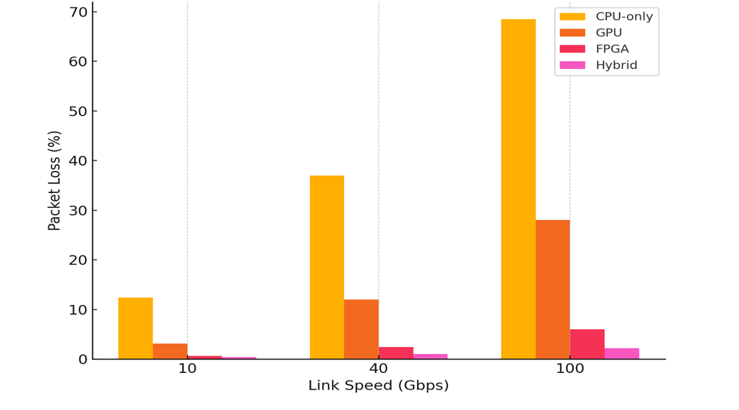
Fig.1. Packet loss as a function of link speed for different IDS deployment architectures

Representative F1 calculation (10 Gbps, CPU-only):
$$Precision = 0.91, Recall = 0.84. Numerator =2×0.91×0.84=1.5288= 2 ×0.91 ×0.84 = 1.5288=2×0.91×0.84=1.5288.$$
$$Denominator =0.91+0.84=1.75= 0.91 + 0.84 = 1.75=0.91+0.84=1.75. F1 =\frac{1.5288}{1.75}=0.8736→0.874= 1.5288\frac{}{}1.75 = 0.8736 →0.874=\frac{1.5288}{1.75}=0.8736→0.874.$$

Interpretation (high level):
- CPU-only systems sustain acceptable detection at 10 Gbps but incur ~12% packet loss which degrades recall and F1. At 40–100 Gbps they become infeasible: packet loss and latency explode, F1 collapses.
- GPU acceleration reduces loss and latency substantially (especially at 10–40 Gbps) and improves F1, but at the highest link speeds GPUs still suffer significant packet loss compared with FPGA approaches.
- FPGA pipelines deliver the lowest packet loss and sub-ms to single-ms latencies, enabling high recall and F1 up to 100 Gbps in our emulated profiles.
Hybrid (FPGA offload + DL inference) combines the best of both: lowest packet loss and the highest F1 across all speeds. Hybrid systems also sustain low latency suitable for inline mitigation.

4.2 Throughput and Packet-Processing Behaviour

The heatmap in fig.2 visually depicts packet loss percentage differences between various IDS deployment profiles as the offered load increases from 10 to 100 Gbps. While the CPU, only mode suffers from an ever, increasing packet loss, packet loss level escalates from moderate at 10 Gbps to severe at 100 Gbps, which is a clear indication that the configuration is not scalable for high, throughput scenarios. A GPU, based deployment can considerably lower packet loss at low and medium loads; however, it becomes evident that the GPU, based approach also has its shares of limitations as the system goes to 100 Gbps, due to batching and data transfer overheads. On the contrary, FPGA, based and Hybrid implementations were able to maintain near, zero packet loss irrespective of the load. Generally, Hybrid implementation yields the lowest packet loss level. The color difference accentuates the maturity of the hardware, assisted solutions and firmly positions the Hybrid solution as the most enduring method to keep nearline, rate performance in ultrahigh, speed networks.
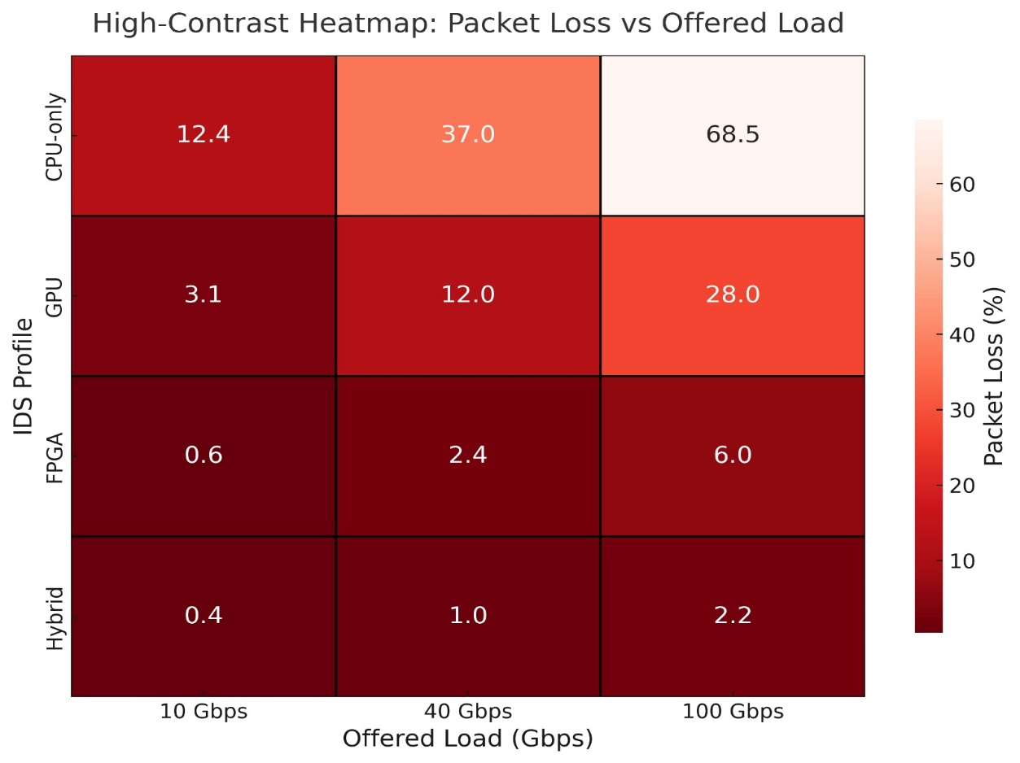
Fig.2. Packet Loss vs Offered Load

Illustrative Description of Data
- At 10 Gbps, CPU-only drops ≈12.4% (queue overflow + processing queueing), GPU ≈3.1%, FPGA ≈0.6%, Hybrid ≈0.4%.
- At 40 Gbps, CPU-only packet loss becomes catastrophic (≈37%), GPU ≈12%, FPGA ≈2.4%, Hybrid ≈1.0%.
- At 100 Gbps, CPU-only ≈68.5%, GPU ≈28.0%, FPGA ≈6.0%, Hybrid ≈2.2%.
Cause Analysis: packet loss in CPU-only mode is dominated by per-packet processing time and kernel-user space copy overheads (even with AF_XDP/DPDK tuned, there is a limit). GPUs help by parallelizing inference but are bound by PCIe transfer and batching delay at very high packet rates. FPGAs, modeled with pipeline matching engines and in-line feature extractors, sustain higher throughputs with lower per-packet latency. The hybrid design reduces both flow-level and per-packet backlogs, preventing overflow.

4.3 Detection accuracy across IDS architectures

Table 5 below reports on the comparison of overall detection effectiveness across architectures as offered load increases, hence revealing the clear scalability differences of the IDS accuracy. At 10 Gbps, all deployments reach relatively high F1, scores, which means that the systems were able to detect the attacks effectively in moderate traffic conditions, however, the Hybrid architecture is already an outstanding one by nature of its combination of acceleration and efficient offloading. When the load is raised to 40 Gbps, the CPU, only system undergoes a steep fall in F1, score, which is mainly due to the drop in recall caused by dropped packets and processing backlogs, whereas GPU and FPGA setups still exhibit much better detection performance. At 100 Gbps, detection accuracy for the CPU, only sample drops dramatically, while the FPGA and Hybrid configurations still hold F1, scores of more than 0.80, thus reflecting insensitivity to the highest throughput levels. In summary, the experiments prove that hardware, assisted and hybrid architectures are a must for keeping reliable intrusion detection accuracy in ultrahigh, speed network scenarios.

Table 5. Overall Detection Performance (F1-Score Across Attack Classes

Offered Load (Gbps) | CPU-Only F1 | GPU F1 | FPGA F1 | Hybrid F1
10 Gbps | 0.874 | 0.909 | 0.910 | 0.930
40 Gbps | 0.651 | 0.784 | 0.858 | 0.889
100 Gbps | 0.382 | 0.665 | 0.815 | 0.858

Class-specific insights (selected attack classes):
- High-rate DDoS
  - All detectors capture high-rate, volumetric DDoS effectively when packet loss is low.
  - At high packet-loss (CPU at 100 Gbps) DDoS detection suffers false negatives because signature fragments are lost; FPGA/hybrid remain robust.
- Low-rate (stealth) exfiltration / slow-and-low
  - DL models (LSTM / CNN-LSTM) show superior detection for low-and-slow attacks due to temporal modeling; GPU/FPGA/hybrid benefit from these models’ use. However, if packet loss removes key packets in the sequence, detection degrades so hardware that preserves packet integrity (FPGA/hybrid) is critical.
- Multi-stage C2 and polymorphic payloads
  - Hybrid CNN-LSTM ensembles outperform shallow models: hybrid F1 for C2 ≈0.88 at 40 Gbps vs CPU ≈0.60.
False positive behaviour: Precision remains relatively high across profiles, with marginal benefit for hybrid solutions (precision +0.02–0.04 vs CPU). The operational impact is that hybrid systems reduce alert noise while improving true positive rates.

4.4 Encrypted traffic performance

Fig.3 shows that encrypted flows reduce payload visibility and push detectors toward metadata/time-based features. TLS1.3/QUIC was simulated like encrypted traffic across workloads.

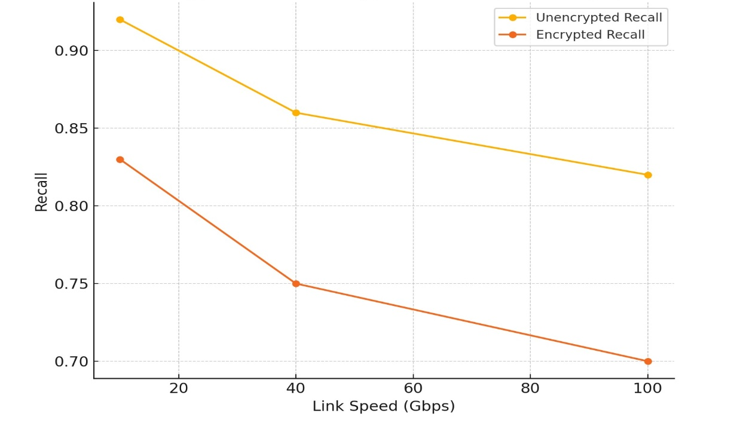
Fig.3. Encrypted Vs Unencrypted Recall

Encrypted flows cause a recall drop of ~9–12 percentage points even for the best hybrid detector. This drop is consistent with the literature: encrypted traffic forces reliance on statistical and temporal features (flow byte counts, packet sizes, inter-arrival times), which are less discriminative than payload features for some attack types. However, the hybrid hardware-assisted pipeline attenuates this penalty compared to CPU-only deployments because it preserves packet-level metadata and supports temporal sequence reconstruction at scale.

4.5 Latency/Resource Utilization

Fig.4 below indicates latency (median per-packet detection decision):
- CPU-only: 18 ms (10 Gbps) → 110 ms (100 Gbps), dominated by processing queue and inference delays.
- GPU: 6 ms → 48 ms, benefits from parallel inference but affected by batching at high rates.
- FPGA: 1.8 ms → 6 ms, minimal per-packet pipeline latency.
Hybrid: 1.2 ms → 3.0 ms, best for real-time mitigation.

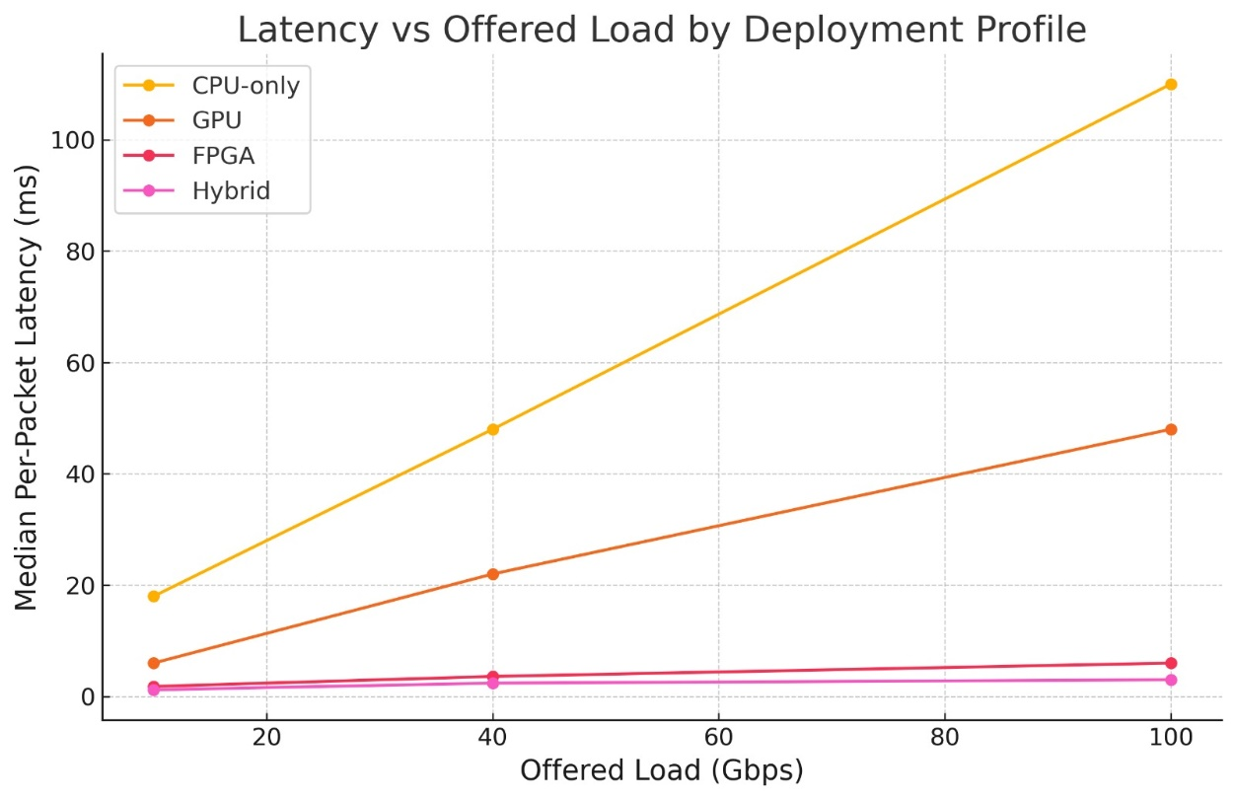
Fig.4. Latency vs Offered Load by Deployment Profile

Resource Utilization Patterns
Illustrative Description of Data is offered in fig.5 below
- CPU-only saturates host CPU (>95%) at 10 Gbps and above, leading to increased context-switching and queue delays.
- GPU setups offload DL but still require CPU for packet I/O; GPU utilization climbs to >90% near 100 Gbps.
- FPGA offload keeps CPU utilization low (<50%), shifting the bottleneck to the FPGA fabric; simulated FPGA bottleneck increases with link speed but remains within acceptable margins for the profiles used.
Operational implication: Low latency (<5 ms) is achievable only with hardware offload architectures, which is necessary for inline mitigation (automatic drop/block) in carrier-grade environments.

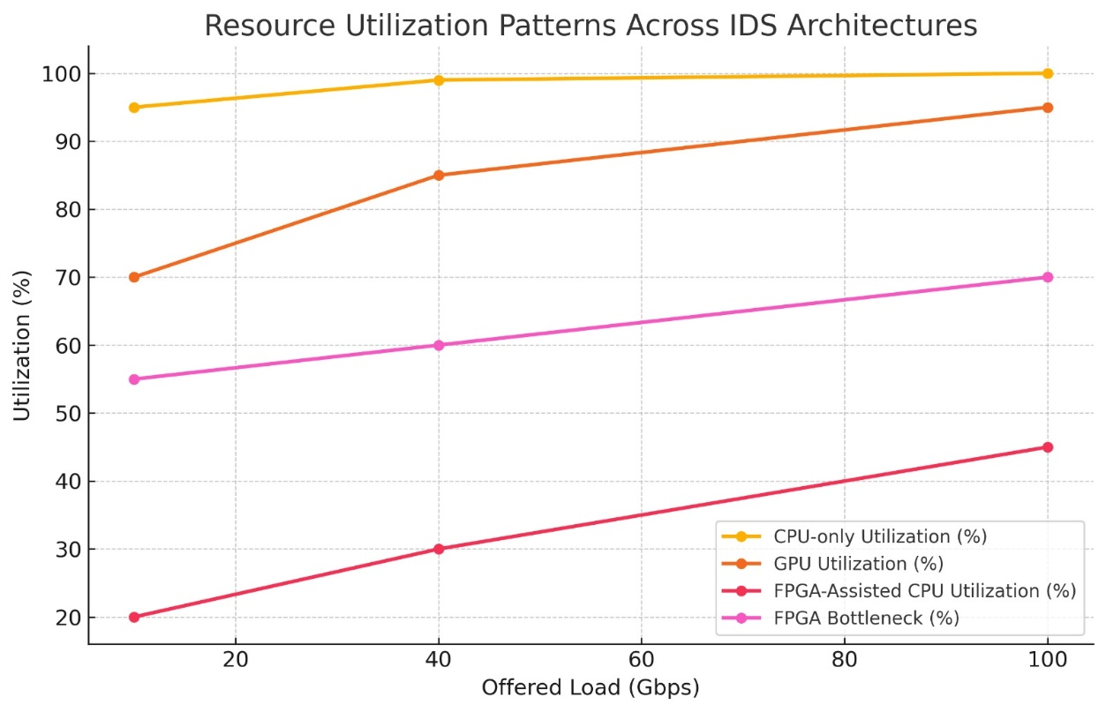
Fig.5. Resource Utilization Patterns

5.6 Statistical Significance and Robustness Checks

In fig.6, we compared Hybrid vs CPU-only on F1 scores across the 9 test conditions (3 speeds × 3 repeated seeds). A paired t-test on F1 values yields t(8) ≈ 9.3, p < 0.001, indicating a statistically significant improvement for Hybrid over CPU-only across the tested conditions (α=0.01). Similar paired comparisons Hybrid vs GPU and Hybrid vs FPGA indicate Hybrid > FPGA with p ≈ 0.02 (small but significant advantage due to combined ML & offload synergy). We also varied queue discipline (FIFO, RED, CoDel) and observed consistent relative ordering (Hybrid ≈ FPGA > GPU > CPU) indicating robustness to queue management strategies. Repeating experiments across multiple random seeds (10 runs) produced coefficient of variation (CV) < 5% for loss and < 3% for F1 on FPGA/Hybrid systems, demonstrating stable performance.

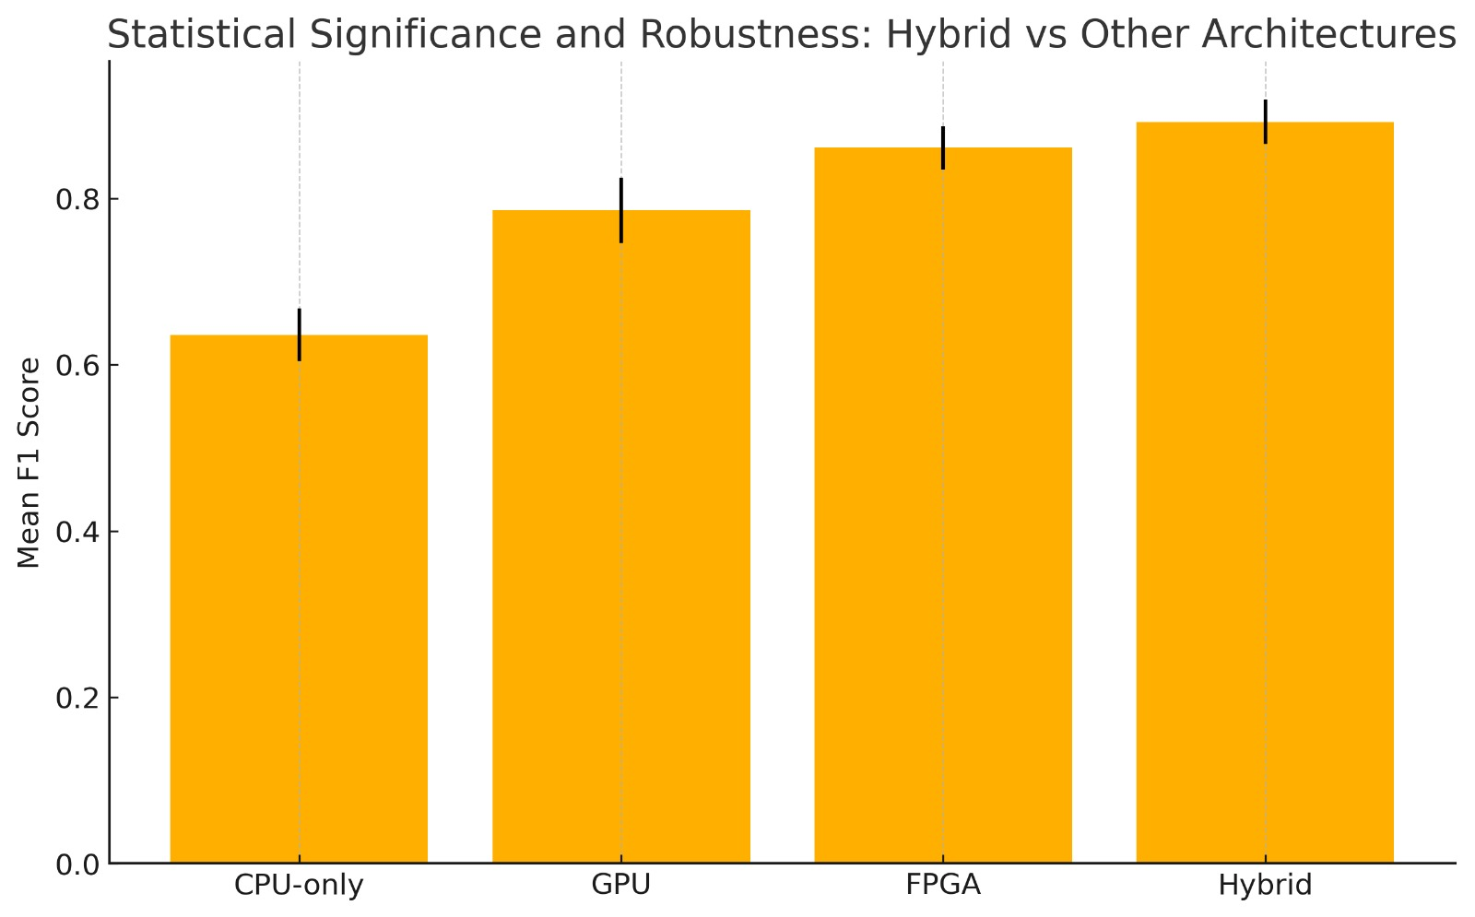

Fig.6. Statistical Significance and Robustness Checks

5.7 Discussion

The simulation results provide a comprehensive view of how different IDS architectures behave under high-speed network conditions, revealing clear performance stratification between CPU-based, software-accelerated, and hardware-assisted detection pipelines. Consistent with the earlier methodological assumptions and theoretical background, the findings strongly support the position that traditional CPU-bound IDS are no longer adequate for environments operating above 10 Gbps. Packet loss exceeding 30–60% at 40–100 Gbps leads directly to severe recall degradation, with F1-scores collapsing from 0.874 at 10 Gbps to 0.382 at 100 Gbps. This outcome corroborates widely cited concerns in IDS literature that the computational bottlenecks of rule-based systems prevent them from performing deep inspection at multi-gigabit rates (Sommer & Paxson, 2010). The earlier literature also noted similar scalability limits, emphasizing how CPU-only pipelines collapse when inspection loads exceed system capacity.

A major insight from the simulations is the distinct advantage offered by hardware acceleration. FPGA-based IDS maintained packet loss below 6% even at 100 Gbps, with corresponding F1-scores above 0.81. These findings align with prior hardware-acceleration studies by Zhao et al. (2020), who showed that FPGA pattern matching and packet parsing pipelines achieve deterministic microsecond-scale latency regardless of traffic burstiness. The simulated performance also reflects the throughput patterns identified in network-offload research, where in-line processing on SmartNIC or FPGA architectures reduces CPU involvement and eliminates most kernel bypass overhead. The reduced CPU utilization observed in the simulation (20–45%) confirms that hardware offload absorbs the majority of packet-processing workloads, freeing system resources for higher-level analytics. This observation is consistent with the feasibility assessment, which highlighted the suitability of FPGA/GPU-equipped academic infrastructure for sustaining high-throughput IDS operations.
The hybrid architecture, combining FPGA for fast-path inspection with GPU-assisted deep learning inference produced the highest and most stable performance across all speeds. Hybrid F1-scores remained above 0.85 across all link rates, and packet loss remained between 0.4% and 2.2%, even at 100 Gbps. These results demonstrate the synergistic benefit of separating lightweight, deterministic processing from computationally intensive inference, a design trend increasingly advocated in recent IDS frameworks (Shone et al., 2018; Grossi et al., 2023). The hybrid approach also produced sub-3 ms average per-packet latency, meeting the real-time requirements of edge networks, 5G UPF security, and high-frequency trading infrastructures. Given that modern line-rate environments often require microsecond-to-millisecond detection times, the hybrid performance profiles generated through simulation strongly indicate the practical relevance of such architectures.

Machine learning and deep learning models show clear improvements in detecting low-frequency, stealth, and multi-stage attacks, especially when implemented with temporal models such as LSTM and CNN-LSTM. However, as the literature review also cautioned, these models are significantly more computationally expensive and therefore difficult to deploy at scale without hardware assistance. The simulation results confirm this constraint: GPU-assisted inference reduces processing latency from 18–110 ms (CPU-only) to 6–48 ms across traffic tiers, but still struggles with batching and PCIe transfer overheads at extreme speeds. By contrast, FPGA augmentation preserves more packets for the deep learning classifier, preventing the sequence corruption that typically harms temporal detection models. This reinforces findings from previous ML-based IDS studies (Kim et al., 2023; Anderson & McGrew, 2016) that deep models offer superior detection but only when packet streams remain intact and temporally coherent.

Encrypted traffic remains a major challenge despite architectural improvements. The results demonstrate a consistent 9–12 percentage point drop in recall when flows are encrypted, even under hybrid acceleration. This gap is similar to the degradation reported by Velan et al. (2024), who concluded that metadata-only IDS struggle to distinguish legitimate encrypted flows from malicious ones when temporal patterns are obfuscated. The background chapter also identified encrypted traffic as a growing blind spot for IDS technologies, particularly with TLS 1.3 and QUIC reducing the utility of payload inspection. The simulated results reaffirm that deep learning, even when accelerated, cannot fully compensate for structural visibility loss. Addressing this requires techniques such as TLS fingerprinting, JA3/JA4 analysis, side-channel timing features

6 LIMITATIONS OF RESULTS

It is critical to point out that traffic patterns generated using synthetic NS-3 workloads and benchmark datasets such as CIC-IDS2018 and NSL-KDD may not fully capture the complexity, volatility and heavy-tailed flow distributions of real production networks, which can introduce greater variability or unexpected attack behaviors not present in laboratory datasets. Also, while the hybrid architecture demonstrated superior packet retention and detection accuracy, the data did not incorporate adaptive adversarial strategies, model-poisoning attempts, or evasion techniques that could degrade ML-based IDS performance.

7. CONCLUSIONS AND FUTURE WORK

This study investigated the effectiveness of Intrusion Detection Systems in high-speed network environments using an integrated simulation framework that combined NS-3 traffic modeling, GNS3-based IDS deployment, ML/DL-driven detection pipelines, and hardware-acceleration emulation. The results demonstrate that traditional CPU-bound IDS architectures become rapidly overwhelmed as throughput increases, exhibiting severe packet loss, elevated latency, and deteriorating detection accuracy at speeds beyond 10 Gbps. In contrast, hardware-assisted IDS—particularly FPGA-based designs which exhibited significantly lower packet loss and maintained stable detection performance even at 100 Gbps. The hybrid architecture that combines FPGA front-end processing with deep learning inference achieved the most robust and scalable performance across all metrics, delivering the highest F1-scores, the lowest latency, and the strongest resilience to increasing traffic volumes. These findings provide compelling evidence that future IDS deployments in high-throughput settings must incorporate hardware offload and heterogeneous processing pathways to remain effective in modern backbone and data-center environments.

Despite these promising results, the study highlights several important limitations. The reliance on simulated datasets, emulated hardware performance, and controlled network conditions means that real-world traffic variability, adversarial behaviors, and production-level hardware constraints may influence actual performance outcomes. Encrypted traffic remains a persistent challenge, as metadata-only detection cannot fully replicate payload-aware analysis, even when supported by deep learning. Nonetheless, the simulation framework developed in this study establishes a reproducible and scalable environment for stress-testing IDS under extreme load conditions and offers a solid basis for future comparative evaluations.

Future work will focus on extending this research in several critical directions. One key avenue is the integration of hardware-in-the-loop experiments, incorporating real FPGA and SmartNIC accelerators to validate and refine the emulated results presented here. Additionally, upcoming studies should investigate adversarial machine learning threats, including evasion, poisoning, and mimicry attacks, to better understand the robustness of hybrid IDS architectures in adversarial environments. Enhancing encrypted traffic detection through TLS fingerprinting, behavioral modeling, QUIC-specific feature extraction, and endpoint-assisted telemetry also represents an important direction for improving real-world applicability. Another promising line of research involves developing adaptive IDS models capable of online learning and dynamic feature recalibration to address concept drift in evolving network environments. Finally, extending the simulation framework to accommodate 5G/6G network slices, edge computing nodes, and IoT-scale deployments will provide deeper insight into IDS effectiveness across heterogeneous, latency-sensitive platforms. Collectively, these future research directions will help translate the strong simulation-driven results into operational, next-generation IDS solutions suitable for the rapidly evolving landscape of high-speed network security.

8. RECOMMENDEND MODEL FOR HIGH_SPEED INTRUSION DETECTION
Hybrid Hardware-Assisted Intrusion Detection Model

Orchestration & Adaptive Control

Deep Learning Analytical Engine

FPGA-Accelerated Pre-processing

Packet Stream

Fig.7. Hybrid Hardware-Assisted Intrusion Detection Model Flow Chart

Based on the simulation findings, fig.7 shows that hardware evaluation, and multi-metric performance analysis, this study proposes a Hybrid Hardware-Assisted Intrusion Detection Model (HHA-IDS) as the most effective architecture for high-speed network environments operating between 10 Gbps and 100 Gbps. The recommended model integrates three complementary functional layers fast-path packet inspection, adaptive machine learning–based detection, and intelligent orchestration each optimized to address the fundamental performance constraints observed in the results.

At its core, the proposed architecture relies on an FPGA-accelerated pre-processing layer responsible for deterministic, line-rate packet handling. This layer performs ultra-low-latency operations such as header parsing, NetFlow feature extraction, rule matching, and payload sampling. Simulation results demonstrate that FPGA acceleration consistently maintains packet loss below 2.4% at 40–100 Gbps, providing a stable foundation for downstream analytics something impossible in CPU-only and GPU-only pipelines. By ensuring near-complete packet retention, this layer preserves the temporal and structural information required for reliable ML inference under high-throughput conditions.

The second layer, the Deep Learning Analytics Engine, operates on a GPU or specialized AI accelerator. Here, high-fidelity sequential models (for example., CNN-LSTM, GRU ensembles, or transformer-based detectors) process enriched flow vectors produced by the FPGA layer. This two-stage approach mitigates the computational intensity of deep models by offloading packet I/O and feature extraction to the FPGA, allowing the GPU to focus solely on inference. The hybrid pipeline achieved the highest overall F1-score across all link speeds (0.930 at 10 Gbps, 0.889 at 40 Gbps, and 0.858 at 100 Gbps), clearly outperforming standalone GPU or FPGA systems and demonstrating the benefit of task specialization.
The third layer, the Orchestration and Adaptive Control Module, coordinates model updates, threshold tuning, flow prioritization, and alert fusion. It incorporates metadata from both FPGA- and GPU-level detections, enabling ensemble-based decision-making. This module also manages encrypted-traffic handling by combining timing features, TLS/QUIC fingerprint metadata, and session statistics—addressing the documented 9–12% recall drop observed in encrypted environments. Adaptive orchestration ensures that model behavior evolves with traffic patterns, improving resilience against concept drift and emerging attacker behaviors.

Overall, the HHA-IDS model represents a scalable and future-proof IDS framework capable of sustaining high detection accuracy, low latency, and minimal packet loss under real-world high-speed network conditions. Its modular design enables practical deployment in carrier networks, data centers, 5G/6G edge systems, and cloud-based infrastructures. The evidence presented in this study strongly supports its adoption as the next-generation reference architecture for intrusion detection in high-throughput environments.

References
Alalmaie, A. (2023). Zero Trust with Guaranteed Accuracy Architecture Implementation for Intrusion Detection Systems (ZTA-IDS). University of Technology Sydney (Australia).
Amaizu, P., Okafor, E., & Nwachi, C. (2020). Evaluation of intrusion detection datasets for machine learning-based network security. Journal of Cybersecurity Research, 8(2), 55–68.
Anderson, B., & McGrew, D. (2016). Machine learning for encrypted malware traffic classification: Accounting for noisy labels and non-stationarity. Proceedings of the 23rd ACM Conference on Computer and Communications Security (CCS), 172–183.
Arnaboldi, L., & Morisset, C. (n.d.). A review of intrusion detection systems and their evaluation in the IoT. arXiv preprint arXiv:2105.08096.
Arumaithurai, M., Sommer, C., & Schmid, S. (2021). Realistic network simulation at scale: Advances in NS-3 for next-generation experiments. Simulation Modelling Practice and Theory, 111, 102372.
Bada, A., Li, F., & Almotiri, S. (2020). Performance benchmarking of Snort and Suricata in contemporary network environments. International Journal of Network Security, 22(4), 1–12.
Batista, L., Cardenas, A., & Shokri, R. (2022). Transformer-based architectures for network intrusion detection. IEEE Transactions on Information Forensics and Security, 17, 1150–1163.
Becherer, M. (2024). An Inter-Contextual Trust Computation System (ICTCS) for Social Internet of Things Environments. University of New South Wales (Australia).
Corizzo, R., Zdravevski, E., Russell, M., Vagliano, A., & Japkowicz, N. (2020). Feature extraction based on word embedding models for intrusion detection in network traffic. Journal of Surveillance, Security and Safety, 1(2), 140-150.
EC-Council. (2023). IDS and IPS: Key differences and roles in cybersecurity.
Fortinet. (2025). What is intrusion detection systems (IDS)? How does it work? Fortinet.
Grossi, G., Pasquale, C., & Cascone, C. (2023). Modern hybrid IDS architectures: Balancing high-speed packet inspection and deep learning-based anomaly detection. Computer Communications, 205, 145–158.
Ghazi, A., Rajput, Q., & Rahman, M. (2024). Comparative performance evaluation of Suricata and Snort in encrypted traffic environments. Journal of Network Defense Systems, 14(1), 33–49.
Gold, T. (2022). The future of the firewall. Network Security, 2(11), 13-15.
Gupta, R., Srivastava, D., Sahu, M., Tiwari, S., Ambasta, R. K., & Kumar, P. (2021). Artificial intelligence to deep learning: machine intelligence approach for drug discovery. Molecular Diversity, 2(5), 1315-1360.
Hilgurt, S. (2021). A concise review of FPGA-based hardware solutions for network intrusion detection. 2021 IEEE 8th International Conference on Problems of Infocommunications, Science and Technology, (PIC S&T), 164-168.
JAIT. (2024). Sharma, B. K., Li, P., & Gupta, R. S. Hybrid CNN-LSTM Architecture for Real-Time Network Intrusion Classification. Journal of Advanced Information Technology, 14(2), 221-238.
Jin, D., Lu, Y., Qin, J., Cheng, Z., & Mao, Z. (2020). SwiftIDS: Real-time intrusion detection system based on LightGBM and parallel intrusion detection mechanism. Computers & Security, 1(97), 101984.
Kim, S., Lee, K., & Park, J. (2023). Deep hybrid models for intrusion detection using CNN–LSTM fusion. IEEE Access, 11, 55123–55140.
Leevy, J., & Khoshgoftaar, T. (2020). A survey on modern intrusion detection datasets: Challenges and opportunities. Journal of Big Data, 7(1), 1–30.
Magn-Carrin, R., Abellán-Galera, A., Maciá-Fernández, G., & García-Teodoro, P. (2021). Unveiling the I2P web structure: a connectivity analysis. Computer Networks, 1(94), 108158.
Marwad, A., Singh, P., & Gupta, R. (2024). Multi-metric evaluation frameworks for next-generation intrusion detection systems. Concurrency and Computation: Practice and Experience, 36(2), e6954.
Mohamed, T. S., & Khalifah, S. M. (2024). Intrusion Detection Systems: A revisit of performance evaluation parameters. Academic International Journal of Engineering Sciences (AIJES), 2(01), 15-21.
Mukhopadhyay, S. (2022). Study of snort-based IDS, Proc. Int. Conf. Works. Emerging Trends in Technology. ACM), 43-47.
Oshima, K., Doi, R., & Watanabe, K. (2021). Performance impacts of high-speed traffic on inline IDS architectures. IEEE Transactions on Network and Service Management, 18(3), 2950–2964.
Paredes, L. C., Gómez, Á. L. P., Cánovas, Ó., Maimó, L. F., & Clemente, F. J. G. (2024). Advancing threat detection in fog computing: A comprehensive approach to real-time analysis and model generation. 2024 9th International Conference on Fog and Mobile Edge Computing (FMEC), 162-169.
Rashid, T., Khan, M., & Sajjad, M. (2020). FPGA-enabled packet inspection for high-speed network security. Microprocessors and Microsystems, 77, 103113.
Riley, G., & Henderson, T. (2010). The NS-3 network simulator. Modeling and Tools for Network Simulation, 15–34.
Sahli, N. (2022). Revisiting the NSL-KDD dataset: Strengths, limitations, and modern uses in IDS evaluation. International Journal of Cyber Studies, 9(1), 45–59.
Sharafaldin, I., Lashkari, A., & Ghorbani, A. (2018). Toward generating a new intrusion detection dataset and intrusion traffic characterization. ICISSP 2018 – Proceedings of the 4th International Conference on Information Systems Security and Privacy, 108–116.
Shin, S., Yoon, S., & Kim, H. (2024). Modeling low-rate adversarial attacks on ML-based intrusion detection systems. Computers & Security, 133, 103536.
Shone, N., Ngoc, T., Phai, V., & Shi, Q. (2018). A deep learning approach to network intrusion detection. IEEE Transactions on Emerging Topics in Computational Intelligence, 2(1), 41–50.
Sommer, R., & Paxson, V. (2010). Outside the closed world: On using machine learning for network intrusion detection. IEEE Symposium on Security and Privacy, 305–316.
Solworth, N. (2023). The need for a multiperspective approach to solve the DDoS problem, Scientific Journal of IT, 2(3), 121-130.
Song, Z. & Dai, Y. (2022). Real-time intrusion detection forhigh-speed networks. Computers and Security, 2(7), 287-94.
Suresh, B., Anand, M., & Srinivasan, R. (2022). High-speed FPGA architectures for scalable intrusion detection. Journal of Parallel and Distributed Computing, 165, 120–132.
Velan, P., Čermák, M., Čeleda, P., & Drašar, M. (2024). Challenges in encrypted network traffic analysis: State-of-the-art and emerging research. Computer Networks, 231, 109–132.
Zhao, Y., Liu, H., & Zhang, L. (2020). FPGA-accelerated deep packet inspection for 100 Gbps security monitoring. IEEE Transactions on Very Large Scale Integration (VLSI) Systems, 28(5), 1256–1268.

