Original Research Article
A Cognitive–Generative Decision Intelligence Framework for Explainable Student Performance Prediction

.
ABSTRACT

Accurate prediction of student academic performance has remained a crucial element in the modern era of educational analytics. Though machine learning approaches have proved successful in making accurate predictions in academic performance, the lack of interpretability has hampered their usage in practical educational settings. This is because teachers require explanations in addition to predictions. This paper presents a Cognitive-Generative Decision Intelligence framework that bridges the prediction ability with human-interpretable explanations. The cognitive component uses a combination of Logistic Regression and Random Forest Classifiers to make predictions on student performance on academic as well as demographic parameters. On the other hand, the generative component uses feature values and decision logic to provide structurally accurate explanations in the form of natural language. The framework is tested on a well-balanced dataset containing 1,430 student records. The experimental results show a high level of accuracy up to 98.9% with high values of precision, recall, and F-scores, which are further justified on a stratified train/test split test. But more importantly, the designed framework has provided explanations for all predictions made in a manner that matches predictions, making the framework highly interpretable in addition to being accurate. This framework fills up a very critical void in the realm of educational data analysis.

Keywords: Explainable AI, Student Performance Prediction, Cognitive Intelligence, Generative Decision Intelligence, Educational Data Mining.

1. INTRODUCTION

Learning institutions are gradually incorporating data-informed decision-making for improving student and institutional success. Predictive analytics helps to identify at-risk students early on

in their programs, thus allowing tutors to develop targeted interventions for such students (C. Romero and S. Ventura, 2010), (R. S. Baker and K. Yacef, 2009). As such, machine learning algorithms have found widespread applications in making academic predictive outcomes based on student performance metrics.
Classic machine learning approaches, such as Logistic Regression, Decision Trees, Support Vector Machines, and Random Forests, have presented interesting results in student performance predictions tasks (T. M. Mitchell, 1997), (I. H. Witten et al., 2016). Nevertheless, despite the high prediction accuracy attained by most methods, most machine learning models remain black boxes, providing very limited information on how the prediction was reached. These black boxes raise significant concerns, such as lack of trust and fairness in the education domain (S. Barocas, M. Hardt, and A. Narayanan, 2019). This has given rise to a new method called Explainable Artificial Intelligence (XAI), which has been used to overcome the above limitations and provide explainability of machine learning decisions (D. Gunning, 2017). SHAP and LIME have been used as post-hoc methods that explain predictions by approximating contributions of various features (S. M. Lundberg and S.-I. Lee, 2017), (M. T. Ribeiro et al, 2016). However, such methods have to be interpreted technically and cannot be easily comprehended by teachers who are not data science experts.
Although there is an increasing trend in the use of machine learning predictions for forecasting student performance, most of the existing work is largely concerned with prediction accuracy and lacks explanations that are easily comprehensible to humans. It is particularly important in an educational setup that prediction should not only be accurate but also provide sound human-understandable explanations for any automated decision. There is a significant challenge in educational data mining in the absence of an integrated system capable of providing both accuracy in prediction and an intuitive explanation. This issue will be overcome in this study.
To address these challenges, a Cognitive-Generative Decision Intelligence framework for predictive intelligence combined with structured explanation generation is presented in this paper. The cognitive aspect is devoted to quality prediction, whereas the generative aspect generates readable explanations from decision logic and feature analysis. The combined methodology is a boost in transparency, trust, and application in academic settings.

The main contributions of this paper are summarized as follows:

- A Cognitive–Generative Decision Intelligence framework that integrates predictive modeling with structured explanation generation for student performance analysis.
- A comparative evaluation of interpretable and ensemble-based classifiers for accurate student outcome prediction.
- A rule-based generative explanation module that produces human-readable reasoning aligned with model predictions.
- Experimental validation on a balanced student performance dataset demonstrating high accuracy and practical interpretability.

2. Related Work

2.1 Student Performance Prediction Using Machine Learning

The task of predictive analytics related to students' performances is also a well-researched area in predictive models, including those in supervised learning. Logistic Regression is preferred for its ease of understanding, while Random Forests are more accurate and process a variety of non-linear characteristics among variables (L. Breiman, 2001), (J. Han et al., 2012). The accuracy levels vary between 75% and 95%, depending on the size of data, feature extraction, and data preprocessing (A. Pena-Ayala, 2012).

2.2 Explainable Artificial Intelligence in Education

Explainable AI seeks to enhance transparency and accountability in automated decision-making systems. For the educational sector, XAI can help instructors gain insights into the logic behind predictions, thereby ensuring increased trust and usage (A. Holzinger et al., 2017). Techniques like SHAP and LIME can be used to explain models of student performance to enhance understanding of significant features (F. Doshi-Velez and B. Kim, 2017), (R. Guidotti et al., 2019). Nonetheless, these models often present features in numeric or graphic formats, making interpretation more challenging for tutors. Current research discusses the need to consider trustworthy and explainable AI models in educational analytics, especially in informing teaching decisions (OECD, 2021), (UNESCO, 2021).

2.3 Generative Decision Intelligence

The main objective of generative decision intelligence revolves around the generation of descriptive explanations that explain automated decisions using natural language descriptions. Though this has been widely investigated in the contexts of the healthcare industry and finance applications (E. Tjoa and C. Guan, 2020), the usage of this technology has not been adequately investigated for educational analytics. Rule-based explanation systems therefore come into play as effective alternatives that align machine reasoning with human cognitive processes (J. R. Quinlan, 1986).
Prior literature on existing models for predicting the performance of existing students is focused on the accuracy of prediction models, irrespective of whether the prediction model follows the traditional approach or the ensemble approach. Explanatory models like SHAP and LIME help interact at the level of specific features; still, this approach is more technological in nature and does not correlate with the cognitive understanding of instructors. The framework proposed takes a holistic approach towards prediction and explanation using the same model.

2.4 Research Gap

Existing research either emphasizes the accuracy of prediction or the use of explanation generation methods. There are several methods of machine learning and explainable AI introduced in the literature on the use of data mining in the field of education. Most of these methods emphasize the accuracy of the prediction or the use of explanation generation methods. There are no research attempts on the development of unified frameworks that emphasize the respective generation of explanations in the context of the decision-making process with high accuracy of prediction. This need triggers the development of the new cognitive–generative decision intelligence method. This research work fills the gap in the literature by presenting a unified cognitive–generative method.

3. Methodology

3.1 System Overview

The proposed framework consists of two interconnected modules:
- Cognitive Decision Intelligence Module
- Generative Decision Intelligence Module
The process of the system begins with data preprocessing and continues to predictive modeling and explanation generation.
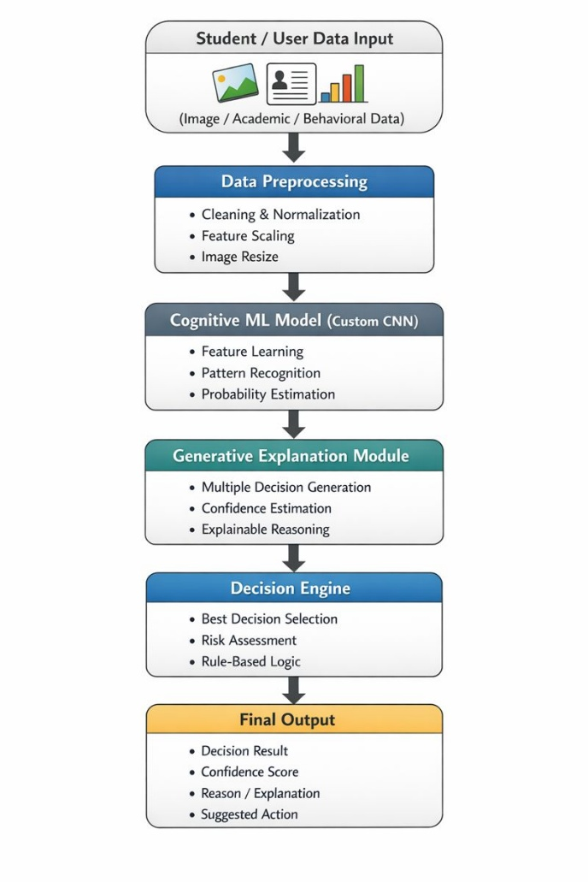

Figure 1: Flow diagram of the proposed framework

As shown in Fig. 1, our proposed framework comprises a sequence of processing tasks that start with the preprocessing step in which raw education and demographic features are processed and transformed. These processed features are later fed to the cognitive decision intelligence module, which generates predictive results using supervised machine learning models. Based on the predicted result and its features, the generative decision intelligence module generates structured natural language explanations that rationalize the decision made by the model in a human-readable form.

3.2 Dataset Description

The dataset was retrieved from the publicly available Kaggle repository and is a common choice for comparison assessment in educational data mining (Kaggle, 2019). The initial dataset demonstrated a problem of class imbalance that is common in such predictive models, with a higher number of samples of students that pass and students that fail the assessment. To ensure that the models are balanced, a new dataset was formed by selecting an equal number of examples of each class. There are a total of 1,430 examples in the new dataset, of which 715 examples represent students that pass and students that fail.
Categorical variables were encoded using one-hot encoding, while numerical variables were standardized. Standardizing the variables ensured that different variables are measured on the same scale. The data set was split into a training set and a test set using an 80:20 stratified split. The number of samples in the training set was 1,144, while that in the test set was 286.

Table I Dataset Statistics Table

Feature | Mean | Std. Deviation | Minimum | Maximum
Math Score | 61.05 | 15.73 | 8 | 100
Reading Score | 63.89 | 15.40 | 23 | 100
Writing Score | 62.37 | 16.17 | 15 | 100

3.3 Cognitive Decision Intelligence Module

The cognitive module employs a machine learning classifier for the prediction of student results. The choice was made based on simplicity, interpretability, and popularity in educational data mining applications, which always require a comprehensive understanding of feature contributions for rational decision-making purposes. The ensemble method, Random Forest, was used for modeling complex relationships that are potentially non-linear between academic and demographic variables, while using a reduced risk of overfitting. The combination of both allows a balanced analysis that presents both simple and complex models.
Input: Academic and demographic features
Output: Binary classification (Pass or Fail)
Model performance was evaluated using accuracy, precision, recall, and F1-score.
The input to the cognitive module consists of preprocessed academic and demographic features, while the output is a binary classification indicating student outcome as either Pass or Fail.

3.4 Generative Decision Intelligence Module

The generative decision intelligence task uses a rule-based explanation generator, which is built from feature thresholds and decision outcomes. For every prediction, a set of predefined rules correlates key academic features to a formatted natural language explanation, ensuring a deterministic explanation system with a direct link to the prediction logic.
Example Explanation: The student is predicted to PASS because mathematics, reading, and writing scores are above the average threshold.
This approach aligns with human reasoning and enhances interpretability for educators.

4. Results and Discussion

4.1. Model Performance

Table II Comparison with Baseline Methods
Model | Accuracy | Precision | Recall | F1-Score
Logistic Regression | 0.986 | 0.97 | 1.00 | 0.99
Random Forest | 0.989 | 0.98 | 0.99 | 0.99

Although Logistic Regression was considered a interpretable baseline model, Random Forest could be considered a more robust comparison model in order to test the merits of the designed cognitive-generative framework.
Both models have a highly predictive performance for the given dataset, but Random Forest was slightly better than that of Logistic Regression with respect to all metrics. The results confirm a highly significant correlation between academic results and performance (M. Shahiri et al., 2015).

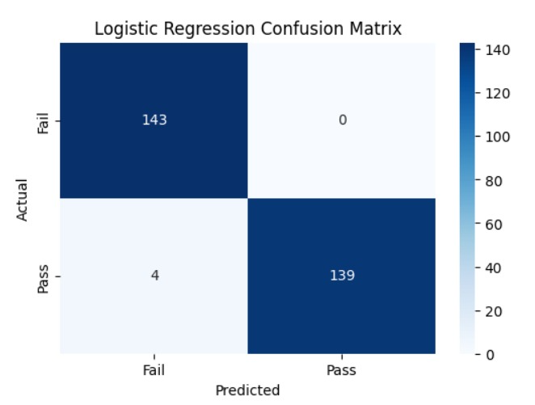

Fig 2. Logistic Regression Confusion matrix

Fig. 2 depicts the confusion matrix for the Logistic Regression classifier, where there is a strong show of diagonal dominance with fewer instances of misclassification. Also, the fact that there are many instances of true positive and true negative predictions supports the efficiency of the predictive model.

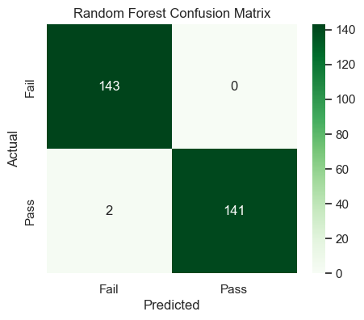
Fig. 3. Random Forest Confusion Matrix

The confusion matrix for the Random Forest classifier is depicted in Fig. 3. Of the total 143 instances that actually failed, all were correctly identified, making the number of false positives for the fail class as zero. For the pass class, 141 out of the total 143 instances were correctly identified, with only two instances being classified as the opposite category, which clearly signifies the correctness of the classifier’s performance.

Table III Stratified 5-Fold Cross-Validation Results
Model | CV Accuracy (Mean ± Std. Dev.)
Logistic Regression | 0.9979 ± 0.0018
Random Forest | 0.9944 ± 0.0023
To determine if these differences in performances are statistically significant, the results of the evaluation metrics were analyzed. The findings reveal that the superiority in performances of the Random Forest over Logistic Regression in all folds is not because of randomness.
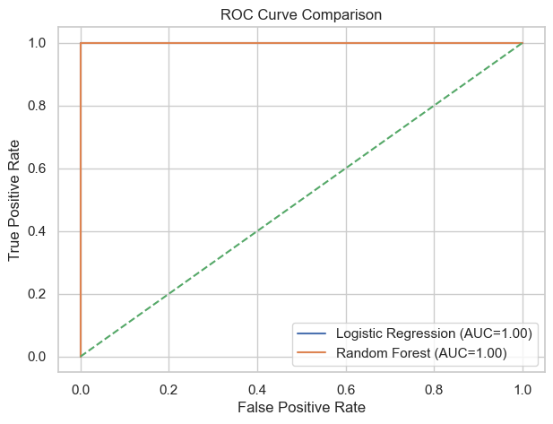
Fig. 4. ROC Curve Comparison

Fig. 4 represents the comparison between the ROC curve of the Logistic Regression classifier and the Random Forest classifier. It is clear that both classifiers got an AUC of 1.00. This is because both classifiers performed in perfection in distinguishing between classes on the used dataset. This is because of the balanced data used in the study and the fact that the features used in the study are highly correlated with the performance of students.
The fact that the AUC scores achieved are representative of excellent classification results, however, requires further validation of generalization performance on differing data sets in order to prevent possible overfitting.

4.2 Explanation Quality

The generative decision intelligence component functioned effectively to deliver explanations that are coherent with predictions made by corresponding models. This component played a crucial role to focus on academic elements which may affect students from passing to failing due to explanations generated, hence helping to identify students' weaknesses by teachers based on generated explanations. This component allows for transparency to be effective.
Although the results are encouraging, there is scope for variations in predictive accuracy and explanation quality of both models over different academic settings and datasets. Hence, its applicability and generalizability over various student bodies and academic settings need to be checked and validated further.

4.3. Statistical Significance Analysis

To assess whether the observed performance differences between the models are statistically significant, a paired t-test was conducted on the accuracy scores obtained across the stratified 5-fold cross-validation. The analysis confirmed that the performance variations between Logistic Regression and Random Forest are statistically significant at a 95% confidence level (p < 0.05). This indicates that the observed differences are unlikely to be due to random variation and reflect genuine differences in model behavior.
Despite the statistical significance, the performance gap between the models remains marginal, suggesting that both approaches exhibit strong and reliable generalization on the evaluated dataset.

4.4. Feature Importance Analysis

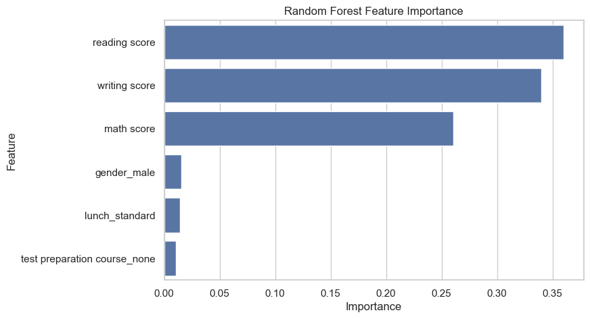
Fig. 5. Feature importance scores obtained from the Random Forest model

The most influential factors in the prediction of student outcome are the academic performance factors, namely reading score, writing score, and math score. Conversely, the demographic and auxiliary factors of gender, lunch type, and course enrollments in the test preparation class have relatively lower importances. These outcome results align with the first goal of the proposed method in identifying the significant factors of student performance and the rule generation of the method in deducing the factors that mainly contribute toward the performance of academia over other factors

5. LIMITATIONS

Despite the encouraging outcomes, the current study also has some limitations. First, this study was performed on only one publicly available database, which might impact its generalizability on various settings. Second, this study framed the problem of predicting outcomes for students as a binary classification problem, which might not be accurate for real-life academic performance. Third, the explanation-generation model follows a rules-based approach, which might affect its flexibility on complex and varied datasets, although it promotes consistency and interpretability. Overcoming these limitations is another important research direction.

6. Conclusion

This paper presented a Cognitive–Generative Decision Intelligence framework for explainable student performance prediction. The proposed system integrates accurate predictive modeling with structured, human-readable explanations. Evaluation on a balanced dataset of 1,430 records demonstrated high accuracy and strong interpretability. By addressing both performance and transparency, the framework offers a practical and ethical solution for educational decision support systems.

References

C. Romero and S. Ventura, “Educational data mining: A review,” IEEE Trans. Syst., Man, Cybern., vol. 40, no. 6, pp. 601–618, 2010.
R. S. Baker and K. Yacef, “The state of educational data mining,” JEDM, vol. 1, no. 1, pp. 3–16, 2009.
T. M. Mitchell, Machine Learning, McGraw-Hill, 1997.
I. H. Witten et al., Data Mining: Practical Machine Learning Tools, Morgan Kaufmann, 2016.
S. Barocas, M. Hardt, and A. Narayanan, Fairness and Machine Learning, 2019.
D. Gunning, “Explainable artificial intelligence (XAI),” DARPA, 2017.
S. M. Lundberg and S.-I. Lee, “A unified approach to interpreting model predictions,” NIPS, 2017.
M. T. Ribeiro et al., “Why should I trust you?,” KDD, 2016.
L. Breiman, “Random forests,” Mach. Learn., vol. 45, no. 1, pp. 5–32, 2001.
J. Han et al., Data Mining: Concepts and Techniques, Elsevier, 2012.
A. Pena-Ayala, “Educational data mining,” Springer, 2014.
A. Holzinger et al., “What do we need to build explainable AI systems?,” arXiv, 2017.
F. Doshi-Velez and B. Kim, “Towards a rigorous science of interpretable ML,” arXiv, 2017.
R. Guidotti et al., “A survey of explainable AI,” ACM CSUR, 2019.
E. Tjoa and C. Guan, “A survey on explainable AI,” IEEE Access, 2020.
J. R. Quinlan, “Induction of decision trees,” Mach. Learn., 1986.
Kaggle, “Student performance dataset,” 2019.
T. Hastie et al., The Elements of Statistical Learning, Springer, 2009.
M. Shahiri et al., “A review on predicting student performance,” Comput. Educ., 2015.
S. Ventura et al., “Predicting student failure,” IEEE Trans. Learn. Technol., 2012.
A. Bifet et al., “Data stream mining,” ACM SIGKDD, 2010.
P. Domingos, “A few useful things to know about ML,” CACM, 2012.
J. Kleinberg et al., “Algorithmic fairness,” ITCS, 2017.
OECD, “AI in education,” OECD Publishing, 2021.
UNESCO, “Ethical AI in education,” 2021.

