Case report
A Pseudotumoral Lesion of the Mitral Annulus: Diagnostic Approach and Clinical Implications

Abstract
Background:
Caseous calcification of the mitral annulus (CCMA) is a rare variant of mitral annular calcification characterized by liquefaction necrosis within chronically calcified annular tissue. Its pseudotumoral appearance may mimic cardiac tumors or infective processes, creating significant diagnostic challenges.
Case Presentation:
An 81-year-old woman was referred for preoperative cardiac evaluation prior to elective hip arthroplasty. She was asymptomatic (NYHA class I). Transthoracic echocardiography revealed a well-defined mass (23 × 20 mm) located at the posterior mitral annulus, associated with moderate mitral stenosis (mitral valve area 1.9 cm², mean gradient 5 mmHg). Left ventricular systolic function was preserved. Cardiac magnetic resonance imaging demonstrated a hypointense lesion with peripheral late gadolinium enhancement, while computed tomography confirmed a hypodense mass with peripheral calcifications, consistent with caseous degeneration. Laboratory findings were unremarkable. A conservative approach was adopted. The patient underwent orthopedic surgery without complications, and six-month follow-up echocardiography showed stable findings.
Conclusion:
CCMA should be considered in the differential diagnosis of mitral annular masses in elderly patients. Multimodality imaging plays a pivotal role in establishing the diagnosis and preventing unnecessary surgical intervention.
Keywords
Caseous calcification; Mitral annulus; Mitral annular calcification; Cardiac mass; Multimodality imaging; Cardiac CT; Cardiac MRI; Mitral stenosis.

Introduction :
Caseous calcification of the mitral annulus (CCMA) is an uncommon variant of mitral annular calcification (MAC), characterized by liquefaction necrosis within chronically calcified annular tissue (1,3). Although MAC itself is a frequent finding in elderly populations, particularly among women, CCMA represents a rare subtype, with a reported prevalence ranging from 0.06% to 0.07% in patients undergoing transthoracic echocardiography and accounting for less than 1% of all MAC cases (1,2).
First described in pathological studies by Pomerance in 1970 (3), CCMA most commonly involves the posterior mitral annulus and may appear as a rounded, well-defined mass. Its pseudotumoral morphology frequently leads to diagnostic uncertainty, as it may mimic atrial myxoma, mitral annular abscess, infective endocarditis, or other primary cardiac tumors (4,5). Misinterpretation can result in unnecessary invasive investigations or surgical intervention (6).
The development of multimodality imaging has significantly improved the noninvasive characterization of such lesions. While echocardiography remains the initial diagnostic tool, cardiac magnetic resonance imaging (MRI) and computed tomography (CT) provide complementary information that enables more accurate tissue characterization and differentiation from malignant or infectious processes (4,7).
We report the case of an elderly woman in whom a pseudotumoral mitral annular lesion was incidentally Discover Ed during preoperative assessment. This case highlights the diagnostic approach and clinical implications of CCMA, emphasizing the essential role of multimodal cardiac imaging in preventing misdiagnosis and inappropriate management.
Case report :
An 81-year-old woman was referred to our cardiology department for preoperative cardiac evaluation prior to elective left hip arthroplasty. She had no history of hypertension, diabetes mellitus, chronic kidney disease, or known cardiovascular disease. She was asymptomatic from a cardiovascular standpoint and was classified as New York Heart Association (NYHA) functional class I.
On physical examination, blood pressure was 123/74 mmHg. Cardiac auscultation revealed an accentuated first heart sound at the mitral area and a low-pitched diastolic rumble at the apex. No peripheral signs of heart failure were noted. Electrocardiography showed normal sinus rhythm without conduction abnormalities or ischemic changes.
Transthoracic echocardiography demonstrated a well-circumscribed echogenic mass located on the posterior mitral annulus, protruding toward the left atrium (Figure 1A, 1B). The lesion measured 23 × 20 mm and appeared non-mobile. It was associated with moderate mitral stenosis, with a mitral valve area of 1.9 cm² by planimetry and a mean transmitral gradient of 5 mmHg. Left ventricular ejection fraction was preserved at 55%. Estimated pulmonary artery systolic pressure was 26 mmHg. No additional valvular calcifications were identified.
Given the pseudotumoral appearance of the lesion, further imaging was performed for tissue characterization.
Cardiac magnetic resonance imaging revealed a well-defined mass located at the posterior mitral annulus. On axial T1-weighted sequences, the lesion appeared hypointense (Figure 2A). Post-contrast T1-weighted imaging following gadolinium administration demonstrated peripheral enhancement consistent with a caseous necrotic core (Figure 2B). T2-weighted sequences showed low signal intensity, indicating absence of edema and further supporting the diagnosis of caseous degeneration (Figure 2C).
Multislice cardiac computed tomography confirmed the presence of a round hypodense mass with peripheral linear calcifications at the posterior mitral annulus (Figure 3), findings highly suggestive of caseous calcification of the mitral annulus.
Laboratory investigations revealed hemoglobin of 13 g/dL, leukocyte count of 6,420/mm³, and platelet count of 240,000/mm³. Renal function was preserved (urea 0.54 g/L, creatinine 9 mg/L), and phosphocalcic balance was within normal limits. There were no biological signs of infection.
Given the absence of symptoms and only moderate mitral stenosis without pulmonary hypertension, a conservative strategy with periodic imaging follow-up was adopted. The patient underwent orthopedic surgery without perioperative cardiac complications. Follow-up transthoracic echocardiography at six months demonstrated stability of lesion size and hemodynamic parameters.
Discussion :
Caseous calcification of the mitral annulus (CCMA) is a rare variant of mitral annular calcification (MAC), with a reported prevalence of approximately 0.06–0.07% in patients undergoing transthoracic echocardiography and representing less than 1% of MAC cases (1,2). First described by Pomerance in 1970, this entity is characterized by liquefaction necrosis within chronic calcified deposits of the posterior mitral annulus (3).
CCMA predominantly affects elderly women and has been associated with hypertension, chronic kidney disease, and disorders of calcium-phosphate metabolism, although such risk factors were absent in our patient (2,4).
Diagnostic Challenge
The principal clinical issue is its pseudotumoral appearance. On echocardiography, CCMA typically appears as a round, well-circumscribed echodense mass located at the posterior mitral annulus (1). However, when protruding into the left atrium, it may mimic:
- Atrial myxoma
- Mitral annular abscess
- Infective endocarditis vegetation
- Primary or metastatic cardiac tumors
Several reports describe cases initially misdiagnosed as cardiac tumors, leading to unnecessary surgical exploration (5,6).
Cardiac magnetic resonance imaging plays an important role in tissue characterization. CCMA typically demonstrates low signal intensity on both T1- and T2-weighted sequences, with peripheral late gadolinium enhancement corresponding to a fibrotic capsule surrounding central caseous material (7).
Cardiac computed tomography is particularly useful for confirming the diagnosis. The characteristic finding is a hyperdense mass with a central hypodense area and peripheral calcifications, which strongly supports CCMA (4,8). CT is especially valuable in excluding malignant or infectious etiologies.
Clinical Implications
Although generally considered benign, CCMA may be associated with mitral valve dysfunction, systemic embolization, and conduction disturbances (2,9). In our patient, moderate mitral stenosis was observed (mitral valve area 1.9 cm², mean gradient 5 mmHg), without pulmonary hypertension or functional limitation (NYHA I).
Longitudinal data suggest that most cases remain stable over time, supporting conservative management in asymptomatic patients (2). Surgical intervention is reserved for severe symptomatic valvular dysfunction or persistent diagnostic uncertainty (6).
In the present case, accurate multimodal imaging prevented misdiagnosis and unnecessary cardiac surgery, allowing safe orthopedic intervention and conservative follow-up.
Conclusion :
Caseous degeneration of the mitral annulus remains an uncommon but important differential diagnosis of intracardiac masses in elderly patients. Its pseudotumoral presentation may lead to diagnostic uncertainty and inappropriate therapeutic decisions if not correctly recognized.
This case underscores the pivotal role of multimodality cardiac imaging—particularly cardiac CT and MRI—in accurately characterizing mitral annular lesions and distinguishing benign degenerative processes from neoplastic or infectious etiologies.
Early recognition of typical imaging features allows for conservative management in asymptomatic patients and prevents unnecessary surgical intervention.
Declarations
Ethics Approval and Consent to Participate
Not applicable.
Patient Consent
Written informed consent was obtained from the patient for publication of this case report and accompanying images.
Competing Interests
The authors declare that they have no competing interests.

References :
- Harpaz D, Auerbach I, Vered Z, Motro M, Tobar A, Rosenblatt S. Caseous calcification of the mitral annulus: a neglected, unrecognized diagnosis. J Am Soc Echocardiogr. 2001;14(8) :825–831.
- Deluca G, Correale M, Ieva R, et al. The incidence and clinical course of caseous calcification of the mitral annulus: a prospective echocardiographic study. J Am Soc Echocardiogr. 2008;21(7):828–833.
- Pomerance A. Pathological and clinical study of calcification of the mitral valve ring. J Clin Pathol. 1970;23(4):354–361.
- Elgendy IY, Conti CR. Caseous calcification of the mitral annulus: a review. Clin Cardiol. 2013;36(10):E27–E31.
- Kronzon I, Winer HE, Cohen ML. Sterile, caseous mitral annular abscess. J Am Coll Cardiol. 1983;2(1):186–190.
- Mudd JO, McCarthy PM, Rodriguez LL, et al. Caseous calcification of the mitral annulus mimicking cardiac tumor. Ann Thorac Surg. 2007;83(5):1786–1788.
- Di Bella G, Gaeta M, Pingitore A, et al. Caseous calcification of the mitral annulus: cardiac magnetic resonance findings. J Cardiovasc Med (Hagerstown). 2008;9(8):827–829.
- Alkadhi H, Leschka S, Prêtre R, et al. Caseous calcification of the mitral annulus: computed tomography findings. J Thorac Imaging. 2010;25(2):W43–W45.
- Grigioni F, Avierinos JF, Ling LH, et al. Mitral annular calcification and cardiovascular outcomes. Circulation. 2005;111(25):3286–3292.

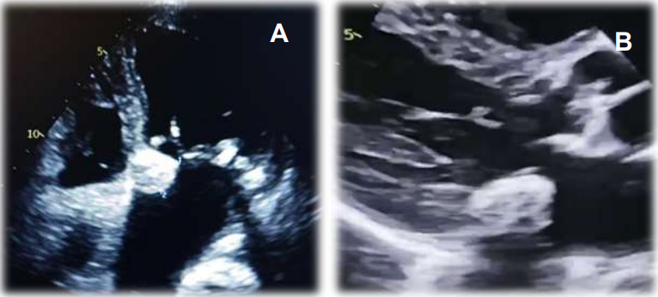
Figure 1 : Transthoracic echocardiography showing caseous calcification of the mitral annulus
A : Apical view, B : Parasternal long-axis view

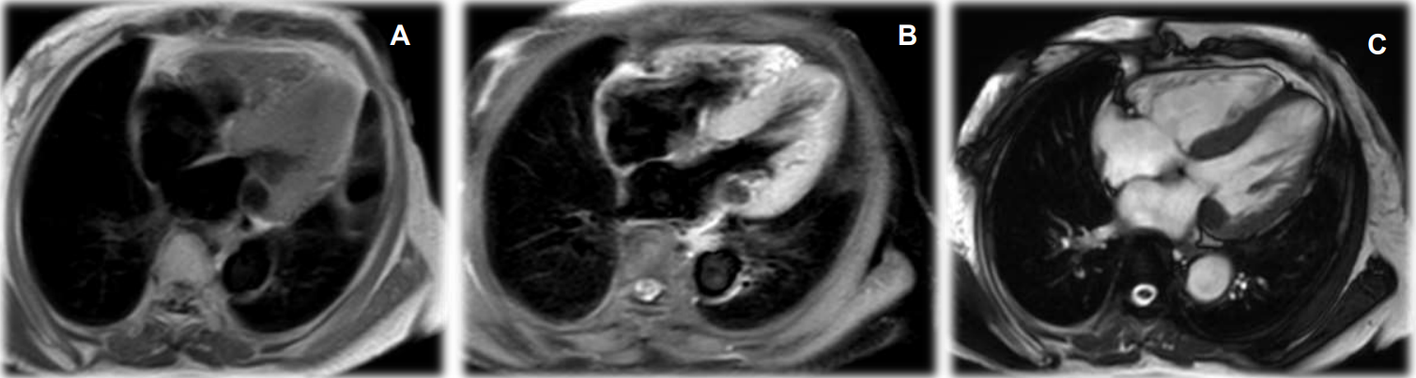
Figure 2 :
(A) Axial T1-weighted image showing a well-defined, hypointense mass at the posterior mitral annulus.
(B) Post-contrast T1-weighted image (after gadolinium injection) demonstrating peripheral enhancement of the lesion, consistent with a caseous necrotic core.
(C) T2-weighted image showing low signal intensity of the mass, indicating the absence of edema and supporting the diagnosis of caseous necrosis.
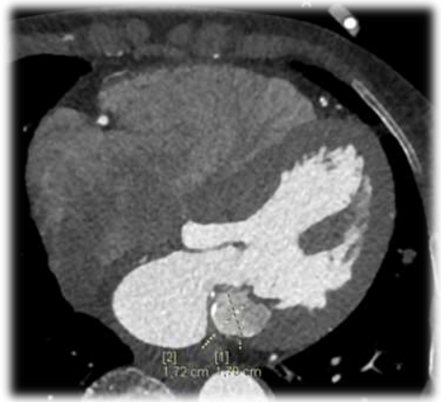
Figure 3 : Cardiac CT scan showing caseous calcification of the mitral annulus.

