Effects of Azadirachta indica aqueous leaf extract on liver and kidney in high-fat diet-induced obese wistar rats

ABSTRACT
Obesity is one of the major health problems worldwide. Azadirachta indica leaf has demonstrated various biological activities such as antioxidant, antipyretic, anti-fundal, anti-bacterial, anti-inflammatory and antimalarial activities e.t.c. This study aimed to evaluate the histopathological effect of Azadirachta indica aqueous leaf extract on liver and kidney in high-fat diet-induced obesity in albino rats. The extract was subjected to acute toxicity study using lorke’s method. The obesity condition was induced in the rats by feeding them with high-fat diet for 12 weeks. Only rats with an abdominal circumference of greater than 18cm, body mass index of 1.0g/cm2 and above respectively, were considered obese and used for the study. Thirty male and female adult wistar rats were divided into five groups, three rats test and three rats as replicate in each group. Group A served as negative control group fed with normal diet for 12 weeks. Group B were administered orally, with the aid of canula, with high-fat diet and normal diet for 12 weeks. Groups C, D and E received high-fat diet + normal diet for 6 weeks and treated with 10mg/kg.bw of lipostatin, 200mg/kg.bw and 400mg/kg.bw of Azadirachta indica extract respectively for another 6 weeks. During the treatment, abdominal circumference, body weight and body mass index were measured weekly. After treatment, animals were euthanized and liver, kidney were harvested for haematoxylin and eosin, sudan black staining techniques. Acute toxicity results showed that the extract had no toxic effect on the rats and the oral LD50 was estimated to be greater than 5000 mg/kg.b.w, the body weight, body mass index, abdominal circumference were significantly decreased (p< 0.05) in the treated groups compared to high-fat diet group, while the histological examination of liver, kidney of treated groups showed clearance of lipid deposition. In conclusion, the higher acceptable dose of Azadirachta indica demonstrated a better on histopathological effect on liver and kidney in high-fat diet-induced obese wistar rats over the selected standard drug. Hence, leaf extract of Azadirachta indica is beneficial in the management of dietary obesity and its related disorders.
Keywords: Azadirachta indica, Histopathology, High-fat diet, Lipostatin, Obesity.
Abbreviations: FDA=Drug Administration, H&E= hematoxylin and eosin, BW1 = Initial Body Weight, BW2 = Body Weight after induction and BW3 = Body Weight after treatment BMI 1 = Initial Body mass Index, BMI2 = Body mass Index after induction and BMI3 = Body mass Index after treatment AC1 = Initial Abdominal circumference, AC 2 = Abdominal circumference after inductionandAC3 = Abdominal circumference after treatment. ANOVA= Analysis of variance. HFD= high-fat diet. A. indica= Azadirachta indica

INTRODUCTION

Obesity is a complex multifactorial disease that accumulated excess body fat leads to negative effects on health (Janez et al., 2024). Obesity continues to accelerate resulting in an unprecedented epidemic that shows no significant signs of slowing down any time soon (Patoulias et al., 2024). Raised body mass index is a risk factor for non-communicable diseases such as diabetes, (Lincoff et al., 2023). Cardiovascular diseases, and musculoskeletal disorders, resulting in dramatic decrease of life quality and expectancy (Drucker, 2024). Obesity is defined as when a person has a body mass index [BMI (kg/m2) (Jastreboff et al., 2022), dividing a person’s weight by the square of their height] greater than or equal to 30, overweight is defined as a BMI of 25.0-29.9 (Rangraze et al., 2024). Being overweight or obesity is linked with more deaths than being underweight and is a more common global occurrence than being underweight (Banerjee et al., 2023). There are several possible mechanisms leading to obesity (Kosiborod et al., 2023). Actually, the traditional view is usually that the main cause is the significantly more excess energy stored than the energy the body used (Lin et al., 2024). The excess energy is stored in fat cells, thereby developing the characteristic obesity pathology (Apperloo et al., 2024). The pathologic enlargement of fat cells will alter the nutrient signals responsible for obesity (Muzurovic et al., 2023). The main cause of obesity is long-term energy imbalance between consumed calories and expended calories (Knop et al., 2023). More and more etiologies or defects that lead to obesity can be identified under the background of struggle between nurture and nature (Jensterle et al., 2022), genetic and epigenetic, environmental and microenvironment (Melson et al., 2024). In addition, genetic factors are known to play critical roles in determining an individual’s predisposition to weight gain ((Rizvi et al.,

2022). Recent epigenetic studies have provided very useful tools for understanding the worldwide increase in obesity (Bliddal et al., 2024). Studies have discussed the relationships between genetics, epigenetics, and environment in obesity and explored the roles of epigenetic factors in metabolism regulation and obesity risk as well as its complications (Noma et al., 2024). Genetic causes of obesity can be broadly classified as: 1) monogenic causes that result from a single gene mutation (Chang-Chusan et al., 2025), primarily located in the leptin-melanocortin pathway (Ponce-Gonzalez et al., 2023). Many of the genes, such as AgRP (Agouti-related peptide), PYY (orexogenic), or MC4R (the melanocortin-4 receptor), (Lin et al., 2024), were identified for monogenic obesity disrupt the regulatory system of appetite and weight (Fitch and Bays, 2022), hormonal signals (ghrelin, leptin, insulin) are sensed by the receptors located in the arcuate nucleus of the hypothalamus (Álvarez-Martín et al., 2024). 2) Syndromic obesity were severe obesity results from neurodevelopmental abnormalities and other organ/system malformations (Drucker, 2024). This may be caused by alterations in a single gene or a larger chromosomal region encompassing several genes (Luis et al., 2023). 3) Polygenic obesity is caused by cumulative contribution of many genes. Globally, the increase in overweight and obesity among youth is alarming. In 2020, 22.4% of 430 million adolescents and children (5-19 years old) were affected (Linge et al., 2024). By 2035, these numbers may increase to 39.2% and 770 million (Marin et al., 2024). In Nigeria, the prevalence of overweight individuals ranged from 20.3%–35.1%, while the prevalence of obesity ranged from 8.1%–22.2% (Marin et al., 2024). Phentermine was approved in 1959 by the Food and Drug Administration (FDA) as most widely prescribed weight-management medication in the United State for short-term use ( <_ 3 months) ( Smith and Weissman, 2010). The availability of five newer FDA-approved medication for long-term weight management along with complexities surrounding the prescribing of phentamine has lead some professional groups to discourage long-term use of phentamine (Apovian et al., 2015).

Following the success of orlistat, lorcaserin, liraglutide, phentamine-topiramate and naltrexome-bupropian as new safer drugs approved by Food and Drug Administration (FDA) (Nyanhanda et al., 2023). In reducing body weight which show the satiety of the drug and a mean difference of 5% or more in weight loss between the medication and placebo group in at least one year duration pivotal trial (Yanuwski and Yanuwski, 2014), they became one-year weight loss drug. These pharmacologic therapies used for the treatment of obesity were formulated to reduce energy intake or increase energy output. (Tan et al., 2024). Azadirachta indica A. Juss is native to India, the family Meliaceae is widespread in the world, and it can grow in most tropical and subtropical countries, including Indonesia. In Indonesia, neem is known locally as Imba, Nimba, or Mimba (Honnayya, 2024). Neem has great medical benefits through its various biological properties (Abdullah et al., 2023). Almost all parts of the neem plant can be used to treat various diseases (Anuradha and Jaganthan, 2023). Based on the previous reports, the neem leaves extract have numerous biological and pharmacological activities including antipyretic, analgesic, antihepatotoxic, spermicide, anti-implantation, antihyperglycemic, antiulcer, antifungal, antibacterial, anti-inflammatory, immunomodulatory, antimutagenic, anticancer, antimalarial, antiviral, antioxidant, antifertility, and contraception (Anuradha et al., 2024 ).

However, little is known about its histopathologic effect on liver and kidney in high-fat-induced obese rats by using H&E, staining techniques. Thus, this study aimed to evaluate histopathologic effects of A. indica aqueous leaf extract in high-fat diet induced obese rats.
MATERIALS AND METHODS
Plant Collection and Identification
The leaf of A. indica was collected at the herbarium of pharmaceutical department Usmanu Danfodiyo University, Sokoto.
The plant taxonomic identification and assigning of Voucher Number was carried-out at harbarium department of pharmacognosy, Usmanu Danfodiyo University, Sokoto with voucher number: PCG/UDUS/Meli/0003
Plant Extraction
Fresh leaf of A. indica was collected and air-dried at room temperature over a period of two weeks. Dried materials was pounded in the laboratory mortar into powder. About 1000g of pounded grinded Azadirachta indica extract was weighed and dissolved in distilled water in 5000ml of distilled water.

The solution was stirred with the use of stirrer for two hours and left to stay over 24hours. This was filtered with muslin cloth and evaporated at 55 ̊C in water bath as described by Majekodunmi et al. (1996). The resultant powder weighed 40.5g and gave 10.1% as percentage yielded.
Procurement of Animals
A total of number of 42 healthy wistar albino rats both male and female weighing between 175-180g was obtained from animal house of the faculty of pharmaceutical science, Ahmadu Bello University Zaria. Thirty were used for the experiment while twelve were used for LD50 determination. They were allowed to acclimatize for a period of 14 days. They were maintained on rat feeds and water ad libitum throughout the experimental period. They were kept in a metal cage in a well ventilated environment at conducive temperature and cleaned regularly at animal house faculty of pharmaceutical science, Usmanu Danfodiyo University, Sokoto.

ANIMAL GROUPING AND EXPERIMENTAL DESIGN
A total number of 30 healthy albino rats were used. After the acclimatization period of two weeks, animals were divided into five groups with three rats and two rats as replicate. Group A, served as negative control group consisting of six rats including replicate, they were given water ad libitum and were fed with standard rat chow for 12 weeks of the experimental period. The group B consist of 6 rats including replicate, received water ad libitum and were administered orally with high-fat diet in the dose of 1ml daily of mixture of melted pig fat and hydrogenated vegetable oil in 4:3 ratio respectively for 12 weeks and also fed with a standard rat chow and served as obese positive control group

(OECD, 2000; Shyamala et al., 2003). The group C, also consist of six rats including replicate, served as standard control group in which they were fed orally with high fat diet in a dose of 1ml of mixture of melted pig fat and hydrogenated vegetable oil in 4:3 ratio for 6 weeks and were orally administered standard drug lipostatin of 10mg/kg body weight daily (Calderon et al., 2011) for another six weeks. While group D and group E had six rats each including replicates, received water and were administered orally with melted pig fat and hydrogenated vegetable oil 1ml daily for 6 weeks and standard rat chow after 6 weeks of feeding of Azadirachta indica extract in a dose of 200 mg/kgbwt and 400mg/kgbwt respectively, daily for another 6 weeks and the dose of extract chosen were based on the result of acute toxicity (LD50) study conducted. The body weight and length of the rats were recorded every week throughout the experimental period (Adekunle et al., 2016). As shown in the table 1.0

Table 1.0 Summary of Experimental Design
Experimental Groups | Intervention Given | Treatment Given | Durations | Laboratory Analysis
Group A: 3 rats (Normal control)  3 rats as replicate | Distilled water + normal diet | No treatment given | 12 weeks | H&E, Sudan Black,
Group B: 3 rats (Negative control)  3rat as replicate | High-fat diet/ + normal diet | No treatment given | 12 weeks | H&E, Sudan Black,
Group C: 3 rats. (standard control):3 rats as replicate | High-fat diet + normal diet for 6 weeks | 10mg/kgbw of lipostatin for 6 weeks | 12 weeks | H&E, Sudan Black,
Group D: 3 rats.  test: 3 rats as replicate | High-fat diet + normal diet for 6 weeks | 200mg/kgbw of A.indica leaf extract for 6 weeks | 12 weeks | H&E, Sudan Black.
Group E: 3rats  test:3 rats as replicate | High-fat diet + normal diet for 6 weeks | 400mg/kgbw of A. indica extract for 6 weeks | 12 weeks | H&E, Sudan Black.

INDUCTION OF OBESITY
High-fat diet was prepared as per method of (OECD, 2000; Shyamala et al., 2003). Obesity was induced by single daily oral dose of 1ml/kg.bw daily of mixture of melted pig
fat and hydrogenated vegetable oil in 4:3 ratio of high-fat diet in addition to normal diet for 12 weeks. Treatment began at 7 weeks week of diet feeding that continued for another six weeks.

Ethical Consideration/Approval
The protocol of this study was approved by Ethics and Research Committee of Department of Health and Biomedical Research Ethics Committee (HBREC). Usmanu Danfodiyo University Sokoto.
Euthanisation and Collection of Samples
After six weeks of the treatment period, the animals were anaesthetized using chloroform vapour in an enclosed transparent plastic jar. The animals were then dissected by longitudinal abdominal incision with aid of surgical blade to carefully harvest the liver and kidney were removed for histopathological analysis.
LABORATORY ANALYSIS
Liver and kidney were grossed and sectioned immediately by using cryostat for Hematoxylin & Eosin staining and sudan black staining technique for histopathological analysis and examined microscopically using (Mag x400) Photomicrograph of liver and kidney were taken using light microscope and Best Scope camera and the results were presented alongside with control.
DATA ANALYSIS
The data analysis was performed using Graph pad prism 6.0 as mean ± SD. Statistical comparison between groups were made using repeated one way analysis of variance (ANOVA) with post hoc Bonferroni Multiple comparison Test to establish the differences in means where appropriate. P < 0.05 was taken as statistically significant. The standard analysis was performed using SPSS Statistical software version 27

RESULTS
Effect of aqeous leaves extract of Azadirachta indica on Body Weight, Body Mass Index and Abdominal Circumference.

The measurements of body weight, BMI, and abdominal circumference (Table 2) before the induction and after treatment of the experimental wistar rats is shown. There was
a satistically significant difference in these measured parameters between treated groups and untreated group.

Table 2. Body Weight, Body Mass Index and Abdominal Circumference.

Groups | Initial measurements |  |  | Measurements at 6 weeks |  |  | Measurements at 12 weeks
 | BW1(g) | BMI1(g/cm²⁾ | AC1(cm) | BW2(g) | BMI2(g/cm²) | AC2(cm) | BW3(g) | BMI3(g/cm²) | AC3(cm)
Group A | 177.67±9.29 | 0.53±0.05 | 13.67±0.58 | 209.00±1.00 | 0.62±0.03 | 14.33±0.58 ª | 221.67±1.53 | 0.66±0.04 | 15.67±0.58
Group B | 176.65  ± 1.76 | 0.52  ± 0.00 | 13.37  ± 0.32 | 342.82  ± 4.22ª | 1.00±0.04 | 19.67±0.78 ª | 451.67±7.64 ª | 1.3±0.006 ª | 19.93±0.58 ª
Group C | 184.33±3.06 | 0.55±0.03 | 14.33±0.58 | 343.67±5.51 ª | 1.02±0.82 | 18.33±0.68 ª | 215.00±5.00 ^{a,b} | 0.62±0.06 ^{a,b} | 15.67±0,58 ^{a,b}
Group D | 176.67±6.03 | 0.52±0.04 | 14.33±0.68 | 343.33±5.77 ª | 1.02±0.92 | 19.33±0.58 ª | 209.00±8.54 ^{a,b} | 0.60±0.06 ^{a,b} | 15.67±0.58 ^{a,b}
Group E | 176.67±7.51 | 0.53±0.05 | 13.33±0.48 | 330±10 ª | 1.02±0.72 | 18.67±0.78 ª | 212±3.61 ^{a,b} | 0.63±0.05 ^{a,b} | 15.32±0.58a,b
Values are presented as mean ± Standard Error of the Mean. a represents a highly significant at p<0.05 when compared to Control Group 1 while b represents highly significant at p<0.05 when compared to HFD group B
Key: BW1 = Initial Body Weight, BW2 = Body Weight after induction and BW3 = Body Weight after treatment BMI 1 = Initial Body mass Index, BMI2 = Body mass Index after induction and BMI3 = Body mass Index after treatment AC1 = Initial Abdominal circumference, AC 2 = Abdominal circumference after inductionandAC3 = Abdominal circumference after treatment.

Effects of Aqueous Leaf extract of Azadirachta indica on the General Tissue Architecture of Liver and Kidney using H & E Staining Technique.
Figure 1: Shows effects of Azadirachta indica leaf extract on liver sections in high-fat diet induced obese wistar rats. (H & E X 400). Group A: Normal control group, hepatocyte (yellow arrow), sinusoid (blue arrow) and central vein (red arrow). When compare with group B. Group B, high-fat diet group shows irregular hepatocyte with micro-vesicular steatosis (green arrow) and macro vesicular steatosis (red arrow), fat deposition obscure the portal triad (blue arrow) and the central vein (black arrow), at hepatocyte, ballooning hepatocyte (yellow arrow), vacuolar degeneration (green arrow). Group C, High fat diet +10mg/kg.b.w of lipostatin, shows no hepatic fatty deposition in hepatocyte (yellow arrow).when compare with group D. Group D, High fat diet + 200mg/kg.b.w extract, shows no hepatic fatty deposition in hepatocyte (yellow arrow), central vein (red arrow) and sinusoid (blue arrow) when compare with group B. Group E, High-fat diet +400mg/kg.b.w of lipostatin, shows no hepatic fatty deposition at hepatocyte (yellow arrow), central vein (red arrow) and sinusoid (blue arrow), when compare with Group B.

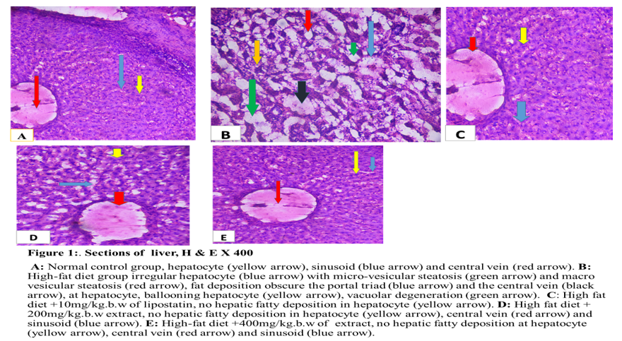

Figure 2. Shows effects of Azadirachta indica leaf extract on liver sections in high-fat diet induced obese wistar rats (Sudan Black X 400). Group A, normal control group, normal hepatocyte (yellow arrow), central vein (red arrow) and portal triad (blue arrow) with dack background when compare with group B.Group B, High-fat diet group,shows dark-brown of fat deposition at portal triad (red arrow), central vein (blue arrow), sinusoid (white arrow), around the vacuoles (black arrow) and hepatocyte (yellow arrow) with brown back-ground when compare with group B. Group C, High-fat diet +10mg/kg.b.w lipostatin shows dark back-ground with no hepatic fatty deposition at hepatocyte (yellow arrow), portal triad (blue arrow) and central vein( red arrow) when compare with group B. Group D, High-fat diet + 200mg/kgb.w extract, no hepatic fatty deposition in hepatocyte (yellow arrow),central vein (red arrow) when compare with group B. group E, High-fat diet + 400mg/kgb.w of lipostatin group,show no hepatic fatty deposition at hepatocyte (yellow arrow), central vein (red arrow), when compare with group B.

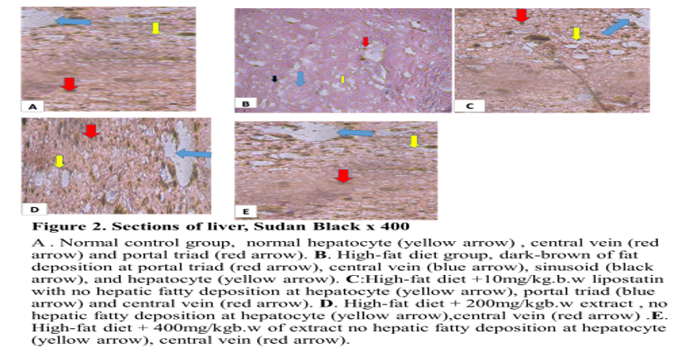

Figure 3: Shows effects of Azadirachta indica leaf extract on kidney sections in high-fat diet induced obese wistar rats. (H & E X 400). Group A. Negative control group, normal glomerulus (yellow arrow), tubule (blue arrow), and bowman’s space (red arrow), when compare with group B: Group B, high-fat diet group, shows glomerulus (red arrow) and tubules (black arrow) have been obscured with large deposition of fats, bowman’s space is wider (yellow arrow). Marked proliferation of adipose tissue in renal sinus (blue arrow), Accumulation of numerous and large deposition of adipose tissue in renal sinus( blue arrow), renal
capsule (brown arrow), group C, high-fat diet + 10mg/kg.b.w extract group, shows no fat deposition at glomerulus (yellow arrow),tubules(blue arrow) and bowman’s space(red arrow) when compare with group B. Group D, High-fat diet + 200mg/kg.b.w extract, shows clearance of fat at tubule (blue arrow) glomerulus (yellow arrow), bowman’s space (red arrow) when compare with group B. Group E, High-fat diet+400mg/kg.b.w lipostatin group , shows clearance of fat at glomerulus (yellow arrow), tubules (blue arrow), bowman’s space (red arrow).when compare with group B.

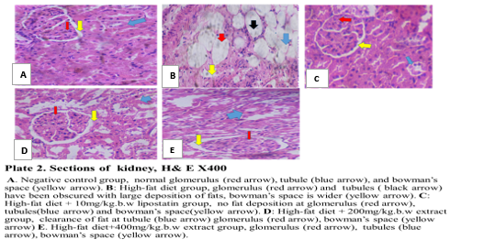
Figure 3 – Section of kidney, H & E X400

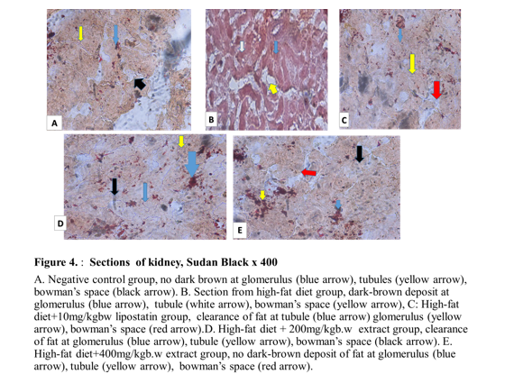

DISCUSION

Histological examination of liver section for Haematoxylin and Eosin staining for general tissue morphology showed normal hepatocytes with intact morphologies in normal control, group A and the treated groups, group C, D and E.when compared with group B. Liver section of group B shows irregular hepatocyte with micro and macro vesicular steatosis, fat deposition obscure the portal triad and the central vein, at hepatocyte, ballooning hepatocyte, vacuolar degeneration. Numerou and large fat deposition in the liver and hepatic structure disorganization. The administration of A. indica reversed the formation of hepatic fatty deposition in hepatocytes at the doses of 200mg/kg body weight and 400mg/kg body weight of Azadirachta indica leaf extract. Similar observation was reported by (Xiaodong, 2024), who also observed fat droplet in the histology of liver and its amelioration after treatment with Hordeum vulgare extract. Liver section of group B shows irregular hepatocyte with micro and macro vesicular steatosis, fat deposition obscure the portal triad and the central vein, at hepatocyte, ballooning hepatocyte, vacuolar degeneration. Numerou and large fat deposition in the liver and hepatic structure disorganization. The administration of A. indica reversed the formation of hepatic fatty deposition in hepatocytes at the doses of 200mg/kg body weight and 400mg/kg body weight of A. indica leaf extract. Similar observation was reported by (Xiaodong, 2024), who also observed fat droplet in the histology of liver and its amelioration after treatment with Hordeum vulgare extract.

The histology of liver section was observed using Sudan black staining technique and showed normal portal vein, central vein, sinusoid and hepatocyte in group A, C, D and E with light brown colouration when compared with group B which showed dark-brown colouration of fat deposit at hepatocyte, sinusoid, central vein and whole area of liver architecture. The similar report was done by (Sweata et al., 2025) and (Saman et al., 2023, who demonstrated fatty deposition in liver using oil red O staining technique and clearance of fat deposition after treatment with Naringin. Histological section of kidney for Haematoxylin and Eosin staining for general tissue morphology in group A showed normal histology of renal parenchyma with normal glomerulus, proximal convoluted tubule, and bowman’s space. Also, in group B there was renal structure disorganization and renal parenchyma occupied by large and numerous fat (adipose tissue). Glomerulus and tubules have been obscured with large deposition of fats with bowman’s space wider in high-fat diet-induced obese rats. while the group C, D and E showed clearance of fat deposition in the glomerulus, tubules and adipose tissue in renal parenchyma with normal bowman’s space after the administration of Azadirachta indica aqueous leaf extract as well as standard drug administration, This in line with the finding of (Paula et al, 2020) who observed the fat deposit at renal parenchyma and its clearance after treatment with Jiangtang Tiaozhi.The histology of kidney using sudan black staining technique, showed no dark brown colouration at the glomerulus, bowman’s space, and renal tubule in group A and standard drug control group C when compared with group B. However, the treated groups D and E with 200mg/kgb.w and 400mg/kgb.w respectively showed no dark brown coloration of fat deposition after the administration of A. indica aqueous leaf extract when compared with group B. This

finding in agreement of (Sweata et al., 2025) who used Oil red O to stain lipid and clearance of lipid after treatment with Syzygium aromaticum.
CONCLUSION
The treatment with Azadirachta indica could ameliorate histopathological alterations of liver and kidney in obese rats. Thus, Azadirachta indica could be useful in the treatment of obesity and its related disorders.

REFERENCES
Abdullah A., and Biswas P., Sahabuddin M., Mubasharah A., Khan D. A. and Hossain, A. (2023). Molecular Dynamics simulation and pharmacoinformatic integrated analysis of bioactive phytochemicals from Azadirachta indica (neem) to treat diabetes mellitus. Journal of Chemistry. 12(2):1–19.
Adekunle, A. S., Adelusi, T. I., Kamdem, J., Ishmael, A. and Akintade, B. B. (2016). Insulinomimetic, Antihyperlipidemic and Antioxidative Properties of Moringa oleifera, Possible Mechanism of Action. British Journal of Medicine and Medical Research. 17(5):1- 11.
Álvarez-Martín, C., Caballero, F. F., Iglesia, R. and Alonso-Aperte, E. (2024). Association of MC4 Rs17782313 Genotype with Energy Intake and Appetite. A Systematic Review and Meta-Analysis. Nutrition. Review. 14(3):20-40.
Anuradha D. S., Julietraja K., Jaganathan B. and Alsinai, A. (2024). Curcumin-conjugated PAMAM Dendrimers of two generations: comparative analysis of physiochemical properties using AdriaticTopological indices. ACS. Omega 9. 2(1):14558–14579.
Anuradha, D. S. and Jaganthan, B. (2023). Topological properties of boron triangular sheet for robotic finger flex motion through indices. AIP. 22(2):29-40.
Apperloo, E. M., Gorriz, J. L., Soler, M. J., Cigarran–Guldris, S., Cruzado, J. M., Puchades, M. J., Lopez-Martinez, M., Waanders, F. and Laverman, G. D. (2024). Semaglutide in patients with overweight or obesity and chronic kidney disease without diabetes: A randomized double-blind placebo-controlled clinical trial. Nature Medicine. 31(2): 278–285.
Avwioro O. G. (2014). Histochemistry and tissue pathology; principles and techniques.Third edition pp 123-425.
Banerjee, Y., Patti, A. M., Giglio, R. V., Ciaccio, M., Vichithran, S., Faisal, S., Stoian, A. P., Rizvi, A. A. and Rizzo, M. (2023). The role of atherogenic lipoproteins in diabetes: Molecular aspects and clinical signiﬁcance. Journal of Diabetes Complication. 37(4):122-130.
Bliddal, H., Bays, H., Czernichow, S., Hemmingsson, J., Hjelmesaeth, J., Morville, T., Koroleva, A., Skov-Neergaard, J., Velez –Sanchez, P. and Wharton, S. (2024). Once-Weekly Semaglutide in Persons with Obesity and Knee Osteoarthritis. The New England Journal of Medicine. 39(1):1573–1583.
Calderon, G. D. (2011). Clinical guidance on the identification .Evaluation and treatment of Overweight and obesity in adult, National instutites of health. Obese. 6(2):51-209.
Chang–Chusan, Y. A., Eneli, I., Hennessy, E, Pronk, N .P. and Economos, C. D. (2025). Next steps in efforts to address the obesity pidemic. Annual Review of Public Health. 11(4):112-114.
Drucker, D. J. (2024). Efﬁcacy and Safety of GLP-1 Medicines for Type 2 Diabetes and Obesity. Diabetes Care. 47: 1873–1888.
Egbujo, E. C., Adisa, J. O. and Yahaya, A. B. (2008). A Study of the Staining Effect of Roselle (Hibiscus sabdariffa) on the Histologic Sections of the Testis. International. Journal of Morphology, 26(4): 927-930.
Fitch, A. K. and Bays, H. E. (2022). Obesity definition, diagnosis, bias, standard operating procedures (SOPs), and telehealth: An Obesity Medicine Association (OMA) Clinical Practice Statement (CPS). Obesity Pillars. 11(4):10-30.
Honnayya, R. (2024). Impact of rhizosphere on competitive effects of neem (Azadirachta indica A. Juss) on associated Pigeon pea in an agroforestry system. 47(1):132–136.
Janez, A., Muzurovic, E., Bogdanski, P., Czupryniak, L., Fabryova, L., Fras, Z., Guja, C., Haluzik, M., Kempler, P. and Lalic, N. (2024). Modern Management of Cardiometabolic Continuum: From Overweight/Obesity to Prediabetes/Type 2 Diabetes Mellitus.Recommendations from the Eastern and Southern Europe Diabetes and Obesity. Expert Group. Diabetes Therapy. 15(3):1865–1892.
Jastreboff, A. M., Aronne, L. J., Ahmad, N. N., Wharton, S., Connery, L., Alves, B., Kiyosue, A., Zhang, S. and Liu, B. and Bunck, M. C. (2022). Tirzepatide Once Weekly for the Treatment of Obesity. The New England Journal of Medicine. 38(7):205–216.
Jensterle, Μ., Rizzo, Μ., Haluzík, Μ. and Janež, A. (2022). Efficacy of GLP-1 RA Approved for Weight Management in Patients With or Without Diabetes: A Narrative Review. Advances in Therapy. 39(4):2452–2467.
Knop, F. K., Aroda, V. R. and Vale, R. D., Holst-Hansen, T., Laursen, P. N., Rosenstock, J., Rubino, D. M., Garvey, W.T. and Investigators, O. (2023). Oral semaglutide 50 mg taken once per day in adults with overweight or obesity (OASIS 1): A randomised, double-blind, placebo-controlled, phase 3 trial. Lancet. 40(2):705–719.
Kosiborod, M. N., Abildstrom, S. Z. and Borlaug, B. A. (2023). Semaglutide in patients with heart failure with preserved ejection fraction and obesity. The New England Journal of Medicine. 38(9):1069-84.
Lin, K., Mehrotra, A. and Tsai, T. C. (2024). Metabolic Bariatric Surgery in the Era of GLP-1 Receptor Agonists for Obesity Management. JAMA. 7(2):5-9.
Lincoff, A. M., Brown-Frandsen, K., Colhoun, H. M., Deanfield, J., Emerson, S. S., Esbjerg, S., Hardt-Lindberg, S., Hovingh, G. K., Kahn, S. E. and Kushner, R. F. (2023). Semaglutide and Cardiovascular Outcomes in Obesity without Diabetes. The New Engand Journal of Medicine. 38(9):2221–2232.
Linge, J., Birkenfeld, A .L. and Neeland, I. J. (2024). Muscle Mass and Glucagon-Like Peptide-1 Receptor Agonists. Adaptive or Maladaptive Response to Weight Loss? Circulation. 150(1):1288
Luis, D., Izaola, O., Primo, D. and Aller, R. (2023). Variation in PERILIPIN Gene Is a Predictor of Weight Loss and Protection against Impaired Glucose Metabolism after a Meal Replacement Diet in Postmenopausal Obese Females. European. Review. Medical. Pharmacological. Science. 22(7): 9355–9362.
Majekodunmi, O. F., Zany, K., Olanyaga, I. E., Shi, L. E. and Melanhin, J. L. (1996). Selective Toxicity Diterpene from Euphorbia Poisonic. Journal of Medicinal Chemistry. 39(3):1005-1008.
Marin, A. G., Filipescu, A. and Petca, A. (2024). The role of obesity in the etiology and carcinogenesis of endometrial cancer. Cureus: 16(3):59-70.
Melson, E., Ashraf, U. and Papamargaritis, D. (2024). What is the pipeline for future medications for obesity? International. Journal of Obesity. 31(1):378–285.
Muzurovic, E., Yumuk, V. D. and Rizzo, M. (2023). GLP-1 and dual GIP/GLP-1 receptor Agonists in overweight/obese patients for atheroscle-rotic cardiovascular disease prevention: Where are we now? Journal of Diabetes Complications. 37(4):231-250.
Noma, J. R., Silva- Rodrigues, G. and Souza, V. C. O. (2024). The Influence of Serum Selenium in Differential Epigenetic and Transcriptional Regulation of CPT1B Gene in Women with Obesity. Journal of Trace Element in Medicine and Biology. 83(7):127-140.
Nyanhanda, T, Mwanri, L. and Mude, W. (2023). Double burden of malnutrition: a population levelcomparative cross-sectional study across three sub-saharan African countries-Malawi, Namibia and Zimbabwe. International Journal of Environmental Research and Public Health: 20(4):121-124.
OECD. (2000). Guidance Document on Acute Oral Toxicity. Environmental Health and Safety Monograph Series on Testing and Assessment.Third Edition, pp 24-29.
Patoulias, D., Koufakis, T., Ruza, I., El-Tanani, M. and Rizzo, M. (2024). Therapeutic Advances in Obesity: How Real-World Evidence Impacts Affordability Beyond Standard of Care. Pragmatic and. Observational Research. 15(6):139–149.
Paula, E., Rafael, R., Mariano, R., Escolastico, A. and Ignacio, L. (2020). Structural and Ultrastructural renal lesions in rats fed high fat and high- phosphorus diets. Clinical Kidney Journal. 14(3):847-854.
Ponce-Gonzalez, J.G., Martínez-Ávila, Á.., Velázquez-Díaz, D., Perez-Bey, A., Gómez-Gallego, F., Marín-Galindo, A., Corral-Pérez, J. and Casals, C. (2023). Impact of the FTO Gene Variation on Appetite and Fat Oxidation in Young Adults. Nutrients. 15(4):20-37.
Rangraze, I., Patoulias, D., Karakasis, P., El-Tanani, M. and Rizzo, M. (2024). Tirzepatide, a novel, dual glucose-dependent insulinotropic polypeptide/glucagon-like peptide-1 receptor agonist for the ongoing diabesity epidemic. The dawn of a new era? Expert Review of Clinical Pharmacology. 17(3):853–856.
Rizvi, A. A., Kathuria, A., Al Mahmeed W., Al-Rasadi K., Al-Alawi K., Banach M., Banerjee Y., Ceriello A., Cesur, M. and Cosentino, F. (2022). Post-COVID syndrome, inflammation, and diabetes. Journal of Diabetes and its Complication. 36(4):108-118.
Saman, A., Irfana, L., Najiya, A., Threem, Z., Mohsin, M. and Ayesha, M. (2023). Obesity theranostics using nanoemulsions of probiotics and local herbs. Saudi Journal of Biological Sciences. 30(5):100-122.
Shyamala, M. P., Venukumar, M. R. and Latha, M. S. (2003). Antioxidant potential of the Syzygiumaromaticum (Gaertn) Linn (Cloves) in rats fed with high fat diet. Indian Journal of Pharmacology. 35(4): 99-103.

Smith, S. R. and Weissman, N. J. (2010). Multicenter, placebo-controlled trial of lorcaserin for weight management. The England Journal of Medicine. 36(3):245-256.
Sweata, S., Sanjib, G. and Maharaj, B. (2025). Naringin ameliorates high-fat diet-induced hepatotoxicity and dyslipidemia in experimental rat model via modulation of anti-oxidant enzymes. AMPK and SERBP-1c signaling pathways. Toxicology Reports. 30(5):14-20.
Tan, S., Santolaya, J.L., Wright, T.F., Liu, Q., Fujikawa, T., Chi, S., Bergstrom, C.P., Lopez, A., Chen, Q. and Vale, G. (2024). Interaction between the Gut Microbiota and Colonic Enteroendocrine Cells Regulates Host Metabolism. Nature. Metabolism. 6(3):1076–1091.
Xiaodong, S. (2024). Highland Barley Alleviates High-Fat Diet-Induced Obesity and Liver Injury Through the IRS2/PI3K/AKT Signaling Pathway in Rats. Nutrients. 22(3):32-34.
Yanovski, S. Z and Yanovski, J. A. (2014). Long-term drug treatment for obesity: a systematic and clinical rview. The Journal of the American Medical Association. 31(1):74-86.

