Case report
Isolated Bilateral Pleural Effusion in Acute Hepatitis A Infection: A Rare Pediatric Presentation

Abstract
Background: Hepatitis A virus (HAV) infection remains a significant cause of acute viral hepatitis among children in developing regions. Although the illness is predominantly self-limiting and primarily affects the liver, atypical systemic manifestations have occasionally been reported. Pleural effusion is an exceptionally rare complication and is generally described in conjunction with ascites.

Case Presentation: We report the case of a four-year-old female with serologically confirmed acute HAV infection who developed bilateral pleural effusion in the absence of ascites. The child presented with prolonged fever followed by jaundice, vomiting, abdominal pain, dark urine, and progressive respiratory difficulty. Laboratory findings demonstrated conjugated hyperbilirubinemia and markedly elevated transaminases. Anti-HAV IgM antibodies confirmed acute infection. Radiological evaluation revealed bilateral pleural effusion without intra-abdominal fluid accumulation. Pleural fluid examination was consistent with a transudative effusion, and microbiological studies were negative. The patient improved with supportive management and showed complete clinical and biochemical recovery.

Conclusion: Pleural effusion represents a rare and typically benign extrahepatic manifestation of acute HAV infection, even in the absence of ascites. Awareness of this self-limiting complication is essential to prevent unnecessary diagnostic procedures and overtreatment.

Keywords: Hepatitis A virus; Bilateral pleural effusion; Extrahepatic complications; Pediatric hepatitis; Transudate; Conservative treatment

Introduction
Acute viral hepatitis continues to impose a considerable health burden in low- and middle-income countries, particularly among children exposed to inadequate sanitation and contaminated water sources. Among hepatotropic viruses, HAV remains one of the leading etiological agents of acute hepatitis in pediatric populations. It is a non-enveloped, single-stranded RNA virus transmitted predominantly via the fecal–oral route.

Clinical manifestations vary according to age. In early childhood, infection is frequently asymptomatic or produces mild, nonspecific symptoms. In contrast, older children more commonly develop classical icteric hepatitis characterized by fever, anorexia, malaise, abdominal discomfort, nausea, dark urine, and jaundice. The disease course is usually self-limited, with recovery occurring over several weeks. Severe hepatic failure is uncommon in children.

Although hepatic involvement predominates, extrahepatic complications have been sporadically described. Reported manifestations include hematologic abnormalities, renal dysfunction, dermatological lesions, neurological symptoms, and serosal inflammation. Among these, pleural effusion is exceedingly rare.

Most pediatric reports describe pleural effusion occurring concurrently with ascites, suggesting peritoneal–pleural communication as a possible mechanism. However, isolated pleural effusion without ascites is extremely uncommon and may create diagnostic uncertainty, particularly in regions where tuberculosis and other infectious causes of effusion are prevalent.

This report describes a child with acute HAV infection presenting with bilateral pleural effusion in the absence of ascites and discusses possible mechanisms and management considerations.

Case Presentation
A previously healthy four-year-old girl was admitted with a 15-day history of fever, followed by six days of jaundice, dark urine, vomiting, and upper abdominal pain. Three days before admission, she developed progressively worsening shortness of breath. There was no history of bleeding manifestations, altered consciousness, seizures, rash, oliguria, or prior similar episodes. Several neighboring children had recently experienced febrile jaundice, suggesting a localized outbreak.

On examination, she appeared ill but was conscious and hemodynamically stable. Tachypnea was present, with oxygen saturation of 93% on room air, which improved with supplemental oxygen. Generalized icterus was noted. Abdominal examination revealed tender hepatomegaly (liver palpable 3 cm below the costal margin) and mild splenomegaly. Clinical signs of ascites were absent.
Respiratory examination demonstrated decreased breath sounds and dullness to percussion over both lower lung zones, more pronounced on the left. Cardiovascular and neurological examinations were normal.
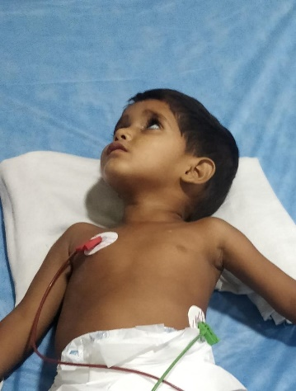
Fig 1- Respiratory examination
Investigations
Laboratory evaluation showed elevated total bilirubin with a predominance of the conjugated fraction. Serum ALT and AST were markedly elevated, indicating acute hepatocellular injury. Serum albumin was mildly reduced. Coagulation parameters were within acceptable limits, reflecting preserved synthetic function.

Serological testing revealed positive anti-HAV IgM antibodies, confirming acute HAV infection. Tests for hepatitis B, C, and E viruses were negative. Screening for malaria, dengue, enteric fever, chikungunya, and scrub typhus was also negative.
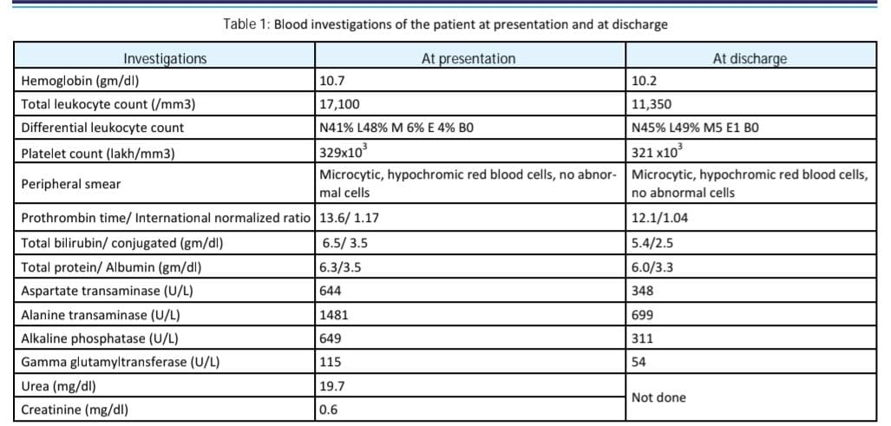

Chest radiography demonstrated bilateral pleural effusion without pulmonary consolidation. Abdominal ultrasonography confirmed hepatosplenomegaly without ascites but visualized pleural fluid on subcostal imaging.
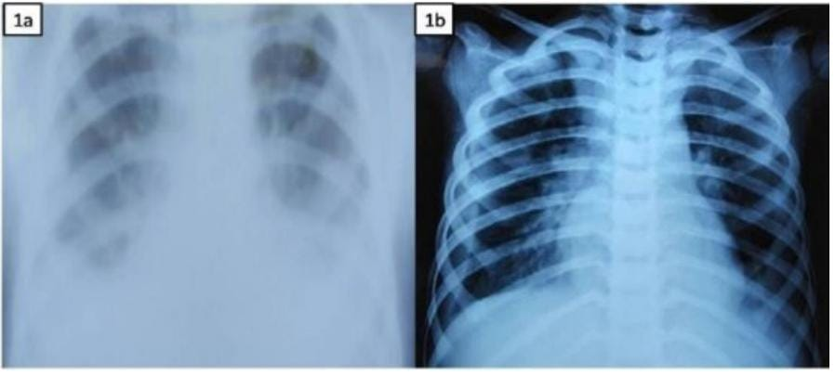
Fig 2- Chest X-Ray
Diagnostic thoracentesis yielded clear, straw-colored fluid. Biochemical analysis indicated a transudative effusion with low protein and LDH levels. Glucose levels were normal. Gram stain and cultures were sterile, and cytology revealed no malignant cells.

Fig 3- pathological testing
Management and Outcome
The patient received supportive therapy, including oxygen supplementation, adequate hydration, antiemetics, and nutritional support. No antiviral therapy was administered, as HAV infection is self-limiting. Antibiotics were not initiated due to lack of evidence of bacterial infection.

Clinical improvement was gradual. Respiratory distress subsided, and oxygen therapy was discontinued by the fifth hospital day. Liver enzymes and bilirubin levels progressively declined. The child was discharged after seven days in stable condition.

Follow-up at two weeks showed near-complete radiological resolution of pleural effusion. Liver function tests normalized within one month. The patient remained asymptomatic thereafter.

Discussion
HAV infection is highly prevalent in regions with suboptimal sanitation, where exposure often occurs in early childhood. While most infections are mild and self-limiting, atypical systemic manifestations may occasionally occur. Hepatitis A virus (HAV) infection is a common cause of acute viral hepatitis in children from developing countries like India, where poor sanitation facilitates fecal-oral transmission.[1][2] While typically self-limiting with predominant hepatic involvement, extrahepatic manifestations such as pleural effusion occur rarely, often alongside ascites due to proposed diaphragmatic fluid leakage.[1][3 ]
Rarity of Isolated Pleural Effusion
Isolated bilateral pleural effusion without ascites, as in this case, is exceptionally uncommon in pediatric HAV infection.[1] Literature review reveals fewer than 20 reported pediatric cases of HAV-associated pleural effusion, with most (70-80%) concurrent with ascites or acalculous cholecystitis. [4][5] Bilateral effusions predominate (over 50% of cases), yet absence of ascites challenges the peritoneal-pleural communication hypothesis and highlights diagnostic challenges in tuberculosis-endemic areas like Uttar Pradesh. Pleural effusion in the setting of acute HAV infection is rare. In most documented cases, effusion accompanies ascites, supporting the hypothesis of fluid migration across diaphragmatic lymphatics or defects. However, in this case, absence of ascites suggests alternative mechanisms.

Possible explanations include:

The transudative nature of the effusion (low protein, LDH) in our patient suggests hypoalbuminemia-induced reduced oncotic pressure or cytokine-mediated capillary leak rather than direct viral pleuritis.[1][3]
Other proposed mechanisms include immune complex deposition on serosal surfaces and hepatic inflammation altering hydrostatic pressures.[7][8]
Unlike exudative effusions in bacterial or tuberculous etiologies, HAV-related cases show sterile fluid and spontaneous resolution, supporting a benign hemodynamic basis.[6]
In tuberculosis-endemic regions, bilateral pleural effusion necessitates careful evaluation. However, the acute presentation, transudative fluid characteristics, negative microbiology, and spontaneous resolution without antitubercular therapy strongly supported a benign association with HAV.

Available literature indicates that pleural effusion associated with HAV does not adversely affect prognosis and typically resolves within weeks under supportive care.
Diagnostic and Management Insights
In resource-limited settings, this presentation mimics infectious effusions, prompting unnecessary thoracentesis or antitubercular therapy.[1]
Positive anti-HAV IgM, transudative biochemistry, and absent intra-abdominal fluid suffice for diagnosis, avoiding invasive procedures.[5][9]
Supportive care yields complete recovery in 95% of cases within 2-4 weeks, with no impact on long-term prognosis.[4][6]
Table 2- Diagnostic and Management
FEATURE | THIS CASE [1] | LITERATURE AVERAGE[4][5]
Age | 4 years | 5-8 YEARS
Effusion type | Bilateral, transudative, isolated | Often right sided or bilateral with ascites
Jaundice present | yes | 80% yes
management | Supportive only | Supportive (90%)
Resolution time | 2 weeks | 2-4 weeks

This table underscores :
Pleural effusion may occur in acute HAV even without ascites
The effusion is generally transudative and sterile
Conservative management is sufficient
Long-term prognosis remains excellent
Early recognition can prevent unnecessary invasive procedures and inappropriate antimicrobial therapy.

Conclusion
Acute HAV infection may rarely present with bilateral pleural effusion in children, even in the absence of ascites. Despite its alarming presentation, the condition appears to be self-limiting and responds well to supportive care. Awareness of this uncommon manifestation can aid clinicians in avoiding unnecessary diagnostic interventions and reassure caregivers regarding favorable outcomes..
References
- Christenson JC, Manaloor JJ. Hepatitis A, B, and C. Pediatr Rev. 2016;37:426–438.
- Amarapurkar DN, Amarapurkar AD. Extrahepatic manifestations of viral hepatitis. Ann Hepatol. 2002;1:192–195.
- Selimoglu MA, Ziraatci O, Tan H, Ertekin V. A rare complication of hepatitis A: pleural effusion. J Emerg Med. 2005;28:229–230.
- Kumar M, Kumar V, Tomar R. Hepatitis A with pleural effusion: a rare association. Ann Trop Paediatr. 2009;29:317–319.
- Ciocca M. Clinical course and consequences of hepatitis A infection. Vaccine. 2000;18(Suppl 1):S71–S74.
- Abdul Rauf KK, Farjana Ahmed, Febna Rahiman, Harish Kumar T, Biju IK, K Naushad. Pleural effusion as an extrahepatic manifestation of Hepatitis A infection in a child. BMH Medical Journal. 2025;12(2):April–June.
- Aslam I, Irshad S, Talib MA, Khosa G, Sheikh A, Shahzadi N. Atypical Presentation of Hepatitis A in Children. J Coll Physicians Surg Pak. 2025 Nov;35(11):1424–1428. doi:10.29271/jcpsp.2025.11.1424.
- Breim F, Roumi Jamal B, Kanaa L, Bourghol S, Jazmati B, Dadah S. Hepatitis A virus infection associated with bilateral pleural effusion, ascites, and acalculous cholecystitis in childhood: a case report. J Med Case Reports. 2024;18:304. doi:10.1186/s13256-024-04627-8.
- Aslam I, Irshad S, Talib MA, et al. Atypical Presentation of Hepatitis A in Children: frequency and outcomes among pediatric patients. J Coll Physicians Surg Pak. 2025. (Study on atypical HAV manifestations including pleural effusion.)
- European Centre for Disease Prevention and Control. Hepatitis A – Annual Epidemiological Report 2022. Stockholm: ECDC; 2024. (Relevant for recent epidemiological trends 2020–2025).
- Centers for Disease Control and Prevention (CDC). Hepatitis A Surveillance – 2023 Viral Hepatitis Surveillance Report. Atlanta, GA: CDC; 2025. (Gives updated incidence and clinical trends).

