Original Research Article

The New Sine Type II Generalized Topp-Leone Distribution: Structural Formulation and Statistical Properties

.
ABSTRACT

The continuous development of flexible probability distributions has become essential for accurately describing complex stochastic phenomena. In this study, a new theoretical based on the New Sine Type II Generalized Topp-Leone distribution is investigated. The model is constructed by integrating the sine trigonometric transformation with the Type II Topp-Leone generator applied to an arbitrary baseline distribution. This combination introduces additional shape parameters that enhance the adaptability of the resulting family of distributions. Several mathematical properties of the proposed model are derived. These include explicit expressions for the cumulative distribution function (cdf), probability density function (pdf), survival function, and hazard rate function. In addition, analytical forms of the quantile function, moments, moment generating function, and order statistics are established. The structural characteristics of the distribution reveal that it is capable of producing a wide range of density and hazard rate shapes depending on the selected baseline model and parameter values. The theoretical results presented in this work provide a general framework for constructing new members of the family and offer a foundation for further statistical developments involving estimation techniques and practical implementations.

Keywords: Distributions, Parameters, Trigonometric, Exponentiated, Topp-Leone.

1. INTRODUCTION

The study of probability distributions has evolved over centuries, from the foundational work of mathematicians like Pascal (1640) and Gauss (1801) to modern developments that incorporate computational techniques. The accurate modeling of lifetime, reliability, biomedical, and environmental data is a fundamental goal in applied statistics, notably, engineering, biomedicine, environmental sciences, and actuarial analysis are fields where it is applied. Many real-world problems across various fields cannot be adequately addressed by conventional probability distributions, such as normal, Weibull, and exponential (Yahaya and Doguwa, 2021). Statistical distributions play a crucial role in modeling and forecasting phenomena across various fields including biology, geography, economics and engineering, enabling informed decision-making and insights (Adekunle et al., 2022).
Traditional probability distributions often struggle to effectively model the complexities of contemporary datasets due to their limited ability to capture nuanced patterns. The simplicity of these models, which typically assume fixed hazard rates and limited skewness, can lead to inadequate representations of real-world data. As datasets become more complex, such as those involving diverse populations, extreme events, or rapidly changing phenomena, the shortcomings of the traditional models become obvious, in other to surmount these barriers, researchers have seen a surge in strategies to modify existing distributions or developed new ones, extended or compound distributions that offer greater flexibility and improve fit to empirical data.
In response to these limitations, researchers recognized the need for more adaptable models. Statisticians have increasingly developed flexible distribution families by applying generator functions to existing base distributions-a method that enables enhanced control over the distribution’s shape and tail properties. One such approach is the Topp-Leone-G (TL-G) family, derived by applying the Topp-Leone transformation to a baseline distribution. The original Topp-Leone distribution, introduced by Topp and Leone (1955), was designed for modeling symmetrical beta-type behavior and has been extended in many forms for greater flexibility.
Furthermore, researchers have been developing new distributions especially trigonometric distributions that build upon existing ones, and offer improved fit and flexibility for real-world datasets. Recent additions to trigonometric distribution families include: Exponentiated Sine – G family by Muhammad et al., (2021), Sine –G family by Sakthivel and Rajkumar (2021), Sine Alpha power- G family by Benchiha, et al. (2023), Tangent Topp – Leone G family by Nanga, et al. (2022), the Tan- G class by Souza, et al., (2021), Sine Topp – Leone G by Al - Babtain, et al. (2020), Sine – Inverse Lomax-G by Fatoye, et al. (2021). Although, various extended distributions have been developed and applied to model real lifetime data, significant hurdles persist, particularly in capturing the intricacies of complex data.
In recent decades, the statistical literature has witnessed rapid growth in the development of generator-based family of distributions. These approaches systematically construct new models from baseline distributions through transformation mechanisms such as exponentiation, compounding, and trigonometric modulation. Well-known examples include exponentiated-G, beta-G, Kumaraswamy-G, and transmuted-G families. Such frameworks introduce additional shape parameters, thereby enhancing flexibility in modeling skewness, tail behavior, and hazard rate structures.
The introduction of sine family of distribution by (Kumar et al, 2015) allows for the creation of new distribution that can better fit biomedical data compared to traditional distributions. Sine transformation helps in capturing the complex nature of biomedical data. That is, it enhance its flexibility by capturing a wider range of behaviors, such as varying hazard rates over time. The incorporation of sine functions allows the distribution to model oscillating or non-monotonic patterns commonly observed in biomedical datasets. The incorporation of trigonometric functions into probability distributions is a relatively recent innovation. Trigonometric transformations, such as the sine and cosine functions, offers unique advantages in statistical modeling. The probability density function (pdf) as well as the cumulative distribution Function (cdf), enabling the modeling of phenomena with asymmetric or multi-modal characteristics. The sine functions allows the distribution to model oscillating or non-monotonic patterns commonly observed in real-world datasets.
Addressing this gap forms the foundation of the present study. The New sine Type II Generalized Type II Topp-Leone (NSTIIGTL) distribution is proposed as a flexible extension that combines the strengths of both approaches. By embedding the Type II generalized Topp-Leone model within a sine-generated Topp-Leone generated structure, the resulting distribution is expected to provide enhanced adaptability, improved hazard rate flexibility, and superior goodness-of-fit performance when compared to existing bounded distributions. The aim of this research work is to develop the New Sine Type II Generalized Topp - Leone (NSTIIGTL) distribution and develop the statistical properties of the New Sine Type II Generalized Topp-Leone (NSTIIGTL) distribution

2. PROPOSED MODEL FORMULATION
2.1 Sine G Family of Distribution
Let H(x) denote the cumulative distribution function (CDF) of a unilabiate continuous distribution and h(x) its probability density function (PDF). The sine-G family of distributions, as introduced by Kumar et al. (2015), is characterized by the cdf expressed as:
(1)
$$F(x; ℘)=\int_{0}^{\frac{π}{2}G(x;℘)}{Cos\left(t\right)dt=Sin\left\{\frac{π}{2}G(x;℘)\right\}}$$
and its corresponding PDF given by:
(2)
$$f(x; ℘)=\frac{π}{2}g(x;℘)Cos\left\{\frac{π}{2}G(x;℘)\right\}$$

2.2 Type II Topp-Leone Generalized Family of Distribution
The cumulative distribution function (CDF) of the Type II Topp-Leone Generalized family of distributions, as introduced by Hassan et al., (2019), is given by:
(3)
$$G\left(x; α,β,℘\right)=1-{\left[1-H{\left(x;℘\right)}^{2β}\right]}^{α}$$

the PDF corresponding to equation (3) is also expressed as:
(4)
$$g\left(x; α,β,℘\right)=2αβh(x; ℘){\left[H(x;℘)\right]}^{2β-1}{\left[1-H{\left(x;℘\right)}^{2β}\right]}^{α-1}$$
here are shape parameters, while represents a vector of parameters from any baseline distribution.
2.3 The Newly proposed New Sine Type II Generalized Topp-Leone (NSTIIGTL) Distribution Family
The proposed distribution is obtained by combining the sine type II generating mechanism with the generalized Topp-Leone baseline model.
Let the baseline family M be theType II Generalized Topp-Leone family of distributions, with pdf and cdf given in equations (3) and (4). The probability density function (pdf) and the cumulative distribution function (cdf) of the New Sine Type II Generalized Topp-Leone family of distributions (NSTIIGTL) are derived by putting equations (3) and (4) into equations (1) and (2) respectively.
$f(x;α,β,℘)$=$\frac{π}{2}2αβh(x;℘){\left[H(x;℘)\right]}^{2β-1}{\left[1-H{\left(x;℘\right)}^{2β}\right]}^{α-1}Cos\left[\frac{π}{2}\left[1-{\left[1-H{(x;℘)}^{2β}\right]}^{α}\right]\right]$
(6)
(5)
$$F\left(x;α,β,℘\right)=Sin\left[\frac{π}{2}\left[1-{\left[1-H{(x;℘)}^{2β}\right]}^{α}\right]\right]$$
here are shape parameters and represents a vector parameter from any baseline distribution.
2.3.1 Validity Test of the pdf and cdf of the NSTIIGTL Family Distribution
(i) The integral of the pdf over its entire range must equal 1:
$$\int_{-∞}^{∞}{f\left(x\right)dx=\int_{0}^{1}{f_{NSTIIGTL}\left(x;α,β,℘\right)dx=1}}$$
To prove the first condition, we start by evaluating the integral of the pdf over its range:
$$\int_{0}^{1}{f_{NSTIIGTL}\left(x;α,β,℘\right)dx=1}$$
$$=\int_{0}^{1}{\frac{π}{2}2αβh(x;℘){\left[H(x;℘)\right]}^{2β-1}{\left[1-H{\left(x;℘\right)}^{2β}\right]}^{α-1}Cos\left[\frac{π}{2}\left[1-{\left[1-H{(x;℘)}^{2β}\right]}^{α}\right]\right]dx}$$
We make a substitution to simplify the integral.
$$Let k=\frac{π}{2}\left[1-{\left[1-H{(x;℘)}^{2β}\right]}^{α}\right], when x⟹0, k⟹0; when x⟹1, k⟹\frac{π}{2};$$
$$dx=\frac{dk}{\frac{π}{2}2αβh(x;℘){\left[H(x;℘)\right]}^{2β-1}{\left[1-H{\left(x;℘\right)}^{2β}\right]}^{α-1}}$$
Substituting these into the integral, we get:
$$=\int_{0}^{\frac{π}{2}}{\frac{\frac{π}{2}2αβh\left(x;℘\right){\left[H\left(x;℘\right)\right]}^{2β-1}{\left[1-H{\left(x;℘\right)}^{2β}\right]}^{α-1}\cos\left(k\right)dk}{\frac{π}{2}2αβh(x;℘){\left[H(x;℘)\right]}^{2β-1}{\left[1-H{\left(x;℘\right)}^{2β}\right]}^{α-1}}}$$
This simplifies to:
$$\int_{0}^{\frac{π}{2}}{\cos\left(k\right)dk={\left[sin⁡(k)\right]}_{0}^{\frac{π}{2}}=1-0=1}$$
Therefore, the first condition for the validity of the pdf of NSTIIGTL family is satisfied.

3. Suitable Expansion of Density for NSTIIGTL
To simplify complex expressions that arise in probability density function and the cumulative distribution function, standard mathematical expansion such as the Maclaurin series, sine and cosine functions and the binomial theorem are employed. These series are expressed as follows:
(7)
$$\sin\left(x\right)=\sum_{n=0}^{∞}{\frac{{(-1)}^{n}x^{2n+1}}{\left(2n+1\right)!}}$$
(8)
$$\cos\left(x\right)=\sum_{n=0}^{∞}{\frac{{(-1)}^{n}x^{2n}}{(2n!)}}$$

$${\left(1-y\right)}^{b}=\sum_{k=0}^{∞}{{(-1)}^{k}\left(\begin{matrix}b \\ k\end{matrix}\right)y^{k}}$$
The probability density function of the NSTIIGTL family is then obtained by utilizing the Maclaurin series expansion of the cosine function, along with the binomial expansion from equations (8) and (9) to equation (6).
(9)
$f(x;α,β,℘)$=$\frac{π}{2}2αβh(x;℘){\left[H(x;℘)\right]}^{2β-1}{\left[1-H{\left(x;℘\right)}^{2β}\right]}^{α-1}Cos\left[\frac{π}{2}\left[1-{\left[1-H{(x;℘)}^{2β}\right]}^{α}\right]\right]$
$$Cos\left[\frac{π}{2}\left[1-{\left[1-H{(x;℘)}^{2β}\right]}^{α}\right]\right]=\sum_{i=0}^{∞}{\frac{{(-1)}^{i}π^{2i}}{(2i)!2^{2i}}{\left[1-{\left[1-H{(x;℘)}^{2β}\right]}^{α}\right]}^{2i}}$$
$${\left[1-{\left[1-H{(x;℘)}^{2β}\right]}^{α}\right]}^{2i}=\sum_{j=0}^{∞}{{(-1)}^{j}\left(\begin{matrix}2i \\ j\end{matrix}\right)}{\left[1-H{(x;℘)}^{2β}\right]}^{αj}$$
$${\left[1-H{(x;℘)}^{2β}\right]}^{α\left(j+1\right)-1}=\sum_{k=0}^{∞}{{(-1)}^{k}\left(\begin{matrix}α\left(j+1\right)-1 \\ k\end{matrix}\right)}H{(x;℘)}^{2βk}$$
Therefore, the Suitable Expansion for pdf can be expressed as:
(10)
$$f\left(x;α,β,℘\right)=\sum_{i,j,k=0}^{∞}{℧_{z}h(x;℘)H{(x;℘)}^{2\left(β+βk\right)-1}}$$
Where,
$$℧_{z}=\sum_{i=0}^{∞}{\frac{2αβ{(-1)}^{i+j+k}π^{2i+1}}{\left(2i\right)!2^{2i+1}}\left(\begin{matrix}2i \\ j\end{matrix}\right)\left(\begin{matrix}α\left(j+1\right)-1 \\ k\end{matrix}\right)}$$
Also, The Suitable Expansion for cdf of the NSTIIGTL can also be expressed as follows:
$$F\left(x;α,β,℘\right)=Sin\left[\frac{π}{2}\left[1-{\left[1-H{(x;℘)}^{2β}\right]}^{α}\right]\right]$$
$$Sin\left[\frac{π}{2}\left[1-{\left[1-H{(x;℘)}^{2β}\right]}^{α}\right]\right]=\sum_{i=0}^{∞}{\frac{{(-1)}^{c}π^{2c+1}}{\left(2c+1\right)!2^{2c+1}}}{\left[1-{\left[1-H{(x;℘)}^{2β}\right]}^{α}\right]}^{2c+1}$$
$${\left[1-{\left[1-H{(x;℘)}^{2β}\right]}^{α}\right]}^{2c+1}=\sum_{q=0}^{∞}{{(-1)}^{q}\left(\begin{matrix}2c+1 \\ q\end{matrix}\right)}{\left[1-H{(x;℘)}^{2β}\right]}^{αq}$$
$${\left[1-H{(x;℘)}^{2β}\right]}^{αq}=\sum_{w=0}^{∞}{{(-1)}^{w}\left(\begin{matrix}αq \\ w\end{matrix}\right)}H{(x;℘)}^{2βw}$$
Thus, the cdf in its reduced form is given by:
(11)
$$F\left(x;α,β,℘\right)=\sum_{c,q,w=0}^{∞}{Q_{r}}H{(x;℘)}^{2βw}$$
Where,
$Q_{r}=\frac{{(-1)}^{c+q+w}π^{2c+1}}{(2c+1)}\left(\begin{matrix}2c+1 \\ q\end{matrix}\right)\left(\begin{matrix}αq \\ w\end{matrix}\right)$

4. STATISTICAL PROPERTIES OF THE NSTIIGTL
After deriving the basic functions of the model, several statistical properties are investigated to better understand its behavior.
4.1 The Moment of the NSTIIGTL
Given the importance of moments in statistical studies and their applications, we derived the r^{th} moments for NSTIIGTL family of distributions.
(12)
$${E(X}^{r})=\int_{0}^{1}{x^{r}f\left(x\right)dx}$$
The r^{th} moments for NSTIIGTL family of distributions are derived through substitution of equation (10) into equation (12), resulting in:
$${E(X}^{r})=\sum_{i,j,k=0}^{∞}{℧_{z}}\int_{0}^{1}{x^{r}h(x;℘){H(x;℘)}^{2\left(β+βk\right)-1}dx}$$
Thus, the moment of the NSTIIGTL family of distribution is obtained as:
(13)
$${E(X}^{r})=\sum_{i,j,k=0}^{∞}{℧_{z}}Υ$$
Where,
$$Υ=\int_{0}^{1}{x^{r}h(x;℘){H(x;℘)}^{2\left(β+βk\right)-1}dx}$$
The first four moments can be obtained by setting and 4 respectively.
4.2 Moment Generating Function (mgf) of the NSTIIGTL
The mgf of x is given as
(14)
$$M_{x}\left(t\right)=\int_{0}^{1}{e^{tx}f\left(x\right)dx}$$
The moment generating function (MGF) of the NSTIIGTL family of distributions is obtained by substituting equation (10) into equation (14) yielding:
$$M_{x}\left(t\right)=\sum_{i,j,k=0}^{∞}{℧_{z}}\int_{0}^{1}{e^{tx}h(x;℘){H(x;℘)}^{2\left(β+βk\right)-1}dx}$$
Therefore
(15)
$$M_{x}\left(t\right)=\sum_{i,j,k=0}^{∞}{℧_{z}}Θ$$
Where,
$$Θ=\int_{0}^{1}{e^{tx}h(x;℘){H(x;℘)}^{2\left(β+βk\right)-1}dx}$$
4.3 Reliability function of the NSTIIGTL
Mathematically, the reliability function gives the probability that the random lifetime variable is greater than a specified time. It can be defined as
$$R\left(x;α,β,℘\right)=1-F\left(x;α,β,℘\right)$$
$R\left(x;α,β,℘\right)=1-Sin\left[\frac{π}{2}\left[1-{\left[1-H(x;{℘)}^{2β}\right]}^{α}\right]\right]$
4.4 The Hazard Function of the NSTIIGTL
(16)
The hazard function describes how the risk of an event changes over time, representing the instantaneous rate of occurrence at a given time, given that the event hasn’t occurred prior to that time. It provide insight into the failure rate or event occurring rate. It can be defined as
$$T\left(x;α,β,℘\right)=\frac{f\left(x;α,β,℘\right)}{R\left(x;α,β,℘\right)}$$
$T\left(x;α,β,℘\right)=\frac{\frac{π}{2}2αβh(x;℘){\left[H(x;{℘)}^{2β}\right]}^{2β-1}{\left[1-H(x;{℘)}^{2β}\right]}^{α-1}Cos\left[\frac{π}{2}\left[1-{\left[1-H(x;{℘)}^{2β}\right]}^{α}\right]\right]}{1-Sin\left[\frac{π}{2}\left[1-{\left[1-H(x;{℘)}^{2β}\right]}^{α}\right]\right]}$
(17)
4.5 Quantile Function of the NSTIIGTL
The quantile function is the inverse of the cumulative distribution function (cdf) of a probability distribution. It determines the value of a random variable corresponding to a specified probability level. For the NSTIIGTL family of distribution, the quantile function is derived using the cdf given in equation (5).
$$F\left(x;α,β,℘\right)=Sin\left[\frac{π}{2}\left[1-{\left[1-H(x;℘)^{2β}\right]}^{α}\right]\right]=U$$
$$\frac{π}{2}\left[1-{\left[1-H(x;{℘)}^{2β}\right]}^{α}\right]=\sin^{-1}(U)$$
$$1-{\left[1-H(x;℘)^{2β}\right]}^{α}=\frac{\sin^{-1}(U)}{\frac{π}{2}}$$
$${\left[1-H(x;℘)^{2β}\right]}^{α}=1-\frac{\sin^{-1}(U)}{\frac{π}{2}}$$
$$1-H(x;℘)^{2β}={\left[1-\frac{\sin^{-1}(U)}{\frac{π}{2}}\right]}^{\frac{1}{α}}$$
$$H(x;℘)^{2β}=1-{\left[1-\frac{\sin^{-1}(U)}{\frac{π}{2}}\right]}^{\frac{1}{α}}$$
$$H\left(x;℘\right)={\left[1-{\left[1-\frac{\sin^{-1}(U)}{\frac{π}{2}}\right]}^{\frac{1}{α}}\right]}^{\frac{1}{2β}}$$
The quantile function of the New Sine-Type II Generalized Topp-Leone (NSTIIGTL) family of distributions is therefore obtained as:
(18)
$${x=ϱ(U)=H}^{-1}{\left[1-{\left[1-\frac{\sin^{-1}(U)}{\frac{π}{2}}\right]}^{\frac{1}{α}}\right]}^{\frac{1}{2β}}$$
where is the quantile function of the baseline distribution.

4.6 Distribution of Order Statistics of the NSTIIGTL
Consider $X_{1},X_{2},…X_{n}$ as independent and identically distributed (i.i.d) random variables with corresponding continuous distribution function$F(x)$. Let $X_{1:n},X_{2:n},<…<X_{n:n}$ denote the ordered random sample from the NSTIIGTL family of distributions. The cdf and pdf of the $r^{th}$order statistics $X_{rn}$ are denoted by $F_{r.n}(x)$ and $F_{r.n}\left(x\right), r=1,2,3,…,n$ respectively, and the pdf of the $r^{th}$ order statistics of$X_{rn}$is expressed as:
(3.19)
$$f_{r:n}(x;α,β,℘)=\frac{f(x)}{B(r:n-r+1)}\sum_{v=0}^{n-r}{{(-1)}^{v}\left(\begin{matrix}n-r \\ v\end{matrix}\right)}{\left[F(x)\right]}^{v+r-1}$$
The r^{th} order statistics pdf for the NSTIIGTL family of distribution is derived through substitution of equations (10) and (11) into equation (19), resulting in:
(20)
$$f_{r:n}\left(x;α,β,℘\right)=\frac{\sum_{i,j,k=0}^{∞}{℧_{z}h\left(x;℘\right)H(x;{℘)}^{2\left(β+βk\right)-1}}}{B(r:n-r+1)}\sum_{v=0}^{n-r}{{(-1)}^{v}\left(\begin{matrix}n-r \\ v\end{matrix}\right)}{\left[\sum_{c,q,w=0}^{∞}{Q_{r}H(x;{℘)}^{2βw}}\right]}^{v+r-1}$$

Where,
$$℧_{z}=\sum_{i=0}^{∞}{\frac{2αβ{(-1)}^{i+j+k}π^{2i+1}}{\left(2i\right)!2^{2i+1}}\left(\begin{matrix}2i \\ j\end{matrix}\right)\left(\begin{matrix}α\left(j+1\right)-1 \\ k\end{matrix}\right)}$$
And
$$Q_{r}=\frac{{(-1)}^{c+q+w}π^{2c+1}}{\left(2c+1\right)!2^{2c+1}}\left(\begin{matrix}2c+1 \\ q\end{matrix}\right)\left(\begin{matrix}αq \\ w\end{matrix}\right)$$
The minimum order statistic’s pdf for the NSTIIGTL family of distribution is determined by substituting r = 1 in equation (20), resulting in:
$$f_{1:n}\left(x;α,β,℘\right)=\sum_{i,j,k=0}^{∞}{℧_{z}h\left(x;℘\right)H(x;{℘)}^{2\left(β+βk\right)-1}}\sum_{v=0}^{n-r}{{(-1)}^{v}\left(\begin{matrix}n-1 \\ v\end{matrix}\right)}{\left[\sum_{c,q,w=0}^{∞}{Q_{r}H(x;{℘)}^{2βw}}\right]}^{v}$$
(21)

Also, the minimum order statistic’s pdf for the NSTIIGTL family of distribution is determined by substituting r = n in equation (3.20), resulting in
(22)
$$f_{n:n}\left(x;α,β,℘\right)=\sum_{i,j,k=0}^{∞}{℧_{z}h\left(x;℘\right)H(x;{℘)}^{2\left(β+βk\right)-1}}{(-1)}^{v}{\left[\sum_{c,q,w=0}^{∞}{Q_{r}H(x;{℘)}^{2βw}}\right]}^{v+n-1}$$

4.7 Renyi Entropy of Sine Type II Generalized Topp-Leone Family of Distribution
Entropy is a fundamental statistical quantity used to quantify the degree of uncertainty or randomness inherent in a random variable X. For the NSTIIGTL family of distributions, the entropy can be mathematically defined as follows:
$$Ι_{R}\left(Ψ\right)=\frac{1}{1-Ψ}log\int_{0}^{1}{{\left(f\left(x\right)\right)}^{Ψ}dx, Ψ>0 and Ψ≠0}$$
The entropy of the NSTIIGTL family of distributions is obtained by substituting equation (3.10) into equation (3.23), which leads to the following expression given beow:
(24)
(23)
$$Ι_{R}\left(Ψ\right)=\frac{1}{1-Ψ}log\int_{0}^{1}{{\left(\sum_{i,j,k=0}^{1}{℧_{z}h(x;℘)^{2\left(β+βk\right)-1}}\right)}^{Ψ}dx}$$

5. Parameter Estimation of the NSTIIGTL
This section outlines the procedures used to estimate the unknown parameters of the NSTIIGTL family of distribution, focusing on two different estimation methods.
5.1 Maximum Likelihood Estimation of the NSTIIGTL
The parameters of the proposed distribution are estimated using the maximum likelihood estimation (MLE) technique. This method determines parameter values that maximize the likelihood function constructed from the probability density function of the model.
Let be a random sample of size n drawn from the NSTIIGTL family of distribution. Then, the likelihood function based on observed sample for the vector of parameter is given
$$\log\left(∅\right)=nlog\left(\frac{π}{2}\right)+nlog\left(2\right)+nlog\left(α\right)+nlog\left(β\right)+\sum_{i=1}^{n}{logh\left(x;℘\right)+(2β-1)\sum_{i=1}^{n}{logH\left(x;℘\right)+}}$$
$$(α-1)\sum_{i=1}^{n}{log\left[1-H{(x;℘)}^{2β}\right]+\sum_{i=1}^{n}{\log{cos\left[\frac{π}{2}\left[1-{\left[1-H{(x;℘)}^{2β}\right]}^{α}\right]\right]}}}$$
(25)
(3.22 components of score vector are given as
$$∪_{α}=\frac{n}{α}+\sum_{i=1}^{n}{log\left[1-H{(x;℘)}^{2β}\right]+\sum_{i=1}^{n}{\frac{π}{2}}}{\left[1-H{(x;℘)}^{2β}\right]}^{α}log\left[1-H{(x;℘)}^{2β}\right]$$

$$tan\left[\frac{π}{2}\left[1-{\left[1-H{(x;℘)}^{2β}\right]}^{α}\right]\right]$$
$$∪_{β}=\frac{n}{β}+2\sum_{i=1}^{n}{\log{ H(x;℘)}-2(α-1)\sum_{i=1}^{n}{\frac{H{(x;℘)}^{2β}log\left(x;℘\right)}{\left[1-H{(x;℘)}^{2β}\right]}-2α\sum_{i=1}^{n}{{\frac{π}{2}\left[1-H{(x;℘)}^{2β}\right]}^{α-1}}}}$$
(26)
(27)
$$H{(x;℘)}^{2β}logH\left(x;℘\right)tan\left[\frac{π}{2}\left[1-{\left[1-H{(x;℘)}^{2β}\right]}^{α}\right]\right]$$
$$∪_{℘}=\sum_{i=1}^{n}{\left[\frac{h{(x_{i};℘)}^{℘}}{h(x_{i};℘)}\right]}+(2β-1)\sum_{i=1}^{n}{\left[\frac{H{(x_{i};℘)}^{℘}}{H(x_{i};℘)}\right]-2β(α-1)\sum_{i=1}^{n}{\left[\frac{H{(x_{i};℘)}^{2β-1}{H(x_{i};℘)}^{℘}}{\left[1-H{(x;℘)}^{2β}\right]}\right]-}}$$
$$2αβ\sum_{i=1}^{n}{{\frac{π}{2}\left[1-H{(x_{i};℘)}^{2β}\right]}^{α-1}H{(x_{i};℘)}^{2β-1}}{H(x_{i};℘)}^{℘}tan\left[\frac{π}{2}\left[1-{\left[1-H{(x_{i};℘)}^{2β}\right]}^{α}\right]\right]$$
(28)

The MLEs are obtained by setting $∪_{α}, ∪_{β}, ∪_{℘}$to zero and solving these equations simultaneously.
5.2 Maximum Product of Spacing Estimates of the NSTIIGTL
Cheng and Amin (1979), (1983) proposed the maximum product of spacing (MPS) method as an alternative to MLE for estimating unknown parameters in continuous univariate distributions. Ranneby (1984) also developed the MPS approach as an approximation to the Kullback Leibler measure of information. Let be a random sample from the NSTIIGTL family of distribution with cdf and represents the corresponding order sample. The spacing
(3.29)
$$A_{i}=F(x_{\left(i\right)}-F\left(x_{\left(i-1\right)}\right) for i=1, 2, …n+1$$
Where
$$F\left(x_{\left(0\right)}\right)=0 and F\left(x_{\left(n+1\right)}\right)=1$$
Therefore
(30)
$$F\left(x_{(i)};α,β,℘\right)=Sin\left[\frac{π}{2}\left[1-{\left[1-H{(x_{i};℘)}^{2β}\right]}^{α}\right]\right]$$
$$F\left(x_{(i-1)};α,β,℘\right)=Sin\left[\frac{π}{2}\left[1-{\left[1-H{(x_{(i-1)};℘)}^{2β}\right]}^{α}\right]\right]$$
Substituting equations (30) and equation (31) into equation (29), we have
(32)
(31)
$$A_{i}=\left[Sin\left[\frac{π}{2}\left[1-{\left[1-H{(x_{i};℘)}^{2β}\right]}^{α}\right]\right]\right]-\left[Sin\left[\frac{π}{2}\left[1-{\left[1-H{(x_{(i-1)};℘)}^{2β}\right]}^{α}\right]\right]\right]$$
The parameter estimates are obtained by maximizing equation (32)
(33)
$$Ω\left(x;α,β,℘\right)=\frac{1}{n+1}\sum_{i=1}^{n+1}{logA_{i}}$$
$$Ω\left(x;α,β,℘\right)=\frac{1}{n+1}\sum_{i=1}^{n+1}{log\left\{\left[Sin\left[\frac{π}{2}\left[1-{\left[1-H{(x_{(i)};℘)}^{2β}\right]}^{α}\right]\right]\right]-\left[Sin\left[\frac{π}{2}\left[1-{\left[1-H{(x_{(i-1)};℘)}^{2β}\right]}^{α}\right]\right]\right]\right\}}$$

(34)

By differentiating with respect to individual parameters and solving the resulting non-linear equations, the estimates of ${\hat{α}}_{MPS},{\hat{β}}_{MPS},{\hat{℘}}_{MPS}$ are obtained.
(35)

$$\frac{∂Ω(x;α,β,℘)}{∂α}=\frac{1}{n+1}\sum_{i=1}^{n+1}{\frac{1}{A_{i}}\left[K_{1}{(x}_{(i)};α,β,℘)-K_{2}{(x}_{(i-1)};α,β,℘)\right]}$$
Where
$$K_{1}{(x}_{(i)};α,β,℘)=cot\left[\frac{π}{2}\left[1-{\left[1-H{(x_{(i)};℘)}^{2β}\right]}^{α}\right]\right]{\frac{π}{2}\left[1-H{(x_{(i)};℘)}^{2β}\right]}^{α}log\left[1-H{(x_{(i)};℘)}^{2β}\right]$$
and
$$K_{2}{(x}_{(i-1)};α,β,℘)=cot\left[\frac{π}{2}\left[1-{\left[1-H{(x_{(i-1)};℘)}^{2β}\right]}^{α}\right]\right]{\frac{π}{2}\left[1-H{(x_{(i-1)};℘)}^{2β}\right]}^{α}log\left[1-H{(x_{(i-1)};℘)}^{2β}\right]$$

(36)
$$\frac{∂Ω(x;α,β,℘)}{∂β}=\frac{1}{n+1}\sum_{i=1}^{n+1}{\frac{1}{A_{i}}\left[P_{1}{(x}_{(i)};α,β,℘)-P_{2}{(x}_{(i-1)};α,β,℘)\right]}$$
where
$$P_{1}{(x}_{(i)};α,β,℘)=cot\left[\frac{π}{2}\left[1-{\left[1-H{(x_{(i)};℘)}^{2β}\right]}^{α}\right]\right]2{\frac{π}{2}\left[1-H{(x_{(i)};℘)}^{2β}\right]}^{α-1}$$

$$H{(x_{(i)};℘)}^{2β}log H⁡(x_{\left(i\right)};℘)$$

and
$$P_{2}{(x}_{(i-1)};α,β,℘)=cot\left[\frac{π}{2}\left[1-{\left[1-H{(x_{(i-)};℘)}^{2β}\right]}^{α}\right]\right]2{\frac{π}{2}\left[1-H{(x_{(i-1)};℘)}^{2β}\right]}^{α-1}$$

(37)
$$\frac{∂Ω(x;α,β,℘)}{∂℘}=\frac{1}{n+1}\sum_{i=1}^{n+1}{\frac{1}{A_{i}}\left[M_{1}{(x}_{(i)};α,β,℘)-M_{2}{(x}_{(i-1)};α,β,℘)\right]}$$
$$H{(x_{(i-1)};℘)}^{2β}log H⁡(x_{\left(i-1\right)};℘)$$

Where
$$M_{1}{(x}_{(i)};α,β,℘)=cot\left[\frac{π}{2}\left[1-{\left[1-H{(x_{(i)};℘)}^{2β}\right]}^{α}\right]\right]2{\frac{π}{2}αβ\left[1-H{(x_{(i)};℘)}^{2β}\right]}^{α-1}$$

$$H{(x_{(i)};℘)}^{2β-1}H{(x_{(i)};℘)}^{℘}$$

$$M_{2}{(x}_{(i-1)};α,β,℘)=cot\left[\frac{π}{2}\left[1-{\left[1-H{(x_{(i-1)};℘)}^{2β}\right]}^{α}\right]\right]2{\frac{π}{2}αβ\left[1-H{(x_{(i-1)};℘)}^{2β}\right]}^{α-1}$$

$$H{(x_{(i-1)};℘)}^{2β-1}H{(x_{(i-1)};℘)}^{℘}$$

The MPS are obtained by setting equation (35), (36) and (37) to zero and solving the resulting system of equations simultaneously.

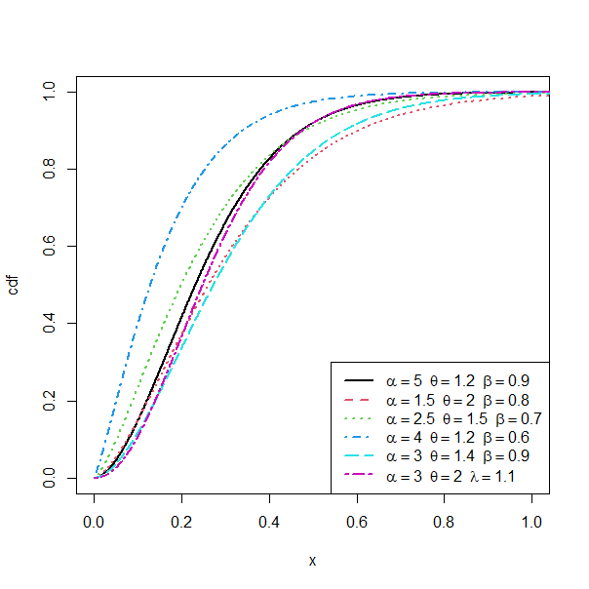
Figure 1: Plots of the cdf of NSTIIGTL distribution with different parameter values

As seen from figure 1, we can deduced that the cdf has varying shapes. Some are steeper, while others are flatter and this indicates that the parameters significantly influence the overall shape of the distribution.
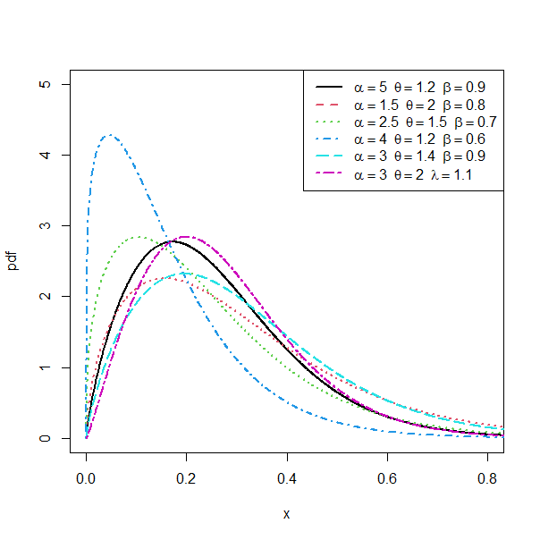
Figure 2: Plots of the pdf of NSTIIGTL distribution under various parameter values are presented. The pdf plot shown in figure 2 explores how different parameter combination affect the shape of the distribution, and these parameters control the location, spread, and skewness of the distribution. We can see that the distribution has varying shapes. Some are more symmetric, while others are skewed. This indicates that the parameters have a substantial impact on the overall shape of the distribution.

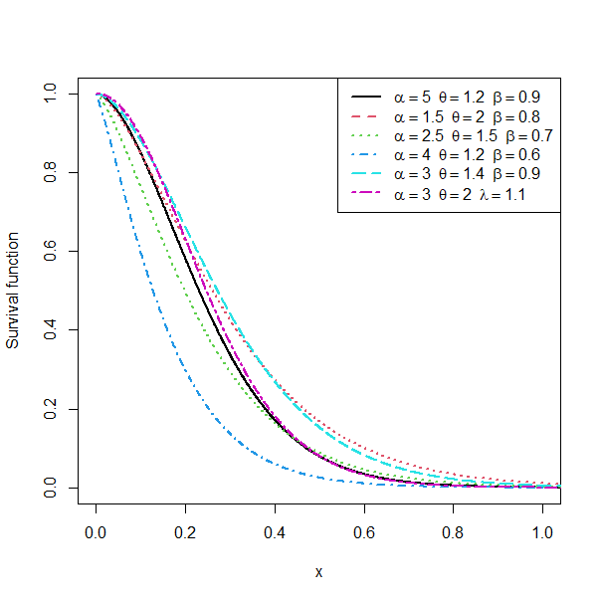
Figure 3: Plots of the survival function of NSTIIGTL distribution with different parameter values

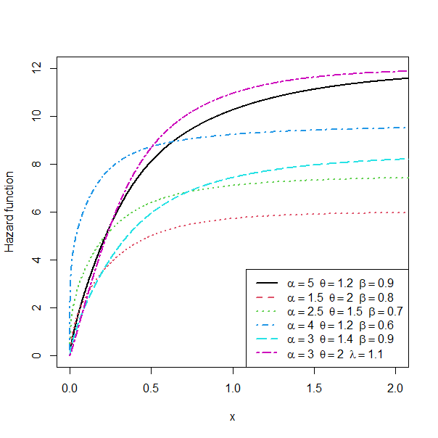
Figure 4: Plots of the hazard function of NSTIIGTL distribution with different parameter values

6. Conclusion

This study presented a theoretical investigation of the New Sine Type II Topp-Leone distribution. The probability density and distribution functions were formulated using a sine transformation applied to the Type II Topp-Leone generator. Several mathematical properties were derived analytically, including the survival and hazard functions, quantile function, and moment generating function, moments, entropy measures and other statistics.
The graphical representation of the pdf demonstrate the flexibility of the model in capturing different distributional shapes. The cdf plot displays the typical monotonic increasing pattern expected for a valid probability distribution i.e the curve begins close to zero for small values of the random variable and steadily approaches one as the variable increases. The survival plot indicate that the survival probability decrease continuously as the value of the variable increases. On the hazard rate function, the graphical results reveal that the new model can exhibit several hazard rate behaviors depending on parameter choices.
The results demonstrate that the distribution possesses a rich mathematical structure and flexible analytical properties. These theoretical findings contribute to the expanding literature on trigonometric-generated probability distributions and provide a foundation for future methodological developments.
REFERENCES
Adekunle, S. I., Yahaya, A., Doguwa, S. I, Yakubu, A. (2024). Exponentiated Type
II Generalized Topp – Leone family of distribution. Communication in physical sciences, 2024: 11(4): 785 – 798
Al-Babtain, A. A., Elbatal, A., Chesneau, M., Elgarhy M. (2020). Sine Topp – Leone
– Gfamilyof Distributions: theory and Applications. Open Physics, 2020:18:574 – 593, published by De Gruyter
Benchiha, S., Sapkota, L. P., Al-Muitairi, A., Kumar, V., Gemeay, A. M., khashab,
R. H.,Nassr,S. G. (2023). A new sine family of Generalized Distributions: Statistical inference with Applications: Mathematical and computational Applications, 28(4), 1 – 19.
Cheng, R.C.H., and Amin, N.A.K. (1979). Maximum product of spacings estimation with application to the lognormal distribution Math report
Cheng, R.C.H., and Amin, N.A.K. (1983). Estimating parameters in continuous univariate distributions with a shifted origin. Journal of the Royal Statistical Society: Series B (Methodological), 45(3), 394-403.
Cox, D. R. (1972). Regression models and life-tables. Journal of the Royal Statistical
Society: Series B (Statistical Methodology), 34(2), 187-220.
Elgarhy M., Nasir M. A., Jamal F., Ozel G. (2018). The Type II Topp – Leone
Generated Family of Distributions: Properties and Applications. Journal of Statistics and management system. Vol. 21, 2018, Issue 8, Pp 1529 – 1551. https://doi.org/10.1080/09720510.2018.1516725.
Fatoye, A., Algarni, A. and Almarashi, A. M. (2021). Sine Inverse Lomax Generated
Family of Distributions with applications. Mathematical problems in Engineering, 1 -11.
Hassan, A. S., Ghosh, S., & Kumar, A. (2019). Type II Generalized Topp-Leone
family of Distributions: Properties and applications. Journal of Statistical Theory and Applications, 18(4), 118-137.
Kumar, A., Ghosh, S., & Gupta, A. (2015). Sine-G family of distributions: A general
framework For modeling complex data. Communications in Statistics-Theory and Methods, 44(10), 2125-2142.
Muhammad, M., Alshanbiri, H. M., Alanzi, A. R., Liu, L., Sami, W., Chesneau, C.,
Jamal, F. (2021). a new generator of probability models: the exponentiated sine-G family for lifetime studies. Entropy, 23(11), 1-30.
Ranneby, B. (1984). The maximum spacing method. An estimation method related to the maximum likelihood method. Scandinavian Journal of Statistics, 11(2), 93112.
Sakthivel, K. M., Dhivakar, K. (2021). Type II Topp-Leone Dagum Distribution for
modeling Faliure Times Data. Malaya Journal of Matematik, Vol.9, No. 01, Pp 343-345
Souza, L. O, Junior, W. R. D., Brito, C. C .R., Chesneau, C., Fernandes, R. L.,
Ferreira, T. A (2021). Tan-G class of trigonometric distributions and its applications. Cubo (Temuco), 23(1), 1 -20
Topp C. W, Leone F. C. (1955). A family of J-shaped frequency functions. Journal
of the American Statisticsal Association,. 1955; 50(269): 209-219
Weibull, W. (1951). A Statistical Distribution Function of Wide Applicability.
Journal of Applied Mechanics, 18(3), 293-297.

