DEVELOPMENT OF CONVOLUTED PROPORTIONAL HAZARD MODEL WITH CONSTRAINED PARAMETERS

Abstract
Conventional models such as the Cox proportional hazards (PH) model or parametric survival distributions are often too restrictive to capture these complexities The literature, therefore, has evolved toward mixture cure models, split‐population models, and hybrid specifications that allow simultaneous modeling of short‐term and long‐term risks. Survival analysis has undergone significant methodological advancement but the dual risk of hazard where short-term and long-term risks follow different trajectories remains unaccounted for many approach.. This study convoluted proportional hazard model with constrained parameters, by predicting the probability of recidivism and identify factors that influence the risk of recidivism and study also offers significant improvement by combining Weibull distribution and Cox model by introducing two additional constrained parameters to capture both short term and long term risk of recidivism. The addition of parameter constraints enhances parsimony and interpretability .Maximum Likelihood estimation approach was used to estimate the parameter of the newly developed Cox-Weibull model.
Keywords: Survival Analysis, Parametric model, Semi-Parametric Model, Cox-Weibull, Cox Regression Model, Weibull Regression Model

INTRODUCTION
The reoccurrence of criminal behavior by individuals previously convicted and sanctioned continues to present significant challenges for criminal justice systems globally. , recidivism data are characterized by time‐to‐event features, since the focus often lies not only on whether an individual reoffends but also on when the re-offense occurs. This dual dimension—occurrence and timing—has made survival analysis one of the most appropriate methodological approaches for criminological research on recidivism The present of complex hazard dynamics such as dual risk, long-term survivorship, or structural heterogeneity , motivated numerous methodological extensions in recent decades, for example, Hannal et al. (2021) proposed shape-constrained Cox models via the CPH-shape algorithm, enabling the baseline hazard to be estimated under monotonic, unimodal, or U-shaped restrictions. While this innovation allowed constraints to be incorporated into the Cox framework, the restrictions apply solely to the baseline hazard and do not address hazard convolution. Importantly, the dual risk of hazard—where short-term and long-term risks follow different trajectories—remains unaccounted for in this approach. Eni et al. (2022) extended survival modeling through mixture cure models, which partition populations into cured and susceptible subgroups. since the introduction of the classical Cox proportional hazards (Cox, 1972) model. The Cox model, by virtue of its semi-parametric formulation, provided researchers with a flexible tool to model time-to-event data without making strict assumptions about the baseline hazard function. However, its flexibility has proven insufficient in many real-world applications, especially Their model incorporates an incidence component (probability of being uncured) and a latency component (conditional survival of the susceptible). While useful in settings where some individuals are not at risk of the event, this approach does not effectively capture both short-term and long-term hazard dynamics for those who remain at risk. Thus, the dual risk nature of hazards is not fully modeled. Begun et al. (2023) advanced the field by introducing double-Cox frailty models, embedding two Cox processes with shared frailty. This structure highlighted the potential of convoluting hazard components, thereby enhancing flexibility. However, this innovation was limited to Cox–Cox interactions and did not extend to hybrid convolution approaches that could disentangle short- and long-term risks more effectively. More recently, Kızılaslan et al. (2024) investigated a Weibull mixture cure frailty model with elastic-net penalization to handle high-dimensional covariates. Their contribution demonstrates the utility of combining parametric and semi-parametric methods in addressing heterogeneity. Nevertheless, because the model is formulated under a cure framework, it presupposes the existence of a cured fraction. This assumption, while appropriate in medical applications, does not generalize well to contexts such as recidivism, where nearly all individuals remain susceptible to the event of interest over varying time horizons. Consequently, the model does not explicitly disentangle or characterize the dual hazard dynamics. In summary, existing extensions of the Cox model—including shape constraints, cure mixtures, frailty structures, and penalization techniques—have advanced survival modeling but fall short of addressing the dual risk of hazard: the distinct short-term and long-term risk patterns that may coexist within survival processes. This limitation is particularly problematic in criminological studies of recidivism, where individuals face heightened risk immediately after release, followed by a different pattern of risk in the longer term. The present study addresses this methodological gap by proposing a convoluted proportional hazard model with constrained parameters. This approach integrates the semi-parametric flexibility of the Cox model with the parametric structure of the Weibull distribution, while incorporating parameter constraints to ensure interpretability and stability. The model provides a more robust framework for analyzing survival data in contexts where dual hazard risk is central, thereby offering an improved analytical tool for understanding recidivism dynamics and similar phenomena.
METHODOLOGY
Relationship between Hazard Function and Survival Function
Regardless of which function $S(t)$ or $h\left(t\right)$ one prefers, there is a clearly defined relationship between the two. If hazard is constant that is $h\left(t\right)$= $λ$, foe some specific values of $λ$, then survivor function is given by
$S(t)$ = ${e^{-}}^{λt}$ (1)
More generally, the relationship between $S(t)$ and $h\left(t\right)$ can be expressed equivalently in either of two calculus formulae as
$S(t)$ = $exp⁡[- \int_{0}^{1}{h\left(u\right)}du]$ (2)
And,
$h\left(t\right)$ = - $\frac{dS(t)/dt}{S(t)}$ (3)
Hazard Ratio (HR)
Hazard ration (HR) is defined as the hazard for one individual divided by the hazard for a different individual. The two individual being compare can be distinguished by their values for the set of predictors, that is the $x$_{I}’s
(4)
Where is the Hazard Ratio Estimate
= and
The groups are typically coded so that group with the larger hazard corresponds to, and the group with the smaller hazard corresponds to. The group with larger hazard is coded 1 and group with smaller hazard is coded 0.
= =
= (5)
3.1 Cox Regression Model
This is a statistical model that takes into consideration time until an event of interest occurs and compares the cumulative probability of event over time of two or more cohort while adjusting other influential covariates. The model is given as;
h(t,) = h_{o}(t) exp (6)
Where h(t,) = the hazard function at time t for a subject with covariate values
h_{o}(t) = the baseline hazard function i.e the hazard function when all covariates equal zero
= the i^{th} covariate in the model and
= the regression coefficient for the i^{th} covariate.
The Cox model is different from ordinary regression in that the covariate are used to predict the hazard function, and not Y itself. The base line hazard function can take any form but it cannot be negative. The exponential function of the covariate is used to insure that the hazard is positive. There is no intercept in the Cox model. (Any intercept could be absorbed into the base line hazard function). The basic Cox model assumes that the hazard functions for two different levels of a covariate are proportional for all values of t.
3.1.2 Estimation of the Coefficient of the Cox’s Regression Model
To estimate the coefficient β₁,…, βp Cox suggest a maximum likelihood procedure where the likelihood function is based on a conditional probability of failure. We have that t(1)<t(2)<…<t(k) are the k exact failure times and R(t(i)) is the risk set of patient(convict) at time t(i). For the particular failure at time t(i), conditional on the risk set R{t(i)}, the probability that the failure is on the individual is
$\frac{exp⁡(\sum_{j=1}^{p}{β_{j}x_{ji})}}{\sum_{1∈R\left(t_{\left(1\right)}\right)}{exp}(\sum_{j=1}^{p}{β_{j}x_{ji})}}$ (7)
Each failure contributes a factor and hence the conditional log-likelihood is
$LL\left(β\right)= \sum_{i=1}^{k}{\sum_{j=1}^{p}{β_{j}j_{i}- \sum_{i=1}^{k}{\log_{e}}\left[\sum_{i∈R(t_{(_{i})})}{exp⁡(\sum_{j=1}^{p}{β_{j}x_{ji}})}\right]}}$ (8)
Maximum likelihood estimate of β’s are obtained by solving simultaneously the P equation that are derivative of LL(β) with respect to β1,…βp respectively, equating to zero. The P equations are
$U\left(β_{1}….β_{P}\right)=\sum_{i-1}^{k}{\left[X_{ui}- A_{ui}\left(β_{1}….β_{p}\right)\right]=0, U=1,…,p}$ (9)
Where
$A_{ui }\left(β_{1},….,β_{p}\right)= \frac{\sum_{1∈R(t_{\left(1\right)})}{x_{ul }exp}(\sum_{j=1}^{p}{β_{j}x_{ji})}}{\sum_{1∈R(t_{\left(1\right)})}{exp}(\sum_{j=1}^{p}{β_{j}x_{ji})}}$ (10)
The P equations can be solved numerically by the Newton-Raphson method of iteration where the estimate of the coefficients are obtained by iteration use of U(β1,β2,…βk) and the second derivative of LL(β):
luv(β₁,….,β_{p})= -$\sum_{i=1}^{k}{C_{\left(uvi\right)}\left(β_{i},….β_{p}\right)}$ (11)
Where
$∁_{\left[uvi\right]}\left(β_{i}….β_{p}\right)=\frac{\sum_{i∈R(t)}{x_{ul} x_{vl }exp\left[\sum_{j=1}^{p}{β_{j}x_{j1}}\right]}}{\sum_{i∈R(t)}{exp\sum_{j=1}^{p}{b_{j}}}x_{j1}}={-A}_{ui }\left(β_{i, }….β_{p}\right)A_{vi}\left(β_{i,}….β_{p}\right)$ (12)
In addition to the values of the estimated regression coefficient β1, β2,…βk give the proportional change that can be expected from the hazard, related to changes in the covariate. If these values are positive, the prognosis is worse for subject with higher values of that covariate, while if the values are negative the prognosis is better for subject with higher values of that covariate. In the particular case where the survival times involve ties (which is a more common problem in practice than the case of continuous survival time) Cox proposed a more general model. This model generalizes
h(t/x) = h_{o}(t) exp($β_{1}x_{1}+ β_{2}x_{2}+….+β_{p}x_{p}$) = h_{o}(t) $exp\sum_{j=1}^{p}{b_{j}}x_{j}$ (13)
To discrete time by a logistic transformation
$\frac{h_{(t)}dt}{1-h_{(t)}dt}=\frac{h_{o}\left(t\right)dt}{1-h_{o}\left(t\right)dt} exp\sum_{j=1}^{p}{b_{j}}x_{j}$ (14)
Suppose that among the survival times t1,t2…,tn there are k distinct failure times
t(1) < . . . < t(k)
Let M(i)= the multiplicity of t(i), M(i) > 1 if there is more than one observation with value t(i),
M(i)=1, if there is only one observation with value t(i)
Let r{t(i)} denote the set of individual at risk at time t(i), and r(i) be the number of such individual. At time t(i), the probability that the individual fails as observed conditionally on the risk set R{t(i)} is
$\frac{exp⁡(β_{1}z_{1i}+β_{2}z_{2i}+…+β_{p}z_{pi})}{\sum_{1∈R\left(t_{\left(1\right)}\right)}{exp} (β_{1}z_{1i}+β_{2}z_{2i}+…+β_{p}z_{pi})}$ (15)
Where Z_{1i} is the sum of x1i’s over the M(i) individual failing at t(1)…
Z_{pi} is the sum of x_{pi}’s over the M(i) individual failing at t(i)
The condition likelihood function, function U and I are,
$LL\left(β\right)= \sum_{i=1}^{k}{\left(β_{1}z_{1i}+β_{2}z_{2i}+…+β_{p}z_{pi}\right)- } \sum_{i=1}^{k}{log}\left[\sum_{i∈R(t_{(_{i})})}{\exp\left(β_{1}z_{1i}+β_{2}z_{2i}+…+β_{p}z_{pi}\right)⁡}\right]$ (16)

$U\left(β_{i}….β_{P}\right)=\sum_{i-1}^{k}{\left[Z_{ui}- m_{(1)}A_{ui}\left(β_{1}….β_{p}\right)\right]=0, U=1,…,p}$ (17)

luv(β₁,….,β_{p})= $\frac{m_{(i)}\left[r_{(i)}-m_{(i)}\right]}{r_{\left(i\right)}-1}C_{\left(uvi\right)}\left(β_{i},….β_{p}\right)$
Weibull Regression Model
Weibull regression model is one of the most popular forms of parametric regression model used in survival analysis; it is more general and flexible than the exponential model. Weibull model allows for non-constant hazard rates, but changes with data set. It provides estimate of baseline hazard function, as well as coefficients for covariates. While semi-parametric model focuses on the influence of covariates on hazard, a fully parametric model like Weibull can also calculate the distribution form of survival time. The Weibull distribution is characterized by its probability density function (PDF):
$f\left(t:α,β\right)=\frac{α}{γ}{\left(\frac{t}{γ}\right)}^{α-1}exp\left(-{\left(\frac{t}{γ}\right)}^{α}\right)$ : Where α, $γ$ > 0 t ≥ 0 (18)
Where α is the shape parameter, $γ$ is the scale parameter and t represent time- to- event variable.

3.2.2 Estimation of Weibull Parameters
$f\left(t:α,β\right)=\frac{α}{γ}{\left(\frac{t}{γ}\right)}^{α-1}exp\left(-{\left(\frac{t}{γ}\right)}^{α}\right)$ : Where α , $γ$ > 0 t ≥ 0

Where α is the shape parameter and β is the scale parameter
The cumulative distribution function (CDF); = $F\left(t\right)=1-exp⁡(-{\left(\frac{t}{γ}\right)}^{α})$ (19)
Survival Function = $S\left(t\right)=$ $F\left(t\right)=1-exp⁡(-{\left(\frac{t}{γ}\right)}^{α})$ (20)
Hazard Function = $h\left(t\right)= \frac{f(t)}{S\left(t\right) }= \frac{α}{γ}{\left(\frac{t}{γ}\right)}^{α-1}$ (21)
Increasing hazard if α > 1
Constant hazard if α = 1
Decreasing hazard if α < 1
Parameter estimation via maximum likelihood estimation (MLE)
Given n i.i.d, lifetimes t₁, …, t_{n}
shape parameter α > 0
scale parameter $γ$ > 0
P.D.F is $f\left(t:α,β\right)=\frac{α}{γ}{\left(\frac{t}{γ}\right)}^{α-1}exp\left(-{\left(\frac{t}{γ}\right)}^{α}\right)$ (22)
The likelihood is $L(α,γ)$ = $\prod_{i=1}^{n}{f\left(t:α,γ\right)}$ (23)
Take the log of $L(α,γ)$ = logL = $\sum_{i=1}^{n}{[\log{α-logγ+\left(α-1\right)logt-}}{\left(\frac{t}{γ}\right)}^{α}$] (24)
logL = $nlogα-nlogγ+(α-1)\sum_{i=1}^{n}{logt-\sum_{i=1}^{n}{{\left(\frac{t}{γ}\right)}^{α}}}$ (25)
Define $\sum_{i-1}^{n}{t}$ = L and $\sum_{i=1}^{n}{{\left(\frac{t}{γ}\right)}^{α}}$ = Z (26)
So, $logL$ = $nlogα-nlogγ+\left(α-1\right)L-Z$ (27)
$$We differentiate logL with respect to α and γ, now with respect to γ, we have;$$
Z = $\sum_{i=1}^{n}{{\left(\frac{t}{γ}\right)}^{α}}$= $\sum_{i=1}^{n}{t^{α}γ^{-α}}$ then (28)
$\frac{∂z}{∂γ}$ = ${-αγ}^{-α-1}\sum_{i=1}^{n}{t^{α}}$ = $\frac{-α}{γ}Z$ (29)

$\frac{∂l}{∂γ}$ = $\frac{-n}{γ}+\frac{∂z}{∂γ}$ = $\frac{-n}{γ}+\frac{α}{γ}Z$ = $\frac{αz-n}{γ}$ (30)
With respect to $α$
$L(P)$ = $nlogα-nlogγ+\left(p-1\right)L$ - $\sum_{i=1}^{n}{{\left(\frac{t}{γ}\right)}^{α}}$ (31)
$\frac{∂}{∂α}$(nlog$α)$ = $\frac{n}{α}$, $\frac{∂}{∂α}(-nlogγ$) = 0, $\frac{∂}{∂α}\left(\left(p-1\right)L\right)$ = L (32)

$\frac{∂}{∂α}(\sum_{i=1}^{n}{{\left(\frac{t}{γ}\right)}^{α}}$) = $\sum_{i=1}^{n}{{\left(\frac{t}{γ}\right)}^{α}}$log$(\frac{t}{γ})$ (33)
$\frac{∂l}{∂α}$ = $\frac{n}{p}+L- \sum_{i=1}^{n}{{\left(\frac{t}{γ}\right)}^{α}}$log$(\frac{t}{γ})$ (34)
MLE
We set the partial derivative to zero
From (1) $\frac{∂l}{∂γ}=0$, $\frac{αz-n}{γ}$ =0, Z = $\sum_{i=1}^{n}{{\left(\frac{t}{γ}\right)}^{α}}$= $\frac{n}{α}$ (35)

(2) $\frac{∂}{∂α}$ = 0, $\frac{n}{p}$ + $\sum_{i-1}^{n}{t}$ - $\sum_{i=1}^{n}{{\left(\frac{t}{γ}\right)}^{α}}$log$(\frac{t}{γ})$ = 0 (36)
Convoluted hazard model
The combination of parametric and semi-parametric models in survival analysis is not a novel concept. Researchers have long recognized that hybrid models can offer the dual advantage of flexibility in hazard specification and robustness to distributional assumptions. Parametric models like Weibull distribution are valued for their ability to capture specific hazard shapes over time, while semi-parametric models, notably Cox proportional hazard models, provide robustness by not requiring a strict specification of the baseline hazard. Several studies have pioneered this integrative approach.
This study, combine hazard function that integrates the Weibull distribution and the Cox proportional hazard model. This combine model account for both baseline hazard shapes (through the Weibull distribution) and covariates effects (through the Cox model).
The Weibull distribution is characterized by its probability density function (PDF):
$f\left(x:α,β\right)=\frac{α}{γ}{\left(\frac{x}{γ}\right)}^{α-1}exp\left(-{\left(\frac{x}{γ}\right)}^{α}\right)$ : Where α , $γ$ > 0 (37) x ≥ 0
Where α is the shape parameter of the Weibull distribution and β is the scale parameter of the Weibull distribution. From this, we derive the Weibull hazard function, which describes the instantaneous failure rate at time t:
$hw\left(t,α,γ\right)=\frac{α}{γ}{\left(\frac{x}{γ}\right)}^{α-1}$ (38)
The Cox proportional hazards model, a semi-parametric model has no probability density function (PDF) but expresses the hazard function as a product of a baseline hazard function and a term that account for covariates
$h\left(t,x_{i}\right)=h_{0}\left(t\right)exp⁡(\sum_{i=1}^{k}{β_{i}x_{i})}$ (39)
$h_{0}\left(t\right)$ is the baseline hazard function,
$x_{i}$ are the covariates,
$B_{i}$ are the coefficients associated with each covariate.
3.2.3 Combined Hazard Function
To combine these models, we introduce weight p and q such that p + q =1, where
0 ≤ p, q ≤ .These weight will control the contribution of each model to the combine hazard function. The combine hazard function is then given by:
$g\left(t,x_{i}\right)=p.h\left(t,x_{i}\right)+q. hw\left(t,α,γ\right)$ (40) Substituting (1) and (2) into (3)
$g\left(t,x_{i}\right)=p.h_{0}\left(t\right)exp\sum_{i=1}^{k}{β_{i}x_{i}}+q. \frac{α}{γ}{\left(\frac{x}{γ}\right)}^{α-1}$ (41) $Using p=1-q$, hence
$g\left(t,x_{i}\right)=p.h_{0}\left(t\right)exp\sum_{i=1}^{k}{β_{i}x_{i}}+(1-p). \frac{α}{γ}{\left(\frac{x}{γ}\right)}^{α-1}$ (42)
Detailed Parameters
α is the shape parameter of the Weibull distribution.
$γ$ is the scale parameter of the Weibull distribution,
$h_{0}\left(t\right)$ is the baseline hazard function in the Cox model.
$x$ are the covariates.
$β_{i}$ are the coefficient for each covariate.
P is the weight for the Cox component.
q is the weight for the Weibull component, such that p + q =1
Interpretation
The Weibull component captures the baseline hazard with shape and scale parameters α
and $γ$
The Cox component adjust the hazard based on the covariates $x_{i}$ through the coefficient
The weight p and q allow for a flexible combination of both models
Interpretation of the Combined Model
The shape parameter α of the Weibull component determines the failure rate
behaviour:
- If α < 1, the failure rate decreases over time
- If α = 1, the failure rate is constant over time ( this reduces to exponential
distribution)
- If α > 1, the failure rate increases over time.
The scale parameter $γ$ of the Weibull component scales the distribution
The baseline hazard function $h_{0}\left(t\right)$ in the Cox component captures the underlying hazard when covariates are zero
The term exp $(\sum_{i=1}^{k}{β_{i}x_{i})}$ in the Cox component adjust the hazard based on the covariates
The weight p and q allow for a flexible combination of the two models where p controls the contribution of the Cox component and q controls the contribution of the Weibull component. If p is closer to 1, the model behaves more like a standard Weibull model with less influence from covariates. If q is closer to 1, the model behaves more like a Cox proportional hazard model with the Weibull baseline hazard having less influence.
3.2.3 Maximum Likelihood Estimation for the Combined Weibull-Cox Model
From the combined hazard function (5), we have
$h\left(t,x_{i}\right)=p.h_{0}\left(t\right)exp\sum_{i=1}^{k}{β_{i}x_{i}}+(1-p). \frac{α}{γ}{\left(\frac{x}{γ}\right)}^{α-1}$ (43)
Define cumulative hazard function of the form
$H\left(t,x_{i}\right)=\int_{0}^{t}{h\left(u,x_{i}\right)}du$ (44)
And a survival function
$S\left(t,x_{i}\right)=\exp{(-H\left(t,x_{i}\right)})$ (45)
Given n observations with survival times $t_{i, }$ covariates $x_{i}$ and censoring indicator$δ_{i}$, the likelihood function id given by
$L\left(α,γ, β_{i},p,t_{i, }x_{i},δ_{i}\right)=\prod_{i}^{n}{h{{(t}_{i, }x_{i})}^{δ_{i}}}.S(t_{i, }x_{i})$ (46)
Taking the natural logarithm of the likelihood function:
Log L = $\sum_{i=1}^{n}{\{}$ $δ_{i}\log{h(}t_{i, }x_{i})-H(t_{i, }x_{i}$)} (47)
$Log L\left(α,γ, β_{i},p,\right)=\sum_{i=1}^{n}{\left[{(δ}_{i}\log{p.h_{0}\left(t\right)exp\sum_{i=1}^{k}{β_{i}x_{i}})+{(\left(\frac{x}{γ}\right)}^{α-1})\frac{α}{γ} \left(1- p\right). -\sum_{i=1}^{k}{\int_{0}^{t}{h\left(u,x_{i}\right)du . }}}\right]}$ (48)
We now differentiate this with respect to α, compute $\frac{∂logL}{∂α}$
Take the derivative term by term, term1: δ_{i} log$h$($x$_{i} ,$t$_{i}) , only the Weibull component depends on α, then; $h$($x$_{i} ,$t$_{i}) = P.$h$_{cox}($x$_{i} ,$t$_{i} ) + (1-p).$\frac{α}{γ}{\left(\frac{t}{γ}\right)}^{α-1}$ (49)
let $h$_{i} =$h$($x$_{i} ,$t$_{i}) , $h$_{wi} = $\frac{α}{γ}{\left(\frac{t}{γ}\right)}^{α-1}$ (50)
ꝺh_{i}/ꝺα = (1 – p). ꝺ$h$_{wi} /ꝺα (51)
we differentiate $h$_{wi} i.e. ꝺ/ꝺα[$\frac{α}{γ}{\left(\frac{t}{γ}\right)}^{α-1}]$by using product rule, we have
ꝺh_{i}/ꝺα = (1 – p).[$\frac{1}{γ}{\left(\frac{t}{γ}\right)}^{α-1}$+ $\frac{α}{γ}{\left(\frac{t}{γ}\right)}^{α-1}$log($\frac{t}{γ})$] (52)
Applying chain rule; $\frac{∂}{∂α}$ $log$ $h$($x$_{i} ,$t$_{i}) = 1/h_{i} . ꝺh_{i}/ꝺα
so the first term becomes $δi \sum_{i=1}^{n}{(}\frac{1}{h(t;x)}$ . $\frac{ꝺh(t;x)}{ꝺα}$) (53)
substituting in $\sum_{i=1}^{n}{ δi (}\frac{(1-p)}{h(t;x)}$ . [$\frac{1}{γ}{\left(\frac{t}{γ}\right)}^{α-1}$+ $\frac{α}{γ}{\left(\frac{t}{γ}\right)}^{α-1}$log($\frac{t}{γ})$]) (54)
factor out common parameters: $\sum_{i=1}^{n}{ δi (}\frac{\left(1-p\right) }{γ}{\left(\frac{t}{γ}\right)}^{α-1}.$ [$\frac{1}{h(t;x)}+\frac{α log(\frac{t}{γ})}{h(t;x)}$]) (55)
$\frac{∂Log L}{∂α}=\sum_{i=1}^{n}{\left[{(δ}_{i}.\frac{\left(1-p\right). \frac{α}{γ}{\left(\frac{t_{i, }}{γ}\right)}^{α-1}.log⁡\left({t_{i, }}/γ\right)}{p.h_{0}\left(t\right)exp\sum_{i=1}^{k}{B_{i}x_{i}}+(1-p). \frac{α}{γ}{\left(\frac{x}{γ}\right)}^{α-1}}\right]}-\sum_{i=1}^{n}{\int_{0}^{t_{i, }}{\frac{∂h(u,x_{i})}{∂α}du}}$ (56)
Differentiate with respect to $γ$
$\frac{ꝺlog}{ꝺβ}$ = $\sum_{i=1}^{n}{[δi}\frac{1}{h(t;x)} . \frac{ꝺh(t;x)}{ꝺγ}- \int_{0}^{t}{\frac{ꝺh(u;x)}{ꝺγ}du}$ (57)
Recall that the mixture is $h\left(t;x\right)$ = P. h_{o}(t) exp ($\sum_{i=1}^{n}{β_{i}x_{i})}$ + (1-p).$\frac{α}{γ}{\left(\frac{t}{γ}\right)}^{α-1}$
Only the Weibull part depends on $γ$
H_{w}(t) = $\frac{α}{γ}{\left(\frac{t}{γ}\right)}^{α-1}$ = $γ$^{-α}.t^{(α- 1)},
we differentiate this w.r.t $γ$ using product and chain rule
$\frac{ꝺ}{ꝺγ}$[$\frac{α}{γ}{\left(\frac{t}{γ}\right)}^{α-1}]$. Let f($γ$) = $\frac{α}{γ}$ and g($γ)$ = ${\left(\frac{t}{γ}\right)}^{α-1}$ (58)
Then, $\frac{ꝺ}{ꝺβ}\left(fg\right)=f^{'}g+fg'$ (59)
$f^{'}$ = $\frac{ α}{γ2 }$, $g={\left(\frac{t}{γ}\right)}^{α-1}$ and $g^{'}=$(α – 1)${\left(\frac{t}{γ}\right)}^{α-2}$ . $\frac{1}{γ2}$ = -(α – 1).${\left(\frac{t}{γ}\right)}^{α-1}$.$\frac{1}{γ }$ (60)
$\frac{ꝺ}{ꝺγ}$h_{w}(t) = - $\frac{ α}{γ2 }$.${\left(\frac{t}{γ}\right)}^{α-1}$ - $\frac{α}{γ}$ . (α – 1) ${\left(\frac{t}{γ}\right)}^{α-1}$. $\frac{1}{γ }$ (63)
Factor common terms
$\frac{ꝺ}{ꝺγ}$h_{w}(t) = - ${\left(\frac{t}{γ}\right)}^{α-1}$. $\frac{1}{γ }$[$\frac{α}{γ}$+$\frac{α(α-1)}{γ}$] =- (1- p)${\left(\frac{t}{γ}\right)}^{α-1}$. $\frac{1}{γ }$[$\frac{α}{γ}$+$\frac{α(α-1)}{γ}$] (61)
$\frac{∂Log L}{∂γ}=\sum_{i=1}^{n}{\left[{(δ}_{i}.\frac{\left(1-p\right). \frac{1}{γ}{\left(\frac{t_{i, }}{γ}\right)}^{α-1}.\left((α-1)\frac{1}{γ}\right) - \frac{α}{γ^{2}}{\left(\frac{t_{i, }}{γ}\right)}^{α-1}}{p.h_{0}\left(t\right)exp\sum_{i=1}^{k}{B_{i}x_{i}}+(1-p). \frac{α}{γ}{\left(\frac{t_{i, }}{γ}\right)}^{α-1}}\right]}-\sum_{i=1}^{n}{\int_{0}^{t_{i, }}{\frac{∂h(u,x_{i})}{∂γ}du}}$ (62)

To get β_{i,} we differentiate $h\left(t;x\right)$ with respect to β_{i}
$\frac{ꝺlog}{ꝺβi}$ = $\sum_{i=1}^{n}{[δi}\frac{1}{h(t;x)} . \frac{ꝺh(t;x)}{ꝺβi}- \int_{0}^{t}{\frac{ꝺh(u;x)}{ꝺβi}du}$
$h\left(t;x\right)$ = = P. h_{o}(t) exp ($\sum_{i=1}^{n}{β_{i}x_{i})}$ + (1-p).$\frac{α}{γ}{\left(\frac{t}{γ}\right)}^{α-1}$
only the Cox part depends on β_{i,} so we have;
$\frac{ꝺh(t;x)}{ꝺβi}$ = P. h_{o}(t) exp ($\sum_{i=1}^{n}{β_{i}x_{i})}$ . $x_{i}$, we plug in to first term (63)
δ_{i} . $\frac{1}{h(t;x)}$ . P. h_{o}(t) exp ($\sum_{i=1}^{n}{β_{i}x_{i})}$ . $x_{i}$ (64)
= $\frac{∂Log L}{∂β_{i}}=\sum_{i=1}^{n}{\left[{(δ}_{i}.\frac{p.h_{0}\left(t\right)exp\sum_{i=1}^{k}{β_{i}x_{i}} . .x_{i}}{p.h_{0}\left(t\right)exp\sum_{i=1}^{k}{β_{i}x_{i}}+(1-p). \frac{α}{γ}{\left(\frac{t_{ }}{γ}\right)}^{α-1}}\right]}-\sum_{i=1}^{n}{\int_{0}^{t_{i, }}{\frac{∂h(u,x_{i})}{∂β_{i}}du}}$ (65)
To get P, we differentiate $h\left(t;x\right)$ with respect to P
$\frac{ꝺlogL}{ꝺp}$ = $\sum_{i=1}^{n}{[δi}\frac{1}{h(t;x)} . \frac{ꝺh(t;x)}{ꝺp}- \int_{0}^{t}{\frac{ꝺh(u;x)}{ꝺp}du}$
But $h(t;x)$ = $P. hₒ(t) exp (\sum_{i=1}^{n}{β_{i}x_{i})} + (1-p). \frac{α}{γ}{\left(\frac{t}{γ}\right)}^{α-1}$
$\frac{ꝺh(t;x)}{ꝺp}$ = $hₒ(t) exp (\sum_{i=1}^{n}{β_{i}x_{i})}$ - $\frac{α}{γ}{\left(\frac{t}{γ}\right)}^{α-1}$ (66)
$\frac{∂Log L}{∂p}=\sum_{i=1}^{n}{\left[{(δ}_{i}.\frac{p.h_{0}\left(t\right)exp\sum_{i=1}^{k}{β_{i}x_{i}} - \frac{α}{γ}{\left(\frac{t_{ }}{γ}\right)}^{α-1}}{p.h_{0}\left(t\right)exp\sum_{i=1}^{k}{β_{i}x_{i}}+(1-p). \frac{α}{γ}{\left(\frac{t_{ }}{γ}\right)}^{α-1}}\right]}-\sum_{i=1}^{n}{\int_{0}^{t_{ }}{\frac{∂h(u,x_{i})}{∂p}du}}$ (67)
Setting (12), (13), (14) and (15) to zero, that is
Setting $\frac{∂Log L}{∂α}= \frac{∂Log L}{∂γ}= \frac{∂Log L}{∂β_{i}}=\frac{∂Log L}{∂p}=0$ (68)
$\frac{∂Log L}{∂α}=\sum_{i=1}^{n}{\left[{(δ}_{i}.\frac{\left(1-p\right). \frac{1}{γ}{\left(\frac{t_{i, }}{γ}\right)}^{α-1}.log⁡\left({t_{i, }}/γ\right)}{p.h_{0}\left(t\right)exp\sum_{i=1}^{k}{β_{i}x_{i}}+(1-p). \frac{α}{γ}{\left(\frac{x}{γ}\right)}^{α-1}}\right]}-\sum_{i=1}^{n}{\int_{0}^{t_{i, }}{\frac{∂h\left(u,x_{i}\right)}{∂α}du}}=0$ (69)
$\frac{∂Log L}{∂γ}=\sum_{i=1}^{n}{\left[{(δ}_{i}.\frac{\left(1-p\right). \frac{α}{γ}{\left(\frac{t_{i, }}{γ}\right)}^{α-1}.\left((α-1)\frac{1}{γ}\right) - \frac{α}{γ^{2}}{\left(\frac{t_{i, }}{γ}\right)}^{α-1}}{p.h_{0}\left(t\right)exp\sum_{i=1}^{k}{β_{i}x_{i}}+(1-p). \frac{α}{γ}{\left(\frac{t_{i, }}{γ}\right)}^{α-1}}\right]}-\sum_{i=1}^{n}{\int_{0}^{t_{i, }}{\frac{∂h(u,x_{i})}{∂γ}du=0}}$ (70)
$\frac{∂Log L}{∂β_{i}}=\sum_{i=1}^{n}{\left[{(δ}_{i}.\frac{p.h_{0}\left(t\right)exp\sum_{i=1}^{k}{β_{i}x_{i}} . .x_{i}}{p.h_{0}\left(t\right)exp\sum_{i=1}^{k}{β_{i}x_{i}}+(1-p). \frac{α}{γ}{\left(\frac{t_{i, }}{γ}\right)}^{α-1}}\right]}-\sum_{i=1}^{n}{\int_{0}^{t_{i, }}{\frac{∂h(u,x_{i})}{∂β_{i}}du=0}}$ (71) $\frac{∂Log L}{∂p}=\sum_{i=1}^{n}{\left[{(δ}_{i}.\frac{p.h_{0}\left(t\right)exp\sum_{i=1}^{k}{β_{i}x_{i}} - \frac{α}{γ^{2}}{\left(\frac{t_{i, }}{γ}\right)}^{α-1}}{p.h_{0}\left(t\right)exp\sum_{i=1}^{k}{β_{i}x_{i}}+(1-p). \frac{α}{γ}{\left(\frac{t_{i, }}{γ}\right)}^{α-1}}\right]}-\sum_{i=1}^{n}{\int_{0}^{t_{i, }}{\frac{∂h\left(u,x_{i}\right)}{∂p}du}}=0$ (72)
The convoluted proportional hazard model with constrained parameters has been structured in a way that facilitates its computational implementation using standard software such as R, Python, and Stata.

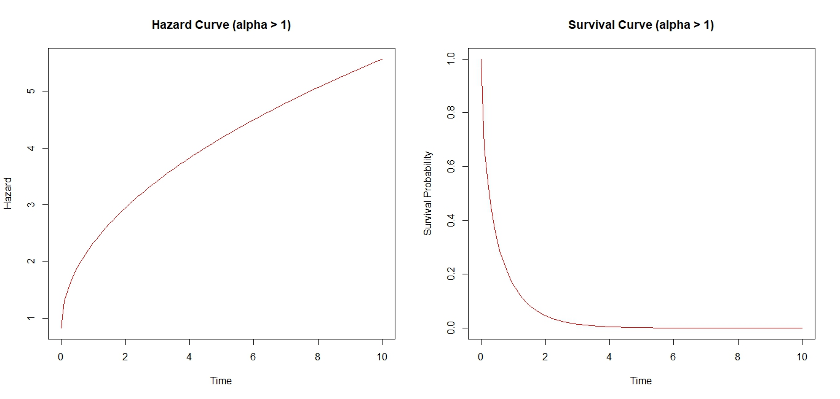
Figure 1 Hazards and Survival Curve of the Model for$α>1$
Interpretation: The plots presented above illustrate the behavior of the proposed Convoluted Cox–Weibull model under the condition α > 1. The hazard curve reveals a monotonically increasing trend, signifying that the instantaneous risk of event occurrence intensifies progressively with time. This indicates that individuals or subjects with longer exposure durations experience cumulative vulnerability, consistent with real-life phenomena such as long-term recidivism where the risk of reoffending increases with continued exposure to underlying criminogenic factors.
In contrast, the survival curve exhibits a steep initial decline followed by a gradual leveling off, implying that the probability of remaining event-free decreases sharply during the early period and becomes almost negligible at later stages. This dynamic suggests that while a subset of individuals may initially resist failure or relapse, the combined effects of time-dependent risk (driven by the Weibull baseline) and covariate-induced proportional hazards (captured by the Cox component) eventually erode survival probabilities.
The observed patterns for α > 1 therefore affirm that the proposed model effectively accommodates increasing hazard dynamics and provides a flexible structure for analyzing both short-term deterrence and long-term relapse tendencies. The interplay between the Cox and Weibull components enhances the model’s explanatory power, allowing it to reflect accelerating risk behavior that would be inadequately captured by a single-component model.
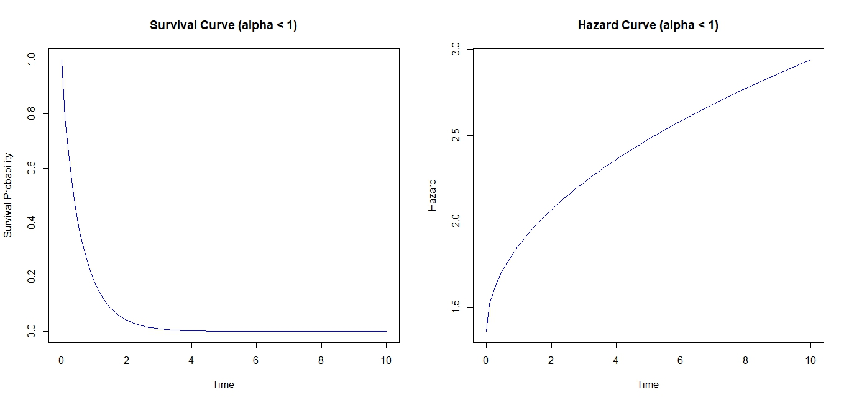Figure.2 Hazard and Survival Curve of the Model for $α<1$
Interpretation:

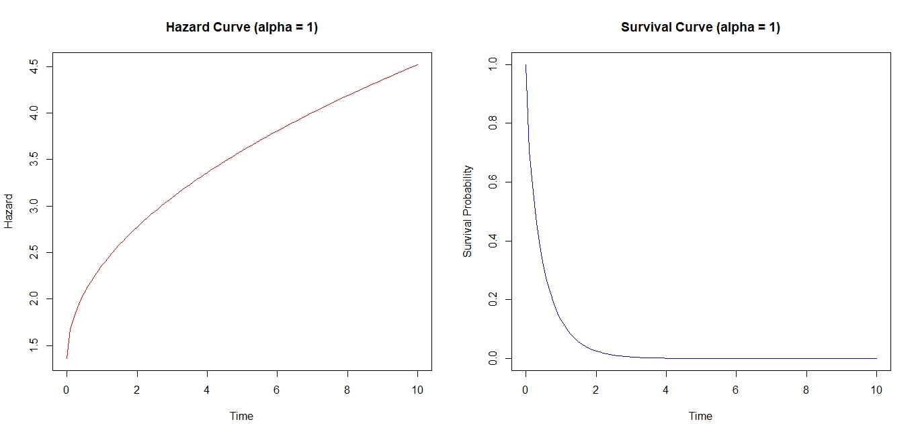
Figure 3: The Hazard and Survival Curve of the Model for $α=1$
Interpretation: When alpha is equals one, it implies that the risk (hazard) is constant.

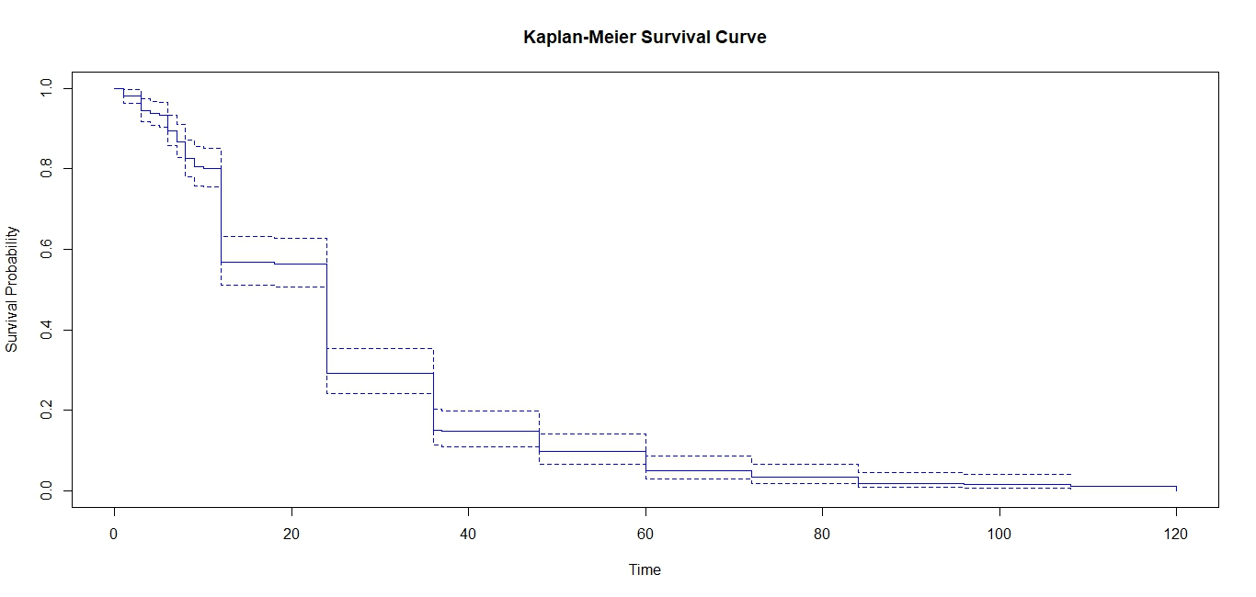
Figure 4: The Kaplan Meier Survival Curve of the Model
Interpretation: figure 4 shows a steady decline in survival probability over time, with sharp drops during the early period. This implies that most recidivism events occur shortly after release, while the remaining population exhibits a slower decline, suggesting the existence of a long-term desisting group.

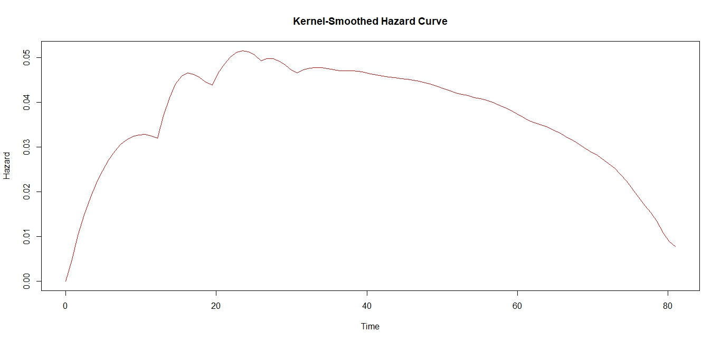
Figure 5: The Kernel-Smoothed Hazard Curve of the Model
Interpretation: figure 5 shows an early rise in hazard rates, peaking around the 20th time unit, and a gradual decline thereafter. This pattern indicates that the risk of reoffending is highest in the early months after release and decreases over time—a dynamic perfectly captured by the proposed hybrid model’s convolution of short- and long-term components.
CONCLUSION
The study combine parametric (Weibull ) distribution which are valued for their ability to capture specific hazard shapes over time, and semi-parametric (Cox proportional hazard models), which provide robustness by not requiring a strict specification of the baseline hazard. The study develops a convoluted proportional hazard model with constrained parameters by employs a Cox–Weibull convolution with additional parameters and Maximum Likelihood estimation approach was used to estimate the parameter of the Cox-Weibull

REFERENCES
Begun, A., Kulinskaya, E., Ncube N. (2023). Double-Cox model for non-proportional hazard in
Survival Analysis with frailty. Statistics in medicine, 2023; 42(18): 3114-3127. Doc;10.1072/Sim.9760

Cox, D. R., & Oakes, D. (1984). Analysis of survival data. Chapman & Hall/CRC.
Cox, Regression models and Life-Tables. Imperial college London, 1972.
Drago, F., Galbiati, R., & Vertova, P. (2011). Prison conditions and recidivism. American Law and Economics Review, 13(1), 103–130. https://doi.org/10.1093/aler/ahq024
Durose, M; Cooper, A; & Synyder, H. (2014) Recidivism of prisoner released in 30 states in 2005: patterns from 2005 to 2010, NCJ 244205 Bureau of Justice Statistics
Freedman, D. (2010) Statistical models and causal Inference New York,NY: Cambridge University press
Goal MK, Khanna P, Kishore J (2010) understanding Survival Analysis: Kaplan-Meier Estimate
Hosmer, Jr D.W. and Lemeshow, S. (1999). Applied Survival Analysis; Regression modeling of Time to Event Data Wiley, New York
International center for prison studies (2014). Highest to Lowest prison population total, Website application Retrieved from http://www.prisonstudies.org/highest-to-lowest/
J.P. Klein & M.L. Moeschberger, Survival Analysis: Techniques for Censored and Truncated Data. Springer, Second Edition, 2003.

