Application of Machine Learning Methods for Predicting Neonatal Mortality in Kenya Based on the 2022 Kenya Demographic and Health Survey

Abstract
Neonatal mortality poses a major hurdle in globe health efforts. As per the 2022 Kenya Demographic and Health Survey (KDHS), the neonatal mortality rate was 21 deaths per 1000 live births. Although the rates have been declining over the years, the rate remains significantly higher than the target set by the Sustainable Development Goals 3.2 of 12 deaths per 1,000 live births by 2030 for preventable deaths endorsed by the United Nations meeting in 2015. To achieve this target, we need a predictive model that could provide actionable insights and timely interventions to predict and avert neonatal deaths. Machine learning has great potential to improve health results for newborns, especially in areas with limited resources. The objective of this study was to develop a predictive model based on ensemble machine learning algorithms to predict neonatal mortality in Kenya using the 2022 KDHS dataset and identify the critical features contributing to the prediction of neonatal mortality. The Synthetic Minority Over-Sampling Technique was used to address the imbalance in the dataset. The Categorical gradient boosting model outperformed others in terms of accuracy (98.00%), precision (97.46%), recall (98.00%), F1 score (97.57%), and the Receiver Operating Characteristic (ROC) area under the curve (92.24%). The major factors identified included the number of children below five in the household, the total births recorded over the past five years, region, religion, sex of the newborn, source of drinking water, occupation, sex of the household head, use of mosquito nets, place of residence, ever-terminated pregnancy and duration of pregnancy. The research findings support the integration of machine learning into healthcare approaches such Kenya Health information system to facilitate the accurate prediction of neonatal deaths and enhance survival for our newborns. The government should also promote family planning in the country to lower the number of children below five years in households and reduce the number of births recorded per woman in the last five years.
Keywords: Kenya Demographic and Health Survey, Machine Learning Algorithms, Neonatal mortality
- Introduction
The initial 28 days of a newborn's life represent the most vital phase for the child's survival. Neonatal mortality is defined as the death of an infant within the first 28 days of life. The world's neonatal mortality was approximately 19 deaths per 1000 live births in 2022, with 2.3 million newborn deaths globally in that year, according to the World Health Organisation [1]. In Sub-Saharan Africa, the neonatal mortality rate stood at 27 deaths for every 1,000 live births, while Central and Southern Asia recorded a rate of 21 deaths per 1,000 live births. As per the 2022 KDHS [2], the neonatal mortality rate was 21 deaths per 1000 live births. The neonatal mortality in Kenya has been declining from 33 deaths per thousand live births in 2003, 31deaths per thousand live births in 2008 and 22 deaths per 1000 live births in 2014. Although the rate has been declining, the rate is still far above the Sustainable Development Goal target 3.2 of 12 deaths per 1,000 live births by 2030 for preventable deaths adopted by the United Nations in 2015. As per the 2022 KDHS, the factors affecting neonatal mortality varied across different groups; for instance, the neonatal mortality was 19 deaths per 1000 live births for females and 24 deaths per thousand live births for males. The neonatal mortality was 21 deaths per thousand live births for infants born in urban areas and 22 deaths per 1000 live births for infants born in rural areas. The neonatal mortality ten years before the 2022 KDHS survey was conducted was lowest in Marsabit with a rate of 4 deaths per thousand live births and highest in Kirinyaga, Wajir and Migori with a rate of 37 deaths per one thousand live births. The significant neonatal mortality rate in Kenya underscores the critical requirement for focused interventions and forecasting models to guide policy and practice. This research explores the significant issue of neonatal mortality in Kenya by pinpointing key risk factors that contribute to this problem and creating predictive models through the use of ensemble machine learning algorithms. By utilizing machine learning techniques, this study seeks to enable prompt, data-informed interventions aimed at lowering neonatal mortality rates and enhancing healthcare outcomes in the nation. Some authors have explored neonatal mortality using various approaches, such as Logistic regression modelling by [3] based on the 2014 KDHS. The risk factors included mothers’ level of education, birth weight and the number of Antenatal care visits.
This research mainly concentrates on ensemble machine-learning techniques to analyze neonatal mortality in Kenya using data from the 2022 KDHS. Machine learning, a subset of artificial intelligence, allows models to independently recognise patterns in data and make predictions without requiring specific programming instructions. They are capable of detecting intricate, nonlinear relationships and interactions within expansive datasets. This ability is especially important in neonatal, where a range of biological characteristics e.g. sex on the newborn, environmental characteristics e.g. clean water, and socioeconomic characteristics e.g. wealth influence each other in a manner that conventional statistical models may struggle to adequately represent. Machine learning has revolutionalised healthcare through disease diagnosis such as alcoholic disorder and its treatment.
Ensemble machine learning algorithms merge several "weak" models to create a unified "strong" model, enhancing predictive accuracy and robustness by mitigating overfitting [4]. Such models include bagging models such as Random Forest, boosting models such as Light Gradient Boosting and stacking models such as logistic regression model to combining the outputs of a decision tree, a support vector machine, and a k-nearest neighbors model [4]. The benefit of ensemble machine learning includes reduction of over fitting, increased accuracy, robustness to noise and bias-variance tradeoff. Boosting is the process of taking a weak learner, modelling sequentially until no further refinement can be made, and turning it into a strong learner, which is used for reducing bias and variance. Bagging is the process that involves training multiple independent models on different random subsets of the data and combining their predictions. This results in variance reduction and helps avoid overfitting.
Class imbalance arises when one category in the target variable contains considerably fewer instances than the other category. Imbalanced datasets can cause machine learning models to favour the majority category, adversely affecting their capacity to accurately predict the minority category. The Synthetic Minority Over-Sampling Technique (SMOTE) is a widely recognized method of over-sampling developed to improve the efficiency of random over-sampling. In situations of significant imbalance, over-sampling techniques can successfully address the differences between the majority and minority classes, thus enhancing the performance of the model [5].
Although neonatal mortality models show great predictive capabilities, many of them operate as "black boxes," offering minimal understanding of the process behind their decision-making. Healthcare professionals need clear and understandable results such as recognising low birth weight, maternal age etc., as crucial factors for trusting and acting on Artificial Intelligent suggestions. Without the ability to interpret results, even accurate models may go underutilized or be incorrectly applied. SHapley Additive exPlanations (SHAP) [6] provide global feature importance by averaging local Shapley values across all data points to represent the overall impact of each feature on a model's predictions for easier interpretation. Local Interpretable Model-Agnostic Explanations (LIME) [7] is a technique used to explain the predictions of any machine learning model by creating a simplified local model around a specific instance.
An explainable AI (XAI) framework for predicting neonatal mortality using 2022 KDHS data (N = 2,000), with a focus on model accuracy, fairness, and clinical relevance, was presented by [8]. Logistic regression model achieved optimal performance (AUC = 1.0, κ = 0.98, F1 = 0.987). SHAP and model breakdown analyses identified Apgar (Appearance (color), Pulse (heart rate), Grimace (reflex irritability), Activity (muscle tone), and Respiration (breathing)) scores (at first and fifth minutes), maternal health, prenatal visit frequency and birth weight as key predictors. Various ensemble machine learning methods were applied by [6] on Ethiopian DHS (2000–2019). The Categorical Gradient Boosting model outperformed other methods by achieving an accuracy of 97.5% in predicting neonatal deaths. They also identified actionable risk factors such as lack of BCG vaccination, neonatal illness, insufficient maternal prenatal care, and larger numbers of young children in the household. Other authors, such as [9], used the United Nations Inter-Agency Group for Child Mortality Estimation (UN IGME) cause-of-death dataset (2024), which provides cause-specific neonatal mortality rates by country and year, and the World Bank Neonatal Mortality Rate dataset (2023), offering total neonatal mortality rates (per 1,000 live births) for each country annually to forecast trends in neonatal mortality based on machine learning. Random Forest had the best predictive accuracy among them (R² = 0.990; RMSE = 1.24). The feature importance analysis showed that birth asphyxia, sepsis, and prematurity are among the leading causes of neonatal deaths in different nations. The authors, [10] used the Nigerian DHS (2015) to predict neonatal mortality risk by applying the Support Vector Machine algorithm to build a predictive model. They found that having nine risk factors gave a sensitivity of 78%, specificity of 43% and AUROC of 60% while with four risk factors, it gave a sensitivity of 63%, specificity of 37% and AUROC of 50%. This additional evidence supports the idea that an increased number of risk factors is associated with a better prediction. The findings from this study showed the model with nine risk factors predicts neonate deaths 78% of the time, which is an improvement on the four risk factors model. Others, such as [11], used machine learning and deep learning techniques to study neonatal mortality based on secondary information on Children's births and deaths in the city of São Paulo between 2012 and 2018. The Extreme gradient boosting and Random classifier had the best accuracy with 94%, and from the machine learning model, the Long short-term memory had the best outcome with 99% accuracy among the deep learning models. Authors such as [12], have considered the prediction of first-day neonatal mortality based on the Bangladesh dataset using machine learning techniques. The Support Vector Machine had the best predictive accuracy, 83.53% among all the models considered. The significant risk included maternal age, age at which the first child is born, the education level of husband or partner, the kind of cooking fuel used, the total number of children ever born, the wealth index, the education level of the mother, access to media resources, and the category of the place of residence.
This study utilised the 2022 KDHS dataset to predict neonatal mortality based on Logistic Regression, a bagging model such as Random Forest and boosting models such as Gradient Boosting, Light Gradient Boosting, Extreme Gradient Boosting, Adaptive Gradient Boosting and Categorical Gradient Boosting models. The study evaluated the performance of each model. The study focused on more predictors and N=19530 live births preceding 2022 KDHS, to improve the predictive power of the models. SHAP and LIME were used to facilitate interpretability and enhances transparency, trust and decision-making.

- Materials and Methods
This study followed a structured, data science-driven methodology to predict neonatal mortality using ensemble machine learning algorithms applied to public health datasets. Feature selection was implemented to improve classification performance regarding speed, learning efficiency, and accuracy, as well as to gain deeper insights into the data generation process. One-hot encoding and ordinal encoding were used to create nominal and ordinal datasets. The steps followed for predictive neonatal mortality are shown in Figure 1

Figure 1. Methodology
Neonatal mortality data were obtained from the Women’s dataset gathered over the five years before the study reported in the 2022 KDHS. The Information was acquired from 19530 live births preceding the 2022 survey. There were 437 neonatal deaths recorded. After data cleaning, the study was left with total of 18978 live births and 422 neonatal deaths. The neonatal death was the target variable (Dead or Alive) representing the survival outcomes. The data cleaning involved removal of outliers, missing values, and elimination of irrelevant entries. Data discretization was applied to transform some variables such forty-seven counties into eight provinces. The discretization significantly reduced amount of computation and improved the model interpretability.
The nominal explanatory variables included whether the mother had ever terminated a pregnancy (Yes or No), Occupation (Working or not Working), Cooking fuel (Traditional or Modern), Place of residence (Rural or Urban), Sex of the child (Male or Female), Currently or formerly in Union (Never in union, Currently in union/living with a man or Formerly in union/living with a man), Sex of household head (Male or Female), Use of Mosquito Net (Yes or No), Source of drinking water (Piped or Others), Household Province (Coast, Rift Valley, Central, North Eastern, Eastern, Nairobi, Nyanza or Western) and Religion (Catholic, Protestants, Muslim or Others). The ordinal explanatory variables included Household floor (Natural or improved), Number of children below five (No Child, One, Two, Three, Four or 5 and Above), Age of household head (0-17, 18-30, 31-60 or 61 and above), Age at first birth (0-17, 18-25, 26-35 or Above 35), Number of pregnancy losses (No loss, One, Two or 3-9), Birth order (One, Two, Three, Four, Five, Six or Above 6), Preceding birth interval (No previous birth, 8-12, 13-24, 25-48 or 28 and above), Household toilet (No Toilet or Toilet), Day of birth (01-05, 06-10, 11-15, 16-20, 21-25 or 26-31), Mertanal Age (15-19, 20-24, 25-29, 30-34, 35-39, 40-44 or 45-49), Highest education level (No Education, Primary, Secondary or Higher), Frequency of Listening to radio (Not at all, Less than once a week or At least once a week), Wealth Combined (Poorest, Poorer, Middle, Richer or Richest), Multiple birth (Single Birth, First Multiple, Second Multiple, Third Multiple or Fouth Multiple), Duration of pregnancy in Months (Five, Six, Seven, Eight, Nine or Ten) and Number of Birth in last five years (One, Two, Three, Four or Five).
The data was split into two categories, that is, the first category for training the model (75%) and the other category (25%) for testing the model. The target variable exhibited a significant class imbalance in the leaning category. To tackle this imbalance, SMOTE (Synthetic Minority Over-sampling Technique) was applied to generate synthetic instances for the minority class, balancing the Dead and Alive classes in the target variable. The technique ensured that the model was not biased toward the majority cases during the learning stage, hence improving the model’s predictive performance.
The study employed ensemble algorithms including Boosting models such as Gradient Boosting, Extreme Gradient Boosting, Adaptive Gradient Boosting, Categorical Gradient Boosting, Light Gradient Boosting and Bagging model such as Random Forest. Additionally, logistic regression was incorporated as a transparent and interpretable baseline for comparison. Grid Search was employed to optimize the hyperparameters for each selected machine-learning algorithm. Before developing the predictive model, an exhaustive search for the optimal set of tuning parameters for each ensemble method was conducted using Grid Search to ensure maximum performance. The results are presented in Table 1.

Table 1: Hyperparameter Tuning for Ensemble Algorithms
Logistic Regression | N_estimators = 100, Penalty= 12 , , C= 10
Random Forest | N_estimators = 300, Depth = 15, max_features = 6
Categorical Gradient Boosting | Iterations = 700, Learning Rate = 0.01, Depth = 10,
Gradient Boosting | N_estimators=1500, Learning Rate = 0.18, Depth = 10
Light Gradient Boosting | N_estimators = 200, Learning Rate = 0.02,
Extreme Gradient Boosting | N_estimators = 800, Learning Rate = 0.02, Depth = 15
Adaptive Gradient Boosting | N_estimators = 2500, Learning Rate = 0.12

Table 1 provides the Hyperparameter tuning for ensemble algorithms. The study used repeated k-Fold cross-validation, which is robust with five folds repeated ten times.

- Result and Discussion
3.1 Performance of the models
The performance of the model is evaluated using performance evaluation metrics such as the confusion matrix. The accuracy, Receiver Operating Characteristic Curve, precision, and recall were computed from the confusion matrix. Table 2 provides the performance metric for the different models. Precision assesses the ratio of true positive predictions to all positive predictions, recall measures the ratio of true positive predictions to the actual positive instances, accuracy evaluates the total correctness of the predictions, and the F1-score merges precision and recall, providing an overview of the model’s performance. The Area under the curve (AUC) metric is especially important for comparing various approaches, as it offers a comprehensive evaluation of the model’s capability to differentiate between the positive and negative classes, making it an appropriate criterion for decision-making.

Table 2: Performance of the Models
 | Accuracy | Precision | Recall | FI Score | AUC
Logistic Regression | 0.9770 | 0.9631 | 0.9770 | 0.9685 | 0.7677
Adaptive Gradient Boosting | 0.9652 | 0.9700 | 0.9652 | 0.9675 | 0.8747
Gradient Boosting | 0.9770 | 0.9709 | 0.9770 | 0.9732 | 0.8868
Light Gradient Boosting | 0.9777 | 0.9727 | 0.9777 | 0.9746 | 0.9303
Extreme Gradient Boosting | 0.9791 | 0.9725 | 0.9791 | 0.9740 | 0.9218
Random Forest | 0.9789 | 0.9714 | 0.9789 | 0.9728 | 0.9098
Categorical Gradient Boosting | 0.9800 | 0.9746 | 0.9800 | 0.9757 | 0.9224

The performance outcomes of these algorithms are summarised in Table 2. TThe Categorical Gradient Boosting leads in the majority of performance metrics, that is, highest accuracy (98.00%), precision (97.46%), recall (98.00%) and F1 score (97.57%). It come second with AUC (92.24%) after Light Gradient Boosting with AUC (93.03%). Categorical Gradient Boosting is recommended for use in predicting neonatal mortality, especially when all the features are categorical.

3.2 Categorical Gradient Boosting Feature Importance
To improve the model's interpretability, the study utilised Shapley Additive exPlanations (SHAP), a technique tailored to explain the complex machine learning models. SHAP values help us measure the impact of each feature on the model's predictions, providing an understanding of how particular factors influence the results of the model. The use of SHAP values greatly improves the clarity of the Categorical Gradient Boosting model, thereby increasing confidence in its predictions. This promotes a clearer comprehension of the predictors that influence the model's decisions, enhancing its transparency and making it more suitable for clinical application. As illustrated in Figure 2, the most significant features for forecasting neonatal mortality, determined using SHAP, encompass the number of children below five in the household, the number of births in the last five years, region, religion, sex of the newborn, source of drinking water, occupation, sex of the household head, use of mosquito nets, place of residence, ever-terminated pregnancy and duration of pregnancy. The analysis showed that these characteristics significantly influence the model's predictions.

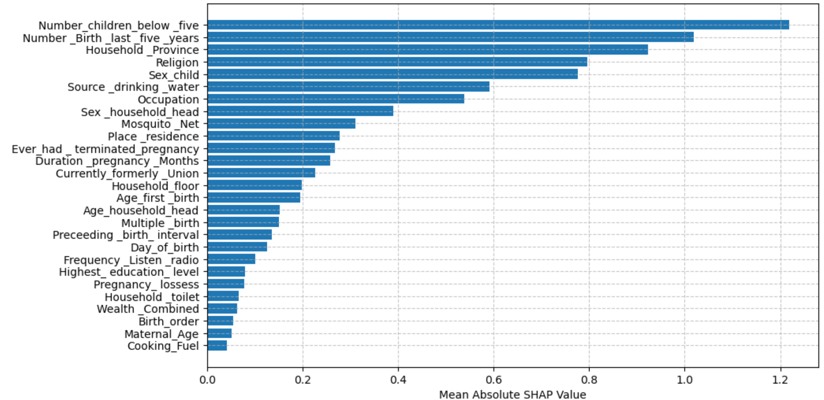
Figure 2. Feature Importance based on Mean Absolute SHAP Values
  - Model Breakdown Profile for the Individual Case.
The Figure 3 provides the predicted probabilities for individual cases and the associated risk for easier interpretability and timely intervention. It provides an example for an individual case. The information provides actionable insight on the predictors influencing the specific case and associated risks for timely intervention.

  - Limitation
The presence of a huge number of missing values in some variables, such as vaccination, antenatal visits, iron tablet intake during pregnancy, place of delivery, birth weight, etc., limited the number of variables to be considered in this study. Such variables were dropped from this study. The absence of external validation may affect the generalizability of the results.

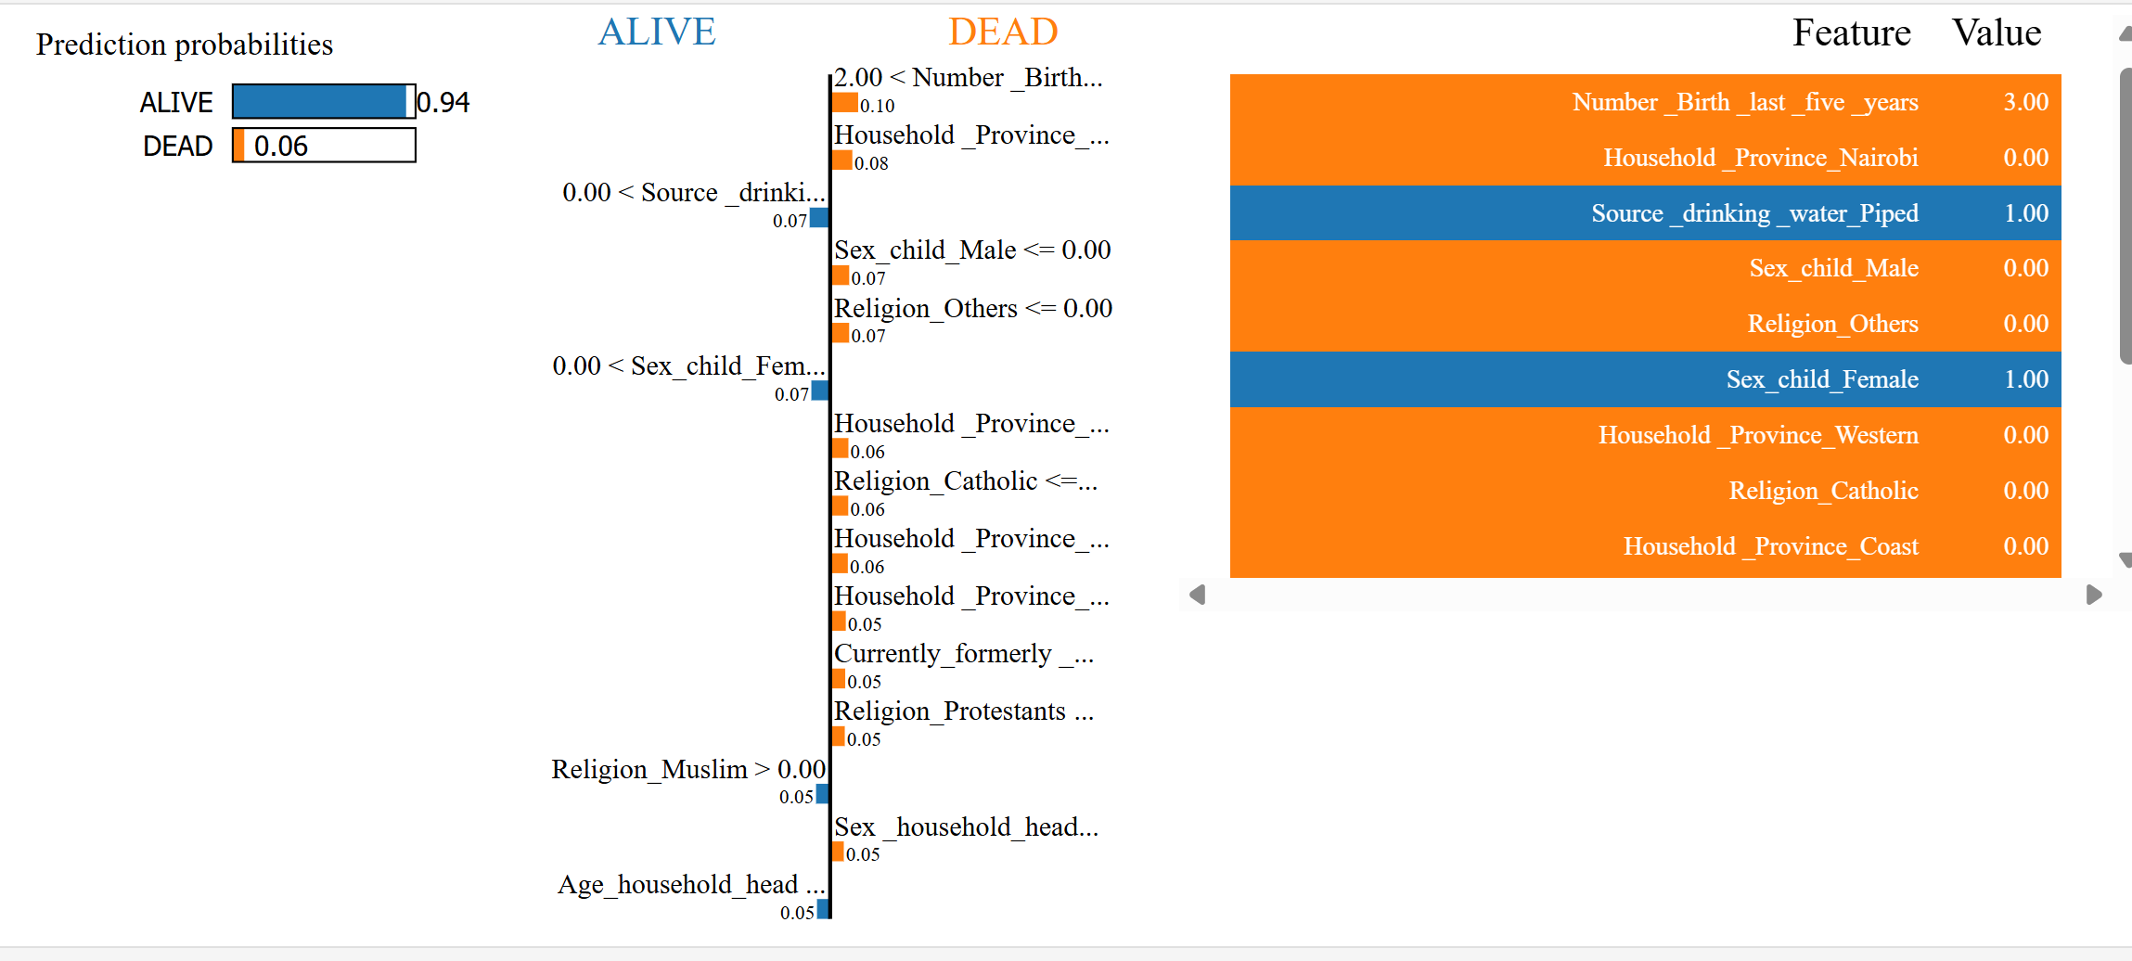
Figure 3: Local Interpretable Model-agnostic Explanations

- Conclusion
Among the different ensemble algorithms that were assessed, the Categorical gradient-boosting model produced superior performance, achieving an accuracy of 98.00%, precision of 97.46%, recall of 98.00%, F1 score of 97.57%, and ROC curve of 92.24%. These findings highlight the Categorical gradient-boosting model's ability to accurately predict neonatal outcomes. Important factors affecting neonatal mortality were identified. Significant risk factors included the number of children below five in the household, the number of births in the last five years, region, religion, sex of the newborn, source of drinking water, occupation, sex of the household head, use of mosquito nets, place of residence, ever-terminated pregnancy and duration of pregnancy. The results of this research hold important consequences for those involved in healthcare policy in the country. The recognised risk factors and the high-performance predictive model can inform healthcare interventions, facilitate prompt and effective healthcare delivery, and lower neonatal mortality rates in Kenya. The Ministry of Health should promote family planning to have manageable children under five in households and number of births within five years. Future research should validate the model by using external datasets from the electronic health records, such as the Health Information System within and outside the country.

Reference
- World Health Organization. (2022). World health statistics 2022: Monitoring health for the SDGs, sustainable development goals. Geneva.
- KNBS & ICF. (2023). Kenya Demographic and Health Survey 2022: Volume 1. Nairobi, Kenya, and Rockville, Maryland, USA: KNBS & ICF.
- Imbo, A. E., Mbuthia, E. K., Ngotho, D. N. (2021). Determinants of Neonatal Mortality in Kenya: Evidence from The Kenya Demographic And Health Survey 2014. International Journal of Maternal and Child Health and AIDS, 10(2): 287–295.
- Mengstie, M. A., & Telele, M. T. (2025). Predicting neonatal mortality using ensemble machine learning algorithms in the case of Ethiopian Rural Areas. Discover Artificial Intelligence. 5:220
- Viadinugroho, R., & Andhika, A. (2021). Imbalanced classification in Python: Smote-tomek links method. Medium.
- Lundberg, S. M., & Lee, S. (2017). “A Unified Approach to Interpreting Model Predictions.” In Proceedings of the 31st International Conference on Neural Information Processing Systems, 4768–77. NIPS’17. Red Hook, NY, USA: Curran Associates Inc.
- Tulio, R. M., Singh, S., and Guestrin, C. (2016). “"Why Should I Trust You?": Explaining the Predictions of Any Classifier.” In Proceedings of the 22nd ACM SIGKDD International Conference on Knowledge Discovery and Data Mining, 1135–44. KDD ’16. New York, NY, USA: Association for Computing Machinery.
- Lumumba, V. W, Muriithi, D. K., Njoroge, E. W., Kipkorir, L., Mwebesa, E., Wanyama, M. A. (2025). An Explainable AI Framework for Neonatal Mortality Risk Prediction in Kenya: Enhancing Clinical Decisions with Machine Learning. Biomedical Statistics and Informatics. 10, 64-83.
- Pal, K., Pal, J. K., Trivedi, S. R., Sharma, N., Patavardhan, P. P., Goswami, S. (2025). Predictive Modelling of Neonatal Mortality Trends Using Machine Learning: A Cross-sectional Data Science Approach. Journal of Neonatal Surgery, 14 (22), 1033-1039.
- Odion, P. O., Musa M. N., Suleiman, T., Isa, M. M. (2020). Application of machine learning technique for the prediction of neonatal mortality using multiple risk Factors. FUDMA Journal of Sciences. Vol. 4 No. 3, 2020, 576 – 58.
- Raihan, M., Saha, P. K., Gupta, R. D., Kabir, T., Tamanna, A. A., Ur-Rashid, M., Salam, A. B., Anjum, T., Kabir, A. (2024). A deep learning and machine learning approach to predict neonatal death in the context of São Paulo. International Journal of Public Health Science (IJPHS). 13. 179-190
- Prima, A.T., Thity, N. T, Rois, R. (2022). Risk predictors selection and prediction for the first-day neonatal mortality in Bangladesh using machine learning techniques. Journal Clinical Images Med Case Rep.3 (1): 1588.

