Application of Machine Learning Techniques in Hernia Classification

Abstract
Machine learning is a branch of artificial intelligence (AI) concerned with designing systems that can learn from data and make predictions or decisions without explicit programming. The rapid progress in machine learning in recent years has been attributed to advances in computing capacity, the growth of large-scale datasets, and the development of novel algorithms. A hernia is a medical condition that occurs when an organ or tissue pushes through a weak spot in the surrounding muscle or connective tissue. Hernia develop due to a combination of muscle weakness and strain. Some common causes include congenital weakness, where some individuals are born with weak abdominal muscles, making them more prone to hernias. Accurate and early classification of hernia is crucial for effective treatment planning and management. Machine learning (ML) techniques have been increasingly applied in medical diagnosis due to their ability to identify complex patterns in clinical data. However, existing studies on hernia classification have been limited in their methodological approaches, that is, most studies have utilized the k-Nearest Neighbors (KNN) algorithm for hernia classification leaving other robust classification algorithms. Data was obtained from vertebral column that has 3 classes (hernia, spondylolisthesis and normal) in UCI machine learning repository. The objective was achieved by applying K- nearest neighbor, the artificial neural networks, the support vector machines, random forest and the naïve bayes algorithms to the hernia data obtain from the UCI machine learning repository. For each method, data was splitted in the ratio 70: 30, that is, 70% of the data was used for training while 30% of the data was used for testing. KNN was optimized when k=6, while the random forest technique outperformed all the algorithms. This study recommends that the supervised random forest algorithm should be used while classifying hernia conditions because of its high accuracy, sensitivity, specificity and kappa values for proper medical diagnostics and treatment. Using the hybrid machine learning models such as RF-SVM, ANN-SVM, RF-NBC, could be possible future research areas.
Introduction
Machine learning is a branch of artificial intelligence (AI) concerned with designing systems that can learn from data and make predictions or decisions without explicit programming (Mitchell, 1997). The rapid progress in machine learning in recent years has been attributed to advances in computing capacity, the growth of large-scale datasets, and the development of novel algorithms. Machine learning allows computers to autonomously handle complex tasks and models or algorithms by discovering patterns and relationships within data. It is commonly classified into three main categories (Alpaydin, 2020): supervised learning, which includes tasks such as classification and regression; unsupervised learning, which involves techniques like clustering and anomaly detection; and reinforcement learning, which is applied in areas such as robotics and autonomous decision-making systems. Machine learning is widely applied across various sectors. In healthcare, it supports disease detection and personalized treatment strategies (Estava et al., 2017). In finance, it is used for fraud prevention and risk evaluation (Lessmann et al., 2015). Additionally, fields such as marketing, supply chain optimization, and cybersecurity employ ML to enhance automation and data-driven decision-making.
Machine learning classification is a type of supervised learning whereby models or algorithms are trained to categorize input data into predefined classes by learning patterns from labeled data (Geron, 2019). The main aim of classification is to predict categorical outcomes, such as distinguishing spam from non-spam emails, identifying the presence or absence of a disease in epidemiology, or determining customer churn in business. Classification tasks can be further put into several types depending on the nature of the response variable. Binary classification deals with problems in which the response variable has two possible classes only, for example in fraud detection, where transactions are labeled as either fraudulent or legitimate (Hastie et al., 2009; Bolton & Hand, 2002). Multiclass classification applies when there are three or more possible classes or groups in a response variable, such as assigning animals to categories like dogs, cats, or birds. Multilabel classification, on the other hand, allows a single instance to be associated with multiple groups at the same time, such as detecting several objects within a single image.
There are wide range of algorithms that are available for solving classification problems in machine learning, each with specific or different assumptions and strengths. Logistic regression is a widely used algorithm for binary classification that models the relationship between independent variables and a categorical outcome by estimating class probabilities through the logistic (sigmoid) function. In spite of its simplicity, it performs well when the relationship between variables is approximately linear. Decision trees are intuitive, tree-structured models that recursively partition data based on feature values to create homogeneous subsets, making them easy to interpret. However, individual decision trees are prone to overfitting. To overcome this limitation, ensemble methods such as random forests combine multiple decision trees trained on different subsets of the data, thereby improving predictive performance, enhancing robustness, and reducing variance (Breiman, 2001). Support Vector Machines (SVMs) are powerful classifiers that aim to identify an optimal separating hyperplane between classes, maximizing the margin between them. SVMs are particularly effective in high-dimensional spaces and can handle nonlinear classification through the use of kernel functions. Naïve Bayes is a probabilistic classification technique grounded in Bayes’ Theorem and the assumption of conditional independence among features. Owing to its computational efficiency, it is frequently applied in text mining and document classification tasks. The k-Nearest Neighbors (k-NN) algorithm is a non-parametric and instance-based method that assigns class labels to observations based on the most common class among their k closest neighbors in the feature space. While simple to implement, its performance depends heavily on the choice of distance metric and the value of k. Neural networks, especially deep learning architectures, are highly effective in capturing complex, nonlinear relationships within large and high-dimensional datasets. These models consist of multiple interconnected layers that enable them to learn hierarchical feature representations, making them particularly suitable for applications such as image recognition, speech processing, and natural language understanding.
A hernia is a medical condition that occurs when an organ or tissue pushes through a weak spot in the surrounding muscle or connective tissue (Nasef et al., 2025). Hernias commonly develop in the abdominal wall but can also occur in the groin, diaphragm, or other parts of the body. The most common types of hernias include inguinal (groin), umbilical (belly button), hiatal (upper stomach), and incisional (resulting from surgical wounds). Hernia develop due to a combination of muscle weakness and strain. Some common causes include congenital weakness, where some individuals are born with weak abdominal muscles, making them more prone to hernias. Heavy lifting without proper technique can strain the muscles and lead to hernia formation. Persistent coughing or sneezing from chronic respiratory conditions can increase abdominal pressure, resulting in hernias. Other causes include obesity, which puts additional strain on abdominal muscles, and pregnancy, where the expansion of the abdomen can weaken muscles, increasing the risk of hernia. Straining during bowel movements due to chronic constipation can also cause excessive strain on abdominal muscles, leading to hernias. The spine consists of a series of vertebrae stacked on top of each other, providing support and flexibility to the body. A normal spine maintains proper alignment and allows smooth movement. However, spondylolisthesis is a spinal disorder in which one vertebra slips forward over the one below it, potentially leading to pain and mobility issues.
Several studies have been using numerous supervised machine learning methods in epidemiology ranging from classification, regression and prediction. Aljahdali & Hussain, (2013) used the support vector machines and the random forest techniques to classify liver and cancer where the two algorithms gave similar results in terms of performance. Kaur et al.,(2023) used ANN, SVM, KNN and random forest to classifier Alzheimer’s disease, random forest gave higher accuracy and sensitivity of 86..24% and 69.32% respectively among all algorithms. Handayani, (2019)….
Problem Statement
Hernia is a medical condition characterized by the protrusion of an organ or tissue through an abnormal opening in the surrounding muscle or tissue. Accurate and early classification of hernia is crucial for effective treatment planning and management. Machine learning (ML) techniques have been increasingly applied in medical diagnosis due to their ability to identify complex patterns in clinical data. However, existing studies on hernia classification have been limited in their methodological approaches. A notable study by Handayani, (2019) utilized the k-Nearest Neighbors (KNN) algorithm for hernia classification. While KNN is a popular supervised learning method due to its simplicity and effectiveness, relying solely on one ML model limits the potential for achieving optimal classification performance. Different supervised learning models, such as Support Vector Machines (SVM), Decision Trees, Random Forest, Naïve Bayes, and deep learning techniques, offer varying levels of accuracy, precision, and robustness depending on the dataset and feature selection process. By restricting the analysis to only KNN, Handayani (2019) may have overlooked potentially superior models that could enhance classification accuracy and reliability. Therefore, there is a critical need to explore the application of a wider range of supervised ML models in hernia classification to determine the most effective technique. A comparative analysis of multiple ML algorithms can provide insights into the strengths and weaknesses of each approach, ultimately leading to improved diagnostic performance. This study aims to fill this research gap by evaluating various supervised ML models for hernia classification, optimizing model parameters, and identifying the best-performing approach. The findings will contribute to the advancement of ML applications in medical diagnosis and support healthcare professionals in making informed decisions.
Objective
To apply the supervised machine learning algorithms in hernia classification
Methodology
Data Source and Variables
Study used secondary data obtained from vertebral column that has 3 classes (hernia, spondylolisthesis and normal) in UCI machine learning repository. These classes were classified according to six explanatory variables namely;
1. Pelvic Incidence (PI)-angle between the perpendicular line between the sacral plates and a line connecting the midpoint of the sacral plate to the bicoxofemoral axis.
2. Pelvic Tilt (PT)- pelvic orientation which connects the femur with other body parts. PT can be moved forward, backward, as well as other directions.
3. Lumbar lordosis angle (LA)-is the characteristic of the human spine and the reference of human posture to see whether the posture is good or bad.
4. Sacral slope (SS)-slope located between the sacral plate and the horizontal plane.
5. Pelvic radius (PR)-value that affects the development of large lumbar lordosis.
6. Degree spondylolisthesis (DG)- measurement that states the degree of how much of the lower body part is slipping forward.
K-Nearest Neighbor (KNN) Methodology
K-Nearest Neighbor (K-NN) is a simple algorithm that stores all available cases and classifies new cases based on a similarity measure (e.g., distance functions). KNN has been used in statistical estimation and pattern recognition already in the beginning of 1970’s as a non-parametric technique. A case is classified by a majority vote of its neighbors, with the case being assigned to the class most common amongst its K nearest neighbors measured by a distance function. If K = 1, then the case is simply assigned to the class of its nearest neighbor. For instance the test sample (green dot) should be classified either to blue squares or to red triangles. If k = 3 (solid line circle) it is assigned to the red triangles because there are 2 triangles and only 1 square inside the inner circle. If k = 5 (dashed line circle) it is assigned to the blue squares (3 squares vs. 2 triangles inside the outer circle).
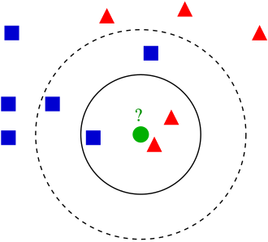
Figure 1: K-NN illustration
Numerical variables should be standardized to values between 0 and 1 when there is a mixture of numerical and categorical variables in the dataset. Choosing the optimal value for K is best done by first inspecting the data. In general, a large K value is more precise as it reduces the overall noise but there is no guarantee. Cross-validation is another way to retrospectively determine a good K value by using an independent dataset to validate the K value. Historically, the optimal K for most datasets has been between 3-10. That produces much better results than 1- NN. One can also use Confusion matrix to optimize on K. The distance between new data point and the k neighbor is usually computed using the Euclidean distance given by;
Distance=$\sqrt{\sum_{i=1}^{k}{{\left(x_{n}-x_{i}\right)}^{2}}}$
A short distance between the new data point $x_{n}$ and a training point $x_{i}$ suggests that the two points are close in the feature space implying that the new point likely shares similar characteristics with the K neighbor/training point. A long distance between new data point $x_{n}$ and a training point $x_{i}$​ suggests that the two points are farther apart in the feature space implying that the new point and the training point are less similar in terms of their features. The K-NN working can be explained on the basis of the below algorithm:
Step-1: Select the number K of the neighbors
Step-2: Calculate the Euclidean distance of K number of neighbors
Step-3: Take the K nearest neighbors as per the calculated Euclidean distance.
Step-4: Among these k neighbors, count the number of the data points in each category.
Step-5: Assign the new data points to that category for which the number of the neighbor is maximum.
Step-6: Our model is ready.
Support Vector Machines (SVM) Methodology
Support vector machine (SVM) is a supervised learning classification algorithm which builds hyper planes as decision surface thereby classifying input data to a high dimensional feature space (Omondiagbe et al.,2019). The hyper plane built distinguishes between the different classes examples and maximizes the separation margin. SVM model represents instances as set of point, mapped so that the instances of the different classes are separated by a distinct line. The set of points are mapped and classified into classes according to the side of the line they belong to. For a given training set ${\{x_{i},y_{i}\}}_{i=1}^{n}$with the input data as $x_{i}ϵR^{m}$ and the corresponding class labels are given as $y_{i}ϵ$ $\left\{-1,,1\right\}$. The classifier model with hyper plane to split the two classes is given as (Omondiagbe et al., 2019).
$y=\left[W^{T}ϕ\left(x\right)+b\right]$ (1)
Where x is the feature vector, W denotes the weight vector perpendicular to the hyperplanes, b is the bias value, $ϕ$ is the non-linear function and y is the class label. Nonlinear function ∅ (.) is the feature map which helps to transfer the input data to a high dimensional feature space. Maximizing the margin (M) gives the weight vector and the bias value. This is defined by:
m=$\frac{2}{|W|}$ (2)
And the minimization is defined as;
$\frac{|W^{2}|}{2}$=$\frac{1}{2}W^{T}W$ (3)
The features of the input data are split accordingly, and the features are mapped to the output class ($y_{i}$=+1) if:
$W^{T}ϕ$($x_{i}$) +b $≥$+1 (4)
Also the features are mapped to the output class ($y_{i}$=-1) if;
$W^{T}ϕ$($x_{i}$) +b $≤$-1 (5)
Where i=1, 2, 3,…, n
These two sets of inequalities, Eqn. (4) and Eqn. (5) are combined into one giving Eqn. (6):
y ($W^{T}ϕ$($x_{i}$)+b) $≥$+1 (6)
The constrained optimization problem which is also known as primal problem can be formulated when Eqn. (3) and Eqn. (6) are combined. This is shown in Eqn. (7)
${MinJ}_{primal}\left(W,λ\right)=\frac{1}{2}W^{T}$W + C$\sum_{i=1}^{n}{λ_{i}} (7)$
Subject to;
y($W^{T}ϕ$($x_{i}$)+b) $≥$+1- $λ_{i}$ (8)
Where $λ_{i}$ $≥$0($λ_{i}$ is a slack variable for data point I and C is a regularization
parameter). $λ_{i}$ is used so that misclassification can be allowed on the training data so as to avoid overfitting the data. Choice of C determines the balance between maximizing and minimizing the margin and classification error respectively. To solve the constrained optimization problem, the Lagrange function is constructed as shown in Eqn. (9);
L$\left(W,b,α,λ,β\right)=\frac{1}{2}W^{T}\text{W + C}\sum_{i=1}^{n}{λ_{i}}$+$\sum_{i=1}^{n}{α_{i}}\left\{y_{i}\left[W^{T}ϕ\text{(}x_{i}\text{)+b}\right]-1+λ_{i}\right\}$ + $\sum_{i=1}^{n}{βλ_{i}}$ (9)
Where $α$ $≥$0,$β≥$0, $α$ and $β$ are the Langrange multipliers. The quadratic optimization problem or dual problem which corresponds to the primal problem is given in Eqn. (10);
${MaxJ}_{dual}\left(α\right)$= $\sum_{i=1}^{n}{α_{i}} -\frac{1}{2}\sum_{i,j=1}^{n}{α_{i}}α_{j}y_{i}y_{j}$K($x_{i}x_{j}$) (10)
Subject to 0 $≤$ $α$ $≤$ C and $\sum_{i,j=1}^{n}{α_{i}}y_{i}$=0, where x=feature vector $α$ is Langrange multiplier, K is the kernel function used and it maps the input features to a high dimensional feature space. The classifier for the linear SVM is then represented by:
f(x)=$W^{T}\left(x\right)+b (11)$
Where f in eqn 11 is the linear function, x is the feature vector, b is the bias and W is the classifier weight which is computed as;
W=$\sum_{α>0}{α_{i}}y_{i}x_{i}$ (12)
f(x)=$\sum_{α>0}{α_{i}}y_{i}{(x}_{i}$,x) + b (13)
The Non-linear SVM can be derived by mapping the input data x into the feature space and the SVM is trained for the mapped features $ϕ$($x_{i}$). For the non-linear SVM, kernel trick is used by replacing the inner product in eqn 13 with kernel K($x_{i},x_{j}$) that corresponds to it. The kernel function maps the input reduced feature space and the goal is to find a separation between the data. The Classifier for the non-linear SVM is;
f$\left(x\right)=\sum_{α>0}{α_{i}}y_{i}$K($x_{i}$,x)+b (14)

Artificial Neural Networks (ANN) Methodology
An artificial neural network (ANN) is a parallel connection of a set of nodes called neurons. From the statistical viewpoint, it represents a function of explanatory variables which is composed of simple building blocks and which may be used to provide an approximation of conditional expectations or, in particular, probabilities in regression or classification. ANN contains intermediary layers between its input and output layer referred to as hidden layers and they have hidden nodes embedded in them. The output received from the input layer will be passed to the output layer after it must have been processed and computed in the hidden layer. Feed forward neural networks are trained with the standard back propagation (BP) algorithm and are broadly used for pattern classification because they learn to convert input data into results that are favorable. The back propagation of errors from the output layer to the hidden layer is the main idea of this algorithm. A back propagation neural network represents a neuron and adjacent layers that are connected by weights.

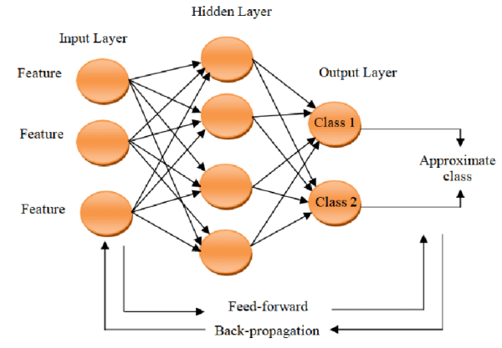
Figure 2: Artificial Neural Network Architecture.
Source: Researchgate.net
The number of neurodes, H, in the hidden layer can be determined as in Looney, (1996) by a rule of thumb:
H=|1.7*$\log_{2}(n)$|+1
A lot of computations takes place in the hidden layer,
$I_{j}=\sum_{i}{W_{ji}x_{i}+a_{j}}$ (15)
$Y_{j}=f_{j}(I_{j})$ (16)
Where, $f_{j} is$activation function, $a_{j}$ is the bias associated at each connection link between the input layer and hidden layer, $x_{i}$ input at nodes in input layer, $I_{j}$ is the summation of weight inputs added with bias, $Y_{j}$ is the output of activation function at hidden layer. The principle of output layer can be deduced using Eqn. (17) and Eqn. (18);
$I_{n}=\sum_{j}{W_{nj}x_{j}+b_{n }}(17)$
$Y_{n}=f_{n}(I_{n})$ (18)
Where; $f_{n}$ is the activation function, $W_{nj}$ is the weight associated at the connection link between nodes in hidden layer j and nodes in output layer n, $b_{n}$ is the the bias associated at each connection link between the hidden layer and output layer, $x_{j}$ input at nodes in hidden layer, $I_{n}$ is the summation of weighted inputs added to the bias, $Y_{n}$ is the final output at the output layer.
Naïve Bayes Classifier (NBC) Methodology
This classifier makes use of the Bayes rule which assumes independence among predictors. NBC postulates that the presence of an attribute in a class is not related to the presence of any other attribute. The Bayes rule calculates conditional probability as;
P$\left(Y|X\right)=\left(\frac{P\left(X | Y\right)P(Y)}{P(X)}\right)$ (19)
Where; P (Y|X)=posterior probability of class Y given predictor (X), P (Y)=prior probability of class, P (X|Y)=likelihood and P (X)=normalizing constant. By using this technique, all the features are presumed independent according to Bayes theorem which means there is no dependency among the attribute value on a given class and the other attributes. The Bayes theorem enables us to express the posterior probability in terms of the prior probability P(Y), the class-conditional probability P (X|Y), and the evidence, P(X) as shown in Eqn. (19). The NBC works by estimating the class-conditional probability. By so doing, it assumes that the attributes are conditionally independent, given the class label y.
The mathematical expression of the conditional independence assumption is given as:
P$\left(X|Y=y\right)=\prod_{i=1}^{d}{P\left(X_{i}|Y=y\right)} (20)$
In Eqn. (20), each attribute set X: {$X_{1}$, $X_{2},$ …., $X_{d}$} consist of d attribute features. To classify a test dataset, NBC works by calculating the posterior probability of each class Y using Eqn. (21).
P$\left(Y|X\right)=\frac{P(Y)\prod_{i=1}^{d}{P(X_{i}|Y=y)}}{P(X)}$ (21)
In Eqn. (21), P(X) is static for every Y, hence the class that maximizes the expression $P\left(Y\right)\prod_{i=1}^{d}{P\left(X_{i} | Y=y\right)}is chosen.$
Random Forest (RF) Methodology
Random Forest algorithm is a powerful tree learning technique in Machine Learning. It works by creating a number of decision trees during the training phase. Each tree is constructed using a random subset of the data set to measure a random subset of features in each partition. This randomness introduces variability among individual trees, reducing the risk of overfitting and improving overall prediction performance. In prediction, the algorithm aggregates the results of all trees, either by voting (for classification tasks) or by averaging (for regression tasks). This collaborative decision-making process, supported by multiple trees with their insights, provides an example stable and precise results.

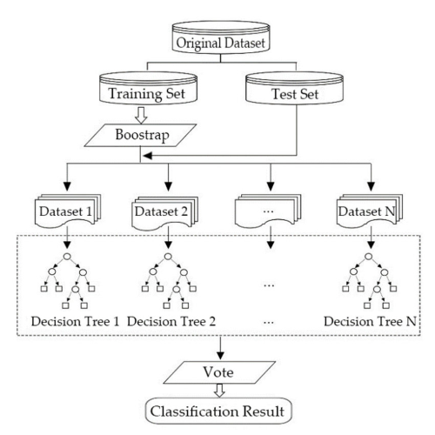
Figure 3: Random Forest Architecture.
Source: Researchgate.net
Model Evaluation
Confusion matrix is a N by N matrix used to know the performance of a machine learning classification. It gives a comparison between the actual and the predicted values. A confusion matrix is a visualization tool that helps in understanding the performance of a classification models. N by N implies that N is the number of classes or outputs. Confusion matrix has four components namely:
True positive(TP)-actual and predicted values are the same.
False Negative(FN)-Actual value is positive while the predicted is negative.
False Positive(FP)-The actual value is negative.
True Negative(TN)-Actual and predicted values are the same.
For 2 classes, we get a 2 by 2 confusion matrix while for 3 classes, we get a 3 by 3 confusion matrix. The evaluation metrics derived from confusion matrix include;
Accuracy – Measures the proportion of correctly classified cases from the total number of objects in the dataset;
Accuracy=$\frac{Correct Predictions}{All Predictions}$
=$\frac{TP+TN}{TP+TN+FP+FN}$ (For Binary Classification)
=$\frac{Sum of the elements in the leading diagonal}{sum of all elements in the confusion matrix}$ (For Multi-Classification)
A model with higher accuracy value is the best model.
The Cohen`s Kappa statistic(k) - It is the statistical measure that evaluates the level of agreement between two raters or between the predicted and actual values(or a model and ground truth) on categorical data (Landis & Koch, 1977);
k =$\frac{p_{o }-{ p}_{e}}{1 -{ p}_{e}}=\frac{total accuracy - random accuracy}{1 - random accuracy}$
$p_{o }$=observed accuracy(proportion of instances where raters agree)
$p_{o }$ =$\frac{correct predictions}{all predictions}$
$p_{e}$= Expected agreement by chance(proportion of agreement that is expected if raters are assigning categories randomly)
${ p}_{e}$ = $\sum_{i=1}^{n}{\left(\frac{R_{i}}{N}*\frac{C_{i}}{N}\right)}$ where $R_{i}$ is row total, $C_{i}$ is column total.
The threshold for Kappa statistic according to Landis & Koch.(1977);
K < 0 = there is poor agreement between predicted & actual values.
0.10 – 0.20 = slight agreement between predicted & actual values.
0.21 – 0.40 = fair agreement between predicted and actual values.
0.41 – 0.60 = moderate agreement between predicted and actual values.
0.61 – 0.80 = substantial agreement between predicted and actual values.
0.81 – 1.00 = almost perfect agreement.
It provides a more detailed evaluation of agreement compared to raw accuracy, especially in situations with class imbalance. It ensures that high agreement scores are not inflated due to chance.
Sensitivity (True Positive Rate) - measures the proportion of true positives (instances correctly identified as belonging to a specific class) out of all actual instances of that class.
sensitivity = $\frac{TP}{TP + FN} (For Binary Classification)$.
For multi class classification, sensitivity is computed for each class.
${sensitivity}_{1}$ = $\frac{{TP}_{1}}{{TP}_{1}+{FN}_{1}}$ (For class 1)
${ sensitivity}_{2}$ = $\frac{{TP}_{2}}{{TP}_{2}+{FN}_{2}}$ (For class 2)
${sensitivity}_{n}$ = $\frac{{TP}_{n}}{{TP}_{n}+{FN}_{n}}$ (For class n)
Specificity - Specificity measures the proportion of true negatives (instances correctly identified as not belonging to a specific class) out of all actual instances that do not belong to that class.
specificity = $\frac{TN}{TN + FP} (For Binary Classification)$.
For multi class classification, sensitivity is computed for each class.
${\text{specificity}}_{1}$ = $\frac{{TN}_{1}}{{TN}_{1}+{FP}_{1}}$ (For class 1)
${\text{specificity}}_{2}$ = $\frac{{TN}_{2}}{{TN}_{2}+{FP}_{2}}$ (For class 2)
${\text{specificity}}_{n}$ = $\frac{{TN}_{n}}{{TN}_{n}+{FP}_{n}}$ (For class n)

Results and Discussions
KNN optimization
KNN model was optimized based on Overall accuracy and Kappa values for k neighbors where k=6 gave optimum results among all k neighbors(K=1,2,3,…,10).
Table 1 : K-NN optimization
K | Overall Accuracy | Kappa-values
1 | 0.7670 | 0.6413
2 | 0.8447 | 0.7582
3 | 0.7864 | 0.6672
4 | 0.8252 | 0.7273
5 | 0.8252 | 0.7248
6 | 0.8544 | 0.7717
7 | 0.8252 | 0.7268
8 | 0.8447 | 0.7575
9 | 0.8447 | 0.7571
10 | 0.8252 | 0.7255

The model was optimized when k=6,that is, the overall accuracy at k=6 was the highest amongst all other accuracies(0.8544). It is apparent futhermore that the overall accuracy can be same for different values of k, this is exhibited vividly by the said ties when is 4,5,7 and 10(82.52%) and also when k is 2,8 and 9(84.47) percent. As far as the overall accuracy is concerned, the conclusion is that better accuracy does not depend on the value of k.

Artificial Neural Network

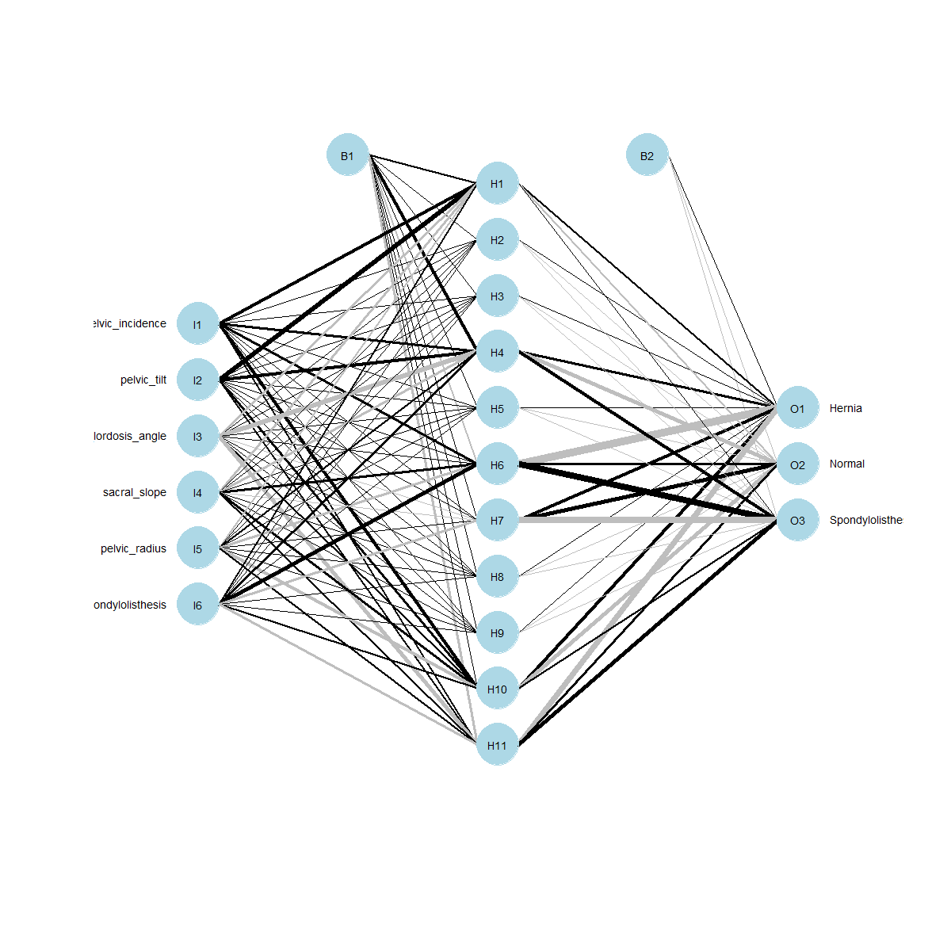
Figure 4: ANN output
Figure 4 shows the output of the artificial neural netwoks with six input variables, 11 hidden nodes and the three outputs, B1 and B2 are the biases associated with the hidden and the output layers respectively. The number of hidden nodes were determined according to Looney, (1996):

Model Evaluation
Table 2: Performance evaluation
Model | Sensitivity | Specificity | Accuracy | Cohen`s Kappa Value
K-NN | 0.8262 | 0.9313 | 0.8544 | 0.7714
ANN | 0.6888 | 0.8828 | 0.7532 | 0.6063
SVM | 0.8264 | 0.9317 | 0.8571 | 0.7724
RF | 0.8266 | 0.9341 | 0.8701 | 0.7901
NBC | 0.7332 | 0.8897 | 0.7792 | 0.6454

From table 4, it is clear that the Random forest is the best machine learning based classification for this data. Random Forest had higher accuracy (87.01%), sensitivity (82.66%), specificity (93.41%), and kappa value (79.01%) compared to other machine learning algorithms. This was followed closely by Support Vector Machine, accuracy (85.71%), sensitivity (82.64%), specificity(93.17%), and kappa value(77.24%). Artificial Neural Network had the poorest performance among all the algorithms, accuracy (75.32%), sensitivity (68.88%), specificity(88.28%), and kappa value(60.63%).
This study diverges with a study by Handayani, (2019) which only utilized the K-NN algorithm in the classification of hernia in vertebral column. Furthermore, the support vector machines also gave higher accuracy compared to the KNN method. The study also is in line with various studies that have shown random forest outperforming other methods in disease classifications for example Kaur et al, (2023) which found that random forest is the best machine learning classifier in Alzheimers`s disease classification.
Conclusions
The main aim of this study was to apply the supervised machine learning methods in classification of hernia. This was achieved by applying K- nearest neighbor, the artificial neural networks, the support vector machines, random forest and the naïve bayes algorithms to the hernia data obtain from the UCI machine learning repository. For each method, data was splitted in the ratio 70: 30, that is, 70% of the data was used for training while 30% of the data was used for testing. KNN was optimized when k=6, while the random forest technique outperformed all the algorithms
Recommendations
This study recommends that the supervised random forest algorithm should be used while classifying hernia conditions because of its high accuracy, sensitivity, specificity and kappa values for proper medical diagnostics and treatment. Future Studies should consider feature-based machine learning classification methods in hernia classification for example Artificial neural networks-recursive feature elimination, artificial neural networks-principal component analysis, artificial neural networks-linear discriminant analysis and the combination of other algorithms with these feature selection methods. In addition, using the hybrid machine learning models such as RF-SVM, ANN-SVM, RF-NBC, could be possible future research areas.
References
Aljahdali, S., & Hussain, S. N. (2013). Comparative prediction performance with support vector machine and random forest classification techniques. International journal of computer applications, 69(11).
Alpaydin, E. (2020). Introduction to machine learning (4th ed). MIT Press.
Bolton, R. J., & Hand, D. J. (2002). Statistical fraud detection: A review. Statistical Science, 17(3), 235–255. https://doi.org/10.1214/ss/1042727940
Breiman, L. (2001). Random forests. Machine Learning, 45(1), 5–32. https://doi.org/10.1023/A:1010933404324
Esteva, A., Kuprel, B., Novoa, R. A., Ko, J., Swetter, S. M., Blau, H. M., & Thrun, S. (2017). Dermatologist-level classification of skin cancer with deep neural networks. Nature, 542(7639), 115–118. https://doi.org/10.1038/nature21056
Géron, A. (2019). Hands-on machine learning with Scikit-Learn, Keras, and TensorFlow (2nd ed.). O’Reilly Media.
Handayani, I. (2019). Application of K-nearest neighbor algorithm on classification of disk hernia and spondylolisthesis in vertebral column. Indonesian Journal of Information Systems, 2(1), 57-66.
Hastie, T., Tibshirani, R., & Friedman, J. (2009). The elements of statistical learning: Data mining, inference, and prediction (2nd ed). Springer.
Kaur, C., Panda, T., Panda, S., Al Ansari, A. R. M., Nivetha, M., & Bala, B. K. (2023, February). Utilizing the Random Forest Algorithm to Enhance Alzheimer’s disease Diagnosis. In 2023 Third International Conference on Artificial Intelligence and Smart Energy (ICAIS) (pp. 1662-1667). IEEE.
Kremic, E., & Subasi, A. (2016). Performance of random forest and SVM in face recognition. Int. Arab J. Inf. Technol., 13(2), 287-293.
Lessmann, S., Baesens, B., Seow, H.-V., & Thomas, L. C. (2015). Benchmarking state-of-the-art classification algorithms for credit scoring. European Journal of Operational Research, 247(1), 124–136. https://doi.org/10.1016/j.ejor.2015.05.030
Looney, C. G. (1996). Advances in feedforward neural networks: demystifying knowledge acquiring black boxes. IEEE Transactions on Knowledge and Data Engineering, 8(2), 211-226.
Yamaguchi, N., Morioka, D., Izumisawa, Y., Toyoda, J., Yamaguchi, K., Horii, N., ... & Endo, I. (2021). A classification system specific for recurrent inguinal hernia following open hernia surgery. in vivo, 35(6), 3501-3508.
S. Ghumbre, C. Patil, and A. Ghatol, “Heart disease diagnosis using support vector machine,” in International conference on computer science and information technology. Pattaya, Thailand: Planetary Scientific Research Centre, 2011, pp. 84–88.
S. Palaniappan and R. Awang, “Intelligent heart disease prediction system using data mining techniques,” in IEEE/ACS International Conference on Computer Systems and Applications. Doha, Qatar, March 2008, pp. 108–115.
Mitchell, T. M. (1997). Machine learning. New York, NY: McGraw-Hill.
Mohammad Abood Kadhim & Abdulkareem Merhej Radhi2. heart disease classification using optimized machine learning algorithms. DOI: https://doi.org/10.52866/ijcsm.2023.02.02.004
Omondiagbe, D. A., Veeramani, S., & Sidhu, A. S. (2019, June). Machine learning classification techniques for breast cancer diagnosis. In IOP conference series: materials science and engineering (Vol. 495, p. 012033). IOP Publishing.
Nasef, D., Nasef, D., Sawiris, V., Girgis, P., & Toma, M. (2025). Machine-Learning-Based Biomechanical Feature Analysis for Orthopedic Patient Classification with Disc Hernia and Spondylolisthesis. BioMedInformatics, 5(1), 3.

