Case Report

Combined Right Posterior and Left Anterior Traumatic Hip Dislocation with Acetabular Posterior Column Fracture: A Rare Case Report

.

ABSTRACT

Introduction: Traumatic hip dislocation is an orthopedic emergency that typically results from high-energy trauma. Bilateral dislocations are rare, and asymmetrical dislocations—where one hip is posteriorly and the other anteriorly dislocated—are even more uncommon. When associated with acetabular fractures, such injuries become complex, requiring prompt recognition and a multidisciplinary approach for optimal outcomes.
Case Presentation: A 40-year-old male presented with pain and immobility of both lower limbs after being struck by a fallen tree during a logging accident. Clinical and radiographic evaluation revealed asymmetrical bilateral hip dislocation: posterior dislocation of the right hip with an associated posterior column acetabular fracture and anterior dislocation of the left hip. Closed reduction was performed on both hips, followed by skeletal traction on the right side and skin traction on the left side. Open reduction and internal fixation (ORIF) of the right acetabular fracture was subsequently performed via a Kocher-Langenbeck approach. Fixation was achieved using straight non-locking reconstruction plates. Postoperative recovery was uneventful, with controlled pain, intact neurovascular status, and preserved distal limb function. Early rehabilitation was initiated, and the patient remained clinically stable.
Conclusion: This case illustrates the rarity and complexity of asymmetrical bilateral hip dislocation with an associated acetabular fracture. Early diagnosis, prompt reduction, appropriate surgical planning based on fracture classification, and multidisciplinary postoperative care are essential for favorable outcomes. Given the scarcity of such cases, further studies and cumulative case reports are necessary to better understand the optimal management strategies and long-term functional results.
reliability.

Keywords: Hip Dislocation, Acetabulum Fractures, Fracture Fixation, Internal

INTRODUCTION
Traumatic hip dislocation is an uncommon but critical orthopedic emergency, most often caused by high-impact incidents like motor vehicle collisions or significant falls. Representing around 2%–5% of all joint dislocations, these injuries are more frequently seen in young, physically active individuals exposed to intense force. Because the hip joint is highly stable—thanks to its deep acetabular socket, strong capsule, and surrounding muscles—a considerable amount of force is needed to dislocate it. As a result, such dislocations are frequently accompanied by other injuries, including fractures of the acetabulum, femoral head, or other skeletal structures. (1).
Among hip dislocations, posterior dislocations are most common, comprising up to 90% of cases. They typically result from axial loading of the femur with the hip in a flexed and adducted position, as seen in "dashboard injuries" during motor vehicle collisions. Anterior dislocations are much less common and occur due to forced abduction and external rotation of the hip. Bilateral hip dislocations are exceedingly rare, representing approximately 0,01-0,02% of all hip dislocations. An even rarer subset is asymmetrical bilateral dislocations, where one hip is dislocated posteriorly and the other anteriorly—a presentation that suggests a complex mechanism involving multidirectional forces acting simultaneously (2,3). The presence of an associated acetabular fracture adds complexity to both diagnosis and treatment. Acetabular fractures, particularly those involving the posterior column, commonly accompany posterior hip dislocations. The Judet and Letournel classification system, established in the 1960s and refined over the decades, remains the preferred method for categorizing these fractures and guiding treatment. It divides acetabular fractures into elementary and associated patterns, with posterior column fractures classified as elementary types (4). The classification is essential for determining the appropriate surgical approach and predicting outcomes.
In the acute phase of a hip dislocation, the primary goal is prompt reduction—ideally within six hours—to restore joint alignment and minimize the risk of avascular necrosis (AVN) of the femoral head, a serious complication that can occur in up to 15% of delayed cases (5). Simple dislocations are often managed successfully with closed reduction, but when fractures such as posterior column fractures are present, open reduction and internal fixation (ORIF) are necessary to reestablish the acetabular structure and ensure joint stability. Failure to achieve timely or proper fixation increases the likelihood of post-traumatic arthritis, persistent instability, and poor functional recovery (6). For posterior column fractures, the Kocher-Langenbeck approach is the most commonly employed surgical method. This posterior approach offers optimal exposure of the posterior wall and column of the acetabulum, making it especially suitable for isolated posterior injuries. It facilitates direct fracture visualization, protection of the sciatic nerve, and secure placement of fixation hardware like reconstruction plates. Research emphasizes that achieving anatomical reduction and stable fixation through this approach is vital for maintaining hip function and preventing long-term complications (7).
In terms of surgical timing, recent evidence supports performing definitive fixation within 7 to 10 days after injury, once the patient is hemodynamically stabilized and soft tissue conditions allow. Delayed surgery beyond 14 days is associated with increased technical difficulty, higher rates of malunion, and inferior functional outcomes (6). Multimodal pain management, including epidural analgesia, enhances patient comfort and facilitates early rehabilitation. Early initiation of active distal range-of-motion exercises and rehabilitation protocols is crucial to prevent complications such as deep vein thrombosis (DVT), joint stiffness, and muscle atrophy (8). A multidisciplinary team—including orthopedic surgeons, anesthesiologists, and rehabilitation specialists—is vital for comprehensive recovery and favorable long-term results.
This case report presents a rare example of asymmetrical bilateral hip dislocation with a concomitant right posterior column acetabular fracture, managed with prompt closed reduction followed by ORIF through a Kocher-Langenbeck approach. Given the rarity and complexity of such cases, this report aims to contribute to the evolving literature by detailing the clinical decision-making, surgical strategy, and early postoperative course of this unusual injury pattern.

CASE PRESENTATION
A 40-year-old male presented to the emergency department after being struck by a fallen tree during a logging accident. He complained of severe bilateral hip pain and inability to mobilize the lower limbs. On physical examination, both lower extremities appeared shortened and deformed. The right limb was adducted and internally rotated, whereas the left limb was abducted and externally rotated. There were no open injuries, and neurovascular status was preserved bilaterally. Radiographic evaluation (Figure 1a) revealed asymmetrical bilateral hip dislocation, characterized by a posterior dislocation of the right hip and an anterior dislocation of the left hip. Further imaging with pelvic CT (Figure 1b) identified an associated posterior column fracture of the right acetabulum, classified as an elementary fracture pattern according to the Judet-Letournel classification. The left hip dislocation was not associated with any fracture.

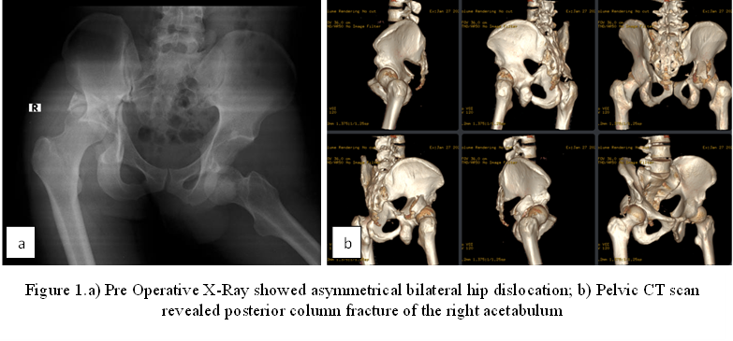

Closed reduction was performed under sedation for both hips. The right hip was stabilized with skeletal traction following reduction, while the left hip was stabilized with skin traction. Post-reduction radiographs confirmed satisfactory alignment of both femoral heads within their respective acetabula. The patient subsequently underwent open reduction and internal fixation (ORIF) of the right acetabular fracture. Under general anesthesia with epidural analgesia, the procedure was carried out with the patient in a left lateral decubitus position. A posterior approach via the Kocher-Langenbeck incision was utilized. Intraoperative findings revealed a transverse fracture line traversing the posterior column. After mobilization of the short external rotator muscles, anatomical reduction was achieved and temporarily held with two Kirschner wires. Fluoroscopic imaging confirmed appropriate alignment and joint stability.
Definitive fixation was performed using two straight, non-locking reconstruction plates: one 8-hole plate with four cortical screws and one 4-hole plate with two screws. Intraoperative assessment confirmed a stable construct. The surgical field was irrigated, and closure was performed in layers with reattachment of the short external rotators and fascia. A surgical drain was placed, and estimated intraoperative blood loss was 200 mL. The procedure was completed without complications.
In the immediate postoperative period, the patient was hemodynamically stable with well-controlled pain (VAS 2–3). The surgical dressing was dry, and the drain output was approximately 60 mL of hemorrhagic fluid over four hours. Mild tenderness was noted at the surgical site. Distal active range of motion and perfusion were preserved. Laboratory evaluation showed a hemoglobin level of 11.6 g/dL. Postoperative management included intravenous ceftriaxone, epidural analgesia with ropivacaine and morphine, and oral paracetamol for pain control. The patient was encouraged to begin active distal range-of-motion exercises, including quadriceps contractions and ankle pumping. Bladder training was initiated following catheter removal, and consultation with the physical medicine and rehabilitation team was undertaken to plan progressive mobilization. The patient remained clinically stable with no signs of infection, neurovascular compromise, or other complications during the early postoperative course.

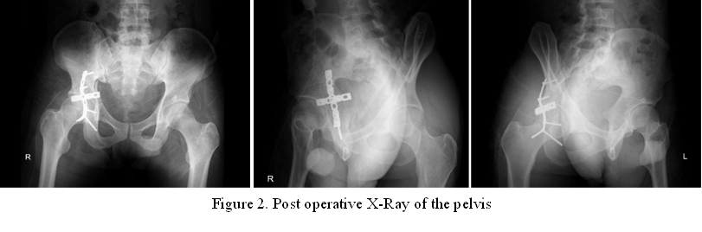
discussion
Asymmetrical bilateral hip dislocation is an exceedingly rare orthopedic injury, particularly when one side is accompanied by a posterior column acetabular fracture. The rarity of this case lies not only in the bilateral nature of the dislocation but also in the differing directions—posterior on the right and anterior on the left—combined with an associated fracture, making both diagnosis and management more complex. Most cases of hip dislocation are unilateral, with posterior dislocations being far more common than anterior, accounting for approximately 90% of all cases. Bilateral dislocations constitute around 0,01-0,02% of all traumatic hip dislocations, and asymmetrical types are even more uncommon (2,3).
The mechanism of injury in asymmetrical dislocations typically involves a high-energy impact with multiple directional force vectors acting on the hips. This aligns with findings from Meena et al., who reported similar mechanisms in their review of asymmetrical hip dislocations, often linked to vehicular trauma (3). In the present case, the clinical presentation—with one limb in adduction/internal rotation and the other in abduction/external rotation—was classic for posterior and anterior dislocations respectively, enabling early diagnosis and urgent management.
Prompt closed reduction is critical in minimizing complications such as avascular necrosis (AVN) of the femoral head, which can occur in up to 10%–15% of cases if reduction is delayed beyond 6 hours. In this patient, timely closed reduction of both hips was successfully performed, and early skeletal traction was applied to maintain stability on the fractured side. This approach is supported by previous study, which emphasized the importance of early reduction and traction in complex hip dislocations with associated acetabular fractures (9).
Posterior column fractures of the acetabulum, classified as elementary types according to Judet and Letournel, typically require open reduction and internal fixation to restore joint congruity and prevent post-traumatic arthritis. The Kocher-Langenbeck approach, as used in this case, is considered the gold standard for surgical exposure of posterior column and wall fractures. Recent literatures have demonstrated that anatomical reduction through this approach leads to superior functional outcomes (7,10). While the long-term outcomes of this patient remain to be seen, early results indicate a favorable prognosis due to timely intervention, anatomical reduction, stable fixation, and multidisciplinary postoperative care. Zhou et al. emphasized that patients with early ORIF and comprehensive rehabilitation after acetabular fractures had lower risks of complications and better joint function over time (11).
In summary, this case reinforces several key principles in the management of complex hip dislocations: the importance of early recognition and reduction, accurate fracture classification using the Judet-Letournel system, selection of appropriate surgical approach, and the role of early rehabilitation. The outcome in this patient is consistent with findings in contemporary literature and highlights the importance of a structured and timely management protocol in achieving optimal results in rare, high-energy pelvic trauma.

Conclusion
Asymmetrical bilateral hip dislocation with an associated acetabular fracture represents a rare and complex orthopedic challenge, typically caused by high-energy trauma. This case highlights the critical role of early recognition, prompt closed reduction, precise classification of acetabular fractures, and timely surgical fixation in achieving favorable outcomes. The posterior Kocher-Langenbeck approach proved effective in managing the posterior column fracture, while multidisciplinary care—including targeted analgesia and early mobilization—supported a smooth postoperative course.
Given the rarity of such injury patterns, there is a lack of robust data guiding optimal treatment protocols, prognosis, and long-term functional outcomes. Future studies and case series are essential to better understand the biomechanics, surgical strategies, complication profiles, and rehabilitation outcomes associated with bilateral and asymmetrical hip dislocations. Enhanced evidence may lead to more refined management guidelines and improve care for patients facing these severe injuries.

Consent (where ever applicable)
All authors declare that written informed consent was obtained from the patient for publication of this case report and accompanying images.

Ethical approval (where ever applicable)
Ethical approval for this case report was obtained and approved.

References
1. Weber CD, Lefering R, Sellei RM, Horst K, Migliorini F, Hildebrand F. Traumatic Hip Dislocations in Major Trauma Patients: Epidemiology, Injury Mechanisms, and Concomitant Injuries. J Clin Med. 2022;11(3):1–13.
2. Garcia BEC, Delgado AMG, Sacoto EPL, Calle JIC, Andrade GKC, Guarango KME, et al. Hip Dislocation, Anatomical Description, Epidemiology, Mechanisms of Action, Classification, Clinical Presentation, Imaging Presentation, Treatment, Complications and Dislocation After Total Hip Replacement. EPRA Int J Multidiscip Res (IJMR)-Peer Rev J [Internet]. 2020;(2):198–210. Available from: https://doi.org/10.36713/epra2013
3. Meena UK, Joshi N, Behera P, Meena BP, Jain S. Simultaneous asymmetrical bilateral hip dislocations – A report of three cases with different presentations and management. J Clin Orthop Trauma [Internet]. 2021;23:101642. Available from: https://doi.org/10.1016/j.jcot.2021.101642
4. Butler BA, Lawton CD, Hashmi SZ, Stover MD. The Relevance of the Judet and Letournel Acetabular Fracture Classification System in the Modern Era: A Review. J Orthop Trauma. 2019;33(2):S3–7.
5. Hougaard K, Thomsen PB. Traumatic posterior dislocation of the hip -Prognostic factors influencing the incidence of avascular necrosis of the femoral head. Arch Orthop Trauma Surg. 1986;106(1):32–5.
6. Wang S, Li B, Zhang Z, Yu X, Li Q, Liu L. Early versus delayed hip reduction in the surgical treatment of femoral head fracture combined with posterior hip dislocation: a comparative study. BMC Musculoskelet Disord [Internet]. 2021;22(1):1–6. Available from: https://doi.org/10.1186/s12891-021-04968-1
7. Tosounidis TH, Giannoudis VP, Kanakaris NK, Giannoudis P V. Subspecialty procedures: The kocher-langenbeck approach state of the art. JBJS Essent Surg Tech. 2018;8(2):1–7.
8. Ruan YL, Wang FT, Du XQ, Sun SS. Rehabilitation nursing after lower limb fracture: Preventing deep vein thrombosis and enhancing quality of life. Med (United States). 2023;102(47):E36180.
9. Milenkovic S, Mitkovic M, Mitkovic M. Avascular necrosis of the femoral head after traumatic posterior hip dislocation with and without acetabular fracture. Eur J Trauma Emerg Surg [Internet]. 2022;48(1):613–9. Available from: https://doi.org/10.1007/s00068-020-01495-x
10. Alexa O, Malancea RI, Puha B, Luncã S, Veliceasa S. Results of surgical treatment of acetabular fractures using kocher-langenbeck approach. Chir. 2013;108(6):879–85.
11. Plaisier BR, Meldon SW, Super DM, Malangoni MA. Improved outcome after early fixation of acetabular fractures. Injury. 2000;31(2):81–4.

