Review Article

Polytrauma: A Review

.
ABSTRACT

Aims: To provide a comprehensive overview of the epidemiology, pathophysiological phases, and current management principles of polytrauma, with particular emphasis on the roles of Early Total Care (ETC), Damage Control Orthopedics (DCO), and modern resuscitation strategies in improving patient outcomes.
Study design: Narrative literature review.
Place and Duration of Study: Department of Orthopaedic and Traumatology, Prof. Dr. I.G.N.G. Ngoerah General Hospital, Denpasar, Bali, Indonesia, conducted between August and December 2025.
Methodology: A structured literature review was performed using major medical databases including PubMed, Scopus, and Google Scholar. Relevant articles discussing the definition, epidemiology, pathophysiology, resuscitation strategies, and orthopedic management of polytrauma were included. Priority was given to international guidelines, systematic reviews, and high-quality clinical studies. The collected evidence was synthesized narratively to describe the progression of polytrauma from early shock through systemic inflammatory response syndrome (SIRS), compensatory anti-inflammatory response syndrome (CARS), and multiple organ dysfunction syndrome (MODS), as well as to evaluate current management approaches including Damage Control Resuscitation (DCR), ETC, and DCO.
Results: The review demonstrates that polytrauma remains a major cause of morbidity and mortality in the productive-age population. Disease progression typically follows a biphasic inflammatory pattern beginning with early hemorrhagic shock and systemic inflammation, which may evolve into immunoparalysis and MODS. The lethal triad (hypothermia, acidosis, and coagulopathy) and the two-hit phenomenon were consistently identified as key determinants of poor outcomes. Evidence supports physiology-based management, where ETC is beneficial in stable patients, while DCO reduces complications in borderline or unstable patients. Early balanced transfusion, prompt tranexamic acid administration within 3 hours of injury, and multidisciplinary coordination were repeatedly associated with improved survival and functional recovery.
Conclusion: Modern polytrauma management requires a multidisciplinary, physiology-driven approach integrating damage control principles, optimized resuscitation, and individualized orthopedic strategies. Appropriate patient stratification between ETC and DCO, along with early correction of the lethal triad, is essential to reduce complications and mortality. Further high-quality clinical studies are needed to refine timing strategies and optimize outcome prediction in polytrauma patients.

Keywords: Polytrauma, Damage Control Orthopedics, Early Total Care, MODS, Trauma Resuscitation
1. INTRODUCTION

Polytrauma represents one of the greatest challenges in modern emergency medicine and traumatology. This term refers to a complex medical condition occurring when a patient sustains two or more severe injuries affecting various body systems simultaneously, such as the musculoskeletal, central nervous, thoracic, abdominal, or vascular systems, accompanied by disturbances in systemic physiological homeostasis that can threaten life.^{[1]} Unlike common multiple traumas, polytrauma implies a sufficient injury burden to cause organ dysfunction, metabolic disturbances, and an immediate need for intensive management.^{[2]}
AO Trauma, as a global authority on education and trauma management standards, emphasizes that the diagnosis of polytrauma should not be solely based on the number of injury locations but must also consider the interaction between the severity of the injuries and their systemic effects on the body's physiology.^{[3]} In modern approaches, the definition of polytrauma encompasses not only anatomical conditions but also inflammatory responses, hemodynamic disturbances, and the potential for multiple organ dysfunction.^{[4]}
The physiology of patients experiencing polytrauma is disrupted systemically due to the activation of inflammatory pathways, immune system responses, and the release of various pro-inflammatory mediators, which worsen metabolic conditions and microcirculation.^{[2]} Therefore, the management of polytrauma patients cannot be performed in isolation between organs but requires a multidisciplinary and integrated approach involving specialties such as orthopedics, general surgery, anesthesia, neurology, and intensive care.^{[1]}
Furthermore, the principles of polytrauma management must follow time-based phases and the physiological status of the patient, starting from early resuscitation, systemic stabilization, surgical interventions adjusted to physiological tolerance (damage control), and early rehabilitation.^{[3]} This approach, known as a physiology-based strategy, ensures that clinical decisions are not solely dictated by radiological findings or anatomy but by the dynamic status of the patient overall.^{[4]}
Globally, polytrauma remains a leading cause of death in productive-age patients and imposes a significant economic and social burden. Therefore, a deep understanding of the concepts, physiological mechanisms, and management standards of polytrauma is critical for every healthcare professional involved in modern emergency care and orthopedic surgery.^{[1]} The purpose of this article review is to provide a comprehensive understanding of polytrauma.

2. methodology
This study was conducted as a narrative literature review to summarize current evidence regarding the definition, epidemiology, pathophysiology, and management principles of polytrauma. A structured search of electronic databases, including PubMed, Scopus, and Google Scholar, was performed to identify relevant publications. Search terms included combinations of keywords such as polytrauma, damage control orthopedics, early total care, trauma resuscitation, systemic inflammatory response, and multiple organ dysfunction syndrome. Articles published in English and considered clinically relevant were prioritized. Eligible sources included international guidelines, systematic reviews, meta-analyses, and key clinical studies addressing the pathophysiology and multidisciplinary management of polytrauma. Editorials, non-peer-reviewed articles, and studies with limited clinical relevance were excluded. The selected literature was analyzed and synthesized narratively to describe the physiological phases of polytrauma, the role of the lethal triad and two-hit theory, and current principles of resuscitation and orthopedic decision-making, including Early Total Care (ETC) and Damage Control Orthopedics (DCO).
3. Article REVIEW

3.1 Definition
Polytrauma is classically defined as multiple injuries with an Injury Severity Score (ISS) >16 and associated systemic physiological responses that may cause organ dysfunction. In 2014, an international consensus refined this definition to include at least two injuries with an Abbreviated Injury Scale (AIS) score ≥3, combined with specific physiological criteria, to improve clinical and epidemiological relevance.^{[3]}
- Hypotension, defined as systolic blood pressure ≤ 90 mmHg. This reflects systemic perfusion disturbances or shock occurring immediately after severe trauma.
- Decreased consciousness, with a Glasgow Coma Scale (GCS) ≤ 8, indicating severe brain injury or other systemic consciousness disturbances.
- Metabolic acidosis, demonstrated by a base deficit ≤ -6 mmol/L, indicating metabolic disturbances due to tissue hypoperfusion and hypoxia.
- Coagulopathy, defined by a partial thromboplastin time ≥ 50 seconds or an International Normalized Ratio (INR) ≥ 1.4, representing a disruption of the hemostatic system due to massive bleeding or systemic dysfunction.
- Advanced age, defined as age ≥ 70 years, which is an important prognostic factor as this group is more vulnerable to inflammatory complications and multiple organ failure.
This redefinition combines clinical and physiological criteria to more accurately identify true polytrauma and guide data-driven triage and management.^{[2,3]} Injury severity is graded using the Abbreviated Injury Scale (AIS), while overall severity is quantified by the Injury Severity Score (ISS), calculated from the three highest AIS scores in different body regions, with higher scores indicating greater trauma severity.^{[3]}

Table 1. Example of ISS Calculation³
Region | Injury description | AIS* | Square top three
Head & neck | Cerebral contusion | 3 | 9
Face | No injury | 0
Chest | Flailed chest | 4 | 16
 | Minor contusion of liver  Complex rupture spleen | 2  5 | 25
Extremity | Fractured femur | 2
External | No injury | 0
Injury severity score |  |  | 50

AO Trauma and the European Society of Trauma and Emergency Surgery (ESTES) agree that an ISS ≥ 16 is the minimum threshold to categorize a patient as a polytrauma case.^{[1]} This value is not just an arbitrary number but is based on epidemiological and prognostic data showing that patients with an ISS ≥ 16 have a significantly higher risk of death, systemic complications, and the need for long-term intensive care.^{[4]}
3.2 Epidemiology
Polytrauma is a serious global health issue and one of the leading causes of morbidity and mortality, particularly in the productive age group. The incidence of polytrauma is most found in individuals aged 15 to 45 years, an age group that is socially and economically active and has a high exposure to accident risks.^{[1]} The high incidence in this group not only creates a medical burden but also significantly impacts the social, economic, and psychological aspects of society at large.^{[4]}
In developing countries, polytrauma is mostly caused by traffic accidents, which contribute about 50–60% of all severe polytrauma cases.^{[1]} This is closely related to the high number of motor vehicles, lack of safe public transport systems, and low compliance with safety regulations such as helmet or seat belt use.^{[2]} In some Southeast Asian and African regions, data even show that polytrauma from traffic accidents exceeds trauma caused by violence or natural disasters.^{[3]} In addition to traffic accidents, other major causes of polytrauma include falls from heights, explosions (both occupational and from armed conflict), and injuries from extreme sports or heavy manual labor such as construction work.^{[4]} In developed countries, the causes of polytrauma tend to be more varied and are often associated with high-energy trauma, such as industrial accidents or high-speed motor recreational activities.^{[1]}

  - Patophysiology

3.3.1 Early Phase (0–2 hours): The Shock Phase
The early phase of polytrauma, known as the shock phase, occurs within the first two hours after injury and is marked by systemic hypoperfusion due to massive blood loss and hypovolemia.^{[2]} This results in impaired oxygen delivery, disruption of homeostasis, and circulatory failure.^{[4]} Acute hypovolemia activates the sympathetic nervous system, leading to catecholamine release that increases cardiac output and systemic vasoconstriction to preserve perfusion of vital organs.^{[1,2]} However, reduced peripheral perfusion causes tissue hypoxia, lactate accumulation, and metabolic acidosis, increasing the risk of multiple organ dysfunction.^{[1,3]}
Simultaneously, tissue injury activates the innate immune response, triggering the release of proinflammatory cytokines such as TNF-α, IL-1, and IL-6, which promote systemic inflammation and initiate SIRS even without infection.^{[2,4]} This phase is also characterized by the lethal triad—hypothermia, metabolic acidosis, and coagulopathy—which synergistically worsen shock and increase mortality.^{[1]} Hypothermia, lactate-induced acidosis, and trauma-induced coagulopathy form a vicious cycle that, without prompt intervention, leads to progressive hypoperfusion and multiple organ failure.^{[2–4]}

3.3.2 Subacute Inflammatory Phase (2–48 hours): Systemic Inflammatory Response
Following successful management of the shock phase, polytrauma patients enter the subacute phase (2–48 hours post-injury), characterized by intense systemic inflammation resulting from prior tissue damage and microcirculatory dysfunction.^{[4]} This phase involves excessive activation of the innate immune system mediated by DAMP–PRR interactions, leading to increased release of proinflammatory cytokines such as IL-6, TNF-α, and IL-1.^{[2,3]} The resulting systemic inflammation increases capillary permeability, promotes tissue edema, and impairs oxygen diffusion, particularly in vulnerable organs such as the lungs and kidneys, thereby raising the risk of ARDS and multiple organ dysfunction.^{[1]} Patients are highly susceptible to Systemic Inflammatory Response Syndrome (SIRS), which may occur even in the absence of infection.^{[4]} The clinical outcome in this phase is largely determined by the balance between pro-inflammatory mediators and anti-inflammatory responses, particularly IL-10. Persistent imbalance may lead to Compensatory Anti-Inflammatory Response Syndrome (CARS), resulting in immune suppression and increased susceptibility to infection and sepsis.^{[2]}

3.3.3 Immunoparalysis and Infection Potential Phase (>48–96 hours)
After the subacute inflammatory phase, polytrauma patients may enter an advanced phase marked by immunoparalysis, typically occurring 48–96 hours post-injury, due to an imbalance between pro-inflammatory activation and compensatory anti-inflammatory responses.^{[2,4]} Also known as Compensatory Anti-Inflammatory Response Syndrome (CARS), this phase is characterized by immune suppression, including reduced HLA-DR expression on monocytes, impaired T-cell activation, and decreased phagocytic function.^{[1,3]}
As a result, patients are at increased risk of nosocomial infections such as ventilator-associated pneumonia, surgical site infections, urosepsis, and severe sepsis, which may present with minimal symptoms but can rapidly progress to septic shock and secondary ARDS.[2,4] Early identification through immunological markers and close monitoring is essential, as this phase represents a critical balance between immune recovery and failure, guiding infection control strategies and the timing of definitive surgical interventions.^{[2]}

3.3.4 Advanced Phase: Multiple Organ Dysfunction Syndrome (MODS)
The advanced phase of polytrauma is characterized by Multiple Organ Dysfunction Syndrome (MODS), defined as dysfunction of two or more organ systems due to immune dysregulation and inadequate perfusion.^{[3]} MODS represents the end stage of uncontrolled systemic inflammation, often following immunoparalysis and unresolved nosocomial infections.^{[2]} Commonly affected organs include the lungs (ARDS), kidneys (acute kidney injury), liver, and cardiovascular system, frequently requiring advanced supportive therapies such as mechanical ventilation, dialysis, and vasopressors.^{[1,2,4]}
A hallmark of MODS is microcirculatory failure, where tissue hypoxia persists despite apparently adequate systemic perfusion, leading to progressive cellular dysfunction.^{[3]} Organ failures are interrelated and mutually aggravating, resulting in sharply increased mortality, exceeding 80% when four or more organs fail.^{[1]} Death in this phase is usually caused by secondary complications rather than the initial trauma, underscoring the importance of early inflammation control, prevention of secondary insults, and microcirculatory monitoring to reduce progression to MODS.^{[2]}

3.3.5 Two-Hit Theory
The two-hit theory is essential in guiding the timing and strategy of interventions in polytrauma management. Disease progression is influenced by the initial injury (first hit) and subsequent physiological stressors (second hit), often related to invasive procedures such as major surgery, massive transfusion, or secondary infections.^{[3]} The first hit induces a systemic inflammatory response through cytokine release and innate immune activation, which may exceed compensatory capacity in severely injured patients.^{[2]}
A second hit occurring before physiological stabilization can further amplify inflammation and precipitate SIRS, immunoparalysis, and Multiple Organ Dysfunction Syndrome (MODS).[1,4] Elevated inflammatory markers such as IL-6 and CRP after major surgery in unstable patients support this concept.^{[2]} Consequently, Damage Control Orthopedics (DCO) is recommended for borderline or unstable patients, while definitive interventions should be guided by dynamic physiological parameters, including hemodynamics, base excess, serum lactate, and vasopressor requirements, to prevent excessive inflammatory escalation.^{[1,4]}

3.3.6 Lethal Triad
The lethal triad—hypothermia, coagulopathy, and metabolic acidosis—is a critical concept in early polytrauma management, as these interrelated conditions form a self-perpetuating cycle that significantly increases mortality if not corrected simultaneously.^{[1]} Hypothermia (<35°C) results from environmental exposure, cold fluid infusion, and poor perfusion, impairing coagulation, platelet function, and cellular metabolism, thereby worsening acidosis.^{[2,3]}
Trauma-induced coagulopathy arises from dilution and consumption of coagulation factors and platelet dysfunction, further aggravated by hypothermia and acidosis, leading to uncontrolled bleeding and reduced organ perfusion.^{[4]} Metabolic acidosis (pH <7.2) is caused by lactate accumulation due to tissue hypoxia and hypoperfusion, impairing coagulation enzyme activity and myocardial function.^{[1,2]} These components interact in a vicious cycle—often termed the “bloody vicious cycle”—that accelerates shock, MODS, and early death.^{[3,4]}
Effective management requires early, aggressive, and simultaneous correction through active rewarming, warm fluid and blood resuscitation, correction of coagulopathy, and prompt hemorrhage control, with close monitoring of core temperature, pH, base excess, and INR during initial resuscitation.^{[1]}
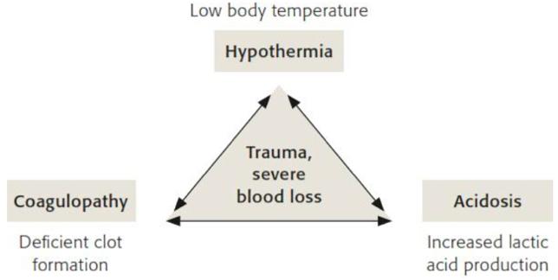

Fig. 1. The Lethal Triad of Death

  - The Importance of Fracture Management in Polytrauma Patients
In the early 20th century, surgical stabilization of long bone fractures in polytrauma patients was avoided due to concerns about fat embolism and respiratory complications such as ARDS. Although survival improved with the use of Thomas splints during World War I, polytrauma patients were long considered “too sick to operate on,” leading to prolonged traction and bed rest with increased systemic complications.^{[5]}
This paradigm changed after the landmark study by Bone et al. (1989), which demonstrated that early femoral fracture fixation reduced respiratory failure and shortened ICU, and hospital stays, forming the basis of the Early Total Care (ETC) concept. ETC became standard practice until later evidence showed increased risks of ARDS and Multiple Organ Failure (MOF) in physiologically unstable patients. This led to the development of Damage Control Orthopedics (DCO), which prioritizes temporary stabilization and delays definitive fixation until physiological recovery. The ongoing ETC–DCO debate highlights that fracture management in polytrauma should be guided primarily by physiological status rather than injury anatomy alone, as major fractures substantially contribute to the systemic inflammatory response due to several factors.^{[1]}
- Bleeding
Unstable pelvic fractures, femur fractures, and multiple open fractures can cause massive bleeding, leading to prolonged hypovolemic shock.^{[5]}
- Wound Contamination
Open fractures are nearly always considered contaminated wounds. If debridement is delayed or inadequate, these wounds become an ideal medium for bacterial growth, which increases the risk of local infection and systemic sepsis. ^{[5]}
- Necrotic and Ischemic Tissue
High-energy open fractures often result in necrotic tissue and hypoxic zones at the wound edges. If aggressive debridement is not performed promptly, this tissue becomes a source of pro-inflammatory mediators that exacerbate SIRS. ^{[5]}
- Ischemia-Reperfusion Injury
Prolonged hypovolemic shock or compartment syndrome can lead to ischemia-reperfusion injury, which causes microcirculatory damage due to the production of free oxygen radicals.^{[2]}
- Pain and Stress
Unstable fractures cause chronic pain stimulation that activates the central nervous system and triggers neuroendocrine and neuroimmunological reflex activation, exacerbating systemic hypermetabolism.^{[4]}
- Intensive Care Barriers
Unstabilized fractures cause severe pain, complicating patient positioning in the ICU (such as in the upright chest position) and hindering early mobilization.^{[4]}
With all these factors in mind, it is clear that fracture management in polytrauma patients has widespread systemic implications. Therefore, fracture fixation timing and technique strategies must be individualized based on the patient’s physiological condition through thorough assessment.^{[4]}

  - Resuscitation in Polytrauma Patients
Resuscitation is a critical component of early polytrauma management and should be guided by an integrated assessment of patient physiology, injury pattern, trauma mechanism, and response to initial therapy. More than 50% of polytrauma patients require blood transfusion, and approximately 15% need massive transfusion.^{[6]} In modern trauma systems, Whole-Body CT (WBCT) has largely replaced conventional imaging, allowing rapid identification of bleeding sources and targeted surgical or interventional radiology control. Early WBCT has been shown to improve survival, saving one life for every 17 patients with an ISS >16, particularly in severely injured patients, although its use should be based on clinical indications rather than mechanism alone^{.[7]}
Shock severity and tissue perfusion are monitored using biochemical markers such as serum lactate and base deficit, while coagulation status is assessed through conventional tests and viscoelastic assays like thromboelastography, which enable real-time detection of coagulopathy and prediction of massive transfusion and mortality. In patients with severe traumatic brain injury (GCS ≤8), mean arterial pressure should be maintained ≥90 mmHg using cautious boluses of warm crystalloid fluids to avoid dilutional coagulopathy and MODS. Normothermia must be actively preserved throughout resuscitation.^{[8]}
Massive transfusion protocols emphasize early balanced blood product administration with a PRC:FFP:platelet ratio of 1:1:1, guided by fibrinogen levels and viscoelastic testing, and have been associated with improved survival.^{[9]} Tranexamic acid (TXA), administered within 3 hours of injury at a dose of 1 g followed by 1 g over 8 hours, reduces mortality and should be given as early as possible, including in the pre-hospital setting.^{[10]} Damage Control Resuscitation (DCR), incorporating early hemorrhage control, permissive hypotension, limited crystalloid use, balanced transfusion, hypothermia prevention, and damage control surgery, has become standard practice and is associated with improved outcomes in polytrauma patients.^{[11]}

  - Timing and Surgical Priorities in Polytrauma Patients
Initial polytrauma management involves pre-hospital and in-hospital phases, both of which critically influence patient survival and outcomes (1). The primary early objective is life-saving stabilization, focusing on airway patency, adequate ventilation, and oxygenation to support vital organ function. The Advanced Trauma Life Support (ATLS) protocol remains the gold standard for initial assessment, with modern trauma systems adapting it to allow simultaneous assessment and interventions to expedite definitive care.^{[2]}

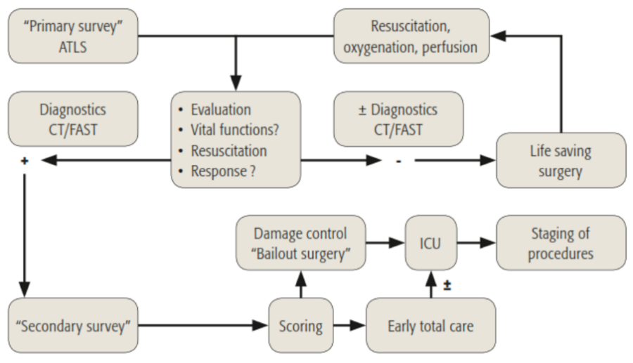
Figure 2. Initial Assessment and Management Pathway for Polytrauma Patients

The key steps in primary resuscitation include life-saving measures such as:
- Decompression of body cavities, e.g., for tension pneumothorax, cardiac tamponade, or epidural hematoma.
- Control of massive hemorrhage, such as in large hemothorax, hemoperitoneum, open pelvic fractures, limb amputations, or severely injured extremities.^{[3]}
Decisions regarding subsequent surgical management strategies heavily depend on the patient’s physiological response to early resuscitation. If clinical status deteriorates or vital signs worsen, rapid reassessment and adjustment of the surgical strategy are necessary according to the principles of damage control surgery (DCS) or early total care (ETC), depending on the patient's condition.^{[3]}
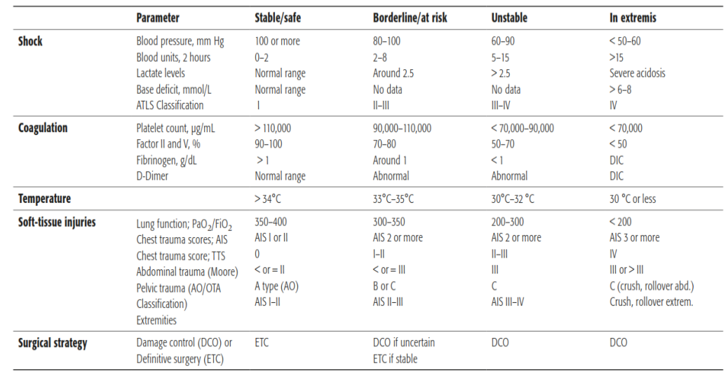
Table 2. Criteria and Stratification of Polytrauma Patients Based on Physiological Status

The timing of surgery also requires identification of resuscitation endpoints, which are indicators that the patient has achieved adequate physiological stabilization to undergo definitive procedures. These resuscitation endpoints include:
- Normal blood pressure and oxygen saturation
- Serum lactate < 2 mmol/L
- No coagulation disturbances
- Normal body temperature (normothermic)
- Urine output >1 mL/kg/hour
- No need for inotropic support.^{[1,8]}
Only after these endpoints are achieved can more invasive operative procedures be performed with a lower risk of systemic complications. Therefore, the process of categorizing patients into the appropriate operative category—such as stable, borderline, or unstable—depends on intensive monitoring of resuscitation parameters and clinical response.^{[3]}

- Indications and Principles of Damage Control Surgery (DCS) in Polytrauma Patients
Damage Control Surgery (DCS) is a surgical approach aimed at saving lives, rather than completing definitive anatomical repairs in the early phase. The main principle of DCS is to delay major surgery and first restore physiological stability. This procedure is chosen when patients do not respond adequately to resuscitation or show signs of progressive physiological failure, such as hypothermia, acidosis, and coagulopathy.^{[1]}

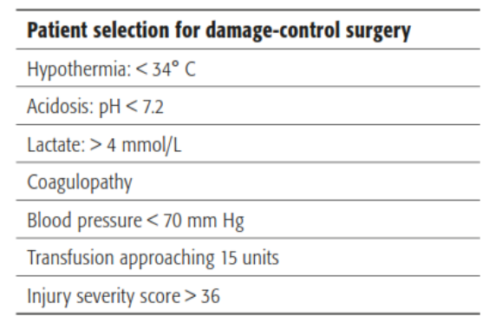
Table 3. Criteria for Selecting Patients for Damage-Control Surgery (DCS)

According to AO Trauma, there are three main categories indicating the need for DCS.[3]
- Physiological Criteria: Patients show hypothermia (<35°C), coagulopathy (INR >1.4), and metabolic acidosis (base deficit ≤ -6 mmol/L). This combination is part of the lethal triad, which increases the risk of death if major surgery is performed.
- Complex Injury Patterns: These include severe thoracic injury, pelvic fractures, bilateral femur fractures, and complex extremity fractures, particularly in elderly patients with low physiological reserves.
- Mass Casualty Situations: When the number of patients exceeds available resources (e.g., beds, surgical teams, ICU), limited surgeries are performed with a focus on saving lives and extremities.
DCS can be performed as:
- Reactive: Bail-out surgery, which halts an ongoing operation due to sudden physiological decompensation.
- Preemptive: A deliberate decision to stage surgery because the patient is not physiologically ready for a single definitive operation.^{[2]}
DCS procedures include:
- Hemorrhage control (ligation, packing)
- Stabilization of long bone fractures and pelvis using external fixators or splints
- Debridement of open wounds and preventive measures against infection (e.g., fecal diversion if abdominal contamination is present)
The main goal of DCS is to limit the duration of surgery and immediately refer the patient to the ICU for further resuscitation and stabilization of physiological systems. Once the patient’s condition improves, staged surgery can be performed during the window of opportunity between days 5 and 10 post-trauma, when the immune response has subsided from the inflammatory phase (SIRS) but before entering the immunosuppressive phase (CARS).^{[1,3]}

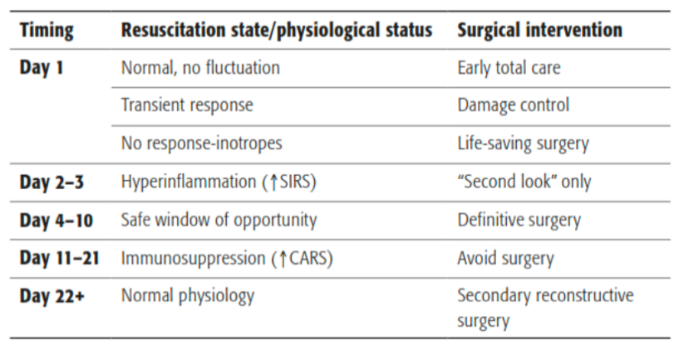
Table 4. Ideal Timing of Surgical Intervention in Polytrauma Patients

If definitive stabilization cannot be performed during this period, elective surgery can only be planned after the third week, once the patient has moved beyond the immunosuppressive phase, reducing the risk of MODS.^{[3]}

- Indications for Early Total Care (ETC) in Polytrauma Patients
The Early Total Care (ETC) principle recommends definitive fixation of long bone fractures from day 1 post-trauma once adequate physiological stabilization has been achieved, including normalized oxygenation, hemodynamics, temperature, coagulation status, and microcirculatory markers such as pH, base deficit, and lactate levels.^{[1]} If full resuscitation targets are not met within 24 hours, fixation may still be safely performed within a window of up to 36 hours, provided physiological parameters show continuous improvement—a strategy referred to as Early Appropriate Care. This approach individualizes surgical timing based on physiological readiness rather than rigid time thresholds, while also considering fracture characteristics, soft tissue condition, and surgical expertise. According to AO Trauma, this strategy allows safe early definitive fixation in most polytrauma patients^{.[3]}

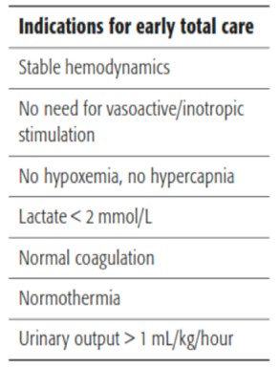
Table 5. Criteria for Selecting Patients for Early Total Care (ETC)

Clinical evidence and literature show that appropriately implemented ETC can provide significant benefits in the management of polytrauma patients, including:^{[1,2,5]}
- Reducing the incidence of ARDS, fat embolism, pneumonia, sepsis, MODS, and thromboembolic complications.
- Facilitating intensive care: enabling upright positioning, early mobilization, and reducing the need for analgesics.
- Accelerating rehabilitation and recovery of limb function.
Therefore, the ETC approach remains a cornerstone in the orthopedic management of polytrauma patients, provided that physiological status is stable and interventions are performed carefully, based on objective parameters and clinical evidence.^{[5]}

  - Specific Injury Patterns
In severe polytrauma, certain complex injury patterns are clear indications for damage-control surgery (DCS) due to the high risk of systemic dysregulation, massive hemorrhage, and multiple organ failure if definitive procedures are performed too early. Decisions regarding DCS must be made collaboratively through real-time, bedside multidisciplinary discussions involving surgeons, anesthesiologists, and intensive care specialists. AO Trauma emphasizes that timely, condition-based intervention during this critical phase is essential for improving patient outcomes and should not be delayed.^{[1]}

- Severe Pelvic Fractures and Hemorrhage Control Strategies
Open or closed pelvic fractures with significant displacement can cause massive hemorrhage into the retroperitoneal space, peritoneal cavity, or soft tissues, leading to life-threatening hemorrhagic shock. Early management includes pre-hospital application of a pelvic binder to reduce pelvic volume and bleeding, which may obviate the need for immediate surgical fixation.^{[1]} Upon hospital admission, aggressive resuscitation with massive transfusion protocols and early administration of tranexamic acid within 3 hours, as supported by the CRASH-2 trial, is essential to reduce mortality. Once hemodynamic stability is achieved, further imaging and staged pelvic reconstruction can be planned. However, if the patient remains hemodynamically unstable, immediate search and control of the bleeding source should be conducted.^{[12]} There are two main approaches:
- Direct surgical control through pelvic packing, which involves tamponading the retroperitoneal space.
- Interventional Radiology through arterial embolization, especially if the bleeding source is from the internal iliac artery branches.
The choice of method depends on available resources, the expertise of the trauma team, and the exact location of the bleeding source. If laparotomy is required (e.g., for intra-abdominal bleeding), there is a risk of abdominal compartment syndrome, which may worsen the patient’s condition. After initial stabilization and recovery in the ICU, patients generally require a "second-look surgery" to reassess bleeding and necrotic tissue. The final step is definitive fixation of the pelvic ring and abdominal wall closure if necessary.^{[12]}

- Traumatic Brain Injury with Long Bone Fractures
Traumatic brain injury (TBI) is a critical component of polytrauma, particularly when associated with long bone fractures. Patients with epidural or subdural hematomas require urgent surgical evacuation to prevent secondary brain injury, and intracranial pressure (ICP) monitoring is essential when the Glasgow Coma Scale (GCS) remains <9 after craniotomy.^{[1,13]}
In patients who respond well to resuscitation, early fixation of long bone fractures may be beneficial by facilitating mobilization, reducing pain-related stress, decreasing sedative requirements, and improving intensive care management, thereby helping to prevent secondary increases in ICP. However, in the presence of TBI, the timing of orthopedic surgery should be individualized rather than dictated by rigid protocols. A multidisciplinary approach with intraoperative ICP monitoring, when indicated, and close coordination between orthopedic, anesthesia, neurosurgical, and ICU teams is essential to ensure physiological stability and minimize secondary brain injury.^{[3]}

- Severe Chest Injury with Long Bone Fractures
In polytrauma patients with severe chest injuries and associated long bone fractures, particularly femoral shaft fractures, the choice of fixation technique is critical due to its potential impact on pulmonary function. Intramedullary (IM) locked nailing remains the gold standard for femur fracture management; however, reaming and intramedullary manipulation can increase intramedullary pressure, leading to the release of fat emboli and inflammatory mediators into the pulmonary circulation, as demonstrated by transesophageal echocardiography.^{[1,2]}
While reamed IM nailing is generally safe in fully resuscitated patients with isolated fractures, it carries a higher risk of pulmonary deterioration and ARDS in patients with incomplete resuscitation or multiple injuries.^{[4]} Evidence from clinical studies remains mixed. A North American randomized trial showed no statistically significant difference in ARDS incidence between reamed and unreamed IM nailing, although the study was underpowered.^{[14]} In contrast, a European study reported a significantly higher risk of acute pulmonary dysfunction in borderline patients undergoing early IM nailing compared to those initially managed with external fixation, while stable patients benefited from shorter ventilation times.^{[15]}
Based on these findings, AO Trauma recommends a Damage Control Orthopedics (DCO) strategy with temporary external fixation for borderline or hemodynamically unstable patients, followed by conversion to definitive IM nailing after physiological stabilization, typically within the safe immunological window of 5–10 days post-injury.^{[1]}

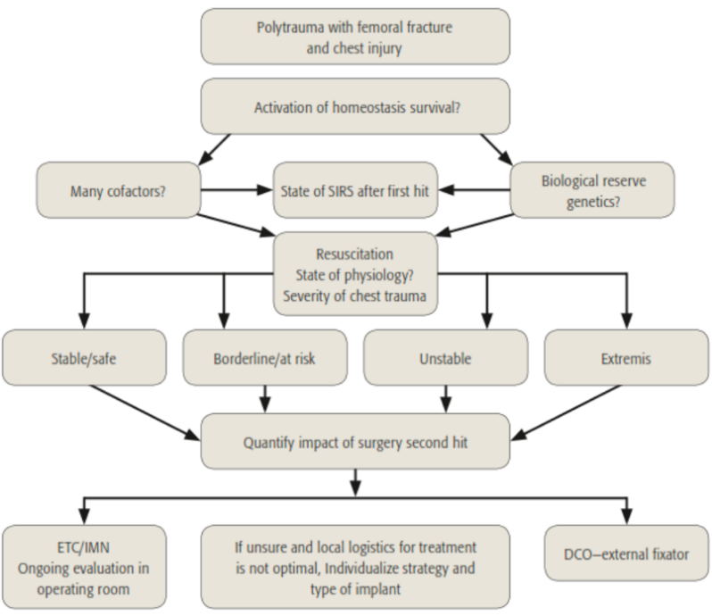
Figure 3. Algorithm for Chest Injury Management in Polytrauma Patients

- Limb Salvage vs. Amputation
The decision to either salvage the extremity (limb salvage) or perform amputation in patients with severe extremity injuries is a significant clinical challenge, especially in polytrauma or blast injury cases. One tool used in this decision-making process is the Mangled Extremity Severity Score (MESS), which considers factors such as the injury mechanism, ischemia, delayed revascularization time, and the patient’s systemic condition.^{[16]} Efforts to salvage the extremity should only be attempted in selected cases that meet both physiological and technical criteria. The approach used is typically multistage, starting with aggressive debridement, revascularization, fasciotomy, and fracture fixation. This is followed by periodic re-debridement and early soft tissue reconstruction, ideally performed during the "immunological window" between days 5 and 10 post-trauma.^{[17]}
If amputation is decided, it should be performed on healthy tissue, following the principles of primary debridement, not as a definitive amputation. Flap formation or stump reconstruction should not be carried out during the early stages because the tissue condition is not yet stable. Stump reconstruction is performed later when the patient’s systemic condition has improved, and infection is controlled. The decision between limb salvage and amputation is not just an orthopedic technical consideration but also involves long-term quality of life, potential complications, and the patient’s psychosocial readiness for an extensive rehabilitation process.^{[18]}

- The Role of Anesthesia and Physiotherapy in Polytrauma Patients
In polytrauma, anesthesia is essential during both resuscitation and surgery and should be individualized to the patient’s physiological status in accordance with damage control resuscitation principles. The main contributions of anesthesia in polytrauma include:
- Airway management and ventilation: Ensuring adequate oxygenation and preventing hypoxia, particularly in patients with thoracic trauma or traumatic brain injury.
- Hemodynamic stabilization: Through appropriate fluid use, blood transfusions, and vasopressors, anesthesia supports tissue perfusion during both the resuscitation and intraoperative phases.^{[19]}
- Multimodal analgesia: Effective pain control is crucial to reduce systemic complications like delirium, sympathetic tone increase, or respiratory depression.
- Intraoperative monitoring with damage control surgery (DCS) approach: Anesthesiologists provide support in terms of invasive monitoring, temperature control, and metabolic status monitoring (e.g., lactate levels, base deficit), in line with AO Trauma’s Early Appropriate Care (EAC) concept.^{[3]}
Physiotherapy is a key component of polytrauma recovery and should begin as early as the patient’s condition allows. AO Trauma recommends early, safe mobilization to reduce complications such as pneumonia, deep vein thrombosis, and muscle atrophy.^{[19]} The main roles of physiotherapy include:
- Respiratory physiotherapy: To prevent pulmonary complications, particularly in patients with thoracic trauma or those undergoing prolonged intubation.
- Early mobilization and functional exercises: To improve circulation, maintain joint range of motion, and support neurological recovery, especially in cases with head or spinal injuries.
- Progressive rehabilitation planning: Tailored to the severity of injuries, stability of surgical fixation, and pain control. Physiotherapists work closely with the surgical team to establish realistic rehabilitation goals.^{[20]}
- Pain management and patient education: Using techniques such as TENS, hydrotherapy, and training for patients and families to support long-term independence.
Early interdisciplinary coordination between the anesthesia, orthopedic, and physiotherapy teams—as emphasized in AO Trauma’s integrated care model—is critical to improving clinical outcomes and reducing the risk of complications and long-term disability.^{[19]}

4. Conclusion

Modern polytrauma management emphasizes a multidisciplinary, physiology-based approach. Orthopedic strategies integrate Early Total Care (ETC) for stable patients and Damage-Control Orthopedics (DCO) for borderline or unstable patients. Timely selection of the appropriate strategy, considering post-trauma immune responses such as SIRS and CARS, is crucial for optimizing outcomes. This individualized, evidence-based approach enhances patient safety, reduces systemic complications, and accelerates recovery.

Consent (where ever applicable)

Not applicable. This study is a narrative literature review and does not involve human participants or identifiable patient data.

Ethical approval (where ever applicable)
Ethical approval was not required for this study because it is a narrative literature review based solely on previously published data and does not involve human participants, patient data, or animal subjects.
References

[1] Trentz O. Polytrauma: Pathophysiology, Priorities, and Management. General Trauma Care and Related Aspects, Berlin, Heidelberg: Springer Berlin Heidelberg; 2014, p. 69–76. https://doi.org/10.1007/978-3-540-88124-7_5.
[2] Keel M, Trentz O. Pathophysiology of polytrauma. Injury 2005;36:691–709. https://doi.org/10.1016/j.injury.2004.12.037.
[3] Pape H-C, Lefering R, Butcher N, Peitzman A, Leenen L, Marzi I, et al. The definition of polytrauma revisited. Journal of Trauma and Acute Care Surgery 2014;77:780–6. https://doi.org/10.1097/TA.0000000000000453.
[4] Pfeifer R, Klingebiel FK-L, Halvachizadeh S, Kalbas Y, Pape H-C. How to Clear Polytrauma Patients for Fracture Fixation: Results of a systematic review of the literature. Injury 2023;54:292–317. https://doi.org/10.1016/j.injury.2022.11.008.
[5] Huber-Wagner S, Lefering R, Qvick M, Kay M V., Paffrath T, Mutschler W, et al. Outcome in 757 severely injured patients with traumatic cardiorespiratory arrest. Resuscitation 2007;75:276–85. https://doi.org/10.1016/j.resuscitation.2007.04.018.
[6] Huber-Wagner S, Lefering R, Qvick L-M, Körner M, Kay M V, Pfeifer K-J, et al. Effect of whole-body CT during trauma resuscitation on survival: a retrospective, multicentre study. The Lancet 2009;373:1455–61. https://doi.org/10.1016/S0140-6736(09)60232-4.
[7] Spahn DR, Bouillon B, Cerny V, Duranteau J, Filipescu D, Hunt BJ, et al. The European guideline on management of major bleeding and coagulopathy following trauma: fifth edition. Crit Care 2019;23:98. https://doi.org/10.1186/s13054-019-2347-3.
[8] Frith D, Brohi K. The acute coagulopathy of trauma shock: Clinical relevance. The Surgeon 2010;8:159–63. https://doi.org/10.1016/j.surge.2009.10.022.
[9] Roberts I, Shakur H, Coats T, Hunt B, Balogun E, Barnetson L, et al. The CRASH-2 trial: a randomised controlled trial and economic evaluation of the effects of tranexamic acid on death, vascular occlusive events and transfusion requirement in bleeding trauma patients. Health Technol Assess 2013;17. https://doi.org/10.3310/hta17100.
[10] Holcomb JB, Tilley BC, Baraniuk S, Fox EE, Wade CE, Podbielski JM, et al. Transfusion of Plasma, Platelets, and Red Blood Cells in a 1:1:1 vs a 1:1:2 Ratio and Mortality in Patients With Severe Trauma. JAMA 2015;313:471. https://doi.org/10.1001/jama.2015.12.
[11] Canadian Orthopaedic Trauma Society. Nonoperative Treatment Compared with Plate Fixation of Displaced Midshaft Clavicular Fractures. J Bone Joint Surg 2007;89:1–10. https://doi.org/10.2106/JBJS.F.00020.
[12] Pape H-C, Giannoudis P V, Krettek C, Trentz O. Timing of Fixation of Major Fractures in Blunt Polytrauma. J Orthop Trauma 2005;19:551–62. https://doi.org/10.1097/01.bot.0000161712.87129.80.
[13] Harwood PJ, Giannoudis P V., van Griensven M, Krettek C, Pape H-C. Alterations in the Systemic Inflammatory Response after Early Total Care and Damage Control Procedures for Femoral Shaft Fracture in Severely Injured Patients. The Journal of Trauma: Injury, Infection, and Critical Care 2005;58:446–54. https://doi.org/10.1097/01.TA.0000153942.28015.77.
[14] Bone LB, Johnson KD, Weigelt J, Scheinberg R. Early versus delayed stabilization of femoral fractures. A prospective randomized study. J Bone Joint Surg Am 1989;71:336–40.
[15] Carney N, Totten AM, O’Reilly C, Ullman JS, Hawryluk GWJ, Bell MJ, et al. Guidelines for the Management of Severe Traumatic Brain Injury, Fourth Edition. Neurosurgery 2017;80:6–15. https://doi.org/10.1227/NEU.0000000000001432.
[16] Park CH, Lee JW. Penetrating liver injury caused by a metal fragment from a blast accident in a factory: a case report. Journal of Trauma and Injury 2022;35:S8–14. https://doi.org/10.20408/jti.2021.0085.
[17] Giannoudis P, Pape H, Sanders R. Practical Procedures in Orthopaedic Trauma Surgery. Cambridge: Cambridge University Press 2014. https://doi.org/10.1017/CBO9780511862328.
[18] Mullenix PS, Steele SR, Andersen CA, Starnes BW, Salim A, Martin MJ. Limb salvage and outcomes among patients with traumatic popliteal vascular injury: An analysis of the National Trauma Data Bank. J Vasc Surg 2006;44:94–100. https://doi.org/10.1016/j.jvs.2006.02.052.
[19] Nicolaides M, Pafitanis G, Vris A. Open tibial fractures: An overview. J Clin Orthop Trauma 2021;20:101483. https://doi.org/10.1016/j.jcot.2021.101483.
[20] Binz S, McCollester J, Thomas S, Miller J, Pohlman T, Waxman D, et al. CRASH-2 Study of Tranexamic Acid to Treat Bleeding in Trauma Patients: A Controversy Fueled by Science and Social Media. J Blood Transfus 2015;2015:1–12. https://doi.org/10.1155/2015/874920.

Definitions, Acronyms, Abbreviations

AIS : Abbreviated Injury Scale
ARDS : Acute Respiratory Distress Syndrome
ATLS: Advanced Trauma Life Support
CARS: Compensatory Anti-Inflammatory Response Syndrome
CRP: C-Reactive Protein
DAMP: Damage-Associated Molecular Pattern
DCO: Damage Control Orthopedics
DCR: Damage Control Resuscitation
DCS: Damage Control Surgery
EAC: Early Appropriate Care
ETC: Early Total Care
ESTES: European Society Of Trauma And Emergency Surgery
FFP: Fresh Frozen Plasma
GCS: Glasgow Coma Scale
ICP: Intracranial Pressure
ICU: Intensive Care Unit
IL: Interleukin
IM: Intramedullary
INR: International Normalized Ratio
ISS: INJURY SEVERITY SCORE
MESS: Mangled Extremity Severity Score
MODS: Multiple Organ Dysfunction Syndrome
MOF: Multiple Organ Failure
PRC: Packed Red Cells
PRR: Pattern Recognition Receptor
SIRS: Systemic Inflammatory Response Syndrome
TBI: Traumatic Brain Injury
TENS: Transcutaneous Electrical Nerve Stimulation
TXA: Tranexamic Acid
WBCT: Whole-Body Computed Tomography

