Original Research Article

A Signal for Caution: Eight Cases of Neurological Injury After Spinal Manipulation and Implications for Future Surveillance

.
ABSTRACT

Aims: We present a two-year, multi-center retrospective case series from Malaysia on spine-related complications caused by spinal manipulation performed by bone setters.
Study design: This retrospective case series
Place and Duration of Study: A Malaysian tertiary hospital from January 2024 to December 2025 (24 months). This study included adults aged 18-65 who presented with spine-related injury secondary to manipulation therapy.
Methodology: A search was made in the hospital record. Patients’ data were tabulated and analyzed using descriptive statistics for variables including demographics, diagnosis, ASIA Impairment Scale, and treatment outcomes.
Results: 8 patients 7 male 1 female age 18 to 57 years old (mean=39.1) 6 cervical injury and 2 thoracic injury with 1 cervical metastasis and 1 thoracic OYL. 4 cervical patients had cervical spondylosis. 1 cervical and 1 thoracic had no predisposition. In the cervical region, 5 patients suffered ASIA C and D injury while 1 patient suffered ASIA A injury from massaging and abdominal bracing. In the thoracic region, 1 patient suffered ASIA A injury from standing on the thoracic spine and ASIA D from rotating the spine. 2 cervical patients underwent operative treatment and showed improvement while conservative treatment showed no worsening. ASIA A patients succumbed to subacute complications of their injury.
Conclusion: Cervical spine injuries are more common than thoracic while pre-existing spinal diseases predispose to injury. To ensure patient safety, serious spinal conditions must be ruled out before manipulation. Larger, multi-center studies are needed to validate findings and improve patient education with robust evidence.

Keywords: [Spinal Manipulation, Bone Setters, Spinal Cord Injury, Malaysia, Traditional Medicine, Cervical Spine, Patient Safety)

1. INTRODUCTION

Spinal manipulative therapy is a high-velocity low-amplitude thrust technique applied to the spine to achieve pain relief. This is one physiotherapeutic modality for conservative treatment of cervical spondylosis, lumbar spondylosis, and chronic pain syndromes and has proven efficacy. Spinal manipulation can be indicated in the treatment of low back pain, neck pain, headache, and hypomobility of spinal joints. Contraindications include, but are not limited to, severe osteoporosis, nerve or spinal cord compression, bleeding or vascular conditions, acute HNP, hypermobility disorders, pregnancy, and in the paediatric population. Common side effects can be temporary and mild, characterized by soreness, fatigue, and headache. Serious side effects are rare and include vertebral artery dissection and stroke. While serious side effects are rare, these reports are based on regulated practice within the physiotherapist community.

With the advent of social media, complementary treatment of common musculoskeletal conditions has become widely popular, often involving dramatic spinal manipulation accompanied by loud popping noises performed by bone setters and laypeople. This has led to many members of the public seeking treatment without first ruling out contraindications to spinal manipulation with a trained medical professional.

There is limited evidence in the literature on the Malaysian population related to spinal injury from passive spinal manipulation. This information is important to educate the public on the safety and risks of untrained and unsupervised spinal manipulation among the Malaysian population. Hence, it is important to provide reliable and strong evidence when counselling patients seeking treatment for spinal conditions. We present a retrospective case series of spine-related complications due to mechanisms related to spinal manipulation by bone setters from multiple spine centers in Malaysia over a period of 24 months.

2. material and methods

This study is a retrospective observational case series of spinal injuries secondary to spinal manipulation therapy. Patient data were collected from a regional tertiary center in Malaysia. The study included patients who presented within a 24-month period from 1 January 2023 to 31 December 2024. This case series included only adult patients aged between 18 and 65 years. The inclusion criterion was a spine-related injury secondary to manipulation therapy, as determined by history and clinical assessment. Data were collected and analyzed using descriptive statistics for the following variables: demographics, diagnosis, ASIA Impairment Scale score, mechanism of manipulation, treatment received, underlying spinal condition and outcome of treatment. Data tabulation was done using Google Sheets and analysis was done using descriptive statistics.

3. results and discussion

There were a total of 8 patients, 7 males and 1 female aged between 18 and 57 years old with a mean age of 39.1 years old. Among the 8 cases, 6 patients suffered injury in the cervical region while 2 patients suffered injury in the thoracic injury. 5 patients suffered incomplete cervical cord injury with 4 presenting with features of central cord syndrome. 1 patient suffered complete cervical cord injury with pathological fracture. In the thoracic region, 1 patient suffered a fracture to the thoracic spine while another patient suffered an incomplete cord injury.

Among those who suffered spinal cord injuries and central cord syndrome, majority 62.5% (5) suffered ASIA D injury, while 25% (2) suffered ASIA A injury and 12.5% (1) suffered ASIA C injury.

Among the patients with cervical cord injury, 1 patient had spinal metastasis while another had unstable os odontoideum. 3 patients had degenerative spinal stenosis changes and one patient had a normal spine. In the patient thoracic level injury, 1 patient had pre-existing ossification of yellow ligament while the other had a normal spine.

In the cervical region, 4 cases related to massaging resulted in 1 ASIA C injury and 3 ASIA D injury. 1 case suffered ASIA D injury. 1 case suffered complete neurology ASIA A and this patient was found to have spinal metastasis in the affected level.
In the thoracic region, 1 patient suffered ASIA D injury when the thoracolumbar spine was rotated. He was found to have pre-existing ossification of yellow ligament at the level of injury.
One ASIA A injury occurred in the normal thoracic spine where the masseuse stood on the spine.

4 patients with cervical cord injury underwent decompression and stabilization while the rest underwent conservative management. 50% or 2 operatively treated patients having improvement from ASIA C to ASIA D. Among the conservatively treated cervical and thoracic incomplete spinal cord injury, neurology remained the same after 3 months of follow up.

Both patients who suffered ASIA A injury passed away during the subacute period of injury. Table 1 summarizes the presentation, mechanism of injury, severity of injury of our patients.

Table 1: Summary of patient presentation, diagnosis, treatment and outcome.
No | Age | Mechanism | Underlying Disorder | Diagnosis | ASIA Classification | Treatment | Neurologic Outcome
1 | 57 | Direct massaging of the neck | Cervical spondylosis | C6 Incomplete spinal cord injury with c5-c6 prolapse intervertebral disc | C | Combined anterior cervical discectomy and fusion c5/6 and posterior cervical decompression and fusion c5-c7 | ASIA D
2 | 32 | Direct massaging of the neck | Cervical spondylosis | C6 Incomplete spinal cord injury with c5-c6 prolapse intervertebral disc | D | Trial of conservative | ASIA D
3 | 33 | Voluntary bracing with isometric contraction of the neck and muscles. | Nil | C6 central cord syndrome 2’ to c5-c6 prolapsed intervertebral disc. | D | Anterior cervical discectomy and fusion c5-c6 | ASIA E
4 | 55 | Direct massaging | Degenerative stenosis | C5 central cord | D | Conservative | ASIA D
5 | 18 | Direct massage | Unstable os odontoideum | Incomplete cord injury | D | Decompression and c0 fusion | ASIA D
6 | 43 | Direct massage | Spinal metastasis | Complete cord injury | A | Conservative | ASIA A
7 | 35 | Rotation | OYL thoracic | T10, 11, 12 OYL with Thoracic myelopathy | D | Conservative | ASIA A
8 | 40 | Standing on the back | Nil | Thoracic chance fracture | A | Posterior Instrumentation and fusion with decompression | ASIA A
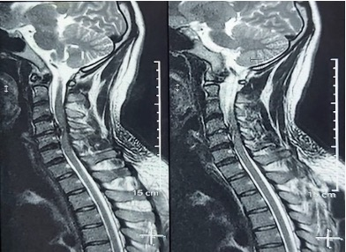
Fig. 1. Demonstrate traumatic cervical prolapsed intervertebral disc as a result of neck manipulation.

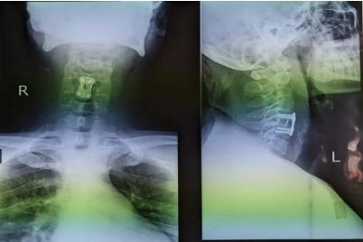
Fig. 2. Postoperative radiograph after anterior cervical discectomy and fusion. This patient had a favourable outcome.

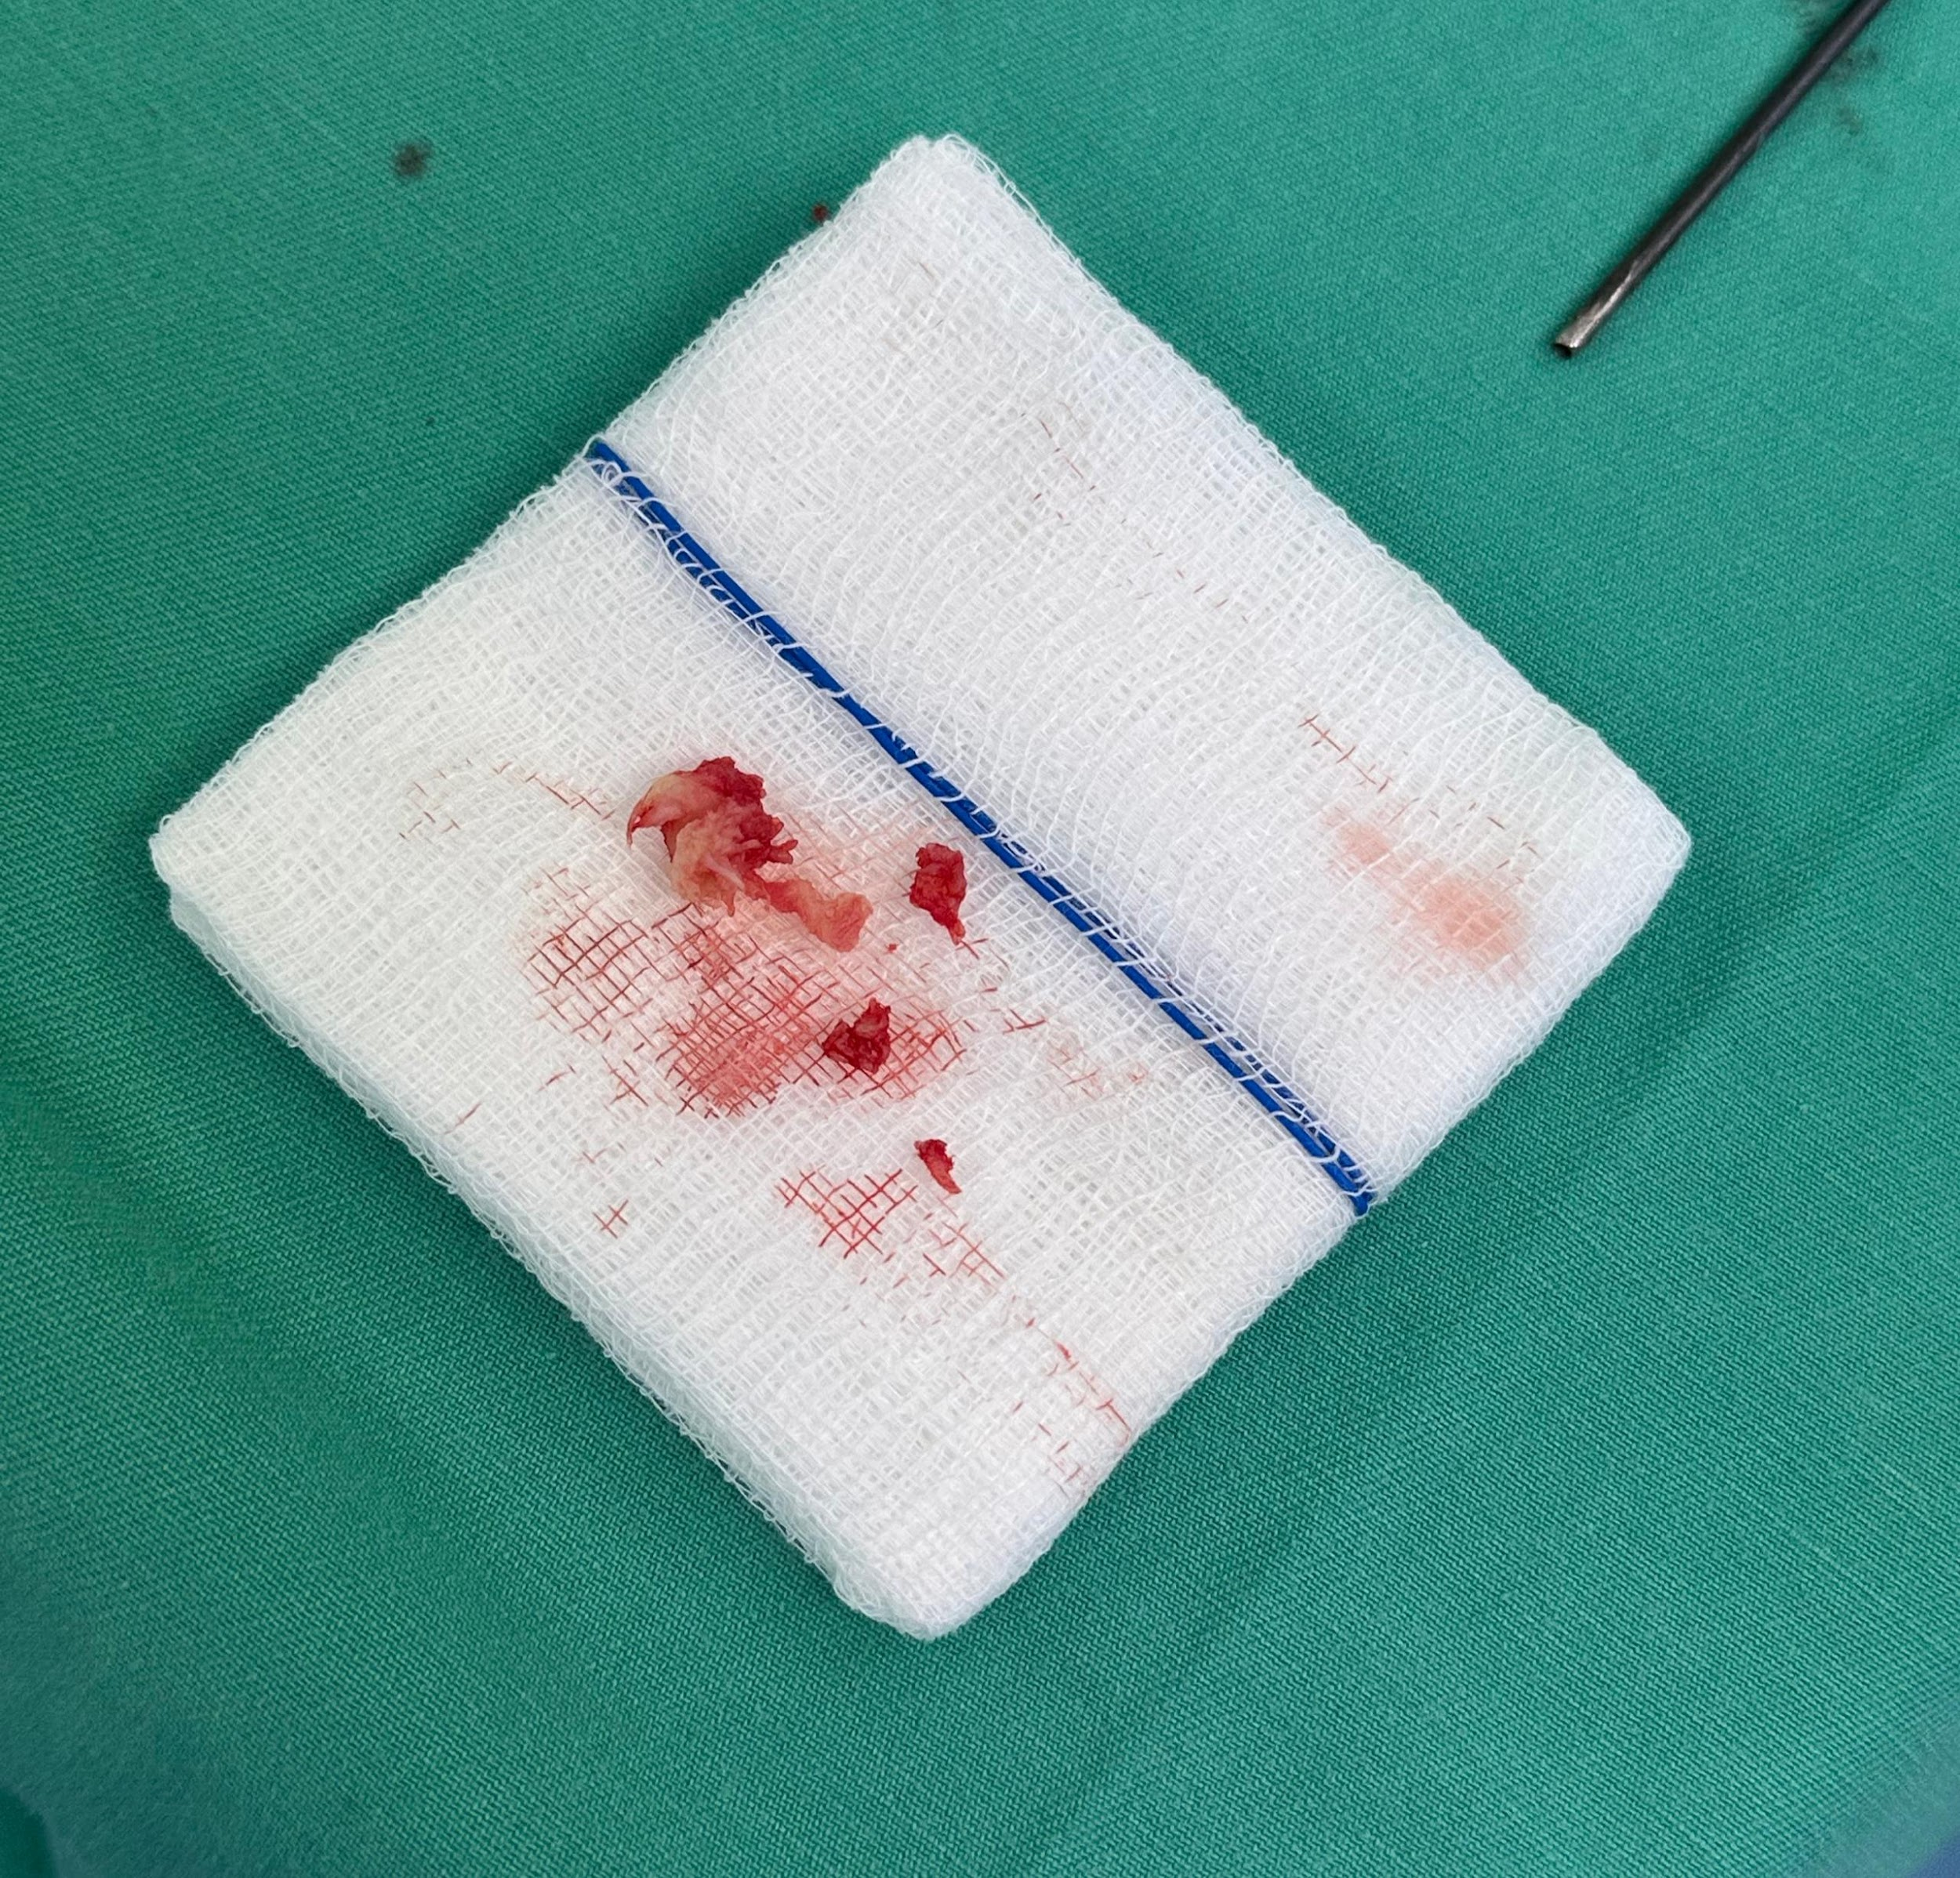
Fig. 3. Intervertebral disc material evacuated during operation.

3.1 Discussion

Spinal manipulative therapy involves high-velocity, low-amplitude thrust technique applied to the spine to achieve pain relief and is one of physiotherapeutic approaches to conservative treatment of cervical spondylosis, lumbar spondylosis and chronic pain syndromes^{1,2}. Pain relief is achieved via forceful stretching which is postulated to induce relaxation mechanisms and disrupting pain-spasm-pain cycle independent from spinal lesion³. Persistent effect may result from neural plastic changes and alteration in motor neuron excitability with associated increase in cortical drive⁴.

In our case series, the application of manipulation ranges from massaging and standing on the thoracic spine. Clearly, forces applied were beyond what was safe for the spine resulting in varying degrees of neurologic injury. Pre-existing condition also alters the biomechanics of the spine predisposing to injury.

Common side effects reported in the literature are temporary and mild, soreness, fatigue and headache⁵. Ernst reported in a 2007 review of 32 case reports, 200 serious adverse events were reported with 30-61% mild events, while serious side effects were vertebral artery dissection and stroke⁶. Spinal manipulation can be applied for chronic low back pain, neck pain, headache, hypomobility of spinal joint⁷.

While the underlying basic science of spinal manipulation has its basis in the literature, bonesetters and laymen in the community have no training in safe application of the maneuvers. Severe osteoporosis, nerve or spinal cord compression, bleeding or vascular conditions, acute herniated nucleus pulposus, hypermobility disorder, pregnancy and paediatric population are contraindicated, these populations might predispose themselves to danger when the spine is being thrusted by untrained personnel. In our case series, pre-existing conditions range from degenerative stenotic disorder, upper cervical congenital instability, spinal metastasis and ankylosing spine.

Mechanism of injury ranges from low energy mechanism by massaging of the neck to standing on the thoracic spine. In our patients, direct massage of the neck resulted in spinal cord injury. We also recorded thoracic injury due to standing on the spine which reflects injudicious use of force on the weakened spine. Due to these mechanisms employed by bonesetters, the safety of these maneuvers are not known.

A case report by Chung in 2002, a case of acute tetraplegia which was confirmed by MRI cord edema, resolved with conservative treatment and methylprednisolone after 6 months⁸. Chu et al studied incidence and severity of adverse events across 30 chiropractic clinics in Hong Kong from 2017 to 2022. They graded into 5 grades of severity and reported 0.21 per 100,000 SMT sessions of grade ≥ 3 injuries severe, life threatening or death. In their report, no grade 4 or grade 5 cases were reported⁹.

In our series of patients, operative treatment yielded favourable neurologic outcomes. These are mainly in patients with cervical region injury with incomplete spinal cord injury. 6 patients suffered injury in the cervical region while 2 in the thoracic region. This could be due to mobility of the cervical spine compared to other regions of the spine¹⁰.

Preexisting conditions can predispose the spinal cord to injury as a result of displacement of the spinal motion segment due to manipulation. Kirnaz et al showed in a review a decrease in normal compressive modulus of the disc from 20 to 5 MPa and 700 to 1800 Nmm/8 as a result of degenerative process¹¹. Alteration in spine stiffness and viscoelasticity coupled with resultant stenosis may lead to widening of elastic or narrowing of neutral zone kinematics predisposing the neural elements to injury from manipulation¹². Destructive disease processes like tumors may also destroy the polyaxial columnar stability of the spine¹³. The mechanisms involved in these patients are low energy. One patient with spinal metastasis and another with thoracic fracture with complete cord injury died during the subacute period of the injury.

This study has several limitations. First, it is a retrospective case series that inherently limits the ability to establish causality. Second, the small sample size from a single center may affect the statistical power and generalizability of our findings. Consequently, these results should be interpreted as preliminary and require validation in larger, prospective, multi-center studies.

We hope that this information can be used to provide evidence during consultation for patients seeking spinal manipulation for the treatment of their spinal condition as well as protecting the general public from potential harm. Further prospective epidemiological study looking into the spine related side effects of spinal manipulation will provide more robust evidence and assist in comprehensive counselling and patient education.

4. Conclusion

While spinal injury due to spinal manipulation is rare within regulated healthcare settings, this may not be the case outside of the regulated physiotherapy community. Serious spinal injury is a significant risk in the hands of untrained and unregulated individuals. Our findings indicate that the threshold for injury in the cervical spine appears to be lower compared to the thoracic spine. Thoroughly ruling out serious spinal conditions is imperative before employing any form of spinal manipulation to ensure patient safety. We suggest that larger, prospective, multi-center studies be conducted to further validate our findings to provide more robust evidence and assist in comprehensive counselling and patient education.

Acknowledgements

A brief acknowledgement section may be given after the conclusion section just before the references. The acknowledgments of people who provided assistance in manuscript preparation, funding for research, etc. should be listed in this section. All sources of funding should be declared as an acknowledgement. Authors should declare the role of funding agency, if any, in the study design, collection, analysis and interpretation of data; in the writing of the manuscript. If the study sponsors had no such involvement, the authors should so state.

Competing interests

We declare that no competing interests exist.

Authors’ Contributions

Author Dr Ahmad Ikhwan bin Mohd Sharfuddin designed the study, performed the statistical analysis, wrote the protocol, and wrote the first draft of the manuscript. Dr Harkeerat and Dr Kishanraj assisted in designing the study, data collection and contributed to the analyses of the study. Author Dr Harkeerat assisted in collecting data and data analysis. All authors read and approved the final manuscript.

Consent

All authors declare that ‘written informed consent was obtained from the patient (or other approved parties) for publication of this case report and accompanying images. A copy of the written consent is available for review by the Editorial office/Chief Editor/Editorial Board members of this journal.

Ethical approval

All authors hereby declare that all experiments have been examined and approved by the appropriate ethics committee and have therefore been performed in accordance with the ethical standards laid down in the 1964 Declaration of Helsinki.

References

- Langenfeld A, Baechler M, Swanenburg J, Mühlemann M, Nyirö L, Streuli D, et al. (2025). Systematic review on biomechanical effects of high-velocity, low amplitude spinal manipulation. PLoS One, 20(7), e0328048.
- Sharma A, Alahmari K & Ahmed I. (2015). Efficacy of manual therapy versus conventional physical therapy in chronic low back pain due to lumbar spondylosis. A pilot study. Medical Sciences, 3(3), 55-63.
- Maigne JY, & Vautravers P. (2003). Mechanism of action of spinal manipulative therapy. Joint bone spine, 70(5), 336-341.
- Gyer G, Michael J, Inklebarger J, & Tedla JS. (2019). Spinal manipulation therapy: Is it all about the brain? A current review of the neurophysiological effects of manipulation. Journal of integrative medicine, 17(5), 328-337.
- Puentedura EJ, March J, Anders J, Perez A, Lander MR, Wallmann HW, et al. (2012). Safety of cervical spine manipulation: are adverse events preventable and are manipulations being performed appropriately? A review of 134 case reports. Journal of Manual & Manipulative Therapy, 20(2), 66-74.
- Ernst E. Adverse effects of spinal manipulation: a systematic review. Journal of the Royal Society of Medicine. 2007;100(7):330-338. doi:10.1177/014107680710000716
- Bronfort G, Haas M, Evans R, Kawchuk G, Dagenais, S. (2008). Evidence-informed management of chronic low back pain with spinal manipulation and mobilization. The Spine Journal, 8(1), 213-225.
- Chung OM. (2002). MRI confirmed cervical cord injury caused by spinal manipulation in a Chinese patient. Spinal Cord, 40(4), 196-199.
- Chu ECP, Trager RJ, Lee LYK, & Niazi IK. (2023). A retrospective analysis of the incidence of severe adverse events among recipients of chiropractic spinal manipulative therapy. Scientific reports, 13(1), 1254.
- Wilke HJ, Kienle A, Werner K, Liebsch C. (2025). Range of motion and neutral zone of all human spinal motion segments: A data collection of 30 years of in vitro experiments performed under standardized testing conditions. JOR spine, 8(1), e70052.
- Kirnaz S, Capadona C, Lintz M, Kim B, Yerden R, Goldberg JL, et al. (2021). Pathomechanism and biomechanics of degenerative disc disease: features of healthy and degenerated discs. International journal of spine surgery, 15(s1), 10-25.
- D’Aprile P, Tarantino A. (2021). Biomechanics of the Spine. In MRI of Degenerative Disease of the Spine: A Case-Based Atlas (pp. 3-9). Cham: Springer International Publishing.
- Xia G, Yu H, Jiang S, Peng X, Fu X, Chen Q, et al. (2024). Biomechanical characteristics of thoracic T10 bone tumor metastasis at different locations: three-dimensional finite element analysis. Chinese Journal of Tissue Engineering Research, 28(36), 5759.

