Case Report

Ankylosing Spondylitis with Thoracolumbar Kyphotic Deformity Managed by Ponte Osteotomy Combined with Pedicle Subtraction Osteotomy: A Case Report

.
ABSTRACT

Introduction and Importance: Ankylosing spondylitis (AS) is a chronic inflammatory disease of the axial skeleton that may lead to pain, stiffness, progressive spinal fusion, and kyphotic deformity. Diagnosis is based on clinical features supported by radiographic evidence, particularly sacroiliitis, and genetic markers such as HLA-B27. In selected patients with severe deformity or instability, corrective spinal osteotomy and fusion may be indicated.
Case Presentation: A 25 year old male with a three-year history of back pain was diagnosed with AS based on HLA-B27 positivity, elevated inflammatory markers, and characteristic imaging findings. Subcutaneous etanercept improved inflammatory symptoms; however, progressive thoracolumbar kyphosis developed, requiring surgical correction. The patient underwent posterior instrumentation with Ponte osteotomy combined with pedicle subtraction osteotomy using cobalt chrome rods. Radiographic evaluation, including sagittal vertical axis (SVA), showed significant postoperative improvement in sagittal alignment, including C2–C7 and C7–S1 parameters.
Clinical Discussion: AS management requires a multidisciplinary approach combining medical therapy and orthopedic intervention. Although etanercept effectively controlled disease activity, surgery was necessary to correct deformity progression and restore sagittal balance. Postoperatively, the patient experienced marked improvement in pain, mobility, and functional capacity. BASDAI and ASDAS-CRP scores improved significantly, supported by clinical and radiological findings. The reduction in SVA suggests improved biomechanics and spinal balance.
Conclusion: Combined Ponte osteotomy and pedicle subtraction osteotomy can effectively correct thoracolumbar kyphotic deformity in AS and improve clinical outcomes and quality of life.

Keywords: ankylosing spondylitis, kyphotic deformity, intraoperative monitoring, pedicle subtraction osteotomy, Ponte osteotomy, case report

1. INTRODUCTION
Ankylosing spondylitis (AS) is a chronic inflammatory disease affecting the spine and sacroiliac joints, leading to back pain, stiffness, and reduced quality of life.¹ Long-standing AS is associated with osteoporosis and vertebral fractures, with a higher fracture risk than the general population, particularly in the thoracolumbar region.^{2,3} Progressive ectopic bone formation may result in spinal rigidity (“bamboo spine”), deformity, and increased skeletal fragility. AS is strongly associated with HLA-B27, present in >90% of patients, although only 1–5% of HLA-B27–positive individuals develop the disease, suggesting additional contributing factors.⁴ Radiographic sacroiliitis remains an important diagnostic indicator. Kyphotic deformity can be assessed using the Cobb angle and chin-brow vertical angle (CBVA).⁵ Severe kyphotic deformities are managed with corrective osteotomies, including Ponte osteotomy (PO) and pedicle subtraction osteotomy (PSO).⁶ PSO provides substantial sagittal correction without anterior column lengthening but is technically demanding and carries risks such as major blood loss, neurological deficits, pseudoarthrosis, implant failure, and loss of correction.^{7,8} Therefore, restoring stable alignment is essential. This case report presents an AS patient with thoracolumbar kyphotic deformity treated with combined PSO and PO, reported according to the SCARE 2020 criteria.⁹

2. CASE REPORT

2.1. Case presentation

We report a case of ankylosing spondylitis (AS) treated using a combined pedicle subtraction osteotomy (PSO) and Ponte osteotomy (PO). A 25-year-old male (villa guardian) presented to the orthopedic outpatient clinic with a 3-year history of progressive low back pain. The pain worsened with position changes, prolonged sitting, standing upright, and lying flat, and was relieved by forward bending and resting. There was no radiating pain to the buttocks or lower limbs. The patient reported intermittent paresthesia over the right small toe and plantar area. No motor weakness, bowel or bladder dysfunction, or gait disturbance was noted, and he remained independent in daily activities without walking aids. He had previously been diagnosed with arthritis by an internist and received anti-inflammatory treatment for one year. There was no family history of AS. The clinical appearance is shown in Fig. 1. Physical examination revealed a thoracolumbar kyphotic deformity without swelling or bruising. Mild tenderness was noted at L5–S1, with preserved sensation and no anesthesia. Motor strength was 5/5 in all extremities with normal reflexes. The Schober test was positive. BASDAI was 6 and ASDAS-CRP was 3.5. Laboratory tests showed elevated erythrocyte sedimentation rate (ESR) and C-reactive protein (CRP). HLA-B27 was positive by PCR. Thoracolumbar radiographs demonstrated kyphotic deformity at the thoracolumbar junction and sacroiliac joint abnormalities (Fig. 2). MRI and myelography confirmed thoracolumbar kyphosis without spinal cord compression (Fig. 3). Based on clinical, laboratory, and radiological findings, the patient was diagnosed with AS.

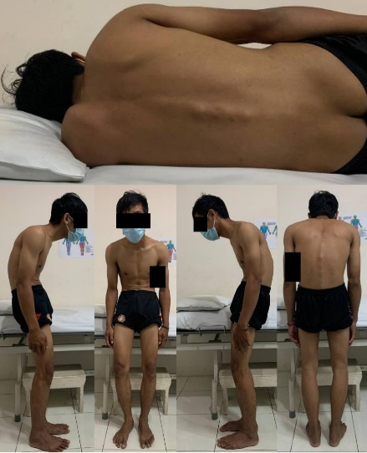

Fig. 1. The initial clinical assessment of the patients (Source: internal documentation)

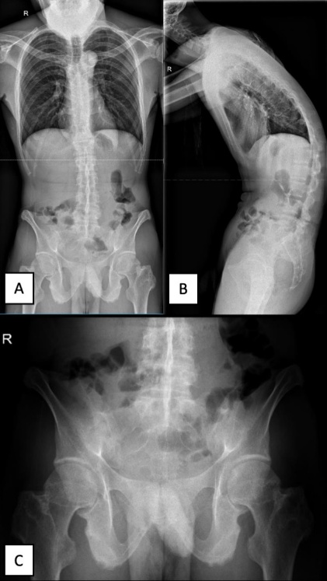

Fig. 2. Preoperative radiological examination of thoracolumbar vertebra X-ray in (A) AP and (B) lateral view; (C) pelvis X-ray in AP (Source: internal documentation)

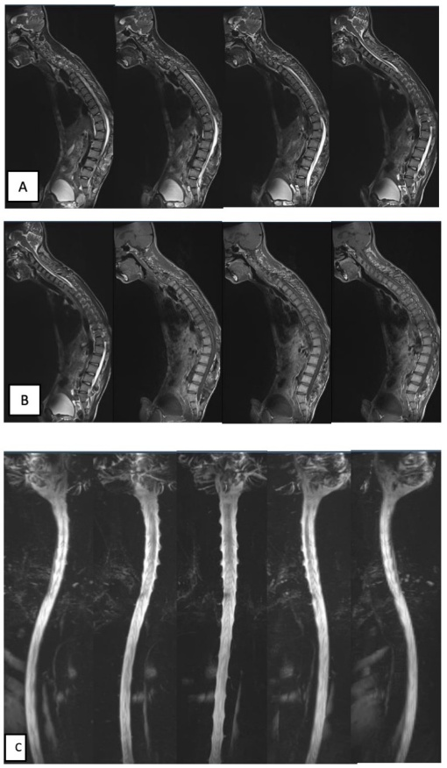

Fig. 3. Preoperative radiological examination of whole spine vertebra MRI (A) T2 weighted; (B) T1 weighted, and myelography (Source: internal documentation)

2.2. Surgical Procedure

The patient underwent planned posterior corrective surgery under general anesthesia in the prone position. A midline posterior incision was made over T11–L3, followed by subperiosteal exposure to the transverse processes and facet joints. Long-arm pedicle screws were inserted bilaterally at T10, T11, L1, L3, and L4, with monoaxial long-arm screws at T12. Ponte osteotomy was performed at T11–T12, followed by L1–L3 laminectomy and pedicle subtraction osteotomy at L2. Deformity correction was achieved under intraoperative neurophysiological monitoring (IOM). Two 250-mm rods with a 42-mm crosslink were applied, and implant position was confirmed using fluoroscopy. Synthetic bone graft was added, and a drain was placed before closure. Estimated blood loss was 3000 mL, requiring two units of packed red cells. No intraoperative complications occurred. The surgical technique is shown in Fig. 4.

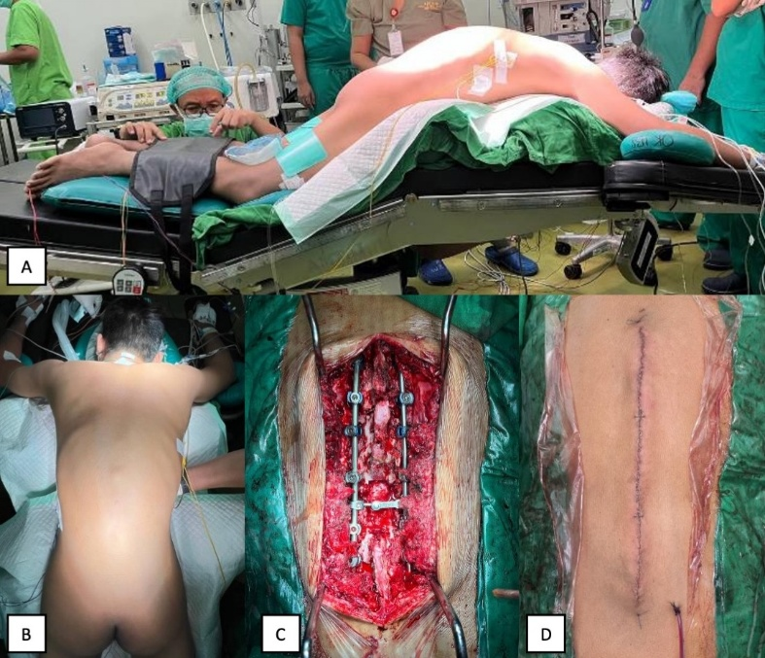
Fig. 4. Clinical pictures of intraoperative: (A) positioning; (B) surgical site; (C) after PSO and PO osteotomy and posterior fusion; (D) skin closure. (Source: internal documentation)

2.3. Post Operative
Postoperatively, a thoracic-lumbo-sacral orthosis (TLSO) brace was applied on day 1. The patient received intravenous NSAIDs for five days combined with methylprednisolone 125 mg for pain control. Sitting mobilization was initiated once pain was tolerable and continued until day 3, when the drain was removed based on output. Rehabilitation progressed to standing and ambulation on postoperative days 4–5. The patient was discharged after a 5-day hospital stay with a TLSO brace to be worn for three months. No additional pharmacological therapy for ankylosing spondylitis was given during this period.

2.4. Follow-up Evaluation
On postoperative day 5, the patient was able to perform basic movements comfortably, including lying supine, rolling side to side, and sitting on the bed (Fig. 5 (A)). On postoperative day 6, the patient was able to stand upright and begin ambulation. At the final follow-up, motor and sensory examinations showed improvement, supported by radiological evaluation. BASDAI decreased to 1, and ASDAS-CRP improved to 1.3. Follow-up anteroposterior and lateral thoracolumbar radiographs are shown in Fig. 5 (B).
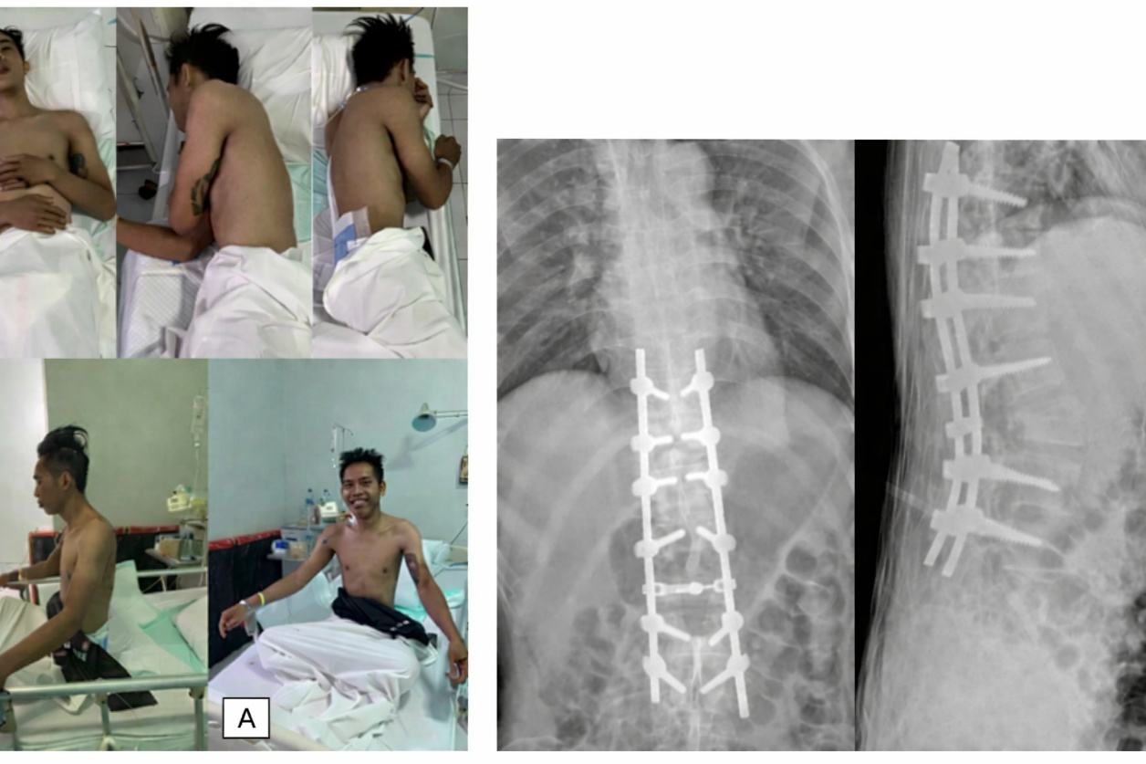
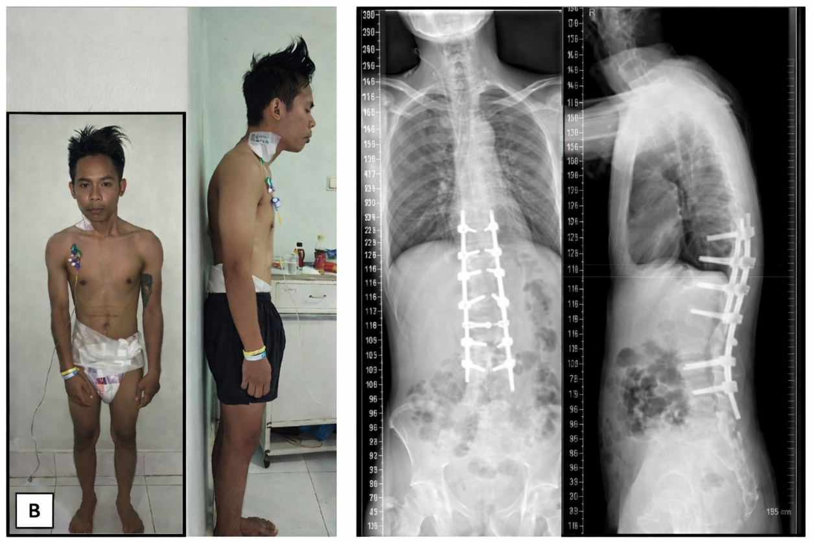
Fig. 5. The postoperative follow-up: (A) clinical evaluation and radiographic thoracolumbar X-ray evaluation of AP and lateral view. The sixth day of postoperative follow-up: (B) clinical evaluation and radiographic thoracolumbar X-ray evaluation of AP and lateral view. (Source: internal documentation).
3. discussion
Ankylosing spondylitis (AS) is an autoimmune inflammatory disease primarily affecting the spine and sacroiliac joints. In advanced stages, inflammation may progress to fibrosis and calcification, resulting in spinal rigidity and fusion (“bamboo spine”). Clinical features include inflammatory back pain, progressive stiffness, and possible involvement of peripheral joints.¹⁰ AS is strongly associated with HLA-B27, although the etiology remains multifactorial.^{11,12} In this case, HLA-B27 mutation testing was not performed due to limited resources. Corrective surgery is indicated in severe deformities causing significant functional limitation. Comprehensive preoperative assessment is essential, including evaluation of pulmonary function, cardiovascular status, renal function related to long-term NSAID use, and cervical spine rigidity for safe airway management.^{13,14,15,16} Osteotomy choice depends on deformity severity and correction goals. Pedicle subtraction osteotomy (PSO) provides major sagittal correction (typically 30°–40°) without anterior column lengthening but is technically demanding and associated with risks such as major blood loss and neurological injury.^{17,18} Ponte osteotomy (PO) is relatively simpler and safer but offers limited sagittal correction and may risk coronal imbalance.^{19,20} Intraoperative neurophysiological monitoring (SSEP/MEP) improves safety during deformity correction.¹³ Postoperatively, BASDAI and ASDAS-CRP scores improved markedly, supporting clinical benefit. Limitations include the single-case design and absence of KA and CBVA measurements. Larger prospective studies are needed.

4. Conclusion
Reconstructive spinal surgery in patients with ankylosing spondylitis is technically demanding and carries substantial risk. However, in patients with severe deformity, surgical correction of spinal alignment and sagittal imbalance can provide meaningful functional improvement. Careful preoperative planning, understanding of the characteristic biomechanics of the ankylosed spine, and meticulous intraoperative and postoperative management are essential to optimize outcomes and improve quality of life.

DATA AVAILABILITY

This study relied on research article data that can be requested from the corresponding author.

ETHICAL APPROVAL

Ethical approval was waived by the author’s institution due to observational studies and multi-centre authors.

CONSENT

Written informed consent was obtained from the patient for publication of this case report and accompanying images. A copy of the written consent is available for review by the Editor-in-Chief of this journal on request.

REGISTRATION OF RESEARCH STUDIES

Not applicable.

REFERENCES
1. Liang Z, Fu C, Zhang Q, et al. Effects of water therapy on disease activity, functional capacity, spinal mobility and severity of pain in patients with ankylosing spondylitis: a systematic review and meta-analysis. Disabil Rehabil. 2021;43(7):895-902. doi:10.1080/09638288.2019.1645218
2. Kim KT, Park DH, Lee SH, Lee JH. Results of corrective osteotomy and treatment strategy for ankylosing spondylitis with kyphotic deformity. CiOS Clin Orthop Surg. 2015;7(3):330-336. doi:10.4055/cios.2015.7.3.330
3. Xin Z, Zheng G, Huang P, Zhang X, Wang Y. Clinical results and surgery tactics of spinal osteotomy for ankylosing spondylitis kyphosis: Experience of 428 patients. J Orthop Surg Res. 2019;14(1):1-8. doi:10.1186/s13018-019-1371-y
4. Ebrahimiadib N, Berijani S, Ghahari M, Pahlaviani FG. Ankylosing spondylitis. J Ophthalmic Vis Res. 2021;16(3):462-469. doi:10.18502/jovr.v16i3.9440
5. Qian BP, Qiu Y, Wang B, et al. Pedicle subtraction osteotomy through pseudarthrosis to correct thoracolumbar kyphotic deformity in advanced ankylosing spondylitis. Eur Spine J. 2012;21(4):711-718. doi:10.1007/s00586-011-2054-5
6. Arun R, Dabke H V., Mehdian H. Comparison of three types of lumbar osteotomy for ankylosing spondylitis: A case series and evolution of a safe technique for instrumented reduction. Eur Spine J. 2011;20(12):2252-2260. doi:10.1007/s00586-011-1894-3
7. Luan H, Liu K, Kahaer A, et al. Pedicle subtraction osteotomy for the corrective surgery of ankylosing spondylitis with thoracolumbar kyphosis: experience with 38 patients. BMC Musculoskelet Disord. 2022;23(1):1-9. doi:10.1186/s12891-022-05693-z
8. Burkhard MD, Suter D, Sigrist B, Fuernstahl P, Farshad M, Spirig JM. Pedicle subtraction osteotomy with patient-specific instruments. North Am Spine Soc J. 2021;7(August):100075. doi:10.1016/j.xnsj.2021.100075
9. Agha RA, Franchi T, Sohrabi C, et al. The SCARE 2020 Guideline: Updating Consensus Surgical CAse REport (SCARE) Guidelines. Int J Surg. 2020;84:226-230. doi:10.1016/j.ijsu.2020.10.034
10. Zhu W, He X, Cheng K, et al. Ankylosing spondylitis: etiology, pathogenesis, and treatments. Bone Res. 2019;7(1). doi:10.1038/s41413-019-0057-8
11. Wenker K, Quint J. Ankylosing Spondylitis. StatPearls [Internet].
12. Chen B, Li J, He C, et al. Role of HLA-B27 in the pathogenesis of ankylosing spondylitis (Review). Mol Med Rep. 2017;15(4):1943-1951. doi:10.3892/mmr.2017.6248
13. Kim KT, Lee SH, Son ES, Kwack YH, Chun YS, Lee JH. Surgical treatment of “chin-on-pubis” deformity in a patient with ankylosing spondylitis: A case report of consecutive cervical, thoracic, and lumbar corrective osteotomies. Spine (Phila Pa 1976). 2012;37(16):1017-1021. doi:10.1097/BRS.0b013e31824ee031
14. Bridwell KH, Lewis SJ, Edwards C, et al. Complications and outcomes of pedicle subtraction osteotomies for fixed sagittal imbalance. Spine (Phila Pa 1976). 2003;28(18):2093-2101. doi:10.1097/01.BRS.0000090891.60232.70
15. Mortezazadeh M, Vahedifard F, Ahmadi-Renani S, Salimzadeh A. A woman with a bamboo spine in the thoracic vertebra and normal sacroiliac joint; a 5-years undiagnosed ankylosing spondylitis: Case report and literature review. Rheumatol Res. 2020;5(1):32-37. doi:10.22631/rr.2020.69997.1088
16. Lazennec JY, d’Astorg H, Rousseau MA. Cervical spine surgery in ankylosing spondylitis: Review and current concept. Orthop Traumatol Surg Res. 2015;101(4):507-513. doi:10.1016/j.otsr.2015.02.005
17. van Loon PJM, van Stralen G, van Loon CJM, van Susante JLC. A pedicle subtraction osteotomy as an adjunctive tool in the surgical treatment of a rigid thoracolumbar hyperkyphosis; a preliminary report. Spine J. 2006;6(2):195-200. doi:10.1016/j.spinee.2005.04.008
18. Qian BP, Wang XH, Qiu Y, et al. The influence of closing-opening wedge osteotomy on sagittal balance in thoracolumbar kyphosis secondary to ankylosing spondylitis: A comparison with closing wedge osteotomy. Spine (Phila Pa 1976). 2012;37(16):1415-1423. doi:10.1097/BRS.0b013e318250dc95
19. Kose KC, Bozduman O, Yenigul AE, Igrek S. Spinal osteotomies: Indications, limits and pitfalls. EFORT Open Rev. 2017;2(3):73-82. doi:10.1302/2058-5241.2.160069
20. Hu Z, Zhong R, Zhao D, et al. Staged osteotomy in lateral position for the treatment of severe kyphotic deformity secondary to ankylosing spondylitis: a retrospective study. J Orthop Surg Res. 2023;18(1):1-10. doi:10.1186/s13018-023-03884-5

