Original Research Article

Histological and Histochemical Studies on the Hippocampus Induced with Lead acetate following Oral Administration of Ethanolic Cowpea Extract on Adult Male Wistar Rats

.
ABSTRACT

Aim: This study was aimed at ascertaining the neuroprotective effects of Vigna unguiculata on adult male wistar rats following lead induced neurotoxicity.
Study design: 25 rats were randomly assigned into five groups (n=5): Group A (control), Group B (15 mg/kg lead acetate), Group C (15mg/kg lead acetate+100 mg/kg cowpea extract), Group D (15mg/kg lead acetate+200 mg/kg cowpea extract), and Group E (200 mg/kg cowpea extract).
Place and Duration of Study: Department of Human Anatomy, Chukwuemeka Odumegwu Ojukwu University, Anambra State, Nigeria between September and October 2021.
Methodology: Sample: 25 male Wistar Rats weighing between 70-120g were used for this study. Acclimatized for 7 days and were randomly selected into five groups of five animals each (A to E).
Results The present study observed that there were histological changes in hippocampus of adult Wistar rats exposed to lead acetate. There was restorative effect in the groups treated with Vigna unguiculata on the hippocampus by the changes induced by lead acetate. Histochemical results revealed that exposure to 15 mg/kg of lead acetate resulted in densely packed neurons with reduced Nissl substance, indicative of cytoplasmic condensation and impaired protein synthesis associated with neurotoxicity. Co-administration of cowpea extract demonstrated a dose-dependent restorative effect. Biochemical analysis in the present investigation further revealed alterations in oxidative stress markers in the brain tissues of the experimental animals.
Conclusion: This present study has established that ethanolic extract of cowpea(Vigna unguiculata) at appropriate doses was able to ameliorate the effect of lead on the hippocampus and may likely be beneficial to the population in areas exposed to lead poisoning.
Keywords: Vigna unguiculata, histochemical, poisoning, neuroprotection, hippocampus, Wistar rats
1. INTRODUCTION
Heavy metal pollution remains a persistent environmental and public health challenge worldwide. Rapid industrialization, mining activities, battery manufacturing, and improper waste disposal have significantly increased the release of toxic metals into the environment. Among these metals, lead (Pb) is particularly concerning due to its widespread distribution, persistence in ecosystems, and strong capacity for bioaccumulation in biological tissues. Human and animal exposure to lead commonly occurs through contaminated air, water, food, and occupational activities. Once absorbed into the body, lead is distributed to various organs including the liver, kidneys, bones, and brain where it exerts toxic effects that may persist for long periods (Caito & Aschner, 2017). Because of its ability to cross the blood–brain barrier and interfere with neuronal signaling, lead is widely recognized as a potent neurotoxin capable of disrupting central nervous system function.
The nervous system is particularly vulnerable to lead toxicity because neurons rely heavily on tightly regulated biochemical and ionic processes for proper function. Lead has a high affinity for calcium-binding sites and is able to disrupt tightly regulated ionic and biochemical processes that are essential for normal neuronal function. By competing with calcium ions, lead alters calcium-dependent signaling pathways, impairs neurotransmitter release at synapses, and interferes with mechanisms of synaptic plasticity that underlie learning and memory. These disruptions contribute to structural and functional neuronal damage observed in experimental models, where lead exposure is associated with impaired synaptic communication, cognitive deficits, and behavioral abnormalities (Tamagno & Freeman, 2025)
Oxidative stress is widely recognized as one of the primary mechanisms underlying lead-induced neurotoxicity. Lead exposure promotes the formation of reactive oxygen species and simultaneously weakens endogenous antioxidant defenses such as superoxide dismutase, catalase, and glutathione peroxidase. This imbalance results in lipid peroxidation, protein oxidation, and DNA damage in neural tissues. Experimental studies using Wistar rats have shown that lead exposure significantly increases oxidative stress biomarkers while decreasing antioxidant enzyme activities in brain tissues, ultimately leading to neuronal degeneration and functional impairment (Oliveira et al., 2021). These biochemical alterations highlight the importance of oxidative damage in the pathogenesis of lead-induced neurological disorders.
The increasing burden of heavy metal toxicity has stimulated interest in identifying natural substances capable of protecting biological systems against oxidative damage. Plant-derived phytochemicals have gained considerable attention due to their antioxidant and therapeutic properties. Many medicinal plants contain polyphenols, flavonoids, carotenoids, and other bioactive compounds that can neutralize free radicals and enhance endogenous antioxidant defenses. These compounds have been widely studied for their protective roles against oxidative stress-related diseases, including neurodegenerative disorders and toxicological damage caused by environmental pollutants (Caito & Aschner, 2017). Consequently, dietary plants with strong antioxidant properties are being investigated as potential therapeutic agents for mitigating heavy-metal-induced toxicity.
Cowpea (Vigna unguiculata), an important leguminous crop widely cultivated in Africa, Asia, and parts of the Americas, has attracted increasing scientific interest because of its nutritional value and phytochemical composition. Cowpea is a major source of plant protein and contains essential nutrients such as vitamins, minerals, and dietary fiber. In addition to its nutritional importance, cowpea contains numerous bioactive compounds including phenolic acids, flavonoids, tannins, and carotenoids. These phytochemicals have been associated with significant antioxidant activity and health-promoting effects. Investigations into the phytochemical composition of different cowpea genotypes have demonstrated that the crop contains substantial levels of phenolic compounds capable of scavenging reactive oxygen species and inhibiting lipid peroxidation (Sombié et al., 2018).
Several studies have further explored the antioxidant properties of cowpea and reported significant biological activity. For instance, Moloto et al. (2020) reported that cowpea leaves contain considerable amounts of phenolic compounds and carotenoids, which contribute to strong antioxidant capacity. These bioactive compounds are believed to play an important role in protecting cells from oxidative stress and maintaining physiological balance. Similarly, research investigating the phenolic profile of cowpea has demonstrated that the plant contains compounds with potent antioxidant potential, suggesting that it may serve as a functional food with therapeutic benefits (Avanza et al., 2021).
Despite the well-documented nutritional and antioxidant properties of cowpea, limited research has investigated its potential protective effects against heavy-metal-induced neurotoxicity. Most previous studies have focused primarily on its phytochemical composition, antioxidant capacity, and nutritional value, with relatively little attention given to its possible neuroprotective roles in toxicological models. Considering that oxidative stress plays a central role in the mechanism of lead-induced neuronal damage, plant extracts rich in antioxidant phytochemicals may provide a promising strategy for mitigating the harmful effects of lead exposure.
Ethanolic extraction is widely employed in phytochemical research because ethanol efficiently dissolves and extracts phenolic compounds and flavonoids from plant materials. Extracts obtained through ethanol extraction often contain higher concentrations of bioactive compounds compared with aqueous extracts, resulting in stronger antioxidant activity. Investigating ethanolic extracts of cowpea may therefore provide valuable insight into the potential neuroprotective mechanisms associated with its phytochemical constituents.
In view of the increasing environmental burden of lead contamination and the need for safer therapeutic interventions, exploring natural plant-based antioxidants has become increasingly important. This study was therefore designed to evaluate the effect of ethanolic cowpea extract on adult male Wistar rats induced with acute lead neurotoxicity. Using Wistar rats as an experimental model allows for controlled investigation of biochemical and structural alterations associated with lead toxicity, as well as the assessment of potential protective effects of plant-derived compounds.
The scope of this study focuses on evaluating the neuroprotective potential of ethanolic cowpea extract against acute lead-induced neurotoxicity in adult male Wistar rats. Specifically, the study examines biochemical indicators of oxidative stress and histological changes using Hematoxylin and Eosin stain, histochemical changes using cresyl violet(nissyl stain) in order to determine whether cowpea extract can attenuate the harmful effects associated with lead exposure.
The justification for this research lies in the increasing prevalence of environmental heavy-metal contamination and the urgent need for accessible and cost-effective strategies to reduce its impact on human health. Since cowpea is widely cultivated and consumed in many developing countries, particularly in Nigeria, understanding its potential neuroprotective properties could contribute to the development of nutritional and therapeutic approaches aimed at combating heavy-metal-induced oxidative damage.

2. material and methods
2.1 Plant Collection
Cowpea was purchased from a local farm, at Uli, Anambra state. The botanical identification was confirmed in the herbarium unit of the Department of Biological Science, Chukwuemeka Odumegwu Ojukwu University, Uli Campus, Anambra State.
2.2 Preparation of Cowpea extract
Fresh cowpea seeds were cleaned and air-dried at room temperature until a constant weight was obtained. The dried samples were then ground into fine powder using an electric grinder. A measured quantity of the powdered sample was macerated in 95% ethanol for 48 hours at room temperature with intermittent shaking to facilitate extraction of bioactive compounds. The mixture was subsequently filtered using Whatman No. 1 filter paper to obtain the crude filtrate. The filtrate was concentrated under reduced pressure using a digital rotary evaporator at 40 °C to remove the solvent and obtain a concentrated extract. The resulting extract was further dried in a laboratory oven at 40 °C until a semi-solid mass was obtained. The concentrated extract was then transferred into sterile airtight containers and stored in a refrigerator at 4 °C until required for experimental use.

2.3 Declaration of Interest

None

2.4 Funding Source
This research did not receive any specific grant from funding agencies in the public, commercial, or non-profit sectors.
2.5 Experimental Design
Twenty-five (25) male Wistar Rats weighing between 70-120g were used for this study. The animals were allowed to acclimatize for a period of fourteen days with full access to feed and water, after which were randomly selected into five groups of five animals each (A to E). The grouping was as follows:
Group A (Control Group): animals received distilled water and laboratory chow
Group B (Lead acetate group): received 15mg/kg of lead only.
Group C (lead+low dose cowpea extract): received Lead acetate + 100mg/kg of cowpea extract.
Group D (lead+ high dose cowpea extract): received Lead acetate + 200mg/kg of cowpea extract.
Group E (Cowpea group): received 200mg/kg of cowpea extract.

The administration was done orally using oral canula within the period of 6am to 8am every day. The experimental animals were administered with lead acetate for 7 days and ethanolic extract of Vigna unguiculata for 21 days orally. Before dissection, an ocular puncture was carried out and blood was released into blood containers. After this, a cervical dislocation was carried out to further reduce the movement of the animals during dissection and thereafter anaesthetized with 50mg/kg ketamine. The brain was perfused fixed in 10% buffered formalin, dissected and processed for histological studies using H&E technique as described by Kieman (2008)
2.6 Statistical Analysis
Research objectives and hypothesis of the study was considered before analyzing data. The results were statistically analyzed using the SPSS software. Two principal statistical tests were used i.e. Dependent t-test and One-way ANOVA served explicit purposes in examining various sorts of data gathered during the study. The results were expressed as mean± S.E.M. Statistical differences between the experimental and control groups were determined using ANOVA and values were considered significant at p ≤ .05.

3. results and discussion

Table 1: Descriptive table of stress markers of the brain

Descriptive Statistics
Dependent Variable: STRESSMARKERS
Parameters | Experiment | Mean | Std. Deviation | N
GLUTA | Group A | 72.1067 | 1.08011 | 3
GLUTA | Group B | 97.9500 | 1.09891 | 3
GLUTA | Group C | 42.7400 | 1.28946 | 3
GLUTA | Group D | 58.6067 | .52272 | 3
GLUTA | Group E | 68.1600 | .98000 | 3
GLUTA | Total | 67.9127 | 18.76740 | 15
SEROTONIN | Group A | 88.7033 | .79463 | 3
SEROTONIN | Group B | 43.8700 | 1.01129 | 3
SEROTONIN | Group C | 27.8133 | 1.04882 | 3
SEROTONIN | Group D | 30.9367 | .88500 | 3
SEROTONIN | Group E | 68.6300 | .75319 | 3
SEROTONIN | Total | 51.9907 | 24.14769 | 15
MDA | Group A | 41.2800 | 1.01237 | 3
MDA | Group B | 26.9400 | .52202 | 3
MDA | Group C | 29.9900 | .19079 | 3
MDA | Group D | 32.0500 | .67506 | 3
MDA | Group E | 37.0933 | .50954 | 3
MDA | Total | 33.4707 | 5.32364 | 15

MDA: malondialdehyde, GLUTA: glutathione, significance is indicated at p≤0.05.

Table 2: ANOVA results for the stress markers of the brain
(I) Experiment | (J) Experiment | Mean Difference (I-J) | Std. Error | Sig.
Group A | Group B | 11.1100* | .41140 | .000
Group A | Group C | 33.8489* | .41140 | .000
Group A | Group D | 26.8322* | .41140 | .000
Group A | Group E | 9.4022* | .41140 | .000
Group B | Group A | -11.1100* | .41140 | .000
Group B | Group C | 22.7389* | .41140 | .000
Group B | Group D | 15.7222* | .41140 | .000
Group B | Group E | -1.7078* | .41140 | .002
Group C | Group A | -33.8489* | .41140 | .000
Group C | Group B | -22.7389* | .41140 | .000
Group C | Group D | -7.0167* | .41140 | .000
Group C | Group E | -24.4467* | .41140 | .000
Group D | Group A | -26.8322* | .41140 | .000
Group D | Group B | -15.7222* | .41140 | .000
Group D | Group C | 7.0167* | .41140 | .000
Group D | Group E | -17.4300* | .41140 | .000
Group E | Group A | -9.4022* | .41140 | .000
Group E | Group B | 1.7078* | .41140 | .002
Group E | Group C | 24.4467* | .41140 | .000
Group E | Group D | 17.4300* | .41140 | .000
Values are significant at (p < 0.05).

Figure 1: Effect of extract of cowpea across the groups following lead exposure

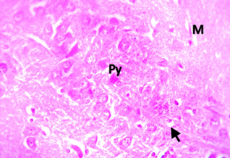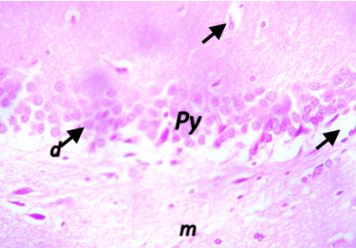
- (B)
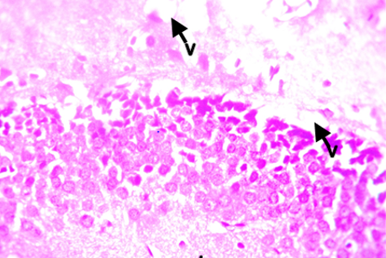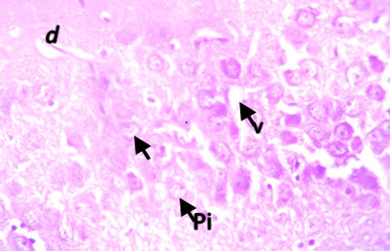
(C) (D)

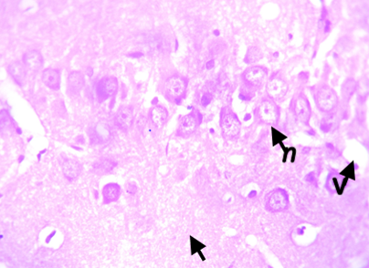
(E)

Fig 2: Photomicrograph of the hippocampus of (A) control rats showing normal morphology of the hippocampus. The molecular layer (M), Pyramidal layer (Py), and the Polymorphic layer (Pm) (B) 15mg/kg of lead-acetate showing necrosis of pyramidal cells (n) with vacoulization. However, there are sparse appearance of cells in the molecular layer (arrow).
(C) 15mg/kg of lead-acetate+100mg/kg of cowpea extract showing sparse degeneration of appearance of cells in the molecular layer. (D) 15mg/kg of lead-acetate+200mg/kg of cowpea extract showing pyknosis of pyramidal neuron, few vacoulization with reduced appearance of cells in the polymorphic layer. (E) 200mg/kg of cowpea extract showing mild degeneration of pyramidal neuron (d), few vacoulization with reduced appearance of cells in the polymorphic layer (arrow).

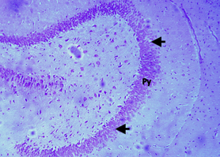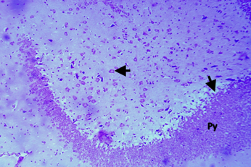
- (B)
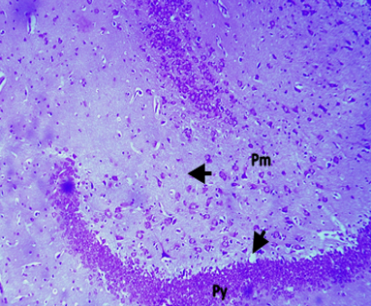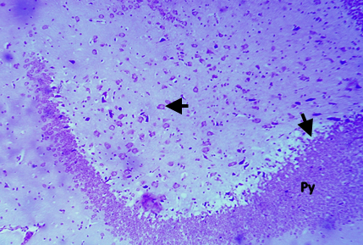
(C) (D)

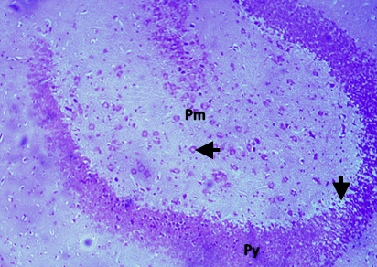
(E)

Fig 3: Photomicrograph of hippocampus stained with Cresyl Violet (Nissl stain) of (A) control rats showing numerous neurons with Nissl substance. (B) 15mg/kg of lead-acetate chloride showing densely packed neurons within the pyramidal cell layer. (C) 15mg/kg of lead-acetate+100mg/kg of cowpea extract showing fewer pyramidal neurons with nissl substance. (D) 15mg/kg of lead-acetate+200mg/kg of cowpea extract showing densely packed pyramidal neurons(P). (E) 200mg/kg of cowpea extract showing densely packed pyramidal neuron with nissl substance

The results of this investigation indicate that exposure to lead acetate induced noticeable neurodegenerative alterations in the brain tissues of the experimental rats. However, treatment with Vigna unguiculata extract appeared to lessen the severity of these pathological changes, suggesting a possible neuroprotective effect. Lead is recognized as a highly toxic environmental contaminant that can accumulate in neural tissues and disrupt normal cellular processes within the central nervous system. Because of its capacity to cross the blood–brain barrier, lead interferes with neurotransmitter systems, promotes oxidative stress, and alters neuronal signaling pathways. Both acute and chronic exposure to this heavy metal have been associated with structural and functional damage in several brain regions, particularly the cerebral cortex, hippocampus, and cerebellum, which are important for cognitive processing, learning, memory, and motor coordination (Flora et al., 2017).
Histological examination in this study revealed neuronal degeneration within the hippocampus and a reduction in the number of Purkinje cells within the cerebellar cortex of lead-exposed animals. Purkinje neurons represent the primary output neurons of the cerebellar cortex and play a crucial role in the integration of motor coordination and balance. Damage or loss of these neurons has been widely associated with impairments in motor control and postural stability. Experimental investigations have shown that exposure to heavy metals such as lead can result in degeneration of cerebellar Purkinje cells, which may ultimately lead to deficits in coordination, muscle tone regulation, and locomotor performance (Oliveira et al., 2021). The decrease in Purkinje cell density observed in the present investigation may therefore contribute to disturbances in motor activity such as reduced movement coordination and compromised equilibrium.
One of the important mechanisms underlying neuronal degeneration during lead exposure is mitochondrial dysfunction. Mitochondria are responsible for energy production in neurons and play a key role in maintaining cellular survival. Toxic metals such as lead can interfere with mitochondrial respiratory processes, leading to decreased ATP production and increased generation of reactive oxygen species (ROS). Structural alterations in mitochondria, including swelling and disruption of cristae architecture, have been reported in neurons exposed to lead, indicating impaired oxidative phosphorylation and cellular energy metabolism (Flora et al., 2017). Such disturbances can compromise neuronal viability and may contribute to the progressive degeneration of brain cells observed in lead toxicity.
In addition to neuronal damage, alterations in myelin integrity have been implicated in lead-induced neurotoxicity. Myelin sheaths surrounding neuronal axons are essential for rapid conduction of electrical impulses along nerve fibers. Damage to myelin or oligodendrocytes can therefore disrupt neuronal communication and impair cognitive and motor functions. Previous research has demonstrated that exposure to heavy metals can induce structural abnormalities in myelin and reduce oligodendrocyte function, which may lead to impaired neural transmission and decreased functional connectivity within neuronal networks (Caito & Aschner, 2017). Disruption of myelin integrity may consequently contribute to deficits in motor coordination and cognitive performance.
The study also demonstrated histological alterations within the hippocampus in lead-exposed groups, including nuclear pyknosis and a reduction in pyramidal and stellate neuronal populations. Pyramidal neurons represent the principal excitatory neurons of the brain and are critically involved in processes such as voluntary motor control, sensory perception, and higher cognitive functions including learning and memory. Degeneration of these neurons can therefore lead to substantial neurological dysfunction. Evidence from experimental studies suggests that lead exposure may trigger neuronal apoptosis and DNA fragmentation in multiple brain regions, including the cortex and hippocampus, thereby contributing to cognitive impairment and behavioral disturbances (Liu et al., 2018). Treatment with cowpea extract helped restore the hippocampal architecture to normalcy.
Histochemical analysis of the hippocampus stained with Cresyl Violet revealed clear structural differences between experimental groups, highlighting the neuroprotective effects of Vigna unguiculata extract against lead-induced damage. In control rats, the pyramidal cell layer displayed numerous neurons with prominent Nissl substance, reflecting healthy and metabolically active neurons. Exposure to 15 mg/kg of lead acetate resulted in densely packed neurons with reduced Nissl substance, indicative of cytoplasmic condensation and impaired protein synthesis associated with neurotoxicity. Co-administration of cowpea extract demonstrated a dose-dependent restorative effect: at 100 mg/kg, partial recovery of pyramidal neurons was observed, while at 200 mg/kg, the neurons were densely packed with abundant Nissl bodies, suggesting significant preservation of neuronal integrity and functional protein synthesis. Notably, rats treated with 200 mg/kg of cowpea extract alone maintained dense pyramidal neurons with well-defined Nissl substance, comparable to controls, emphasizing the extract’s inherent neuroprotective potential. These observations are consistent with evidence that plant-derived antioxidants can protect hippocampal neurons from oxidative stress and apoptosis induced by heavy metals, likely by preserving cytoplasmic structure and supporting neuronal metabolism (Sharma et al., 2020).
Biochemical analysis in the present investigation further revealed alterations in oxidative stress markers in the brain tissues of experimental animals. Oxidative stress plays a central role in the pathogenesis of lead toxicity. Exposure to lead is known to disturb the redox equilibrium within biological systems by promoting the excessive production of reactive oxygen species while simultaneously weakening endogenous antioxidant defenses. This imbalance results in oxidative injury to essential cellular components such as membrane lipids, structural proteins, and genetic material. Glutathione plays a critical role as a major intracellular antioxidant responsible for neutralizing reactive oxygen species and maintaining cellular redox stability. Variations in glutathione concentration observed in the present study may therefore represent a protective physiological response aimed at counteracting the oxidative stress triggered by lead toxicity (Flora et al., 2017).
Malondialdehyde (MDA), a widely recognized biomarker of lipid peroxidation, is commonly used to evaluate oxidative damage within biological systems. Elevated MDA levels indicate increased degradation of membrane lipids resulting from excessive reactive oxygen species activity. Elevated levels of lipid peroxidation are a hallmark of lead-induced neurotoxicity and are widely recognized as a major factor contributing to the disruption of neuronal membrane integrity and compromised cellular function. Experimental studies have consistently demonstrated that lead exposure enhances oxidative degradation of membrane lipids, thereby impairing neuronal signaling and overall brain function (Liu et al., 2020).Oxidative damage to neuronal membranes can compromise cellular integrity and disrupt synaptic signaling processes.
Treatment with Vigna unguiculata extract in this study appeared to mitigate several of the structural and biochemical alterations induced by lead acetate. The improvement observed in histological features of the cerebellum, cerebrum, and hippocampus following extract administration suggests a potential neuroprotective effect of the plant. Cowpea is known to contain several biologically active compounds including phenolic acids, flavonoids, and carotenoids that possess strong antioxidant properties. These compounds have the ability to neutralize free radicals, inhibit lipid peroxidation, and enhance endogenous antioxidant defense systems (Moloto et al., 2020).
Furthermore, increasing doses of the extract appeared to produce progressive improvements in oxidative stress markers, suggesting a dose-dependent protective effect. The antioxidant phytochemicals present in cowpea may therefore contribute to the attenuation of oxidative damage caused by lead exposure. Plant-derived antioxidants have been widely reported to exert protective effects against heavy-metal-induced toxicity by reducing oxidative stress, stabilizing cellular membranes, and improving neuronal survival (Caito & Aschner, 2017).
Overall, the findings of the present study suggest that Vigna unguiculata extract possesses neuroprotective properties capable of reducing lead-induced neuronal degeneration. The observed restoration of neuronal structures and improvement in oxidative stress parameters indicate that the extract may help protect brain tissues from the damaging effects of lead toxicity. These results highlight the potential therapeutic value of cowpea-derived phytochemicals as natural antioxidants in the management of heavy-metal-induced neurotoxicity.

4. Conclusion

This study showed that oral administration of ethanolic extract of cowpea significantly mitigates lead-induced neurotoxicity in the hippocampus of adult male wistar rats. The study also revealed histological changes on the hippocampus of adult wistar rats exposed to lead acetate which was ameliorated in cowpea treated groups. Based on these findings, it is recommended that subsequent studies should assess the long-term functional outcomes of Vigna unguiculata treatment in lead-exposed rats, including learning, memory, and motor coordination. Correlating histological and biochemical improvements with behavioral performance would provide stronger evidence for the extract’s neuroprotective efficacy and potential translational application.

Ethical approval

This was obtained from the ethical committee, faculty of basic medical sciences Chukwuemeka Odumegwu Ojukwu University, Uli campus in compliance with the relevant laws and institution’s guidelines.
All authors hereby declare that "Principles of laboratory animal care" (NIH publication No. 85-23, revised 1985) were followed, as well as specific national laws where applicable. All experiments have been examined and approved by the appropriate ethics committee.

COMPETING INTERESTS DISCLAIMER:
Authors have declared that they have no known competing financial interests OR non-financial interests OR personal relationships that could have appeared to influence the work reported in this paper.

References

Avanza, M. V., Álvarez-Rivera, G., Cifuentes, A., Mendiola, J. A., & Ibáñez, E. (2021). Phytochemical and functional characterization of phenolic compounds from cowpea (Vigna unguiculata (L.) Walp.) obtained by green extraction technologies. Agronomy, 11(1), 162.Almeida, J. R. G. S., Oliveira, A. P., Araújo, A. A. S., & Silva, M. S. (2022). Pharmacological and pharmacokinetic properties of steroidal sapogenins: Neuroprotective and therapeutic perspectives. Frontiers in Neuroscience, 16, 853214.
Caito, S., & Aschner, M. (2017). Neurotoxicity of metals. Current Opinion in Toxicology, 1, 21–27.
Caito, S., & Aschner, M. (2017). Neurotoxicity of metals. Handbook of Clinical Neurology, 131, 169–189.
Flora, G., Gupta, D., & Tiwari, A. (2017). Toxicity of lead: A review with recent updates. Interdisciplinary Toxicology, 10(2), 77–87.
Liu, C. M., Ma, J. Q., & Sun, Y. Z. (2018). Quercetin protects the rat kidney against oxidative stress-mediated DNA damage induced by lead. Environmental Toxicology and Pharmacology, 36(2), 572–578.
Liu, Y., Wang, Q., Zhang, H., & Li, X. (2020). Lead exposure induces oxidative stress and neurodegeneration in rat brain: Protective effects of antioxidant treatment. Neurotoxicology, 78, 79–87.
Moloto, M. R., Phan, A. D. T., Shai, J. L., Sultanbawa, Y., & Sivakumar, D. (2020). Comparison of phenolic compounds, carotenoids, amino acid composition and antioxidant activities in leaves of cowpea (Vigna unguiculata) cultivars. Foods, 9(9), 1285.
Oliveira, J. S., Maciel, E. N., Leão, L. K. R., et al. (2021). Lead-induced motor dysfunction is associated with oxidative stress and neurodegeneration in the motor cortex of rats. International Journal of Molecular Sciences, 22(20), 10945
Sharma, P., Dubey, R. S., & Rani, P. (2020). Neuroprotective effects of plant-derived antioxidants against heavy metal-induced hippocampal damage: A review. Neurotoxicology, 78, 134–145.
Sombié, P. A. E. D., Compaoré, M., Coulibaly, A. Y., Ouédraogo, J. T., Tignégré, J. B. D. L. S., & Kiendrébéogo, M. (2018). Antioxidant and phytochemical studies of 31 cowpeas (Vigna unguiculata (L.) Walp.) genotypes from Burkina Faso. Foods, 7(9), 143.

