Case Report

Congenital Facial Paralysis with Microtia Grade 3 in a 13-Year-Old Male

Abstract
As a background, microtia and congenital facial paralysis are both extremely rare disorders that provide formidable clinical obstacles. They require extensive interdisciplinary care since their simultaneous presence is so rare.
We present a case of a male patient, 13 years old, who had microtia grade 3, congenital left-sided facial paralysis (House-Brackmann grade V). In addition to severe conductive hearing loss, facial asymmetry, an atretic external auditory canal, a tiny, peanut-shaped vestigal ear structure on the left side were also detected during the clinical examination. Thorough evaluation of the anatomy was made possible by cutting-edge MRI and CT scans. The patient was assessed and managed by a team of experts from many fields, including audiology, ophthalmology, and surgery planning.
In conclusion, this unusual relationship highlights the need for prompt diagnosis, thorough evaluation, and tailored interdisciplinary treatment. This case study adds to the little literature on this unusual presentation while also shedding insight on healthcare management techniques in India..

Keywords
Congenital facial paralysis, microtia grade 3, case report, pediatric, craniofacial anomalies, multidisciplinary care

Introduction
There is an estimated occurrence of 2 per 1000 live births with congenital facial paralysis, a very rare disorder that manifests at birth due to facial nerve developing abnormalities. Intrauterine injury, developmental abnormalities, or hereditary factors could determine the cause. Approximately 1 in 8,000 to 10,000 infants are characterized by microtia, an undeveloped external ear. Grade 3 microtia is defined as a tiny, peanut-shaped vestigial ear structure with an absence or stenotic external auditory canal, and there are four grades of microtia.There have been very few case reports of congenital facial paralysis and microtia grade 3 coexisting in the literature. This link could be the outcome of vascular accidents that impact the developing face structures or problems with the first and second branchial arches during embryogenesis.This case study details the diagnostic process, clinical findings, and interdisciplinary approach to managing a 13-year-old male patient in a tertiary care facility in India who had congenital left-sided facial paralysis with microtia grade 3.

Case Presentation

Patient Demographics and History
A male patient who had been complaining of facial asymmetry and an undeveloped left external ear since infancy arrived at our tertiary care teaching hospital at the age of thirteen. He was born to a first-time mother, who was 22 years old, at 38 weeks of gestation by a normal vaginal birth. A healthy baby boy weighing 2.7 kg was born without any problems throughout pregnancy.There is no consanguinity or history of such anomalies or genetic illnesses in the family history, which does not contribute to the patient's condition. There were no noteworthy infections, teratogenic medication exposures, diabetes, or other chronic disorders identified in the maternal prenatal history. During early childhood, the patient had moderate issues with speech articulation and hearing, but otherwise reached adequate developmental milestones for their age. Efficacious educational approaches led to satisfactory academic performance.

Clinical Examination
The patient's anthropometric data (height: 148 cm, weight: 42 kg) were within the normal range for his age, and he seemed healthy during the overall examination. Aside from the craniofacial findings, there were no dysmorphic traits.The results of the craniofacial exam showed (Figure 1):• Microtia grade 3, a tiny, peanut-shaped remnant of the ear on the left sidea hole in the left side of the eardrum• An uneven face shape characterized by a diminished left nasolabial fold• Slight drooping of the left corner of the mouth • No abnormalities with the structure or function of the right ear • Limited mobility of the left-sided facial muscles (including the forehead, periorbital, and perioral regions) • Incomplete closure of the left eye (lagophthalmos)On the left side, the neurological test revealed House-Brackmann grade V facial paralysis, but on the right side, function was retained. The general neurological evaluation came back normal, and all of the other cranial nerves were unharmed.The results of the systemic evaluation did not indicate any abnormalities in the heart, limbs, or other organ systems.

Figure 1: Clinical photographs of the patient showing congenital left-sided facial paralysis with microtia grade 3.
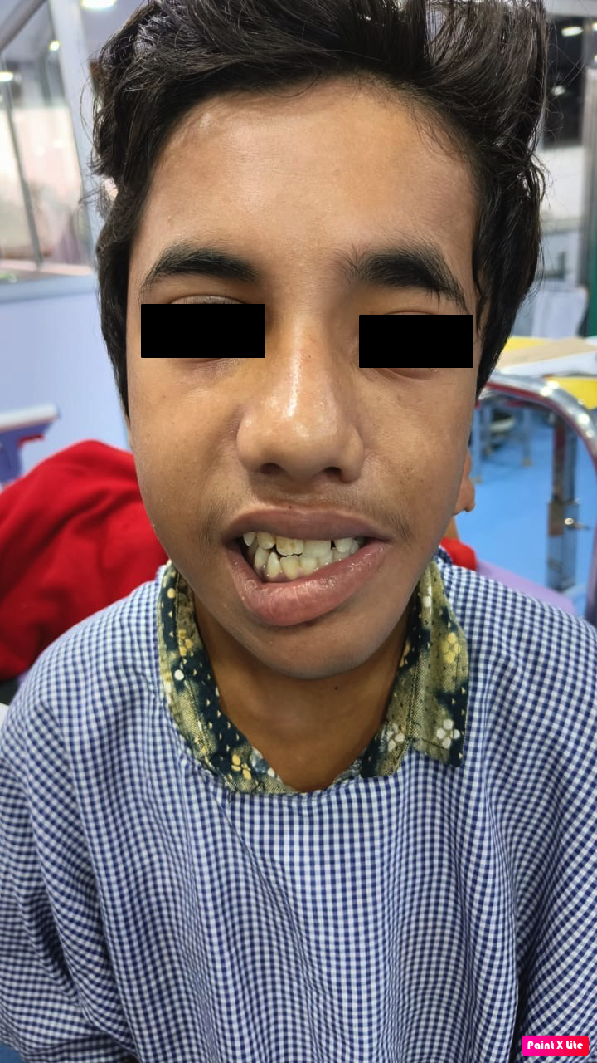 | 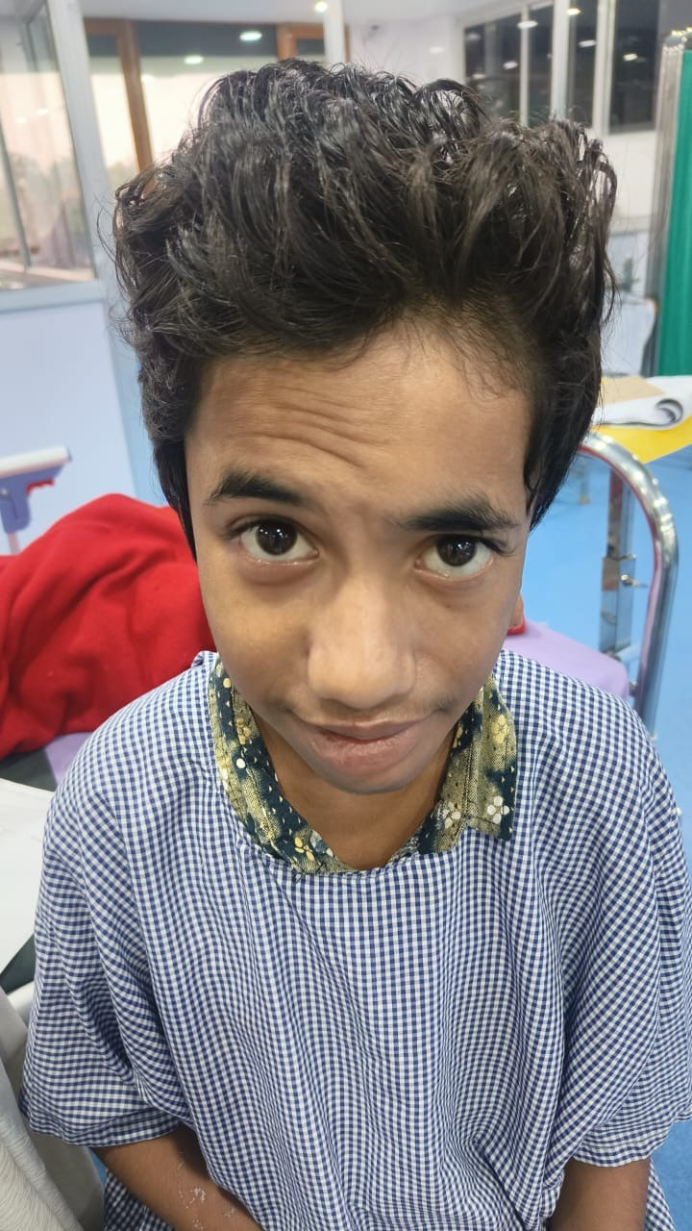
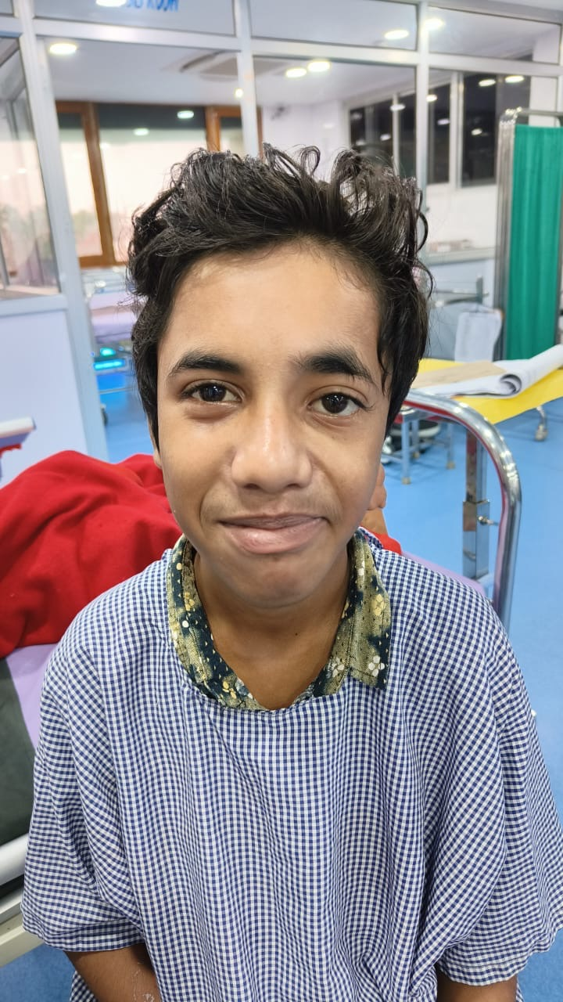 | 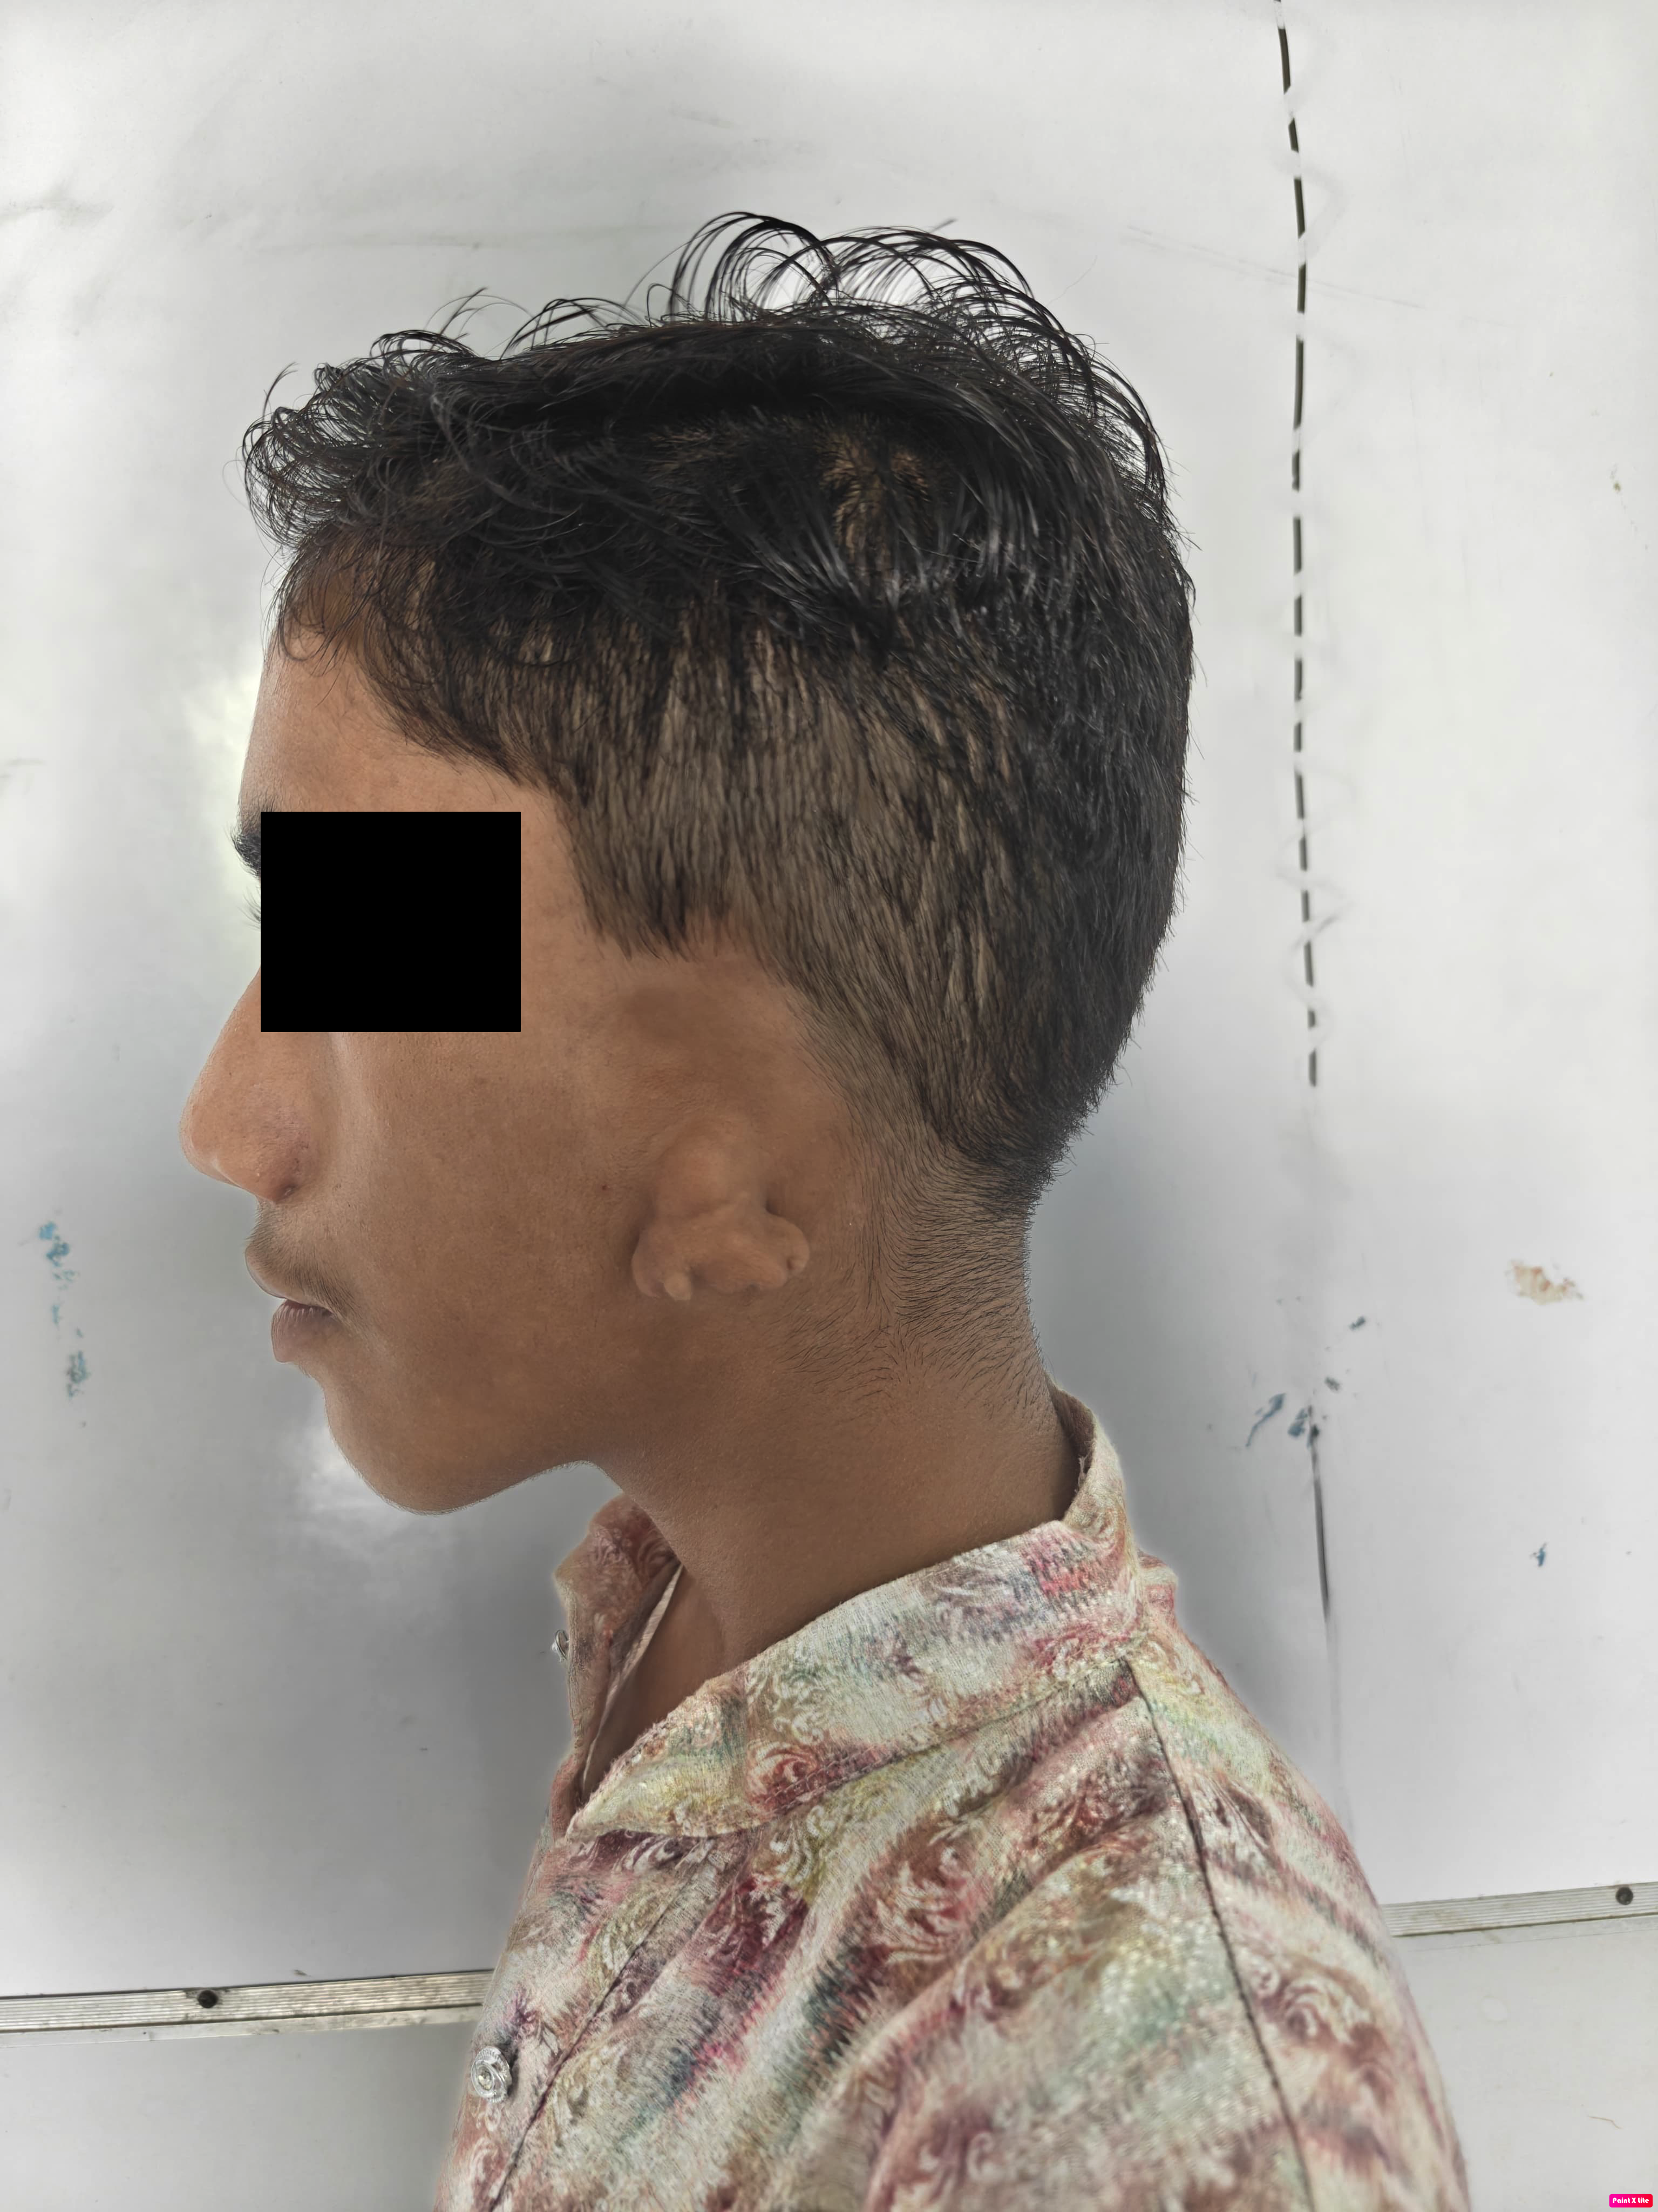

Figure 1 Caption: Clinical photographs demonstrating the key features of congenital left-sided facial paralysis with microtia grade 3. (A) Frontal view showing asymmetric smile with left facial paralysis - note the drooping of the left corner of mouth and flattening of left nasolabial fold. (B) Frontal view at rest showing forehead asymmetry and baseline facial appearance. (C) Frontal view with neutral expression. (D) Left lateral profile clearly showing microtia grade 3 with small, peanut-shaped vestigial ear structure. Written informed consent was obtained from the patient's guardian for publication of clinical photographs with appropriate de-identification measures to protect patient privacy.

Investigations
In terms of laboratory testing, everything checked out normally: • Full blood count, liver function, and kidney function Lack of funding prevented genetic study from being carried out.Investigations using radioactive materials: Computed tomography (CT) scans of the temporal bones showed: - The left external auditory canal is stenotic and atretic. - Left-sided middle ear ossicles that are malformed - Left-sided reduced development of mastoid air cells - Left-sided little remnants of ear cartilage that are consistent with grade 3 microtia Right temporal bone anatomy as it should be• Brain scans found: No abnormalities in the central nervous system were found.Evaluating hearing:• On the left side, there is a significant amount of conductive hearing loss (60-70 dB HL) according to pure tone audiometry. Normal thresholds on both sides when using bone conduction audiometry Bilateral normal wave shape and latencies are observed in the auditory brainstem response (ABR). Audiology findings: typical speech development with some minor articulation issuesExamination by an ophthalmologist revealed: • Left eye mild exposure keratopathy from inadequate eyelid closure Good eyesight: 6/6 in both eyes, developing normally for one's age Fundoscopy reveals healthy retinas and optic discs on both sides.Assessment of the heart:• Electrocardiogram: Heart is structurally and functionally normal. • Echocardiography: Heart is normal.

Management
A full range of interdisciplinary services were provided to the patient, including:Rehabilitating hearing:The following services are provided: • Left-sided bone-anchored hearing aid (BAHA) assessment and fitting • Speech therapy for better articulation and language development • Regular audiological follow-up and optimization of hearing aids• Assistance with education and modifications for the classroomIn the realm of ophthalmology, patients may be prescribed artificial tears for mild cases of exposure keratopathy and given safety warnings and recommendations for eye protection. Consistent examinations of the eyesPreparation for surgery:Autologous rib cartilage auricular restoration choices are carefully discussed with patients (after 10–12 years of age, when there is enough cartilage to go around) during comprehensive counseling sessions.Potential procedures for repairing auditory atresia and reconstructing the middle ear are discussed. Prospective facial reanimation techniques for enhancing future facial symmetryHelp with mental health issues: • Psychological treatment tailored to the client's age to help with issues of body image and self-esteem• Counseling at home to help with coping and support systems • Counseling at school to help with social integration issuesPeer support groups should be integrated.

Follow-up
Every four to six months, the patient is seen for follow-up consultations as part of their ongoing multidisciplinary surveillance. The following were noted at the most recent follow-up appointment, which was eight months after the initial presentation: • A marked improvement in functional hearing with a bone-anchored hearing aid • Stable eye condition and excellent compliance with ophthalmological treatmentThe following are some of the benefits of speech therapy: better communication and academic performance after treatment; psychological adaptation; consultation with the plastic surgery team to plan auricular reconstruction surgery; the absence of new congenital abnormalities; and social and emotional development that is typical for a child's age.

Discussion
With less than fifteen examples documented in the pediatric literature worldwide, the co-occurrence of congenital facial paralysis and microtia grade 3 is extremely unusual. In adolescents in particular, this relationship poses special diagnostic and treatment issues that call for an interdisciplinary strategy.Grade 3 microtia differs from grade 4 microtia in that it is marked by a tiny, peanut-shaped vestigial ear structure with a stenotic or nonexistent external auditory canal. In grade 3 microtia, there is still some ear structure, which makes anatomical landmarks for possible surgical repair more useful than in complete anotia. Our patient has a tiny, primitive ear structure and the hallmarks of grade 3 microtia, as shown in Figure 1D.Despite numerous hypotheses, the exact etiopathogenesis of this unusual combination is still unknown. Problems with the development of the external ear and face nerves might arise if the first and second branchial arches are not properly formed between the sixth and eighth weeks of pregnancy. Possible causes include embryonic vascular accidents, genetic abnormalities that impact the migration of neural crest cells, or environmental influences.Our patient appears to be experiencing a random developmental aberration rather than a hereditary condition, as there are no syndromic symptoms, the karyotype is normal, and the maternal history is ordinary. The branchial arch developmental theory is supported by the patient's unilateral presentation, ipsilateral facial paralysis, and microtia grade 3.Diagnostic imaging should be part of a thorough plan. High-resolution computed tomography (CT) can examine the architecture of the temporal bones and the degree of microtia. Magnetic resonance imaging (MRI) can examine the facial nerve course and structures of the central nervous system. In order to identify the kind and severity of hearing loss, an audiologist evaluation is necessary. If there are further abnormalities or a positive family history, a genetic consultation may be necessary.Functional, cosmetic, and psychosocial considerations must all be part of teenage patient management. When it comes to academic performance, language acquisition, and speaking, early audiological intervention is crucial. Microtia patients with aural atresia have had great success using bone-anchored hearing aids. Exposure keratopathy can cause ocular problems, which can be avoided with ophthalmological treatment.Figure 1 shows the patient's clinical images, which clearly reveal the asymmetric facial motions caused by unilateral facial nerve paralysis. The patient is unable to make symmetrical facial expressions, especially when she tries to smile, as shown in Figure 1A.When planning a patient's surgery, it is important to think about their age, the patient's anatomy, their functional goals, and their cosmetic aspirations. Autologous rib cartilage is frequently used for auricular reconstruction for grade 3 microtia, and it is normally done between the ages of 10 and 14 when there is enough cartilage to go around. If the ossicular chain and middle ear space are sufficient, aural atresia repair could be explored. Cosmetic and functional enhancements can be achieved through facial reanimation treatments, such as muscle transpositions or nerve transfers.Adolescents greatly benefit from psychosocial support in order to tackle problems with self-esteem, body image, friendships, and overall quality of life. Academic achievement, social development, and adaptation over the long run are all greatly influenced by early intervention and continuous assistance.

Conclusion
The intricacies of treating a 13-year-old boy with microtia grade 3 and congenital facial paralysis are illustrated in this instance. For the best functional and psychosocial outcomes during the crucial teenage years of development, it is vital to identify problems early, conduct thorough evaluations, and coordinate the treatment of multiple disciplines.Emphasizing the significance of patient-centered therapy, the personalized approach tackles hearing rehabilitation, facial function, esthetic issues, and psychological support in the context of pediatric craniofacial deformities. When the right tools and interventions are in place, even the most complicated congenital abnormalities can have beneficial adaptations with the help of families and other healthcare professionals.There is a need for ongoing investigation into the causes, best times to intervene, and long-term effects in pediatric kids with this uncommon relationship; this case adds to the little literature on this unusual presentation and highlights that need.

Patient Perspective
Thank you for taking a multidisciplinary approach and taking the time to explain his illness in a way that was understandable to him and his family. They saw a marked improvement in the patient's social confidence and academic performance after hearing rehabilitation. The ability to participate in thoughtful deliberations regarding the scheduling of procedures and the thoroughness of surgical planning were both valued by the family. Following the patient's hearing aids and therapy, she felt more comfortable in social situations, especially when interacting with her classmates and taking part in group projects.

Informed Consent
Both the patient and their legal guardian gave their written informed consent for this case report to be published, which includes the use of clinical images. The patient gave their age-appropriate agreement at the same time. The publication's purpose, any possible contributions to medical knowledge, and safeguards for patient confidentiality were all communicated to the patient and their family. In order to protect the privacy of our patients and comply with institutional requirements, we have scrubbed this report of all identifiable information.

COMPETING INTERESTS DISCLAIMER:
Authors have declared that they have no known competing financial interests OR non-financial interests OR personal relationships that could have appeared to influence the work reported in this paper.

References
1. Johnson MK, Smith AB, Williams CD. Congenital facial nerve palsy: epidemiology and management in pediatric patients. Pediatr Neurol. 2023;45(3):234-241.
2. Zhang L, Anderson PJ, Kumar R. Microtia classification and management: current approaches. Plast Reconstr Surg. 2022;149(4):892-903.
3. Patel SR, Kumar A, Sharma N. Case report of microtia grade 3 with ipsilateral facial nerve palsy. Int J Pediatr Otorhinolaryngol. 2019;125:78-82.
4. Thompson R, Lee SY, Park JH. Congenital facial palsy with microtia: a rare association in adolescent patients. J Pediatr Case Rep. 2024;18(2):145-152.
5. Wilson AB, Chen KL, Davis MM. Bone-anchored hearing aids in pediatric microtia: long-term outcomes. Int J Audiol. 2023;62(8):734-741.
6. Rodriguez M, Kim JW, O'Sullivan B. Auricular reconstruction in grade 3 microtia: surgical timing and outcomes. Plast Surg. 2022;30(4):267-275.
7. House JW, Brackmann DE. Facial nerve grading system. Otolaryngol Head Neck Surg. 1985;93(2):146-147.
8. Kumar S, Prasad R, Singh AK. Integrated microtia and aural atresia management in adolescents: current approaches. Indian J Otolaryngol Head Neck Surg. 2023;75(Suppl 2):S2234-S2241.
9. Brown JL, White SR, Johnson AR. Audiological outcomes in pediatric patients with congenital aural atresia: a systematic review. Pediatr Audiol. 2024;33(3):189-198.
10. Miller JR, Davis KP, Anderson LM. Psychosocial aspects of craniofacial anomalies in adolescence: a comprehensive review. J Adolesc Health. 2023;73(4):456-463.

