Molecular Refinement in Oligodendroglioma Diagnosis: Role of Next Generation Sequencing

.
ABSTRACT

Introduction: Oligodendroglioma is a rare, slow-growing glioma originating from oligodendrocytic cells and primarily affects adults. According to the 5th edition (2021) of the World Health Organization Classification of Tumors of the Central Nervous System (WHO 2021, CNS5), a definitive diagnosis requires the presence of an Isocitrate Dehydrogenase (IDH) gene mutation and co-deletion of chromosome arms 1p and 19q. Histopathology, immunohistochemistry (IHC), and molecular genetic analyses form the diagnostic foundation. However, the accuracy of IHC alone in distinguishing oligodendrogliomas from astrocytomas remains questionable.
Methods: Based on IHC findings, 11 cases were initially diagnosed as oligodendroglioma, they all were found positive for IDH1 R132H mutation and retained ATRX protein expression and were subjected to further molecular testing. Next Generation Sequencing (NGS) was used to identify the single nucleotide variations (SNVs), fusions and copy number variations (CNVs). The gold standard technique Fluorescence In-Situ Hybridization (FISH) technique was used to identify 1p/19q co-deletion detection along with CNVs.
Results: Our NGS results demonstrated that out of 11 patients who were positive for IDH mutation by IHC, 4 patients had IDH wild-type glioma tumors. In another result, we found that 1 patient had 1p/19q co-deletion by FISH and had IDH mutation alongwith ATRX retained by IHC, however, by NGS, it showed presence of ATRX mutation and no co-deletion in CNVs. Rest 5 samples showed concordance findings with FISH results proving to be negative for oligodendrogliomas.
Conclusion: NGS is a sensitive advanced molecular technique. In our study, we might conclude that IHC alone is insufficient for definitive oligodendroglioma diagnosis, while FISH remains the diagnostic gold standard, NGS surpasses traditional this technique by offering higher throughput, multi-analyse profiling, and superior utility with limited biopsy material, enabling precise sub-typing even in challenging cases aligning with WHO CNS5 recommendations.

Keywords: Oligodendroglioma, Next-Generation Sequencing (NGS), 1p/19q Co-deletion, Immunohistochemistry (IHC), Fluorescence in Situ Hybridization

- Introduction
Oligodendroglioma represents a rare, distinct subtype of primary central nervous system (CNS) tumors originating from Oligodendrocyte, the glial cells responsible for myelinating axons in the brain and spinal cord (Bale et al., 2022). Oligodendrogliomas make up 3% to 4% of all brain tumours and 5% to 15% of all gliomas. Approximately 24,000 individuals worldwide receive a diagnosis of oligodendroglioma tumour each year. They usually occur in frontal lobe, with people having age from 40 years to 50 years. (Jiang et al., 2025). The WHO 2021 CNS5 classification stratifies oligodendroglioma into grade 2 (low-grade, slow-growing, seizure-prone tumors with minimal mitotic activity) and grade 3 (anaplastic variants showing elevated mitotic activity, increased cellularity, microvascular proliferation, and aggressive recurrence risk) tumors (Guo et al., 2023).

Molecularly, oligodendroglioma tumors are defined by mandatory co-deletion of chromosomal arms 1p/19q, occurring in ~70–90% of cases. (Mandaliya et at., 2023) Nearly all (>95%) carry IDH1 (most commonly R132H) or IDH2 (R172K) mutations. This IDH-mutant, 1p/19q-codeleted molecular profile is pathognomonic for oligodendrogliomas and distinguishes them from astrocytomas, which typically lack 1p/19q loss and instead demonstrate TP53 mutations and ATRX loss, whereas oligodendrogliomas show ATRX retention and wild-type TP53 (Higuchi et al., 2024) . TERT promoter mutations co-occur in 70–80% of oligodendrogliomas, activating telomerase and enhancing diagnostic specificity when combined with IDH/1p19q status. (Arita et al., 2022)

The fluorescence in situ hybridization (FISH) has been regarded valuable for targeted 1p/19q confirmation with >95% specificity. (Brandner et al., 2022). However, advances in molecular diagnostics have transformed oligodendroglioma classification from histology-dependent to molecularly-driven precision. NGS stands out for detecting IDH mutations, 1p/19q co-deletion, TP53, ATRX, and TERT alterations, simultaneously and provides comprehensive genomic insights, including variant allele frequencies, CNVs via read-depth analysis, and fusion detection-critical for distinguishing oligodendrogliomas from histological mimics like IDH-mutant astrocytomas. (Tirro et al., 2022). This comprehensive molecular profiling approach provides objective, quantitative, and highly reproducible results that are fully aligned with the WHO CNS5 classification framework. Thus, by capturing the complete molecular landscape, NGS allows accurate and confident distinction between oligodendroglioma and astrocytoma, even in diagnostically challenging cases.

For oligodendroglioma tumors, apart from classical known genes, other genes such as ARID1A, MAGOH, and ERCC2 reflect chromatin regulation, RNA processing, and DNA repair alterations. (Dand et al., 2023) Also, MTOR, AKT2, NRAS, and JAK1 converge on PI3K-AKT-mTOR, MAPK, and cytokine signaling pathways, highlighting oncogenic growth and survival mechanisms. (Wu et al., 2022) MYCL and CCNE1 drive transcriptional activation and cell-cycle progression (Li HL et at., 2023), while NOTCH2 and AXL influence differentiation and invasiveness. (Abdallah 2023) PPP2R1A modulates phosphatase-mediated signaling control. Collectively, these genes define molecular pathways useful for oligodendroglioma classification, prognostication, and therapeutic targeting (Peris-Martínez et al., 2023). Based on these information, in the current study, we investigated oligodendroglioma tumor samples on NGS platform.

- Materials and Methods
After collecting consent form and taking ethical approval from “Institutional Ethics Committee”, in the current study, histologically confirmed 11 oligodendrogliomas tumors were analysed for comprehensive molecular profiling. DNA and RNA were extracted from fresh-frozen tissues using the QIAamp DNA & RNA kits, respectively.

Nucleic acid concentrations were quantified via Qubit 4 Fluorometer (Thermo Fisher Scientific, Waltham, MA, USA) with dsDNA HS and RNA HS assay kits. Quality assessment involved spectrophotometric analysis on the Varioskan LUX multimode microplate reader, evaluating 260/280 nm (1.8–2.0) and 260/230 nm (>1.8) ratios to confirm minimal contamination or degradation.

Further for the NGS, 25 µL sample with the concentration of 5 ng/µL DNA and RNA respectively were loaded in the Ion Torrent Genexus Integrated Sequencer (Thermo Fisher Scientific) and analysed using the Oncomine Comprehensive Assay v3 (OCAv3) panel. This multiplex assay enables simultaneous detection of SNVs, CNVs, and gene fusions critical to glioma biology, including IDH1/IDH2 hotspots and 1p/19q co-deletions.

- Results
- Clinicopathological Features
The clinicopathological characteristics of the oligodendroglioma were identified in age, gender, grade, tumor location, MGMT status & therapies. 6 males and 5 females were enrolled in our study. Further grade based analysis showed that 6 patients were of grade 2 and 5 patients with grade 3. Regarding tumor location, frontal lobe involvement was most common followed by parietal lobe tumors. 9 out of 11 patients lacked MGMT methylation. 54.55% Patients received combined surgery, chemotherapy, and radiotherapy followed by received surgery with chemotherapy surgery with radiotherapy 19.11%, and surgery alone 9.09%. Overall, the figure illustrates demographic trends, molecular features, and treatment patterns characteristic of oligodendroglioma management.
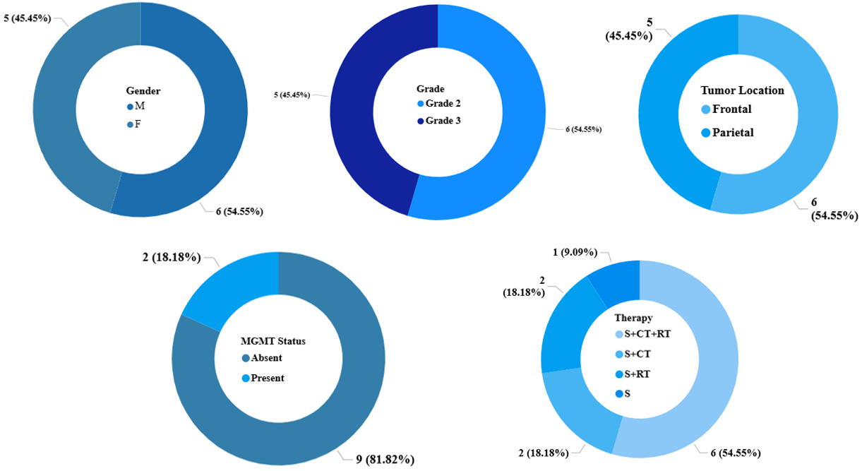
Fig 1:- Distribution of Clinicopathological parameters among 11 patients studied

- Immunohistochemistry Marker Analysis
Across all 11 tumor samples, IDH mutations were uniformly detected by IHC, confirming an IDH-mutant status in the entire cohort. TP53 mutations were identified in three samples. ATRX expression was retained in all tumors, with one sample showing focal, patchy partial positivity. TERT promoter mutations could not be evaluated using IHC. Collectively, these IIHC findings are consistent with the molecular profile of IDH-mutant oligodendrogliomas.

- Florescent In-Situ Hybridization (FISH)
For 1p/19q co-deletion, all samples evaluated by FISH. Out of 11 samples, 10 cases were negative, indicating absence of whole-arm 1p and 19q loss. Only one sample demonstrated a positive result, confirming true 1p/19q co-deletion and supporting a definitive oligodendroglioma diagnosis in that case.

- Single Nucleotide Variants
On NGS platform, we detected total 40 SNVs in 14 glioma-associated genes. The highest mutation frequencies observed in IDH1 (26.7%) followed by TERT (20%), TP53 (10%), NOTCH1 (6.7%), PIK3CA (6.7%), and a spectrum of lower-frequency alterations in ATRX, FBXW7, MTOR, PDGFRA, PIK3R1, POLE, PTEN, ROS1, and SLX4 (each 3.3%). This mutational landscape reflects canonical glioma biology, where the co-occurrence of IDH1 with TP53 and/or ATRX is more characteristic of IDH-mutant astrocytoma, whereas isolated TERT promoter mutations are more often associated with oligodendroglioma, although they are not dominant in this cohort. Overall, the profile highlights convergent disruption of DNA repair and PI3K–AKT–mTOR signaling pathways, supporting the role of panel-based molecular profiling in refining integrated histomolecular diagnosis and improving clinicopathological stratification.
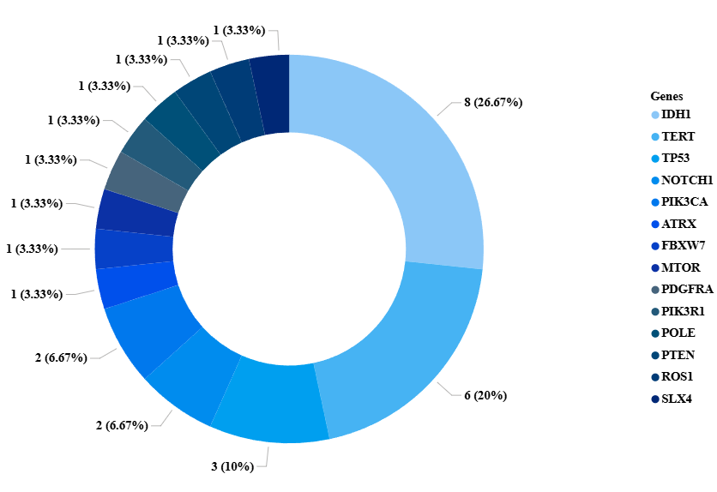
Fig 2:- Distribution of various SNVs found across 11 Patients from the study cohort

On SNV analysis using the NGS platform, four of the eleven samples demonstrated an IDH-wild-type profile, thereby precluding an oligodendroglioma diagnosis and instead favouring classification as IDH-wild-type astrocytomas.
One sample was IDH-mutant by NGS and IHC and showed 1p/19q co-deletion by FISH. However, NGS revealed an ATRX mutation and TP53 mutations, despite retained ATRX on IHC, highlighting NGS’s higher sensitivity and accuracy over IHC and FISH in detecting clinically relevant molecular alterations.

Sample 5 By NGS
Gene | AA Change | Type | Call
IDH1 | p.Arg132His | snp | PRESENT (HETEROZYGOUS)
TP53 | p.Arg273Cys | snp | PRESENT (HETEROZYGOUS)
ATRX | p.Gln2194Leu | snp | PRESENT (HETEROZYGOUS)
IHC
Sample ID | IDH | P53 | ATRX
Sample 5 | Mutant | Mutant | Retained
Table 1:- Genetic alterations and protein expression of various oligodendroglioma specific genes

- Detection of Fusions in NGS
NGS identified nine fusion events spanning four fusion types. The most frequent, PTPRZ1–MET, is a recognized astrocytoma hallmark, driving MET activation and aggressive tumor behaviour (Rodriguez et al., 2025). C11orf95–RELA characterizes astrocytic tumors through NF-κB pathway activation (Kardian et al., 2024). EGFR–DYRK1A supports oncogenic EGFR signaling, predominantly in astrocytoma (Liao et al., 2025). EML4–ALK, though rare in gliomas, is reported more often in astrocytic lineages and carries potential therapeutic relevance (Blandin et al., 2023).

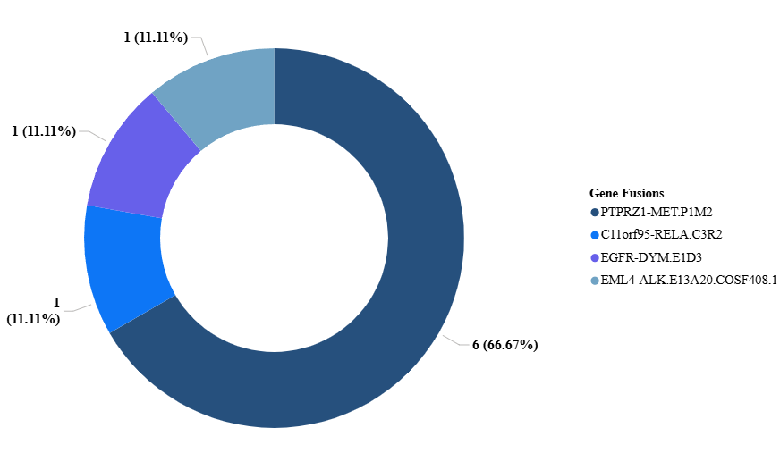
Figure 3:- Gene fusion spectrum detected by NGS across 11 patients

- Analysis Using Copy Number Variation
The remaining 6 genes that showed IDH mutation and ATRX retention, were analysed using another parameter- CNV, which has 12 specific genes for oligodendrogliomas; out of which 7 genes namely ARID1A, JAK1, MAGOH, MTOR, MYCL, NOTCH2 and NRAS are located on p-arm of chromosome 1 and rest 5 genes namely AKT2, AXL, CCNE1, ERCC2 and PP2RIA are located on q-arm of chromosome 19. Using Torrent Suite™ and Ion Reporter™ software, CNV analyses were classified as "definite" or "probable" based on confidence intervals of p-values, amplicon coverage, and the coefficient of variation metrics, respectively where A gene is considered DEFINITE if any P-value < 0.05, Valid CNV amplicons > 10 and 95% CNV confidence < 2, otherwise the gene is classified as PROBABLE (Ali et al., 2020)

Sample 1:- Although 7 out of 12 genes on both arms, showed significant p-values, only 2 genes - specifically on 19q arm showed definite loss, eliminating the probability of sample to be classified as oligodendroglioma.
Variant ID | Locus | Call | P-Value | CNV Confidence | Valid CNV Amplicons | Loss | Arm
ARID1A | chr1:27022977 | ABSENT | 0 | 5%:0, 95%:0.3 | 95 | Probable | p
JAK1 | chr1:65310460 | ABSENT | 0.03493 | 5%:0, 95%:1.53 | 3 | Probable | p
MAGOH | chr1:53692719 | ABSENT | 0.5071 | 5%:0, 95%:4.46 | 1 | Probable | p
MTOR | chr1:11168315 | ABSENT | 1.10E-04 | 5%:0, 95%:0.97 | 13 | Probable | p
MYCL | chr1:40362966 | ABSENT | 2.83E-04 | 5%:0, 95%:0.9 | 9 | Probable | p
NOTCH2 | chr1:120457924 | ABSENT | 0 | 5%:0.09, 95%:0.44 | 111 | Probable | p
NRAS | chr1:115252191 | ABSENT | 0.05443 | 5%:0, 95%:1.69 | 3 | Probable | p
AKT2 | chr19:40739755 | ABSENT | 0.00196 | 5%:0, 95%:1.23 | 11 | Definite | q
AXL | chr19:41725295 | ABSENT | 0.002916 | 5%:0.03, 95%:1.29 | 11 | Definite | q
CCNE1 | chr19:30303882 | ABSENT | 3.03E-06 | 5%:0, 95%:0.5 | 10 | Probable | q
ERCC2 | chr19:45855711 | ABSENT | 0.02773 | 5%:0, 95%:1.55 | 5 | Probable | q
PPP2R1A | chr19:52715952 | ABSENT | 0.07519 | 5%:0, 95%:1.81 | 2 | Probable | q

Table 2:- Identification of co-deletion of 1p/19q arm specific genes using CNV-NGS analysis

Sample2:- Although 4 out of 12 genes on both arms, showed significant p-values, only 1 gene - specifically on 1p arm showed definite loss, ruling out the sample to be classified as oligodendroglioma.

Variant ID | Locus | Call | P-Value | CNV Confidence | Valid CNV Amplicons | Loss | Arm
ARID1A | chr1:27022977 | ABSENT | 0 | 5%:0.36, 95%:0.69 | 95 | Probable | p
JAK1 | chr1:65310460 | ABSENT | 0.137 | 5%:0, 95%:2.16 | 3 | Probable | p
MAGOH | chr1:53692719 | ABSENT | 0.543 | 5%:0, 95%:4.01 | 1 | Probable | p
MTOR | chr1:11168315 | ABSENT | 3.25E-04 | 5%:0.26, 95%:1.23 | 13 | Definite | p
MYCL | chr1:40362966 | NO CALL | . |  | 9 | Probable | p
NOTCH2 | chr1:120457924 | ABSENT | 0 | 5%:0.44, 95%:0.77 | 110 | Probable | p
NRAS | chr1:115252191 | ABSENT | 0.101 | 5%:0, 95%:2.02 | 3 | Probable | p
AKT2 | chr19:40739755 | ABSENT | 0.007218 | 5%:0.38, 95%:1.53 | 11 | Probable | q
AXL | chr19:41725295 | ABSENT | 0.007695 | 5%:0.4, 95%:1.55 | 11 | Probable | q
CCNE1 | chr19:30303882 | ABSENT | 2.90E-05 | 5%:0, 95%:0.92 | 10 | Probable | q
ERCC2 | chr19:45855711 | ABSENT | 0.08453 | 5%:0.21, 95%:1.96 | 5 | Probable | q
PPP2R1A | chr19:52715952 | ABSENT | 0.0575 | 5%:0, 95%:1.73 | 2 | Probable | q

Table 3:- Understanding co-deletion of 1p/19q arm specific genes using CNV-NGS analysis

Sample 4:- Out of 12 genes, only 1 gene on 1p arm showed definite loss and statistically significant P-value. Thus, this sample cannot be classified as oligodendroglioma.
Variant ID | Locus | Call | P-Value | CNV Confidence | Valid CNV Amplicons | Loss | Arm
ARID1A | chr1:27022977 | ABSENT | 0.6259 | 5%:1.67, 95%:2.19 | 95 | Probable | p
JAK1 | chr1:65310460 | ABSENT | 0.1641 | 5%:1.78, 95%:5.94 | 3 | Probable | p
MAGOH | chr1:53692719 | ABSENT | 0.5149 | 5%:0.72, 95%:7.8 | 1 | Probable | p
MTOR | chr1:11168315 | ABSENT | 0.8975 | 5%:1.4, 95%:2.85 | 13 | Probable | p
MYCL | chr1:40362966 | NO CALL | . |  | 9 | Probable | p
NOTCH2 | chr1:120457924 | ABSENT | 1.76E-9 | 5%:2.76, 95%:3.38 | 111 | Definite | p
NRAS | chr1:115252191 | ABSENT | 0.3327 | 5%:1.44, 95%:5.21 | 3 | Probable | p
AKT2 | chr19:40739755 | ABSENT | 0.3666 | 5%:1.66, 95%:3.39 | 11 | Probable | q
AXL | chr19:41725295 | ABSENT | 0.9679 | 5%:1.28, 95%:2.83 | 11 | Probable | q
CCNE1 | chr19:30303882 | ABSENT | 0.2195 | 5%:0.81, 95%:2.21 | 10 | Probable | q
ERCC2 | chr19:45855711 | ABSENT | 0.9437 | 5%:1.03, 95%:3.38 | 5 | Probable | q
PPP2R1A | chr19:52715952 | ABSENT | 0.7828 | 5%:0.35, 95%:3.82 | 2 | Probable | q

Table 4:- Interpreting co-deletion of 1p/19q arm specific genes using CNV-NGS analysis

Sample 3:- Although partial molecular evidence of 1p/19q loss was observed, definitive deletion was confirmed in only three of twelve genes. As complete whole-arm 1p/19q co-deletion was not demonstrated by FISH, the tumor did not fulfill WHO 2021 diagnostic criteria for oligodendroglioma.
Variant ID | Locus | Call | P-Value | CNV Confidence | Valid CNV Amplicons | Loss | Arm
ARID1A | chr1:27022977 | ABSENT | 0 | 5%:0, 95%:0.19 | 95 | Probable | p
JAK1 | chr1:65310460 | ABSENT | 0.09483 | 5%:0, 95%:1.97 | 3 | Probable | p
MAGOH | chr1:53692719 | ABSENT | 0.3232 | 5%:0, 95%:3.31 | 1 | Probable | p
MTOR | chr1:11168315 | ABSENT | 1.084E-07 | 5%:0, 95%:0.58 | 13 | Definite | p
MYCL | chr1:40362966 | ABSENT | 0.00000032 | 5%:0, 95%:0.43 | 9 | Probable | p
NOTCH2 | chr1:120457924 | ABSENT | 0 | 5%:0.38, 95%:0.72 | 111 | Probable | p
NRAS | chr1:115252191 | ABSENT | 0.0268 | 5%:0, 95%:1.49 | 3 | Probable | p
AKT2 | chr19:40739755 | ABSENT | 0.00002239 | 5%:0, 95%:0.87 | 11 | Definite | q
AXL | chr19:41725295 | ABSENT | 6.183E-07 | 5%:0, 95%:0.6 | 11 | Definite | q
CCNE1 | chr19:30303882 | ABSENT | 8.23E-10 | 5%:0, 95%:0.18 | 10 | Probable | q
ERCC2 | chr19:45855711 | ABSENT | 0.003783 | 5%:0, 95%:1.15 | 5 | Probable | q
PPP2R1A | chr19:52715952 | ABSENT | 0.01116 | 5%:0, 95%:1.06 | 2 | Probable | q

Table 5:- Analysing co-deletion of 1p/19q arm specific genes using CNV-NGS analysis

Sample 8:- Three genes out of twelve showed definite loss on 1p/19q arm, making sample partial positive for oligodendroglioma; but complete 1p/19q co-deletion was not demonstrated by FISH in the sample and thus the tumor did not fulfill WHO 2021 diagnostic criteria for oligodendroglioma.
Variant ID | Locus | Call | P-Value | CNV Confidence | Valid CNV Amplicons | Loss | Arm
ARID1A | chr1:27022977 | ABSENT | 0 | 5%:0.28, 95%:0.61 | 95 | Probable | p
JAK1 | chr1:65310460 | ABSENT | 0.1161 | 5%:0, 95%:2.06 | 3 | Probable | p
MAGOH | chr1:53692719 | ABSENT | 0.5676 | 5%:0, 95%:4.13 | 1 | Probable | p
MTOR | chr1:11168315 | ABSENT | 6.77E-07 | 5%:0.15, 95%:1.09 | 13 | Definite | p
MYCL | chr1:40362966 | NO CALL | . |  | 9 | Probable | p
NOTCH2 | chr1:120457924 | ABSENT | 0 | 5%:0.46, 95%:0.79 | 110 | Probable | p
NRAS | chr1:115252191 | ABSENT | 0.07484 | 5%:0, 95%:1.88 | 3 | Probable | p
AKT2 | chr19:40739755 | ABSENT | 0.001744 | 5%:0.25, 95%:1.34 | 11 | Definite | q
AXL | chr19:41725295 | ABSENT | 0.001064 | 5%:0.22, 95%:1.29 | 11 | Definite | q
ERCC2 | chr19:45855711 | ABSENT | 0.02812 | 5%:0.01, 95%:1.62 | 5 | Probable | q
CCNE1 | chr19:30303882 | ABSENT | 6.25E-07 | 5%:0, 95%:0.78 | 10 | Probable | q
PPP2R1A | chr19:52715952 | ABSENT | 0.03477 | 5%:0, 95%:1.5 | 2 | Probable | q

Table 6:- Evaluating co-deletion of 1p/19q arm specific genes using CNV-NGS analysis

Sample 9:- Definite loss of three out of twelve genes on the 1p/19q arms rendered the sample partially positive for oligodendroglioma; however, complete whole-arm 1p/19q co-deletion was not demonstrated by FISH. Consequently, the tumor did not meet the WHO 2021 diagnostic criteria for oligodendroglioma.
Variant ID | Locus | Call | P-Value | CNV Confidence | Valid CNV Amplicons | Loss | Arm
ARID1A | chr1:27022977 | ABSENT | 0 | 5%:0.04, 95%:0.37 | 95 | Probable | p
JAK1 | chr1:65310460 | ABSENT | 0.2353 | 5%:0, 95%:2.5 | 3 | Probable | p
MAGOH | chr1:53692719 | ABSENT | 0.7233 | 5%:0, 95%:5.06 | 1 | Probable | p
MTOR | chr1:11168315 | ABSENT | 3.72E-07 | 5%:0, 95%:0.96 | 13 | Definite | p
MYCL | chr1:40362966 | NO CALL | . |  | 9 | Probable | p
NOTCH2 | chr1:120457924 | ABSENT | 0 | 5%:0.35, 95%:0.7 | 111 | Probable | p
NRAS | chr1:115252191 | ABSENT | 0.03028 | 5%:0, 95%:1.5 | 3 | Probable | p
AKT2 | chr19:40739755 | ABSENT | 7.76E-08 | 5%:0, 95%:0.94 | 11 | Definite | q
AXL | chr19:41725295 | ABSENT | 9.98E-08 | 5%:0, 95%:0.96 | 11 | Definite | q
ERCC2 | chr19:45855711 | ABSENT | 0.0004424 | 5%:0, 95%:0.77 | 5 | Probable | q
CCNE1 | chr19:30303882 | ABSENT | 2.433E-07 | 5%:0, 95%:0.44 | 10 | Probable | q
PPP2R1A | chr19:52715952 | ABSENT | 0.01855 | 5%:0, 95%:1.21 | 2 | Probable | q
Table 7:- Assessment of 1p/19q arm–specific gene co-deletion using CNV-NGS analysis

In CNV analysis by NGS, a “Call: ABSENT” across all six samples indicates the absence of statistically significant CNVs (deletions or amplifications) at the assessed loci relative to a diploid reference. Although these tumors were IDH-mutant and ATRX-retained, the consistent absence of CNV calls across the 1p/19q regions precludes classification as oligodendroglioma, as WHO 2021 criteria require complete whole-arm 1p/19q co-deletion for this diagnosis( Sejda et al., 2023).

Discussion

The WHO 2021 (CNS5) classification has fundamentally reshaped the diagnosis of diffuse gliomas by prioritizing molecular features over histology alone, particularly for oligodendrogliomas, which now require the mandatory presence of IDH mutation and whole-arm 1p/19q co-deletion for diagnosis (Reuss 2023). This integrated diagnostic paradigm shifts away from the subjective variability inherent in morphological assessment, reducing inter-observer discordance rates that historically exceeded 20-30% in glioma classifications. By mandating these molecular hallmarks, the CNS5 framework enhances prognostic accuracy, as IDH-mutant, 1p/19q-codeleted oligodendrogliomas exhibit distinctly favorable outcomes compared to IDH-mutant astrocytomas or IDH-wild type glioblastomas (Kessler et al., 2023).

Next-generation sequencing (NGS) provided deeper molecular resolution than immunohistochemistry (IHC), revealing that several tumors initially classified as oligodendroglioma lacked defining genomic features. Some cases were IDH-wildtype or did not demonstrate whole-arm 1p/19q codeletion, supporting reclassification toward astrocytic lineage. NGS simultaneously detects point mutations, copy number variations, and large-scale chromosomal alterations, enabling more accurate tumor stratification. Thus, comprehensive sequencing-based profiling improves the distinction between oligodendroglial and astrocytic tumors by capturing critical structural and copy number changes that may be missed by conventional methods (Guarnaccia et al., 2022).

NGS-based SNV analysis revealed a molecular landscape dominated by TP53 (13.3%), IDH1 and ATRX (each 10.3%), and TERT (8.6%) alterations. This mutation pattern is strongly indicative of IDH-mutant astrocytoma rather than oligodendroglioma (Houssaini et al., 2024). The co-occurrence of TP53 and ATRX mutations is a well-established hallmark of astrocytic tumors and supports lineage-specific classification. These findings closely mirror large-scale genomic observations from The Cancer Genome Atlas, where TP53 and ATRX co-mutations are reported in the majority of IDH-mutant astrocytomas but are rarely detected in oligodendrogliomas. Such concordance with reference genomic datasets reinforces the diagnostic value of NGS in refining tumor classification, enabling more accurate molecular stratification, and supporting biologically informed distinctions between astrocytic and oligodendroglial tumors.

Further, lower-frequency mutations involving PIK3CA, NOTCH1, FGFR3, MTOR, PIK3R1, and PTEN further support an astrocytic molecular bias. These genes converge on the RTK/PI3K/AKT/mTOR signaling pathway, which is reported to be enriched a in astrocytomas compared with oligodendrogliomas (Mohamed et al., 2022). NOTCH1 and FGFR3 alterations add layers of receptor tyrosine kinase (RTK) crosstalk, amplifying gliomagenesis in an IDH-mutant context ( D’ Amico ., et al 2022). PTEN loss, a frequent event, removes negative regulation of this axis, exacerbating aggressiveness. The presence of these alterations highlights the biological heterogeneity of gliomas and reinforces the importance of pathway-level interpretation (Davalan et al., 2025)

Additionally, variants detected in H3F3A and SLX4 indicate disruptions in histone regulation and DNA damage repair, respectively. H3F3A mutations, such as K27M, alter histone H3 lysine 27 trimethylation, reprogramming the epigenetic landscape toward a more proliferative state (Lowe et al., 2019), while SLX4 defects impair homologous recombination, fostering genomic instability (Payliss et al.,2021). Such epigenetic and genomic perturbations are more frequently observed in astrocytic gliomas with co-existing IDH, TP53, and ATRX alterations, where they synergize to drive progression from lower-grade to high-grade disease. In contrast, 1p/19q-codeleted oligodendrogliomas demonstrate relative genomic stability, with fewer structural variants and a distinct mutational spectrum enriched for metabolic genes (Masui et al., 2025). The absence of canonical oligodendroglioma-specific alterations in this cohort further supports molecular reclassification toward astrocytoma, emphasizing the diagnostic value of broad NGS panels that interrogate thousands of genes simultaneously.

FISH analysis identified complete 1p/19q co-deletion in only one of eleven cases, while the remaining tumors were negative. Although FISH remains a gold standard for detecting 1p/19q co-deletion due to its high sensitivity for large structural changes, it is limited by probe coverage (Ball et al., 2020). Partial deletions, or segmental losses may yield equivocal or false-negative results, potentially leading to misclassification, of gliomas per validation studies. This limitation was evident in several cases here, where FISH negativity conflicted with partial CNVs detected by NGS, highlighting the need for integrative interpretation that combines orthogonal assays. CNV analysis using NGS provided additional resolution by assessing multiple genes distributed across 1p and 19q arms, leveraging read-depth algorithms like those in Genexus (Sina M 2023). Despite observing “probable” or partial losses in several samples—such as heterozygous deletions definitive whole-arm co-deletion was not demonstrated in most cases.

According to WHO 2021 criteria, partial or segmental deletions are insufficient for oligodendroglioma diagnosis, as they do not confer the same chemo sensitivity mediated by whole-arm loss (Sahm et al., 2023). These findings illustrate that IDH mutation with ATRX retention alone does not confirm oligodendroglioma; instead, CNV-NGS serves as a powerful adjunct to exclude false-positive cases suggested by histology or limited molecular assays like IHC for IDH1 R132H. Fusion analysis further reinforced astrocytic lineage assignment. Recurrent detection of PTPRZ1–MET, C11orf95–RELA, EGFR–DYRK1A, and EML4–ALK fusions is well documented in astrocytomas and rarely observed in oligodendrogliomas (Polivka et al., 2022). PTPRZ1–MET drives MET kinase activation, promoting invasion (Yang et al., 2023), while C11orf95–RELA induces NF-κB signaling in pediatric high-grade gliomas (Mulgulwar et al., 2018). Importantly, several of these fusions have therapeutic relevance: MET fusions respond to capmatinib (Zukermann et al., 2024), and EML4–ALK to alectinib (Chen et al., 2024), both FDA-approved in other cancers and under investigation in glioma trials.

Thus, this highlights how NGS not only refines diagnosis but also expands treatment options through actionable genomic findings (Vashisht et al., 2024). Overall, the comprehensive NGS profiling enables simultaneous detection of mutations, copy-number alterations, and chromosomal co-deletions, providing an integrated genomic view that improves diagnostic precision compared to IHC or FISH, which assess limited markers or loci. NGS captures genome-wide alterations and reduces observer variability supporting more accurate, objective tumor classification and aligns with modern molecular diagnostic standards in glioma taxonomy (Wong D, 2025). Further, the integration of SNVs, CNVs, and fusions in a single assay by NGS technique, enables precise classification, prognostic stratification, and identification of therapeutic targets (Gargallo et al., 2022).

Conclusion
This study highlights the critical role of NGS in the accurate classification of diffuse gliomas under WHO 2021 guidelines. While histology, IHC, and FISH remain useful, they are insufficient when used in isolation and may lead to misclassification. NGS offers comprehensive detection of SNVs, CNVs, and gene fusions, enabling precise distinction between oligodendroglioma and astrocytoma. Importantly, NGS identifies actionable molecular alterations that support personalized therapy and improved clinical decision-making. Integrating NGS into routine glioma diagnostics is essential for accurate diagnosis, optimal treatment selection, and improved patient outcomes.

Consent
The consent from every patient is taken.

Ethical approval
“All authors hereby declare that all experiments have been examined and approved by the appropriate ethics committee and have therefore been performed in accordance with the ethical standards laid down in the 1964 Declaration of Helsinki.”

- References
- Bale, Tejus A., and Marc K. Rosenblum. "The 2021 WHO classification of tumors of the central nervous system: an update on pediatric low‐grade gliomas and glioneuronal tumors." Brain Pathology 32.4 (2022): e13060.
- Jiang, K., Kalluri, A., Odonkor, M., Heinemann, D. M., Weber-Levine, C., Raj, D., ... & Rincon-Torroella, J. (2025). Trends in the Management of Oligodendrogliomas: A Multinational and Multidisciplinary Survey Study. World neurosurgery, 196, 123716.
- Guo, X., Shi, Y., Liu, D., Li, Y., Chen, W., Wang, Y., ... & Ma, W. (2023). Clinical updates on gliomas and implications of the 5th edition of the WHO classification of central nervous system tumors. Frontiers in Oncology, 13, 1131642.
- Mandaliya, N., Trivedi, P., Patel, D. M., Kazi, M., & Trivedi, P. (2023). Significance Of Molecular Markers and Deletion Of 1p/19q In Oligodendroglioma Patients by Fluorescence in Situ Hybridization Technique: An Institutional Study. Clinical Reviews and Case Reports, 2(5).
- Higuchi, F., Uzuka, T., Matsuda, H., Sumi, T., Iwata, K., Namatame, T., ... & Ueki, K. (2024). Rise of oligodendroglioma hypermutator phenotype from a subclone harboring TP53 mutation after TMZ treatment. Brain Tumor Pathology, 41(2), 80-84.
- Arita, H., & Ichimura, K. (2022). Prognostic significance of TERT promoter mutations in adult-type diffuse gliomas. Brain Tumor Pathology, 39(3), 121-129.
- Brandner, S., McAleenan, A., Jones, H. E., Kernohan, A., Robinson, T., Schmidt, L., ... & Kurian, K. M. (2022). Diagnostic accuracy of 1p/19q codeletion tests in oligodendroglioma: A comprehensive meta‐analysis based on a Cochrane systematic review. Neuropathology and applied neurobiology, 48(4), e12790.
- Tirrò, E., Massimino, M., Broggi, G., Romano, C., Minasi, S., Gianno, F., ... & Vigneri, P. (2022). A custom DNA-based NGS panel for the molecular characterization of patients with diffuse gliomas: diagnostic and therapeutic applications. Frontiers in Oncology, 12, 861078.
- Dang, D. D., Rosenblum, J. S., Shah, A. H., Zhuang, Z., & Doucet-O’Hare, T. T. (2023). Epigenetic regulation in primary CNS tumors: an opportunity to bridge old and new WHO classifications. Cancers, 15(9), 2511.
- Wu, H., Wei, M., Li, Y., Ma, Q., & Zhang, H. (2022). Research progress on the regulation mechanism of key signal pathways affecting the prognosis of glioma. Frontiers in Molecular Neuroscience, 15, 910543.
- Li, H. L., Dong, L. L., Jin, M. J., Li, Q. Y., Wang, X., Jia, M. Q., ... & Yuan, S. (2023). A review of the regulatory mechanisms of N-myc on cell cycle. Molecules, 28(3), 1141.
- Abdallah, A. S. (2023). Investigation of the Initiation, Progression and Treatment of Pediatric Gliomas (Doctoral dissertation, Northwestern University).
- Peris-Martínez, I., Romero-Murillo, S., Vicente, C., Narla, G., & Odero, M. D. (2023). Regulation and role of the PP2A-B56 holoenzyme family in cancer.
- Rodriguez, A., Dixit, K., O’Hara Jr, R. M., & Vojnic, M. (2025). Efficacy of tepotinib in patients with high-grade glioma with MET alterations: A case series. Neuro-Oncology Practice, npaf130.
- Kardian, A. S., & Mack, S. (2024). The intersection of epigenetic alterations and developmental state in pediatric ependymomas. Developmental Neuroscience, 46(6), 365-372.
- Liao, C., Wang, Q., & Xie, Z. (2025). Kinase Inhibitors for the Treatment of Brain Diseases. Trends in CNS Drug Discovery, 311-352.
- Blandin, A. F., Giglio, R., Graham, M. S., Garcia, G., Malinowski, S., Woods, J. K., ... & Ligon, K. L. (2023). ALK amplification and rearrangements are recurrent targetable events in congenital and adult glioblastoma. Clinical Cancer Research, 29(14), 2651-2667.
- Ali, R. H., Alateeqi, M., Jama, H., Alrumaidhi, N., Alqallaf, A., Mohammed, E. M., ... & Bahzad, S. (2023). Evaluation of the Oncomine Comprehensive Assay v3 panel for the detection of 1p/19q codeletion in oligodendroglial tumours. Journal of Clinical Pathology, 76(2), 103-110.
- Sejda, A., Grajkowska, W., Trubicka, J., Szutowicz, E., Wojdacz, T., Kloc, W., & Iżycka-Świeszewska, E. (2022). WHO CNS5 2021 classification of gliomas: A practical review and road signs for diagnosing pathologists and proper patho-clinical and neuro-oncological cooperation. Folia neuropathologica, 60(2), 137-152.
- Reuss, D. E. (2023). Updates on the WHO diagnosis of IDH-mutant glioma. Journal of Neuro-oncology, 162(3), 461-469.
- Kessler, T., Ito, J., Wick, W., & Wick, A. (2023). Conventional and emerging treatments of astrocytomas and oligodendrogliomas. Journal of Neuro-oncology, 162(3), 471-478.
- Guarnaccia, M., Guarnaccia, L., La Cognata, V., Navone, S. E., Campanella, R., Ampollini, A., ... & Cavallaro, S. (2022). A targeted next-generation sequencing panel to genotype gliomas. Life, 12(7), 956.
- Houssaini, A. S., Lamrabet, S., Senhaji, N., Sekal, M., Nshizirungu, J. P., Mahfoudi, H., ... & Bennis, S. (2024). Prognostic value of ATRX and p53 status in high-grade glioma patients in Morocco. Cureus, 16(3).
- Mohamed, E., Kumar, A., Zhang, Y., Wang, A. S., Chen, K., Lim, Y., ... & Phillips, J. J. (2022). PI3K/AKT/mTOR signaling pathway activity in IDH-mutant diffuse glioma and clinical implications. Neuro-oncology, 24(9), 1471-1481.
- D’Amico, M., & De Amicis, F. (2022). Aberrant Notch signaling in gliomas: A potential landscape of actionable converging targets for combination approach in therapies resistance. Cancer Drug Resistance, 5(4), 939.
- Davalan, W., & Alkins, R. (2025). Prognostic and predictive determinants in high-grade gliomas: integrating tumor-intrinsic biology with patient and system-level factors. Frontiers in Neurology, 16, 1664458.
- Lowe, B. R., Maxham, L. A., Hamey, J. J., Wilkins, M. R., & Partridge, J. F. (2019). Histone H3 mutations: an updated view of their role in chromatin deregulation and cancer. Cancers, 11(5), 660.
- Payliss, B. J., Patel, A., Sheppard, A. C., & Wyatt, H. D. (2021). Exploring the structures and functions of macromolecular SLX4-nuclease complexes in genome stability. Frontiers in Genetics, 12, 784167.
- Masui, K., Onizuka, H., Muragaki, Y., Kawamata, T., Kurata, A., & Komori, T. (2025). Progression of long-term “untreated” oligodendroglioma cases: Possible contribution of genomic instability. Brain Tumor Pathology, 42(2), 43-47.
- Ball, Matthew K., Thomas M. Kollmeyer, Corinne E. Praska, Michelle L. McKenna, Caterina Giannini, Aditya Raghunathan, Mark E. Jentoft et al. "Frequency of false-positive FISH 1p/19q codeletion in adult diffuse astrocytic gliomas." Neuro-oncology advances 2, no. 1 (2020): vdaa109.
- Sina, M. (2023). Identification and interpretation of pathogenic variants following Next Generation Sequencing (NGS) analysis in human Mendelian disorders.
- Sahm, F., Brandner, S., Bertero, L., Capper, D., French, P. J., Figarella-Branger, D., ... & Wesseling, P. (2023). Molecular diagnostic tools for the World Health Organization (WHO) 2021 classification of gliomas, glioneuronal and neuronal tumors; an EANO guideline. Neuro-oncology, 25(10), 1731-1749.
- Polivka, J., Svajdler, M., Priban, V., Mracek, J., Kasik, P., Martinek, P., ... & Topolcan, O. (2022). Oncogenic fusions in gliomas: an institutional experience. Anticancer Research, 42(4), 1933-1939.
- Yang, W., Zhao, X., Zheng, A., Liu, Z., Ma, J., Zhang, X., ... & Liu, Q. (2023). Identification of MET fusions in solid tumors: a multicenter, large scale study in China. International journal of cancer, 152(6), 1259-1268.
- Malgulwar, P. B., Nambirajan, A., Pathak, P., Faruq, M., Rajeshwari, M., Singh, M., ... & Sharma, M. C. (2018). C11orf95-RELA fusions and upregulated NF-KB signalling characterise a subset of aggressive supratentorial ependymomas that express L1CAM and nestin. Journal of neuro-oncology, 138(1), 29-39.
- Zuckermann, M., He, C., Andrews, J., Bagchi, A., Sloan-Henry, R., Bianski, B., ... & Baker, S. J. (2024). Capmatinib is an effective treatment for MET-fusion driven pediatric high-grade glioma and synergizes with radiotherapy. Molecular cancer, 23(1), 123.
- Chen, H., Zhang, M., Bai, L., Niu, Y., Wang, X., Jiang, R., ... & Zhong, D. (2024). Coexistence of a novel SV2B-ALK, EML4-ALK double-fusion in a lung poorly differentiated adenocarcinoma patient and response to alectinib: a case report and literature review. Frontiers in Oncology, 14, 1453259.
- Vashisht, V., Vashisht, A., Mondal, A. K., Woodall, J., & Kolhe, R. (2024). From genomic exploration to personalized treatment: next-generation sequencing in oncology. Current Issues in Molecular Biology, 46(11), 12527-12549.
- Wong, D. (2025). A Review of Molecular Techniques and Biomarkers for the Diagnosis of Tumors of the Central Nervous System. Advances in Molecular Pathology.
- Gargallo, P., Molero, M., Bilbao, C., Stuckey, R., Carrillo-Cruz, E., Hermosín, L., ... & Calabria, I. (2022). Next-generation DNA sequencing-based gene panel for diagnosis and genetic risk stratification in onco-hematology. Cancers, 14(8), 1986.

