Original Research Article
EFFECT OF PURIFICATION ON THE SOLUBILITY OF NATURAL TAHOUA PHOSPHATE IN PERCHLORIC ACID AND DISTILLED WATER

Abstract
The commercial phosphate from Tahoua is a sedimentary phosphate containing impurities that make phosphorus less available to plants. Furthermore, the industrial use of commercial phosphates containing non-essential metals increases the risk of environmental pollution. It is within this context that we undertook this study to enrich the commercial phosphates from Tahoua using particle size analysis and demagnetization techniques. These techniques improve its solubility and preserve its natural structure. After these treatments, we analyzed the commercial phosphate and the purified phosphate (obtained after treatment) using Brunuer-Emmett-Teller (BET) and scanning electron spectroscopy (SEM). The results obtained show that the specific surface area of ​​the raw phosphate obtained is 487.250 m²/g and that of the purified phosphate is 695.864 m²/g. The micropore volume of the raw phosphate before treatment is 0.410 cc/g, and the volume of the phosphate after treatment without the use of any chemicals is 0.591 cc/g. This demonstrates an increase of 208.614 m²/g in the specific surface area and 0.181 cc/g in the micropore volume of the phosphates. Furthermore, the images obtained show a release of phosphate particles from the purified phosphate compared to the initial product. These results indicate an increase in the P₂O₅ content. This confirms a significant decrease in most oxides such as Al₂O₃, SiO₂, Fe₂O₃, MgO, MnO, etc. Finally, we dissolved the obtained products in perchloric acid and distilled water. The results obtained show an increase in the product's solubility. The dissolved phosphorus content, expressed as a percentage of P₂O₅ in the treated (purified) phosphate and in the marketable phosphate in perchloric acid and water, is 69.38%; 34.21% and 17.44%; 7.48%, respectively. These particle size analysis and magnetic separation techniques for the marketable phosphate have increased the P₂O₅ content in the solutions. This dissolved P₂O₅ content is more significant in soluble water.
- Introduction: -
The natural phosphate of Tahoua is a nodular sedimentary phosphate (Franconi, A., Julien, and Zibo, I., 1983). It contains impurities and is also the basic product for the production of almost all fertilizers used in agriculture. The presence of impurities in the apatite makes phosphorus less available to plants. Furthermore, low phosphate application in Africa is considered one of the causes of poor performance in production systems. In Niger, as in other West African countries, agriculture faces a progressive loss of soil fertility. Low organic matter content, insufficient nutrients such as nitrogen (N), phosphorus (P), and potassium (K), soil acidification, and droughts all hinder production (SAWADOGO et al., 2024). Furthermore, poor agricultural land management and the use of phosphates containing impurities have negative effects on the environment and on plants (Jacques S, et al., 2025). Studies have shown that the presence of impurities in natural phosphates prevents their dissolution. It is within this context that we carried out this purification work on commercial phosphate from Tahoua (KORIKO, 2010; OUSMANE MS, et al., 2017). The objective was to extract the maximum amount of metallic elements from natural phosphates from Tahoua using hydromechanical techniques (washing and demagnetization) and to study their solubilization in order to suggest possible applications, particularly in fertilizer production. In this chapter, we will present and discuss the results of the purification of natural phosphate from Tahoua.
II. Materials and Methods: -
II.1. Materials
II.1.1. Phosphate Materials: -
Natural phosphate must undergo several processing stages to obtain the desired quality. At the Tahoua mining complex, processing is geared towards producing a specific quality of phosphate, known as marketable phosphate. In this research, we used natural phosphate powder (marketable phosphate) from Tahoua (see figure below), purchased from the Central Supply Center for Agricultural Inputs and Materials (CAIMA). The particle size of this powder ranges from 63 to 160 μm. Elemental analysis of this ore allowed us to establish its chemical composition. Other characteristics of the ore enabled us to establish its general formula: : Ca_{10-x} (K, Na, Mg) x(PO₄)_{6-y} (CO₃F, SO₃, SiO₄) yF_{2-z(}OH) z.x is the degree of molar substitution of Ca by K, Na, Sr, Mg, y that of PO₄ by CO₃F, SO₃, SiO₄ and z that of F by OH (Basirou I, 2015; Franconi and Z, 1983).
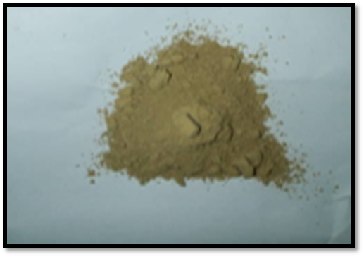
Figure 1: Photo of Tahoua merchant phosphate powder
II.1.2. Instruments Used
Sieving: -
After adding a small amount of water to the natural phosphate, the mixture was filtered through a 90-micrometer sieve.
Sedimentation: -
The natural phosphate was decanted after filtration using an IEC CENTRA-3E instrument.
Magnetic Separator: -
The separation of phosphate and metal oxides was carried out using a magnetic separator. This is commonly called a demagnetizer. The separator is shown in Figure 2.
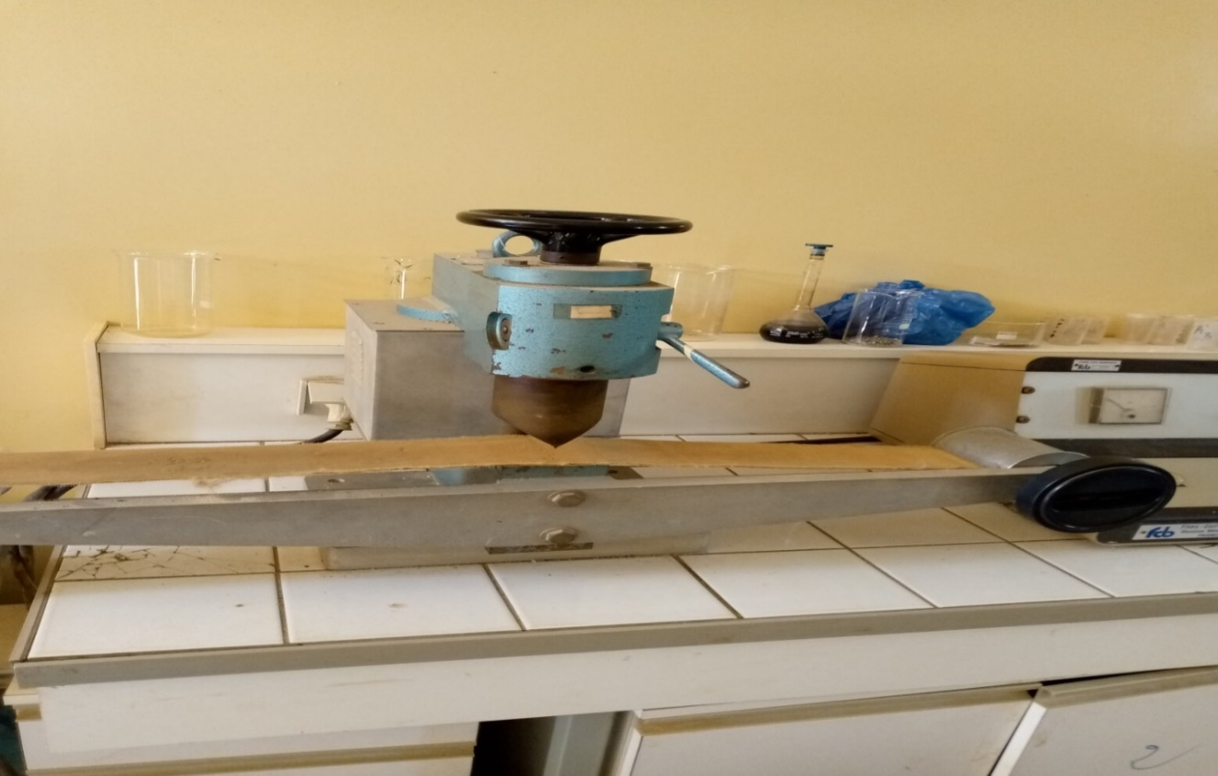
Figure 2: Photograph of a magnetic separator
II.2. Methodologies
Phosphate determination: -
Dissolved P₂O₅ levels were determined using an Evolution 300 spectrometer.
Total phosphorus
Total phosphorus encompasses all forms of phosphorus present in a phosphate sample, whether organic or mineral (BAIZE 2000). It therefore includes a mineral fraction and an organic fraction, representing percentages of 5 to 95% of the total phosphorus. A small amount is present in the phosphate solution (0.002 to 2 mg/L) (TARAFDAR and CLAASSEN, 2004). It represents the overall quantity of phosphorus in the given sample. Some authors have shown that the mineral fraction represents 50 to 70% of the total phosphorus and the organic phosphorus represents 25% (PEREDA CAMPOS, 2008 ; Mr. MIHOUB Adil., 2012).
A 0.50 g mass of finely ground ore, weighed using a precision balance (Precisa 205 A type), is placed in a previously dried 200 mL beaker. A few mL of distilled water are added, along with 7.5 mL of perchloric acid. The mixture is placed on a hot plate until all the white color disappears. After cooling, the mixture is transferred quantitatively into a 250 mL volumetric flask, after thoroughly rinsing the beaker with distilled water. The mixture is then homogenized and adjusted to the calibration mark. It is filtered through a pleated filter, discarding the first few mL of filtrate into a dry bottle. The filtrate is now ready for analysis. Finally, the dissolved phosphoric anhydride (P₂O₅) content was determined. To ensure the reproducibility of the results, these measurements were performed three times (B, Hani 2010). The dissolution reaction of phosphate by perchloric acid occurs in 3 stages:
Ca(PO₄)₂ + 2 HClO₄ → Ca (ClO₄)₂ + 2 CaHPO₄
3Ca²⁺ + 2PO₄³⁻ +2H⁺ +2ClO₄⁻ → Ca²⁺ + 2 ClO₄ ⁻ + 2 Ca²⁺ + HPO₄²⁻.
PO₄³⁻ + H⁺ → HPO₄² ⁻.
Water-soluble phosphate
In this analysis, the determination of the water-soluble P₂O₅ content, i.e., monocalcium phosphate and dicalcium phosphate. Water-soluble P₂O₅ is measured by spectrophotometry at a wavelength of 340 nm.
In a 250 mL volumetric flask, 0.25 g of commercial phosphate is introduced, and approximately 100 mL of distilled water is added. The mixture is stirred for about 20 minutes to dissolve the phosphate up to the 250 mL mark with distilled water. The mixture is then stirred to homogenize it. It is filtered through rapid filter paper, collecting the solution in a clean, dry plastic bottle (discard the first few milliliters of the filtered solution until a clear filtrate is obtained). The filtrate is ready for analysis. The P₂O₅ content was determined on the filtrate (B, Hani 2010).
III. Results and Discussion : -
III.1. Enrichment of natural phosphate from Tahoua
The purification of sedimentary phosphates is a technique for enriching the phosphate content and removing impurities. It allows for the removal of the few metallic elements present in natural phosphates in order to increase the percentage of phosphorus pentoxide. Natural phosphate underwent purely hydromechanical treatments in several stages before being used. In the first stage, the natural phosphate was transformed into a pulp by adding seawater in a beaker while stirring with a magnetic stirrer. The mixture was vigorously kneaded to obtain a homogeneous slurry. This slurry then passed through a very fine sieve with a diameter of 90 micrometers, which retained the water-insoluble calcium phosphate apatite. This operation eliminated non-essential particles consisting of clays. In the second stage, the product, now free of the clay fraction, was introduced into a centrifuge. The collected phosphate material is mixed with excess fresh water and then subjected to vigorous centrifugation to separate the insoluble matter, composed primarily of calcium phosphate, and to reduce the chlorine content, which originates mainly from seawater. The final stage of the treatment, after drying the resulting powder in open air and in an oven at 100-150°C for 24 hours, involves passing the treated product through a demagnetizing roller bench to reduce traces of metal oxides. After this demagnetization phase, we obtain a material consisting essentially of calcium phosphate, which we have named "phosphate," ready to dissolve in acids or distilled water. This process promotes an increase in the phosphorus pentoxide content of the phosphate. Through the description of the different steps, we observe that the treatment consists of separating the targeted calcium phosphate from other organic or mineral compounds that constitute impurities, which negatively influence the quality of the desired product during phosphate dissolution. Furthermore, no chemical treatment was carried out during this work. Therefore, the phosphate's structure remains unchanged. It retains its natural character as the final product obtained (Tchangbedji et al, 200). Next, the solubilization of different samples was carried out by acid or water treatment to determine the dissolved P₂O₅ content. Solubilization tests using water and perchloric acid allowed us to determine the total phosphorus content and the water-soluble phosphorus content.
III.1.1. Determination of the Specific Surface Area of ​​Tahoua Merchant Phosphate (PMT) and Purified Merchant Phosphate (PMP)
The specific surface areas of Tahoua merchant phosphate, after treatment, were determined using the Brunuer-Emmett-Teller (BET) technique. The specific surface area of ​​Tahoua merchant phosphate obtained was 487.250 m²/g, and that of purified phosphate was 695.864 m²/g. This demonstrates an increase in the specific surface area of ​​Tahoua merchant phosphate. The micropore volume of merchant phosphate before treatment was 0.410 cc/g, and after treatment without the use of any chemicals, it was 0.591 cc/g.
III.1.2. Scanning Electron Microscopy
These highly detailed images of Tahoua merchant phosphate (Figures 3 and 4) were obtained using scanning electron microscopy (SEM). These results show a granular structure of the phosphates. The black spots could correspond either to oxides such as Fe₂O₃, Al₂O_{3,} SiO₂, SrO, and CaO, or to the intergranular porosity of the rock. We therefore observed a higher concentration of black spots in Figure 3 and a lower concentration in Figure 4. This can be explained by the removal of several metallic oxides. These results are illustrated in Figures 3 and 4.
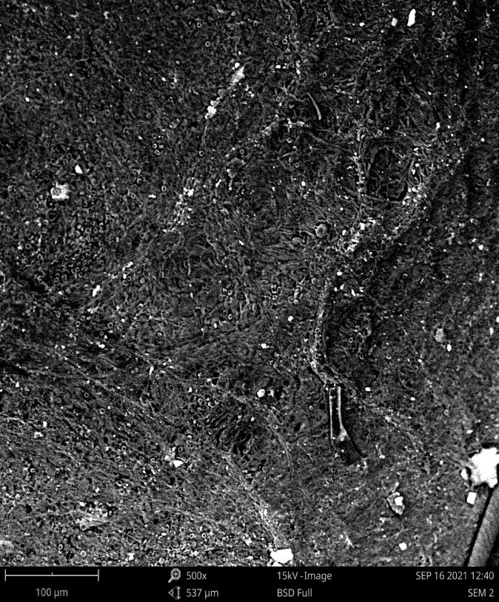
Figure 3: SEM images of merchant phosphate before treatment
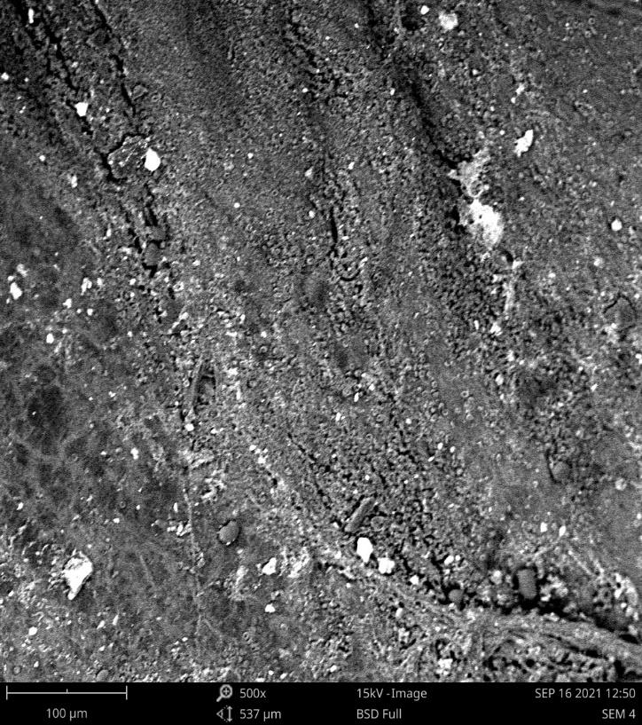
Figure 4: SEM images of phosphate after treatment
III.1.3. Determination of the chemical composition of phosphates
Three samples of Tahoua marketable phosphate and three 10g samples of purified marketable phosphate (PMP) powder were analyzed using an energy-dispersive X-ray fluorescence spectrometer (Minipal 4 model). The selected filters were Kapton for major oxides and Ag/Al-thin for trace elements and rare earths. The measurement time for each sample was 100 seconds, and the medium used was always air (G. Tchangbedji, G. Djeteli, K. A. Kili, O. A. Tchassanti, J., 2000). The average results are summarized in Table XVI. We observed an increase in the P₂O₅ content of the purified phosphate and a decrease in certain impurities such as Fe₂O₃ ; Al₂O₃ ; de SiO₂ ; TiO₂ and MgO. This can be explained by the removal of large portion of the metallic elements commonly referred to as impurities. These impurities prevent the valorization of phosphates and their direct use in agriculture (Cuney, M., 2004). The results obtained are more significant than those obtained through thermal treatment of commercial phosphate (Basirou, I., 2015). Studies have shown that the presence of impurities influences the solubility of phosphates (Ousmane, M.S., 2018; Gondah, I., 2020).

Table 1: Chemical composition of commercial and purified phosphate
Major elements in % |  |  | Trace elements in ppm
Oxides | Merchant phosphate | Purified phosphate | Metals | Merchant phosphate | Purified phosphate
CaO | 50,18 | 51,13 | Sr | 4579,02 | 3191,69
P₂O₅ | 20,13 | 33,80 | Sc | 41,667 | 212,18
Fe₂O₃ | 9,89 | 5,88 | Nb | 39,967 | 150,73
Al₂O₃ | 4,64 | 1,485 | Ba | - | 501,52
SiO₂ | 3,35 | 0,051 | Cu | 219,68 | 60,23
MnO | 0,931 | 2,751 | Zr | 301,96 | 200
MgO | 0,763 | 0 | Zn | 8,246 | 5,03
TiO₂ | 0,346 | 0,258 | Bi | - | 28,5
Na₂O | 0,081 | <0,001 | Hg | - | 3,869
K₂O | 0,048 | 0,151 | La | - | 0,48
LOI | 5,25 | 1,2 | Hf | 24,06 | 41,465
 |  |  | Pb | <0,01 | 225
 |  |  | Y |  | 21,25

III.1.4. Study of the Solubilization of Tahoua Merchant Phosphate and Purified Phosphate
Phosphate merchant in Tahoua is a sedimentary phosphate (G. Tchangbedji, G. Djeteli, K. A. Kili, O. A. Tchassanti, J., 2000). It is composed mainly of fluorapatite. The decomposition reaction of fluorapatite occurs on the surface of solid materials; it is a chemical reaction without a catalyst (Ousmane, M. S., 2018). The solubilization of several samples was carried out by treatment with perchloric acid and water at room temperature. This was evaluated by measuring the P₂O₅ content in the different filtrates collected after treatment. We will present and discuss the results of this study in the following paragraphs.
III.1.4.1. Dissolution of Purified Phosphate and Merchant Phosphate in Water
The dissolution of purified phosphate (PMP) and merchant phosphate (PM) was carried out by water treatment. The results are shown in Figure 5. This figure presents the P₂O₅ concentration of purified merchant phosphate and merchant phosphate from Tahoua.

Figure 5: Rate of P2O5 dissolved in distilled water

Analysis of these results indicates that the percentage of dissolved P₂O₅ in the purified commercial phosphate (17.44%) is more than double that of the natural Tahoua phosphate (7.48%). The solubilization rate achieved following purification is highly significant. This increase in the dissolved P₂O₅ content of the purified phosphate can be attributed, on the one hand, to an increase in the specific surface area of ​​the phosphate and, on the other, to the liberation of phosphate particles and the removal of a substantial portion of the impurities. Research by Akila D. and F. Zahia (2016) demonstrated that the increase in P₂O₅ content results from the liberation of phosphate particles following the removal of impurities. This leads to a significant consumption of H₃O⁺ ions within the medium, thereby enhancing the dissolution of the minerals (Basirou, I., 2015).

II.1.4.2. Dissolution of purified phosphate and commercial-grade phosphate in perchloric acid solution
We also conducted a study on the dissolution of purified phosphate and commercial-grade phosphate by dissolving them in perchloric acid under agitation for one hour. The results obtained are presented in Figure 6. This figure illustrates the evolution of total P₂O₅ in the purified phosphate and in the commercial-grade phosphate.
Figure 6: Dissolved P₂O₅ in Perchloric Acid
In view of these results, the dissolution rate of enriched phosphate and crude phosphate in the perchloric acid solution shows that the P₂O₅ level of purified phosphate has the highest dissolution rate than that of commercial phosphate. The dissolution rates of purified phosphate and commercial phosphate are 69.38% and 34.21%, respectively. This method is superior to the calcination of commercial phosphate from Tahoua dissolved in sulfuric acid (51.65%). This increase in the dissolved P₂O₅ content of purified phosphate can be explained by the increase in the specific surface area of ​​the purified phosphate, on the one hand, and, on the other hand, the release of phosphate minerals and the removal of ferrous matter and clays. Consequently, there is significant consumption of H₃O⁺ ions in the medium, leading to increased phosphate dissolution. Research has shown that the increase in P2O5 content is due to the release of phosphate particles and the increase in the specific surface area of ​​the ore (Claire, C., 2005) after the breakdown of carbonates and the removal of impurities. The solubilization rates we obtained after purification are higher than those obtained from several deposits in different countries (Akila, D., Zahia, F., 2016; FAO, 2013) for the dissolution of marketable phosphate from Tahoua, natural phosphate from Togo (Boujier, V., 2007), and natural phosphate from Algeria (Lassis, M., et al., 2015).
Conclusion
The purification techniques used in this study successfully eliminated impurities from the Tahoua marketable phosphate. The results show the removal of ferrous mass and clay from the phosphate sample. Characterization of the purified and marketable phosphate using BET (Bio-Electron Microscopy) revealed that the specific surface area increased from 487.250 m²/g for the marketable phosphate to 695.864 m²/g after purification, representing an increase of 208.614 m²/g. Furthermore, the micropore volume increased from 0.410 cc/g in the marketable phosphate to 0.591 cc/g in the purified phosphate, an increase of 0.181 cc/g. The marketable and enriched phosphate were analyzed by scanning electron microscopy. These results demonstrate the release of phosphate particles from the purified phosphate, unlike the more condensed black spots in the marketable phosphate. We also studied the dissolution of commercial and purified phosphates in perchloric acid and water. The results of the dissolved phosphorus analysis, expressed as a percentage of phosphoric anhydride (P₂O₅), showed that purified phosphate dissolves better than commercial phosphate in these media.

References
Akila, D., Zahia, F. (2016). The influence of heat treatment on the particle size distribution of beige phosphate ore from the Kef Es Sannoun Djebel Onk deposit. Master's thesis in mineral resource valorization. Abderrahmane Mira University, Bejaia.
Baize, D. (2000). Guide to soil analysis, 2nd ed., INRA, Paris. 280 pages.
Bassirou, I., Halidou (2015). Comparative study of the dissolution of natural phosphate from Tahoua in various mineral and organic acids. Master's thesis in inorganic chemistry, Abdou Moumouni University of Niamey. 60 pages.
Boujier, V. (2007). Influence of monohydrogen phosphate and fluorophosphate ions on the properties of phosphogypsum and the reactivity of phosphoplating. Doctoral thesis in process engineering. National School of Mines of Saint-Étienne
Claire, C., (2005). Experimental study of the kinetics and alteration mechanisms of apatitic minerals. Application to the behavior of a ceramic for confining minor actinides. Doctoral thesis, University of Toulouse III, in experimental geochemistry. Pascal de Clermont-Ferrand (France). 158p
Cuney, M., (2004). “Factors controlling the nature and concentration of impurities in sedimentary phosphates”, Covaphos I (ed), proceedings of the first international conference on the valorization of phosphates and phosphorus compounds, pp. 11-14
Franconi, A., J. Julien and I. Zibo, (1983). Mineral map of the Republic of Niger, Volume IV, Part 1. Specific study of the main mineral substances and their geological context, 725p.
G. Tchangbedji G. Djeteli K. A. Kili, O. A. Tchassanti, J. (2000). Extraction of some metallic elements from natural phosphates (apatites) by particle size analysis and demagnetization: Case of the phosphates of / hahotoé (logo)". Scientific Research of the University of Burkina Faso (Togo). 4 (1), 5 Pages
Gondah, i, (2020). Effect of heat treatment on the solubility of natural phosphate from Tahoua in sulfuric acid and citric acid. Master's thesis at Abdou Moumouni University of Niamey. 52 p
Jacques SAWADOGO1*, Yitcherpin Naomi Rebecca BADOLO2, Sogo Bassirou SANON1, Abalo-Esso MAGAMANA3, Hama DIALLO1, Adama COULIBALY4 (2025). Effect of phosphate fertilization on cowpea [Vigna unguiculata (L.) Walp] production in the northern Sudanian zone of Burkina Faso. https://doi.org/10.64707/revstsna.v44i2.2155
Lassis, M., A. Mizane, N. Dadda, R. Rehamnia, (2015). Dissolution of djebel onk phosphate ore using sulfuric acid. ENMM-20; no., p. 5.
M. Mihoub, Adil., (2012). Phosphorus dynamics in the soil-plant system under Saharan pedoclimatic conditions. Master's thesis in agronomic sciences at Kasdi Merbah University, Ouargla. 101 pages.
Food and Agriculture Organization of the United Nations (FAO, 2013). Use of natural phosphates for sustainable agriculture. FAO Fertilizers and Plant Nutrition Bulletin. Mining of natural phosphates in Khouribga, Morocco.
Ousmane Mahamane Sani, Zanguina Adamou, Natatou Ibrahim. (2017). Treatment of Natural Phosphates from Tahoua (Niger) with Some Conventional Acids.
PEREDA CAMPOS M.V., (2008). Contribution to the study of phosphate transporters of the PHT1 family in Poplar (Populus trichocarpa Torr. & Gray) and the ectomycorrhizal fungus Laccaria bicolor (Maire) P. D. Orton. Doctoral thesis. Plant and Forest Biology. Nancy (France), 141 pages.
SAWADOGO J., KABORE R.F.W.-P., OUIYA A., SAVADOGO C.A., BOUGOUMA M. and LEGMA J.B. (2024). Optimization of the chemical properties of a hydromorphic soil in the central region of Burkina Faso. Afrique SCIENCE, 25 (4), 15-24. https://doi.org/http://www.afriquescience.net
TARAFDAR J.C., CLASSEN N., (2004). Adsorption behaviors of inorganic and organic sources of phosphorus in soils. Agrochemica, (VXLVIII) 12: 42-49 Pages.
Valyasko V. M., Kogardo L. N., Khodakovsky I. L (1968)., Stability of fluorapatite, chlorapatite and hydroxyapatite in aqueous solutions at different temperature. Goech. Inter., 5, (1968), p. 21-30.

