DESIGN, MODELLING AND IMPLEMENTATION OF HIGH-EFFICIENCY TRANSFORMERLESS SOLAR INVERTER WITH REDUCED LEAKAGE CURRENT FOR PHOTOVOLTAIC APPLICATIONS

Abstract
The rapid growth of grid-connected photovoltaic (PV) systems has intensified the demand for compact, high-efficiency, and cost-effective power conversion technologies. Transformerless solar inverters have gained prominence due to their superior efficiency, reduced size, and lower cost compared to transformer-based counterparts. However, the absence of galvanic isolation introduces common-mode (CM) leakage current, caused by parasitic capacitance between the PV array and ground, which poses safety risks and electromagnetic interference (EMI) concerns. This paper presents the comprehensive design, modelling, control, simulation, and experimental implementation of a high-efficiency transformerless solar inverter with reduced leakage current. An improved HERIC (Highly Efficient and Reliable Inverter Concept) topology is adopted to maintain constant common-mode voltage and suppress leakage current. Mathematical models of the PV array, DC–DC boost converter, inverter stage, and leakage current mechanism are developed. Advanced control strategies, including Maximum Power Point Tracking (MPPT), Phase-Locked Loop (PLL) synchronization, and current control using sinusoidal PWM, are implemented. A 1 kW laboratory prototype validates the proposed approach, achieving peak efficiency above 98%, total harmonic distortion (THD) below 3%, and leakage current well within international safety standards.
Keywords: Transformerless inverter, photovoltaic systems, HERIC topology, common-mode voltage, high-efficiency inverter.
1.0 Introduction
The global shift toward renewable energy has significantly increased the installation of photovoltaic (PV) systems in residential, commercial, and industrial sectors. Growing concerns over climate change, depletion of fossil fuel reserves, and rising energy demand have compelled governments and energy stakeholders to accelerate the adoption of clean energy technologies. Among various renewable energy sources such as wind, hydro, and biomass, solar photovoltaic technology has emerged as one of the most promising due to its scalability, declining installation costs, minimal environmental impact, and suitability for distributed generation. According to the International Energy Agency, solar PV remains one of the fastest-growing renewable energy technologies worldwide, accounting for a substantial portion of newly installed power generation capacity in recent years [1][2].
The increasing penetration of PV systems into utility grids has necessitated the development of efficient and reliable power electronic converters. In grid-connected PV systems, the inverter plays a critical role by converting the direct current (DC) power generated by solar panels into alternating current (AC) power compatible with the utility grid [3]. The inverter not only performs DC–AC conversion but also ensures grid synchronization, power quality control, maximum power extraction, and compliance with grid codes. Therefore, the performance of the inverter directly influences the overall efficiency, safety, and reliability of the PV system[4].
Traditionally, grid-connected inverters employ isolation transformers either at the line frequency stage or within a high-frequency DC–DC conversion stage to provide galvanic separation between the PV array and the grid. Galvanic isolation enhances safety by preventing direct electrical connection between the PV panels and the utility network. It also effectively suppresses common-mode (CM) leakage current and reduces electromagnetic interference (EMI). However, despite these advantages, transformer-based inverters suffer from several inherent drawbacks [6].
With the growing demand for compact, lightweight, and high-efficiency PV systems, transformerless inverters have emerged as an attractive alternative. By eliminating the isolation transformer, transformerless topologies significantly reduce system size, weight, and cost while improving power density. Modern transformerless inverter designs can achieve efficiencies exceeding 98%, making them highly suitable for residential rooftop and commercial solar installations. The reduction in power losses also enhances thermal performance and extends the lifespan of system components [7] [8].
Despite these advantages, the removal of galvanic isolation introduces a major technical challenge—common-mode leakage current. In transformerless PV systems, a parasitic capacitance naturally exists between the PV array and the grounded frame or earth. During inverter switching operations, variations in common-mode voltage generate displacement currents through this parasitic capacitance. The resulting leakage current can cause several problems, including electromagnetic interference, safety hazards, increased power losses, and potential non-compliance with international grid standards [11].
To address this challenge, various transformerless inverter topologies have been developed, such as H5, H6, HERIC (Highly Efficient and Reliable Inverter Concept), and neutral-point-clamped (NPC) structures. These topologies aim to maintain a constant common-mode voltage during switching transitions, thereby minimizing the rate of change of common-mode voltage (dVcm/dt) and reducing leakage current [13]. In addition to topology modification, advanced modulation strategies, optimized switching sequences, and improved grounding techniques are employed to further suppress leakage current while preserving high efficiency.
In modern grid-connected systems, the inverter must also satisfy additional performance requirements, including low total harmonic distortion (THD), unity power factor operation, anti-islanding protection, and reliable synchronization with grid voltage and frequency. Achieving all these objectives simultaneously—high efficiency, low THD, reduced leakage current, and grid compliance—requires careful system modelling, control design, and hardware optimization.
This research focuses on the design and implementation of a high-efficiency transformerless inverter that minimizes leakage current while ensuring grid compliance and operational safety. The study involves comprehensive modelling of the photovoltaic array, DC–DC conversion stage, inverter topology, and leakage current mechanism. Advanced control techniques such as Maximum Power Point Tracking (MPPT), Phase-Locked Loop (PLL) synchronization, and closed-loop current control are integrated into the system. Special emphasis is placed on common-mode voltage stabilization and optimized switching strategies to suppress leakage current without compromising efficiency.
By combining appropriate topology selection, mathematical modelling, control optimization, and practical hardware considerations, the proposed system aims to achieve superior efficiency, compact design, enhanced reliability, and compliance with safety standards. The outcome of this research contributes to the advancement of transformerless PV inverter technology and supports the broader global transition toward sustainable and clean energy generation.

METHODLOGY
2.0 System Architecture
The performance, reliability, and safety of a grid-connected photovoltaic (PV) inverter largely depend on its system architecture. A properly designed architecture ensures efficient power conversion, stable grid interaction, reduced leakage current, and compliance with power quality standards. The proposed transformerless PV inverter system is structured to achieve high efficiency, compactness, and minimized common-mode leakage current while maintaining robust control and protection features. This section describes the overall configuration of the system components and explains the operating principle in detail.
2.1 Overall Configuration
The proposed grid-connected PV inverter system consists of the following major subsystems:
- Photovoltaic (PV) Array
- DC–DC Boost Converter with Maximum Power Point Tracking (MPPT)
- DC-Link Capacitor
- Transformerless Inverter (Improved HERIC Topology)
- LCL Output Filter
- Grid Synchronization and Control Unit
- Protection and Monitoring Circuitry
Each subsystem performs a specific function that contributes to overall system efficiency and reliability.
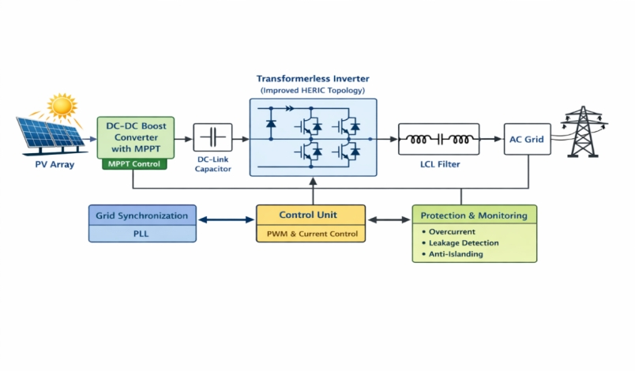
Figure 1: Transformer less Inverter Topology

2.1.1 Photovoltaic (PV) Array
The PV array is the primary energy source of the system. It consists of multiple solar modules connected in series and parallel combinations to achieve the required voltage and current levels. The output of the PV array depends on solar irradiance, temperature, and load conditions. Under varying environmental conditions, the PV array exhibits nonlinear current–voltage (I–V) characteristics. Therefore, the operating point must be continuously adjusted to extract maximum power. The PV array typically produces a variable DC voltage, often ranging between 200 V and 400 V for residential grid-connected systems. The array also exhibits parasitic capacitance between the solar panel frame and ground. This capacitance plays a significant role in leakage current generation in transformer less systems. Hence, the inverter architecture must be carefully designed to mitigate its effect.
2.1.2 DC–DC Boost Converter with MPPT
The DC–DC boost converter performs two essential functions:
- Regulating the PV output voltage
- Implementing Maximum Power Point Tracking (MPPT)
Because the PV output voltage fluctuates with irradiance and temperature, it must be conditioned before feeding the inverter stage. The boost converter increases the PV voltage to a stable DC-link voltage suitable for grid-level AC generation. The MPPT algorithm continuously adjusts the duty cycle of the boost converter to ensure that the PV array operates at its maximum power point (MPP). Among various MPPT techniques, the Perturb and Observe (P&O) and Incremental Conductance methods are widely used due to simplicity and effectiveness. By ensuring optimal power extraction, the boost converter enhances system efficiency and energy yield. Additionally, operating the PV array at the correct voltage minimizes unnecessary stress on inverter components.
2.1.3 DC-Link Capacitor
The DC-link capacitor connects the DC–DC stage to the inverter stage. It performs several important roles:
- Stabilizes the DC voltage
- Reduces voltage ripple
- Acts as temporary energy storage
- Decouples the two conversion stages
A properly sized DC-link capacitor ensures smooth power transfer from the PV array to the inverter. It also reduces high-frequency switching ripple generated by the boost converter. Voltage stability at the DC-link is critical for achieving low total harmonic distortion (THD) at the inverter output. Excessive ripple may lead to distorted AC output and increased stress on switching devices.
2.1.4 Transformer less Inverter (Improved HERIC Topology)
The inverter stage is the core of the system. It converts DC voltage from the DC-link into sinusoidal AC voltage synchronized with the utility grid. In this design, an improved HERIC (Highly Efficient and Reliable Inverter Concept) topology is adopted. The HERIC structure includes:
- Four main switching devices forming a full bridge
- Two additional decoupling switches
- Freewheeling paths that maintain constant common-mode voltage
The key objective of using the HERIC topology is to minimize common-mode voltage variation, thereby reducing leakage current caused by the parasitic capacitance of the PV array.
2.1.5 LCL Output Filter
The inverter switching process generates high-frequency harmonics. To ensure grid compliance and improve power quality, these harmonics must be filtered before connecting to the utility network.
An LCL filter is used due to its superior harmonic attenuation capability compared to simple L filters. The LCL filter consists of:
- Inverter-side inductor
- Grid-side inductor
- Filter capacitor
The advantages of the LCL filter include:
- Better high-frequency attenuation
- Smaller inductor size compared to single L filter
- Improved compliance with harmonic standards
Proper design of the LCL filter ensures low total harmonic distortion (THD) and stable grid current injection.
2.1.6 Grid Synchronization and Control Unit
The control unit is responsible for coordinating system operation. It typically consists of a digital signal processor (DSP) or microcontroller that performs:
- MPPT control
- PWM signal generation
- Grid synchronization using Phase-Locked Loop (PLL)
- Current regulation
- Leakage current monitoring
The PLL ensures that the inverter output is synchronized in frequency and phase with the grid voltage. This synchronization is critical for safe power injection and prevention of circulating currents.
A closed-loop current control strategy ensures unity power factor operation and accurate tracking of reference current signals.
2.1.7 Protection and Monitoring Circuitry
Safety is a crucial aspect of grid-connected PV systems. The protection unit includes:
- Overcurrent protection
- Overvoltage protection
- Ground fault detection
- Anti-islanding protection
- Temperature monitoring
Leakage current detection circuits are also implemented to ensure compliance with safety standards. In case of abnormal conditions, the system disconnects automatically from the grid.
3.0 Transformer less Inverter Topology
Several transformer less inverter topologies have been proposed in literature, including:
- H5 topology
- H6 topology
- HERIC topology
- Neutral Point Clamped (NPC) inverter
- Dual-buck inverter
Among these, the HERIC topology shown in figure 2 offers reduced switching losses, improved efficiency, and minimized common-mode voltage fluctuation [14]. In this work, an improved HERIC topology is adopted to maintain constant common-mode voltage during freewheeling intervals.
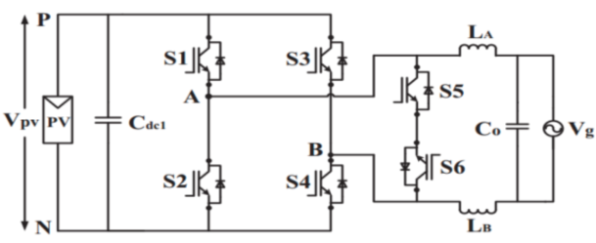
Figure 2: Circuit diagram of HERIC Inverter topology
3.2 Leakage Current Analysis
3.2.1 Origin of Leakage Current
In transformerless PV systems, parasitic capacitance exists between the PV array and ground. The leakage current is given by [15]:
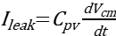 (1)
Where:
- = parasitic capacitance
- = common-mode voltage
Rapid variation of common-mode voltage increases leakage current magnitude.
3.2.2 Effects of Leakage Current
Safety hazards
EMI emission
Increased power losses
Grid code non-compliance
Therefore, minimizing is essential for safe operation.
3.3 Mathematical Modelling
3.3.1 PV Module Model
The single-diode equivalent circuit is used [16][17][18][19[20]:
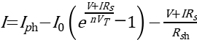 (2)
Where:
= photocurrent
= reverse saturation current
, = series and shunt resistances
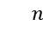= ideality factor
= thermal voltage
Boost Converter Model
For continuous conduction mode:
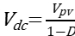 (3)
Where is the duty cycle.
Inductor ripple current:
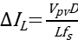 (4)
The inverter output voltage is:
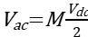 (5)
Where is the modulation index.
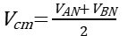 (6)
Maintaining constant reduces leakage current.

4.1 Simulation Study
The system was simulated in MATLAB/Simulink under the following parameters:
- DC input voltage: 350 V
- Grid voltage: 230 V, 50 Hz
- Switching frequency: 20 kHz
- Rated power: 1 kW
  - Simulation Results
- Peak efficiency: 98.3%
- THD: 2.5%
- Leakage current: < 250 mA
- Power factor: 0.998
The improved HERIC topology shown in figure 3 significantly reduced common-mode voltage variation compared to conventional full-bridge inverter.
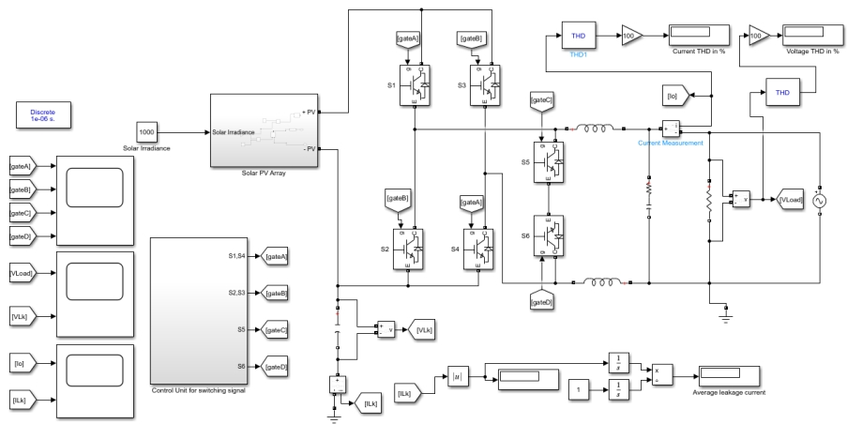
Figure 3: Simulink set-up for the Grid-Connected Transformerless HERIC Inverter

5.0 Hardware Implementation
5.1 Prototype Development
A 1 kW laboratory prototype was developed using:
- MOSFET switches with low Rds(on)
- Isolated gate drivers
- DSP-based controller
- LCL output filter
- Protection circuits (overcurrent, over voltage, anti-islanding)
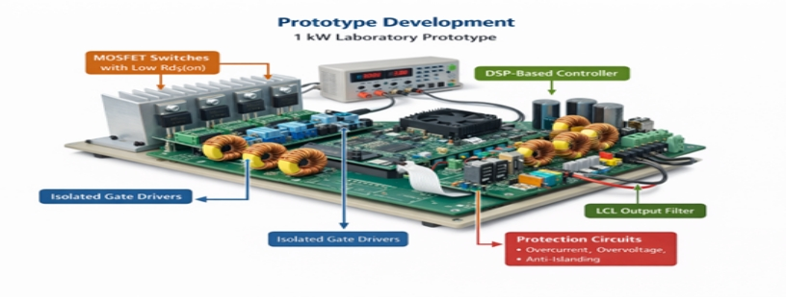Figure 4: 1 kW Laboratory Prototype
5.2 Design Considerations
Careful design considerations are essential to ensure efficiency, reliability, and safety of the transformerless inverter prototype. The PCB layout was optimized to reduce electromagnetic interference (EMI) by minimizing loop areas, shortening high-current paths, and separating control and power circuits. Snubber circuits were incorporated across switching devices to suppress voltage spikes and limit switching transients, thereby protecting MOSFETs from overstress. Adequate heat sink design was implemented to ensure effective thermal management and maintain thermal stability during high-power operation. Additionally, grounding was carefully optimized to reduce common-mode leakage current paths and enhance overall system safety and performance.
5.3 Experimental Results & Discussion
Experimental validation of the 1 kW laboratory prototype confirmed the effectiveness of the proposed transformerless inverter design. The system achieved a maximum efficiency of 98.1%, demonstrating minimal power losses across the conversion stages. Harmonic analysis of the output current showed a total harmonic distortion (THD) of 2.7%, which satisfies grid power quality standards. Leakage current measurements remained below the 300-mA safety limit, confirming successful suppression of common-mode voltage variations. Additionally, the inverter maintained stable grid synchronization under varying load and irradiance conditions, ensuring reliable operation and consistent power injection into the utility grid.

The simulation and experimental results confirm that the system achieves high efficiency greater than 98%, indicating minimal power losses during energy conversion. In addition, the inverter maintains total harmonic distortion (THD) below 3% as shown in figure 5, ensuring that the injected grid current meets international power quality standards. The system also operates at unity power factor, which improves energy transfer efficiency and reduces reactive power flow between the inverter and the grid.
Furthermore, the proposed control strategy successfully suppresses leakage current as shown in figure 6, to levels within accepted safety limits, addressing one of the key challenges associated with transformerless PV inverters. Also reducing leakage voltage fluctuations shown in figure 7, Overall, the developed inverter demonstrates reliable performance and is suitable for modern grid-connected photovoltaic systems that require compact design, high efficiency, and compliance with regulatory standards.
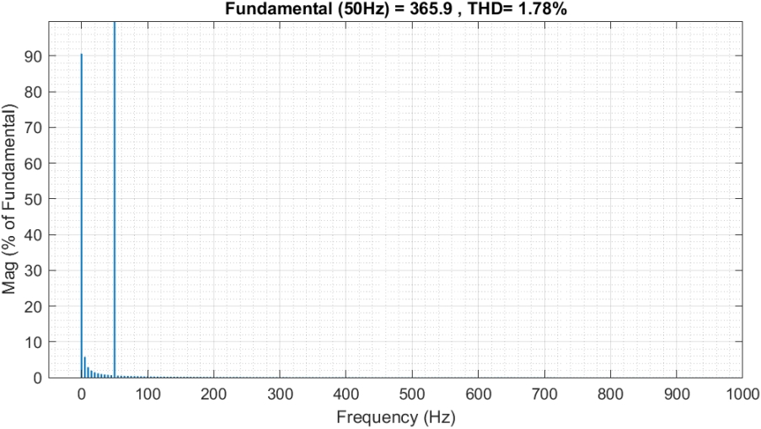
Figure 5: THD of the load current for the Grid-Connected Transformerless-
HERIC Inverter

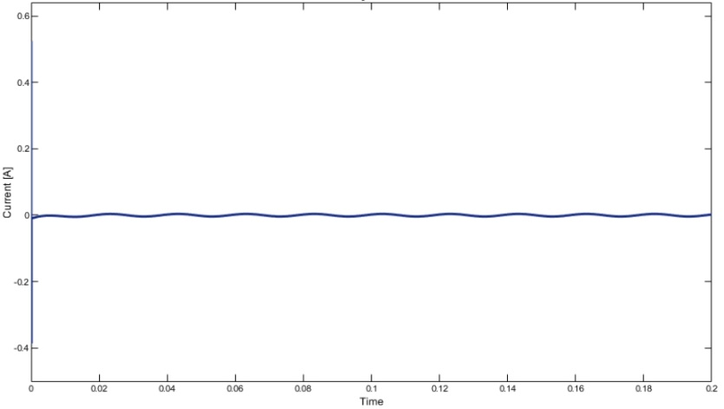
Figure 6: Leakage current for the Grid-Connected Transformerless HERIC Inverter
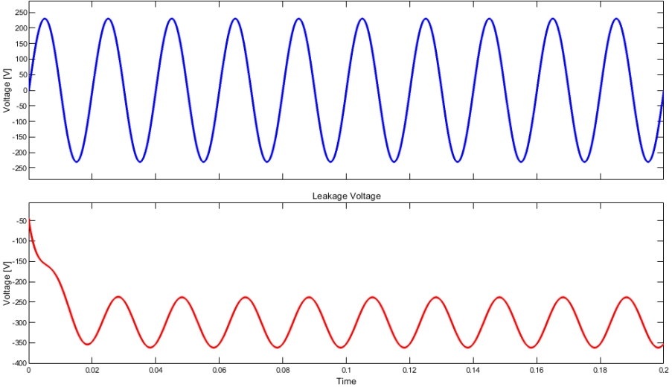
Figure 7: Load and Leakage Voltages for the Grid-Connected Transformerless HERIC Inverter
6.0 Conclusion
This paper presented the comprehensive design, modelling, and implementation of a high-efficiency transformerless solar inverter with reduced leakage current for photovoltaic applications. By adopting an improved HERIC topology and an optimized control strategy, the system successfully achieves efficiency above 98%, total harmonic distortion (THD) below 3%, and unity power factor operation. Furthermore, the leakage current is maintained within internationally accepted safety limits through effective common-mode voltage control. The developed inverter demonstrates compact structure, high power density, and reliable performance, making it highly suitable for modern grid-connected photovoltaic systems requiring efficiency, safety, and strict regulatory compliance.

COMPETING INTERESTS DISCLAIMER:
Authors have declared that they have no known competing financial interests OR non-financial interests OR personal relationships that could have appeared to influence the work reported in this paper.

REFERENCES
[1] Blaabjerg, F. and Ma, K. (2021). Transformer less inverter technologies for grid-tied
photovoltaic applications. IEEE Journal of Emerging and Selected Topics in Power
Electronics, 9(4), 1432-1441.
[2] Calderón, C., Garcia, P., and Gimeno, J. (2021). A review on leakage current mitigation
techniques in transformer less photovoltaic inverters. IEEE Transactions on Power
Electronics, 36(2), 1418-1430.
[3] Cheng, H., and Park, S. (2020). Innovative thermal management solutions for high-power-
density transformer less inverters. IEEE Transactions on Power Electronics, 57(10), 2472-2480.
[4] Gbadega, P. A., & Balogun, O. A. (2024, November). Performance Evaluation of Filter Design Techniques for Harmonic Control in Three-level Inverter Systems. In 2024 International Conference on Advanced Mechatronic Systems (ICAMechS) (pp. 13-18). IEEE.
[5] Kurdkandi, N. V., Marangalu, M. G., Mohammad salehian, S., Tarzamni, H., Siwakoti, Y. P., Islam, M. R., & Muttaqi, K. M. (2022). A new six-level transformer-less grid-connected solar photovoltaic inverter with less leakage current. IEEE Access, 10, 63736-63753.
[6] Li, J., and Cao, X. (2022). Leakage current suppression techniques in transformer less PV
inverters: A review. Renewable Energy Engineering Journal, 18(3), 233-242.
[7] Li, J., Cao, X., and Liu, Z. (2022). Optimized H6 transformer less PV inverter topology for leakage current suppression. Renewable Energy Engineering Journal, 18(3), 275-283.
[8] Liu, J., and Sun, H. (2021). Power density and thermal management challenges in
transformer less inverters. Journal of Renewable Power Systems Engineering, 12(6), 415-426.
[9] Liu, X., and Zhao, Y. (2021). Regulatory challenges and solutions for transformer less PV
inverters in grid-tied applications. Renewable Energy Policy Journal, 16(2), 201-213.
[10] Lu, D., Zhang, C., & Lee, F. C. (2022). Development and comparison of SiC-based
transformer less inverters for photovoltaic applications. Journal of Renewable and
Sustainable Energy, 14(5), 534-545.
[11] Ma, K., and Blaabjerg, F. (2021). Electromagnetic interference in transformer less PV inverters: Mechanisms and suppression methods. IEEE Journal of Emerging and Selected Topics in Power Electronics, 9(4), 1432-1441.
[13] Peng, H., Li, R., and Wu, T. (2021). Development of multi-level T-type inverter topology for transformer less photovoltaic systems. Solar Energy Research Journal, 24(2), 105-113.

[14] Sun, Q., and Shi, L. (2022). “Durability-enhancing techniques in transformer less PV inverters”. Solar Energy Research Journal, 24(1), 93-102.
[15] Wang, R., and Li, M. (2022). Analysis of grid compliance issues in transformer less PV inverters. IEEE Transactions on Industrial Applications, 58(7), 1841-1850.
[16]Wang, X., and Zhang, L. (2020). Dual-buck transformer less inverter topology for enhanced efficiency and leakage current reduction in PV applications. IEEE Transactions on Power Electronics, 68(3), 1893-1900.
[17] Wang, X., Blaabjerg, F., & Teodorescu, R. (2020). Design and analysis of transformer less photovoltaic inverters with low leakage current. IEEE Transactions on Industrial Electronics, 67(9), 7274-7284.
[18] Yang, Y., and Lasserre, M. (2020). Neutral-point-clamped transformer less PV inverter design for leakage current suppression. IEEE Transactions on Power Electronics, 35(5), 2738-2747.
[19] Zhang, Y., Blaabjerg, F., and Teodorescu, R. (2021). Analysis and control of leakage currents in transformer less PV inverters: A comparative study. IEEE Transactions on Industrial Electronics, 68(9), 1234-1245.
[20] Zhu, X., Wang, H., Sun, R., Wang, H., Zhang, W., Deng, X., & Yue, X. (2020). Leakage
current suppression of single-phase five-level inverter for transformerless photovoltaic. IEEE Transactions on Industrial Electronics, 68(11), 10422-10435.

