The Physical Properties of Vanadium(V)-Rhodium(Rh)-Tellurium(Te), and Vanadium(V)-Ruthenium(Ru)-Antimony(Sb) are Investigated using First-Principles Calculation

Abstract
This work investigated the structural, mechanical, thermodynamic, and phonon characteristics of Vanadium-Rhodium-Tellurium (VRhTe) and Vanadium-Ruthenium-Antimony (VRuSb) compounds by first-principles calculations grounded on density functional theory (DFT). The computations were performed under the generalised gradient approximation (GGA) utilising the Perdew–Burke–Ernzerhof (PBE) functional as processed in the Quantum ESPRESSO software package. The optimised structures indicated that both compounds crystallise in cubic Heusler-type (Fm–3m) symmetry and display thermodynamic stability, as proved by their negative formation energy and absence of structural distortions. The lattice parameter of VRuSb was slightly higher than that of VRhTe owing to the larger atomic radius of Sb. The results revealed that the Pugh's ratio for VRhTe is 11.94, whereas for VRuSb has the value 2.67, this demonstrates the compounds VRhTe, and VRuSb are ductile. The Poisson's ratio (ⱱ > 0.3) signifies the metallic bonding characteristics of the materials. The findings revealed that VRhTe has a higher dynamic heat capacity (C_{v}) than VRuSb, suggesting that VRhTe is more suitable for use in optoelectronic devices. The thermal conductivity of a substance is been determined by the debye temperature. The materials suggest improved thermal conductivity at the debye temperature. Meanwhile, at high temperature the Dulong and Petit law agrees with the specific heat capacity of the heusler materials and adheres to the T³ rule as the temperature decreases. The heusler compounds reveals phonon dynamical stability as the frequencies and the phonon density of ststes are positives.

Keywords: Structural, Mechanical, Thermodynamic, and Phonon

1. INTRODUCTION
The continuous advancement in materials science and solid-state physics has been greatly driven by the quest to design and discover new compounds with exceptional physical properties suitable for advanced technological applications [1].Transition metals and their intermetallic compounds occupy a special place in this regard because of their diverse electronic structures, mechanical robustness, and catalytic properties. In particular, compounds involving Vanadium (V), Rhodium (Rh), and Ruthenium(Ru) have allure significant awareness due to their relevant thermal stability, corrosion resistance, and wide range of oxidation states, rendering them suitable for applications in electronics, catalysis, energy storage, and thermoelectric devices [2].
Vanadium is known as a 3d transition metals, and for its capacity to form diverse oxidation states and compound, that manifest semiconducting, metallic, and superconducting characteristic. Rhodium is known as a 4d transition metal, it is one of the important nobles metals, essentially due to it uniqueness catalystic effectiveness and chemical passivity. The combination of P-block atoms such as tellurium(Te), and antimony(Sb); these transition metals can form ternary material with captivating electronic configurations, which could be useful compounds for spintronic, or thermoelectric application [4, 5].
Te and Sb frolic important roles in modulating the electronic structure of transition metal materials[6]. Tellurium , an oxigen group, denotes graetly localized P-states that can affect the band gap and conductivity. Additionally, antimony is a element in group 15, which improves thermodynamic performance by altering carrier mobility and DOS close to the fermi level[7, 8]. The combination of V, Rh Ru, Te, and Sb atoms can give birth to a novel materials with amplify electrical conductivity, efficient temperature performance, and mechanical stability.
Irrespective of the relevant of the compounds, limited information on the half heusler alloys (VRhTe, and VRuSb) system. The physical characteristic remain largely understudied experimental and theoretically[9]. The setback linked to the experimental synthesis and characterization of these materials, first principles calculations base on DFT offer an sufficient and reliable means to forecast and examine their rudiment properties from atomic scale interaction [10].
DFT approach has become influential software for investigating noval materials by providing precise information into crystal structure, bonding nature, electronic characterizatic, mechanical stability, and thermodynamic features. By adopting this computational tool, it is possible to forecast and interpret the stability, ductility, and conductivity of the compounds before they are synthesized in the laboratory [11].
Ab-initio density functional theory methodology have become essential techniques in understanding and forecasting the structural, elastic, and lattice constants characteristic of a mterials. This computational method permit reseaerchers to traverse materials that are tough to synthesis or investigate experimentally, providing informations into bonding mechanisms, electronic transitions, and thermodynamic stoutness [12, 13].
Research on transition metal-based intermetallic materials have signify that their heusler properties can be moderated constructively through the replacemnent of different elements, leading to compounds with unique electrical and mechanical characteristic. To be specific vanadium-based compounds have gained neccessary attention due their wide oxidation states, well built bonding features, and capacity to configurate stable structure with both semiconducting and metallic characterizatic [14]. For instants, vanadium tellurides (such as VTe and V₂Te₃) possesses relevant electronic features, including metallic conduction and magnetoresistance effects, making them possible condidates for thermoelectric and spintronic application [15].
Furthermore, rhodium-containing compounds have been widely studied because of their excellent catalytic and corrosion resistant properties. Rhodium configuration stable alloys and intermetallics with tarnsition and post tarnsition metals, which possess improved thermal and elastic constants stability [16]. Rhodium tellurides and antimonides, such as RhTe and RhSb₃, have demonstrated outstanding electrical conductivity and thermal equilibrium, characterizatic that are vital for high temperature thermoelectric components. [17].
Tellerium and antimony are both groups 13 through 18 of the periodic table elements that consequentially impact the structural and electronic features of transition metals materials. Tellerium containing materials often reveal strong spin-orbit couplig effects, minimal band gap, and high electrical conductivity [18]. Due to their high seebeck values and low heat conductivity, antimony-based compounds like CoSb₃ and FeSb₂ have been extensively studied as thermodynamic materials [19].
Previous theoretical research on ternary and quaternary compounds remain constrained, although similar materials have been investigated [20]. Meanwhile [21] reported that Rh-containing Heusler alloys possess outstanding ductility and thermal equilibrium. These outcome forcast that the combination of V, Rh, and groups 13 through 18 of the periodic table elements could yield compounds with advantageous mechanical and elastic constants properties compatable for structural requisition.
The mechanical and thermodynamic characteristic of these materials is equally essential for investigating their compactibility for experimental application. Elastic constant properties gotten from DFT calculations provide details into the stability and ductility of the materials [22]. A high ratio of bulk modulus to shear volume (B/G > 1.75) in the mechanical properties often denote ductility features. Additionally, thermodynamic features like debye temperature, specific heat, and entropy are essential in studying lattice vibrations, and phonon interactions, which influences stability and conductivity of the thermal behavior at high temperature [23].
Irrespective of the numerous literature on binary and ternary intermetallic materials, no comprehensive DFT research has been reported of the half-heusler compounds VRhTe, and VRuSb. Their prospects as metallic and thermoelectric materials remains unvestigated. This project aims to explore the deficiency by providing a thorough theoretical research of their structural, mechanical, thermodynamic, and phonon charateristic using DFT-based first principles approach.

2. MATERIALS AND METHOD

This study employed ab-initio calculation rooted in DFT as contained in Quantum ESPRESSO computational tool [24]. The Generalised Gradient Approximation (GGA) in the Perdew-Burke-Ernzerhof (PBE) expression concisely designate the exchange correlation interactions among electrons [25] was applied. The pseudopotential technique was applied to effectively designate the ion-electron interactions. A plane-wave energy cutoff of 600 eV was adopted for all materials to secured the convergence of total energy and forces.
The elastic parameters (C₁₁, C₁₂, and C₄₄) were deduced through stress-strain interconnection during average deformations. The simulated lattice parameters (C₁₁, C₁₂, and C₄₄) were therefore applied to assess the polycrystalline mechanical moduli through the Voigt–Reuss–Hill averaging approach [22].
Mechanical balance was substantiated based on Born’s stability criteria for cubic crystals:
$C_{11}>0;C_{44}>0;C_{11}-C_{12}>0;C_{11}+2C_{12}>0$ (1)
The thermodynamic characteristics, including Debye temperature (Θ_{D}), specific heat (C_{v}), and entropy (S), were computed using the quasi-harmonic Debye model as implanted in the GIBBS2 algorithm [23]. The model examined the vulnerability the dependence of vibrational frequencies on volume, enabling the investigation of temperature-dependent properties under dissimilar pressures.
The Debye temperature (Θ_{D}) was simulated from the average sound velocity, which is predictabe upon elastic moduli, as follows:

$Θ_{D}=\frac{h}{K_{B}}{\left(\frac{3n}{4πV}\right)}^{1/3}ν_{m}$ (2)
In equation (1), h represents Planck’s constant, k_{B} denotes Boltzmann’s parameter, n signifies the number of atoms per formula unit, V_{m} marks the atom volume, and ⱱ_{m} denote the mean sound velocity derived from longitudinal and transverse elastic wave velocities.
Convergence assessment was carry-out to verify numerical accuracy about plane-wave cut-off energy and k-point mesh density. Energy variation below 1meV/atom were considered acceptable for convergence. Additionally, all findings were ratified using DFT code calculations documented in the literature to verify consistency and reliableness.
This meticulous approach offered a detailed account of the physical (structural, mechanical, thermodynamic, and phonon) properties of the VRhTe and VRuSb compounds at the atomic level.

3. RESULTS AND DISCUSSION

3.1 Structural Features
The optimized lattice parameters and associated equilibrium energies for VRhTe and VRuSb were acquired following complete structural relaxation. The convergence of total energy with respect to the lattice parameters was established through a the fourth Birch–Murnaghan equation of states fit.

Table 1. The simulated equilibrium lattice parameters compounds
Compound | Lattice Parameters(a.u) | Bulk coefficient/modulu(GPa) | Cohesive Energy(ev/atom)
VRhTe | 11.61 | 147.2 | -3.42
VRuSb | 11.41 | 161.7 | -5.24

The atomic mass of Te(127.6 g/mol) resulted to the moderately larger lattice constant of VrhTe, over VRuSb, since Sb has lesser atomic mass (121.76 g/mol). Consequently, the bulk modulus decreases corresponding to the slight increase in lattice constant, indirectly that VRhTe is moderately more compressible than VRuSb.

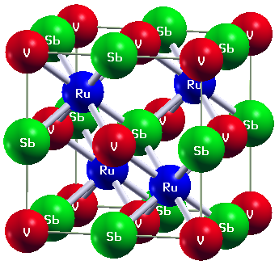
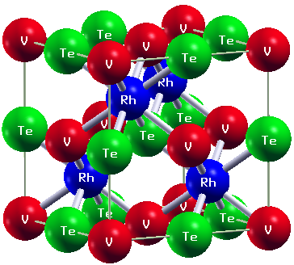

Fig.1a. Structural atomic positions for VRhTe. Fig.1b. Structural atomic positions for VRuSb

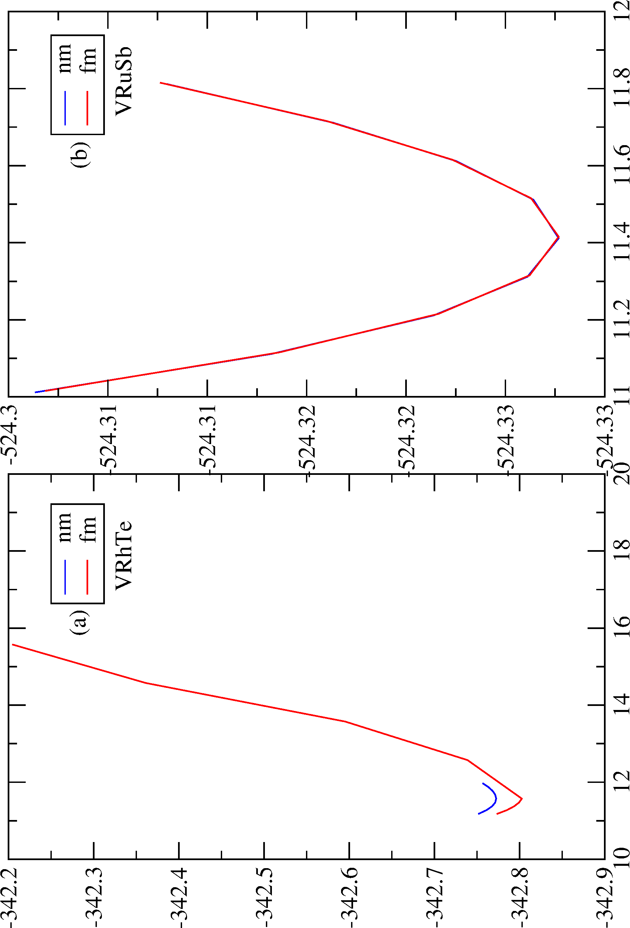

Fig. 2: A chart of the relationship between energy(Ry), and lattice parameter(a.u), feromagnetic(fm), and non-magnetic(nm) for; (a). VRhTe, and (b). VRuSb.

Both structures in fig. 1 sustained the cubic heusler consistency space group fm-3m with distinguish structural disfurement in the time of optimization. The composite energy against volume curves showed clear average, substantiating the mechanical strenght of both compounds at their appropriate equilibrium volumes. Furthermore, in Fig.2 (a), feromagnetic chatacteristic has more lower ground state energy, than the nonmagnetic features, which connote stability at fm. Moreover their complement Fig.2 (b) overlapped at both fm and nm state, revealed same ground state energy.
Formation energies were negative in the computed outcome; agreeing to their thermodynamic balance: ΔEₓ (VRhTe) = –3.42 eV/atom and ΔEₓ (VRuSb) = –5.24 eV/atom. These outcome predict thta both compounds can be synthesized under balance conditions without phase decomposition, making them optimistic candidates for practical application.

3.2 Mechanical Properties
The elastic features (C₁₁, C₁₂, and C₄₄) were simulated from the stress–strain correspondence and used to predict mechanical stability in alignment to Born’s criteria. The computed elastic parameters(in GPa unit) are summarized in table 2.

Table.2: Elastic Constants (C_{ij} in GPa) and Derived Mechanical parameters
Compound | C₁₁ (GPa) | C₁₂ (GPa) | C₄₄ (GPa) | B  (GPa) | G  (GPa) | B/G | ⱱ | A | C_{p}
VRhTe | 130.06 | 105.75 | 7.78 | 113.86 | 9.53 | 11.94 | 0.45 | 0.14 | 97.97
VRuSb | 220.89 | 115.49 | 58.84 | 150.62 | 56.38 | 2.67 | 0.33 | 1.11 | 56.65

The foregone satisfied the conditions C₁₁ > C₁₂, C₄₄ > 0, and C₁₁ + 2C₁₂ > 0, indicating that both compounds possesses mechanical stability. Pugh’s ratio critical value is 1.75, whereas Poisson’s ratio evaluative value is o.3 [26]. The cpmpounds are considered brittle if the B/G ratio is less than 1.75 and it is brittle if the B/G ratio is less than 1.75. The research reveals that the Pugh's ratio for VRhTe is 11.94, and 2.67 was for VRuSb accordingly; indicating the compounds reflects ductility. Consequently, the Poisson's ratio is less than 0.3; signifying the metallic bonding qualities of the materials. The positive Cauchy’s pressure (C_{p}) values (+97.97 and +56.65) affirm metallic bonding. Moreover, the positive Cauchy’s pressure(C_{p}) values +97.97, and +56.65 for VRhTe, and VRuSb respectively, support metallic bonding. The simualted bulk modulus of VRhTe predicts moderately more resistance structure to compression compared to VRuSb, in alignment with its smaller lattice constants. These outcome reveal that both materials possesses mechanical balance under average stress, making them promising for structural and high temperature applications.

3.3 Thermodynamic Properties
The thermodynamic characteristic of half-heusler compounds bestow vital comprehension into their thermal stability, lattice dynamic, and high heat energy for both VRhTe and VRuSb. Some of the thermodynamic parameters such as Debye temperature (Θ_{D}), heat energy (C_{v}), entropy (S), and linear expansion coefficient (α) were simulated using the quasi-harmonic Debye approximation (QHDA) based on the equilibrium structural data deduced from DFT simulations.
The QHDA approach permit the prediction of temperature and pressure dependent outcome by taking into cognizant the lattice vibrations and their anharmonic contribution donation to free energy. The results are discussed as follows:

3.4 Debye Temperature (Θ_{D})
The Debye heat energy (Θ_{D}) is a key parameter that harmonize with phonon vibration frequencies, lattice stiffness, and atomic bonding strenght. A higher Θ_{D} often signifies enhance bonding and increased thermal conductivity. The simulated Θ_{D} for VrhTe, and VRuSb at absolute minimum pressure and temperature are 135.77k and 330.90k, respectively. The slightly greater Θ_{D} of VRuSb signifies that it possesses stronger interatomic bonding and stronger lattice rigidity compared to VRhTe. This pattern aligns with their elastic constants, which show that VRuSb has a greater bulk modulus. The findings suggest that VRuSb would be more at higher temperature, and more resistance to thermal agitation.

Table 3. The two half-heusler alloys were assessed based on their average sound velocity(V_{avg} in m/s), Debye heat energy(θ_{D}), specific heat capacity(C_{v}), and zero-point energy(E₀ in kJ/Nmol).
Compounds | C_{v}(J/Nmol) | Q_{D}(K) | E_{o}(KJ/Nmol) | V_{avg}(m/s)
VRhTe | 74.83 | 135.77 | 3.80 | 1216.04
VRuSb | 74.30 | 330.90 | 9.28 | 2934.57

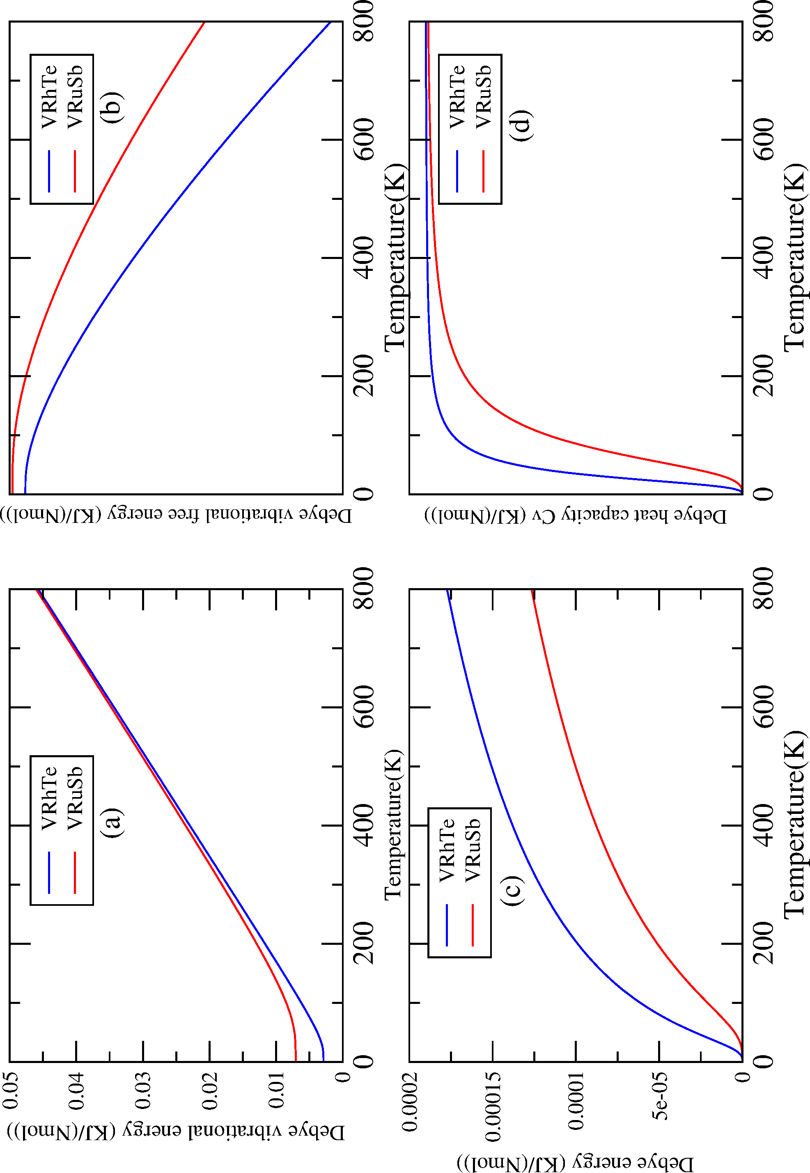

Fig.3: (a). Charts that illustrates the link between the temperature(K) and the debye vibrational energy. (b). Illutrates the relationship between temperature (K) and the free energy of debye vibrations. (c). Present Debye entropy, as a function of temperature (K). (d). Present the correlation between temperature(K) and the Debye heat capacity C_{v,} all in (KJ/K(Nmol)) respectively.

Figure 3.(a): The enthalpy of the system is shown by the debye vibrational energy against the temperature graph. As the tempearture rises, enthalpy increases as well, the temperature varies from 0 to 800K. The compound VRuSb posseses a greater enthalpy with temperature variation. A unit of thermodynamic measure of energy is enthalpy. It signifies a system's peak thermal power, which is determined by the aggregate of internal free energy and the pressure-volume work. (b): The debye vibrational free energy for the compounds VRhTe, and VRuSb is shown against temperatue in the plot. The term “free energy” frequently refers to the quality of energy available to carry-out advantageous tasks within a system. Furthermore, free energy is a thermodynamic prospective that depends on the entropy and the inner energy of the system. Consequently, VRuSb has a higher debye vibrational free energy than VRhTe. (c): The chart illustrates debye entropy in relation to temperature. Entropy qunantifies the degree of variability or dispersion in the energy of the atoms or molecules that make up a system. Consequently, energy get more evenly distributed as entropy increases, resulting in a system that is less organized and more chaotic. Furthermore, a notable feature of thermal systems is their dependence on the quantity of matter, which is employed to determined the degree of order in the system. This inherent characteristic of thermodynamic system indicates that the value fluctuates with the amount of material present. There are two possible values for entropy; negative and positive. Consequently, the second law of thermodynamic sates that “a system entropy may only drop if another system entropy increases. (d): The chart present the findings of the investigation of the heat capabilities of VRuSb, and VRhTe. The dynamic heat capacity for VRhTe, is higher than that of VRuSb. Hence, VRhTe is a material that is more suitable for application in optoelectronic devices. Consequently, the material exhibits better thermal transformation at the temperature if its debye heat energy is higher. Therefore, at low temperatures, the specific heat capacity plot for the two materials VRhTe, and VRuSb demostrates adherence to the T³ rule; at higher temperature, it adhere to the law of Dulong and Petit.

3.5 Phonon Properties
The phonon properties of crystalline materials provide crucial insight into their lattice dynamics, thermal stability, and thermodynamic behavior. This work estimated the phonon dispersion curves and related phonon density of states (PHDOS) for VRhTe and VRhSb using density functional theory (DFT) based on optimised structures. The results reveal key information about the dynamical stability and vibrational characteristics of both compounds

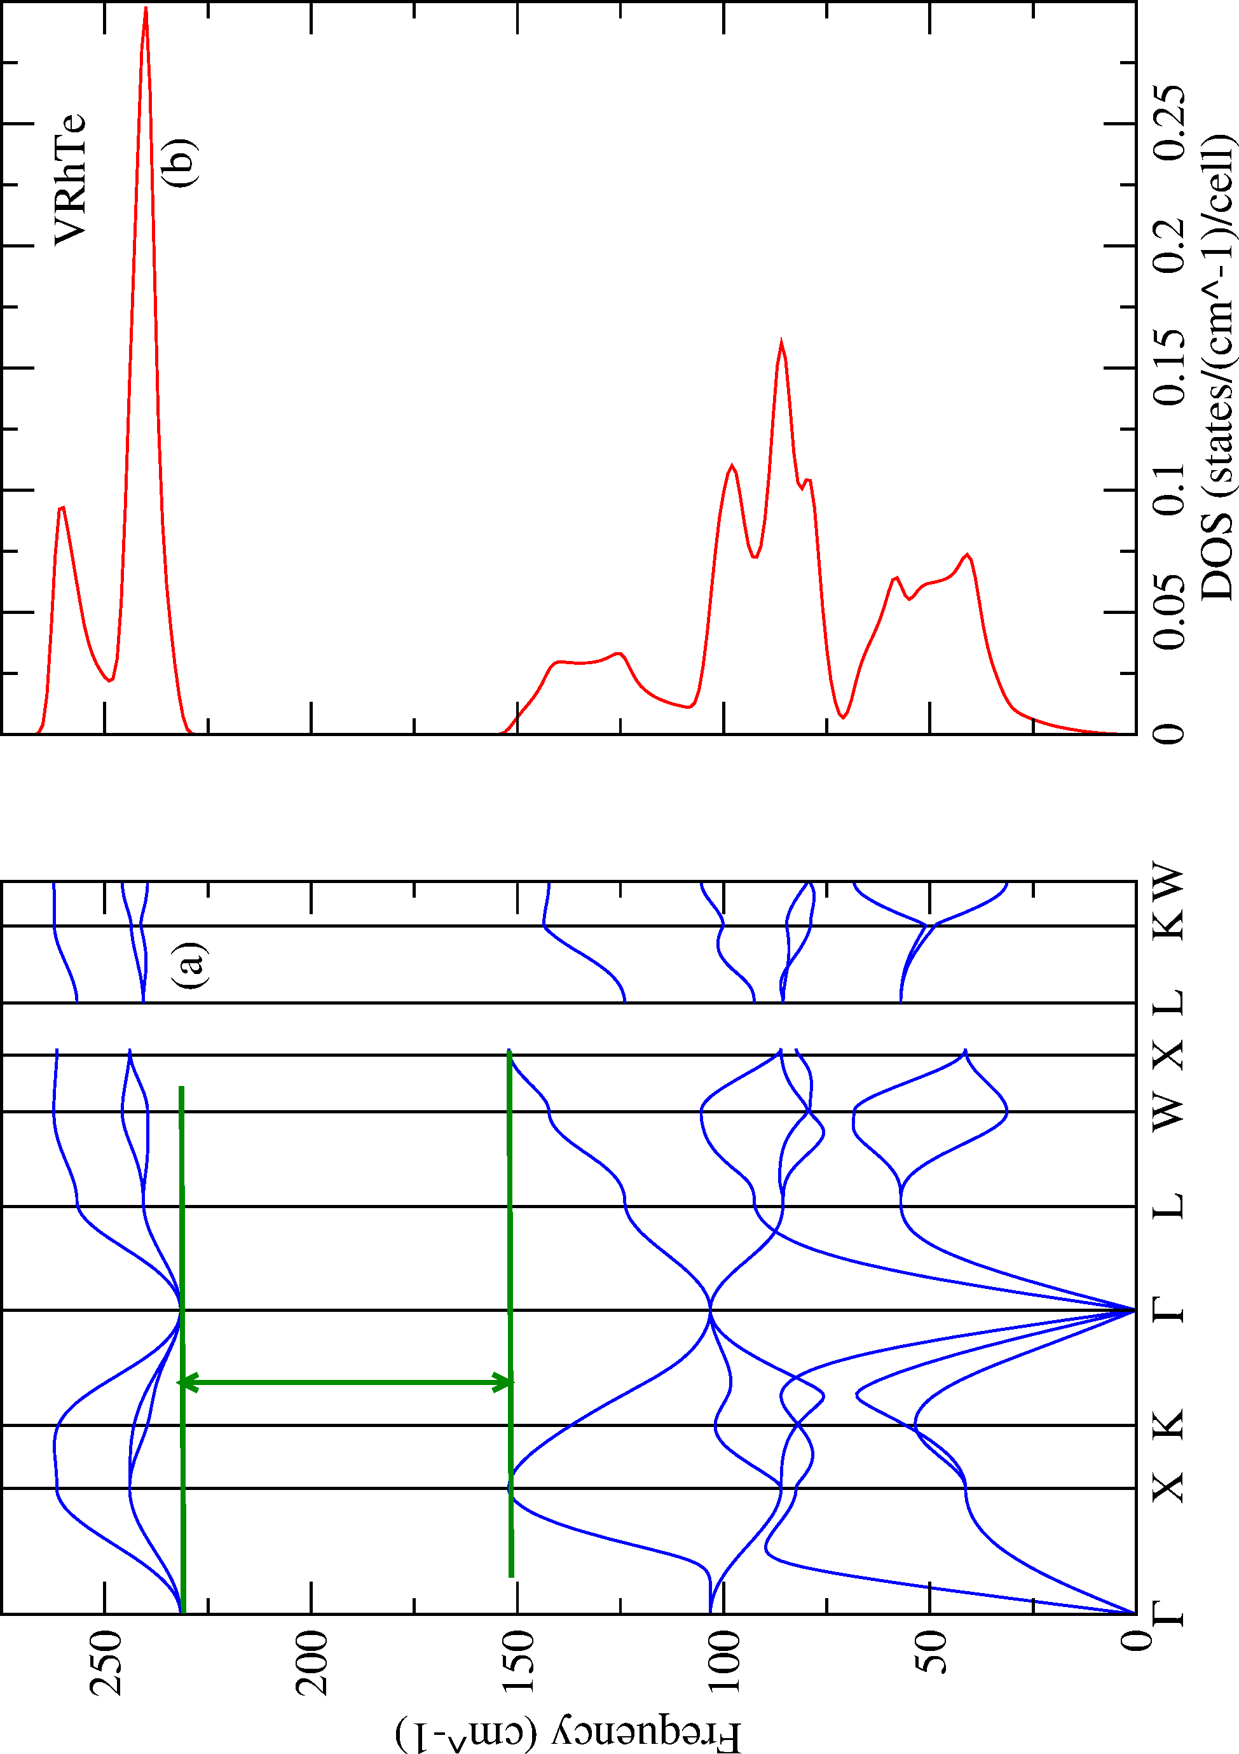

Fig. 4: The phonon dispersion relations and Phonon Density of States (PDOS) for VRhTe

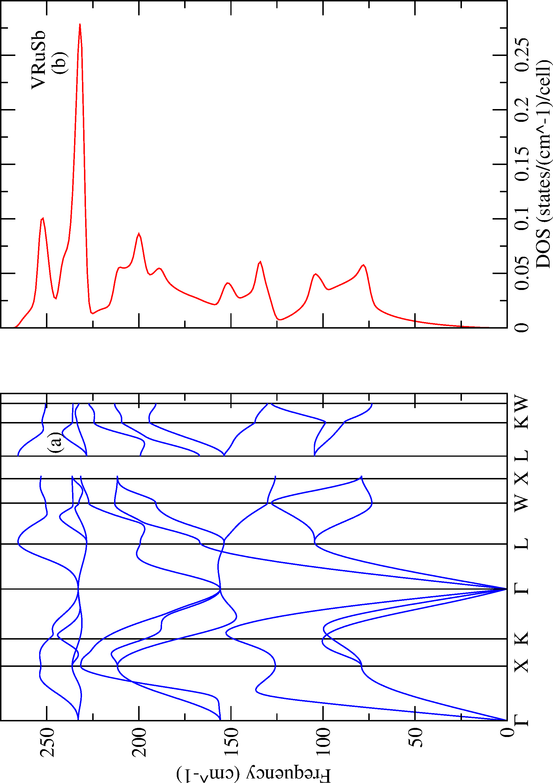

Fig. 5 a & 5b: The Phonon Density of States (PDOS) and phonon dispersion relations for VRuSb.

Positive phonon frequencies are present in both compounds over the whole Brillouin zone, with no imaginary modes, predicting their dynamical stability at ambient pressure and zero temperature.
In both systems, the acoustic phonon branches show smooth dispersion from the Γ-point, indicating strong interatomic bonding and uniform lattice interactions. The optical branches are more pronounced in VRhSb on account of heavier atomic mass of Sb contrast to Te, which causes a downward shift in phonon frequencies and a narrower band gap between acoustic and optical modes.
The phonon dissemination curve is position in the inner symmetry area of 𝛤 − 𝑋 − K − 𝛤 − L − W − 𝑋, as seen in Fig. 4(a). The primeral cells contained three components: V, Rh, and Te. The curves presents 9 vibrational modes; the first 3 are from the acoustic, while the other 6 are from the optical branches. Consequently, the frequencies of the acoustic modes ranges from around 0 and 85 cm⁻¹. The frequencies displaed by the optical branches also ranges from around 75 and 265 cm⁻¹. Therefore, the band gap between the two modes is about 80 cm⁻¹. The lowest optical modes spread from roughly 75 to 150cm⁻¹, and the highest optical modes expand from roughly 230 to 265cm⁻¹. Every modes stand for antom in the unit cell. Also 3 phonon branches often controlled the atom with the highest atomic mass, Te – 127.6g/mol. Simultaneously, the lowest optical mode is predominantly influenced by the lowest atomic mass, specifically V ~ 50.9415 g/mol. Furthermore, VRhTe exhibits no imaginary frequencies throughout the Brillouin zone, thereby confirming its dynamical stability. The seperation of acoustic from optical branches is a crucial characteristic of half-heusler alloys. Additionally, in Fig.4(b), the PHDOS offers additional insight into which atoms contribute most to the lattice vibrations. The low-frequency region of roughly (0 to 155 cm⁻¹) is primarily influenced by vibrations of Rh, and V. In contrast, Te atoms play a substantial role in the mid and high frequency modes, specifically between 230 and 265cm⁻¹, attributed to their lighter mass and elevated vibrational frequencies.
The phonon dispersion curve is pinpoint within the symmetry region of 𝛤 − 𝑋 − K − 𝛤 − L − W − 𝑋, as seen in Fig. 5(a). The primordial cells consist of three compnents: V, Ru, and Sb. The curves exhibit 9 vibrational modes, with the first 3 arising from acoustic branches, while the latter 6 represent optical branches. The frequency of the acoustice modes span from approximately 0 to 150cm⁻¹. Meanwhile, the optical branches display frequencies ranging from around 125 to 265cm⁻¹. Additionally, the two optical mode did not present a band gap; there interject through the acoustic path. The lowest optical modes spread through 150cm⁻¹ to 230cm⁻¹, whereas the greater optical modes ranges more or less than 225cm⁻¹ to 265cm⁻¹. Therefore, each mode represent an atom within the unit cell. Given the present of three atoms or elements, namely V, Ru, and Sb; thus there are three phonon branches. The atom with the highest mass is typically governed by the acoustic branches (e.g. Sb~ 121.76 g/mol). The lowest optical mode is predominantly affected by the lowest optical mass, specifically V ~ 50.9415 g/mol. Furthermore, VRuSb displays no imaginary frequencies across the acoustic branches are partly distinct from the optical branches. Additionally, in figure 5(a) and (b), phonon anomalies in the density of states for VRhTe, and VRuSb were not observed, indicating a deviation from the expected vibrational spectrum of a material, which often implies strong interactions between electrons and phonon.

4.0 Conclusion
In this study, the structural features, mechanical paramters, thermodynamic, and phonon properties of VRhTe and VRhSb intermetallic compounds were systematically explored. The optimized structures revealed that both compounds crystallize in the cubic Heusler-type (Fm–3m) symmetry and are thermodynamically stable, as rectified by their negative formation energies and absence of structural distortions. The lattice parameter of VRuSb was moderately bigger than that of VRhTe due to the greater atomic radius of Sb. The mechanical features indicates that the Pugh’s ratio for VrhTe is 11.94, and VRuSb is 2.67. Consequently, the outcomes reveals ductility of the two materials. The Poisson’s ratio (ⱱ > 0.3) signifies the metallic bonding characteristic of the materials. The Cuachy’s pressure values obtaine were +97.79 and +56.65 which suggest metallic bonding. The elevated bulk modulus of VrhTe indicates slightly more resistance structure to compression compared to VRuSb, consistent with its smaller lattice constant. These outcome indicate that both materials possesses mechanical robustness under moderates stress, making them appropiate for high temperature or structural applications. Additionall, according to the results, VrhTe has a graeter Cv than VRuSb, making it a more suiatble compounds for optoelectronic appliances. The phonon anomalies in the density of states for VrhTe and VRuSb suggests strong iteractions between electrons and phonons.

COMPETING INTERESTS DISCLAIMER:
Authors have declared that they have no known competing financial interests OR non-financial interests OR personal relationships that could have appeared to influence the work reported in this paper.

References

[1] Tunes M. A., Drewry S. M., Schmidt F., and Valdez A., (2025). A New Family of Ternary Intermetallic Compounds with Dualistic Atomic Ordering – The ZIP Phases. Advanced Materials, 08(168), 1- 23. DOI:10.1002/adma.202308168

[2] Machin A., Morant C., and Marquez F.M., (2024). Advancements and Challenges in Solid-State Battery Technology: An In-Depth Review of Solid Electrolytes and Anode Innovations
Batteries MDPI, 10(1) (2024) 29. https://doi.org/10.3390/batteries10010029

[3] Zhang H T , Shukla N., Datta S., and Paik H., (2017). Opportunities in vanadium-based strongly correlated electron systems, MRS Communications 7(1) 27–52.

[4] Jian-Fang Wang, Wei-Hui Fang, Dong-Sheng Li, Lei Zhang, and Jian Zhang, (2017). Cocrystal of {Ti4} and {Ti6} Clusters with Enhanced Photochemical Properties. Inorganic Chemistry 56 (5), 2367- 2370.

[5] Iyorzor B.E., and Babalola M.I., (2022). Half-metallic Characteristics of the Novel Half Heusler Alloys XCrSb (X=Ti, Zr, Hf ). Journal of the Nigerian Society of Physical Sciences, 4(1) (2022) 138- 145.https://doi.org/10.46481/jnsps.2022.297

[6] Volker L. Deringer, Ralf P. Stoffel, Matthias Wuttig, Richard Dronskowski (2015). Vibrational properties and bonding nature of Sb2Se3 and their implications for chalcogenide materials. Royal Society of Chemistry – Chemical Science, 6(9), 5255-5262. https://doi.org/10.1039/c5sc00825e

[7] Babalola M.I., and Enaroseha O.O., Pressure induced structural phase transition and influence of pressure on the electronic and mechanical properties of TiPdSn: an ab initio study, Iranian Journal of Physics Research, 23 (2023) DOI:10.47176/ijpr.23.3.41671

[8] Hu Q., Yang M., Zhou X., and Li. S., (2025). Modulated electrical transport properties and Enhanced Thermoelectric Performance in Tellurium by Compositing with Copper and Doping with Antimony, Vacuum, 238, 114249. DOI:10.1016/j.vacuum.2025.114249

[9] Soltanbek N. S., Merali N.A., SagatovN. E., Abuova F. U., Elsts E., Abuova A. U., Khovaylo V. V., Inerbaev T. M., Konuhova M., and Popov A. I., (2025). Ab Initio Investigation of the Stability, Electronic, Mechanical, and Transport Properties of New Double Half Heusler Alloys Ti₂Pt2ZSb (Z = Al, Ga, In), Metals 15, 329. https://doi.org/10.3390/met15030329

[10] Ciftci Y, and Gemici I. A., (2025). Ab-initio Study on Half-Heusler Semiconductor PtTiSn Compound: Pressure effects, Physica B Condensed Matter 707(8), 417180. DOI:10.1016/j.physb.2025.417180

[11] Md. Tarekuzzaman, Md. Hasin Ishraq, Nazmul Shahadath, Md. Raihan Kabir, Rayhan M. A., Sohail Ahmad, Md. Abdul Qader, Md. Rasheduzzaman, YasirArafat & Md. Zahid Hasan, (2025). DFT analysis of structural, electronic, optical, and thermodynamic properties of LiXI3 (where X=Ca, Sr, Ba) halide perovskites for optoelectronics, Nature 15, 25304 https://doi.org/10.1038/s41598- 025- 91458-2.

[12] Ishaje M. E., Kseniia Minakova, Babalola M.I., Iyorzor B.E., Valentyna Sirenko, (2025). KCrAs half- metallic properties of alkali-metal-based compound: A first-principles study, Low Temperature Physics, 51 , pp629-635 https://doi.org/10.1063/10.0036529
[13] Kohn W., & Sham L.J., (1965). Self-consistent equations including exchange and correlation effects. Physical Review, 140, A1133–A1138 DOI: https://doi.org/10.1103/PhysRev.140.A1133
[14] Liu Y., Chabane D, Elkedim O., (2021). Intermetallic Compounds Synthesized by Mechanical Alloying for Solid-State Hydrogen Storage: A Review, Energy MDPI, 14 DOI:10.3390/en14185758.
[15] Shi J., Huan Y., Zhao X., Pengfei Y., Hong M.J, Xie C., Pennycook S., and Zhang Y.F., (2021). Two- Dimensional Metallic Vanadium Ditelluride as a High-Performance Electrode Material, ACS Nano, 15 DOI:10.1021/acsnano.0c10250
[16] Ishaje M. E., Faustina A., Igomah G. O., (2024). Density Functional Theory (DFT) study of Alkali- Metal-based Half heusler Compound NaCrSb, International Astronomy and Astrophysics Research Journal, 6 pp49-58 http://authors.go2articles.com/id/eprint/1451
[17] Hohenberg, P., & Kohn, W. (1964). Inhomogeneous electron gas, Physical Review, 136. B864–B871 DOI: https://doi.org/10.1103/PhysRev.136.B864
[18] Chmielowski S., Bhattacharya S., Xie W., Pere D., Jacob S., Stern R., Moriya K., Weidenkaff A., Madsen G. K. H., Dennler G., (2016). High thermoelectric performance in Tellurium doped Paracostibite, Journal of materials Chemistry C, 4 3094 – 3100. DOI:10.1039/C6TC00410E.
[19] Nolas G. S., Sharp J., & H.J. ( 2021). Goldsmid, “Thermoelectrics: Basic Principles and New Materials Developments”, edition number 1, Springer Berlin, Heidelberg, Germany Springer. https://doi.org/10.1007/978-3-662-04569-5, VIII, 293.
[20] Ettah E.B., Ishaje M.E, Minakova K.A., Sirenko V.A., Bondar I.S., (2024). Machine-learning assisted DFT study of full-heusler alloy N2CaNa: Structural, electronic, mechanical, and thermodynamic properties, Low Temp. Phys. 50 pp834–842 https://doi.org/10.1063/10.0028623
[21] Wen Z., Zhao Y., Hou H., Wang B., and Han P., The mechanical and thermodynamic properties of Heusler compounds Ni2XAl (X = Sc, Ti, V) under pressure and temperature: A first-principles study, Materials & Design 144 2016 DOI:10.1016/j.matdes.2016.11.005
[22] Hill, R., (1952). The elastic behaviour of a crystalline aggregate, Proceedings of the Physical Society Section A, 65 pp 349–354 DOI 10.1088/0370-1298/65/5/307
[23] Blanco M. A., Francisco E., & Luaña V. (2004). GIBBS: Isothermal-isobaric thermodynamics of solids from energy curves using a quasi-harmonic Debye model, Computer Physics Communications, 158 pp 57–72 https://doi.org/10.1016/j/comphy.2003.12.001.
[24] Giannozzi P., Baroni S., Bonini N., Calandra M., Car R., Cavazzoni C., Ceresoli D., Chiarotti G.L., Cococcioni M., Dabo I., Corso A.D, de Gironcoli S., Fabris S., Fratesi G., Gebauer R., Gerstmann U, Gougoussis C., Kokalj A., Lazzeri M., Martin-Samos L., Marzari N., Mauri F., Mazzarello R., Paolini S., Pasquarello v, Paulatto L., Sbraccia C., Scandolo S., Sclauzero G., Seitsonen A. P, Smogunov A., Umari P., and Wentzcovitch R. M., QUANTUM ESPRESSO: A modular and open- source software project for quantum simulations of materials, Journal of Physics: Condensed Matter, 21 395502, DOI10.1088/0953-8984/21/39/395502.
[25] Perdew J. P., Burke K., & Ernzerhof M., (1996). Generalized Gradient Approximation Made Simple, Physical Review Letters, 77 3865–3868 DOI:https://doi.org/10.1103/PhysRevLett.77.3865
[26] Pugh S., (1954). XCII. Relations between the Elastic Moduli and the Plastic Properties of Polycrystalline Pure Metals, The London, Edinburgh, and Dublin Philosophical Magazine and Journal of Science, 45, 823-843. https://doi.org/10.1080/14786440808520496

