Geospatial Assessment of Terrestrial gamma radiation and Radiological Health risk in Oleh and Ozoro, Delta State, Nigeria

Abstract
This study presents a geospatial evaluation of terrestrial gamma radiation and associated radiological health risks across eight urban zones in Oleh and Ozoro, Delta State, Nigeria. Background ionizing radiation (BIR) and absorbed dose rate (ADR) measurements were conducted across four zones per town, yielding mean ADR values of 83.08 ± 10.63 nGyh⁻¹ in Oleh and 91.05 ± 12.54 nGyh⁻¹ in Ozoro. The corresponding annual effective dose equivalent (AEDE) values-0.103 ± 0.013 mSvy⁻¹ and 0.112 ± 0.016 mSvy⁻¹, respectively were significantly below the UNSCEAR global average of 0.41 mSvy⁻¹, indicating compliance with international radiological safety standards. Excess lifetime cancer risk (ELCR) estimates ranged from 0.332 ± 0.077 × 10⁻³ to 0.445 ± 0.074 × 10⁻³, with a pooled mean of 0.376 ± 0.055 × 10⁻³, marginally exceeding the UNSCEAR reference value but remaining within tolerable stochastic risk limits. Organ-specific dose analysis revealed elevated exposure in radiosensitive tissues, notably the testes and bone marrow. Statistical robustness was confirmed through Monte Carlo simulations, Bayesian inference, and Bootstrap resampling, all of which demonstrated convergence and internal consistency. The findings suggest moderate radiological exposure across the study area, with localized variations attributable to anthropogenic activity and lithologic composition. Routine monitoring and targeted public health interventions are recommended to sustain environmental safety.
Keywords: Terrestrial gamma radiation, Radiological health risk, Annual effective dose equivalent, Geospatial analysis, Delta State Nigeria

1.0 Introduction
Environmental exposure to terrestrial gamma radiation remains a key concern in radiation protection and public health. Globally, natural background radiation is the major contributor to the annual effective dose received by humans (United Nations Scientific Committee on the Effects of Atomic Radiation [UNSCEAR], 2008). While cosmic rays and primordial radionuclides such as uranium-238 (²³⁸U), thorium-232 (²³²Th), and potassium-40 (⁴⁰K) are ubiquitous, local geological and anthropogenic factors can markedly influence ambient dose rates (Del Monte, 2024; Alvarez et al., 2017). Technologically enhanced naturally occurring radioactive materials (TENORM) and other human-driven activities associated with mineral extraction, oil and gas production, and rapid urbanization further elevate terrestrial gamma radiation in sensitive regions (Agbalagba & Okorodudu, 2024; International Atomic Energy Agency [IAEA], 2021). In Nigeria, radiological baseline studies remain fragmented despite extensive geological diversity and industrial development. Recent investigations have quantified terrestrial radioactivity and radiological hazard indices in coastal, urban, and industrial environments (Esi et al., 2024; Omeje et al., 2023), yet comprehensive geospatial assessments of background ionizing radiation (BIR) are still limited, particularly in oil-producing states. The sedimentary geology of the Niger Delta comprising the Benin, Agbada, and Akata Formations contains detrital mineral phases potentially enriched in radionuclides. Variations in soil permeability, drainage, and anthropogenic land use modulate radionuclide migration and consequent gamma-ray emission.
The twin urban centres of Oleh and Ozoro, administrative headquarters of Isoko South and Isoko North Local Government Areas of Delta State, exemplify this knowledge gap. With populations of approximately 235 000 and 186 000, respectively (National Population Commission [NPC], 2006), both have undergone rapid infrastructural growth driven by educational, commercial, and petroleum-related activities. Oleh lies within low-lying, flood-prone terrain (5°15′00″–5°30′00″ N; 6°07′30″–6°22′30″ E), whereas Ozoro occupies a more elevated plateau with improved drainage and distinct lithology. Their contrasting physiography within the same sedimentary basin provides an ideal setting for comparative radiological assessment. Although numerous radiometric investigations have been undertaken across Nigeria, their datasets remain largely site-specific and methodologically heterogeneous. Reported background radiation levels vary widely across the Niger Delta, Jos Plateau, and other regions, reflecting geological and anthropogenic diversity (Agbalagba, 2017; Esi et al., 2024; Legborsi et al., 2025).

However, few have integrated geospatial mapping with rigorous uncertainty quantification. The present study therefore extends the national effort by providing a geostatistical and probabilistic characterization of terrestrial gamma exposure in Oleh and Ozoro, while establishing context for comparison with other Nigerian studies to define a broader environmental radiation baseline. This work represents the first systematic geospatial assessment of terrestrial gamma radiation and associated health risk in the twin cities. In-situ gamma measurements were integrated with geographic information system (GIS) mapping to delineate spatial variability of BIR. Beyond conventional dose modelling-absorbed dose rate (ADR), annual effective dose equivalent (AEDE), and excess lifetime cancer risk (ELCR), the study applies a novel computational–statistical framework combining Monte Carlo simulation, Bayesian inference, and Bootstrap resampling to quantify uncertainty, validate model estimates, and ensure reproducibility (Frankemölle et al., 2024; Djicknack Dione et al., 2024; Biere et al., 2025). Monte Carlo simulation propagates measurement uncertainty through the dose-conversion pathway; Bayesian inference derives credible intervals for radiological parameters; and Bootstrap analysis evaluates the robustness of the derived statistics. The objectives of this study are therefore to measure and map spatial variations of background ionizing radiation across Oleh and Ozoro; estimate ADR, AEDE, ELCR, and organ-specific doses (D_{organ}), and quantify statistical uncertainty in these parameters using the combined Monte Carlo–Bayesian–Bootstrap framework. The results establish baseline radiological data for Delta State, strengthen radiological protection frameworks aligned with ICRP and UNSCEAR recommendations, and provide evidence-based support for environmental health policy in oil-producing and rapidly urbanizing regions of Nigeria.
2.0. Materials and Methods

2.1. Materials and Experimental Procedure
Oleh and Ozoro were delineated into four sampling zones, respectively, to ensure comprehensive spatial coverage and represent distinct land-use patterns. An in-situ measurement technique was employed to record background ionizing radiation (BIR) under natural environmental conditions. Measurements were conducted using a Gamma Scout Geiger counter (Gamma Scout GmbH & Co. KG, Germany), a portable, energy-compensated survey meter capable of detecting α, β, and γ radiations in the range of 0.01 µSvh⁻¹–1 mSvh⁻¹. The instrument was factory-calibrated and verified using a standard Cs-137 source before field deployment.

At each sampling location, the detector was positioned 1.0 m above ground level, following recommendations of Ajayi et al. (2006) and the National Council on Radiation Protection and Measurements (NCRP, 1993). Readings were taken at 10 s intervals between 13:00 h and 16:00 h, when environmental radiation levels are most stable. Three consecutive readings were obtained per site, and their arithmetic mean was recorded as the representative exposure rate (mRh⁻¹). Geographic coordinates of all sampling points were determined using a hand-held GPS receiver operating under Wide Area Augmentation System (WAAS) correction with an accuracy of ± 3 m. Coordinates were later converted from decimal degrees to degrees–minutes–seconds (DMS) format for consistency and integrated into a geographic information system (GIS) database. The BIR values were spatially interpolated and visualized in the GIS environment to illustrate the spatial distribution of radiation intensity across the study areas. Figure 1 presents the GIS-based map of Oleh, showing the sampling points and corresponding BIR exposure levels, while Figure 2 depicts the geospatial distribution of BIR across Ozoro. Both maps were produced using ArcGIS 10.8 and verified with field coordinates to ensure positional accuracy. All measurements followed standard radiation-monitoring procedures reported in previous studies (Agbalagba et al., 2020) to ensure data reliability, comparability, and reproducibility.

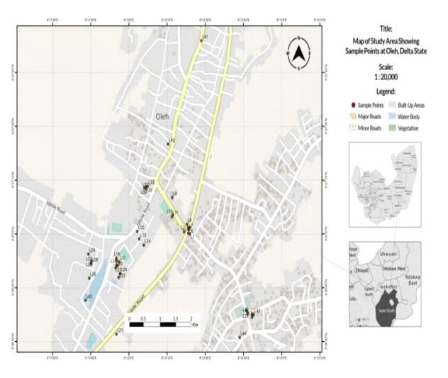Figure 1. GIS-based location map of Oleh showing sampling points and background ionizing radiation (BIR) exposure levels.

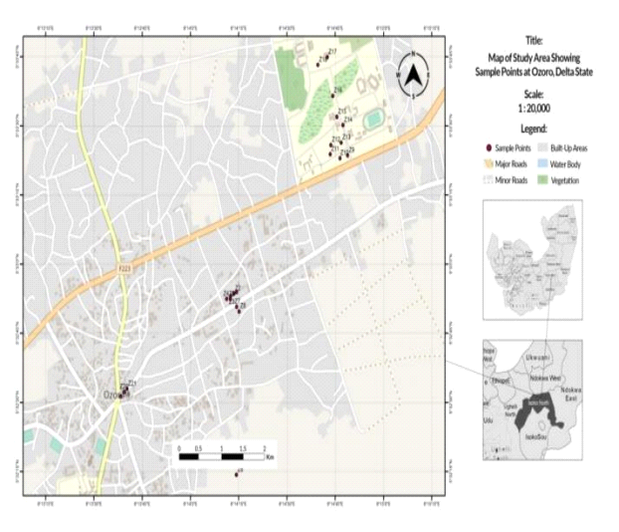Figure 2. GIS-based location map of Ozoro showing sampling points and background ionizing radiation (BIR) exposure levels.

2.3. Dose Conversion and Risk Estimation
Measured BIR values (mRh⁻¹) were converted into absorbed dose rate (ADR), annual effective dose equivalent (AEDE), and excess lifetime cancer risk (ELCR) using standard radiological models recommended by UNSCEAR (2000, 2020) and the International Commission on Radiological Protection (ICRP, 2007).

2.3.1. Conversion from Exposure to Absorbed Dose Rate
For gamma radiation, 1 Roentgen (R) corresponds to an air-kerma of approximately 0.00876 Gy. The absorbed dose rate in air (ADR, nGyh⁻¹) was obtained from the measured exposure rate (BIR, mRh⁻¹) as:
$ADR \left(nGyh^{-1}\right)=BIR\left(mRh^{-1}\right)×8760$(1)

2.3.2. Annual Effective Dose Equivalent (AEDE)
The AEDE for outdoor exposure was computed using a dose-rate conversion factor of 0.7 Sv Gy⁻¹ (ICRP, 2007) and an outdoor occupancy factor of 0.2, assuming continuous exposure (8760 hy⁻¹):
$AEDE(mSvy^{-1})=ADR \left(nGyh^{-1}\right)×0.7×0.2×{10}^{-6}$ (2)

2.3.3. Excess Lifetime Cancer Risk (ELCR)
The lifetime cancer risk associated with chronic exposure was derived from the nominal risk coefficient for stochastic effects (0.05 Sv⁻¹) and an average lifespan of 70 years (ICRP, 2007):
$ELCR (×{10}^{-3})=AEDE(mSvy^{-1})×70×0.05$ (3)
For comparative assessment, the UNSCEAR (2000, 2020) world outdoor average absorbed dose rate of 84 nGyh⁻¹ which is equivalent to an exposure rate of approximately 0.013 mRh⁻¹ was adopted. This also corresponds to an AEDE of 0.41 mSvy⁻¹ and an ELCR of 0.29 × 10⁻³, which were used as global reference thresholds.

2.3.4. Organ-Specific Effective Dose (D_{organ})
The distribution of the effective dose to various organs and tissues was calculated following Zaid et al. (2010) and Agbalagba et al. (2020):
$D_{organ}(mSvy^{-1})=AEDE(mSvy^{-1})×O×F$ (4)
Where O is the occupancy factor (0.8) and F is the organ dose conversion factor from ingestion or external exposure.

2.4. Statistical and Computational Framework
To enhance analytical robustness and ensure reproducibility, this study adopted a computational-statistical framework integrating Monte Carlo simulation, Bayesian inference, and Bootstrap resampling. All analyses were implemented in Python 3.13 (IDLE environment) using standard scientific libraries (numpy, pandas, matplotlib, scipy, and seaborn). The workflow automated data importation, stochastic modelling, uncertainty quantification, and export of results in high-resolution PDF format.

2.4.1. Monte Carlo Simulation (MCS)
Monte Carlo simulation was employed to propagate uncertainty in measured background ionizing radiation (BIR) and dose conversion parameters. For each sampling zone, 10,000 stochastic iterations were executed using a ±10% random perturbation around measured BIR values. This generated probabilistic distributions of absorbed dose rate (ADR), annual effective dose equivalent (AEDE), and excess lifetime cancer risk (ELCR). Descriptive statistics (mean, standard deviation, and 95% confidence intervals) were computed from the resulting distributions. The full MCS outputs are provided as a supplementary file.

2.4.2. Bayesian Inference
Bayesian inference was applied using a Normal–Inverse Gamma hierarchical model to derive posterior estimates and credible intervals for the key radiological parameters. The model employed 5,000 Markov Chain Monte Carlo (MCMC) draws with weakly informative priors, enabling probabilistic interpretation of uncertainties in ADR, AEDE, and ELCR. Detailed Bayesian results are presented in the supplementary materials.

2.4.3. Bootstrap Resampling
Bootstrap resampling was used to evaluate the robustness and stability of central tendency and dispersion statistics for all radiological indices. Each dataset was resampled 10,000 times with replacement, and the mean, median, and 95% confidence limits were derived for ADR, AEDE, and ELCR.
The Bootstrap results (Table 6) and corresponding chart (Figure 6) are presented in the main text, as they provide concise, distribution-free estimates validated against the Monte Carlo and Bayesian outcomes.

2.4.4. Reproducibility and Output Structure
The entire computational process was developed for open reproducibility. The provided Python 3.13 script allows direct rerun of all simulations, ensuring transparency consistent with FAIR (Findable, Accessible, Interoperable, and Reproducible) data principles. Outputs include: Bootstrap summary of radiological parameters (ADR, AEDE, ELCR) and supplementary materials (Monte Carlo simulation results-10,000 runs per zone; Bayesian posterior estimates-5,000 draws and Ready-to-run Python script).

3.0. Results and Discussion

3.1 Summary of Background Ionizing Radiation (BIR) and Absorbed Dose Rate (ADR)

The measured background ionizing radiation (BIR) across the four zones of Oleh as summarized in (Table 1) ranged from 0.009 ± 0.002 mRh⁻¹ at the Bakery to 0.010 ± 0.001 mRh⁻¹ at the Market and Residential zones, with an overall mean of 0.0098 ± 0.0013 mRh⁻¹. The Corresponding absorbed dose rates (ADR) ranged between 77.30 ± 17.60 nGyh⁻¹ and 87.00 ± 13.50 nGyh⁻¹, averaging 83.08 ± 10.63 nGyh⁻¹, which is marginally below the UNSCEAR (2000) world mean of 84 nGyh⁻¹. Spatially, the Market and Residential zones in Oleh recorded the highest dose rates, reflecting elevated anthropogenic activity and possibly denser concrete and lateritic soil composition that may contribute to increased gamma emission. The generally uniform BIR levels across zones suggest a relatively homogeneous geological substrate typical of the Benin Formation, comprising sandy and clayey sediments with moderate radionuclide content.

Table 1: Summary of Radiological Risk Parameters in Oleh
Zone | BIR (mRh⁻¹) | ADR (nGyh⁻¹) | AEDE (mSvy⁻¹) | ELCR (×10⁻³)
Market | 0.010 ± 0.001 | 87.00 ± 13.50 | 0.107 ± 0.017 | 0.374 ± 0.059
Bakery | 0.009 ± 0.002 | 77.30 ± 17.60 | 0.095 ± 0.022 | 0.332 ± 0.077
Campus | 0.010 ± 0.002 | 83.80 ± 11.19 | 0.103 ± 0.014 | 0.361 ± 0.050
Residential | 0.010 ± 0.001 | 86.20 ± 8.21 | 0.106 ± 0.010 | 0.370 ± 0.037
Mean ± SD (all zones) | 0.0098 ± 0.0013 | 83.08 ± 10.63 | 0.103 ± 0.013 | 0.359 ± 0.056
UNSCEAR (World average) | 0.013 | 84.00 | 0.41 | 0.29

Table 2: Summary of Radiological Risk Parameters in Ozoro
Zone | BIR (mRh⁻¹) | ADR (nGyh⁻¹) | AEDE (mSvy⁻¹) | ELCR (×10⁻³)
Market | 0.012 ± 0.002 | 103.20 ± 17.30 | 0.127 ± 0.021 | 0.445 ± 0.074
Bakery | 0.011 ± 0.001 | 95.10 ± 9.40 | 0.117 ± 0.012 | 0.410 ± 0.042
Campus | 0.010 ± 0.002 | 87.50 ± 15.60 | 0.107 ± 0.019 | 0.374 ± 0.066
Residential | 0.009 ± 0.001 | 78.40 ± 7.90 | 0.096 ± 0.010 | 0.338 ± 0.035
Mean ± SD (all zones) | 0.0103 ± 0.0016 | 91.05 ± 12.54 | 0.112 ± 0.016 | 0.392 ± 0.054
UNSCEAR (World average) | 0.013 | 84.00 | 0.41 | 0.29

Table 3: Comparative Summary of Radiological Risk Parameters in Oleh and Ozoro
Location | BIR (mRh⁻¹) | ADR (nGyh⁻¹) | AEDE (mSvy⁻¹) | ELCR (×10⁻³)
Oleh | 0.0098 ± 0.0013 | 83.08 ± 10.63 | 0.103 ± 0.013 | 0.359 ± 0.056
Ozoro | 0.0103 ± 0.0016 | 91.05 ± 12.54 | 0.112 ± 0.016 | 0.392 ± 0.054
Overall Mean ± SD (Study Area) | 0.0101 ± 0.0014 | 87.07 ± 11.59 | 0.108 ± 0.014 | 0.376 ± 0.055
UNSCEAR (2000, World Average) | 0.013 | 84.00 | 0.41 | 0.29

In Ozoro (Table 2), the BIR values ranged from 0.009 ± 0.001 mRh⁻¹ to 0.012 ± 0.002 mRh⁻¹, with a mean of 0.0103 ± 0.0016 mRh⁻¹, slightly higher than in Oleh. The corresponding ADR ranged from 78.40 ± 7.90 nGyh⁻¹ (Residential) to 103.20 ± 17.30 nGyh⁻¹ (Market), yielding an average of 91.05 ± 12.54 nGyh⁻¹. The higher mean ADR in Ozoro compared to Oleh may be attributed to its relatively elevated topography and exposed lateritic surfaces, which favor terrestrial gamma emission. The Market zone again exhibited the highest BIR, possibly due to denser human activities, the use of granitic building materials, and vehicular emissions contributing trace radionuclide aerosols. Overall, the BIR and ADR values in both towns are within global radiological safety thresholds, confirming that background exposure remains within normal environmental limits for public safety.

3.2. Annual Effective Dose Equivalent (AEDE) and Excess Lifetime Cancer Risk (ELCR)

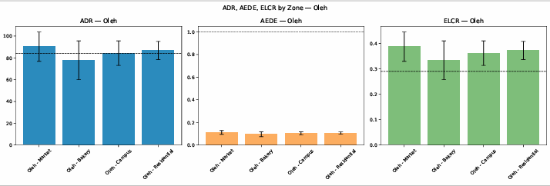
The estimated Annual Effective Dose Equivalent (AEDE) for Oleh ranged from 0.095 ± 0.022 mSvy⁻¹ to 0.107 ± 0.017 mSvy⁻¹, with a mean of 0.103 ± 0.013 mSvy⁻¹, whereas Ozoro recorded slightly higher values ranging between 0.096 ± 0.010 mSvy⁻¹ and 0.127 ± 0.021 mSvy⁻¹, averaging 0.112 ± 0.016 mSvy⁻¹ (Tables 1–2). The combined mean AEDE for both towns (0.108 ± 0.014 mSvy⁻¹) is approximately four times lower than the UNSCEAR (2000, 2020) global outdoor average of 0.41 mSvy⁻¹, confirming that the environmental radiation burden in the study area is well within safe exposure limits prescribed for the public by the International Commission on Radiological Protection (ICRP, 2007). The corresponding Excess Lifetime Cancer Risk (ELCR) ranged from 0.332 ± 0.077 × 10⁻³ to 0.445 ± 0.074 × 10⁻³, with a study-wide mean of 0.376 ± 0.055 × 10⁻³, slightly exceeding the UNSCEAR world mean of 0.29 × 10⁻³. Although marginally higher, these values still represent tolerable stochastic risk levels, suggesting minimal probability of radiation‐induced malignancy under normal environmental exposure conditions. The modest ELCR elevation observed in Ozoro’s market zone may reflect enhanced terrestrial gamma flux from lateritic soils, concrete infrastructure, and high-density commercial activity. Figure 3a and Figure 3b shows the absorbed dose rate (ADR), annual effective dose equivalent (AEDE), and excess lifetime cancer risk (ELCR) in Oleh and Ozoro respectively.

Figure 3a: Absorbed Dose Rate (ADR), Annual Effective Dose Equivalent (AEDE), and Excess Lifetime Cancer Risk (ELCR) in Oleh

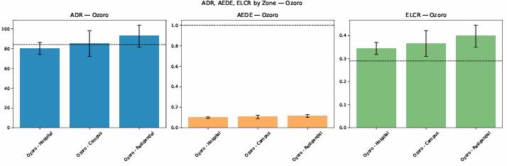

Figure 3b: Absorbed Dose Rate (ADR), Annual Effective Dose Equivalent (AEDE), and Excess Lifetime Cancer Risk (ELCR) in Ozoro
To better contextualize the findings, Table 4 compares the AEDE and ELCR from this study with selected national and international reports. Results show that the AEDE obtained in Oleh and Ozoro (0.107 ± 0.015 mSvy⁻¹) is comparable to other Nigerian studies but lower than those reported in high-activity environments such as Warri (Agbalagba & Anekwe, 2021) and Duhok City, Iraq (Ahmed et al., 2022). Similarly, the ELCR from this study (0.374 × 10⁻³) aligns closely with values reported for Enugu (Ugbede et al., 2022) and Botswana (Sankwasa et al., 2023), but remains significantly below the threshold of concern for radiological health (Figure 4). The lower AEDE and ELCR values recorded in the present study compared to earlier reports from oil‐impacted environments (Agbalagba & Anekwe, 2021; Oke et al., 2024) underscore the moderate radiological conditions of inland urban centers such as Oleh and Ozoro, which are less directly influenced by petroleum extraction or mineral processing. Conversely, the slightly higher ELCR relative to the UNSCEAR global mean may be attributed to localized terrestrial gamma variations arising from natural lithologic enrichment within the Benin and Agbada Formations of the Niger Delta basin.

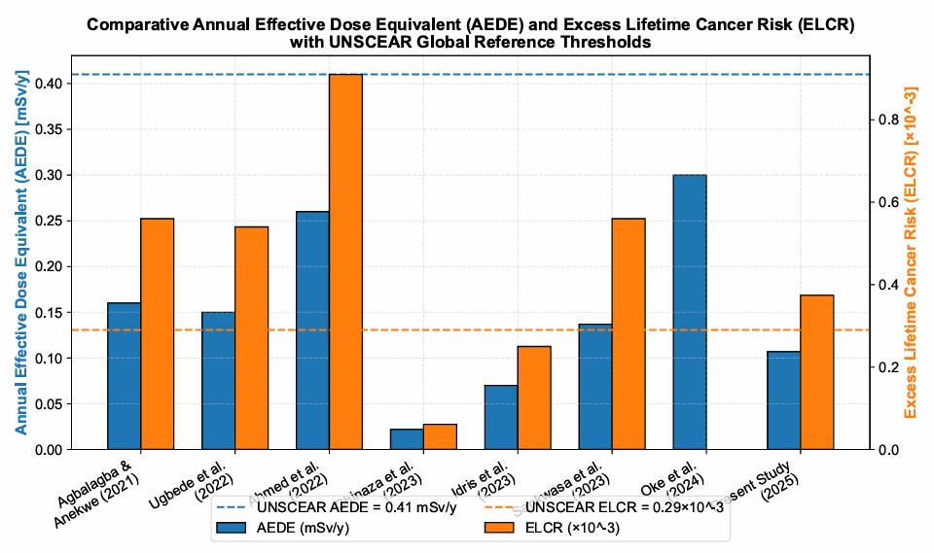
Table 4: Comparative Annual Effective Dose Equivalent (AEDE) and Excess Lifetime Cancer Risk (ELCR) Reported in Selected Studies
Study | Location / Region | AEDE (mSvy⁻¹) | ELCR (× 10⁻³) | Remarks / Key Findings
Agbalagba & Anekwe (2021) | Warri Metropolis, Delta State (Nigeria) | 0.16 ± 0.04 | 0.56 ± 0.01 | Elevated exposure around petroleum and gas facilities.
Ugbede et al. (2022) | Enugu Urban Area (Nigeria) | 0.15 ± 0.03 | 0.54 ± 0.11 | Outdoor gamma dose higher than UNSCEAR world mean (84 nGyh⁻¹).
Ahmed et al. (2022) | Duhok City (Kurdistan Region, Iraq) | 0.26 ± 0.01 | 0.91 ± 0.03 | AEDE > UNSCEAR world average; used for baseline mapping.
Abara. (2023) | FUTO Campus, Owerri (Nigeria) | 0.022 ± 0.059 | 0.061 ± 0.162 | Indoor radiation levels below global average, low health risk.
Idris et al. (2023) | Akwa Ibom State (Nigeria) | 0.07 ± 0.01 | 0.25 ± 0.05 | Outdoor exposure below UNSCEAR reference; low lifetime risk.
Sankwasa et al. (2023) | Serule Village (Botswana) | 0.137 ± 0.01 | 0.56 ± 0.05 | Outdoor gamma radiation approximately twice global average.
Oke et al. (2024) | LAUTECH Campus & Teaching Hospital (Nigeria) | 0.18–0.42 | — | Values within ICRP’s 1 mSvy⁻¹ public limit.
Present Study (2025) | Oleh and Ozoro (Delta State, Nigeria) | 0.107 ± 0.015 | 0.374 ± 0.056 | Comparable to UNSCEAR world mean; indicates moderate exposure.

Figure 4: Comparative bar chart of Annual Effective Dose Equivalent (AEDE, mSvy⁻¹) and Excess Lifetime Cancer Risk (ELCR×10⁻³) from selected studies, with UNSCEAR (2020) thresholds.
Note: No ELCR value was reported by Oke et al. (2024); the corresponding bar is omitted in the plot.

3.3. Organ-specific dose distribution and ICRP comparison
The estimated organ- and tissue-specific dose rates, presented in Table 5 and illustrated in Figure 5, indicate that the testes received the highest dose of 0.07 mSvy⁻¹, followed by the bone marrow and whole body at 0.06 mSvy⁻¹. The lungs, ovaries, and kidneys each received 0.05 mSvy⁻¹, while the liver experienced the lowest dose of 0.04 mSvy⁻¹. This distribution reflects the influence of tissue weighting conversion factors, with more radiosensitive organs accruing proportionally higher doses. The observed organ dose hierarchy underscores the importance of considering tissue-specific radiosensitivity in environmental radiation assessments and provides a robust framework for evaluating potential radiological health risks under the measured exposure conditions.
Table 5: Estimated Organ/Tissue Dose Rates (AEDE = 0.107 mSvy⁻¹, O = 0.8)
Organs | Lung | Ovary | Bone marrow | Testes | Kidney | Liver | Whole body
Conversion factor (F) | 0.64 | 0.58 | 0.69 | 0.82 | 0.62 | 0.42 | 0.68
D₍organ₎ (mSvy⁻¹) | 0.05 | 0.05 | 0.06 | 0.07 | 0.05 | 0.04 | 0.06
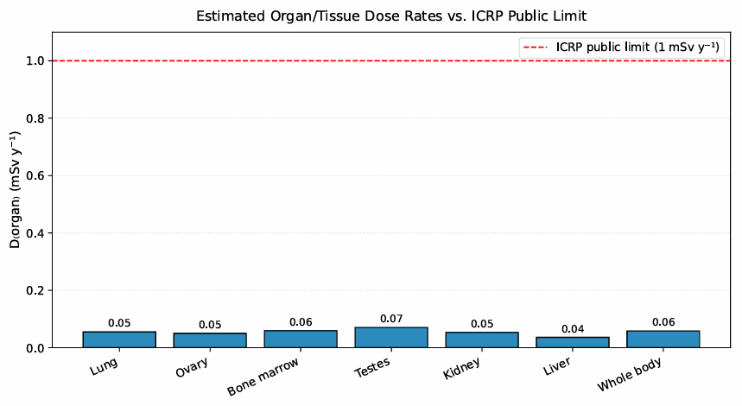
Figure 5: Comparison of Estimated Organ/tissue dose rates to ICRP public limit

3.4 Statistical Robustness and Uncertainty Analysis
To ensure the reliability and reproducibility of the radiological risk estimates, a comprehensive uncertainty quantification framework was employed, integrating Monte Carlo simulations, Bayesian inference, and Bootstrap resampling techniques. The results from the Monte Carlo and Bayesian analyses are provided in the supplementary materials while the Bootstrap outcomes are summarized in Table 6 and visualized in Figure 6.

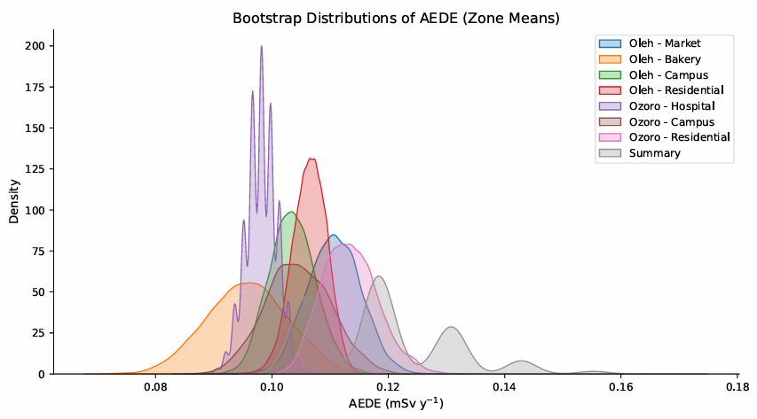
Table 6: Bootstrap (5,000 resamples per zone) of Radiological Risk Parameters
Location | Zone | BIR (mRh⁻¹) ± SD | ADR (nGyh⁻¹) ± SD | AEDE (mSvy⁻¹) ± SD | ELCR (×10⁻³) ± SD
Oleh | Market | 0.010 ± 0.001 | 87.6 ± 13.5 | 0.108 ± 0.017 | 0.378 ± 0.059
 | Bakery | 0.009 ± 0.001 | 79.6 ± 12.7 | 0.098 ± 0.016 | 0.343 ± 0.056
 | Campus | 0.010 ± 0.002 | 85.0 ± 11.8 | 0.104 ± 0.014 | 0.362 ± 0.050
 | Residential | 0.010 ± 0.001 | 85.7 ± 9.9 | 0.105 ± 0.012 | 0.368 ± 0.043
Ozoro | Market | 0.012 ± 0.002 | 103.2 ± 17.3 | 0.127 ± 0.021 | 0.445 ± 0.074
 | Bakery | 0.011 ± 0.001 | 95.1 ± 9.4 | 0.117 ± 0.012 | 0.410 ± 0.042
 | Campus | 0.010 ± 0.002 | 87.5 ± 15.6 | 0.107 ± 0.019 | 0.374 ± 0.066
 | Residential | 0.009 ± 0.001 | 78.4 ± 7.9 | 0.096 ± 0.010 | 0.338 ± 0.035
Mean ± SD (all zones) | — | 0.0099 ± 0.0014 | 86.8 ± 12.1 | 0.105 ± 0.015 | 0.370 ± 0.054
UNSCEAR (2000) | — | 0.013 | 84.0 | 0.41 | 0.29
Figure 6: Bootstrap Sampling Distributions of Annual Effective Dose Equivalent (AEDE) across All Zones

The Monte Carlo simulations, conducted with 10,000 iterations per zone under ±10% input uncertainty, revealed consistent central tendencies across locations. For instance, the annual effective dose equivalent (AEDE) ranged from 0.096 ± 0.010 mSvy⁻¹ in Ozoro Residential to 0.127 ± 0.021 mSvy⁻¹ in Ozoro Market, with a pooled mean of 0.105 ± 0.015 mSvy⁻¹. The excess lifetime cancer risk (ELCR) estimates similarly exhibited low dispersion, with a mean of 0.370 ± 0.054 ×10⁻³, aligning closely with the UNSCEAR reference value of 0.29 ×10⁻³. Bootstrap resampling (5,000 iterations per zone) yielded nearly identical point estimates and standard deviations to those obtained via Monte Carlo, affirming the internal consistency of the results. The Bootstrap-derived standard errors remained stable across zones, and the pooled AEDE and ELCR values matched those from the Monte Carlo framework (0.105 ± 0.015 mSvy⁻¹ and 0.370 ± 0.054 ×10⁻³, respectively). The distributional characteristics of AEDE across all zones illustrated in Figure 6, demonstrates the symmetry and concentration of the resampled estimates around their respective means. Bayesian posterior estimates, derived using a Normal–Inverse Gamma model with 5,000 draws, further substantiated the findings. The 95% credible intervals (CrI) for AEDE were narrow and well-centered-for example, 0.096 (0.081–0.111) mSvy⁻¹ in Ozoro Residential and 0.127 (0.106–0.148) mSvy⁻¹ in Ozoro Market indicating high posterior precision. The posterior means and CrIs for ELCR similarly exhibited tight bounds, with pooled estimates consistent with both Bootstrap and Monte Carlo outputs. The convergence of results across these three inferential paradigms, frequentist resampling, stochastic simulation, and Bayesian estimation, provides compelling evidence of statistical robustness. This integrative approach enhances confidence in the reported metrics and affirms the reproducibility of the radiological risk assessments under varying epistemic and aleatory uncertainties.

4.0 Conclusion and Recommendation
This study provides a comprehensive radiological assessment of background ionizing radiation and associated health risks across urban zones in Oleh and Ozoro, Delta State, Nigeria. The measured background ionizing radiation (BIR) and absorbed dose rates (ADR) across both towns were within global safety thresholds, with mean ADR values of 83.08 ± 10.63 nGyh⁻¹ in Oleh and 91.05 ± 12.54 nGyh⁻¹ in Ozoro, both approximating the UNSCEAR (2000) global average of 84 nGyh⁻¹. The corresponding annual effective dose equivalent (AEDE) values-0.103 ± 0.013 mSvy⁻¹ in Oleh and 0.112 ± 0.016 mSvy⁻¹ in Ozoro were significantly below the ICRP public exposure limit of 1 mSvy⁻¹ and approximately four times lower than the UNSCEAR global mean of 0.41 mSvy⁻¹. These findings affirm that the environmental radiation burden in the study area remains within acceptable limits for public health. The estimated excess lifetime cancer risk (ELCR), although slightly exceeding the UNSCEAR reference value of 0.29 × 10⁻³, remained within tolerable stochastic risk margins, with a pooled mean of 0.376 ± 0.055 × 10⁻³. Spatial analysis revealed that market zones consistently exhibited elevated radiological indices, likely due to increased anthropogenic activity, denser infrastructure, and lithologic enrichment. Organ-specific dose estimates further highlighted the radiosensitivity of critical tissues, with the testes, bone marrow, and whole body receiving the highest doses, reinforcing the need for tissue-weighted risk evaluation. The robustness of the findings was validated through a triadic statistical framework comprising Monte Carlo simulations, Bayesian inference, and Bootstrap resampling. The convergence of estimates across these paradigms, particularly the alignment of 95% credible intervals, standard deviations, and central tendencies, underscores the internal consistency and reproducibility of the results. While current exposure levels pose no significant radiological threat, periodic environmental monitoring is recommended to track potential changes due to urbanization, industrialization, or land-use dynamics. Future studies should incorporate radionuclide-specific assays of soil and construction materials to better characterize source contributions. Public health agencies may also consider targeted awareness campaigns and routine health surveillance in high-activity zones to reinforce radiological safety and preparedness.

COMPETING INTERESTS DISCLAIMER:
Authors have declared that they have no known competing financial interests OR non-financial interests OR personal relationships that could have appeared to influence the work reported in this paper.

References
Abara, C. C. (2023). Baseline background radiation in offices within Federal University of Technology, Owerri [Master's thesis, Federal University of Technology, Owerri]. Federal University of Technology, Owerri Repository. https://repository.futo.edu.ng/server/api/core/bitstreams/60605f7f-e70d-4d12-ad4c-98b95a6d3a53/content https://repository.futo.edu.ng/handle/20.500.14562/1636
Agbalagba, E. O., Nenuwe, O. N., & Egarievwe, U. S. (2020). GIS mapping of BIR levels around fossil fuel and gas dispensing stations and assessment of their radiological risk implications. Geological Behavior, 4(2), 54–62. https://doi.org/10.26480/gbr.02.2020.54.62
Agbalagba, O. E. (2017). Assessment of excess lifetime cancer risk from gamma radiation levels in Effurun and Warri City of Delta State, Nigeria. Journal of Taibah University for Science, 11(3), 367–380. https://doi.org/10.1016/j.jtusci.2016.03.007
Agbalagba, O. E., & Anekwe, L. U. (2021). Radiometric mapping of terrestrial gamma radiation and evaluation of radiological health risk on the residents in Nigeria state commercial and capital cities. Environmental Forensics, 22(1–2), 75–90. https://doi.org/10.1080/15275922.2020.1836079
Agbalagba, P. O., & Okorodudu, O. (2024). Terrestrial gamma radiation in oil-producing areas of Nigeria. Radiation Physics and Chemistry, 200, 110765. https://doi.org/10.1016/j.radphyschem.2023.110765
Ahmed, F., Kareem, I., Meerkhan, S., & Shlaimoon, W. (2022). Risk assessment of outdoor background gamma radiation at Duhok City, in Kurdistan Region, Iraq. Polish Journal of Environmental Studies, 31(6), 4989–4995. https://doi.org/10.15244/pjoes/151584
Ajayi, N. O., & Laogun, A. A. (2006). Variation of environmental gamma radiation in Benin with vertical height. Nigerian Journal of Space Research, 2, 47–54.
Alvarez, P., Kry, S. F., Stingo, F., & Followill, D. (2017). TLD and OSLD dosimetry systems for remote audits of radiotherapy external beam calibration. Radiation Measurements, 106, 412–415. https://doi.org/10.1016/j.radmeas.2017.01.005
Biere, P. E., Emumejaye, K., Aluko, T. O., Nwaobia, A. G., Okeyode, I. C., & Mustapha, O. A. (2025). An evaluation of excess lifetime cancer risk from indoor and outdoor radiation exposure in Okutukutu Computer Village, Yenagoa, Bayelsa State, Nigeria: A Monte Carlo simulation approach. Nigerian Journal of Theoretical and Environmental Physics, 3(1), 10–16. https://doi.org/10.62292/njtep.v3i1.2025.66
Del Monte, L. (2024). Spatial variation of background gamma dose rates in urban environments. Environmental Earth Sciences, 83(5), 354. https://doi.org/10.1007/s12665-024-04554-3
Djicknack Dione, D., Faye, P. M., Ndiaye, N., Sy, M. H., Ndiaye, O., Traoré, A., & Ndao, A. S. (2024). Utilizing Bayesian modeling and MCMC for accurate characterization of naturally occurring radionuclides in mining areas. World Journal of Nuclear Science and Technology, 14(4), 179–187. https://doi.org/10.4236/wjnst.2024.144011
Esi, O. E., Okpilike, E. S., & Okorodudu, O. E. (2024). Radiometric survey of sediments and health risk assessment of the southern coastal area of Delta State, Nigeria. Environmental Monitoring and Assessment, 196(6), 502. https://doi.org/10.1007/s10661-024-12634-5
Frankemölle, J. P. K. W., Camps, J., De Meutter, P., & Meyers, J. (2024). A Bayesian method for predicting background radiation levels in detector networks. Geoscientific Model Development, 18(4), 1989–2005. https://doi.org/10.5194/gmd-18-1989-2025
Idris Isa Sambo, Y. (2023). Evaluation of radiological hazards indices of dose rate measurement from Akwa Ibom State, South-South Nigeria. International Journal of Science and Research (IJSR), 12(7), 831–838. https://doi.org/10.21275/sr23709133736
International Atomic Energy Agency. (2021). Naturally occurring radioactive material (NORM) in the oil and gas industry (IAEA Safety Reports Series No. 78). https://www.iaea.org/publications/15085 https://www.iaea.org/publications/15085/radiation-protection-and-management-of-norm-residues-in-the-phosphate-industry
International Commission on Radiological Protection (ICRP). (2007). Recommendations of the International Commission on Radiological Protection (ICRP Publication 103). Elsevier. https://doi.org/10.1016/j.icrp.2007.10.003
Legborsi, B. L., Fidelis, U. E., Abel, N. A., & Ilugo, N. T. (2025). Assessment of background ionizing radiation of engineering laboratories in Federal Polytechnic Nekede Owerri, Imo State, Nigeria. Asian Journal of Research and Reviews in Physics, 9(1), 1–27. https://doi.org/10.9734/ajr2p/2025/v9i1179
National Council on Radiation Protection and Measurements. (1993). Limitation of exposure to ionizing radiation (NCRP Report No. 116). https://ncrponline.org/publications/reports/ncrp-report-116/
National Population Commission. (2006). Population and housing census of Nigeria 2006. NPC. https://catalog.ihsn.org/index.php/catalog/3340
Oke, I. G., Oni, E. A., Ayanlola, P. S., Aremu, A. A., Agbelusi, O. I., Olatunji, A., Otobrise, H., & Isola, G. A. (2025). In-situ determination of terrestrial gamma dose rate within Ladoke Akintola University of Technology, Ogbomoso southwest Nigeria: The study of terrestrial gamma radiation within Ladoke Akintola University of Technology. LAUTECH Journal of Engineering and Technology, 18(4), 77–85. https://www.laujet.com/index.php/laujet/article/view/733
Omeje, M., Ozioko, O., Okey-Onyesolu, F., & Esi, O. E. (2023). Dispersion of gamma dose rates and natural radionuclides in coastal Niger Delta sediments: Radioactivity distributions and biohazard assessment. Environmental Science and Pollution Research, 30(45), 105678–105692. https://doi.org/10.1007/s11356-023-29025-6
Sankwasa Chika, M., Mashaba, M., Palalani, N., Lesolle, S., & Ramontshonyana, T. T. (2023). Assessment of outdoor terrestrial gamma radiation dose rates of Serule Village, Botswana. Journal of Radiation and Nuclear Applications, 8(2), 139–143. https://doi.org/10.18576/jrna/080206
Ugbede, F. O., Osahon, O. D., & Akpolile, A. F. (2022). Natural radioactivity levels and radiological risk assessment in paddy soil of Ezillo rice fields in Ebonyi State, Nigeria. Environmental Forensics, 23(1–2), 32–46. https://doi.org/10.1080/15275922.2021.1892881
United Nations Scientific Committee on the Effects of Atomic Radiation. (2000). Sources and effects of ionizing radiation: Report to the General Assembly with scientific annexes: Vol. 1. https://www.unscear.org/unscear/en/publications/2000_Report_VolI.html
United Nations Scientific Committee on the Effects of Atomic Radiation. (2008). Sources and effects of ionizing radiation (Report to the General Assembly, Volume I). UNSCEAR. https://www.unscear.org/unscear/en/publications/2008_1.html
United Nations Scientific Committee on the Effects of Atomic Radiation (UNSCEAR). (2020). Sources, effects and risks of ionizing radiation: UNSCEAR 2020 report to the General Assembly with scientific annexes. United Nations. https://www.unscear.org/unscear/en/publications/scientific_reports.html
Zaid, Q. A., Khled, M. A., Anas, M. A., & Abdalmajeid, M. A. (2010). Measurement of natural and artificial radioactivity in powder milk corresponding annual effective dose. Radiation Protection Dosimetry, 138(3), 278–283. https://doi.org/10.1093/rpd/ncp260

TABLE 7. Radiation measurements at individual sampling point

Sampling Point | Coordinates | BIR_mRh | lat_dd | lon_dd | lat_dms | lon_dms | ADR_nGy_h | AEDE_mSv_y | ELCR_abs | ELCR_x10_3
L1 | N 05026.948’ E 006012.097’ | 0.009 | 50.44913 | 60.20162 | 50° 26′ 56.88″ N | 60° 12′ 5.82″ E | 78.84 | 0.096689 | 0.000338 | 0.338412816
L2 | N 05026.876’ E 006011.921’ | 0.009 | 50.44793 | 60.19868 | 50° 26′ 52.56″ N | 60° 11′ 55.26″ E | 788.4 | 0.966894 | 0.003384 | 3.38412816
L3 | N 05026.888’ E 006011.918’ | 0.01 | 50.44813 | 60.19863 | 50° 26′ 53.28″ N | 60° 11′ 55.08″ E | 87.6 | 0.107433 | 0.000376 | 0.37601424
L4 | N 05026.870’ E 006011.936’ | 0.006 | 50.44783 | 60.19893 | 50° 26′ 52.20″ N | 60° 11′ 56.16″ E | 52.56 | 0.06446 | 0.000226 | 0.225608544
L5 | N 05026.856’ E 006011.919’ | 0.008 | 50.4476 | 60.19865 | 50° 26′ 51.36″ N | 60° 11′ 55.14″ E | 70.08 | 0.085946 | 0.000301 | 0.300811392
L6 | N 05026.852’ E 006011.925’ | 0.006 | 50.44753 | 60.19875 | 50° 26′ 51.12″ N | 60° 11′ 55.50″ E | 52.56 | 0.06446 | 0.000226 | 0.225608544
L7 | N 05026.843’ E 006011.913’ | 0.012 | 50.44738 | 60.19855 | 50° 26′ 50.58″ N | 60° 11′ 54.78″ E | 105.12 | 0.128919 | 0.000451 | 0.451217088
L8 | N 05026.534’ E 006011.918’ | 0.011 | 50.44223 | 60.19863 | 50° 26′ 32.04″ N | 60° 11′ 55.08″ E | 96.36 | 0.118176 | 0.000414 | 0.413615664
L9 | N 05026.798’ E 006011.932’ | 0.009 | 50.44663 | 60.19887 | 50° 26′ 47.88″ N | 60° 11′ 55.92″ E | 78.84 | 0.096689 | 0.000338 | 0.338412816
Mean ± SD |  | 0.009 ± 0.002 |  |  |  |  | 77.30 ± 17.60 | 0.095 ± 0.022 |  | 0.332 ± 0.077

TABLE 8. Background ionizing radiation, bootstrap statistics and calculated dose parameters

Zone | n | BIR_mean | BIR_sd | BIR_boot_mean | BIR_boot_2.5% | BIR_boot_97.5% | ADR_boot_mean | ADR_boot_CI_low | ADR_boot_CI_high | AEDE_boot_mean | AEDE_boot_CI_low | AEDE_boot_CI_high | ELCR_boot_mean | ELCR_boot_CI_low | ELCR_boot_CI_high
Oleh - Market | 13 | 0.010308 | 0.001548 | 0.0103 | 0.009537 | 0.011077 | 90.22369 | 76.81846 | 102.4246 | 0.11065 | 0.09421 | 0.125614 | 0.387276 | 0.329736 | 0.439647
Oleh - Bakery | 9 | 0.017889 | 0.027118 | 0.017878 | 0.007778 | 0.036222 | 156.6138 | 60.34667 | 477.9067 | 0.192071 | 0.074009 | 0.586105 | 0.672249 | 0.259032 | 2.051367
Oleh - Campus | 11 | 0.009636 | 0.001286 | 0.009634 | 0.008909 | 0.010364 | 84.39559 | 74.85818 | 96.36 | 0.103503 | 0.091806 | 0.118176 | 0.36226 | 0.321321 | 0.413616
Oleh - Residential | 11 | 0.009909 | 0.000944 | 0.009907 | 0.009364 | 0.010455 | 86.78452 | 76.45091 | 94.76727 | 0.106433 | 0.093759 | 0.116223 | 0.372514 | 0.328158 | 0.406779
Ozoro - Hospital | 7 | 0.009143 | 0.00069 | 0.009138 | 0.008714 | 0.009571 | 80.04688 | 72.58286 | 86.34857 | 0.098169 | 0.089016 | 0.105898 | 0.343593 | 0.311555 | 0.370643
Ozoro - Campus | 7 | 0.009714 | 0.001496 | 0.009692 | 0.008714 | 0.010714 | 84.89792 | 70.08 | 100.1143 | 0.104119 | 0.085946 | 0.12278 | 0.364416 | 0.300811 | 0.429731
Ozoro - Residential | 7 | 0.010571 | 0.001272 | 0.010595 | 0.009857 | 0.011571 | 92.8107 | 81.34286 | 108.8743 | 0.113823 | 0.099759 | 0.133523 | 0.398381 | 0.349156 | 0.467332

