GEOMORPHOLOGICAL MAPPING AND LANDFORM CHARACTERIZATION OF THE LOWER PAPAGNI RIVER BASIN, KARNATAKA STATE

ABSTRACT
The study presents a geomorphological mapping and landform characterization of the Lower Papagni River Basin, Chikkaballapura District, Karnataka, situated within the semi-arid hard rock terrain of the Peninsular Gneissic Complex. The basin exhibits a diverse assemblage of structural, denudational, and fluvial landforms developed under prolonged weathering and erosional processes typical of crystalline terrains (King, 1953; Kale and Gupta, 2001). Geospatial techniques integrating Remote Sensing, Geographic Information Systems (GIS), and Digital Elevation Model (DEM) analysis were employed for systematic delineation of geomorphic units (Nag and Kudrat, 1998; Singh et al., 2013). Multi-temporal Landsat 8 OLI and Sentinel-2 MSI datasets, along with SRTM-DEM, were utilized to extract terrain attributes such as slope, drainage pattern, morphometric parameters, and structural controls. The analysis indicates the dominance of pediplains, accompanied by structural hills, denudational hills, pediments, inselbergs, valley fills, and lateritic surfaces, reflecting a mature geomorphic stage with extensive planation and residual uplands. The drainage network exhibits predominantly dendritic to sub-dendritic patterns, suggesting lithological homogeneity with localized structural influence (Strahler, 1964). Hydrogeomorphically, pediplains and valley fill deposits constitute favourable groundwater potential zones due to thicker weathered mantles and enhanced infiltration capacity, whereas structural and denudational hills represent runoff dominated terrains. Lineaments and fracture systems act as significant conduits for groundwater movement in the crystalline basement (Krishnamurthy et al., 1996).
- INTRODUCTION
Landforms are natural physical features developed on the Earth’s surface through the combined influence of internal tectonic forces and external geomorphic processes such as weathering, erosion, transportation, and deposition (King, 1953; Kale and Gupta, 2001; Singh, 2013). They vary widely in scale, ranging from extensive plains and plateaus to isolated hills, ridges, pediments, and valleys. Scientific investigation of landforms helps in understanding landscape evolution, surface dynamics, and terrain stability (Strahler, 1964; Kale and Gupta, 2001) and provides essential inputs for environmental management and regional planning. In recent years, geomorphometry and terrain analysis have gained considerable importance due to the availability of high-resolution satellite data and Digital Elevation Models (DEMs), which enable precise mapping and classification of geomorphic units (Clark, 1991; Coe and Flug, 1999; Prenzel et al., 2012).
Geomorphological maps depict the spatial distribution, morphology, and genetic classification of landforms (Jones, 1996; King, 1953). Such maps serve as fundamental tools for interpreting the origin and evolution of landscapes and for assessing their influence on natural resources and environmental hazards. The occurrence and intensity of environmental problems such as soil erosion, land degradation, runoff variability, and groundwater depletion are closely linked to geological structure, lithology, topography, and geomorphic setting (Horton, 1945; Rai and Rao, 2012; Sreedevi et al., 2006). Therefore, systematic mapping of landform units is a prerequisite for watershed planning, groundwater exploration, land-use management, and sustainable development (Nag and Kudrat, 1998; Hema et al., 2021). The basin is drained by the Papagni River, an important tributary of the Pennar River (Verma, 2022). The region is predominantly underlain by granitic gneisses and associated crystalline formations of the Peninsular Gneissic Complex. Structurally controlled ridges, denudational hills, pediments, pediplains, residual hills, valley fills, and shallow weathered surfaces characterize the landscape (Kale and Gupta, 2001; Singh, 2013). The general topography is undulating with isolated uplands and broad pediplain surfaces, reflecting prolonged weathering and denudation under semi-arid climatic conditions (King, 1953). Unlike high rainfall mountainous regions where landslides dominate, the study area faces issues related to seasonal runoff, soil erosion, groundwater stress, and land degradation (Hema et al., 2021; Nirmala et al., 2020). The geomorphic framework of the basin significantly influences drainage development, infiltration capacity, aquifer characteristics, and sediment transport (Strahler, 1964; Horton, 1945). Structural features such as lineaments and dykes control both surface water flow and subsurface groundwater movement, thereby shaping the hydrological behaviour of the basin (Krishnamurthy et al., 1996; Rai and Rao, 2012).
The present study focuses on the identification, classification and mapping of landform units using integrated classical field investigations and modern geospatial techniques, including Remote Sensing and GIS analysis (Nag and Kudrat, 1998; Hema et al., 2021; Krishnan and Arjun, 2024). The derived geomorphological map provides a scientific basis for understanding landscape evolution and supports future studies related to groundwater assessment, watershed management, and sustainable land resource planning in the region.
- LOCATION AND PHYSIOGRAPHY:

Lower Papagni River Basin, a sub basin of Pennar River in south east part of Karnataka situated between 13°30'23.48"N latitudes to 13°37'22.22"N latitudes and 77°45'50.74"E latitudes to 78° 9'26.95"E latitudes and covers an area about 623 km² and perimeter 172 km of it covers three taluks in Chikkaballapura district of Karnataka state lie within the study basin (Fig.1). It is the principle right side tributary of Pennar River, one of the major east flowing rivers in southern India. Lower Papagni River originates near east side of Chikkballapura town located in same district and takes a course flowing towards north east direction through Shildhaghatta, Chintamani taluk and crocess the boarder of Karnataka at Chalur town and making the large watershed as Vyasarayana Samudram Cheruvu (Kandukur Cheruvu) Chittoor District.
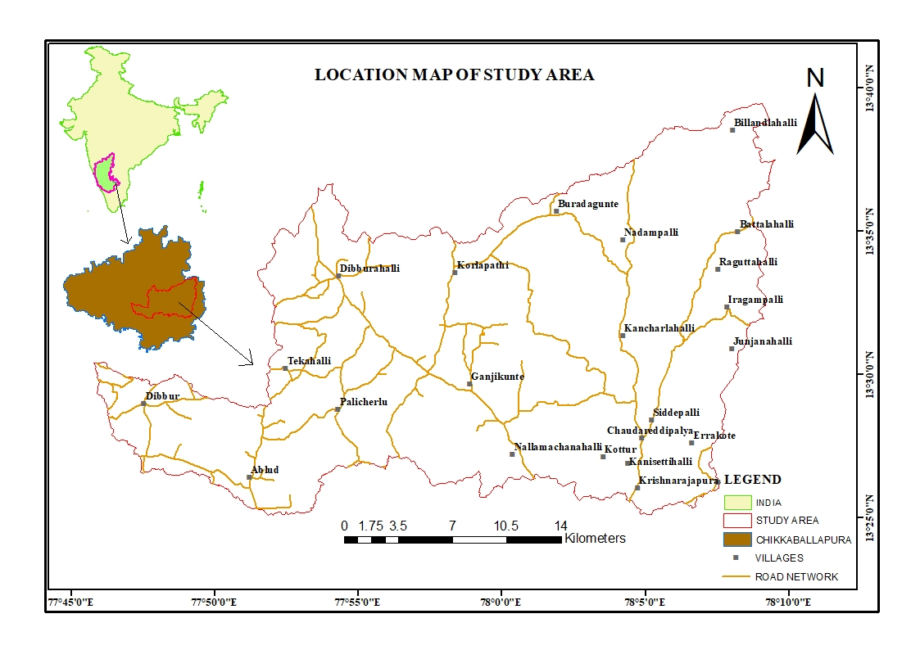
Fig. 1. Location map of study area
- METHODOLOGY AND MATERIALS USED
The methodology was structured to delineate geomorphic units systematically, evaluate terrain attributes, and interpret landscape evolution within the semi-arid hard-rock setting of the basin (Clark, 1991; Coe and Flug, 1999). Multi-temporal satellite data from Landsat 8 OLI and Sentinel-2 MSI were processed through radiometric and atmospheric corrections and standardized to the UTM projection (WGS 84 datum). False Colour Composite images were generated to enhance lithological variations, vegetation patterns, drainage features, and geomorphic boundaries (Prenzel et al., 2012). A 30 m resolution DEM obtained from the Shuttle Radar Topography Mission (SRTM) was utilized to derive slope, aspect, contour, and hill shade maps (Tarboton et al., 1991). Hydrological modelling techniques were applied to generate flow direction and accumulation grids, enabling watershed delineation and drainage extraction (Horton, 1945). Stream ordering followed Strahler’s classification (Strahler, 1964), and key morphometric indices including drainage density, bifurcation ratio, stream frequency, relief ratio, and ruggedness number were computed to assess basin morphology and erosional status (Horton, 1945; Angadi et al., 2025; Chalapathi and Inayathulla, 2022). Landform mapping was accomplished through integrated interpretation of satellite imagery and DEM derivatives using standard visual interpretation criteria such as tone, texture, pattern, and association (Jones, 1996; Clark, 1991). Major geomorphic units including structural and denudational hills, inselbergs, pediplain, valley fills, and alluvial plains were digitized in GIS and assigned relevant topographic and geomorphic attributes (Kale & Gupta, 2001; Singh, 2013). Further terrain analysis involved slope categorization and hypsometric assessment to evaluate relief characteristics and geomorphic maturity (Kadalli and Devappa, 2022; Angadi et al., 2025). Field verification was conducted through GPS based surveys to validate mapped units and document lithology, weathering profiles, soil thickness, and structural controls. The validated datasets were incorporated into the GIS framework to finalize thematic outputs. The study culminated in the preparation of geomorphological, slope, and drainage maps at 1:50,000 scale, ensuring a scientifically rigorous and integrated characterization of landforms within the Lower Papagni River Basin.
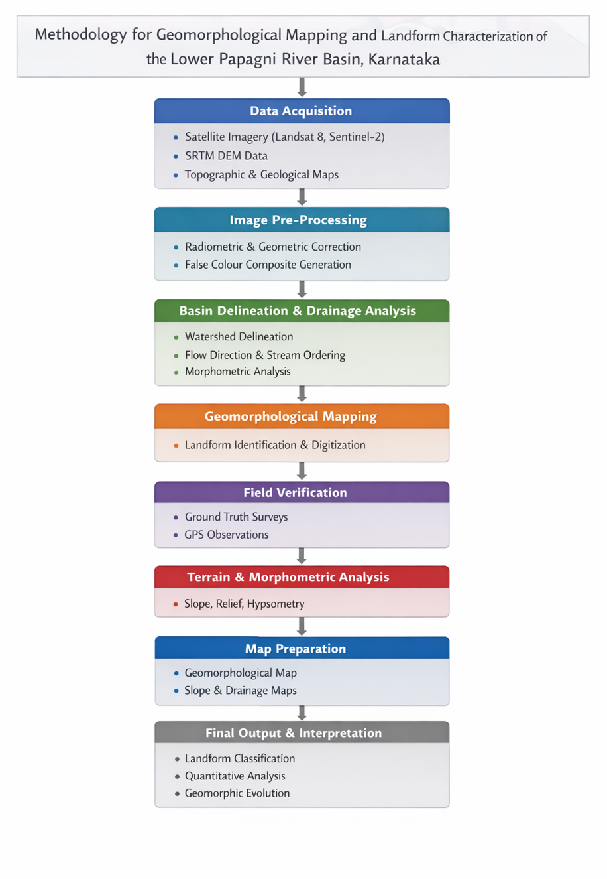
Fig. 2 Methodology of Landform characterization.
RESULT AND DISCUSSION

4.1 GEOMORPHOLOGICAL CHARACTERISTICS
The geomorphological map of the present study area reveals a landscape predominantly shaped by denudational and fluvial processes under semiarid climatic conditions. The basin exhibits a complex assemblage of structural, erosional, and depositional landforms, reflecting prolonged weathering of hard rock terrain and structural control over geomorphic evolution.
Sl. No | Landform Characterization | Area in km² | Percentage(%)
1 | Denudational Hills | 1.61 | 0.26
2 | Inselberg | 0.45 | 0.07
3 | Lateritic plain shallow | 19.79 | 3.18
4 | Linear Ridge/ Dyke | 0.13 | 0.02
5 | Moderately weathered/ moderately buried Pediplain | 98.71 | 15.84
6 | Pediment - Inselberg Complex | 31.11 | 4.99
7 | Pediment/ Valley Floor | 112.76 | 18.09
8 | Pediplain Eroded | 7.69 | 1.23
9 | Residual Hill | 12.35 | 1.98
10 | Ridge type Structural Hills (Small) | 6.79 | 1.09
11 | Shallow weathered/ shallow buried Pediplain | 223.94 | 35.93
12 | Valley Fill/ filled-in valley | 76.25 | 12.23
13 | Water Body Mask | 31.63 | 5.08
 | Grand Total | 623.21 | 100

Table. 1 Classification of Landform Characters.

4.1.1 Pediplain Dominance
The most extensive geomorphic unit in the basin is the pediplain, occurring in Shallow weathered/shallow buried pediplains occupy the largest share, covering 223.94 km² (35.93%), and are widely distributed across the basin, particularly along transitional zones between uplands and valley floors. Moderately weathered/moderately buried pediplains extend over 98.71 km² (15.84%), predominantly in the central and northern sectors, indicating advanced stages of planation and regolith development.
Shallow weathered pediplain are widely distributed, particularly along transitional zones between uplands and valley floors. The presence of pediplain eroded surfaces account for 7.69 km² (1.23%), representing zones of active denudation and stripping of weathered material. The dominance of pediplains indicates long term pediplanation processes typical of stable cratonic regions in Peninsular India (King, 1953; Kale & Gupta, 2001).

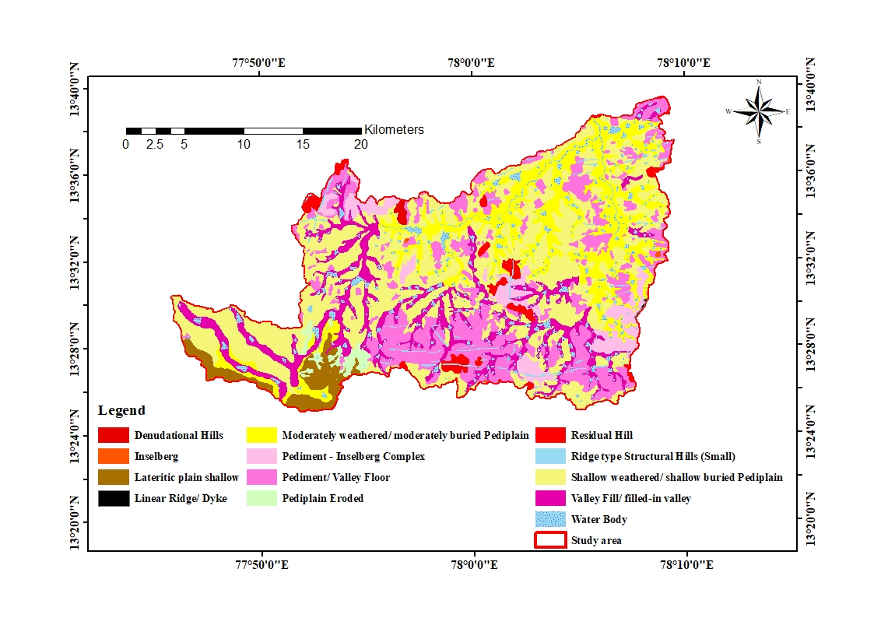
Figure. 3 Geomorphological map of the study area.

4.1.2 Structural and Residual Landforms
Structural control is evident through ridge-type hills and linear features influenced by fractures and joints (Krishnamurthy et al., 1996). The Ridge type structural hills (small) cover 6.79 km² (1.09%), while linear ridges/dykes occupy a limited area of 0.13 km² (0.02%), showing preferred orientations that suggest tectonic influence and lithological resistance. The distribution of these landforms suggests that fractures and joints have guided both topographic development and drainage alignment. Denudational and residual hills represent remnants of older erosion surfaces (Singh, 2013). The Residual geomorphic features include residual hills covering 12.35 km² (1.98%) and denudational hills occupying 1.61 km² (0.26%). These elevated terrains represent remnants of older erosion surfaces that resisted weathering due to lithological competence. Isolated inselbergs are covering 0.45 km² (0.07%) scattered across the pediplain surfaces, rising abruptly as resistant granitic outcrops. Their occurrence reflects differential weathering and selective erosion.

4.1.3 Pediment and Pediment–Inselberg Complex
Pediment surfaces occur along the foothill zones, often forming pediment inselberg complexes. Pediment surfaces occur along foothill zones and transitional slopes. The pediment–inselberg complex occupies 31.11 km² (4.99%), marking the interface between uplands and plains. The Pediment development reflects lateral planation and slope retreat processes (King, 1953; Kale & Gupta, 2001). The broader pediment/valley floor unit extends over 112.76 km² (18.09%), representing gently sloping erosional surfaces formed by lateral planation and slope retreat processes.

4.1.4 Valley Fill and Fluvial Features
Valley fills and filled-in valleys are distributed along major drainage courses with covering area of 76.25 km² (12.23%), particularly in the central and southwestern parts of the basin. These depositional features indicate sediment accumulation in low gradient zones. Valley fills indicate depositional environments and enhanced groundwater prospects (Rai & Rao, 2012; Sreedevi et al., 2006).The drainage pattern is predominantly dendritic to sub-dendritic, characteristic of homogeneous hard-rock terrain (Strahler, 1964). However, localized linear alignment of streams suggests structural influence in certain sectors. Water bodies account for 31.63 km² (5.08%) of the total basin area.

4.1.5 Lateritic Plains and Weathering
Lateritic shallow plains are observed mainly in the southwestern portion of the basin covering 19.79 km² (3.18%). These plains reflect prolonged sub-aerial exposure and intense chemical weathering processes (Singh, 2013). and lateritization under favorable geomorphic and climatic conditions. Their occurrence indicates prolonged sub aerial exposure and intense leaching processes.

4.2 Geomorphic Evolution
The spatial distribution of landforms suggests that the Lower Papagni River Basin has reached a mature stage of geomorphic development. Extensive pediplain surfaces, isolated residual hills, and well developed valley fills indicate long term denudation under semi-arid climatic conditions. Structural features such as ridges and dykes have influenced both relief distribution and drainage orientation, demonstrating tectonic inheritance in the landscape evolution. The combination of erosional uplands and depositional valley floors reflects ongoing dynamic equilibrium between weathering, erosion, and sedimentation processes.

4.3 Implications for Terrain Stability and Groundwater
The distribution of landforms within the studyarea has significant implications for terrain stability and groundwater occurrence. Pediplain and valley-fill deposits constitute favourable zones for groundwater accumulation due to enhanced infiltration and storage capacity (Rai & Rao, 2012; Hema et al., 2021). These areas generally exhibit gentle slopes, low runoff intensity, and higher porosity, making them suitable for groundwater recharge and sustainable extraction.
In contrast, Structural and denudational hills function predominantly as runoff-dominated zones with limited recharge (Horton, 1945). Their steep slopes, exposed bedrock surfaces and limited soil cover reduce infiltration capacity and promote rapid surface drainage. Consequently, these elevated terrains contribute more to surface flow than to subsurface recharge and typically display lower groundwater potential.
Pediment zones, occurring at the foothills of structural uplands, serve as transitional geomorphic units between hills and plains. These gently sloping rock cut surfaces with a thin veneer of weathered material facilitate moderate infiltration and act as secondary recharge areas. Their geomorphic position allows them to receive runoff from adjacent uplands while permitting partial percolation into fractured bedrock.
Linear structural features such as faults, fractures, and Lineaments and fracture systems act as conduits for groundwater movement in hard rock terrains (Krishnamurthy et al., 1996). These structural discontinuities may function as conduits for groundwater movement by enhancing secondary porosity and permeability along fracture systems. Therefore, areas exhibiting higher lineament density are often associated with improved groundwater prospects, provided they intersect favourable geomorphic units such as pediplain or valley fills.

- REFFRENCES
- Angadi, S., Girijamma, B. M., and Bhagwat, T. N. (2025). Morphometric analysis of the Tunga River sub-catchment, Karnataka, India using remote sensing and QGIS: Implications on water resource allocation. Journal of Geomatics, 19(2), 156–164. https://doi.org/10.58825/jog.2025.19.2.190
- Chalapathi, K., and Inayathulla, M. (2022). Quantitative morphometric analysis of Kolar Taluk watershed using remote sensing and GIS techniques. International Advanced Research Journal in Science, Engineering and Technology (IARJSET), 9(11). https://doi.org/10.17148/IARJSET.2022.9113
- Clark, M. J. (1991). Terrain mapping: A systematic methodology for deriving landform information from aerial photographs. Earth Surface Processes and Landforms, 16(5), 437–452. https://doi.org/10.1002/esp.3290160508
- Coe, J. A., and Flug, M. (1999). A digital terrain model for geomorphologic mapping. Geomorphology, 31(1), 27–37.
- Hema, H. C., Vittala, S. S., and Govindaiah, S. (2021). Quantitative morphometric inference in hard rock terrain based on SRTM-DEM and GIS — Chintamani Watershed, Chikkaballapur District, Karnataka, India. Sustainable Water Resources Management, 7, Article 57. https://doi.org/10.1007/s40899-021-00534-8
- Horton, R. E. (1945). Erosional development of streams and their drainage basins: Hydrophysical approach to quantitative morphology. Geological Society of America Bulletin, 56(3), 275–370. https://doi.org/10.1130/0016-7606(1945)56[275:EDOSAT]2.0.CO;2
- Jones, D. K. C. (1996). Geomorphological mapping — An introduction. Geomorphology, 15(3), 179–183. https://doi.org/10.1016/0169-555X(95)00113-8
- Kadalli, G. G., and Devappa. (2022). Integrated morphometric and hypsometric analysis of Niragantipalli micro-watershed using remote sensing and GIS techniques. International Journal of Environment and Climate Change. (DOI not available; verify from journal website or CrossRef.)
- Krishnan, A., and Arjun, S. (2024). Morphometric analysis in the sub basins of the Kali River using Geographic Information System, Karnataka, India. Geomatica, 76, 100013. https://doi.org/10.1016/j.geomat.2024.100013
- Mayachar, S. K., Nandini, N., and Ramesh, K. S. (2018). Morphometric analysis for peak discharge estimation of sub- and micro-watersheds of Vedavathy river sub-basin, Karnataka. GEO – Bu Journals, 7(1), 43–52. https://doi.org/10.53989/bu.ge.v7i1.9
- Horton, R. E. (1945). Erosional development of streams and their drainage basins: Hydrophysical approach to quantitative morphology. Geological Society of America Bulletin, 56(3), 275–370. https://doi.org/10.1130/0016-7606(1945)56[275:EDOSAT]2.0.CO;2
- Kale, V. S., and Gupta, A. (2001). Introduction to geomorphology. Orient Longman Private Limited, New Delhi.
- King, C. A. M. (1953). Methods of landform analysis. Harper & Brothers Publishers, New York.
- Krishnamurthy, J., Srinivasalu, S., and Subramanian, V. (1996). Lineament control on groundwater occurrence in hard rock terrains. Journal of the Geological Society of India, 47(2), 283–286.
- Nag, S. K., and Kudrat, M. (1998). Morphometric analysis using remote sensing techniques in the Chaka sub-basin, Purulia district, West Bengal. Journal of the Indian Society of Remote Sensing, 26(1–2), 69–76. https://doi.org/10.1007/BF02990775
- Singh, S. (2013). Geomorphology. Prayag Pustak Bhawan, Allahabad.
- Strahler, A. N. (1964). Quantitative geomorphology of drainage basins and channel networks. In V. T. Chow (Ed.), Handbook of applied hydrology (Section 4-II, pp. 4–39). McGraw-Hill Book Company, New York.
- Nirmala, R., Singh, R. P., Verma, N., and Bongale, P. (2020). A GIS-based approach in drainage and morphometric analysis of Suvarnavathi River Basin and sub-watersheds, Karnataka, India. Arabian Journal of Geosciences, 17(4), 81–87. https://doi.org/10.3233/AJW200054
- Prenzel, B., et al. (2012). Landform classification and mapping using airborne LiDAR. International Journal of Digital Earth, 5(5), 362–392. https://doi.org/10.1080/17538947.2011.630728
- Rai, B., and Rao, K. S. (2012). Morphometric analysis and evaluation of groundwater potential zones using geospatial tools in a semi-arid region of India. Arabian Journal of Geosciences, 6(10), 3533–3546. https://doi.org/10.1007/s12517-011-0322-3
- Sreedevi, P. D., Vijaykumar, K., and Reddy, M. J. (2006). GIS and remote sensing techniques for morphometric analysis of a watershed, Tirupati, Andhra Pradesh, India. Journal of the Indian Society of Remote Sensing, 34(4), 419–431.
- Tarboton, D. G., Bras, R. L., and Rodriguez-Iturbe, I. (1991). On the extraction of channel networks from digital elevation data. Hydrological Processes, 5(1), 81–100. https://doi.org/10.1002/hyp.3360050107
- Verma, N. (2022). The study of the drainage basin morphometry of Papagni River Basin, a tributary of Pennar River in South India. National Geographical Journal of India, 61(4), 419–434. Retrieved from https://ngji.in/index.php/ngji/article/view/367
- Horton, R. E. (1945). Erosional development of streams and their drainage basins: Hydrophysical approach to quantitative morphology. Geological Society of America Bulletin, 56(3), 275–370. https://doi.org/10.1130/0016-7606(1945)56[275:EDOSAT]2.0.CO;2
- Kale, V. S., and Gupta, A. (2001). Introduction to geomorphology. Orient Longman Private Limited, New Delhi.
- King, C. A. M. (1953). Methods of landform analysis. Harper & Brothers Publishers, New York.
- Krishnamurthy, J., Srinivasalu, S., and Subramanian, V. (1996). Lineament control on groundwater occurrence in hard rock terrains. Journal of the Geological Society of India, 47(2), 283–286.
- Nag, S. K., and Kudrat, M. (1998). Morphometric analysis using remote sensing techniques in the Chaka sub-basin, Purulia district, West Bengal. Journal of the Indian Society of Remote Sensing, 26(1–2), 69–76. https://doi.org/10.1007/BF02990775
- Singh, S. (2013). Geomorphology. Prayag Pustak Bhawan, Allahabad.
- Strahler, A. N. (1964). Quantitative geomorphology of drainage basins and channel networks. In V. T. Chow (Ed.), Handbook of applied hydrology (Section 4-II, pp. 4–39). McGraw-Hill Book Company, New York.

