Minireview Article
Research Progress on Multimodal Extraction Processes and Biological Activities of Perilla Essential Oil

.
ABSTRACT

Perilla frutescens, rich in active terpene components such as perillaldehyde and perillartine, holds great promise in the field of botanical pesticides. This article focuses on essential oil extraction techniques such as enzyme-assisted extraction and ultrasonic-microwave synergy, comparing the yield, component enrichment, and scalability of each method. It also clarifies the repellent and antifeedant activities of perilla essential oil against stored product pests, orchard pests, mosquitoes, and piercing-sucking pests, and elucidates the organ distribution and chemotype differences of the core components. Perilla essential oil possesses a triple mechanism of "lethal toxicity - repellency - antifeedancy", and the extraction technology has developed towards green and efficient directions. However, there are still deficiencies in field persistence, standardized evaluation, and environmental safety assessment. In the future, it is necessary to deepen process optimization and mechanism research to promote industrial application.

Keywords: Perilla essential oil; extraction process; botanical pesticide; antifeedant activity; repellent effect

1. Introduction

In recent years, the disordered use of conventional chemical pesticides has led to problems such as increased resistance in harmful organisms and pesticide residues. Monitoring has detected pesticides in soils, air, water, and even precipitation in agricultural regions worldwide (Kinniburgh et al., 2023), and they have also been found in remote regions where pesticides are not used (Park et al., 2023). They not only kill pests, but can also harm human health and disrupt the delicate balance of microbial communities in soil and aquatic ecosystems (El Nahhal et al., 2013). Data from the post-Green Revolution period show that nearly 800,000 people have died due to chemical pesticide pollution (Wolfe & Marsit, 2023).
Domestic monitoring data show that the detection rate of pesticide residues in leafy vegetables is as high as about one-seventh, and the resistance of stubborn pests represented by phyllotreta striolata continues to rise, with the effectiveness of chemical control continuously declining.
Against this background, promoting the green transformation of agriculture and developing efficient, low-toxicity, and easily degradable botanical pesticides has become an urgent task to safeguard food security and ecological security. Compared with traditional chemical pesticides, botanical pesticides have diverse modes of action, high bioactivity, low toxicity, and low residues, and are relatively safe for non-target organisms (Yang et al., 2022), which is consistent with the concepts of environmental protection, health, and sustainable development in modern agriculture.
Perilla (Perilla frutescens), a traditional medicinal plant in China, is an annual erect herb of the genus Perilla (Lamiaceae). Its stems, leaves, seeds, and roots can all be used medicinally, and it has both medicinal and edible value. Perilla contains perilla ketone. Studies have shown that when the concentration of perilla ketone is 50–100 mg/kg, it can completely inhibit the growth of various microorganisms, and therefore can be used to produce biopesticides.
Perilla essential oil is a secondary metabolite in perilla. It has been found to exhibit fumigant, contact-killing, and repellent activities against pests, and is an environmentally friendly natural insecticidal active substance. Current studies show that perilla oil exhibits high fumigant toxicity against lucilia sericata, and perilla ethanol crude extract has obvious antifeedant, avoidance, and insecticidal effects on tobacco aphids (Yuan et al., 2016). Extracts from different perilla organs and obtained with different solvents have antifeedant and repellent effects on adult phyllotreta striolata (Liang, 2007). The major active component of perilla essential oil, perillaldehyde, has been confirmed to have significant bioactivity against various pests. For example, Dong et al. reported that the LC50 of perilla essential oil against the pear psylla was only 0.28 mg/ml, and the natural degradation rate in 48 h was as high as 92%, indicating a low risk of environmental residues (Dong et al., 2019).
However, some studies still have limitations in extraction processes, activity-evaluation dimensions, and the range of target pests. The yields of traditional distillation methods are generally low (Zhang et al., 2016), and activity studies are mostly focused on lethal effects (Dong et al., 2019), with insufficient attention paid to behavioral interference mechanisms such as antifeedant and repellent effects; moreover, systematic evaluations against important pests such as phyllotreta striolata are lacking (Zhang et al., 2016).
Therefore, this review aims to present the research progress on perilla essential oil extraction processes and the mechanisms of action of its active substances, providing theoretical support for the green control of leafy-vegetable pests.
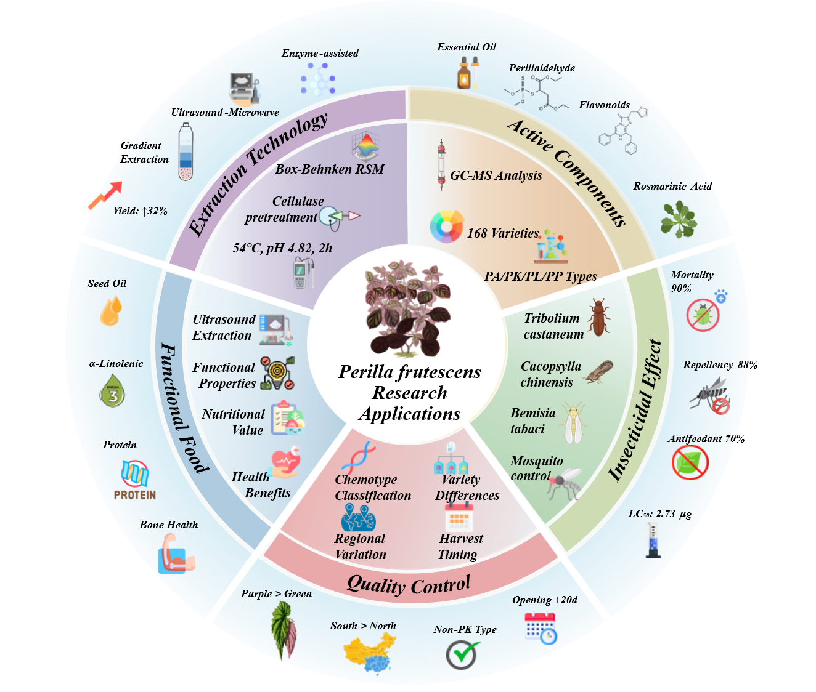
Fig. 1. Perilla: A Comprehensive Overview of Research and Applications
Icons: Flaticon (flaticon.com);
Molecular structures: BioRender (biorender.com)
Illustrations: Freepik (freepik.com)

2. Research on Extraction Processes of Perilla Essential Oil

2.1 Traditional Extraction Methods

Steam distillation has long been used as a classical method for extracting volatile oils, and is widely applied at laboratory and pilot scales due to its simple equipment and low cost. Zhang Bo pointed out that when the moisture content of fresh leaves is relatively high, the distillation time needs to be extended to more than 3 h to obtain a stable yield; conversely, when the raw material is shade-dried to a moisture content below 10%, only 1.5 h is needed to achieve the same extraction effect (Zhang & Ye, 2015). However, this method is time-consuming and energy-intensive, and prolonged high-temperature heating may cause degradation or loss of heat-sensitive components, as also mentioned in the study by Chen et al. (Chen et al., 2020).
Organic solvent extraction performs well in enriching lipophilic active components, especially for perilla seeds. Xian Zhenhua et al. confirmed that the extraction yield of petroleum ether for seeds (4.11%) was significantly higher than that of absolute ethanol (3.17%) and methanol (2.49%), but subsequent solvent removal under reduced pressure and testing for solvent residues are required (Xian et al., 2009). Although this method has high extraction efficiency, the use of organic solvents brings safety hazards and environmental pressure, and solvent residues may affect the quality of the final product; Feng et al. also discussed this (Feng et al., 2024).
Simultaneous distillation-extraction can be regarded as an improvement over traditional steam distillation. Based on single-factor experiments, Zhang Chenlu et al. optimized the SDE process using a Box–Behnken response surface method, and determined the optimal conditions as a material-to-liquid ratio of 1:7, a distillation time of 2.5 h, and dichloromethane as the extraction solvent. Under these conditions, the relative content of perillaldehyde increased by 12% and the total recovery increased by 40% (Zhang et al., 2016). However, this method still involves the use of organic solvents and has higher equipment complexity.

2.2 Enzyme-assisted Extraction

Enzyme-assisted extraction uses cellulase, pectinase, and other enzymes to specifically hydrolyze components of the plant cell wall, thereby promoting the release of intracellular active substances. Liu Na et al. introduced cellulase pretreatment in the extraction of total flavonoids from perilla leaves and systematically investigated the effects of ethanol volume fraction, enzyme dosage, enzymolysis temperature, and enzymolysis time (Liu et al., 2023). The results showed that a 50% ethanol solution provided an appropriate polarity environment; cellulase activity was optimal at an addition level of 0.5%, whereas excessive amounts could lead to product inhibition; enzymolysis at 30°C for 3 h could sufficiently disrupt the plant cell wall. Under these optimized conditions, the extraction yield of total flavonoids reached 3.45%, an increase of about 30% compared with the non-enzymolysis group.
Zhang Chenlu et al. were the first to couple cellulase pretreatment with a Box–Behnken response surface method for extracting volatile oil from perilla leaves (Zhang et al., 2016). Under optimized conditions of 54°C and pH 4.81, only 2 h of enzymolysis was needed to increase essential-oil yield by 32% while raising the content of the main component, perillaldehyde, to more than 78%. Compared with traditional steam distillation (4–6 h), this method markedly shortens processing time and reduces energy consumption.
Khruengsai et al. coupled enzymatic pretreatment with microwave-assisted extraction (EP-MAE) for extracting Zanthoxylum limonella essential oil, and optimized parameters such as water-to-material ratio, enzyme dosage, microwave time, and microwave power using Plackett–Burman and Box–Behnken designs (Khruengsai et al., 2023). Under the optimal conditions, the essential-oil yield reached 7.89 mg/g, which was significantly higher than that of microwave extraction alone (7.26 mg/g) and steam distillation (7.04 mg/g). This study confirmed that enzymolysis can effectively disrupt the cell-wall structure and enhance mass transfer efficiency during subsequent microwave extraction; however, enzyme cost and control of reaction conditions remain issues that need to be considered for industrial application.

2.3 Ultrasound-assisted Extraction

Ultrasound-assisted extraction disrupts cell structures through cavitation, mechanical shear, and micro-jet effects, thereby accelerating mass transfer. Liu Na et al. introduced ultrasound treatment in flavonoid extraction (Liu et al., 2023) and found that ultrasound treatment at 60°C for 20 min could increase the diffusion rate while avoiding degradation of heat-sensitive flavonoids. Singh et al. used response surface methodology to optimize the conditions for ultrasound-assisted extraction of perilla protein, examining the effects of ultrasound power, extraction temperature, and time on protein yield (Singh et al., 2025). The results showed that under the optimal conditions of 55 W ultrasound power, 50°C, and 10 min, the protein yield reached 67.44%, and the amino-acid profile was dominated by glutamic acid (39.511 Pmol/mg), glycine (26.196 Pmol/mg), and arginine (26.166 Pmol/mg). Ultrasound treatment reduced the particle size of protein aggregates by 18-fold, and functional properties such as solubility, emulsifying capacity, foaming capacity, and oil- and water-holding capacities increased by more than 100% compared with the untreated group. The study also pointed out that although ultrasound can significantly improve protein functional properties, it has little effect on protein molecular-weight distribution and the secondary structure remains intact.

2.4 Microwave-assisted Extraction

Microwave-assisted extraction takes advantage of the volumetric heating characteristics of microwaves to rapidly increase system temperature, disrupt cell structures, and shorten extraction time. Yuan Lianlian et al. used 95% ethanol to macerate whole-plant perilla powder at room temperature for 48 h, and obtained a paste-like crude extract after vacuum concentration; this process is simple to operate and has relatively low energy consumption, making it suitable for large-scale preparation in the field (Yuan et al., 2016). However, the extraction time is relatively long and the efficiency still needs to be improved.
Chen et al. coupled ultrasound pretreatment with microwave-assisted hydrodistillation (UP-MAHD) for extracting essential oil from perilla leaves, and systematically optimized parameters such as ultrasound frequency, power, and time, as well as microwave power and material-to-liquid ratio (Chen et al., 2020). The results showed that after ultrasound pretreatment at 45 kHz and 160 W for 10 min, followed by microwave extraction at 540 W for 10 min, the essential-oil yield reached 5.79 mg/g, which was significantly higher than that of the non-ultrasound group (4.34 mg/g) and the steam-distillation group (5.10 mg/g/60 min). GC–MS analysis showed that the contents of oxygenated monoterpenes (83.69%) and oxygenated sesquiterpenes in the essential oil obtained by UP-MAHD were significantly higher than those obtained by other methods, and the perilla ketone content reached 80.76%. Kinetic fitting indicated that the process better conformed to a first-order kinetic model. This study confirmed that ultrasound–microwave coupling can produce a synergistic effect, improving essential-oil quality while increasing yield.

2.5 Stepwise and Coupled Extraction Technologies

A single technique often cannot simultaneously balance yield, purity, and energy consumption. In recent years, coupled technologies such as ultrasound–enzyme (Liu et al., 2023), ultrasound–microwave (Chen et al., 2020), and enzyme–microwave (Khruengsai et al., 2023) have become research hotspots.
Liang Hongwei proposed a three-step polarity-gradient extraction strategy of “n-hexane → ethyl acetate → methanol” (Liang, 2007) for stepwise enrichment of perilla active components with different polarities. Experiments showed that the low-polarity fraction was rich in sesquiterpenes and could achieve a 24 h corrected mortality of up to 90% against adult flea beetles; the medium-to-high polarity fraction, rich in flavonoid glycosides, showed an antifeedant rate of more than 70% against larvae of plutella xylostella. This strategy provides a feasible path for precise extraction with a “one fraction–one target” approach.
Feng et al. designed a stepwise microwave hydrodistillation and extraction (SMHDE) process to simultaneously separate essential oil and seed oil from perilla seeds (Feng et al., 2024). In the first stage, essential oil was separated by microwave distillation (yield 0.55 mL/kg; main component perillaldehyde 20.50%), and in the second stage, a solvent was added to extract seed oil. Using Plackett–Burman and Box–Behnken designs, parameters such as moisture content, microwave time and power in the first stage, liquid-to-solid ratio, and microwave time and power in the second stage were optimized. Under the optimal conditions, the seed-oil yield reached 36.49% and the α-linolenic acid content reached 69.90%, which was significantly higher than that obtained by microwave-assisted extraction (66.59%) and Soxhlet extraction (66.51%). GC–MS analysis showed that the total content of volatile compounds in seed oil obtained by SMHDE (9.20%) was significantly lower than that obtained by MAE (10.94%) and SE (15.23%); the contents of off-odor substances such as perillaldehyde and 2-acetylfuran were markedly reduced, and sensory evaluation indicated a roasted aroma with higher consumer acceptance. The energy consumption (0.21 kWh) and CO₂ emissions (168 g) of this process were significantly lower than those of the control methods, consistent with the concept of green and sustainable development.

2.6 Analysis of Shortcomings in Existing Studies

Although significant progress has been made in research on perilla extraction processes, the following shortcomings remain. First, studies on synergistic extraction of multiple components are insufficient. Existing studies mainly focus on optimizing extraction of single components such as volatile oils or flavonoids, and lack systematic investigation of simultaneous extraction of multiple components from the whole perilla plant and their synergistic effects. For example, although the polarity-gradient extraction strategy proposed by Liang Hongwei demonstrates the potential for multi-target extraction (Liang, 2007), few follow-up studies have been conducted. Perilla leaves, seeds, and stems are rich in diverse active components; how to achieve efficient separation of multiple components such as volatile oil, flavonoids, proteins, and fatty acids within the same process is a direction that needs to be addressed in the future.
Second, high-value utilization of by-products is weak. The press cake after perilla oil extraction contains as much as 35%–45% protein, but it is currently mostly used as feed or discarded, resulting in serious resource waste. Although Singh et al. demonstrated the potential of ultrasound-assisted protein extraction (Singh et al., 2025), subsequent studies on functional applications and industrial translation are still insufficient. How to organically integrate extraction processes with deep processing of by-products to build a whole-industry-chain utilization model deserves further exploration.
Third, process scale-up and the general applicability of models remain to be validated. Existing studies are mostly at the laboratory scale. Although kinetic models (e.g., first-order and second-order models) have been used to fit extraction processes (Chen et al., 2020), model parameters are greatly affected by factors such as raw-material batch, cultivar, and origin, and studies on general applicability and scale-up design are still lacking. In addition, the process conditions differ substantially among studies, making direct comparison and promotion difficult.
Fourth, green solvents and safety evaluation are insufficient. Although some studies have used green solvents such as water and ethanol (Yuan et al., 2016), the application of novel green media such as ionic liquids and deep eutectic solvents in perilla extraction remains blank. In organic-solvent extraction, solvent-residue issues have not received sufficient attention, and relevant safety evaluation standards still need to be improved.
Fifth, the effects of cultivar and origin have not been fully incorporated into process optimization. Feng et al. revealed that 168 perilla cultivars include different chemotypes such as PA, PK, PL, and PP, but current extraction-process optimization usually targets a single cultivar and does not consider cultivar differences in process-parameter design (Feng et al., 2024). In the future, metabolomics and process simulation should be combined to establish an integrated optimization strategy of “cultivar–composition–process”.
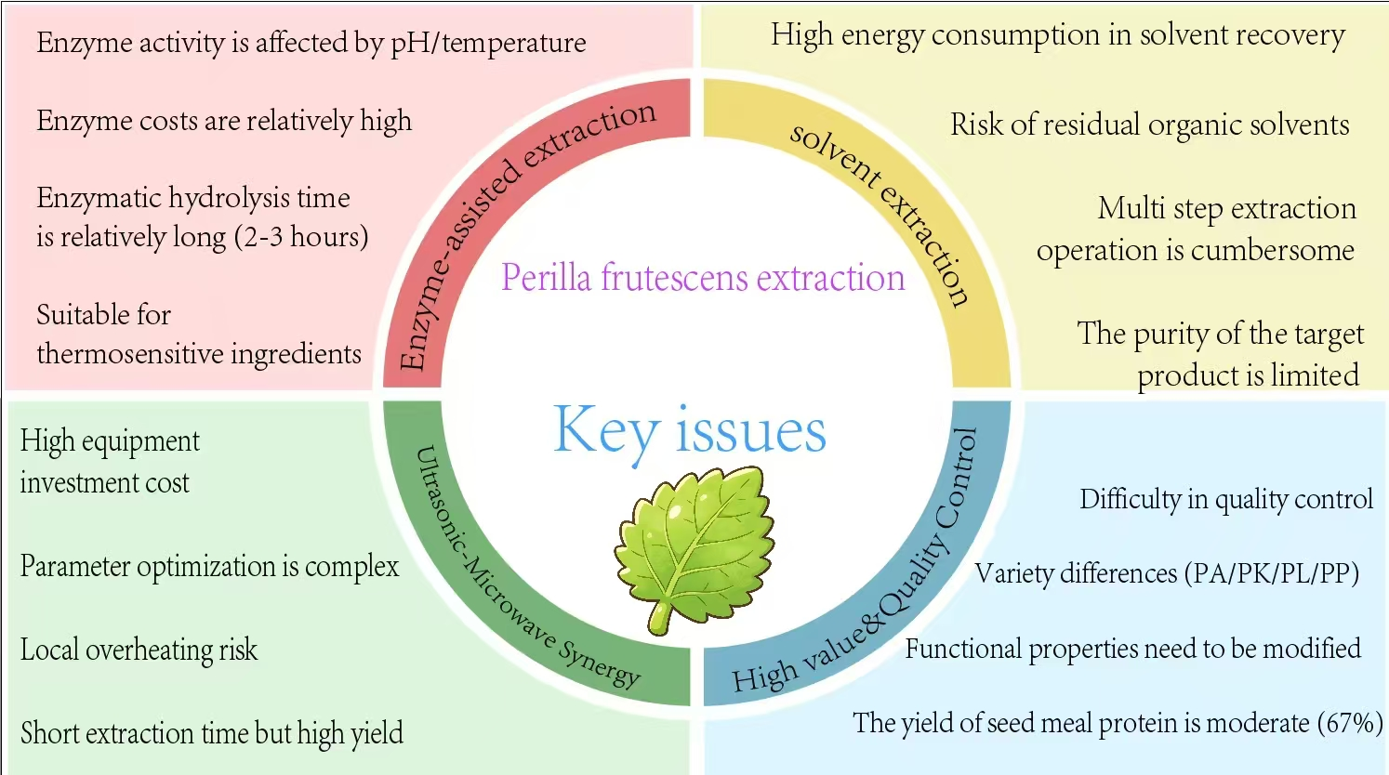
Fig. 2. Key Issues in Perilla frutescens Extraction

3.Insecticidal, Repellent and Antifeedant Effects of Perilla Essential Oil

Plants in the Lamiaceae family are generally rich in monoterpene and sesquiterpene volatiles, which can produce lethal effects through neurotoxicity and can also alter the orientation/avoidance and feeding behaviors of insects (mites) through olfactory interference, providing important clues for developing botanical repellents (Wang, 2010). In this context, studies on perilla (Perilla frutescens) show that its volatile components can exhibit a composite effect in which “lethal toxicity—repellency—behavioral inhibition” coexist across different pests, while different pest groups and exposure routes (contact-killing, olfactory repellency, ingestion via feeding) determine differences in effects.

3.1 Contact and Fumigation Bioassays of Insecticidal Activity

In stored-product pest systems, perilla essential oil has been used in contact-killing, fumigation, and repellency experiments, showing high application potential against coleopteran stored-product pests. Taking essential oil from the aerial parts of perilla as an example, one study identified its constituents by GC–MS and conducted contact and fumigation toxicity assays on Tribolium castaneum and Lasioderma serricorne; the results suggested that the essential oil and its active constituents can cause mortality through multiple modes of action and have practical control value (Liu et al., 2014). Furthermore, studies on L. serricorne also indicate that perilla essential oil and its isolated monomers have contact-killing and repellent activities against the target insect, and R-(+)-carvone, perilla aldehyde, and 2-furyl methyl ketone are considered important candidate constituents contributing to the activity. Perilla aldehyde is considered the key component contributing to contact toxicity, whereas 2-furyl methyl ketone is more prominent in fumigant toxicity (You et al., 2014).
The evidence chain for perilla essential oil is not limited to laboratory bioassays. In orchard pest systems, one study screened 26 essential oils indoors and carried out field confirmation; the results showed that perilla leaf essential oil performed best, with significant acute contact toxicity to adults of the pear psylla (Cacopsylla chinensis) (LD₅₀ = 0.63 μg/adult). After field spraying with a 1 mg/mL perilla leaf oil solution, 1st–2nd instar nymphs achieved a 72% corrected reduction 7 d after treatment (Dong et al., 2019).
In mosquito systems, perilla essential oil also shows lethal effects on different life stages. Studies have shown that the LC50 of perilla essential oil against third-instar larvae of Culex pipiens pallens is 45 mg/L, while the LC50 of its main component 2-hexanoylfuran is 25 mg/L; moreover, in ovicidal experiments, high-concentration treatment can achieve nearly complete egg mortality, indicating multi-stage control potential from larvae to eggs (Zhang et al., 2023). In addition, research on mosquito management has compared the potential of essential oils from different perilla types (e.g., green perilla and red perilla) in repellency and larvicidal activity, suggesting that differences in plant material types and chemotypes of perilla may cause changes in the bioactivity spectrum, and emphasizing that the source and chemical composition of the essential oil need to be reported simultaneously in reviews and follow-up experiments (Tabanca et al., 2015).

3.2 Repellency And Behavioral Regulation

In addition to lethal effects, repellency rate can also be used as one of the criteria for evaluating the protective efficacy of essential oils. Studies on stored-product pests show that perilla essential oil not only has lethal toxicity against targets such as Lasioderma serricorne, but can also exhibit repellent effects (Liu et al., 2014). Mosquito studies further demonstrate that perilla essential oil has good “repellency persistence”. For example, in repellency assays against adult Culex pipiens pallens, 10% perilla essential oil still maintained a repellency rate of more than 88% at 360 min, and maintained 100% repellency within the first 60 min, performing comparably to DEET at 330 min, indicating its applicability in outdoor and semi-outdoor protection scenarios that require a certain duration of effect (Zhang et al., 2023).
For piercing–sucking pests, key components were identified from the volatile organic compounds (VOCs) of perilla leaves, and their effects on pest behavioral choice were verified using a Y-tube olfactometer. Combined with molecular docking, RT-qPCR, and detoxification-enzyme activity assays, it was inferred that the volatiles may achieve repellency through the combined effects of olfactory recognition and neural interference (Gao et al., 2024).

3.3 Antifeedant Effect

Compared with lethal and repellent effects, the antifeedant and avoidance effects of perilla can be exerted both by spraying ethanol crude extracts and by intercropping plants to release volatiles. The ethanol crude extract of perilla shows coexistence of antifeedant and avoidance rates against tobacco aphids, and the lethal effect is closely associated with time (Yuan et al., 2016). Meanwhile, in the phyllotreta striolata system, field intercropping results and indoor antifeedant assays demonstrate that perilla can significantly reduce damage, mainly through repellency and antifeedant effects (Liang, 2007). Extracts from different perilla organs show different degrees of antifeedant activity against adults. Xian Zhenhua et al. used the dipped circular leaf-disc method (d = 1.5 cm) to determine the antifeedant activity of 10 g/L methanol, absolute ethanol, and petroleum ether extracts from different perilla organs. The results showed that in the choice antifeedant test, the methanol and petroleum ether extracts of perilla flowers both achieved a 24 h antifeedant rate of 100.00%, significantly higher than the stem and leaf extracts; and overall, the 24 h antifeedant rate tended to be higher than that at 48 h, indicating that antifeedant activity decreased with prolonged time. In the no-choice antifeedant test, the 24 h antifeedant rate of the flower petroleum ether extract reached 86.65%, also the highest among treatments, further indicating that perilla flowers are rich in active components with behavioral regulatory effects (Xian et al., 2009).

4. Composition and distribution differences of active components

Volatile oil is the most representative insecticidal active component of perilla, mainly enriched in leaves and calyces. Zhang Chenlu et al. identified 26 compounds by GC–MS, among which perillaldehyde accounted for 53.97%, followed by caryophyllene (11.85%) and limonene (9.13%) (Zhang et al., 2016). Zhang Bo et al. extracted perilla essential oil by steam distillation, with an oil yield of 0.033%. The study showed that origin, harvest season, and drying method significantly affect the composition of volatile oil (Zhang & Ye, 2015). Regional surveys across China have further confirmed this variability, showing that both the dominant components and the antifungal activity of the essential oil differ markedly among production areas (Tian et al., 2014).
Liu Na et al. optimized the extraction process of total flavonoids from perilla leaves through ultrasound–enzyme synergy. Under the optimal conditions, the extraction yield of total flavonoids reached 3.45%, and the major flavonoid components in leaves were rutin, apigenin, and luteolin glycosides (Liu et al., 2023). Yuan Lianlian et al. used 95% ethanol maceration at room temperature, and HPLC-DAD analysis showed that the crude extract contained flavonoids, phenolic acids, fatty acids, and a small amount of terpene lactones (Yuan et al., 2016). Xian Zhenhua et al. showed that methanol gave the highest extraction yield for calyces (7.32%), while petroleum ether gave the best extraction of lipophilic components from seeds (4.11%) (Xian et al., 2009).
In recent years, international research has made important progress. Metabolomics analysis divides perilla chemotypes into two major categories: monoterpene (MT) and phenylpropanoid (PP). MT types include subtypes such as the high phenolic-acid type (PA), perilla-ketone type (PK), high essential-oil type (EK), umbellone type (PT), perilla-alcohol type (PL), perilla-furan type (SF), and pleurisy type (C) (Yi et al., 2025). Wang et al. found that perilla leaves with purple coloration on both sides, from southern origins, and from non-perilla-ketone chemotypes had the best quality (Wang et al., 2025).
Studies on the organ distribution of phenolic acids show that 20 days after flowering, flower tissues have the highest phenolic-acid yield. The content of rosmarinic acid in seeds can reach 4606.4 μg/g, and total phenols can reach 4856.8 μg/g dry weight (Yi et al., 2025). Pattananandecha et al. found that perilla seed meal is rich in rosmarinic acid and luteolin, significantly increasing alkaline phosphatase activity in human osteoblasts and showing potential to promote bone health (Pattananandecha et al., 2025).
Yang et al. performed integrated transcriptome–metabolome analysis and identified 35 terpene compounds and 109 terpene synthase-encoding genes in four cultivated varieties of different chemotypes (PA, PK, PL, PT), including three linalool synthases and one geranyl synthase (Yang et al., 2024). Evaluation of 28 genotypes from the North Himalayas showed that seed oil content ranged from 35.6% to 48.2%, and α-linolenic acid content reached up to 60.9% (Ansari et al., 2025), providing genetic resources for breeding high-oil varieties.

5. Outlook

As a traditional plant with both medicinal and edible value, research on perilla in the field of botanical pesticides has achieved important progress in green extraction processes, identification of active components, and multi-target pest control, clarifying the insecticidal potential of key substances such as perillaldehyde. On the extraction side, the limitations of traditional processes have been overcome, and green and efficient technologies such as enzyme assistance, ultrasound–microwave synergy, and polarity-gradient extraction have been developed, enabling efficient extraction of core insecticidal active components and high-value utilization of perilla seed meal. Bioactivity studies have confirmed that perilla has triple effects—lethal toxicity, repellency, and antifeedant activity—against multiple types of pests such as stored-product pests, orchard pests, and piercing–sucking pests, highlighting its significant advantages as a substitute for chemical pesticides. At the component-research level, the organ-distribution patterns of active substances such as perillaldehyde and perilla ketone have been clarified, providing a theoretical basis for targeted breeding of highly active perilla varieties.
Perilla extraction processes are evolving from traditional steam distillation and organic-solvent extraction toward green coupled technologies such as ultrasound, microwave, and enzymolysis. New processes such as ultrasound–microwave coupling and stepwise extraction show significant advantages in increasing yield, improving quality, and reducing energy consumption. However, current research still suffers from problems such as insufficient synergy among multiple components, weak utilization of by-products, and a lack of scale-up data. In the future, interdisciplinary integration should be strengthened, extraction mechanisms should be studied in depth, high-value utilization pathways for by-products should be expanded, and a green development model for the entire perilla industry chain should be built.
However, research on perilla-based botanical pesticides still faces many problems that urgently need to be solved. In terms of extraction processes, practical issues remain, such as sensitivity of enzymolysis conditions, risks of organic-solvent residues, high equipment investment costs, and cumbersome multi-step extraction operations. Studies on mechanisms of activity are mostly based on indoor bioassays, and the field persistence and synergistic effects with other control measures are still unclear. At the same time, no standardized evaluation framework has yet been established in the industry, resulting in low comparability among different research results. In addition, studies on the environmental behavior of perilla extracts in field applications, safety to non-target organisms, and residue degradation patterns are relatively weak, becoming an important bottleneck for industrial application.
Based on existing experimental results, perilla-related formulations tend to show a “behavioral regulation + lethality” effect more readily against piercing–sucking pests, whereas they may mainly act through repellency and antifeedant effects against some chewing pests. In targets such as stored-product pests and mosquitoes, the essential oil and its monomers more prominently exhibit contact-killing and lethal effects. This indicates that the mode of action of perilla volatile active components may be closely related to the feeding mode of pests, the olfactory sensory system, and exposure pathways. However, studies that use perilla essential oil as the material and quantify antifeedant indices (FDI/AFI) using the standard leaf-disc method/feeding-amount measurement are relatively insufficient, which also implies that subsequent essential-oil experiments should, as much as possible, adopt a standardized assay framework in which “lethal toxicity—repellency—antifeedant” are measured in parallel, and should investigate chemical composition in depth to improve comparability among studies.
Future research and development of perilla-based botanical pesticides should focus on two core aspects—process optimization and mechanism elucidation—while taking both practicality and scientific rigor into account. In terms of extraction processes, it is necessary to develop low-cost, easy-to-operate, residue-free green extraction technologies, simplify multi-step extraction procedures, optimize parameter systems for combined techniques such as enzymolysis, ultrasound, and microwave, and improve scalability and process suitability for industrial scale-up; in terms of activity mechanisms, molecular docking, transcriptomics, and other technologies should be integrated to clarify the targets and metabolic pathways of key active components, providing theoretical support for breeding highly active perilla varieties and targeted extraction; at the evaluation and application level, unified multi-dimensional bioactivity assay standards should be established, field plot trials and demonstration applications should be strengthened, synergistic control modes combining perilla extracts with physical control and biological control should be explored, and environmental safety assessments should be systematically carried out to clarify residue-degradation patterns and impacts on non-target organisms. In addition, based on the structural characteristics of perilla active components, new biomimetic pesticide lead compounds could be developed to further expand their application scope in the field of botanical pesticides.

References

Kinniburgh, F., Selin, H., Selin, N. E., & Schreurs, M. (2023). When private governance impedes multilateralism: the case of international pesticide governance. Regul Gov, 17(2), 425–448. https://doi.org/10.1111/rego.12463
Park, B. K., Joo, K. S., & Heo, M. J. (2023). Evaluation of pesticide residues in vegetables and risk assessment from Incheon. Environ Sci Pollut Res Int, 30(15), 43795–43803. https://doi.org/10.1007/s1135602325307y
El Nahhal, Y., Radwan, A., & Radwan, A. M. (2013). Human health risks: impact of pesticide application. Environ Earth Sci, 3(7), 199–209. https://api.semanticscholar.org/corpusid:262475391
Wolfe, J., & Marsit, C. (2023). Pyrethroid pesticide exposure and placental effects. Mol Cell Endocrinol, 112070. https://doi.org/10.1016/j.mce.2023.112070
Yang, X., Liao, Y., Zhao, P., et al. (2022). Research progress on botanical pesticides and their development and utilization. South China Agriculture, 16(11), 33–36. https://doi.org/10.19415/J.Cnki.1673-890x.2022.11.010
Yuan, L., Wang, Y., Jin, Z., Zhang, J., Li, W., Dong, S., et al. (2016). Biocontrol effect of perilla ethanol crude extract on tobacco aphids. Chinese Tobacco Science, 37(2), 11–15. https://doi.org/10.13496/J.Issn.1007-5119.2016.02.003
Liang, H. (2007). Preliminary study on the control effect of perilla on Phyllotreta striolata [D]. Guangxi University.
Dong, Z.-X., Wang, Y.-W., Liu, Q.-Z., Tian, B.-L., & Liu, Z.-L. (2019). Laboratory screening of 26 essential oils against Cacopsylla chinensis (Hemiptera: Psyllidae) and field confirmation of the top performer, Perilla frutescens (Lamiales: Lamiaceae). J Econ Entomol, 112(3), 1299–1305. https://doi.org/10.1093/jee/toy414
Zhang, C., Zhang, X., Zhu, S., Feng, Z., Liang, Z., & Zhao, H. (2016). Optimization of cellulase-assisted extraction of perilla leaf volatile oil by Box–Behnken response surface methodology. Chinese Traditional Patent Medicine, 38(9), 2055–2059. https://doi.org/10.3969/J.Issn.1001-1528.2016.09.038
Khruengsai, S., Promhom, N., Sripahco, T., Siriwat, P., & Pripdeevech, P. (2023). Optimization of enzyme-assisted microwave extraction of Zanthoxylum limonella essential oil using response surface methodology. Sci Rep, 13(1), 12872.
Liu, N., Chen, J., Yan, W., Yuan, Y., Wang, K., Zhang, Z., et al. (2023). Process study on ultrasound- and enzyme-assisted extraction of flavonoid compounds from perilla leaves. Guangzhou Chemical Industry, 51(16), 76–77.
Guo, D., Li, R., Du, G., & Li, L. (2006). Preparation method of a perilla extract with nematicidal activity against the pine wood nematode. CN1795724A.
Chen, F., Liu, S., Zhao, Z., Gao, W., Ma, Y., Wang, X., et al. (2020). Ultrasound pre-treatment combined with microwave-assisted hydrodistillation of essential oils from Perilla frutescens (L.) Britt. leaves and its chemical composition and biological activity.
Feng, S. H., Shen, Q., & Chen, S. (2019). Essential oil profiles of 168 perilla cultivars by head space solid phase micro-extraction gas chromatography mass spectrometry. J Essent Oil Bear Plants, 22(6), 1519–1536.
Feng, C., Zhao, R., Yang, X., Ruan, M., Yang, L., & Liu, T. (2024). A novel stepwise microwave hydrodistillation and extraction process for separating seed oil and essential oil simultaneously from perilla seeds. LWT, 198, 116048.
Singh, T., Awasthi, R., Prabhakar, P. K., & Madhumita, M. (2025). Optimization of ultrasound mediated extraction of perilla protein isolate: study of ultrasonication effect on amino acid profile and functional characteristics. J Food Meas Charact, 19(4), 2574–2594.
Wang, Y.-N. (2010). Research progress on plant-derived acaricidal active substances. Sci Silvae Sin, 46(6), 118–127.
Liu, Z.-L., Zhang, W.-J., You, C.-X., Xu, Y., Wang, W.-X., Du, S.-S., et al. (2014). Chemical composition and insecticidal activities of the essential oil of Perilla frutescens (L.) Britt. aerial parts against two stored product insects. Eur Food Res Technol, 239(4), 481–490. https://doi.org/10.1007/s00217-014-2242-8
You, C.-X., Wang, Y., Zhang, W.-J., Yang, K., Wu, Y., Geng, Z.-F., et al. (2014). Chemical constituents and biological activities of the purple perilla essential oil against Lasioderma serricorne. Ind Crops Prod, 61, 331–337. https://doi.org/10.1016/j.indcrop.2014.07.021
Zhang, R., Zhang, W., Zheng, J., Xu, J., Wang, H., Du, J., et al. (2023). Toxic effects of Perilla frutescens (L.) Britt. essential oil and its main component on Culex pipiens pallens (Diptera: Culicidae). Plants, 12(7), 1516. https://doi.org/10.3390/plants12071516
Tabanca, N., Demirci, B., Ali, A., Ali, Z., Khan, S. I., Liu, Z.-L., et al. (2015). Essential oils of green and red Perilla frutescens as potential sources of compounds for mosquito management. Ind Crops Prod, 65, 36–44. https://doi.org/10.1016/j.indcrop.2014.11.043
Tian, J., Zeng, X., Zhang, S., Wang, Y., Zhang, P., Lü, A., et al. (2014). Regional variation in components and antioxidant and antifungal activities of Perilla frutescens essential oils in China. Ind Crops Prod, 59, 69–79. https://doi.org/10.1016/j.indcrop.2014.04.048
Zhang, B., & Ye, Y. (2015). Study on repellency and toxicity tests of perilla essential oil against the museum pest Dermestes maculatus. Sci Educ Mus, 1(4), 245–248. https://doi.org/10.16703/j.cnki.31-2111/n.2015.04.005
Xian, Z., Sun, J., & Zou, X. (2009). Study on the antifeedant activity of perilla extracts against adult Phyllotreta striolata. Guangdong Agric Sci, 8, 126–128. https://doi.org/10.16768/j.issn.1004-874x.2009.08.015
Yi, D., Wang, Z., & Peng, M. (2025). Comprehensive review of Perilla frutescens: chemical composition, pharmacological mechanisms, and industrial applications in food and health products. Foods, 14(7), 1252. https://doi.org/10.3390/foods14071252
Wang, M., Shen, R., Wang, X., Zhang, J., Ma, J., Shi, Y., et al. (2025). Evaluation of edible and medicinal varieties based on multidimensional quantitative data: a case study of perilla leaf. J Food Compos Anal, 140, 107196. https://doi.org/10.1016/j.jfca.2025.107196
Pattananandecha, T., Apichai, S., Sukkho, T., Sirilun, S., Ogata, F., Kawasaki, N., et al. (2025). Perilla seed meal extract enriched with rosmarinic acid and luteolin: natural active pharmaceutical ingredients (NAPIs) for osteoprotective effects. Antioxidants, 14(8), 973. https://doi.org/10.3390/antiox14080973
Yang, S. M., Chu, H. Y., Wang, Y. X., Guo, X. Y., Zhao, L., Liu, S. J., et al. (2024). Analysis of monoterpene biosynthesis and functional TPSs of Perilla frutescens based on transcriptome and metabolome. Med Plant Biol, 3, e017. https://doi.org/10.48130/mpb-0024-0017
Ansari, M. A., Kumar, A., Ahammed Shabeer, T. P., Dar, M. U. D., Dar, T. A., & Jan, N. (2025). Exploring the genotypic potential of perilla (Perilla frutescens L.) for climate-resilient agriculture in the North Eastern Himalayas. Front Sustain Food Syst, 9, 1549061. https://doi.org/10.3389/fsufs.2025.1549061
Gao, L., Wei, Y., Li, K., et al. (2024). Perilla frutescens repels and controls Bemisia tabaci MED with its key volatile linalool and caryophyllene. Crop Prot, 184, 106837. https://doi.org/10.1016/j.cropro.2024.106837

